ExMC/1070/INF
September 2015

INTERNATIONAL ELECTROTECHNICAL COMMISSION SCHEME FOR CERTIFICATION TO STANDARDS RELATING TO EQUIPMENT FOR USE IN EXPLOSIVE ATMOSPHERES (IECEx SCHEME)

Title: Nomination of ExSFC Chairman from NL

INTRODUCTION

In line with the Call for nominations ExMC/1045/INF, the IECEx Secretariat received a nomination from NL for Mr Marco Erdhuizen as a candidate for ExMC to consider.

The CV for Mr Marco Erdhuizen is attached.

ExMC Members will be asked to consider this and other nominations in order to arrive at an ExMC agreed appointment for the position of ExSFC Chairman, assuming that this new Committee is approved by both ExMC and CAB.

Chris Agius
IECEx Secretariat

Address:  Level 33, Australia Square  264 George Street  Sydney NSW 2000  Australia | Contact Details:  Tel: +61 2 46 28 4690  Fax: +61 2 46 27 5285  e-mail: info@iecex.com  http://www.iecex.com

Brief CV

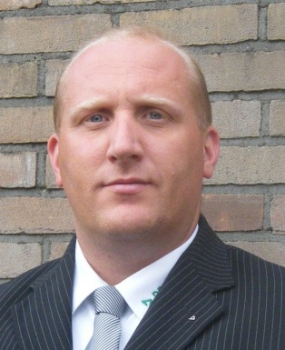

Marco Erdhuizen

Born in 1973, I studied Mechanical Engineering in Arnhem (B. Eng. Diploma).
Working for DEKRA Certification B.V. for more than 10 years in the field of Ex certification as Senior Project Manager (ATEX, IECEx 02), Lead Assessor (ATEX, IECEx 02, IECEx 03, INMETRO, KC) and Certification Manager (ATEX, IECEx 02, IECEx 03).
Memberships:
- Member of IECEx ExMC WG10 (IECEx 03)
- Member of the national working group on IECEx 03-5
- Member of the Dutch IECEx 05 NL committee

Within the national working group on IECEx 03-5 additional national technical requirements for IECEx 03 service facilities were established. A pilot project is currently running in which I conduct the audits and evaluate the results with the auditee and the IECEx ExMC WG10 convener, my colleague Theo Pijpker.

Together with two colleagues (Dirk-Jan Schreurs and Theo Pijpker) I am member of the Dutch IECEx 05 NL committee that has been setup by DEKRA in April 2014, acting as a national platform with over 50 stakeholders: asset owners, service facilities, training organizations, exam bureaus, regulators and DEKRA.

I my nonworking time I spend quite some time in organizing and participating in events for the village community.

