COLLECTION OF IECEx / ExTAG DECISIONS

Standard:  N/A | Clauses:  N/A | Draft Decision Sheet:  ExTAG/445B/CD
Subject: Guidance on issuance of QARs when products are manufactured at multiple sites  Status of document: Approved | Key words:  - QAR  - Manufacturing Location | Date: November 2016  Originator of proposal: ExMC WG01

Background:

ExCBs are employing different methods when issuing QARs to Manufacturers with worldwide operations, i.e. products are being produced in multiple facilities around the globe. Some ExCBs require that each site audited receive a separate QAR. Other ExCBs are including multiple sites within the same QAR.

Each approach has advantages and disadvantages. An advantage of issuing a separate QAR for each site audited is that the overall QAR will not be suspended due to a problem or delay at any one site. A disadvantage of this approach is that multiple QARs must be linked to each CoC, introducing the possibility of errors or creating confusion among CBs.

QUESTION: Do the IECEx Rules or Operational Documents require a separate QAR to be issued for each site audited?

ANSWER: No, the rules and ODs leave this up to the discretion of the issuing ExCB. Recognizing that this may lead to different approaches among ExCBs, the following guidance is provided to assist with various situations an ExCB may encounter:

- When a manufacturer controls multiple manufacturing locations and/or production sites under the same quality management system, the manufacturer may prefer that one QAR is issued to cover all locations. See Examples 1 and 2 below, for two acceptable methods of indicating this arrangement on the online QAR registration. If different sites contain different protection methods within their scope, then the format in example 1 should be used. If different product types are produced at different sites, this shall also be indicated.
- When a product is manufactured at multiple manufacturing locations or production sites that are not under the same quality management system, it is recommended that a separate QAR be issued due to the differences that may exist between locations. However, the ExCB may decide to issue a single QAR as shown in examples 1 and 2.
- When some manufacturing locations or production sites hold certification to ISO 9001 and other locations do not, then separate QARs should be issued, due to the different audit frequencies. If only one QAR is issued covering all sites, then all sites will need to be audited annually.

In all cases, the ExCB and manufacturer shall work together to ensure that audit(s) at each site(s) (manufacturer, manufacturing location, and/or productions sites) support timely completion. The ExCB and manufacturer shall consider the time required for a manufacturer’s response to audit findings and acceptance by the ExCB, when scheduling the audit.

It should also be noted that the Rules, IECEx02, distinguish between a Manufacturer, Manufacturing Location, Production Site, and Supplier. Suppliers are not normally required to be audited by the ExCB if the manufacturer’s quality system complies with the requirements in 7.4 of ISO/IEC 80079-34:2011.
Production sites and manufacturing locations shall be audited by the ExCB in accordance with the frequency defined by IECEx Rules and Operational Documents.

QAR Example 1:
Include details in the “Comments” field:
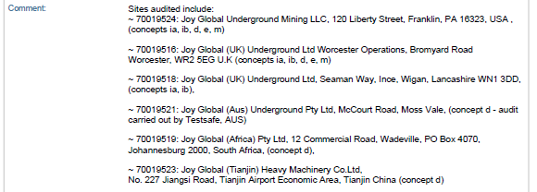

QAR Example 2:
List all sites audited in the “Site(s) audited” field. Use this example if the product types, protection techniques, and audit frequency are the same for all sites audited.
