ExMC WG1 Draft  prExMC/987/CD  March 2015 | ExMC/1152/CD  July 2016

INTERNATIONAL ELECTROTECHNICAL COMMISSION SYSTEM FOR
CERTIFICATION TO STANDARDS RELATING TO EQUIPENT FOR USE
IN EXPLOSIVE ATMOSPHERES (IECEx SYSTEM)

To: Members of the IECEx ExMC
Title: ExMC WG1 Proposals to Amend IECEx 02 and ODs to clarify Manufacturer, Manufacturing Location, Production Site

---------------------------
As the IECEx 02 Certified Equipment Scheme has both grown and matured over the years, questions have arisen concerning clarification over the terms:-
Manufacturer,
Manufacturing Location,
Production Site

ExMC WG1 formed a Specialist Task Group under the Convenorship of Mr Mike Slowinske from the US. The ExMC WG1 Task Group has conducted significant work over the past year with further work done both during and following the ExMC WG1 Northbrook 2016 meeting.

ExMC WG1 are now in a position to propose changes to IECEx 02 and related Operational Documents, e.g. OD 009, via this document.

Therefore, ExMC will be asked during the 2016 Umhlanga meeting to agree with the ExMC WG1 recommendations contained in this document, for the Secretariat to prepare revised Editions of both IECEx 02 and related ODs, eg OD 009.

Chris Agius
IECEx Executive Secretary

Address:  Level 33, Australia Square  264 George Street  Sydney NSW 2000  Australia | Contact Details:  Tel: +61 2 4628 4690  Fax: +61 2 4627 5285  e-mail:chris.agius@iecex.com  http://www.iecex.com

ExMC WG01 proposal: Use of the terms “Manufacturer”, “Manufacturing Location”, and “Production Site”

Background
In the 2014 meeting of ExMC Working Group 01, a task group was formed in response to a proposal to clarify the term “Manufacturer” throughout IECEx Rules and Operational Documents. The output of the task group was subsequently discussed in WG01 meetings in 2015 and 2016. The results of these discussions are as follows:

The “Manufacturer” is the organization carrying responsibility for continued compliance of the product. ExMC WG01 does not recommend changing the definition of the term “Manufacturer”. However, there is a need for defined terms to address manufacturing sites performing manufacturing activities, but who do not carry overall responsibility for the product compliance. To distinguish between the “Manufacturer” and other locations performing manufacturing activities, new defined terms are proposed: “Manufacturing Location” and “Production Site.” These terms currently appear on the COC and QAR, and new definitions for these terms are included in the proposal below.

Along with these changes to the Rules and Operational Documents, a Decision Sheet is also proposed, to help provide guidance and ensure consistency among ExCBs when auditing manufacturers producing products at multiple manufacturing locations (see separate attachment).

It should be noted that the changes proposed below are intended to provide clarification, and are not intended to require changes in the ways that ExCBs perform assessments of quality management systems.

Proposed revisions to IECEx02:
New Clause 3.xx
Manufacturing Location
A facility that carries out manufacturing, handling, storage, and/or other activities (e.g. routine tests), up to and including releasing to the market the product bearing the IECEx Certificate number. The Manufacturing Location(s) operate under the control of the Manufacturer listed on the Certificate.

New Clause 3.yy
Production Site
A facility that carries out manufacturing, handling, and/or storage of the product, in part, under the control of a Manufacturing Location.
Note: A Production Site will provide product to a Manufacturing Location for final release. A Production Site is not a Supplier.

No changes are being proposed to the definition of a Manufacturer, which is included here for reference only:
3.17 Manufacturer
an organization, situated at a stated location or stated locations, that carries out or controls such stages in the manufacture, assessment, handling and storage of a product that enables it to accept responsibility for continued compliance of the product with the relevant requirements and undertakes all obligations in that connection
Proposed revisions to IECEx02 (continued):
3.9
IECEx Quality Assessment Report (QAR)
a document that presents the results of an on-site assessment of the quality management system of a manufacturer’s, manufacturing location, or production site quality management system by an ExCB, to the requirements of the IECEx Certified Equipment Scheme. A summary of the QAR is published on the IECEx website: www.iecex.com

8.3.1 Assessment of the manufacturer’s quality management system
The manufacturer can apply to any ExCB for the assessment of his quality management system (QMS). The ExCB shall assess the conformity of the QMS and associated quality plan(s) relevant to the Ex equipment requested, for compliance with ISO/IEC 80079-34. In order to demonstrate how the quality system QMS ensures that equipment is manufactured in conformity with the requirements, the manufacturer shall provide the ExCB with a copy of a quality plan for the Ex equipment or equipment categories to be listed on the QAR. The manufacturer may provide evidence of the suitability of the quality system such as certification/registration to ISO 9001 by a competent body. The ExCB shall take the evidence into account when deciding the extent of the assessment that it needs to conduct. The assessment shall include “on-site assessment” at the manufacturer’s premises, and other manufacturing location(s)/production site(s) as needed, to confirm implementation of the quality system QMS and associated quality plan(s).

QAR Form F-001
Revise form to state “Manufacturing Location(s)/Production Site(s) audited”
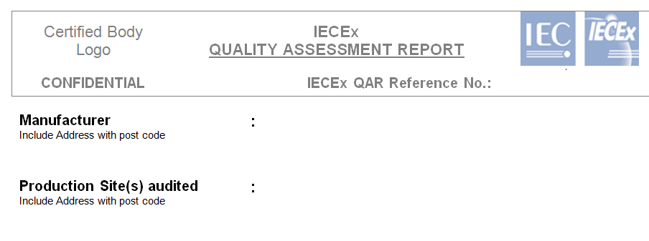

Revisions to OD011-2
1.2.16 Manufacturer
The name of the organization that produces the product. Except for licensed equipment (See IECEx 02, Clause 9.8) this is the same as that of the “applicant”. The address listed should be the location where the product is principally produced. A physical (street) address is required and a Postal Box number is not acceptable.
NOTE According to IECEx 02, 3.17, the “manufacturer” is the entity that actually produces and accepts responsibility for continued compliance of the product.

1.2.17 Manufacturing locations
This space is for the inclusion of more than 1 manufacturing site location. When selecting additional manufacturing locations, it is necessary to “Save” the Draft CoC first then “Edit” to add more Locations. Once the information has been entered it may be deleted/edited as required. When a New Issue of a CoC is raised (See Section 2.2 ) all existing Locations from the Previous issue is copied into the New Issue. These existing Locations may be deleted/edited and new Locations added without changing previous Issues.

3.1 Step 1 (page 18)
…Furthermore, the System is structured on a “linkage” system whereby an IECEx certificate of Conformity may be linked to one or more ExTRs and QARs. For example, where a product that is to be covered by an IECEx Certificate of Conformity is manufactured at two or more locations, then there may be two or more QARs issued. Only Manufacturing Locations (as defined in IECEx 02, clause 3.xx) shall appear in the “Additional Manufacturing Location(s)” field on the CoC.

4.1 Step 1 (page 24)
…Furthermore, the System is structured on a “linkage” system whereby an IECEx certificate of Conformity may be linked to one or more ExTRs and QARs. For example, where a product that is to be covered by an IECEx Certificate of Conformity is manufactured at two or more locations, then there may be two or more QARs issued. Only Manufacturing Locations (as defined in IECEx 02, clause 3.xx) shall appear in the “Additional Manufacturing Location(s)” field on the CoC. Both Manufacturing Locations and Production Sites are to be entered in the “Site(s) Audited” field of the QAR Summary.
For complex arrangements, the ExCB decides whether to issue separate QAR Summaries for each location, or list multiple sites in the same QAR Summary.

4.1 Step 2 (page 25)
Sites audited:
This is where the site(s) audited must be clearly shown by using a street address - a Postal Box address for the manufacturer is not acceptable. If multiple sites are audited and they do not each receive their own separate QAR, then the manufacturer’s location and/or any additional production sites should be listed either in this field, or in the Comments field.

Revisions to OD009
Step 6 (page 11):
…The ExCB has to review the manufacturer’s QAR summary report, and the report(s) of all Manufacturing Locations and Production Site(s), ensuring that
a) type of protection
b) product type
c) manufacturing location/production site
d) validity date
e) issuing ExCB still competent/approved
of the certified product are covered.

Revisions to OD025
3.16 Initial Assessment
Activities related to the notification of a manufacturer to determine whether the manufacturer and the applicable manufacturing sites location(s) and production site(s) meet all the requirements of the relevant clauses of the specified standard necessary for granting notification as to whether they have effectively implemented, including documentation review, site audit at the manufacturer’s premises, manufacturing location(s) and production site(s), preparation and consideration of the audit report and other relevant activities necessary to provide sufficient information to allow a decision to be made as to whether notification shall be granted. Audit results shall be recorded on an Quality Assessment Report.

5.2.2.1 Scope of initial assessment, surveillance and re-assessment
a) Initial assessments and re-assessments:
For initial assessments and re-assessments all requirements of ISO/IEC 80079-34 apply. These assessments may be conducted in whole or part at the manufacturer’s premises, as well as other manufacturing location(s)/production site(s) if applicable.
It is the CB (Certification Body) responsibility to determine what level of assessment is required for suppliers / sub-suppliers that are responsible for critical operations and requirements laid down in ISO/IEC 80079-34. Examples of critical operations include, but are not limited to:
• Design and development changes
• Assembly / sub-assembly of product
• Routine Testing/Final testing of product
• Labelling of product
• Inspection and control of critical operations.

“Storage” and “handling” are activities included in the definitions of “Manufacturing Location” and “Production Site.” Storage and handling are critical operations only in cases where improper storage or handling of parts or assemblies may potentially impact the certification or safety of the final product. It is not the intent of this clause to require assessment of locations whose sole function is the storage of finished goods inventory after final assembly and packaging.

It is not the intent of this clause to require CB’s to audit suppliers or subsuppliers.
It is however the responsibility of the CB’s to evaluate if suppliers /
sub-suppliers responsible for requirements of ISO/IEC 80079-34 have the
necessary quality systems and quality plans in place to insure the requirements of ISO/IEC 80079-34 are being met. Examples of evaluations of suppliers / subsuppliers can include:
• Review of a current ISO certificate with the proper scope
• Audits performed by the supplierManufacturer
• Audits performed by another CB
• Audits by the CB
• Components covered by the IECQ Scheme ( www.iecq.org)

b) Surveillance:
The surveillance visits at the manufacturer’s premises shall include:
• the system maintenance elements, which are internal audit, management review and preventive and corrective action;
• customer complaints;
• changes to the documented system;
• areas subject to change;
• selected elements of the certification/registration standard;
• other selected areas as appropriate.
• identification of any new manufacturing locations /production sites
• review of suppliers and/or sub-suppliers performing critical operations.
• re-assessment is defined in clause 3.18 of this document.

5.2.2.2.2 Surveillance Assessments
Surveillance assessments shall be carried out as follows:-
a) For manufacturers without a certified ISO 9001: 2008 Quality System, surveillance audits should be conducted every 12 months.
b) Manufacturers with a Qualified ISO 9001: 2008 Quality System, surveillance audits should be carried out every 18 months.
Additional surveillance / assessments may be conducted at the discretion of the IECEx Certification Body based on the manufacturer’s / manufacturing location’s/production site’s performance and results of previous surveillance / audit results. It is recommended that the time frame for audit intervals begin when the initial assessment report is issued.

6.8.2 Issue of QAR
A Quality Assessment Report (QAR) shall be valid for a period not exceeding 3 years.

IECEx Certification Bodies shall register the QAR on the IECEx Website in
accordance with Operational Document OD 011 Part 2. This On-line registration provides the following summary information, which is publicly available.
• QAR reference number
• ExCB conducting the audit
• Manufacturer and audit location(s)
• IECEx Certificates of Conformity linked to the QAR
• Comments of the ExCB if any

In accordance with OD 011-2, the online QAR summary should include the Manufacturer’s name in the “Manufacturer” field, and the location(s) audited in the “Site(s) Audited” field. The ExCB shall consider whether a separate QAR is needed for each site audited.

The “Comments” field of the QAR summary should be used to explain the relationships between sites audited, in cases when different critical operations take place at different locations. One exception to this is for Case 2 or Case 3 Trade Agents per OD 203, when the relationship between the trade agent and OEM is to be kept confidential. In these cases the details are to appear in the QAR but not in the online QAR summary.

In addition, IECEx Certification Bodies shall inform the IECEx Secretary of any IECEx Certificates of Conformity that are to be suspended or cancelled. This will ensure that other IECEx Certification Bodies are informed of all Certificates that are issued, suspended or cancelled.

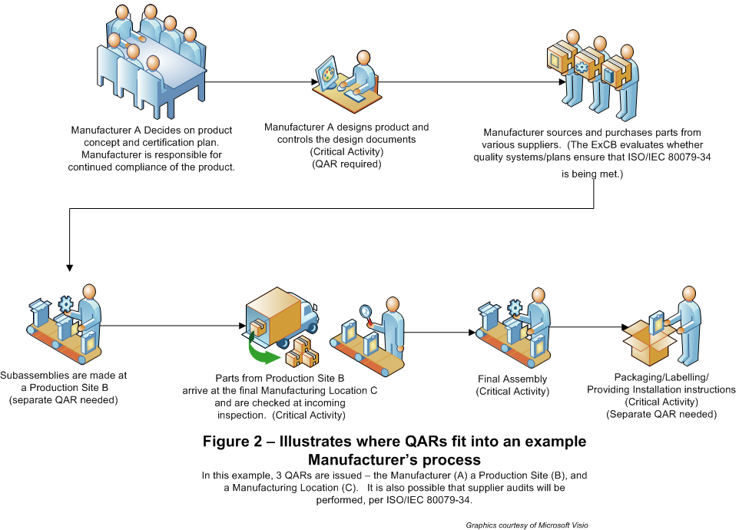
New proposed diagram (suggested as new Figure 2 at the bottom of clause 5.2.2.1):

