INTERNATIONAL ELECTROTECHNICAL COMMISSION SYSTEM FOR
CERTIFICATION TO STANDARDS RELATING TO EQUIPENT FOR USE
IN EXPLOSIVE ATMOSPHERES (IECEx SYSTEM)

NOTICE OF MEETING & GENERAL INFORMATION
for the 2021 Series of IECEx Annual Meetings
to be held via web conference facilities

Dear Madam / Sir

This document provides advice on the dates and planned schedule for the 2021 IECEx ExTAG and ExMC Meetings and associated events that will be conducted only by web conferencing facilities.

I thank you in anticipation of your assistance and invite you to contact me or Mark Amos should you have any questions regarding the meetings.

Kind regards,
Chris Agius
IECEx Secretariat

Address:  Level 33, Australia Square  264 George Street  Sydney NSW 2000  Australia | Contact Details:  Tel: +61 2 4628 4690  Fax: +61 2 4627 5285  e-mail: info@iecex.com  http://www.iecex.com

MEETING VENUE / METHOD

In recognition of the travel restrictions in place in many IECEx Member Countries, the 2021 IECEx Annual meetings and associated events will be conducted via web conference format using the GoToMeeting software (Annex A to this document explains the installation and use of GoToMeeting)

MEETING SCHEDULE

Time | Mon  30th Aug  2021 | Tue  31st Aug  2021 | Wed  1st Sept  2021 | Thu  2nd Sept  2021 | Fri  3rd Sept  2021
Full Session from  12:00 to 16:00  Time Zone = UTC  NOTE: Maximum Session Duration of 4 Hours  (including a 15 min break at time to be decided by Chair)  UNLESS STATED OTHERWISE | Assessor Training  (2 hours) | ExTAG Technical  Session 1  Incorporating a members only Closed Session at time decided by Chair | ExTAG Technical  Session 2 | ExMC  Session 1 | ExMC  Session 2
IECEx Executive

(2 hours)

NOTE: Conversions for UTC to your location’s time zone can be done using https://www.timeanddate.com/worldclock/converter.html

MEETING PARTICIPATION & PROTOCOLS

MEETING PARTICIPATION
- Participation in the IECEx Executive meeting is restricted to members of the IECEx Executive and others specifically invited to register for this meeting.

- For the ExTAG Meeting sessions permitted participation is as follows:
The following may participate as active delegates with access to speak during the meeting:
  - Representatives from ExCBs / ExTLs Operating in the IECEx 02 Equipment Scheme
  - Chair and Secretary of IEC TC 31
  - IEC TC31 & IECEx Liaison
  - Chairs of IEC SC 31s
  - IECEx Executive members
NOTE 1: Delegates registered as Observers shall be endorsed by the relevant National Member Body on request from the IECEx Secretariat
NOTE 2: Delegates registered as Observers will receive a meeting invitation link and can join the meeting but will have their microphone access muted)
NOTE 3: The IECEx Secretariat reserves the right to block meeting access to anyone that has not been validated by their National Member Body and/or has not registered correctly
- For the ExMC Meeting sessions permitted participation is as follows:
  - A maximum of three persons per country may participate as active delegates with access to speak during the meeting. For countries where more than three persons wish to register as participants the additional delegates may join the meetings as Observers. In this situation, the IECEx Secretariat requests that the National Member Body confirm the names of the three active delegates and advise which delegate will be the Head Delegate. In the absence of this information from the National Member Body, the ExMC Chair and Executive Secretary shall decide whom may actively participate.
additionally, the following may also articipate as active delegates with access to speak during the meeting:
  - Chair and Secretary of IEC TC 31
  - IEC TC31 & IECEx Liaison
  - Chairs of IEC SC 31s
  - IECEx Executive members
  - IECEx Committee Chairs or Deputy Chairs
  - ExMC Working Group Convenors
NOTE 1: The Head of Delegation (HoD) is responsible for speaking on behalf and voting on behalf of their respective IECEx National Member Body and may invite other delegates to speak.
NOTE 2: Delegates registered as Observers shall be endorsed by the relevant National Member Body on request from the IECEx Secretariat
NOTE 3: Delegates registered as Observers will receive a meeting invitation link and can join the meeting but will have their microphone access muted.
NOTE 4: The IECEx Secretariat reserves the right to block meeting access to anyone that has not been validated by their National Member Body and/or has not registered correctly
MEETING PROTOCOLS
- A Consent Agenda will be used for the ExMC Meeting
- The agenda and documents will be shared on the computer screen during discussions
- The Chair or a requested person will introduce the document at the appropriate time
- Meeting Decisions to be prepared live on screen and individually confirmed during the meeting according to the following process:
  - The draft decisions will be shared on the computer screen and the text can be modified until it appears that there is consensus on the final draft Decision
  - The final draft Decision text will then be displayed and read aloud
  - If you want to speak to comment on the final draft Decision text, use the Chat box and type “floor”
  - The Chair will then seek agreement on the Decision text. Decisions will be presumed as unanimously agreed unless any Head Delegate indicates their objections via use of the Chat feature (by typing “against”). The Chat box is also to be used to register an abstention (by typing “abstention”).
  - In the event of sustained objections, the discussion may, at the discretion of the Chair, be continued to find consensus
  - If no consensus can be found the Chair shall determine the course of action which may be to either postpone the matter OR advise vote by correspondence on the item in question
  - A list of all agreed Decisions will be issued following the meeting.

- The meetings will be recorded and the recordings will be ONLY used for the purpose of preparing Formal Minutes by the IECEx Secretariat.
- Although GoToMeeting allows each participant to see the list of the other participants, a roll call will be conducted at the meeting start to capture presence on the recording of the meeting

INSTRUCTIONS & HINTS FOR PARTICIPANTS
- Use a computer, rather than a phone, in order to see the screen and the slides
- Use a headset rather than the computer microphone and speakers
- Minimize distractions by closing your door, other web browsers and email applications, and turn off your mobile phone
- Store away wireless data devices, such as phones, because of potential interference with the conference line
- Please aim to connect (by joining the meeting) at least 15 minutes before the start of the meeting to ensure the meeting starts on time.
- Where possible co-located experts should connect with a single ‘account’
- Delegates registered for a meeting will have received an email containing a Please join my meeting hyperlink that is to be used to join the meeting so that you can participate. After using the Please join my meeting hyperlink to join the meeting use the pencil icon (see screenshot below) and then type relevant text to edit your name to add the following essential information:
- your full name (First name then Surname with Surname in upper case text)
- your two-digit country code (e.g. US), and
- your position or role if you have a position or role ... if you are Head of Delegation use HoD, Ex??? Chair for Commitee Chair, ExMC WG# for ExMCWG Convenor, etc.
As an example: Paul MEANWELL, ZA, ExMC Chair
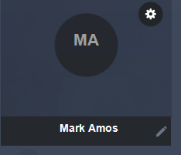
- Please ensure mute is selected when first joining the meeting and whenever NOT addressing the meeting
- The meeting host/moderator will mute anyone who does not do so at the appropriate times.
- Please do not use the camera / video feature as this will impact bandwidth and introduce time delays.
- The Chat function in GoToMeeting can be used to request the “floor” from the Chairman – type “FLOOR” to request the opportunity to the address the meeting and wait for the Chairman’s call to speak
  - the Chair announces who should speak next – wait until you are invited to speak
  - when invited to speak unmute your microphone
  - state your name before speaking then speak clearly and slowly
  - be brief, to the point and avoid repetition
  - mute yourself after speaking
- Note the Chat function can also be used for private one to one exchanges and messages to the whole group BUT be aware that others may be able to see these if you are not careful in selecting the recipients.
- To ensure the smooth running of the meeting, questions on reports should be done only after the presentation is completed not within / during the related presentation.
AND REMEMBER
- A successful web conference meeting relies on polite and respectful behaviour even when there are issues. Please also recognise that remote electronic interactions and discussions can take longer than for face to face meetings. Please also note that the time zones may be not be convenient for everyone so please respect the time limits for each session.
MEETINGS REGISTRATION

Please register BEFORE 13th August 2021 for participation in the relevant meetings by completing the online form at
http://iecex-events.iec.ch/iecex/exm.nsf/pg.xsp?v=wf

After you have registered, you will receive an automated e-mail confirmation of your registration.

If you have any question or have any problems using the Online Registration System, please contact mark.amos@iecex.com

IMPORTANT: Only those delegates that register BEFORE 13th August 2021 will receive separate GoToMeeting webinar meeting invitations that will contain a Please join my meeting hyperlink that is used to join the respective meetings.

Note that each meeting or event will have a different hyperlink so please ensure that you are using the correct hyperlink for each meeting or event.

IECEx Secretariat
Level 33 Australia Square, 264 George Street
Sydney NSW 2000 Australia
Tel: +61 2 4628 4690
Email: info@iecex.com

ANNEX A
Installation & Use of GoToMeeting

If you are already a GoToMeeting user and have other meetings scheduled you can access these and choose today’s meeting from the My Meetings list as shown below

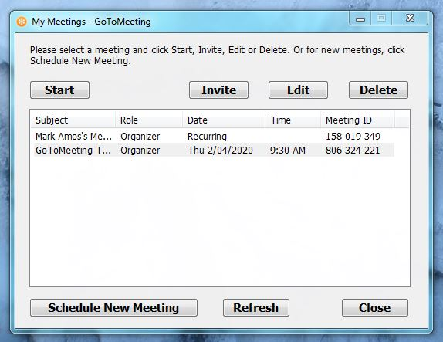

Alternatively, if you are a new user OR only want to participate in today’s meeting now then you can access today’s meeting via the hyperlink under “Please join my meeting …” in the Meeting Invitation email that you would have received (if you have accepted this invitation in Outlook the meeting will now appear in your Outlook Calendar from where it can be accessed) – see example email below:

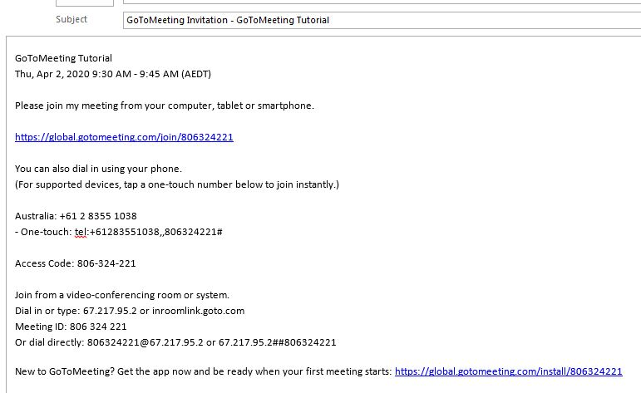
If you have not used GoToMeeting before or if it possible your company IT security protections may block the downloading of external applications including GoToMeeting, then we strongly recommend that you review this with your IT department at least 2 weeks prior to the scheduled sessions and request the relevant permissions to install and use GoToMeeting. The alternative is to use a private computer that does not have security software that prevents GoToMeeting installation.

We ALSO strongly recommend that you click on the meeting hyperlink at least 15 minutes before the scheduled meeting start time so that any software installation or updates needed for you to participate have sufficient time to complete their processes.

If you have not used GoToMeeting before you will be directed to the download, installation and system configuration screen series as shown below ……

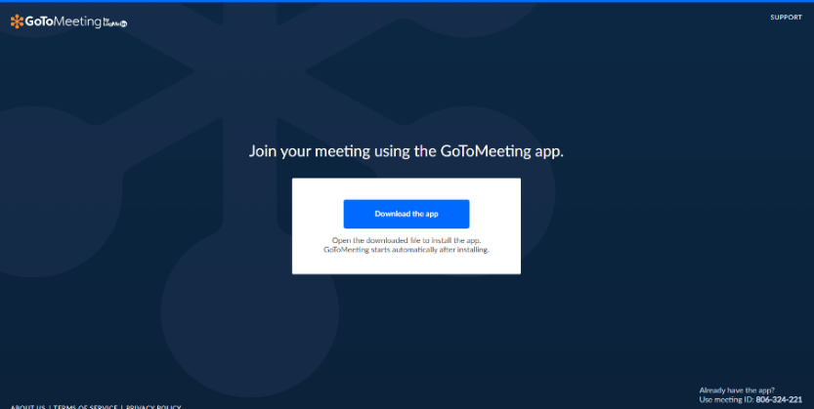
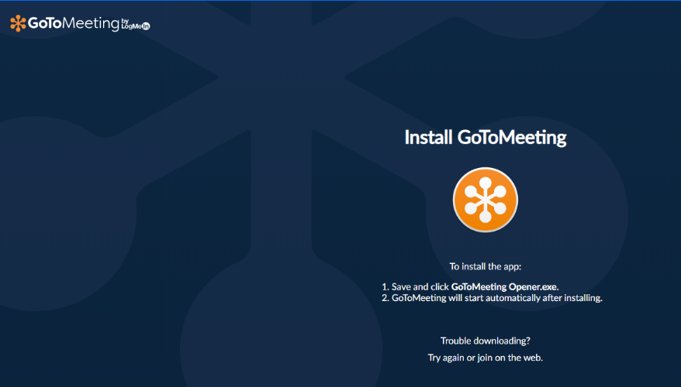
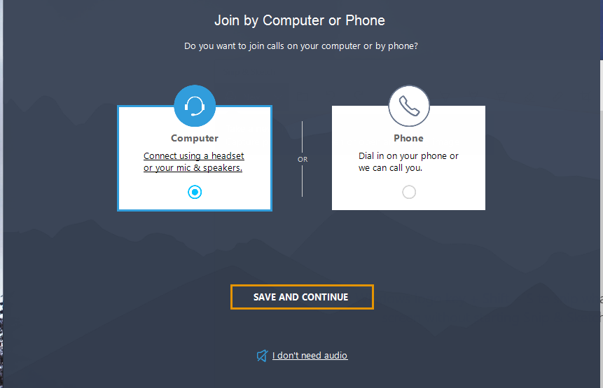

First time users will then be given an optional tour (that can be skipped via use of Skip icon)

Once a meeting starts you will see a view as below …. And there are number of tools available to you … in the example below it is showing who is participating in this meeting (the Organiser is visible via his webcam, the other participant is not using their webcam)

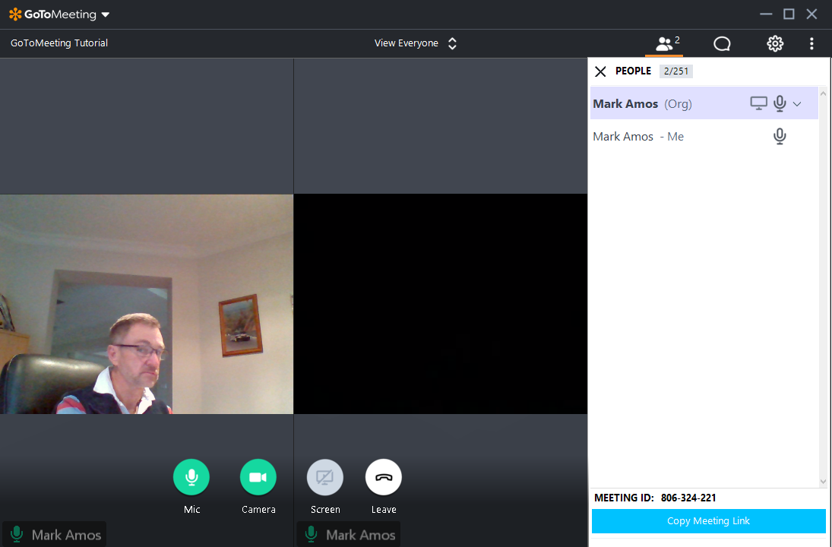

In the image (of the Organiser view where some additional icons and features are shown but these may not be visible to all participants / attendees at all times) above you will see
- A ‘Mic’ icon … this will be green if your microphone is active OR red if you are muted

- A ‘Camera’ icon … this will be green if your webcam is active OR red if you are not using a webcam

- A ‘Screen’ icon that is used (when displayed and available) to share your computer screen content with others

- A ‘Leave’ icon that is used to exit the meeting at any time

…. the Chat tool that can be used to communicate (by text) with other participants during the meeting (NOTE that unless you select specific recipients of your message, ALL meeting participants will see what you have typed. If you want to communicate ONLY with certain participants you need to select them individually)

… and the Settings Tool allows you to change configurations (eg of audio equipment) during a meeting

You may also find the following videos of use with additional information on the above instructions:
- https://www.youtube.com/watch?v=95dRdnMMgbQ
- https://support.goto.com/meeting/attendee-user-guide?c_prod=g2m&c_name=mktg&c_cmp=attendee
- https://support.goto.com/meeting

