INTERNATIONAL ELECTROTECHNICAL COMMISSION SYSTEM FOR
CERTIFICATION TO STANDARDS RELATING TO EQUIPENT FOR USE
IN EXPLOSIVE ATMOSPHERES (IECEx SYSTEM)

GENERAL INFORMATION
ON THE MEETINGS OF THE IECEx SYSTEM
to be held in Christchurch, New Zealand
14 – 18 September 2015

Dear Colleagues

This document contains details relating to the IECEx System Meetings to be held in Christchurch, New Zealand 14 – 18 September 2015

Details relating to general information, online meeting registration and accommodation bookings are included.

I thank you in anticipation of your assistance and invite you to contact me should you have any questions relating to the meetings.

Kind regards
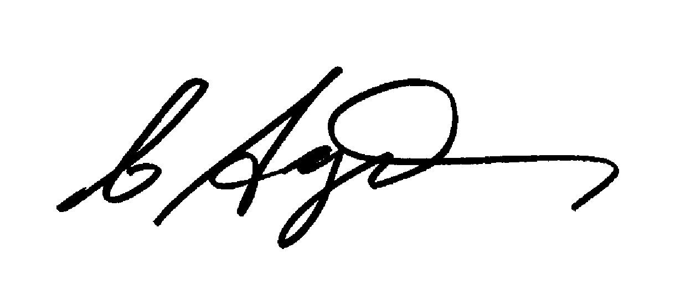
Chris Agius
IECEx Secretariat

Address:  Level 33, Australia Square  264 George Street  Sydney NSW 2000  Australia | Contact Details:  Tel: +61 2 4628 4690  Fax: +61 2 4627 5285  e-mail:chris.agius@iecex.com  http://www.iecex.com
GENERAL INFORMATION
ON THE MEETINGS OF THE IECEx SYSTEM
to be held in Christchurch, New Zealand
14 – 18 September 2015

MEETING CITY

This year, the Annual IECEx series of meetings are being held in Christchurch, New Zealand. Christchurch is called the garden city as it has many parks and open spaces. It is New Zealand's second-largest city and the gateway to the South Island. Bordered by hills and the Pacific Ocean, it is situated on the edge of the Canterbury Plains that stretch to the Southern Alps. Within two hours of Christchurch international airport, you can ski at a world-class alpine resort, play golf, bungy jump, raft, mountain bike, hot-air balloon, wind surf, whale watch and visit internationally-acclaimed wineries and gardens.

MEETING PLACE

The meeting will be held at:
The Chateau on the Park
189 Deans Avenue
Riccarton
Christchurch, 8440
New Zealand
Phone: +64 3 348 8999
Website: www.chateau-park.co.nz

Contact:
Ms Laura Gorrie
E-mail: res@chateau-park.co.nz

MEETING SCHEDULE

Date | Meeting | Location
Monday, 14 September 2015 | ExTAG Training Workshop a.m.  Assessor Training p.m. | The Great Hall
Tuesday, 15 September 2015 | ExTAG Meeting | The Great Hall

Standards New Zealand Workshop

Wednesday, 16 September 2015
- Industry tour (afternoon)
- Dinner (evening)

Date | Meeting | Location
Thursday, 17 September 2015 | ExMC Meetings | The Great Hall
Friday, 18 September 2015 | ExMC Meetings | The Great Hall

MEETING HOURS:*
9.00 a.m. to 12.30 p.m.
2.00 p.m. to 5.00 p.m.

Beverages will be available throughout the meetings. There will be two official coffee breaks during the meetings at approximately 10.30 a.m. to 11.00 a.m. and 3.00 p.m. to 3.30 p.m.

*Unless otherwise advised

LUNCH:

Lunch break will be from 12.30 p.m. to 2.00 p.m. A daily lunch buffet has been arranged for the delegates, at their own expense, at the hotel. Alternative eateries in the area.

ACCOMODATION:

A block of rooms has been reserved at the meeting venue:
The Chateau on the Park
189 Deans Avenue
Riccarton
Christchurch, 8440
New Zealand
Phone: +64 3 348 8999

Contact:
E-mail: res@chateau-park.co.nz

Special hotel rates are available, however delegates are advised that hotel accommodation and rates can only be guaranteed for reservations made by 17 July 2015.

The special rate for IECEx Delegates is $161.00 per room per night. This is for single or double occupancy and includes one breakfast per room per night.

Delegates are requested to make reservations directly with the Hotel: Chateau on the Park

MEETINGS REGISTRATION

This year we are moving to an Online registration system for the meetings. Please use the link below-

IECEx Meeting Registration Form for completion

Once you have registered you will receive an automatic e-mail response to your registration. If you have any questions or difficulties relating to the use of the Online System please do not hesitate to contact me-

Christine Kane

For any further questions or details please feel free to contact the Organising Committee or the IECEx Secretariat, contact details below-

Organising Committee
Mr John Kelly
Standards New Zealand
Private Bag 2439
Wellington 6140
New Zealand
Tel: +64 4 498 5990
Fax: +64 4 498 5994
E-mail: registrations.iecex@standards.co.nz

with a copy to:
IECEx Secretariat
Ms Christine Kane
IECEx Secretariat
Level 33 Australia Square
264 George Street
Sydney NSW 2000
Australia
Tel: +61 2 4628 4690
Fax: +61 2 4627 5285
E-mail: christine.kane@iecex.com

REGISTRATION AT THE MEETING

The registration desk will be open in the hotel foyer as follows:

Date | Time
Sunday, 13 September 2015 | From 4:00 p.m. to 6.00 p.m.
Monday, 14 September 2015 | From 8.00 a.m. to 10:00 a.m.
Tuesday, 15 September 2015 | From 8:00 a.m. to 10:00 a.m.
Wednesday, 16 September 2015 | From 8:00 a.m. to 10:00 a.m.
Thursday, 17 September 2015 | From 8.00 a.m. to 10:00 a.m.
Friday, 18 September 2015 | From 8.00 a.m. to 10.00 a.m.

The hotel reception is open 24 hours a day.

DINNER ON 16 SEPTEMBER 2015

Standards New Zealand wishes to invite all delegates and their accompanying persons to a dinner on September 16, 2015 at 06:30 p.m. Dress code is Business Casual.

Delegates are asked to indicate whether they will attend the dinner when completing the meeting registration form and also advise if there are any special dietary requirements.

ARRIVAL BY AIR

The Chateau on the Park is located approximately 6 km from Christchurch Airport. It is a 15 minute drive and is approximately NZ $35.00 by taxi.

PARKING

For those travelling by car, free parking is available at the hotel.
ATMs (Automatic Banking Machines)

ATMs are readily available. The nearest ATM is at the Bank of New Zealand in the Westfield Mall, Riccarton Road (a 5 minute walking distance).

BUSINESS HOURS

Banks are open Mondays to Fridays from 9 a.m. until 5 p.m though some banks close at 4.30 pm. The BNZ in Riccarton Road is open 10 a.m. to 4 p.m. Saturdays and 10 a.m. to 2 p.m. Sundays.

Shops are generally open Monday to Friday from 8.30 a.m. until 5.30 p.m. and weekends from 9 a.m to 4 p.m

CLIMATE AND CLOTHING

Christchurch has a temperate climate with few extremes and low rainfall. The average temperature in September is about 14°C. A jumper and jacket is all that will be required.

CREDIT CARDS

American Express and Diners Club, credit cards are accepted in most hotels, restaurants and shops. Mastercard and Visa credit cards are accepted in all hotels, restaurants and shops.

CURRENCY

All prices quoted in this programme are in NZ dollars. Currency can be exchanged at banks, exchange houses or at the airport.

ELECTRICITY SUPPLY

Electricity supply in New Zealand is 230 V/50 Hz

Power outlets are specialist to Australia and New Zealand and will require an adaptor available at the airport and in many shops.

FIRST AID

In case of emergency, contact the reception of the hotel.

INSURANCE

Participants are advised to obtain travel, medical, personal, accident and luggage insurance in their country prior to departure.

INTERNET CONNECTIONS

Wi-Fi service is free of charge throughout the hotel, including the meeting facilities.

MEAL FACILITIES

A variety of restaurants and cafes are available at, and in the vicinity of the meeting place.

PASSPORT, VISA AND VACCINATION

All visitors need a valid passport to enter New Zealand. Details of regulations related to all countries are available from all New Zealand embassies.

Participants are advised to check their local travel agency about regulations regarding passport, visa and vaccination and, particularly, the length of notice required for obtaining a visa, if required. In case of doubt, information can be obtained from the nearest New Zealand embassy or consulate.

If a letter is required for visa applications, Standards New Zealand will send an official invitation to delegates. Please contact Mr John Kelly: registrations for that purpose.

PHARMACIES

In Christchurch pharmacies can be found all over the city. A few 24 hr pharmacies are available.

SHOPPING

The venue and hotel are located in the Riccarton area. Riccarton has one of New Zealand’s largest shopping malls sited 3 km from the hotel. There are many shops within walking distance.
SMOKING

Smoking is not permitted in closed areas, airports, hotels, restaurants, shops, or workplaces and is only allowed in specific designated areas.

TAXES

All goods and services are subject to a 15% Goods and Services Tax (GST), generally included in the displayed price.

TELEPHONES

International/domestic calls can be made from your hotel room at your own expense.

TIME ZONE

The time zone in Christchurch is GMT +12.

TIPPING
Tipping is not essential or expected and should be at your own discretion and for good service only.
Map of Christchurch showing the location of the hotel.

