INTERNATIONAL ELECTROTECHNICAL COMMISSION (IEC) SYSTEM FOR CERTIFICATION TO STANDARDS RELATING TO EQUIPMENT FOR USE IN EXPLOSIVE ATMOSPHERES (IECEx SYSTEM)

Title: Equipment and Component acc. to Directive 94/9/EC

Circulation: ExTAG Members

Introduction

This document, prepared by Dr. Ing. Martin Thedens (PTB Braunschweig) and Ursula Aich (RP Darmstadt, Abt. IV/Wi) has been issued to provide advanced information reltaing to ExTAG/332A/DA Agenda Item 8. Under this Item Mrs Aich will present a regulators view of the use of X and U on Certificates and use of such certificates in the marketplace.

This document was received after the issue of the ExTAG Zip File but has now been added to the ExTAG The Hague Documents page.

Julien Gauthier

ExTAG Secretary

Address:  IECEx Secretariat  Level 33 Australia Square  264 George Street  Sydney NSW 2000  Australia  Web: www.iecex.com | ExTAG Secretary  Mr Julien Gauthier  LCIE S.A.  33 Avenue du General Leclerc  92260 Fontenay-aux-Roses  FRANCE  Tel: +33 1 40 95 55 26  Fax: +33 1 40 95 89 37  Email : julien.gauthier@fr.bureauveritas.com


Regierungspräsidium Darmstadt 21.13.2
revised
Equipment and Component acc. to Directive 94/9/EC
This paper intends to draw attention of the stakeholders to the question whether a product under Directive 94/9/EC is to be considered as equipment or as component. It is not intended to affect existing documents, but to give guidance for the future.
It is the obligation of manufacturers, importers or authorized representatives to follow the requirements for products within the scope of Directive 94/9/EG, when they are placing these products on the market. For some products the involvement of a Notified Body is required. Both, manufacturer and Notified Body have to consider, whether a product is equipment or component.
Any equipment and its instructions must meet the essential health and safety requirements of the Directive. It is the obligation of the manufacturer to issue instructions (Annex II, 1.0.6). These instructions can include so called “special conditions of use”.
These special conditions of use cannot specify additional safety measures which have to be part of the manufacturing process or are part of the type testing by a Notified Body.
The main differences between equipment and components are:
Equipment | Component
Definition of ATEX Directive 94/9/EC:  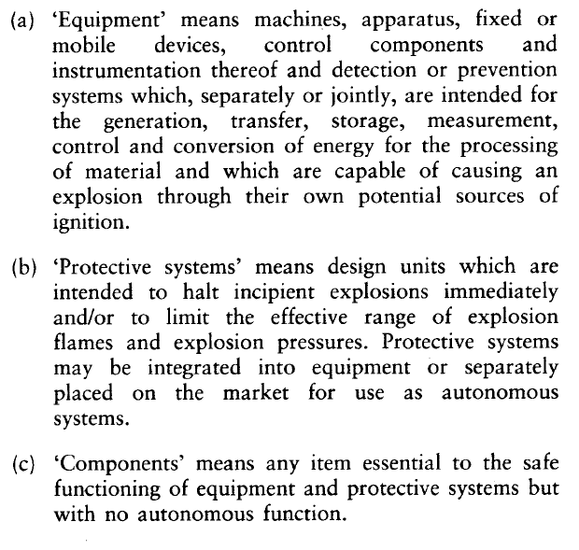 | Definition of ATEX Directive 94/9/EC:
All aspects and requirements of explosion protection according to Annex II of Directive 94/9/EG have to be fulfilled. | Components must be so designed and constructed that they function safely for their intended purpose of explosion protection when they are installed in accordance with the manufacturer's instructions. (Annex II, 1.2.2)
The equipment is marked according to the ATEX Directive and marked with the CE marking and is accompanied by  a) the EC Declaration of Conformity and  b) instructions for use. | The component is marked according to the ATEX Directive (see. Chapter 11.4 of the ATEX guidelines) but not marked with the CE marking and is accompanied by  a) a written attestation of conformity and b) an instruction for assembling.
The equipment is ready for use based on the instructions for use of the manufacturer and installation requirements. | The component is not ready for use. The final conformity assessment of the component is done together with the assessment of the complete equipment, in/with which the component will be fixed or installed.
Definition of the EN 60079-0:2012:  3.25  equipment (for explosive atmospheres)  general term including apparatus, fittings, devices, components, and the like used as a part of, or in connection with, an electrical installation in an explosive atmosphere. | Definition of the EN 60079-0:2012:  3.28  Ex Component  part of electrical equipment or a module, marked with the symbol “U”, which is not intended to be used alone and requires additional consideration when incorporated into electrical equipment or systems for use in explosive atmospheres.
3.8.2  Equipment Certificate  A certificate prepared for equipment other than an Ex Component. Such equipment may include Ex Components, but additional evaluation is always required as part of their incorporation into equipment | 3.8.1  Ex Component Certificate  A certificate prepared for an Ex Component
3.53  symbol “X”  symbol used to denote specific conditions of use  NOTE:  The symbol “X” is used to provide a means of identifying that essential information for the installation, use, and maintenance of the equipment is contained within the certificate | 3.52  symbol “U”  symbol used to denote an Ex Component  NOTE:  The symbol “U” is used to identify that the equipment is incomplete and is not suitable for installation without further evaluation.

Controversial examples
Panel
A product with open terminals is placed on the market as equipment category 3. In the instructions the following “special condition of use” requires: “The use of this equipment needs an enclosure of at least IP65. The equipment has to be mounted in an area with a lower risk of mechanical impact”.

Problem:
This product is a component because it is incomplete (missing enclosure) and further actions (e.g. test), considerations and information are necessary for safe use.
The manufacturer has to consider following topics:
- IP 65 alone is not sufficient to make clear the requirements of Annex II of the Directive 94/9/EG. The enclosure has to fulfil also the requirements of Annex II and the EN 60079-0 ff.
- The meaning of “low risk of mechanical impact” is unclear. The manufacturer has to specify the details to fulfil this special condition.
- It is not sufficient to use any enclosure to protect the equipment against impact!
The same questions arise for similar category 2 equipment certified by a Notified Body.
Switch
In an EC Type examination Certificate for a Cat. 2 switch the following “special condition of use” was found:
“The mechanical test according EN 60079-0:2006, clause 26.4.1.2 and the impact test according clause 26.4.2 were not done with this switch. A similar protection technique has to be used for an installation in hazardous areas.”

Problem:
This special condition of use is not allowable, because further tests are required, which have to be done by a Notified Body. Therefore this product is to be regarded a component.
Empty Ex- “d” enclosure
An Ex-“d” empty enclosure was certified as category 2 equipment with a “special condition of use”, describing how to drill the holes for cable entry devices by a Notified Body. During the Ec type examination the manufacturer showed the Notified Body an assembled enclosure. But the manufacturer sold the enclosures without assembling them
Problem:
This product is a component because part of the production process of assembling has to be covered by the quality assessment of the manufacturer and must not be part of the installation.
If the manufacturer allows machining works (e.c. drilling holes) done by the user, he is nevertheless responsible for the final product. Normally this machining work is part of the quality assessment done by a Notified Body. In case of drilling holes into an Ex-d-Enclosure this assessment for the machining work would be necessary but is not done by the user.
After drilling the holes and mounting the cable entries or other devices additional tests of the applicable standards, such as flame transmission and pressure tests according EN 60079-1?
Another problem is the maximum surface temperature. Also this assessment of maximum surface temperature and of the temperature behaviour inside of the enclosure is up to the manufacturer and the Notified Body involved.

Remark:
It is the task of the Notified Body, conducting the quality assessment, if such enclosures are sold without any components, to stop such trading.

Conclusion
If it is not possible for the end-user to fulfill the requirements given as “special conditions of use” because they are too general, a product does not meet the requirements of the Directive 94/9/EG. The manufacturer and the Notified Body involved have to bear in mind, that the users normally do not have the detailed knowledge or the needed test equipment. Therefore the special conditions of use in the aforesaid examples will not result in a product complying with the requirements of the Directive 94/9/EC. The complete safety evaluation of equipment has to be done by the manufacturer based on his responsibility for the equipment. With his EC Declaration of Conformity the manufacturer attests the full compliance with the ATEX Directive 94/9/EC. The use of such equipment must not create dangerous situations. The manufacturer is responsible for the foreseeable misuse if the user is not able to fulfill the special conditions for use correctly.
It is the clear aim of the ATEX Directive that only safe products are being placed on the European market. Products, which have undergo additional verification acts, are components. These components cannot be transferred into equipment by creating non-compliable “special conditions for use”. With the manual the manufacturer has to prescribe the details, how it will be possible for the user to fulfill the special conditions of use. If the user has to add items such as an enclosure, the user will act as a manufacturer.
Question | Answer
How can wrongly designated “equipment” be identified? | Users, market surveillance authorities and Notified Bodies should have a detailed look into the EC Declaration of Conformity (for equipment) or the attestation of conformity (for components), to the manual / instructions and to the related EC type-examination certificates (if any), especially for devices such as multipurpose distribution, switching and control units or empty enclosures or switches or indicating lights.  Very often e.g. for category 2 electrical equipment the EC Declaration of Conformity itself and the name of the product are not identical with the name of the product of the cited EC type-examination certificate.
Is the problem limited only to electrical equipment respectively components of category 2? | No, there are electrical and mechanical products on the market – in some cases also together with certificates for category 3 or category 2 “mechanical” issued by a Notified Body – which are not in line with the requirements of the ATEX Directive in the same way described above.
How should a Notified Body deal with such non-conformity products?  (→ to avoid legal trouble for the manufacturer) | In the area of the Quality Assessment the Notified Body has to have a look on the correct application of the ATEX Directive 94/9/EC by checking that a correct version of the EC Declaration of Conformity for the complete equipment (or attestation of conformity as a conformity statement for components) is available and that the related valid EC type-examination certificate (if any) and the manual (or instruction for the assembling for components) describe the same equipment.
Is it possible to use special conditions for use? | Principally yes, but such special conditions of use shall prescribe all requirements in detail so that it is possible for the user to operate the equipment in a safe way without any doubt. The manufacturer has to consider the critical questions mentioned in the examples above and has to give all necessary information in his instructions for use.

Dr. Ing. Martin Thedens (PTB Braunschweig), Ursula Aich (RP Darmstadt, Abt. IV/Wi)

