INTERNATIONAL ELECTROTECHNICAL COMMISSION (IEC) SYSTEM
FOR CERTIFICATION TO STANDARDS RELATING TO EQUIPMENT FOR USE
IN EXPLOSIVE ATMOSPHERES (IECEx SYSTEM)

Title: Report from Dr Uwe Klausmeyer, Convenor ExTAG WG 10, Proficiency Testing
Circulated to: Ex Testing and Assessment Group (ExTAG)

INTRODUCTION

This document is a report prepared by Dr. Uwe Klausmeyer the Convenor of ExTAG WG10, Proficiency Testing. The report will be presented by Dr. Klausmeyer during the ExTAG
The Hague Meeting for discussion and consideration.

Julien Gauthier
ExTAG Secretary

Address:  IECEx Secretariat  Level 33 Australia Square  264 George Street  Sydney NSW 2000  Australia  Web: www.iecex.com | ExTAG Secretary  Mr Julien Gauthier  LCIE S.A.  33 Avenue du General Leclerc  92260 Fontenay-aux-Roses  FRANCE  Tel: +33 1 40 95 55 26  Fax: +33 1 40 95 89 37  Email : julien.gauthier@fr.bureauveritas.com

Report of the convenor of ExTAG WG 10 “Proficiency Testing”, Dr. Klausmeyer, for the ExTAG meeting in The Hague (NL) 2014

- Results of the PTB Ex PT programs 3 “FT(flame transmission)” and 4 “TC (temperature classification)” launched in 2013/2014

The results of the flame transmission tests (47 laboratories) are shown in the figure 1, and (by this) the degree of improvement potential. Statistically the assigned value was 17 propagations (red cross), using the results of all laboratories and tests (30 tests per laboratory).

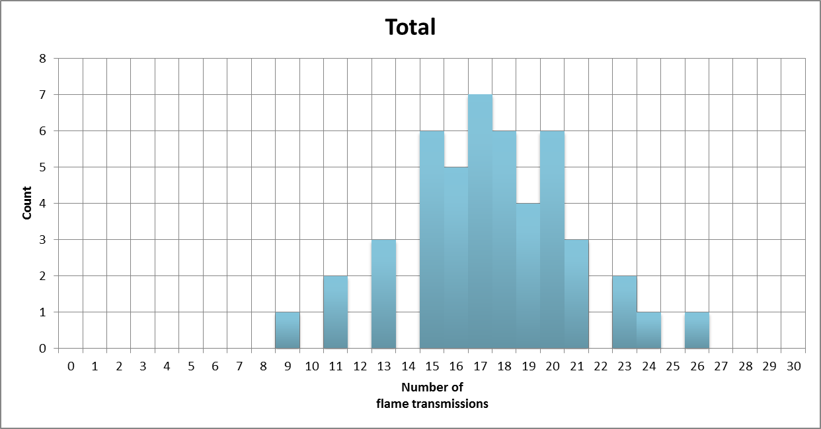
X
Figure 1

15 to 19 propagations (17 plus/minus 2) have been reported by the majority of laboratories. In reflecting the complexity of a propagation test, the results are very satisfying, but showing still an improvement potential for several laboratories.

In figure 2 first results are presented for the program TC. Further and deeper evaluation will be presented during the ExTAG meeting in The Hague. At the borderline T6/T5 the window is around 8 K, at T4/T3 it is found 15 K. Most of the laboratories are always close to the assigned value, but the differences are more significant than for the program FT. Daily tests at prototypes are in general close to the temperature class limit, so there is a need how to deal with this issue.
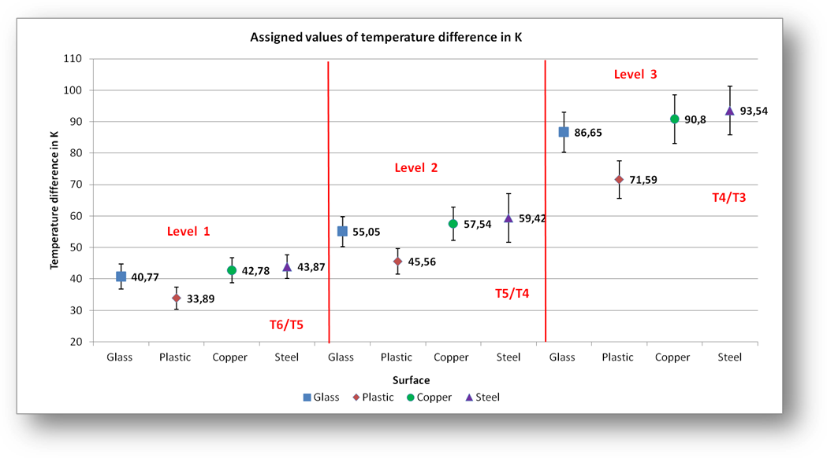
Figure 2

- New programs 2015/2016

Based on the feedback of the questionnaire sent out to all laboratories end of July 2014, two new programs will be developed and launched in 2015, to be conducted in 2016. Input of member bodies and their experts is deeply appreciated in order to find the right workload and cost frame for the programs. The balance between effort and value for the individual laboratories needs to be found. First ideas will be discussed during the ExTAG WG 10 meeting in The Hague.

- Draft of an Operational Document “Proficiency Testing Programs”

As already discussed during the Braunschweig meeting 2012, IECEx needs a similar OD like the IECEE CTL-OP 103, Ed. 10, in order to have guidance for consequences e.g. how to deal with outliers. A second internal draft will be presented during the next meeting of the ExTAG WG 10 in The Hague.

- Financial matters of the PTB Ex PT Scheme

While PTB is proud to be the pioneers of the scheme and is willing to continue with its role there are some management and financial issues that need to be addressed for the longer term. These include:

- whether this remains a voluntary scheme for ExTLs or mandatory participation by all ExTLs
- consideration of an appropriate funding model as at present this is a combination of contributions from participating ExTLs and also from the PTB own Budget
- management and use of results.

PTB notes that some of these matters were also raised by some ExMC Members and discussed during the recent 2014 IECEx Operational meetings in Dubai with the Executive agreeing that these items need further discussion. On this basis PTB would be pleased to assist IECEx in any way it can.

Draft agenda of the next ExTAG WG 10 meeting

Date and time: Monday, 25th of August, 2014, 17:30
Venue: meeting room to be advised in the World Hotel Bel Air, The Hague

- New convenor for the ExTAG WG 10 to be elected. Dr Klausmeyer wants to retire from this position because he is manager of the PTB Ex PT scheme. To avoid an interest conflict, a new convenor needs to be elected.
- Overview and discussion of the results of the 2014 programs 3 FT “Flame transmission” and 4 TC “temperature classification”
- Cooperation with ExMC WG 4, see report of ExMC WG 4, to be discussed:

===============================================================

Laboratory Proficiency Testing
At the request of ExMC WG10 Proficiency test (Convenor by Dr Uwe Klausmeyer) WG4 members discussed the preparation by of a draft IECEx Operational Document on “Proficiency Testing”.
NOTE: It is planned that ExTAG WG10 will work with ExMC WG4 on this matter.
WG4 also considered a letter from AU regarding proficiency testing. There was in-principle support for the idea of making proficiency testing mandatory for all IECEx ExTLs, but noting that there might need to be a method of ensuring the costs of the program did not become excessive. There may be opportunities through IECEx assessment of PTB as a proficiency provider for IECEx to have more involvement in the process. WG4 noted that this matter will be further considered by WG10 when it meets prior to the ExTAG and ExMC meetings in The Hague.
Recommendation from ExMC WG4
That ExTAG and ExMC consider making involvement in the proficiency program run by PTB compulsory for all IECEx ExTLs, taking into account any associated further recommendation from ExTAG WG10.
================================================================

- Results and conclusions of the feedback survey after the Ex PT pilot program and the workshops
- New programs (first ideas):
a) program 5 (IEC 60079-11): assessment of a model amplifier circuit with 5 sets of parameters, laboratory has to find out the intrinsically safe limit
b) program 6 (IEC 60079-0): measurement of an electrostatic charge on 5 different plastic component models, to be decided which plastic component is acceptable
- Manufacturer laboratories to be involved, impact of the OD 024
- Presentation of the second internal draft of an IECEx OD “Proficiency Testing Programs”
- Any other business.

