INTERNATIONAL ELECTROTECHNICAL COMMISSION SYSTEM FOR CERTIFICATION TO STANDARDS RELATING TO EQUIPMENT FOR USE
IN EXPLOSIVE ATMOSPHERES (IECEx SYSTEM)

Circulated to: ExTAG – IECEx Testing and Assessment Group

TITLE: Draft Decision Sheet - Measurement of Pressure Rise Time in relation to determination if Pressure Piling has occurred

INTRODUCTION

This proposed Draft ExTAG Decision Sheet was prepared by BASEEFA, GB, and is issued for your consideration.
Please submit comments by -

18th December 2009 to ExTAG Secretary, Mr. Michel Brenon, via

Christine Kane

If comments have not been received by the above date this document will be published as an ExTAG Decision Sheet.

Michel Brenon

ExTAG Secretary

Address:  IECEx Secretariat  286 Sussex Street  Sydney NSW 2000  Australia | Contact Details:  Tel: +61 2 8206 6940  Fax: +61 2 8206 6272  E-mail: chris.agius@iecex.com  http://www.iecex.com | ExTAG Secretary  Mr Michel Brenon/LCIE  Tel: +33 1 40 95 5519  Fax: +33 1 40 95 5520  e-mail  michel.brenon@lcie.fr

Member Body | Clause/ Subclause | Paragraph Figure/ Table | Type of  comment  General/technical/  editorial | COMMENTS | Proposed change | Observation

COLLECTION OF IECEx / ExTAG DECISIONS

Standard:  IEC 60079-1: 2007 (Ed 6)  IEC 60079-1: 2003 (Ed 5) | Clauses:  3.10, 15.1.2.3
Subject:  Measurement of Pressure Rise Time in relation to determination if Pressure Piling has occurred  Status of document: Draft | Key words:  - Pressure Measurement  - Pressure Rise Time  - Pressure Piling | Date: 2009.11.16  Originator of proposal:  Baseefa  TC/SC involved: 31
Introduction

This Decision Sheet applies to all flameproof equipment.
Question

How is rise time to be determined”?
Answer

Rise time is to be determined in accordance with the following figure which was published in earlier editions of IEC 79-1 and has been reinstated by MT 60079-1 in the current draft for the next edition of IEC 60079-1.
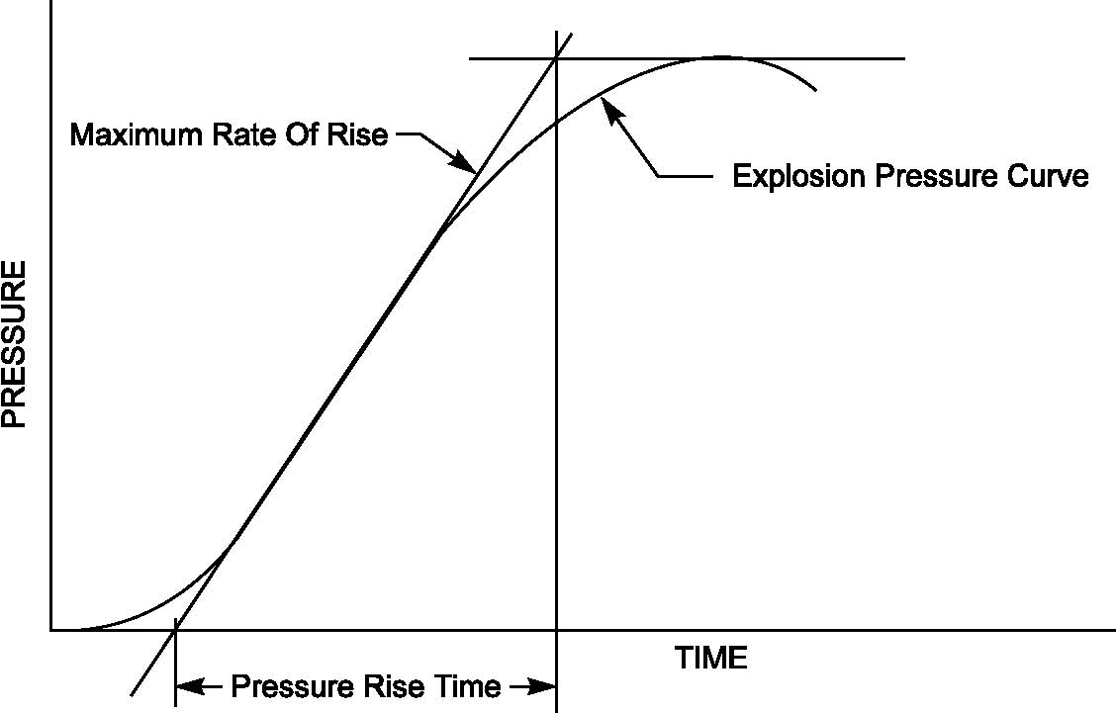
Figure 23 – Pressure rise time

Additional Information

This figure is also currently published in some national implementations of IEC 60079-1.

When pressure piling occurs as a result of compartmentalisation of the flameproof enclosure, the pressure curve in the compartment remote from the ignition source will usually show an initial gradual rise of pressure. This is as a result of the pre-pressurisation of the compartment, before the rapid increase in pressure as ignition of the pre-pressurised mixture occurs. It is important that the pre-pressurisation is not confused with the actual explosion. The shape of the initial slope will depend greatly on the individual physical layout and the determination of rise time based on the maximum rate of rise is intended to ensure a common interpretation by all testing laboratories.

MT 60079-1 is asked to consider the issue of an ISH for editions 5 and 6 of the standard.

