INTERNATIONAL ELECTROTECHNICAL COMMISSION SYSTEM FOR
CERTIFICATION TO STANDARDS RELATING TO EQUIPENT FOR USE
IN EXPLOSIVE ATMOSPHERES (IECEx SYSTEM)

Title: Scope Extension Assessment Report for, TÜV NORD CERT GmbH, an Accepted ExCB and ExTL within the IECEx System, Equipment Scheme 02 to include ISO 80079-36 and ISO 80079-37 in their scope.

To: Members of the IECEx Management Committee, ExMC

Introduction

Following an application for a scope extension by TÜV NORD CERT GmbH, to include ISO 80079-36 and ISO 80079-37 within their scope, a special site assessment visit was arranged and conducted.

This report details the assessment findings of this scope extension with the IECEx
Assessment Team recommending the acceptance of the above scope extension.
It is now hereby submitted for voting by ExMC.

Please consider the report and return the completed voting form, separate Word
Document, to the Secretariat by 2017 03 31

Your speedy response to the voting process will be very much appreciated.

Chris Agius
IECEx Secretary
Address:

IECEx Secretariat  Australia Square  Level 33, 264 George Street  Sydney NSW 2000  Australia | Tel: +61 2 4628 4690  Fax: +61 2 46 27 5285  Email: chris.agius@iecex.com

IEC System for certification to standards relating to equipment for use in Explosive Atmospheres (IECEx System)

IECEx Assessment Report Form

IECEx Assessment Report Form for use by IECEx Assessment Teams to report Assessments conducted according to the IECEx Assessment Procedures of

- Operational Document IECEx OD 003-2 for the Certified Equipment Scheme
- Operational Document IECEx OD 016 for the Certified Service Facility Scheme
- Operational Document IECEx OD 022 for the IECEx Conformity Mark Licensing System

IECEx ExCB/ExTL assessment report for
TÜV NORD CERT GmbH

Hannover Office Am TUV1 D-30519 Hannover

GERMANY

INTERNATIONAL
ELECTROTECHNICAL
COMMISSION

CONTENTS

1 Assessment information 4
1.1 Type of Body covered by this assessment: 4
1.2 Type of assessment: 4
1.3 Details of body 4
1.3.1 Country 4
1.3.2 Name of body 4
1.3.3 Name and title of nominated principal contact 4
1.4 Assessment information 4
1.4.1 Members of the assessment team 4
1.4.2 Place(s) of assessment 4
1.4.3 Assessment date(s) 4
1.5 Scope 5
1.5.1 ExCB scope for equipment certification scheme 5
1.5.2 ExTL scope 6
1.5.3 ExCB scope for Service Facilities Scheme 7
1.5.4 ExCB scope for ExMark Scheme 7
2 Common information 7
2.1 Legal entity of body 7
2.2 Financial support 7
2.3 History 7
2.4 Documentation 7
2.4.1 Quality manual 7
2.4.2 Procedures 8
2.4.3 Work instructions 8
2.4.4 Records (including test records where relevant) 8
2.4.5 Document change control 8
2.5 Confidentiality 8
2.6 Publications (Hard cover and Electronic) 8
2.7 Recognition and agreements 8
2.8 Internal audit and periodic management review 8
2.9 Contracting, subcontracting, use of other labs and use of other locations 8
2.10 Training and competence 9
2.11 Complaints and appeals (including appeals to IECEx) 9
2.12 Special facts to be noted 9
2.12.1 Supporting documentation 9
2.13 Recommendations 10
3 ExCB for IECEx Certified Equipment Scheme 11
3.1 Assessment references 11
3.2 ExCB persons interviewed 11
3.3 Associated ExTL(s) 11
3.4 Associated certification functions 11
3.5 National marks and certificates 12
3.6 Standards accepted 12
3.7 National differences to IEC standards 12
3.8 Organisation 12
3.8.1 Names, titles and experience of the senior executives 12
3.8.2 Name, title and experience of the quality management representative 12
3.8.3 Name and title of signatories for certification 12
3.8.4 Other employees in ExCB activity 12
3.9 Organizational structure 12
3.10 Administration 13
3.10.1 Administrative structure 13
3.10.2 Indemnity insurance 13
3.11 Resources 13
3.12 Committees (such as governing or advisory boards) 13
3.13 Certification operations 13
3.13.1 National approval/certification methods 13
3.13.2 Certification policy 13
3.13.3 Application for certification 13
3.13.4 Certification decision 13
3.14 Certificates issued 14
3.15 National accreditation 14
3.16 Assessment of manufacturers and issue of QARs 14
3.17 Comments (including issues found during assessment) 15
4 ExTL for IECEx Certified Equipment Scheme 15
4.1 Assessment references 15
4.2 ExTL persons interviewed 15
4.3 Associated ExCB(s) 15
4.4 Organisation 15
4.4.1 Names, titles and experience of the senior executives 15
4.4.2 Name, title and experience of the quality management representative 16
4.4.3 Other employees in ExTL activity 16
4.5 Organizational structure 16
4.6 Resources 16
4.7 Test reports issued 16
4.8 National accreditation 16
4.9 Calibration 17
4.10 Proficiency 17
4.11 Comments (including issues found during assessment) 17
Annexes 17
Annex A Overall Organisation Chart 18
Overall Organization Chart of TÜV NORD CERT GmbH 19
Annex B Accreditation Certificate for ISO/IEC 17065 22
Annex C Accreditation Certificate for ISO/IEC 17025 (relevant pages only) 23

Assessment information

Type of Body covered by this assessment:
ExCB for IECEx Certified Equipment Scheme | ✓
ExTL for IECEx Certified Equipment Scheme | ✓
ExCB for IECEx Certified Service Facilities Scheme
ExCB for IECEx Conformity Mark Licensing System

NOTE 1 ExCB - IECEx Certification Body
NOTE 2 ExTL - IECEx Testing Laboratory

Type of assessment:
Pre-assessment for candidate body
Initial assessment for candidate body
Surveillance
Re-assessment
Scope extension | ✓

Details of body

Country
GERMANY

Name of body
TÜV NORD CERT GmbH

Name and title of nominated principal contact
Name | Title | E-mail address
Mr. Karl-Heinz Schwedt  (up to October 2016) | Head of ExCB | kschwedt@tuev-nord.de
Mr. Andreas Meyer  (after October 2016) | Head of ExCB | ameyer@tuev-nord.de

Assessment information

Members of the assessment team
Name | Role (modify as necessary)
Thierry Houeix (INERIS) | Lead assessor

Place(s) of assessment
Hannover Office
Am TUV1
D-30519 Hannover

Assessment date(s)
14 June 2016

Scope

ExCB scope for equipment certification scheme
Number | Title | Scope
IEC 60079-0 Ed. 6 | Explosive atmospheres - Part 0: Equipment - General requirements | Already in
IEC 60079-1 Ed. 7 | Explosive atmospheres - Part 1: Equipment protection by flameproof enclosures “d” | Already in
IEC 60079-2 Ed. 6 | Explosive atmospheres - Part 2: Equipment protection by pressurized enclosure «p» | Already in
IEC 60079-5 Ed. 4 | Explosive atmospheres - Part 5: Equipment protection by powder filling «q» | Already in
IEC 60079-6 Ed. 4 | Explosive atmospheres - Part 6: Equipment protection by oil immersion «o» | Already in
IEC 60079-7 Ed. 5 | Explosive atmospheres - Part 7: Equipment protection by increased safety "e" | Already in
IEC 60079-11 Ed. 6 | Explosive atmospheres - Part 11: Equipment protection by intrinsic safety “i” | Already in
IEC/TR 60079-13 Ed. 1 | Explosive atmospheres - Part 13: Equipment protection by pressurized room 'p' | Not Requested
IEC 60079-15 Ed. 4 | Explosive atmospheres - Part 15: Equipment protection by type of protection "n" | Already in
IEC/TR 60079-16 Ed. 1 | Explosive atmospheres - Part 16: Artificial ventilation for the protection of analyser (s) houses | Already in
IEC 60079-18 Ed. 4 | Explosive atmospheres - Part 18: Equipment protection by encapsulation “m” | Already in
IEC 60079-25 Ed. 3 | Explosive atmospheres - Part 25: Intrinsically safe electrical systems | Already in
IEC 60079-26 Ed. 3 | Explosive atmospheres - Part 26: Equipment with equipment protection level (EPL) Ga | Already in
*IEC 60079-27 Ed. 2 | Explosive atmospheres - Part 27: Fieldbus intrinsically safe concept (FISCO) | Already in
IEC 60079-28 Ed. 2 | Explosive atmospheres - Part 28: Protection of equipment and transmission systems using optical radiation | Already in
IEC 60079-29-1 Ed. 1 | Explosive atmospheres -Part 29-1: Gas detectors - Performance requirements of detectors for flammable gases | Not requested
IEC 60079-30-1 Ed. 1 | Explosive atmospheres -Part 30-1: Electrical resistance trace heating - General and testing requirements | Not requested
IEC 60079-31 Ed. 2 | Explosive atmospheres - Part 31: Equipment dust ignition protection by enclosure "t" | Already in
IEC 60079-33 Ed. 1 | Explosive atmospheres - Part 33: Equipment protection by special protection 's' | Not requested
IEC 60079-35-1 | Explosive atmospheres - Part 35-1: Caplights for use in mines susceptible to firedamp - General requirements - Construction and testing in relation to the risk of explosion | Not requested
IEC 60079-39 Ed. 1 | Explosive atmospheres – Part 39: Intrinsically safe systems with electronically controlled spark duration  limitation | Not requested
*IEC 61241-0 Ed. 1 | Electrical apparatus for use in the presence of combustible dust - Part 0: General requirements | Already in
*IEC 61241-1 Ed. 1 | Electrical apparatus for use in the presence of combustible dust - Part 1: Protection by enclosure “tD” | Already in
*IEC 61241-1-1 Ed. 1 | Electrical apparatus protected by enclosures and surface temperature limitation – specification for apparatus | Not requested
*IEC 61241-4 Ed. 1 | Electrical apparatus for use in the presence of combustible dust - Part 4: Protection by pressurization "pD" | Already in
*IEC 61241-11 Ed. 1 | Electrical apparatus for use in the presence of combustible dust – Part 11: Protection by intrinsic safety 'iD' | Already in
*IEC 61241-18 Ed. 1 | Electrical apparatus for use in the presence of combustible dust - Part 18: Protection by encapsulation "mD" | Already in
*IEC 61779-1 Ed. 1 | Electrical apparatus for the detection and measurement of flammable gases - Part 1: General requirements and test methods | Not requested
*IEC 61779-2 Ed. 1 | Electrical apparatus for the detection and measurement of flammable gases - Part 2: Performance requirements for group I apparatus indicating a volume fraction up to 5% methane in air | Not requested
*IEC 61779-3 Ed. 1 | Electrical apparatus for the detection and measurement of flammable gases - Part 3: Performance requirements for group I apparatus indicating a volume fraction up to 100% methane in air | Not requested
*IEC 61779-4 Ed. 1 | Electrical apparatus for the detection and measurement of flammable gases - Part 4: Performance requirements for group II apparatus indicating a volume fraction up to 100% lower explosive limit | Not requested
*IEC 61779-5 Ed. 1 | Electrical apparatus for the detection and measurement of flammable gases - Part 5: Performance requirements for group II apparatus indicating a volume fraction up to 100% gas | Not requested
*IEC 62013-1 Ed. 2 | Caplights for use in mines susceptible to firedamp - Part 1: General requirements - Construction and testing in relation to the risk of explosion | Not requested
*IEC 62086-1 | Electrical resistance trace heating – Part 1: General and testing requirements | Not requested
ISO 80079-36 Ed. 1 | Explosive atmospheres - Part 36: Non-electrical equipment for explosive atmospheres – Basic method and requirements | Extension
ISO 80079-37 Ed. 1 | Explosive atmospheres - Part 37: – Non-electrical equipment for explosive atmospheres - Non electrical type of protection constructional safety "c", control of ignition source "b", liquid immersion "k" | Extension
DS 2015/001A | IECEx Assessment and Certification of Equipment assemblies | Already in
NOTE 1 Standards shown with an asterisk (*) are superseded standards
NOTE 2 Unless otherwise indicated, earlier editions of standards (even if with a different number) are considered to be covered in the above scope for the purposes of the assessment.
NOTE 3 The above list highlights any extension of scope in the list above for new standards or later editions of standards already in scope.

1.5.2 Additional Standards for ExCB scope for equipment certification scheme
Number | Title
ISO 80079-36 Ed. 1 | Explosive atmospheres - Part 36: Non-electrical equipment for explosive atmospheres - Basic method and requirements
ISO 80079-37 Ed.1 | Explosive atmospheres - Part 37: Non-electrical equipment for explosive atmospheres - Non electrical type of protection constructional safety "c", control of ignition source "b", liquid immersion "k"

Additional Standards for ExTL scope for equipment certification scheme
Number | Title
ISO 80079-36 Ed. 1 | Explosive atmospheres - Part 36: Non-electrical equipment for explosive atmospheres - Basic method and requirements
ISO 80079-37 Ed.1 | Explosive atmospheres - Part 37: Non-electrical equipment for explosive atmospheres - Non electrical type of protection constructional safety "c", control of ignition source "b", liquid immersion "k"

ExCB scope for Service Facilities Scheme
Not in the scope of ExCB.

ExCB scope for ExMark Scheme
The ExMark scheme is the outside scope of TÜV NORD.

Common information

Legal entity of body
TÜV NORD CERT GmbH is a legally registered company. The company is registered under the number HRB 9976 by the Local Court in Essen, Germany. The validity is unlimited. The certification and testing processes for Ex proof equipment takes place at the Hanover office.

The document was checked during the assessment and found to meet the requirements of the IECEx.

Financial support
TÜV NORD CERT GmbH has its income from testing, certification, inspection and training.

History
The history of TÜV NORD dates back to 1873. TÜV’s was first involved in the testing of steam boilers and mining. Later it expanded in to a number of other fields, including pressure vessels and motor vehicles. The TÜV NORD GROUP has now 10300 employees worldwide in 70 countries. Product certification covers a number of areas including material testing.
TÜV NORD CERT GmbH is a merger of TÜV NORD and RW TÜV registered on first of April 2006 in the city of Essen and employs 340 employees. The present group “Explosion protection” has been involved in Ex-Certification since 1989, has been accepted as a notified body according to the ATEX Directive in 1996, and within the IECEx Scheme in 2001.
Notified Body in European Certification System. The Notified Body (certification body) number is 0044 for ATEX the Directive 2014/34/EU. See NANDO for the notification.

Documentation

Quality manual
The quality system of TÜV NORD CERT is described in the document "Document Structure". The first part concerns the TÜV NORD GROUP. The second part concerns TÜV NORD CERT in general. The Ex department is part of TÜV NORD CERT. The third part of the quality manual concerns all departments where the Ex department is following documents starting with the number P17. Documents within P17 are structured as follows: VA: Procedures, AA: Work instructions; F: forms and MU: additional documents.
Persons needing access to these documents can see them on the Intranet, Extranet and Internet. They are all password protected. The administration of all these documents is centralized and updated on a regular basis. Only documents available on electronic means are valid.
Some of these documents were checked during the assessment and found to meet the requirements of the IECEx.

Procedures
Two procedures one for testing and one for certification rule the work with ex proof equipment. In addition, various instructions and forms are available. The documents were checked during the assessment and found to meet the requirements of the IECEx

Work instructions
Work instructions are included in the documents mentioned above.

Records (including test records where relevant)
Procedure CERT-AA-010 describes the order process including records. This procedure is a superimposed procedure for all certification departments of TÜV NORD CERT.
NOTE 1 Example records should be sought of oldest records both in electronic and hard copy to test the retrieval and existence of records, including archival records.
NOTE 2 Information should be sought on whether there is a method of secure disposal of hard copy records once they have been placed on an electronic system.

Document change control
Document change control is described in procedure CERT-VA-007, to be applied by all TÜV CERT departments. Responsible for the changes concerning IECEx is the Head of the IECEx CB. Changes of documents are compiled according to CERT-MU-010 and CERT-MU-011.

Confidentiality
Every employee is required to sign an employment contract that includes a provision to ensure confidentiality of company and customer information with the potential penalty of immediate dismissal and possible criminal action. Several agreements were checked and found to meet the requirements of the IECEx.

Publications (Hard cover and Electronic)
Offer request is available on request or on-line:
https://www.tuev-nord.de/fileadmin/Content/TUEV_NORD_DE/pdf/iecex-offer-request.pdf

Recognition and agreements
There are agreements on mutual acceptance of reports with Nanio CCVE in Russia and NEPSI in China and KOSHA in Korea.

Internal audit and periodic management review
Internal audits are described in procedure CERT-VA-008. During the assessment, the internal audit plan for 2010 and 2011 were checked as well as the minutes from the 2010 internal assessment including the resolution of open issues. It was found to meet the requirements of the IECEx.
Management reviews are described in procedure CERT-VA-022. The last management review was held on January 27th, 2011. During the assessment the procedure and the minutes were checked and found to meet the requirements of the IECEx.

Contracting, subcontracting, use of other labs and use of other locations
Subcontracting is described in procedure P17-VA-02.
TÜV NORD CERT is using subcontracting in the following areas:
- IEC 60079-0: Small component ignition, resistance to light, resistance to chemical agents
- IEC 60079-1: Annex B bubble test
- IEC 60079-7: Bi-pin lamps
- IEC 60079-28: Ignition tests
All contracts were presented and found to meet the requirements of the IECEx.

Training and competence
Training is described in procedure CERT-AA-013. Training is defined in annual meetings with personnel and according to new requirements given by the IECEx System.
The training plan and its performance was checked during the assessment and found to meet the requirements of the IECEx.
The TÜV NORD GROUP is presently implementing the system "CARUSO" which will give a comprehensive overview about the status of education and training.

Complaints and appeals (including appeals to IECEx)
Complaints and appeals are described in procedure CERT-VA-012. The complaints and appeals are handled using an electronic system. The procedure was checked and found to meet the requirements of the IECEx. The demonstration of the electronic system showed the high efficiency of the system.

Special facts to be noted

Supporting documentation
Copies of additional supporting information for this assessment have been provided to the applicant and the IECEx Secretariat. These are included in a site assessment report and include:

- Details of issues raised and how these have been resolved
- Completed Technical Capability Document (TCD) including the 80079-36 and 80079-37 parts
- Assessors’ notes

Recommendations
Based on the assessment performed on 14 June 2016, TÜV NORD is recommended for continued acceptance in the IECEx scheme as ExCB and ExTL for:

  - Extension of ISO 80079-36 and ISO 80079-37
This is according to the scope of the standards listed in this document including the extension of scope.

Thierry Houeix
Lead Assessor
Date: 11 January 2017

ExCB for IECEx Certified Equipment Scheme

Assessment references
- IECEx02 IECEx Certified Equipment Scheme covering equipment for use in explosive atmospheres – Rules of Procedure
- OD003-2 Assessment, surveillance assessment and re-assessment of ExCBs and ExTLs operating in the IECEx 02, IECEx Certified Equipment Scheme
- OD005-1 IECEx Quality System Requirements for Manufacturers – Part 1: Guidance on the establishment and maintenance of a quality system
- OD005-2 IECEx Quality System Requirements for Manufacturers – Part 2: Audit Checklist. (This is available in a Word format for use by ExCBs)
- ISO/IEC 80079-34 Edition 1, Explosive atmospheres – Part 34: Application of quality systems for equipment manufacture
- OD009 Issuing of CoCs, ExTRs and QARs
- IECEx Document OD 025 Guidelines on the Management of Assessment and Surveillance programs for the assessment of Manufacturer’s Quality Systems in accordance with the IECEx Scheme
- OD0026 IECEx Certified Equipment Scheme – Guidelines for the qualification of Lead Auditor and Auditors, in accordance with the IECEx System
- ISO/IEC 17065, General requirements for bodies operating product certification systems
- IECEx Document OD17 Drawing and documentation guidance
- IECEx Technical Capability Documents (TCD)
- ExTAG decision sheets (DSs)
NOTE The latest editions of the above documents were applied

ExCB persons interviewed
Name | Position
Karl-Heinz Schwedt | Head of IECEx Certification Body
Claudia Käsehagen | Head of Division Technology
Andreas Meyer | Deputy Head of the IECEx Certification Body
Björn Müller | Test Engineer / Expert
Przemyslaw Glowacki | Deputy Head of Laboratory Hanover
Matthias Böttcher | Certification Scheme Manager

Associated ExTL(s)
The ExTL is integral with the ExCB.
The main laboratories for IECEx testing is located at Am TÜV 1, 30519 Hannover, Germany.

Associated certification functions
TÜV NORD provides ATEX certificates in accordance with ATEX Directive 2014/34/EU and their operations are accredited to IEC/ISO 17065 by the National Accrediting body ZLS.
TÜV NORD is a Notified Body according to the ATEX directive 2014/34/EU. Their Notified Body number is 0044.

National marks and certificates
TÜV NORD ATEX certificates are accepted by the European commission and by European state regulators.

Standards accepted
See clause 1.5 of this report

National differences to IEC standards
National differences to IEC standards are those differences listed in the latest version of the IECEx Scheme Bulletin.

Organisation

Names, titles and experience of the senior executives

Name | Title | Experience  Ex/Overall
Klaus Oberste Lehn | Head of the Certification Body | 7 / 24 years
Hakan Sen | Deputy Head of the Certification Body | -- / 11 years
Karl-Heinz Schwedt | Head of the IECEx Certification Body | 15 / 33 years
Andreas Meyer | Deputy Head of the IECEx Certification Body | 20 / 22 years

Name, title and experience of the quality management representative

Name | Title | Experience
Martin Deter | Quality Management Representative | 16 years
Hakan Sen | Deputy Quality Management Representative | 11 years

Name and title of signatories for certification

Name | Title | Comments
Karl-Heinz Schwedt | Head of the IECEx Certification Body
Andreas Meyer | Deputy Head of the IECEx Certification Body

Other employees in ExCB activity
Name | Title | Responsibility and Experience in Ex
Anke Drews | Test Engineer / Expert | Reviewer
Klaus Hoferichter, | Test Engineer / Expert | Reviewer
Christian Roder | Test Engineer / Expert | Reviewer
Björn Müller | Test Engineer / Expert | Reviewer

Organizational structure
See Annex A

Administration

Administrative structure
Sufficient administrative assistance is provided

Indemnity insurance
TÜV NORD holds professional indemnity and public liability insurance. These are covered in one policy from HDI Gerling. The insurance number is 39-130133-01020. The cover is considered acceptable.

Resources
TÜV NORD appears to have an adequate number of staff for the current level of business. There are a few experienced staff in Ex activities.
The laboratory and offices are located in an industrial unit which provides an adequate environment for the work. The testing equipment is suitable for the range of tests carried out in house.

Committees (such as governing or advisory boards)
The composition and terms of reference of the Advisory Board are described in the Quality Management Handbook Chapter 5.3.8. The Ex Committee comprises representatives of market surveillance, research and education and industry representatives with no single interest predominating. The content of the procedures meets the requirements of ISO/IEC 17065 and the IECEx requirements.

Certification operations

National approval/certification methods
TÜV NORD is recognised under the National accreditation systems and schemes. It has procedures for compliance with IECEx Rules and Operational Documents.

Certification policy
The Quality Manual is available in printed form. It contains a quality policy that makes reference to product certification. Further aspects related to certification policy are covered in the general quality policy and were seen to be in conformity with the requirements of ISO/IEC 17065 and IECEx 02

Application for certification
The complete certification process for delivering certificates is contained in Quality Management Handbook Chapter 5.3 provided to customers either by the website of TÜV NORD or by the staff by email.

Certification decision
The Certification decision is documented in the Procedure CERT-310-AA-005.
Suspension and cancellation of certificates
The suspension of certificates rules is well defined in the procedure CERT-310-AA-015 and there is specific reference as to how this relates to the IECEx System.

Certificates issued
Number of certificates issued under for the preceding four years for each type of protection.
Standard numbers | Type of protection or other identifying information | Number of issued certificates  (for last years)
 |  | 2013 | 2014 | 2015 | 2016 | Total
13463-1 | Non-electrical equipment for use in potentially explosive atmospheres - Part 1: Basic method and requirements | 28 | 23 | 36 | 15 | 102
13463-5 | Non-electrical equipment intended for use in potentially explosive atmospheres - Part 5: Protection by constructional safety 'c' | 15 | 12 | 20 | 9 | 56
13463-6 | Non-electrical equipment for use in potentially explosive atmospheres - Part 6: Protection by control of ignition source "b" | 7 | 4 | 8 | 3 | 22
13463-8 | Non-electrical equipment for potentially explosive atmospheres - Part 8: Protection by liquid immersion 'k' | 4 | 6 | 5 | 2 | 17

National accreditation
TÜV NORD has DAkkS accreditation to ISO/IEC 17065 as a certification body. The certificate number is D-ZE-12007-01-04 is valid until May 2019 and a copy is shown at Annex B of this report. The link to the DAKKS site is
http://www.dakks.de/en/content/accredited-bodies-dakks?Regnr=D-ZE-12007-01-04
The scope of this accreditation include the national scheme for Ex Certificate which compliance to the ATEX Directive 2014/34/EU. The scope is available online on:
http://www.dakks.de/as/ast/d/D-ZE-12007-01-04.pdf

Assessment of manufacturers and issue of QARs
TÜV NORD has a procedure to addresses assessments of manufacturers. The report format includes the all requirements from the IECEx Scheme together with ATEX requirements including ISO 80079-36 and ISO 80079-37.

For IECEx certification schemes a set of documented procedures is in place to enable surveillance to be carried out in accordance with the criteria of the certification systems.

Comments (including issues found during assessment)
Minor issues were found which were cleared to the satisfaction of the assessment team during the visit.
These included:
- QAR template need to be updated in order to include Non-Electrical equipment
No issues requiring action remained after the visit.
ANNEXES
ANNEX A Organisation Structure
ANNEX B Accreditation Certificate for ISO/IEC 17065
ANNEX C Accreditation Certificate for ISO/IEC 17025

ExTL for IECEx Certified Equipment Scheme

Assessment references
- IECEx02 IECEx Certified Equipment Scheme covering equipment for use in explosive atmospheres – Rules of Procedure
- IECEx OD003-2 Assessment, surveillance assessment and re-assessment of ExCBs and ExTLs operating in the IECEx 02, IECEx Certified Equipment Scheme
- IECEx OD009 Issuing of CoCs, ExTRs and QARs
- ISO/IEC 17025:2005 Edition 2, General requirements for the competence of testing and calibration laboratories
- IECEx Document OD17 Drawing and documentation guidance
- IECEx Technical Capability Documents (TCD)
- ExTAG decision sheets (DSs)
NOTE The latest editions of the above documents were applied.

ExTL persons interviewed
Name | Position
Karl-Heinz Schwedt | Head of IECEx Certification Body
Claudia Käsehagen | Head of Division Technology
Andreas Meyer | Deputy Head of IECEx Certification Body
Björn Müller | Test Engineer / Expert
Przemyslaw Glowacki | Deputy Head of Laboratory Hanover
Matthias Böttcher | Certification Scheme Manager

Associated ExCB(s)
The ExTL is integral with the ExCB

Organisation

Names, titles and experience of the senior executives

Name | Title | Experience
Claudia Käsehagen | Head of Division Technology | -- / 25 years
Frank Hiller | Head of Test Laboratory | 9 / 3 years
Karl-Heinz Schwedt | Head of IECEx Certification Body | 15 / 33 years
Andreas Meyer | Deputy Head of the IECEx Certification Body | 20 / 22 years
Przemyslaw Glowacki | Deputy Head of Laboratory Hanover | 6 / 6 years

Name, title and experience of the quality management representative

Name | Title | Experience
Martin Deter | Quality Management Representative | 16 years
Hakan Sen | Deputy Quality Management Representative | 11 years

Other employees in ExTL activity

Name | Title/responsibility | Experience in Ex and Ex h
Marco Ghisu | Test Engineer | 6 year / 5 year
Przemyslaw Glowacki | Test Engineer | 6 year / 6 year
Boris Göppert | Test Engineer | 24 year / 10 year
Thomas Heinen | Test Engineer | 10 year / 7 year
Klaus Hoferichter | Test Engineer | 25 year / 15 year
Thomas Hübner | Test Engineer | 10 year / 10 year
Björn C.F Müller | Test Engineer | 5 year / 5 year
Christian Roder | Test Engineer | 6 year / 6 year
Mark Willemeit | Test Engineer | 10 year / 10 year
Rafik Boukthir | Test Engineer | 4 year / 0 year
Jan Ewald | Test Engineer | 4 year / 4 year
Gäbelein Gerald | Test Engineer | 22 year / 0 year
Lampe Daniel | Test Engineer | 5 year / 5 year
Sittko Martin | Test Engineer | 6 year / 6 year

Organizational structure
See Annex A

Resources
The Ex operation at TÜV NORD has about 17 employees.

Test reports issued
Number of test reports (ExTRs) issued under for the preceding years for each type of protection
Regarding Scope Extension for ISO 80079-36 and ISO 80079-37, the assessment team interviewed the relevant staff and found them to have a thorough understanding of the Standards and the assessment required.
A review of files relating to non-electrical Ex equipment (under the ATEX Directive) was also undertaken during the assessment and found to be satisfactory and complete with evidence that the concepts were well understood by the Staff.
The principle of risk assessment is also well understood

National accreditation
TÜV NORD has accreditation from DAkkS: Accreditation D‐PL‐12007‐02‐01 to ISO/IEC 17025:2005. A copy of the accreditation is attached at Annex C.
The link to the DAkkS site is:
http://www.dakks.de/en/content/accredited-bodies-dakks?Regnr=D-PL-12007-02-01
The online scope is available on
http://www.dakks.de/as/ast/d/D-PL-12007-02-01.pdf
The 17025 accreditation scope of TÜV NORD include EN 13463 series which are the previous and European version of ISO 80079-36 and -37.

Calibration
The majority of test equipment is sent out for calibration by an external calibration facility. These calibration facilities are DAkkS accredited.

Proficiency
TÜV NORD partakes in the Proficiency testing organised by PTB.

Comments (including issues found during assessment)
Minor issues were found which were cleared to the satisfaction of the assessment team during the visit.
These included:
- Assessment template has been updated in order to use the tables defined in Annex B of ISO 80079-36
- The tests performed outside the Testing Facilities by the Non-Electrical Team need to be performed in accordance with OD24. For the moment, only the test performed at the Testing Facilities are allowed. In addition, the Non-Electrical Team will need to be trained against OD024.
No issue requiring action remained after the visit

Annexes
ANNEX A Organisation Structure
ANNEX B Accreditation Certificate for ISO/IEC 17065
ANNEX C Accreditation Certificate for ISO/IEC 17025
- Overall Organisation Chart
Organization Chart of the TÜV NORD GROUP

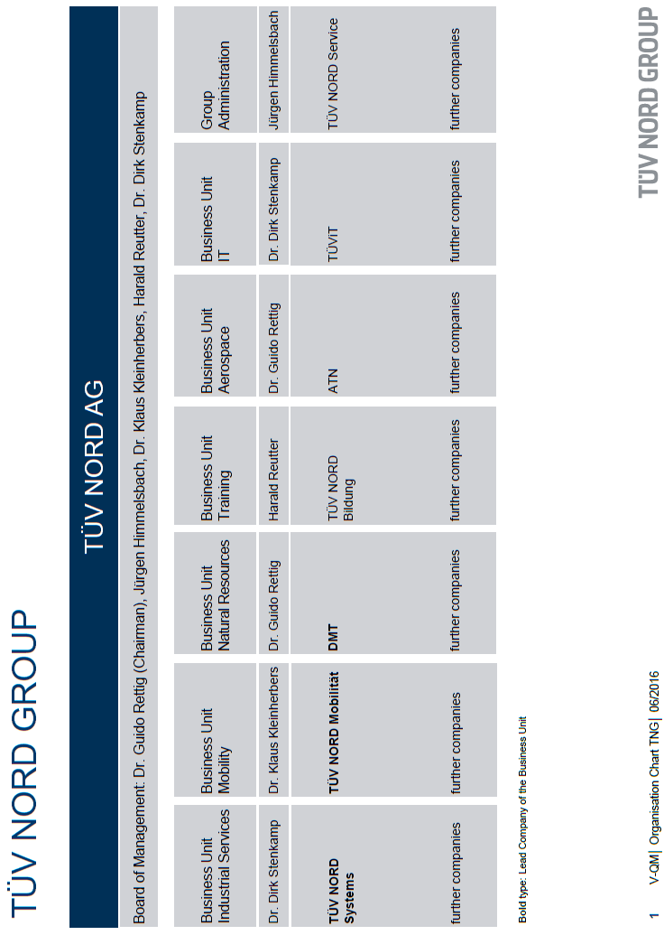

Overall Organization Chart of TÜV NORD CERT GmbH

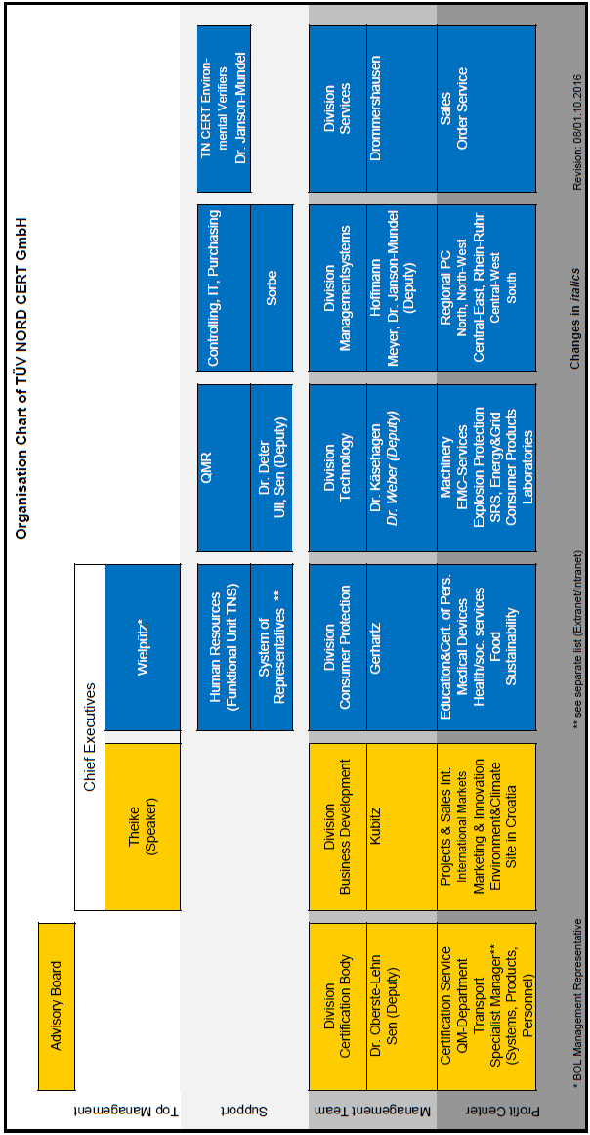
Organization Structure of Certification

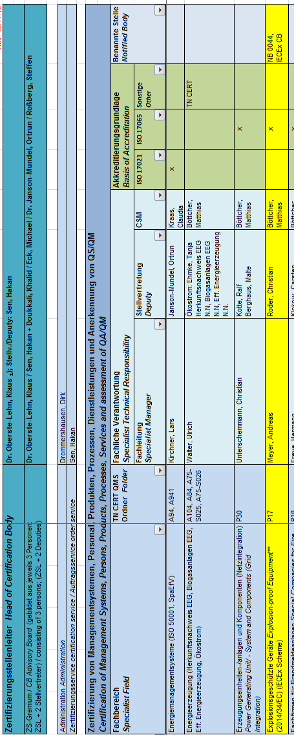
- Accreditation Certificate for ISO/IEC 17065
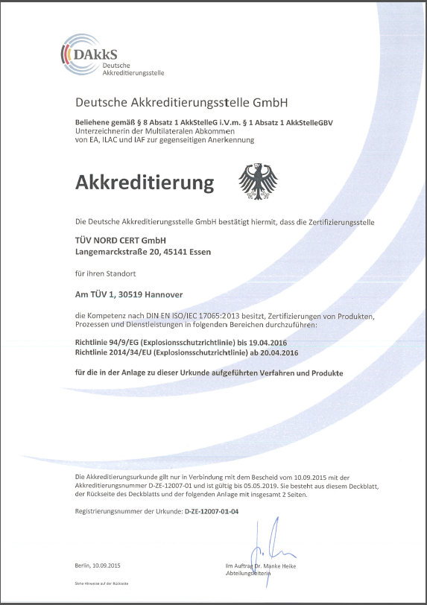
- Accreditation Certificate for ISO/IEC 17025
(relevant pages only)

