IECEx Operational Document

IEC System for Certification to Standards relating to Equipment for use in Explosive Atmospheres

OD 011-5

Guidance on Use of the IECEx Internet based “On-Line” Certificate of Conformity System – Second Generation

Part 5: Creating IECEx Certificates of Personnel Competence (IECEx CoPCs)

CONTENTS

1 Creating IECEx Certificates of Personnel Competence CoPCs 4
1.1 General Information 4
1.1.1 System 4
1.1.2 Passwords 4
1.1.3 Further Guidance 4
1.1.4 Printing CoPCs 4
1.2 Notes for each field 5
1.2.1 Certificate No. 5
1.2.2 Status 5
1.2.3 Issue No. 5
1.2.4 Date of Original Issue 6
1.2.5 Date of Expiry 6
1.2.6 Applicant 6
1.2.7 Scope of Competence 6
1.2.8 Photograph 6
1.2.9 Personnel Competence Assessment Report (PCAR) 6
1.2.10 Approved for issue on behalf of the IECEx Certification Body 6
1.2.11 Position 6
1.2.12 Signature 6
1.2.13 Date 6
1.2.14 Attachments 7
1.2.15 Wallet size ID Card 7
2 Creation of a new IECEx Certificate of Personnel Competence (CoPC) or Ex Facility Orientation Certificate (EFOC) 8
2.1.1 Entering details for a new CoPC or EFOC 8
2.2 Entering Personal Competence Assessment Report (PCAR) details 10
2.3 Creating a “New Issue” of a previously issued CoPC 10
3 Registration of a new PCAR 11
3.1 Registration of a new PCAR 11
3.2 Notes for the various fields of a PCAR: 12
3.3 Supplementary changes and updates to an Issued PCAR 13
ANNEX A 14

INTERNATIONAL ELECTROTECHNICAL COMMISSION

IECEx Operational Document 011-5

Guidance on Use of the IECEx Internet based “On-Line” Certificate of Conformity System Part 5: Creating IECEx Certificates of Personnel Competence CoPCs

INTRODUCTION
This Operation Document provides guidance for IECEx Certification Bodies (ExCBs) when creating IECEx Certificates of Personnel Competence CoPCs using the IECEx Internet based “On-Line” System.
OD 011 consists of six parts as follows:
OD011, Guidance on Use of the IECEx Internet based “On-Line” Certificate of Conformity System
OD 011-1 Part 1: General Information
OD 011-2 Part 2: Creating IECEx Equipment Certificates of Conformity CoCs
OD 011-3 Part 3: Creating IECEx Service Facility Certificates of Conformity CoCs
OD 011-4 Part 4: Creating IECEx Conformity Mark Licenses
OD 011-5 Part 5: Creating IECEx Certificates of Personnel Competence CoPCs (This part)
OD 011-10 Part 10: IECEx OCS Back Office

This Document should be read in conjunction with OD 011-1, Part 1: General Information. As a means of promoting the IECEx and its Members, OD 011-1 has been prepared in a format suitable for public access.
Inquiries relating to this IECEx “On-Line” CoC System or any other aspect of the IECEx System may be directed to the IECEx Secretary using the contact details below.

Document History

Date | Summary
2010 08 | Original Issue (Edition 1)
2015 01 | Edition 1.1  This edition of IECEx OD 011-5 has been issued to include updates to images and expansion on text. Changes are shown with a “Red” margin stripe.
2019 09 | - Complete revision to reflect structure and use of new IECEx On-line Certificate System  - Addition of Annex regarding Certificate and PCAR Data Fields content

Address:  IECEx Secretariat  Level 33, Australia Square  264 George Street  Sydney NSW 2000  Australia | Tel: +61 2 4628 4690  Fax: +61 2 4627 5285  Email: chris.agius@iecex.com

Guidance on Use of the IECEx Internet based “On-Line” Certificate of Conformity System Part 5: Creating IECEx Certificates of Personnel Competence CoPCs

Creating IECEx Certificates of Personnel Competence CoPCs

General Information

System
The IECEx CoC System is based on the IECEx On-line Certificate System (“IECEx OCS”) that uses HTML as per most Web based documents. The items below provide guidance to ExCBs when creating CoCs

Passwords
The IECEx OCS uses a two level password system (as outlined in IECEx OD 011-1 and below) to provide the necessary security for the content of IECEx Certificates and supporting Reports.
- A 1st level password (that provides ExCBBasic access rights) that the ExCB’s Official IECEx representative may provide to various staff within their organisation, to enable them to create a new certificate as a Draft. This level password will enable the staff member to create a new draft certificate and save it as a draft. It WILL NOT allow them to change the status from “Draft” to “Current”.
- A 2nd level password (that provides ExCBAdmin access rights) that is assigned to the official IECEx representative for issue only for the function that is authorised (within the ExCB management system) to formally issue certificates. This 2nd level password enables the person the same access as the 1st level password PLUS the authority to change the Status from “Draft” to “Current”.
The two levels of passwords mean that entering certificate information can be done by staff within the ExCB other than the certification authority. The 2nd level password ensures that there is the final check by the authorised person.
It is most important that the ExCB’s official representative to IECEx ensures that these passwords are kept secure and that they notify the IECEx Secretary immediately, of any possible breaches of security as new passwords can be assigned.

Further Guidance
For further information or guidance on using this new IECEx OCS please contact the IECEx Secretariat.

Printing CoPCs
The second generation IECEx OCS displays and stores IECEx Certificates and Reports as PDF files – the following guidance is provided to assist with printing CoPCs from the IECEx OCS as hard copy documents.
The preferred browser is Internet Explorer 10 or later. Compatibility with other browsers like Google Chrome is maintained, but should functional issues occur, revert back to Internet Explorer.

The facility to ‘‘download’ CoPCs to electronic files in PDF format is available (uncontrolled version) however it should be understood that these are uncontrolled copies and may not represent the latest version that is maintained on the IECEx OCS as the Master version. Also
Please note that PDF files ‘printed’ by public users are secured files that cannot be edited. They should also be referred to as uncontrolled versions, as any subsequent changes or edits to the on-line master version CoPC (controlled copy) will differ from the previous PDF version.

To accommodate the need for ExCBs to provide uncontrolled copies of certificates with electronic signatures and other additions the facility for ExCBs to ‘print’ CoPCs as unsecured PDF files exists – this requires the ExCB to login using their password (refer Section 1.1.2) and then open the file to be ‘printed to PDF’ and use the “print to pdf’ tool – this will create an unsecured PDF file that can be edited using Adobe Acrobat or similar software to insert text, images, etcetra.

Notes for each field

Certificate No.
The certificate number consists of the following characters:
IECEx CP AAAZZ.0000
Where “AAA” is the ExCB identifier. The ZZ.0000 field is automatically generated by the system and advances in number by “1”for each new issue of a certificate. “ZZ” is the last two digits of the year of issue.

Status
Operational Document OD 011-1 provides an explanation of the Status options. The “Draft” status should be selected when the ExCB is compiling or preparing the CoPC. When saved as a Draft, the CoPC remains on the System BUT IT CANNOT be viewed by other ExCBs or the public.
When ready to formally issue the CoPC, the issuing ExCB re-enters the IECEx CoC “On-Line” System and then selects the Draft CoPC. Once the Draft CoPC appears, the ExCB then selects “Edit” from the options located directly above the CoPC. This then opens all fields of the Draft CoPC ready for any last minute changes. Once complete and ready to issue, the issuing ExCB (using the level 2 password) changes the “Status” field from “Draft” to “Current” and then selects the “Save” option, located directly above the certificate. This step is regarded as the ExCB’s official “Decision to Issue” the Certificate, which is similar to the ExCB’s authorizing Officer signing a paper certificate.
Please note that a Current CoPC may only be edited in the first 14 days of it being made current. A change of status after this time is to be referred to the IECEx Secretariat.
Once saved as “Current” the CoPC is then available for anyone to view or print.
Once a CoPC is issued as Current, the issuing ExCB must include the Competent Person covered by the Certificate under a surveillance program, in accordance with the IECEx Rules of Procedure IECEx 05. During this surveillance program, an ExCB may be required to change the status of an IECEx CoPC from “Current” to “Suspended” or even “Cancelled”. However this must only occur in accordance with IECEx 05 and the ExCB’s Certification procedures.
It should also be noted that, in accordance with the IECEx Rules, the Applicant, should they object to the decision of the ExCB, always has the option of lodging an appeal with the IECEx Board of Appeal.

Issue No.
The Issue Number acts as a change control device to record the number of changes that have been made to the CoPC, with “Issue No. 0” representing the “Original Issue”.
Where an Applicant requests a change to an IECEx CoPC, the ExCB must first judge whether such a change is appropriate or whether the change is sufficient to warrant the issue of a new CoPC.
When an ExCB issues a change to a CoPC, the ExCB must include brief details of the change in the Personnel Competence Assessment Report (PCAR) (See 1.2.9 below).

Date of Original Issue
The Date of Original Issue should be regarded as the date on which the ExCB is satisfied that all the requirements of the IECEx System have been satisfied. This date should not be changed for any subsequent New issues. (refer Annex A for guidance and examples) .

Date of Expiry
The date of Expiry will be initially set as five years after the date of original issue. The five year expiry period must be applied to each new issue (refer Annex A for guidance and examples).

Applicant
As required by the IECEX Rules, IECEx 05, the certificate should be in the name of the Applicant.

Scope of Competence
The particular Competence(s) held by the Applicant is selected from the “drop down” list. See Section 2.1 in this document for further guidance.

Photograph
A passport type photograph of the Applicant is to be inserted. See Clause 3.3.5 of OD 502 for appropriate size and format (JPEG). The appropriate size and format is visible on the CoPC in edit mode. This photograph becomes an attachment to the CoPC. Any attachment in JPEG format is only visible to the issuing ExCB. It is not visible to the public or other ExCBs.

Personnel Competence Assessment Report (PCAR)
The reference number of the IECEx Personnel Competence Assessment Report (PCAR) is assigned by the “On-Line” CoC system. Generally, a PCAR would have been issued before it comes time to create a CoPC. Therefore the ExCB must use the “Inset/delete PCAR” to insert a link to the appropriate PCAR. Refer to Section 2.3 of this document for further guidance

Approved for issue on behalf of the IECEx Certification Body
This name should be the person within the ExCB authorized, in accordance with the ExCB’s quality system, to issue Certificates. In many cases this person is regarded as the ExCB’s “Signatory”.

Position
This is the title of the signatory’s position within the ExCB.

Signature
This space has been provided for instances where a paper certificate or a copy of a certificate, endorsed by the issuing ExCB may be required. The blank space for signatures only appears when the Certificate is printed.

Date
This space is intended to apply to paper copies of the certificate and is the date when the IECEx Certificate of Personnel Competence is signed.

Attachments
This field enables the optional attachment of additional information or documents if necessary. All such attachments should be in text or PDF format so they are visible to all. See Clause 1.2.8 for information on photographs.

Wallet size ID Card
The CoPC system provides for a wallet size ID card. To ensure consistency this card will be generated by the IECEx Secretariat following an email request from the ExCB. This card will be sent to the ExCB by the IECEx Secretariat for formal issue to the Applicant.

Example of wallet size ID Card showing typical front and back content:

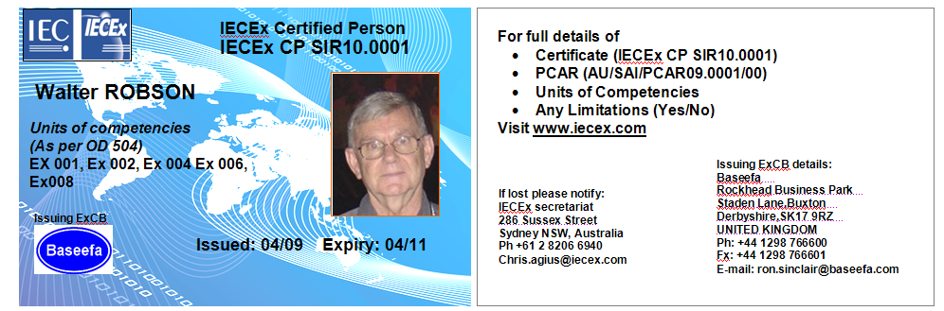

Creation of a new IECEx Certificate of Personnel Competence (CoPC) or Ex Facility Orientation Certificate (EFOC)

Entering details for a new CoPC or EFOC
STEP 1: Select “View Certificates & Licenses” from IECEx Website: www.iecex.com or access directly via https://www.iecex-certs.com




STEP 2: Select ExCB Login and then log on using the assigned user name and password.
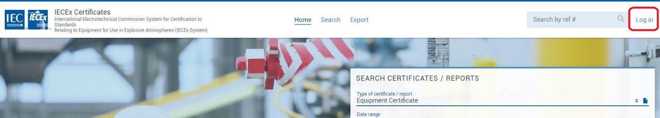

STEP 3: Select “Create”
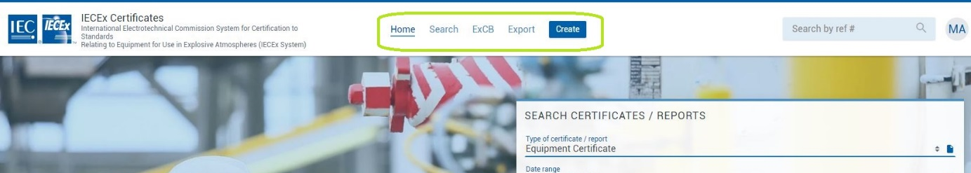

STEP 4: Select type of Certificate or Report as “Certified Persons Certificate” or “Facility Orientation Certificate”
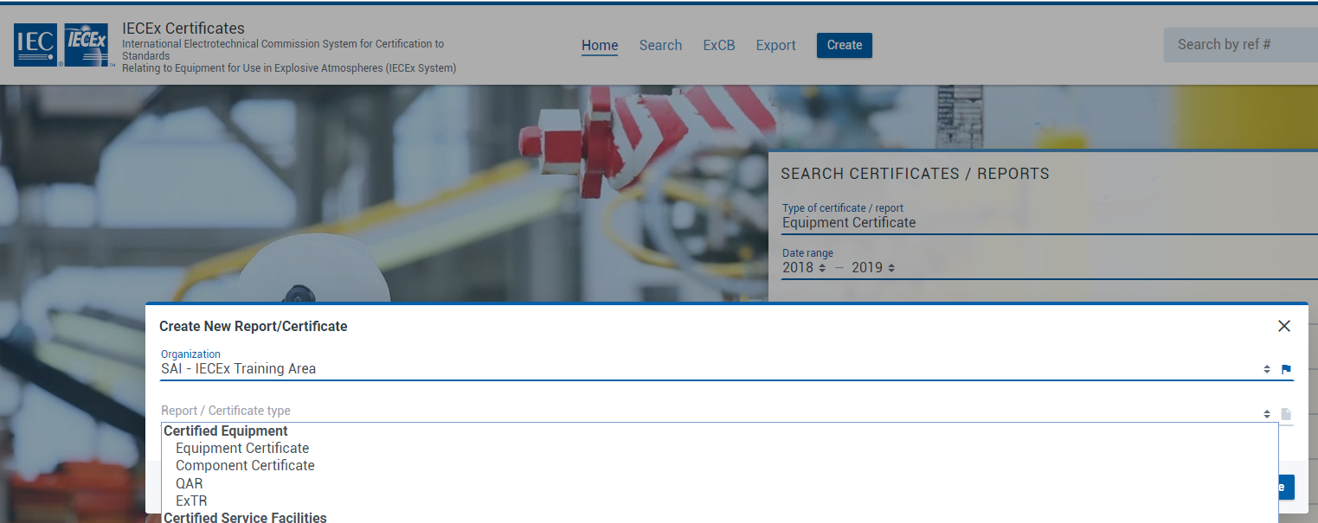

STEP 5: Select the  icon to open edit mode, then add details (IECEx OD 011-1 provides more guidance on data entry processes etc.) and then save as either status = Draft or Current.
Note that some fields (for example, the Applicant field) utilise the ‘auto-suggest’ tool that draws on date already in the IECEx OCS that can be selected so as to avoid the need to type content. The facility also exists to add details to the IECEx OCS database by creating new identities.
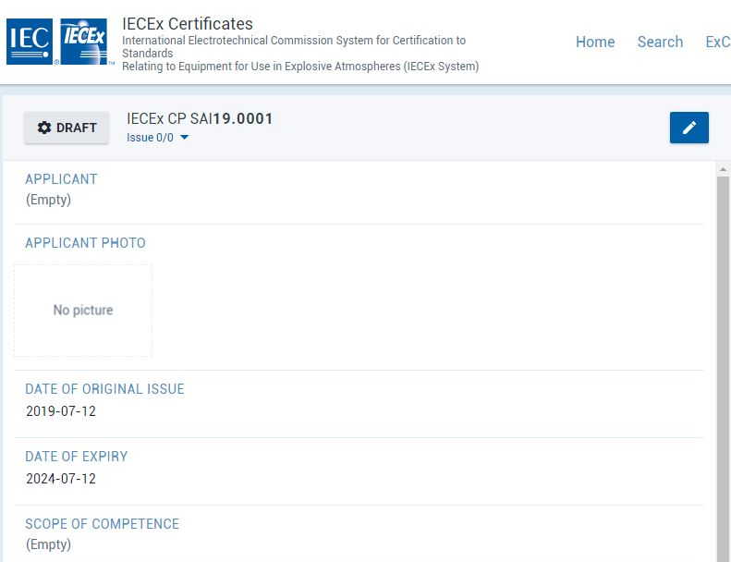
The status of a Certificate or Report can be changed by an ExCBAdmin level user by clicking on the status indicator (that is the Draft icon in the image below) to reveal the Change issue status icon. The status options available to ExCBs are presented in the “Update Status” window when editing a certificate or report – refer example (that shows the full range of options – the actual options vary according to access level rights) below:

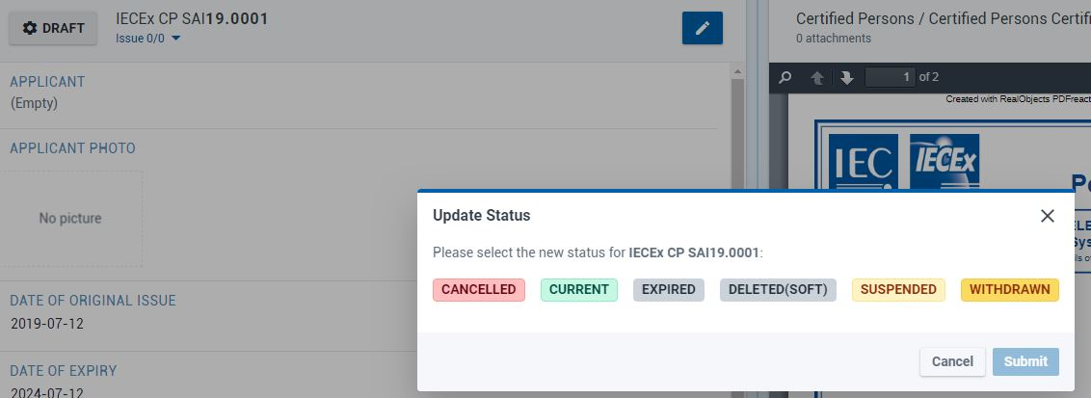

Entering Personal Competence Assessment Report (PCAR) details
The system provides for the linkage of the Certificate to the PCAR details that have been previously issued (status = “Issued”) on the IECEx OCS by an issuing ExCB.
When in the “creation” or “edit” mode to create or update an IECEx Certificate, selecting the ExTR field title or the QAR field title opens a window in which the appropriate PCAR Summary can be searched, highlighted and then selected by use of the  icon to move it to the Selected window as shown below. The icon pointing the other way can be used to remove items from the Selected window.
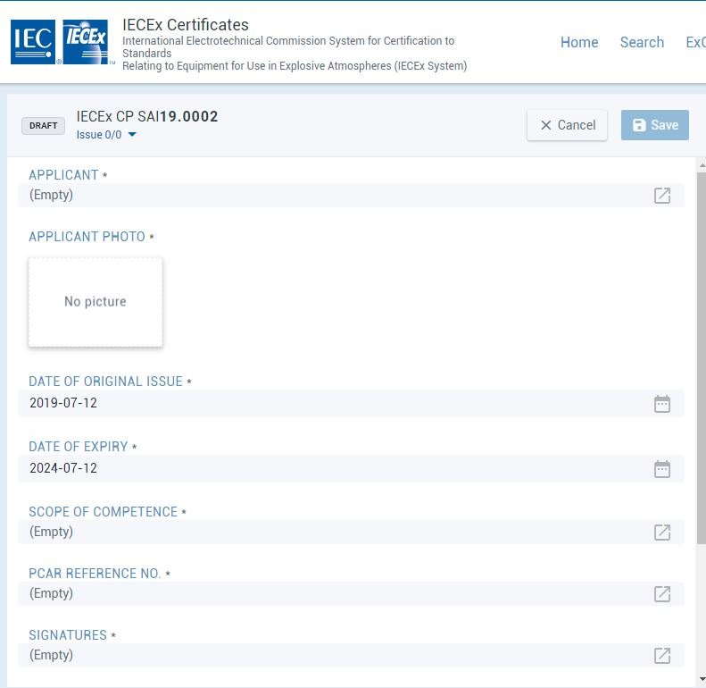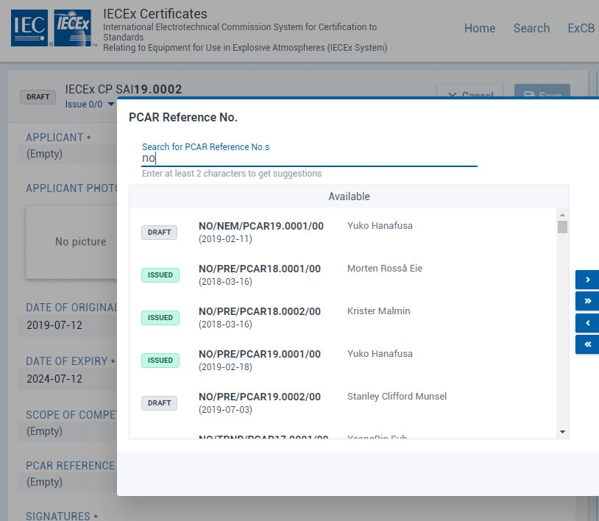

Note that EFOCs do not require a PCAR to be linked.

Creating a “New Issue” of a previously issued CoPC
STEP 1: Open appropriate CoPC and select the  icon to open a “New issue”, select “CONFIRM”, fill in details and save (noting that the content of the earlier issue is copied into the new issue and can be retained, edited or removed as required). The “Details of Certificate Changes” field in the new issue will be empty therefore all relevant details of changes for this issue must be added as this field.
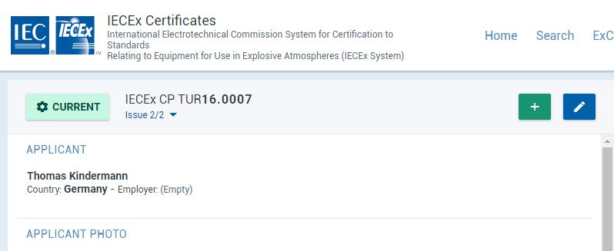
Notes:
- the Next issue Number is automatically assigned.
- the default Status is Draft - a Level 2 Password required to change Status from “Draft” to “Current”.
- the Original CoPC (“Issue 0”) and subsequent Issues are retained on the System permanently

Registration of a new PCAR

Registration of a new PCAR
STEP 1: Select ExCB Login and then log on using the assigned user name and password.

STEP 2: Select “Create”

STEP 3: Select type of Certificate or Report as ‘PCAR’

STEP 4: Select the icon to open edit mode, then add details (IECEx OD 011-1 provides more guidance on data entry processes etc.) and then save as either status = Draft or Issued (noting that only users with ExCBAdmin level access rights can set an ExTR Summary to status of Issued). Note that some fields utilise the ‘auto-suggest’ tool that draws on date already in the IECEx OCS that can be selected so as to avoid the need to type content. The facility also exists to add details to the IECEx OCS database by creating new identities.

Notes for the various fields of a PCAR:
PCAR Number This number is generated by the system with the following assigned attributes- an example of an ExTR issued in Great Britain (GB) by the ExCB “SGS Baseefa” follows:
GB / BAS / PCAR10.0001/00

Country Code

ExCB issuing the PCAR

PCAR Reference Number

Revision number of the PCAR
With 00 assigned for the original issue

Note: The System allows for additional reference numbers to be added, for internal ExCB use, but the System only lists according to the number generated by the system. In addition, there is a comments field where additional information may also be included, such as ExCB file numbers etc.
Status:
This feature allows the PCAR to be saved as either a “Draft” or as “Issued”. However the PCAR must be saved in the “issued” status before it can be linked to a CoPC.
PCAR Free Reference Number:
This is where an ExCB may wish to add numbers/letters or other characters to the PCAR Reference Number generated by the “On-Line” CoC system.
The preferred situation is for the ExCB to adopt the PCAR numbering system that is automatically generated by the system.
In any case, the system will not allow a deletion or change to the PCAR Number that has been automatically assigned by the system.
Date of Issue:
The date of issue of the PCAR is to be specified here. The system will default by showing the current day that the “New PCAR” window was opened.
Due Date of Recertification:
This date is five years after the date of issue in accordance with IECEx 05 Rules of procedure. (refer Annex A for guidance and examples) .
Applicant Name:
This is where the name of the Applicant is recorded.
Applicant Employer:
(Optional Field)
The name of the Employer of the Applicant may be inserted if the Applicant wishes.
Issuing ExCB:
This is usually the ExCB that provided the new PCAR Details.
Units of Competence:
The Units of Competence, as listed in OD 504, are to be recorded. They are selected from a drop down list.

List of Standards:
The Standards associated with the recorded competencies to be selected from a drop down list.
Limitations:
Any limitations in accordance with Clause 2.3 of OD 502 are to be recorded.
If Ex 001 is the only Unit mentioned in the PCAR the following statement shall be added to this field:
Ex 001 is a knowledge only Unit and does not cover work functions
Related IECEx Certificates CoPC:
The related CoPC to which the PCAR is linked is automatically inserted here by the System.
Comments:
(Optional Field)
This area is provided for the ExCB to record any relevant information that may assist the International Ex industry understand the PCAR. The reason for creating a new issue of a CoPC may be placed here. If consent has been given by the applicant, their contact details may also be included here (noting that the applicant can subsequently request a revision of the PCAR (and all previous versions) to remove contact details)
Attachments;
This field enables the optional attachment of additional information or documents if necessary.

Supplementary changes and updates to an Issued PCAR
This section applies where it is necessary to issue a supplement (New version) change or update to an Issued PCAR. In most cases the cause for the update will be to inform that a surveillance audit has been completed.
STEP 1: Open appropriate PCAR to be updated and then select the icon to open a “New issue”, select “CONFIRM” and fill in details (noting that the content of the earlier issue is copied into the new issue and can be retained, edited or removed as required). The “Comments” field may be used to outline the details of changes as compared to the earlier version.
Step 2: When completed, select “Save” from the top bar of the edit screen to save the PCAR as status of Draft or Issued (noting that only users with ExCBAdmin level access rights can set a QAR Summary to status of Issued)

ANNEX A
Guidance on required content of Date fields in IECEx CoPCs & PCARs

Situation Examples (where red text highlights what needs to change / can be changed)

- NEW / Original Issue (Issue … /00) of a PCAR on 1st January 2018

Field | Content | Comment
Date of Original Issue | 2018-01-01
Date of Issue of this PCAR | 2018-01-01
Due Date for Recertification | 2023-01-01 | = Date of Issue of this PCAR plus 5 years

- NEW / Original Issue (Issue 0) of a Certificate of Personnel Competence (CoPC) on 1st January 2018

Field | Content | Comment
Date of Original Issue | 2018-01-01
Date of Expiry | 2023-01-01 | = same as Due Date for Re-certification on PCAR

- Up-issue (Issue … /01 or higher) of the same PCAR by the same issuing ExCB

- For Scope Extension to add Units before Re-certification is required (as per IECEx 05, Clause 8.7.1)

Field | Content | Comment
Date of Original Issue | 2018-01-01 | Does not change
Date of Issue of this PCAR | 2019-04-25
Due Date for Re-certification | 2023-01-01 | Does not change - refer IECEx 05, Clause 8.7.1 …  A change of scope of competence during the five (5) year validity period does not extend the Date of Expiry on the Certificate or the Due Date of Re-certification on the PCAR.

- Following Re-certification (as per Clause 8.6 of IECEx 05)

Field | Content | Comment
Date of Original Issue | 2018-01-01 | Does not change
Date of Issue of this PCAR | 2022-12-01 | Up-issued PCAR has updated Date of Issue
Due Date for Re-certification | 2027-12-01 | = Date of Issue of up-issued PCAR issue plus 5 years

- Up-issue (Issue 1 or higher) of the same Certificate of Personnel Competence (CoPC) by the same issuing ExCB

- For Scope Extension to add Units before Re-certification is required (as per IECEx 05, Clause 8.7.1)

Field | Content | Comment
Date of Original Issue | 2018-01-01 | Does not change
Date of Expiry | 2023-01-01 | Does not change – refer IECEx 05, Clause 8.7.1 …  A change of scope of competence during the five (5) year validity period does not extend the Date of Expiry on the Certificate or the Due Date of Recertification on the PCAR.

- Following Re-certification (as per Clause 8.6 of IECEx 05)

Field | Content | Comment
Date of Original Issue | 2018-01-01 | Does not change
Date of Expiry | 2022-12-01 | = same as Due Date for Re-certification on PCAR

- Scope extension OR Recertification of a Certificate of Personnel Competence (CoPC) by a different issuing ExCB

- For Scope Extension done on 23rd March 2020 to add Units before Re-certification is required (as per IECEx 05, Clause 8.7.2)

Field | Content | Comment
Date of Original Issue | 2020-03-23 | NEW PCAR and NEW Certificate required as per IECEx 05, Clause 8.6 – see Situation #1 above for details on how to prepare NEW PCAR and NEW Certificate
Date of Expiry | 2025-03-23 | NEW Certificate has later Date of Expiry than PCAR linked to replaced Certificate because IECEx 05, Clause 8.7.1 does NOT apply in this situation

- Re-certification (as per Clause 8.6 of IECEx 05) via issue of a NEW Certificate to replace a Certificate previously issued by different issuing ExCB

Field | Content | Comment
Date of Original Issue | 2020-03-23 | New PCAR and NEW Certificate is required as per IECEx 05, Clause 8.6 – see Situation #1 above for details on how to prepare NEW PCAR and NEW Certificate
Date of Expiry | 2025-03-23 | = same as Due Date for Re-certification on NEW PCAR

