INTERNATIONAL ELECTROTECHNICAL COMMISSION SYSTEM FOR CERTIFICATION TO STANDARDS RELATING TO EQUIPMENT FOR USE IN EXPLOSIVE ATMOSPHERES (IECEx SYSTEM)

TITLE: Re-assessment and relocation report for the continued acceptance of, CSA Group Testing UK Limited as an Accepted Test Laboratory, ExTL, within the IECEx System, Equipment Scheme 02.

Circulation to: Members of the IECEx Management Committee, ExMC

INTRODUCTION

In accordance with the 5 year re-assessment plan for the surveillance and monitoring of bodies within the IECEx System, the following document contains the IECEx Re-assessment Report for the continued acceptance of CSA Group Testing UK Limited, as an Accepted Test Laboratory, ExTL.

This report is hereby submitted for endorsement during the ExMC 2016 Meeting being held in Umhlanga, South Africa.

Chris Agius

IECEx Secretariat

IECEx Secretariat  Australia Square  Level 33, 264 George Street  Sydney NSW 2000  Australia | Tel: +61 2 4628 4690  Fax: +61 2 4625 3480  Email: chris.agius@iecex.com

IECEx ASSESSMENT REPORT for CSA Group Testing UK Limited, Unit 6, Hawarden Industrial Park, Hawarden, Deeside, CH5 3US, United Kingdom
(IECEx Test Laboratory, ExTL)

Type of Assessment: (please mark)

Initial Assessment for Candidate ExTL

Re-Assessment of ExTL X

Re-Location Assessment X

Scope Extension of ExTL

- OBJECT AND FIELD OF APPLICATION

  - Country:

United Kingdom

  - Name of Candidate TL

CSA Group Testing UK Limited

  - Members of the Assessment Team

Heinz Berger - IECEx Lead Assessor
Heinz Farke - IECEx Expert Assessor

  - Place and Date of Assessment

CSA Group Testing UK Limited, Unit 6, Hawarden Industrial Park, Hawarden, Deeside, CH5 3US, United Kingdom

July 8th to 10th, 2015

  - Assessment References

- IECEx 02 Equipment Scheme Rules (current version)
- IECEx OD 003-2 Assessment Procedures (current version)
- IECEx OD 005-2; Manufacturer Assessment (current version)
- IECEx OD 009 Equipment Scheme Procedures(current version)
- IECEx OD 018 Checklist 17025 (current version)
- IECEx OD 024 Witness Testing/manufacturer and users Facility
- ISO/IEC 17025:2005
- IECEx Technical Capability Document (TCD)
- ExTAG decision sheets (DSs)
- OD's related to technical issues

  - Scope of Application

Number | Title | Acceptance
60079-0  Edition 5  Edition 6 | Explosive atmospheres - Part 0: Equipment - General requirements | YES
60079-1  Edition 6  Edition 7 | Explosive atmospheres - Part 1: Equipment protection by flameproof enclosures 'd' | YES
60079-2  Edition 5  Edition 6 | Explosive atmospheres -  Part 2: Equipment protection by pressurized enclosures 'p' | YES
60079-5  Edition 3  Edition 4 | Explosive atmospheres -  Part 5: Equipment protection by powder filling 'q' | YES
60079-6  Edition 3  Edition 4 | Explosive atmospheres -  Part 6: Equipment protection by oil immersion 'o' | YES
60079-7  Edition 4  Edition 5 | Explosive atmospheres -  Part 7: Equipment protection by increased safety 'e' | YES
60079-11  Edition 5  Edition 6 | Explosive atmospheres -  Part 11: Equipment protection by intrinsic safety 'i' | YES
60079-13  Edition 1 | Explosive atmospheres - Part 13: Equipment protection by pressurized room 'p' | YES
60079-15  Edition 3  Edition 4 | Explosive atmospheres -  Part 15: Equipment protection by type of protection 'n' | YES
60079-18  Edition 3  Edition 4 | Explosive atmospheres - Part 18: Equipment protection by encapsulation "m" | YES
60079-25  Edition 1  Edition 2 | Explosive atmospheres -  Part 25: Intrinsically safe systems | YES
60079-26  Edition 2  Edition 3 | Explosive atmospheres -  Part 26: Equipment with equipment protection level (EPL) Ga | YES
60079-27  Edition 1  Edition 2 | Explosive atmospheres -  Part 27: Fieldbus intrinsically safe concept (FISCO) | YES
60079-28  Edition 1  Edition 2 | Explosive atmospheres -  Part 28: Protection of equipment and transmission systems using optical radiation | YES
60079-29-1  Edition 1 | Explosive atmospheres -  Part 29-1: Gas detectors - Performance requirements of detectors for flammable gases | YES  GasPTS
60079-30-1  Edition 1 | Explosive atmospheres - Part 30-1: Electrical resistance trace heating - General and testing requirements | YES
60079-31  Edition 1  Edition 2 | Explosive atmospheres -  Part 31: Equipment dust ignition protection by enclosure "t" | YES
60079-35-1  Edition 1 | Explosive atmospheres -  Part 35-1: Caplights for use in mines susceptible to firedamp - General requirements - Construction and testing in relation to the risk of explosion | YES
61779-1  Edition 1 | Electrical apparatus for the detection and measurement of flammable gases -  Part 1: General requirements and test methods | YES  GasPTS
61779-2  Edition 1 | Electrical apparatus for the detection and measurement of flammable gases -  Part 2: Performance requirements for group I apparatus indicating a volume fraction up to 5% methane in air | YES
61779-3  Edition 1 | Electrical apparatus for the detection and measurement of flammable gases -  Part 3: Performance requirements for group I apparatus indicating a volume fraction up to 100% methane in air | YES
61779-4  Edition 1 | Electrical apparatus for the detection and measurement of flammable gases -  Part 4: Performance requirements for group II apparatus indicating a volume fraction up to 100% lower explosive limit | YES  GasPTS
61779-5  Edition 1 | Electrical apparatus for the detection and measurement of flammable gases -  Part 5: Performance requirements for group II apparatus indicating a volume fraction up to 100% gas | YES  GasPTS
61241-0  Edition 1 | Electrical apparatus for use in the presence of combustible dust –  Part 0: General requirements | YES
61241-1  Edition 1 | Electrical apparatus for use in the presence of combustible dust – Part 1: Protection by enclosures ‘tD’ | YES
61241-1-1  Edition 2 | Electrical apparatus for use in the presence of combustible dust –  Part 1: Electrical apparatus protected by enclosures and surface temperature limitation – Specification for apparatus | YES
61241-4  Edition 1 | Electrical apparatus for use in the presence of combustible dust –  Part 4: Type of protection ‘pD’ | YES
61241-11  Edition 1 | Electrical apparatus for use in the presence of combustible dust –  Part 11: Protection by intrinsic safety ‘iD’ | YES
61241-18  Edition 1 | Electrical apparatus for use in the presence of combustible dust –  Part 18: Protection by encapsulation ‘mD’ | YES
62013-1  Edition 1  Edition 2 | Caplights for use in mines susceptible to firedamp -  Part 1: General requirements - Construction and testing in relation to the risk of explosion | YES
62086-1  Edition 1 | Electrical apparatus for explosive gas atmospheres –  Electrical resistance trace heating – Part 1: General and testing requirements | YES

  - Candidate TL Persons Interviewed

Name | Position
A C Smith | Certification Manager Ex Products
A Myler | Quality Manager
S Cork | Laboratory Technical Manager
Raymond Papiah | Certification Engineer
Barry Ellis | Laboratory Technician
Liam Jones | Laboratory Technician
Ian Carrington | Laboratory Technician
Declan Boyle | Laboratory Technician

  - Legal Entity of The Candidate TL

CSA Group Testing UK Limited is based at the Chester location and registered at Companies House; it is a separate legal entity from Sira Certification Service.

The legal status of the companies, as checked on Companies House Website is:-

Sira Certification Service is a private company, limited by guarantee (company number 2266287). (In this report also referred to as SCS).

CSA Group Testing UK Limited is a private company, registered at company house as 5569145. (In this report also referred to as ST&C).

  - Associated ExCB

Sira Certification Service, Unit 6, Hawarden Industrial Park, Hawarden, Deeside, CH5 3US, United Kingdom

  - Financial Support

CSA Group Testing UK Limited is both wholly owned subsidies of CSA Certification UK Ltd, which in turn is owned by CSA Group.

The income of CSA Group Testing UK Limited is derived solely from its Testing and Certification activities; they do not receive any additional financial support.

Individual accounts are prepared for each of the Sira companies. The last audited accounts for the year ending March 2015 were seen during the visit.

  - History

Sira Test & Certification Limited started as a wholly owned subsidiary of the Sira Group.

From 2005 up until the end of June 2009 the 4 Sira companies, Sira Certification Services, Sira Test and Certification, Sira Environmental Ltd. and Sira Consulting Ltd. were owned by Volvere PLC who are a UK public limited company. In July 2009 the Sira group of companies was bought by CSA Certification UK Ltd which is registered in the UK as 06947589. In turn they are owned by CSA (CSA International of Canada).

In April 2014 Sira Consulting Ltd ceased trading. In March 2015 Sira Test and Certification Limited (the ExTL) changed its name to CSA Group Testing UK Limited. The name of the ExCB Sira Certification Services remains unchanged.

- ORGANISATION

  - Names, Titles and Experience of the Senior Executives

Name | Title | Experience
I Rippin | Managing Director | 1 year
A C Smith | Certification Manager Ex Products | 13 years
O Hughes | Operations Manager | 5 years
W Thomas | Manager, Accreditations | 15 years
S Cork | Laboratory Technical Manager | >30 years

  - Name, Title and Experience of the Quality Management Representative

Name | Title | Experience
A Myler | Quality Manager
Ian Rippin | Deputy QM, Managing Dir.

  - Name and Title of Nominated Principal Contact

Name | Title | Comments
A C Smith | Certification Manager Ex Products | andy.smith@csagroup.org
  - Employees

Chester Laboratory Staff
Name | Title | Experience
S Lindley | Deputy Laboratory Manager | <1 year
+ 6 Technicians

ExTL Certification Staff who may perform Ex / ATEX Testing and Assessment
Name | Title | Experience
S Finch | Consultant Engineer | 25 Years
P Walsh | Technical Advisor | 30 Years
M Halliwell | Certification Specialist | 11 Years
D Holton | Senior Certification Engineer | 20 Years
B Allen | Senior Certification Engineer | 20 Years
N Jones | Senior Certification Engineer | 25 Years
A Ashburner | Senior Certification Engineer | 20 Years
D Hanks | Senior Certification Engineer | 20 Years
I Hulse | Senior Certification Engineer | 20 Years
R Papiah | Senior Certification Engineer | >10 Years
T Doubleday | Senior Certification Engineer | >10 Years
M Curkovic | Senior Certification Engineer | >10 Years
B Spencer | Senior Certification Engineer | >10 Years
S Hills | Senior Certification Engineer | >10 Years
L Pall | Senior Certification Engineer | >10 Years
+ 13 Engineers

  - Organizational Structure
See ANNEXS 1a, 1b and 1c

- RESOURCES
There are 13 employees and 5 sub-contractors directly involved in the conformity assessment activities.

A total of 7 employees are directly employed in the Sira Chester laboratory carrying out Ex / ATEX Testing and Assessments. A further 29 Certification employees at Chester are involved in the Ex / ATEX Testing and Assessments. There is one person, Andrew Keenan directly involved in the testing and assessment of Gas Detectors.

There are a further 25 people involved in support and administration activities, trainings, etc.

- DOCUMENTATION
  - Quality Manual

The Quality Manual describes the Quality System in the laboratory. Included in the Quality Manual are descriptions of the organization, its generic policies and objectives relating to quality, and its general operations. The Quality Manual was reviewed during the assessment and found appropriate.

The ST&C Quality Manual is issue 5 dated 18/06/2015. The structure of the Manual is shown in the graph below.

ST&C Quality Manual
Calibration Laboratory
0060
ST&C Chester Test Laboratory

0327 (Sections 1 & 2)

General Laboratory Operating ProceduresLOP100.01
Receipt of test samplesLOP100.02
External enquiriesLOP100.03
Preparation of a UKAS test reportLOP100.04
List of approved signatoriesLOP100.06
Test requestsLOP100.07
Internal test reportsLOP100.08
Sub ContractingLOP100.09
Calibration ProceduresLOP300.01
Gas detector testing procedures

Test Laboratory

0327 (Section 3)

Gas detector calibration procedures
Optical calibration procedures
VEGA/DSM calibration procedures manual
Procedures for the operation of the VEGA/DSM scheme
Site audit procedures for calibration of VEGA/DSM
ST&C Chester Test Laboratory

IECEx (EXTL)

Work Instructions

SCS Hazardous Area Product Certification & Assessment Procedures Manual
ST&C WI 54 - Uncertainty
ST&C WI 64- Overview of Proquis System
ST&C WI 66 – Document Control
ST&C WI 67 – Equipment Control
ST&C WI 68 – Issue & Actions
ST&C WI 69 – Audits
ST&C WI 70 - Proquis System Personnel
SEL WI 02 – Lab Notebook – recording experimental findings
SEL WI 05 – External repair maintenance & calibration control
SEL WI 08 – Test programme preparation
SEL WI 15 – Selection of suppliers of calibration & test services
SEL WI 71 – Training records for staff
SEL WI 73 – Recording ad analyzing laboratory ambient conditions

  - Procedures

The procedures for the Laboratory operations are contained in LOP series. Procedure 100.01, issue 13 dated 12 August 2014 is the General Laboratory Operating Procedure.

Laboratory Operating Procedures and amendments are issued under the authority of the Technical Manager and the Quality Manager

  - Work Instructions

The work instructions needed for laboratory testing are retained in the LOP series documents on Proquis.

PROQUIS (PE) work instructions are issued under the authority of the Quality Manager and are approved by the relevant Manager (which is dependent on the subject of the work instruction).

  - Records

Documents are stored in electronic and/or paper form.

Quality records such as audit reports, corrective and preventative actions and customer complaints have been kept in the PROQUIS system until recently when Sira transitioned this to the CSA records system.

Equipment and calibration records are stored in the MET / TEAM database.

Training records, such as education certificates, CV’s etc. are also maintained in the Quality Department. A competency matrix is maintained in electronic form by the Laboratory Technical Manager.

The policy regarding records is detailed in section 8.1 of LOP 100.01 although there are no specific procedures and a finding regarding this was raised during the visit.

  - Document Change Control

Document control and change is described in ST&C WI 66 PROQUIS (PE) System – Documentation Control.

Documents such as manuals and standards which regulate the operations are controlled by the document control centre, which is administered by the Quality Manager.

All documents, including forms and publicity material, are subject to a controlled system of updating and amendment.

Most documents are controlled and available through a system called PROQUIS. The issue of controlled documents is to the extent necessary to provide ready access for all appropriate personnel.

Control of standards is achieved by the electronic standards database, IHS, accessible through the CSA Group portal. Standards are labelled as ‘controlled’ or ‘uncontrolled’.

For the updating of standards CSA subscribes to the updating service provided by IHS for all controlled BS, EN, IEC and ISO standards.

Other controlled documents including UKAS and notified body related documents are updated by direct mailing from the issuing authorities or by checking relevant websites.

  - Test Records

Test records and test reports are scanned and stored on the Z:drive of the main local server. Once jobs are completed, the original paper records are sent to the certification department for inclusion in the certification records. The electronic records are stored on the server by year and then by test number.

- TEST REPORTS

  - Test Reports Issued

Number of test reports issued under the IECEx System and the national or regional schemes in the preceding four years for each type of protection:

Standards | Title | Number of issued test reports
 |  | 2012 | 2013 | 2014 | 2015 | Total
60079-0 | Explosive atmospheres - Part 0: Equipment - General requirements | --- | --- | --- | --- | Part 0 included in numbers below
60079-1 | Explosive atmospheres - Part 1: Equipment protection by flameproof enclosures 'd' | 174 | 177 | 156 | 80 | 587
60079-2 | Explosive atmospheres -  Part 2: Equipment protection by pressurized enclosures 'p' | 2 | 7 | 3 | 0 | 12
60079-5 | Explosive atmospheres -  Part 5: Equipment protection by powder filling 'q' | 2 | 4 | 2 | 2 | 10
60079-6 | Explosive atmospheres -  Part 6: Equipment protection by oil immersion 'o' | 0 | 0 | 3 | 0 | 3
60079-7 | Explosive atmospheres -  Part 7: Equipment protection by increased safety 'e' | 106 | 109 | 92 | 48 | 355
60079-11 | Explosive atmospheres -  Part 11: Equipment protection by intrinsic safety 'i' | 141 | 132 | 145 | 67 | 485
60079-13 | Explosive atmospheres - Part 13: Equipment protection by pressurized room 'p' | 0 | 0 | 0 | 1 | 1
60079-15 | Explosive atmospheres -  Part 15: Equipment protection by type of protection 'n' | 25 | 36 | 37 | 24 | 122
60079-18 | Explosive atmospheres - Part 18: Equipment protection by encapsulation "m" | 32 | 40 | 39 | 24 | 135
60079-25 | Explosive atmospheres -  Part 25: Intrinsically safe systems | 1 | 0 | 0 | 0 | 1
60079-26 | Explosive atmospheres -  Part 26: Equipment with equipment protection level (EPL) Ga | 62 | 68 | 64 | 34 | 228
60079-27 | Explosive atmospheres -  Part 27: Fieldbus intrinsically safe concept (FISCO) | 2 | 0 | 1 | 0 | 3
60079-28 | Explosive atmospheres -  Part 28: Protection of equipment and transmission systems using optical radiation | 1 | 11 | 10 | 11 | 33
60079-29-1 | Explosive atmospheres -  Part 29-1: Gas detectors - Performance requirements of detectors for flammable gases | 0 | 0 | 1 | 1 | 2
60079-30-1 | Explosive atmospheres - Part 30-1: Electrical resistance trace heating - General and testing requirements | 8 | 9 | 4 | 1 | 22
60079-31 | Explosive atmospheres -  Part 31: Equipment dust ignition protection by enclosure "t" | 131 | 132 | 111 | 67 | 441
60079-35-1 | Explosive atmospheres -  Part 35-1: Caplights for use in mines susceptible to firedamp - General requirements - Construction and testing in relation to the risk of explosion | 0 | 0 | 0 | 0 | 0
61779-1 | Electrical apparatus for the detection and measurement of flammable gases -  Part 1: General requirements and test methods | 0 | 1 | 2 | 0 | 3
61779-2 | Electrical apparatus for the detection and measurement of flammable gases -  Part 2: Performance requirements for group I apparatus indicating a volume fraction up to 5% methane in air | 0 | 0 | 0 | 0 | 0
61779-3 | Electrical apparatus for the detection and measurement of flammable gases -  Part 3: Performance requirements for group I apparatus indicating a volume fraction up to 100% methane in air | 0 | 0 | 0 | 0 | 0
61779-4 | Electrical apparatus for the detection and measurement of flammable gases -  Part 4: Performance requirements for group II apparatus indicating a volume fraction up to 100% lower explosive limit | 0 | 1 | 2 | 0 | 3
61779-5 | Electrical apparatus for the detection and measurement of flammable gases -  Part 5: Performance requirements for group II apparatus indicating a volume fraction up to 100% gas | 0 | 0 | 0 | 0 | 0
61241-0 | Electrical apparatus for use in the presence of combustible dust –  Part 0: General requirements | --- | --- | --- | --- | Part 0 included in numbers below
61241-1 | Electrical apparatus for use in the presence of combustible dust –  Part 1: Protection by enclosures ‘tD’ | 40 | 27 | 13 | 2 | 82
61241-1-1 | Electrical apparatus for use in the presence of combustible dust –  Part 1: Electrical apparatus protected by enclosures and surface temperature limitation – Specification for apparatus | 0 | 1 | 0 | 0 | 1
61241-4 | Electrical apparatus for use in the presence of combustible dust –  Part 4: Type of protection ‘pD’ | 0 | 0 | 1 | 0 | 1
61241-11 | Electrical apparatus for use in the presence of combustible dust –  Part 11: Protection by intrinsic safety ‘iD’ | 5 | 4 | 3 | 1 | 13
61241-18 | Electrical apparatus for use in the presence of combustible dust –  Part 18: Protection by encapsulation ‘mD’ | 0 | 0 | 0 | 0 | 0
62013-1 | Caplights for use in mines susceptible to firedamp -  Part 1: General requirements - Construction and testing in relation to the risk of explosion | 0 | 0 | 0 | 0 | 0
62086-1 | Electrical apparatus for explosive gas atmospheres –  Electrical resistance trace heating – Part 1: General and testing requirements | 0 | 0 | 0 | 0 | 0

- CALIBRATION

The equipment necessary for IECEx Testing is subject to external calibration using UKAS accredited calibration facilities, in accordance with the laboratory quality manual. There is a system in place to ensure that each month all equipment requiring calibration is identified and sent out for calibration. The equipment list was reviewed during the assessment as well as several calibration certificates. The requirements of the IECEx are fulfilled.

- CONFIDENTIALITY

Confidentiality is covered by section 1.7 of the STC Quality Manual. All work is treated as confidential and employee’s contracts incorporate a confidentiality / impartiality statement as a condition of employment. The work is treated as confidential to that client unless otherwise agreed or as required by law.

Staff will ensure that confidential information is not left visible or easily accessible in areas that may be accessible to visitors.

- NATIONAL ACCREDITATION

CSA Group Testing UK Limited holds an accreditation according to ISO 17025:2005, issued by UKAS under the reference 0327, see Annex 2 for a copy of the accreditation certificates. The scope of accreditation is detailed in the UKAS Product Certification Schedule which is available from the UKAS web site at www.ukas.com

UKAS accreditation certificates are valid as long as the schedule of accreditation is published on the UKAS Website (www.ukas.com). This means, that they are valid until a possible suspension or withdrawal. The latest ST&C certificate was issued on 7th of July, 2015.

- RECOGNITION AND AGREEMENTS

SCS maintains recognition agreements with a variety of certification bodies and test laboratories. For IECEx certification, only those that are an ExCB or ExTL are accepted.

- INTERNAL AUDIT AND PERIODIC REVIEW

Periodic internal audits are carried out as detailed the ST&C Quality Manual Section 5.

The Quality Manager is responsible for ensuring that an internal audit program is carried out at least annually to review the organization’s compliance with relevant accreditation and Notified Body criteria as well as with its own Quality Manual & Procedures.

Audits are conducted either by the Quality Manager or a suitably qualified and experienced person. The minimum requirements for an internal auditor are that they have attended an appropriate training course or have had at least one year’s auditing experience.

Audits cover the requirements specified in the Quality Manual and relevant Procedures documents. In addition random audits of any area may be undertaken if the Managing Director or Quality Manager considers them necessary.

The performance of tasks carried out directly by the Quality Manager is audited by a competent person independent of the function being.

The audit programmed was managed by using the Audit Module of the PROQUIS Management System. This is now undertaken in the CSA Group system. Results of audits are recorded by the auditor, together with any nonconformities and resulting actions. The system informs the appropriate person of the agreed non conformance/action with an appropriate timescale for completion. The auditor records a summary of the audit with general observations, conclusions and recommendations as appropriate. The Quality Manager/auditor will verify completion of the agreed corrective action.

The internal audit plan for 2015 as well as audits records was reviewed during the visit. Audits are being carried out, appropriate details are recorded and findings from the audits are addressed in an appropriate manner. The requirements of the IECEx are fulfilled.

Two meetings per year are planned. The last management review was performed on November 19th, 2014. The minutes of the meeting were reviewed during the assessment and found to meet the requirements of the IECEx. The next meeting is foreseen in July 2015.

- COMPLAINTS AND APPEALS (Including appeals to IECEx)

The policy regarding complaints is detailed in section 6.1 of the ST&C Quality Manual.

All complaints were recorded in the “Proquis” system maintained by the Quality Manager, now maintained in the CSA Group system, with each complaint being given a unique reference number. The entry is controlled via CSA procedure DQD 306 – handling customer complaints.

Information regarding the complaints and appeals process is published on the Sira web site, www.csagroupuk.org.

The complaints database was reviewed during the visit, noting no issues raised that warrant concern to IECEx.

- SPECIAL FACTS TO BE NOTED

    - Supporting Documentation

Copies of additional supporting information for this assessment have been provided to the audited organization and the IECEx Secretariat. These include:

- On-Site Assessment report (IECEx OD/006)
- Details of issues raised and how these have been resolved
- Checklist for ISO/IEC 17025
- IECEx Technical Capability Document (TCD)
- Photos of facilities and equipment
- List of Subcontractors and Contractors
- Competence Matrix

    - Tests Witnessed

Standard: IEC 60079-0: 2011 General Requirements

Clause 26.13 | Surface resistance test
Clause 26.10 | Resistance to light
Clause 26.4.5 | IP testing
Clause 26.14 | Measurement of capacitance

Standard: IEC 60079-1: 2014 Flameproof enclosures ‘d’

Clauses  15.2.2 / 15.2.3 | Determination of explosion pressure (reference pressure) /  Overpressure test
Clause 15.3 | Test for non-transmission of an internal ignition

Standard: IEC 60079-11: 2011 Intrinsic Safety ‘i’

Clause 10.1 | Spark ignition test
Clause 10.5.3 | Temperature rise test on batteries

Standard: IEC 60079-18: 2014

Clause 8.2.4 | Dielectric strength

Standard: IEC 60079-31: 2013

Clause 6.1.3 | Pressure test

Extra’s witnessed and reviewed during the assessment
Extra 15.0092/00 | Type of protection “Ex i”
Extra 14.0181/00 | Type of protection “Ex e pox”
Extra 13.0249/00 | Type of protection “Ex d I Mb”
Extra 14.0133/00 | Types of protection “Ex i, m, op is, e”

- COMMENTS (Including issues found during assessment)

During the whole assessment, Mr. Alex Penfold, Senior Assessment Manager for UKAS, was present as observer.

Issues were found concerning recording the use of IECEx ODs, test good preparation, measurement records, test processes, test procedures (LOPs), links to instructions and test qualification issues. All issues were resolved to the satisfaction of the assessment team.

The power system of the laboratories were checked due to re-location and found to meet the requirements if ISO/IEC 17025.

- RECOMMENDATION

Based on the re- and re-location assessment performed from July 8th to 10th, 2015, the testing laboratory of SIRA Certification Service is recommended for continued acceptance in the IECEx scheme as an IECEx Testing Laboratory (ExTL) according to the scope of the standards listed in this document.

Lead Assessor  Heinz Berger | Expert Assessor  Heinz Farke
Date: June 26th, 2016

List of Annexes:

Annex 1a: Overall Organization Chart of CSA Group Europe Holdings UK Ltd.
Annex 1b: Organization Chart of the ExCB and related Extols
Annex 1c: Detail Organization Chart of Sira Certification Service
Annex 2a: ISO/IEC 17025 # 0327; Accreditation Certificate for ExTL from UKAS
Annex 2b: ISO/IEC 17025 # 0011; Accreditation Certificate for ExTL from UKAS
Annex 1a: Overall Organization Chart of CSA Group Europe Holdings UK Ltd.

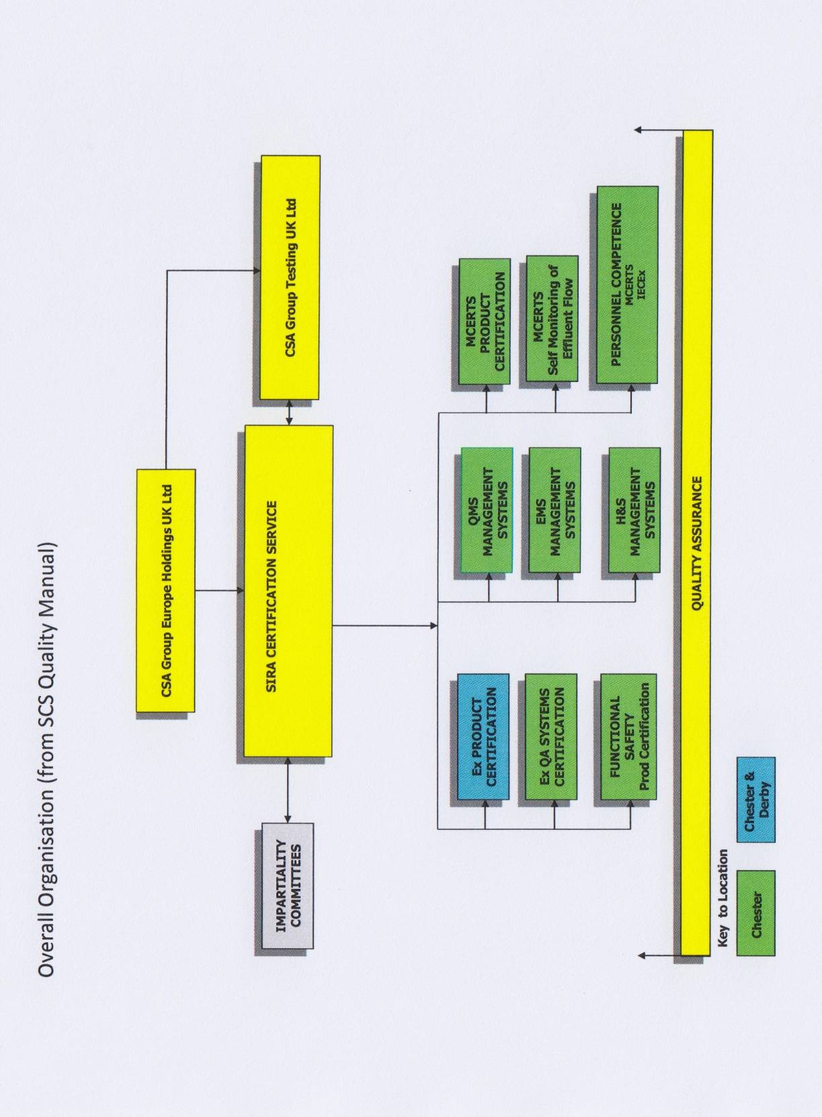

Annex 1b: Organization Chart of the ExCB and related Extols

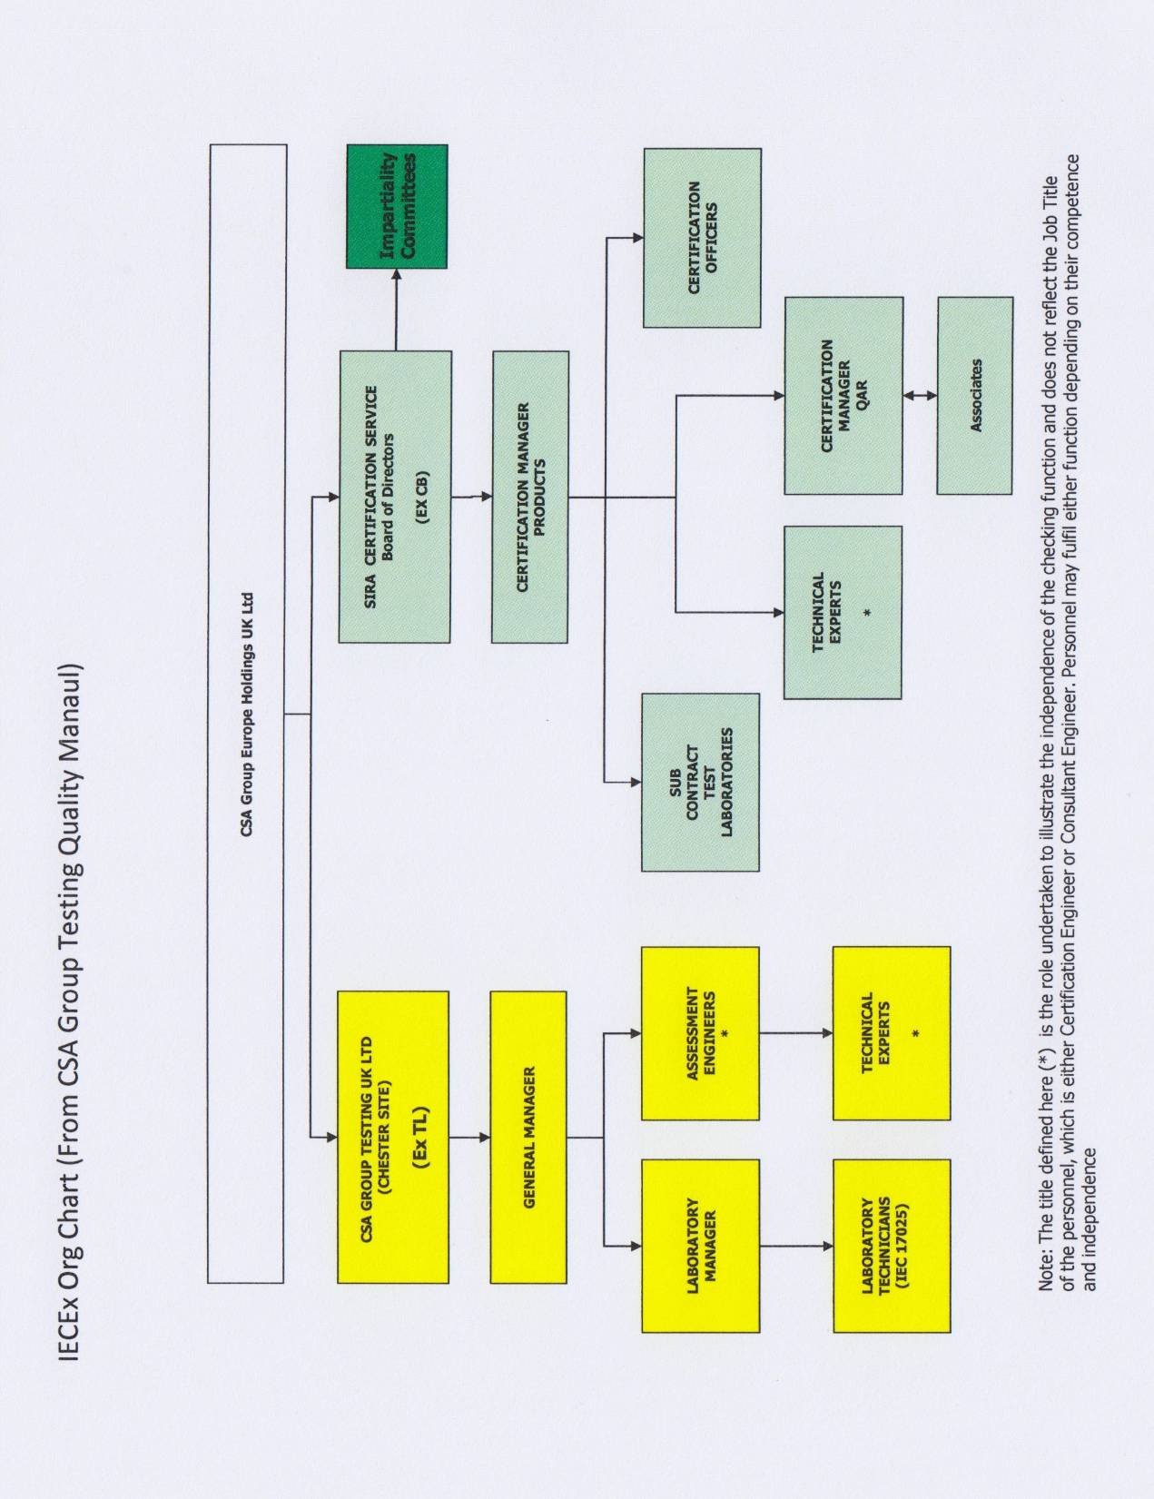

Annex 1c: Detail Organization Chart of Sira Certification Service

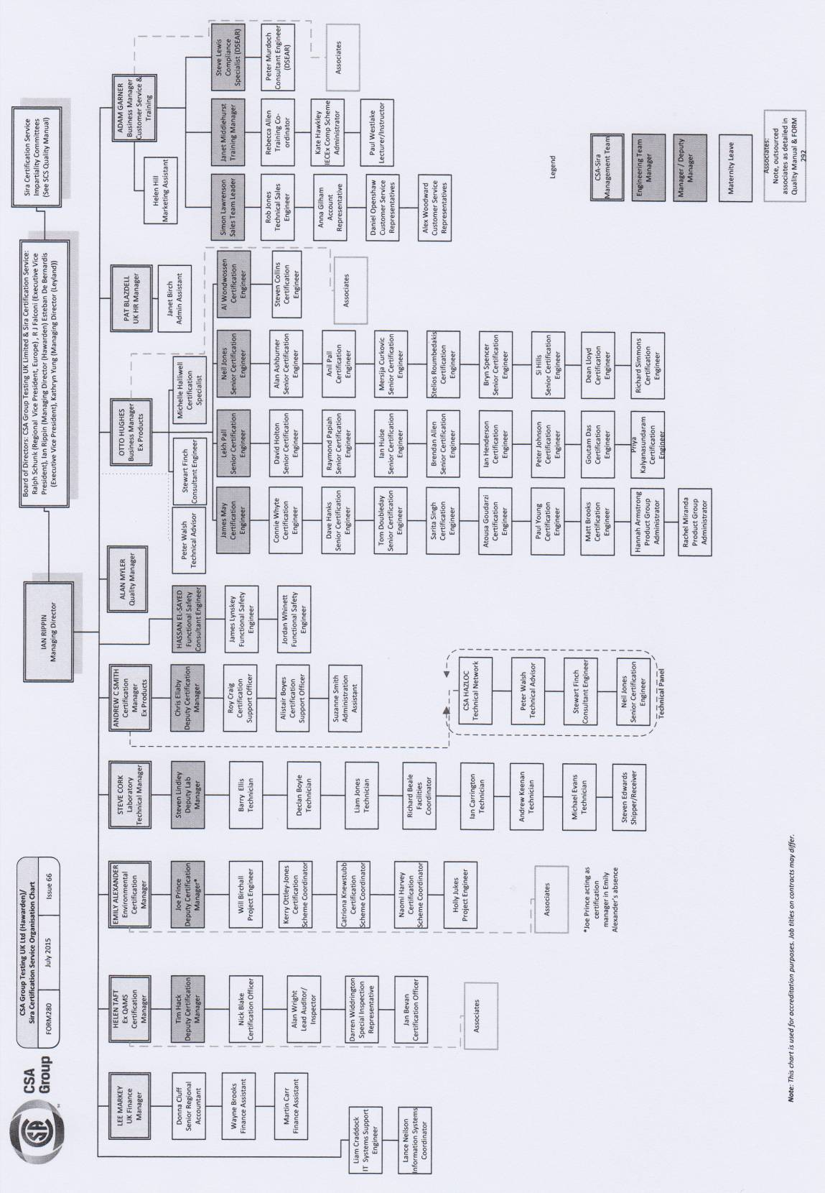

Annex 2a: ISO/IEC 17025 # 0327; Accreditation Certificate for ExTL from UKAS

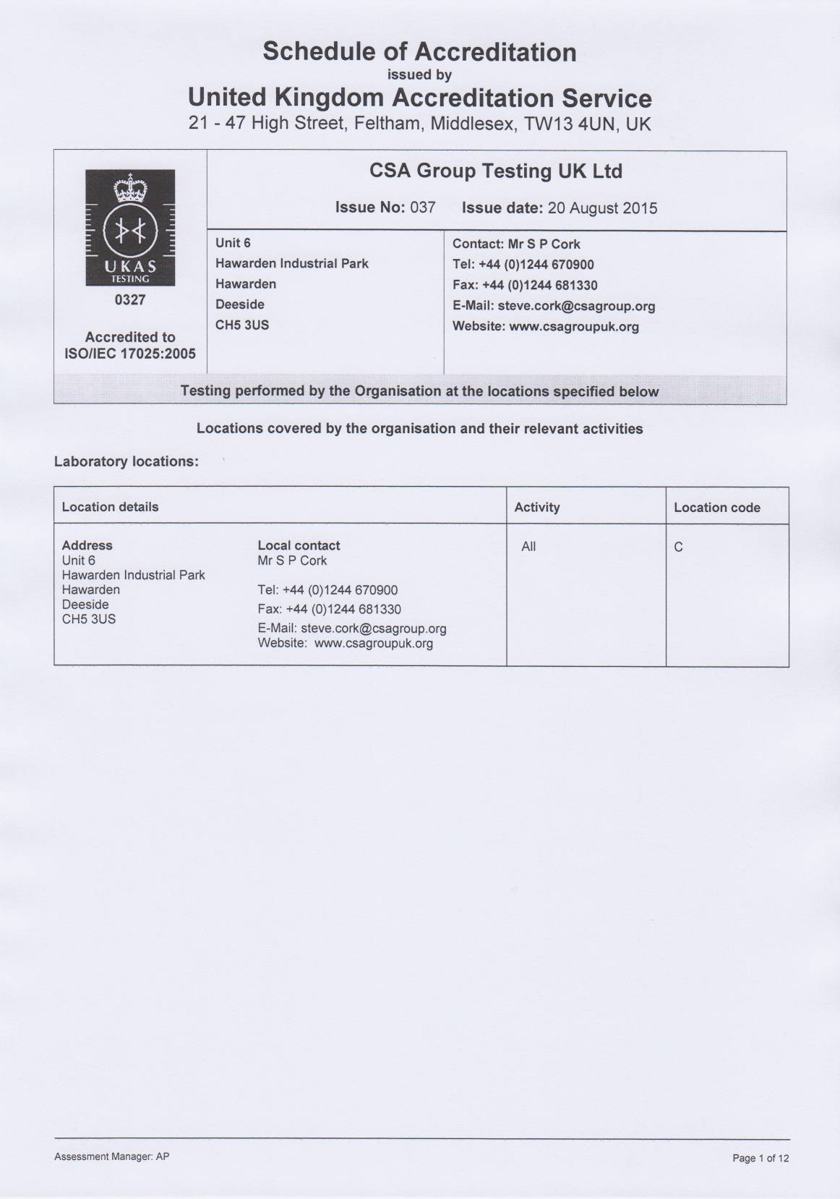

Annex 2b: ISO/IEC 17025 # 0011; Accreditation Certificate for ExTL from UKAS

