INTERNATIONAL ELECTROTECHNICAL COMMISSION SYSTEM FOR CERTIFICATION TO STANDARDS RELATING TO EQUIPMENT FOR USE IN EXPLOSIVE ATMOSPHERES (IECEx SYSTEM)

TITLE: Re-assessment and Scope Extension Report for the continued acceptance of TÜV SÜD Product Service GmbH an Accepted Certification Body, (ExCB), within the IECEx System, Equipment Scheme 02.

Circulation to: Members of the IECEx Management Committee, ExMC

INTRODUCTION
In accordance with the 5 year re-assessment plan for the surveillance and monitoring of bodies within the IECEx System, the following document contains the IECEx Re-assessment and Scope Extension Report for the continued acceptance of TÜV SÜD Product Service GmbH as an Accepted Certification Body (ExCB) within the IECEx System, Equipment Scheme 02.

During the re-assessment, the IECEx Assessment Team took the opportunity to assess the following as a scope extension.
Number | Title
IEC 60079-13  Edition 1.0 | Explosive atmospheres -  Part 13: Equipment protection by pressurized room 'p'
IEC/TR 60079-16  Edition 1.0 | Artificial ventilation for the protection of analyser (s) houses
IEC 60079-25  Edition 2.0 | Explosive atmospheres – Part 25: Intrinsically safe electrical systems
IEC/IEEE 60079-30-1  Edition 1.0 | Explosive atmospheres – Part 30-1: Electrical resistance trace heating – General and testing requirements
IS0 80079-36  Edition 1.0 | Explosive atmospheres - Part 36: Non-electrical equipment for explosive atmospheres – Basic method and requirements
ISO 80079-37  Edition 1.0 | Explosive atmospheres - Part 37: Non-electrical equipment for explosive atmospheres – Non electrical type of protection constructional safety ”c” control of ignition source ”b”, liquid immersion ”k”

Please consider the assessment and scope extension report and return the completed voting form, (A separate Word document) by 2017 09 01 to the Secretariat

Chris Agius

Chris Agius

IECEx Secretariat
IECEx Secretariat  Australia Square  Level 33, 264 George Street  Sydney NSW 2000  Australia | Tel: +61 2 4628 4690  Fax: +61 2 4625 3480  Email: chris.agius@iecex.com

IEC System for certification to standards relating to equipment for use in Explosive Atmospheres (IECEx System)

IECEx Assessment Report Form

IECEx Assessment Report Form for use by IECEx Assessment Teams to report Assessments conducted according to the IECEx Assessment Procedures of

- Operational Document IECEx OD 003-2 for the Certified Equipment Scheme

IECEx ExCB assessment report for TÜV SÜD Product Service, Munich, Germany

INTERNATIONAL
ELECTROTECHNICAL
COMMISSION

CONTENTS

Assessment information 5
1.1 Type of Body covered by this assessment: 5
1.2 Type of assessment: 5
1.3 Details of body 5
1.3.1 Country 5
1.3.2 Name of body 5
1.3.3 Name and title of nominated principal contact 5
1.4 Assessment information 5
1.4.1 Members of the assessment team 5
1.4.2 Place(s) of assessment 5
1.4.3 Assessment date(s) 5
1.5 Application information and background information on the assessment 6
1.6 Scopes 6
1.6.1 ExCB scope for equipment certification scheme 6
1.6.2 ExTL scope 8
Common information 8
2.1 Legal entity of body 8
2.2 Financial support 8
2.3 History 8
2.4 Documentation 8
2.4.1 Quality manual 8
2.4.2 Procedures 9
2.4.3 Work instructions 9
2.4.4 Records (including test records where relevant) 9
2.4.5 Document change control 9
2.5 Confidentiality 9
2.6 Communication with public and customers (Hard copy and Electronic) 10
2.7 Recognitions and agreements 10
2.8 Internal audit 10
2.9 Management review 10
2.10 Contracting, subcontracting and witness testing 10
2.10.1 Contracting 10
2.10.2 Subcontracting 10
2.10.3 Witness testing 12
2.11 Training and competence 12
2.12 Complaints and appeals (including appeals to IECEx) 12
2.13 Commenting on ExTAG Documents 13
2.14 Special facts to be noted 13
2.15 Supporting documentation 13
2.16 Recommendations 13
ExCB for IECEx Certified Equipment Scheme 14
3.1 Assessment references 14
3.2 ExCB persons interviewed 14
3.3 Associated ExTL(s) 14
3.4 Associated certification functions 14
3.5 National marks and certificates 14
3.6 Standards accepted 15
3.7 National differences to IEC standards 15
3.8 Organisation 15
3.8.1 Names, titles and experience of the senior executives 15
3.8.2 Name, title and experience of the quality management representative 15
3.8.3 Name and title of signatories for certification 15
3.8.4 Other employees in ExCB activity 15
3.9 Organizational structure 15
3.10 Indemnity insurance 16
3.11 Resources 16
3.12 Committees (such as governing or advisory boards) 16
3.13 Certification operations 16
3.13.1 National approval/certification methods 16
3.13.2 Certification policy 16
3.13.3 Application for certification 16
3.13.4 Certification decision 16
3.13.5 Suspension and cancellation of certificates 17
3.14 Certificates issued 17
3.15 National accreditation 18
3.16 Assessment of manufacturers and issue of QARs 18
3.17 Comments (including issues found during assessment) 18
Annex A Overall Organisation Chart 20
Annex B Organisation Chart of ExCB 22
Annex C Accreditation Certificate for ISO/IEC 17065 23

Assessment information

Type of Body covered by this assessment:
ExCB for IECEx Certified Equipment Scheme | ✓
ExTL for IECEx Certified Equipment Scheme
ExCB for IECEx Certified Service Facilities Scheme
ExCB for IECEx Conformity Mark Licensing System | ✓

NOTE 1 ExCB - IECEx Certification Body
NOTE 2 ExTL - IECEx Testing Laboratory

Type of assessment:
Pre-assessment for candidate body
Initial assessment for candidate body
Surveillance
Re-assessment | ✓
Scope extension | ✓

Details of body

Country
Germany

Name of body
TÜV SÜD Product Service GmbH

Name and title of nominated principal contact
Name | Title | E-mail address
Mr. Klaus Lorenz | Head of ExCB | Klaus.lorenz@tuev-sued.de

Assessment information

Members of the assessment team
Name | Role
Heinz Berger | IECEx Lead Assessor
Allan Ogden | IECEx Assessor

Place(s) of assessment
Ridlerstrasse 65
80339 Munich
Germany

Assessment date(s)
11/12.07.2016

Application information and background information on the assessment
The ExCB of TÜV SÜD
Product Service GmbH is operating with the following ExTLs:
TÜV NORD CERT GmbH in Hannover, Germany, as an Associated Laboratory;
Professional Testing (EMI), Inc. Round Rock, Texas, USA, as an Associated Laboratory;
In addition to the above, TÜV SÜD Product Service GmbH, Filderstadt, Germany, has applied as an Integral Laboratory. The IECEx Assessment team has conducted a site assessment of the applicant ExTL function as a combined assessment however as there are some open issues as at June 6th, 2017, the application cannot proceed until these items are closed. Until the TÜV SÜD Product Service GmbH, Filderstadt Laboratory is finalised and accepted by ExMC, TÜV SÜD Product Service GmbH, will only continue to work as an ExCB with TÜV NORD CERT and Professional Testing (EMI) as their associated ExTLs.
The ExCB applied on June 5th, 2016 for a scope extension (IEC 60079-13, IEC TR 60079-16, ISO 80079-36, and ISO 80079-37) and on June 16th, 2016 for a further scope extension (IEC 60079-25 and IEC/IEEE 60079-30-1.
IEC 60079-7: The limitations “no rotating machines, luminaries devices” can be shipped (test equipment show during the assessment).
IEC 60079-28: The limitation can be skipped as the associated ExTL of TÜV NORD CERT does not have a limitation.
The scopes of standards of the three laboratories are fully covered by the ExCB.

Scopes

ExCB scope for equipment certification scheme
Number |  | Title
IEC 60079-0  Edition 6.0 |  | Explosive atmospheres - Part 0: Equipment - General requirements
IEC 60079-1  Edition 7.0 |  | Explosive atmospheres - Part 1: Equipment protection by flameproof enclosures “d”
IEC 60079-2  Edition 6.0 | Explosive atmospheres - Part 2: Equipment protection by pressurized enclosure «p»
IEC 60079-5  Edition 4.0 | Explosive atmospheres - Part 5: Equipment protection by powder filling «q»
IEC 60079-6  Edition 4.0 | Explosive atmospheres - Part 6: Equipment protection by oil immersion «o»
IEC 60079-7  Edition 5.0 | Explosive atmospheres - Part 7: Equipment protection by increased safety "e"
IEC 60079-11  Edition 6.0 |  | Explosive atmospheres - Part 11: Equipment protection by intrinsic safety “i”
IEC 60079-14  IECEx DS2015/001A  2015 10 09 |  | Equipment assemblies
IEC 60079-15  Edition 4.0 |  | Explosive atmospheres – Part 15: Equipment protection by type of protection "n"
IEC 60079-18  Edition 4.0 | Explosive atmospheres – Part 18: Equipment protection by encapsulation “m”
IEC 60079-26  Edition 3.0 | Explosive atmospheres - Part 26: Equipment with equipment protection level (EPL) Ga
IEC 60079-28  Edition 2.0 | Explosive atmospheres - Part 28: Protection of equipment and transmission systems using optical radiation
IEC 60079-31  Edition 2.0 |  | Explosive atmospheres – Part 31: Equipment dust ignition protection by enclosure "t"
IEC 60079-35-1 |  | Explosive atmospheres - Part 35-1: Caplights for use in mines susceptible to firedamp - General requirements - Construction and testing in relation to the risk of explosion
*IEC 61241-0  Edition 1.0 |  | Electrical apparatus for use in the presence of combustible dust - Part 0: General requirements
*IEC 61241-1  Edition 1.0 |  | Electrical apparatus for use in the presence of combustible dust - Part 1: Protection by enclosure “tD”
*IEC 61241-1-1  Edition 1.0 |  | Electrical apparatus for use in the presence of combustible dust - Part 1-1: Electrical apparatus protected by enclosures and surface temperature limitation – Specification for apparatus
*IEC 61241-4  Edition 1.0 |  | Electrical apparatus for use in the presence of combustible dust - Part 4: Protection by pressurization "pD"
*IEC 61241-11  Edition 1.0 |  | Electrical apparatus for use in the presence of combustible dust – Part 11: Protection by intrinsic safety 'iD'
*IEC 61241-18  Edition 1.0 |  | Electrical apparatus for use in the presence of combustible dust - Part 18: Protection by encapsulation "mD"

NOTE 1 Standards shown with an asterisk (*) are superseded standards
NOTE 2 Unless otherwise indicated, earlier editions of standards (even if with a different number) are considered to be covered in the above scope for the purposes of the assessment.
Requested Scope Extension
Number | Title | Scope  Extension
IEC 60079-13  Edition 1.0 | Explosive atmospheres -  Part 13: Equipment protection by pressurized room 'p' | Scope Extension
IEC/TR 60079-16  Edition 1.0 | Artificial ventilation for the protection of analyser (s) houses | Scope Extension
IEC 60079-25  Edition 2.0 | Explosive atmospheres – Part 25: Intrinsically safe electrical systems | Scope Extension
IEC/IEEE 60079-30-1  Edition 1.0 | Explosive atmospheres – Part 30-1: Electrical resistance trace heating – General and testing requirements | Scope Extension
IS0 80079-36  Edition 1.0 | Explosive atmospheres - Part 36: Non-electrical equipment for explosive atmospheres – Basic method and requirements | Scope Extension
ISO 80079-37  Edition 1.0 | Explosive atmospheres - Part 37: Non-electrical equipment for explosive atmospheres – Non electrical type of protection constructional safety ”c” control of ignition source ”b”, liquid immersion ”k” | Scope Extension

ExTL scope
TUV SUD as an ExTL is subject to a separate application and a separate Report is expected to be issued in due course. The scope extension requested for TUV SUD as an ExCB has been confirmed as being covered among their associated ExTLs, (TUV Nord and PTI)

Common information

Legal entity of body
TÜV SÜD Product Service GmbH
Ridlerstrasse 65
80339 Munich
Germany

The legal entity document with the number HRB 85742 was last issued on February 15th, 2017, reviewed in the post assessment process, and found to meet the requirements of the IECEx.

Financial support
TÜV SÜD, a 100% private owned company, is self-funded relying on revenues based on certificate fees, license fees and testing activities.

The annual financial report was reviewed and found to meet the requirements of the IECEx.

History
Under the leadership of the former TÜV Bayern (now: TÜV SÜD), founded in 1872, several product safety laboratories in Munich were united and formed to TÜV Product Service GmbH in 1988. In 1990, TÜV Hessen’s safety laboratory joined, and in 1997, TÜV Südwest in Filderstadt / Stuttgart was integrated into the organization of TÜV Product Service GmbH. In 2006, the TÜV SÜD Holding introduced a new Corporate Identity and the former TÜV Product Service GmbH was renamed as TÜV SÜD Product Service GmbH. Nowadays, in a worldwide network, manufacturers of all kind of consumer products are served by TÜV SÜD based on various accreditations and notifications.

Documentation

Quality Manual
Die Quality Manual is built up according to the pyramid as shown below.
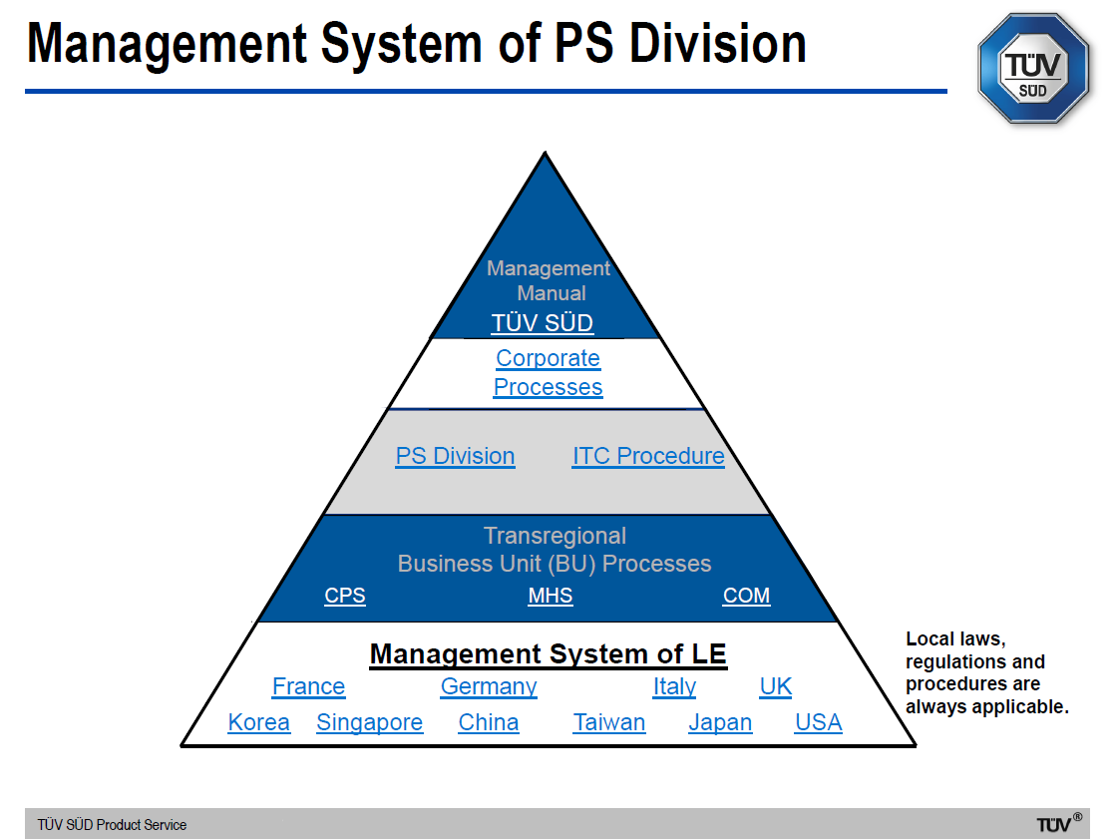
The Quality system of TÜV SÜD is incorporated into the Corporate Management System of TÜV SÜD Group and documented in following controlled document: TÜV SÜD _MAN_01E for PS Division. There following manuals apply:
Management Manual Certification Bodies for Management Systems - ISO/IEC 17021
Management Manual Certification Bodies for Products - ISO/IEC 17065
The ExCB of TÜV SÜD PS is mentioned under COM (as shown in the graph above).
Procedure carry a P in the document number, work instructions a W and forms an F.
The activities concerning IECEx are described in procedure ITC_P_10.14E, version 1, last issued on October 20th, 2011. This procedure was reviewed in detail and found to meet the requirements of the IECEx.

Procedures
Main procedure ITC_P_10.14 “Testing, Auditing, and Certification in the IECEx System”.

Work instructions
All work instructions are available on the Intranet. These were reviewed and found to meet the IECEx requirements.

Records (including test records where relevant)
The issue of records is described in procedure TÜV SÜD _P_05.01. The storage duration is described in procedure IT_TT_W_09.02.
Documents related to IECEx certification are forwarded by the ExTLs in electronic form to the ExCB. They are available and retrievable on the TÜV SÜD PS Intranet as well as in hard copy in protected archives. Certification documentation is handled the same way and according to IECEx procedures.

Document change control
Document change control is described in procedure TPS_P_05.01. Document control was reviewed during the assessments and found to meet the requirements of the IECEx.

Confidentiality
(For staff, contractors, and members of advisory bodies)
CPL_P_10.03 “Procedure for the Certification Body for Products”, clause 5.13 as well as for contractors and members of the advisory board.
Confidentiality declarations of the staff, contractors and members of the advisory board were reviewed and found to meet the requirements of the IECEx.

Communication with public and customers (Hard copy and Electronic)
http://www.tuev-sued.de/industrie_konsumprodukte
There are also brochures available.

Recognitions and agreements
TÜV SÜD PS is participating in the IECEE CB and CB-FCS Schemes as NCB and CBTL. Furthermore, TÜV SÜD PS is presently the only NRTL (Nationally Recognized Testing Laboratory) in the OSHA scheme (USA) outside the American continent.

An agreement between TÜV SÜD PS GmbH and the ExTL of TÜV NORD CERT (acting as an Ex Associated Laboratory) was reviewed and found to meet the requirements of the IECEx.

The signed agreement between TÜV SÜD PS GmbH and Professional Testing (EMI) Inc. (acting as an Ex Associated Laboratory) was reviewed and found to meet the requirements of the IECEx.

Internal audit
Internal audits are described in Procedure TPS_P_17.01E “Internal Quality Audits”.

The internal assessment plans for 2016 and 2017 as well as the audit reports from 2016 were reviewed and found to meet the requirements of the IECEx. Open issues from the internal audit were resolved.

Management review
The Management Review procedure is described in GER_P_01.04D “Management Review”.

The minutes of the last management report were reviewed. There are two management reviews per year.

Contracting, subcontracting and witness testing
The procedure for use of external laboratories is described in the Quality system of TPS: CPL_W_06.03 “External Laboratories Program”.

Contracting
See clause 2.7. above.

Subcontracting
Subcontracting is described in procedure ITC_P_06.02. The procedure was reviewed and found to meet the requirements of the IECEx.
The associated ExTLs TÜV NORD CERT, Hanover, Germany and PTI (EMI), Texas, USA, are using subcontracting.
Summary of subcontracting under the responsibility of the ExCB of TÜV SÜD PS, Munich, Germany
Detailed information is provided in the on-site assessment report OD 006.
TÜV NORD CERT, Hanover, Germany
Standards IEC or ISO: | Clauses:
60079-0 | 26.5.3 Small component ignition test (Group I and II)
60079-1 | 15.2 Tests of ability of the enclosure to withstand pressure  15.3 Test for non-transmission of an internal ignition  15.4 Test of flameproof enclosures with breathing and draining devices  B1 Determination of maximum pore size by the method specified in ISO 2738 (bubble test)
60079-7 | 6.2.1 Determination of starting current ratio IA/ IN and the time Te
60079-28 | 6.3 Ignition test with continuous wave radiation and pulses above 1 s duration as well as with pulsed radiation,
80079-36 | 8.2 Hot surface ignition test,
80079-37 | B.2 Type test for determining the maximum engaging time of clutch assembly
60079-7 | 6.3.4 Vibration test for luminaires with bi-pin lamps
60079-0 | 26.11 Resistance to chemical agents for Group I electrical equipment
60079-0 | 26.10 Resistance to light
PTI (EMI), Texas, USA
60079-0 | 26.5.3 Small component ignition test (Group I and Group II)  26.10 Resistance to light  26.15 Verification of ratings of ventilating fans26.16 Alternative qualification of elastomeric sealing O-rings
60079-6 | 6.1.5 Switching tests
60079-7 | 6.2.1 Determination of starting current ratio IA/ IN and the time tE  6.2.3.1 Stator winding insulation  6.2.3.2 Cage rotor  6.2.4 Overspeed test of cemented magnets  6.3.4 Abnormal operation of luminaires  6.3.5 Sulphur dioxide test for level of protection "eb" for the connection of bi-pin lamp caps to lampholders  6.3.7 Tests for wiring of luminaires subject to high-voltage impulses from ignitors  6.3.8 Tests for electronic starters for tubular fluorescent lamps and for ignitors in level of protection “ec” for discharge lamps  6.6.4 Test for Level of Protection "eb" ventilation of battery container  6.7 Verification and tests for cells and batteries of Level of Protection “ec”
60079-15 | 22.4 Enclosed break tests  22.7 Screw lampholder tests  22.8 Starter holder test (for luminaires)  22.9 Electronic starter tests  22.10 Test for wiring of luminaries’ subject to high-voltage impulses from ignitors22.13 Ignition tests for large or high-voltage machines
60079-18 | 8.2.7 Test for resettable thermal protective device

Witness testing
ITC_P_10.14E Testing, Auditing and Certification in the IECEx System
There are presently no such activities. The procedure was reviewed and found to meet the requirements of the IECEx including IECEx OD 024.

Training and competence
Competence Matrix & Participation list of the annual EoE for IECEx/ATEX auditors.
Details of staff training procedures and competencies were reviewed and found are covered in the site assessment report. TUV SUD were found to have sufficiently well qualified staff to perform their ExCB functions. There are presently no IECEx Assessors from TÜV SÜD.

Complaints and appeals (including appeals to IECEx)
The complaints procedure is described in the Quality system of TPS: TPS_P_19.01E “Handling complaints and incidents” and CPL_P_19.04E” Complaint Procedure Certification Body CRT3”, including the definitions, classification, responsibility, processing. There are presently no complaints concerning IECEx.

Commenting on ExTAG Documents

This is described in procedure ITC_F_10.14. This procedure was reviewed in detail and found to meet the requirements of the IECEx.

Special facts to be noted
Since the re-assessment of the ExCB in July 2016 PTI (EMI), Round Rock, TX, USA, was accepted by the IECEx. The integral ExTL of TÜV SÜD PS in Filderstadt, Germany, is currently under assessed as an as an ExTL, with a separate report to be issued for voting by ExMC in due course.

Supporting documentation
Copies of additional supporting information for this assessment have been provided to the ExCB and the IECEx Secretariat. These are included in a site assessment report or provided separately and include:
- Details of issues raised and how these have been resolved
- Checklist for ISO/IEC 17065
- Completed Technical Capability Document (TCD)
- Assessors’ notes

Recommendations
Based on the re-assessment and scope extension assessment performed on July 11th & 12th, 2016, and follow up reviews TÜV SÜD PS GmbH is recommended for continued acceptance in the IECEx scheme as:
- An ExCB in the IECEx Certified Equipment Scheme
This is according to the scope of the standards listed in this document including the extension of scope.

Heinz Berger | Allan Ogden
IECEx Lead Assessor | IECEx Assessor

ExCB for IECEx Certified Equipment Scheme

Assessment references
- IECEx02 IECEx Certified Equipment Scheme covering equipment for use in explosive atmospheres – Rules of Procedure
- OD003-2 Assessment, surveillance assessment and re-assessment of ExCBs and ExTLs operating in the IECEx 02, IECEx Certified Equipment Scheme
- ISO/IEC 80079-34 Edition 1, Explosive atmospheres – Part 34: Application of quality systems for equipment manufacture
- OD009 Issuing of CoCs, ExTRs and QARs
- IECEx Document OD 025 Guidelines on the Management of Assessment and Surveillance programs for the assessment of Manufacturer’s Quality Systems in accordance with the IECEx Scheme
- OD0026 IECEx Certified Equipment Scheme – Guidelines for the qualification of Lead Auditor and Auditors, in accordance with the IECEx System
- ISO/IEC 17065: 2012, Edition 1, General requirements for bodies operating product certification systems Conformity assessment — Requirements for bodies certifying products, processes and services
- IECEx Document OD17 Drawing and documentation guidance
- ExTAG decision sheets (DSs)
NOTE The latest editions of the above documents were applied

Candidate ExCB persons interviewed
Name | Position
Dr. Jens Butenandt | Managing Director TÜV PS
Klaus Lorenz | Head of Certification Body for Products
Norbert Thimm | Certification Officer
Dr. Reinhard Fresia | Quality Management Representative
Ulrich Jacobs | Senior Product Specialist ATEX and IECEx
Sebastian Willer | Team Leader Ex

Associated ExTL(s)
See clause 1.5 above.

Associated certification functions
TÜV SÜD is a Notified Body for a wide range of European Directives, for example the European ATEX Directive 2014/34/EU.

TÜV SÜD is active in a large number of other certification procedures such as the European ENEC Scheme (ISO Type 5 certification system) and the NRTL Program (USA, ISO Type 5 certification system).

Furthermore, TÜV SÜD is a NCB in the IECEE CB Scheme and the IECEE CB-FCS Scheme (FCS: Full Certification Scheme, an ISO type 5 certification system).

National marks and certificates
According to the German Product and Equipment Safety Law (PROD SG), TÜV SÜD is authorized to issue the German GS-mark (GS=Geprüfte Sicherheit, Safety tested). TÜV SÜD further offers a non-mandatory mark for a wide range of products, the TÜV SÜD Octagon Mark.

Standards accepted
See clause 1.6 of this report

National differences to IEC standards
National differences to IEC standards are those for the European Union differences listed in the latest version of the IECEx Scheme Bulletin.

Organisation

Names, titles and experience of the senior executives

Name | Title | Experience
Dr. Jens Butenandt | Chief Technical Officer, Managing Director | 13 years at TÜV SÜD for Product certification
Klaus Lorenz | Head of Certification Body for Products | 18 years for product testing and certification

Name, title and experience of the quality management representative

Name | Title | Experience
Dr. Reinhard Fresia | Quality Manager | 11 years
Josef Wörl | Deputy Quality Manager | 15 years

Name and title of signatories for certification

Name | Title | Comments
Klaus Lorenz | Head of Certification Body for Products | 18 years for product testing and certification
Norbert Thimm | Certification Officer | Accreditation Coordination  (5 years)
Andreas Pfeil | Technical Certifier IECEx, IECEx Auditor | TÜV SÜD Filderstadt, 21 years in Ex field
Ulrich Jacobs | Technical Certifier IECEx, IECEx Auditor | TÜV SÜD Filderstadt, 26 years in Ex field

Other employees in ExCB activity

Name | Title | Responsibility and Experience in Ex
Frank Pscheid-Denzler | IECEx Auditor | 3 years’ experience with IECEx audit
Stefan Vierbücher | IECEx Auditor | 2 years’ experience with IECEx audit
Frank Zhu | Technical Certifier, IECEx Auditor in application | 3 years
Kristof de Gersem | Technical Certifier, IECEx Auditor | 5 years
Sebastian Willer | Technical Certifier | 5 years

Organizational structure
See Annexes A and B

Indemnity insurance
TÜV SÜD PS holds an indemnity insurance by “Allianz Global Corporate & Specialty SE under the number DEL00059817. The contract is valid until January 1st, 2018 and will automatically extend for a further year.
The insurance document was reviewed and found to meet the requirements of the IECEx.

Resources
TÜV SÜD PS have an adequate number of staff for the current level of business. 9 persons are involved in IECEx ExCB activities (9 certification, 1 secretary).

Committees (such as governing or advisory boards)
The Governing Board operates according to their statutes as a committee with representation from parties with an interest in the certification policies and practices of TÜV SÜD . The operating rules for the Board are given in the document of Statutes of Governing Board dated 1 June 2008, indicating the necessity of confidentiality, impartiality, and high quality. The Governing Board covers 5 members from manufacture, standardization, accreditation, government, science and consumer.

The list of committee members was reviewed as well as contracts and confidentiality declarations.

The latest meeting was held on 10th March 2017, and the corresponding minutes were reviewed.

Certification operations

National approval/certification methods
TÜV SÜD operates according to several European conformity assessment procedures such as the ATEX directive 2014/34/EU. TÜV SÜD is also operating the GS Mark, a legal German quality mark which certifies that a product is safe and user-friendly.

Certification policy
The certification policy is described in document CPL_P_10.03 “Procedure for the Certification Body for Products” and meets the requirements of IECEx.

Application for certification
The application for certification is described in the quality management system of TÜV SÜD Product Service GmbH: TPS_P_10.01 “Process Control Certification”, and the specific procedure for the testing, auditing and certification in the IECEx system (ITC_P_10.14E). The application form shall be updated and extended, once scope extension has been accepted by ExMC.

Certification decision
The detailed certification decision is conducted by Technical Certifiers who act on behalf of the Certification Body according to the document ITC_P_18.06.

With reference to the matrix of personnel competence, the technical certifiers also work as manufacturer auditors, but the assessment team noted that precaution is well documented (ITC_P_18.01E) to ensure that the technical certifier does not work on the project that he has been involved in the auditing and testing.
The certification decision is documented on the form CPL_F_10.02. Examples of certification decision records were review and found to be satisfactory with the requirements of IECEx.

Suspension and cancellation of certificates
The process on suspension and cancellation of certificates is described in the quality management system of TÜV SÜD Product Service GmbH: CPL_P_10.09 “Termination of Certificates” and ITC_P_10.14 (Topic 5.6.4) Testing, Auditing and Certification in the IECEx. Scheme

Certificates issued
Number of certificates issued under for the preceding four years for each type of protection. For new applications these should be for national or regional schemes and for currently accepted bodies IECEx certificates should be shown (certificates for other schemes may also be shown):
Standard numbers | Type of protection or other identifying information | Total
60079-0 | Explosive atmospheres -  Part 0: Equipment - General requirements
60079-1 | Explosive atmospheres -  Part 1: Equipment protection by flameproof enclosures “d” | 13
60079-2 | Explosive atmospheres -  Part 2: Equipment protection by pressurized enclosure “p” | 56
60079-5 | Explosive atmospheres -  Part 5: Equipment protection by powder filling “q” | 1
60079-6 | Explosive atmospheres -  Part 6: Equipment protection by oil immersion “o” | 0
60079-7 | Explosive atmospheres -  Part 7: Equipment protection by increased safety “e” | 33
60079-11 | Explosive atmospheres -  Part 11: Equipment protection by intrinsic safety “i” | 33
60079-13 | Equipment protection by pressurized room "p" and artificially ventilated room "v" | 0
60079-14 | IECEx Assessment and Certification of Equipment assemblies | 10
60079-15 | Explosive atmospheres -  Part 15: Equipment protection by type of protection “n” | 36
60079-16 | Electrical apparatus for explosive gas atmospheres Part 16: Artificial ventilation for the protection of analyser(s) houses | 0
60079-18 | Explosive atmospheres -  Part 18: Equipment protection by encapsulation “m” | 29
60079-25 | Explosive atmospheres - Part 25: Intrinsically safe electrical systems | 0
60079-26 | Explosive atmospheres -  Part 26: Equipment with equipment protection level (EPL) Ga | 2
60079-28 | Explosive atmospheres -  Part 28: Protection of equipment and transmission systems using optical radiation | 20
60079-30-1 | Explosive atmospheres - Part 30-1: Electrical resistance trace heating - General, type testing and design requirements | 3
60079-31 | Explosive atmospheres - Part 31: Equipment dust ignition protection by enclosure "t" | 28
80079-36 | Non-electrical equipment for use in explosive atmospheres - Basic method and requirements | 220
80079-37 | Explosive atmospheres - Part 37: Non-electrical equipment for use in explosive atmospheres - Non electrical type of protection constructional safety "c", control of ignition source "b", liquid immersion "h" | 220
NOTE Above include certificates to IEC 60079-0 unless otherwise shown

National accreditation
TÜV SÜD was accredited as an ATEX Certification Body for the equipment used in explosive atmospheres by national accreditation body - DakkS. The latest renewal of the accreditation certificate was issued on 16 March 2016 according to DIN EN ISO/IEC 17065. The certificate with identification number D-ZE-11321-01 is valid until 11 February 2018. See Annex C.

TÜV SÜD also operates as a certification body for ATEX quality management system. The number is ZLS-NB-0203 and is valid until April 19th, 2021. See Annex C.

NOTE The national accreditation is checked annually by the IECEx Secretariat.

Assessment of manufacturers and issue of QARs
The procedure for the assessment of manufacturers is described in the Quality system of TPS: ITC_P_10.14 “Testing, Auditing and Certification in the IECEx System” and CPL_P_10.50 “Certification of Quality Systems by CRT3 in the regulated Area”

Comments (including issues found during assessment)
Issues were found in the area ExTR, QAR and CoC as well as document control, test plan. All issues were resolved to the satisfaction of the assessment team.
IECEx Mark Scheme: The agreements with IECEx and IEC were reviewed during the assessment and found to meet the requirements of the IECEx.
IECEx Mark Scheme activities are described in procedure “Testing, Auditing, and Certification in the IECEx System” in clause 5.4. Clause 5.4. of this document was reviewed and found to meet the requirements of the IECEx.

- Overall Organisation Chart
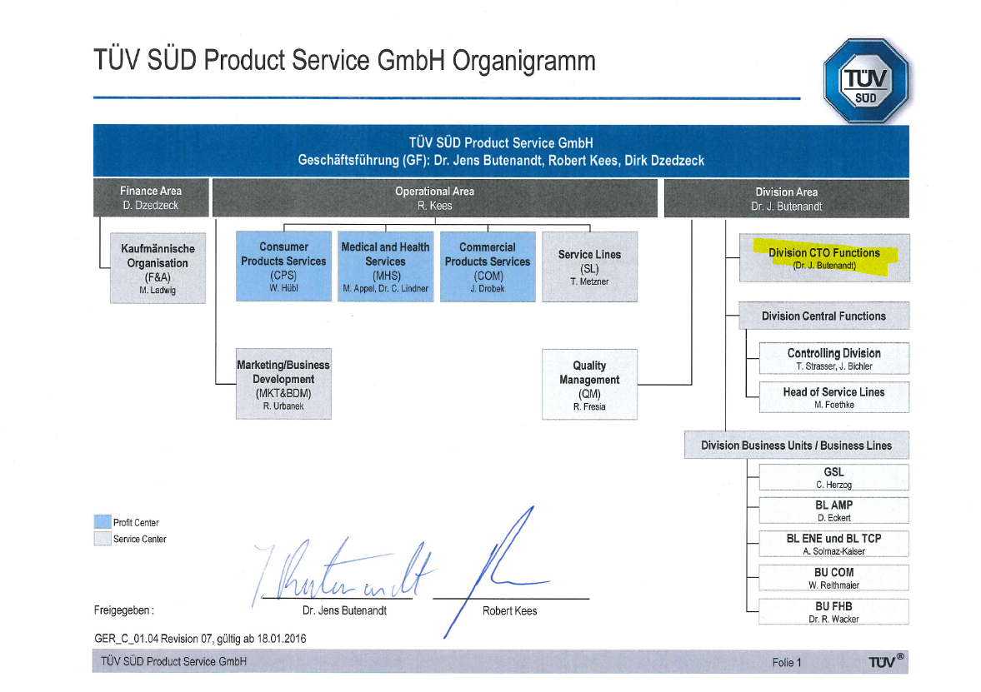
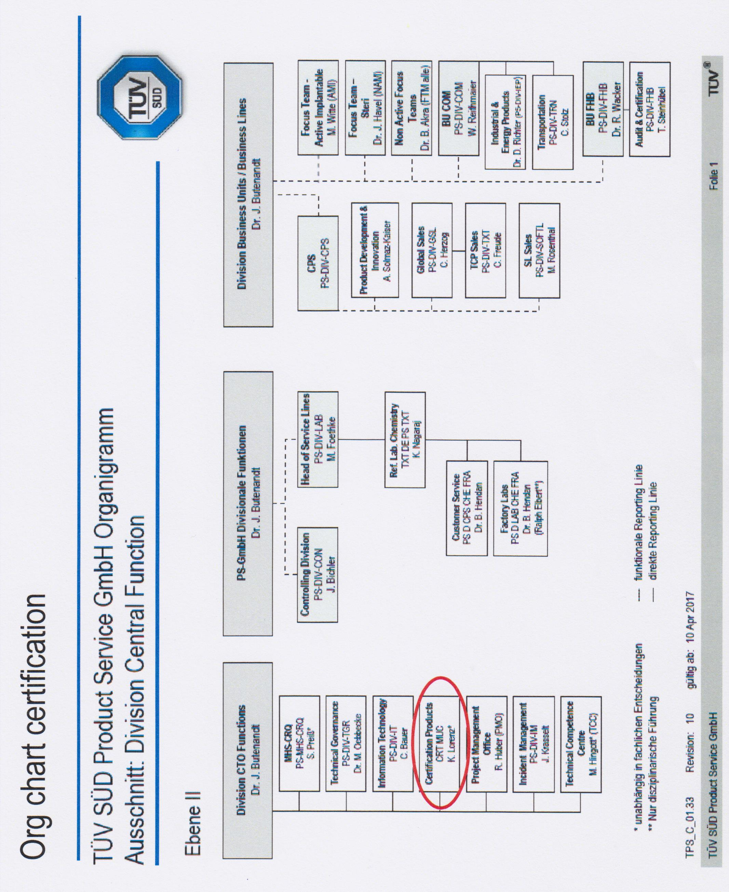

- Organisation Chart of ExCB
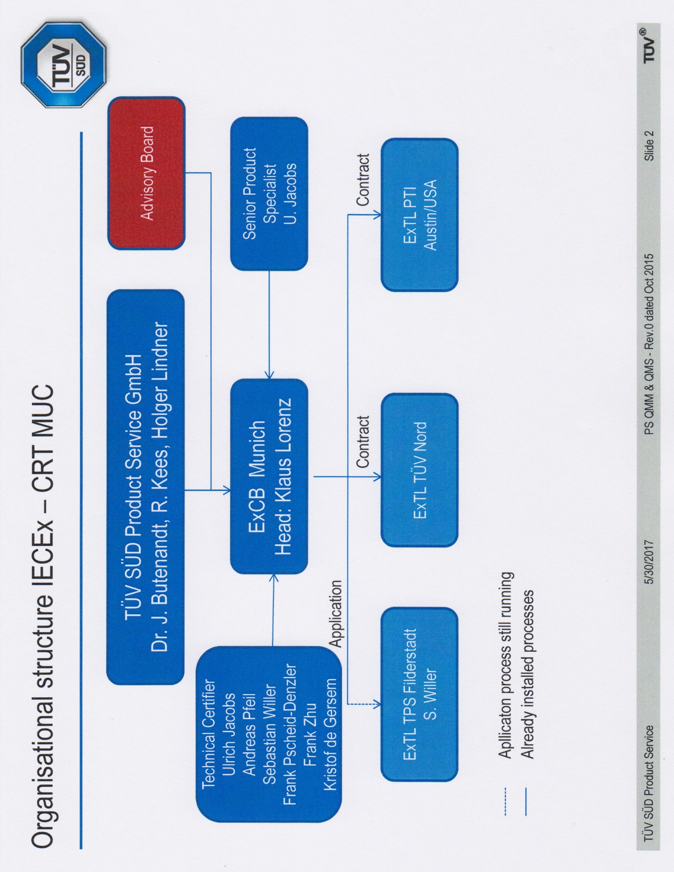
- Accreditation Certificate for ISO/IEC 17065
