INTERNATIONAL ELECTROTECHNICAL COMMISSION SYSTEM FOR
CERTIFICATION TO STANDARDS RELATING TO EQUIPENT FOR USE
IN EXPLOSIVE ATMOSPHERES (IECEx SYSTEM)

Title: Scope Extension Assessment Report for KIWA Nederland B.V., an Accepted ExCB and ExTL within the IECEx System, Equipment Scheme 02, to include ISO 80079-36 and ISO 80079-37 in their scope.

To: Members of the IECEx Management Committee, ExMC

Introduction

Following an application for a scope extension by KIWA Nederland B.V., to include ISO 80079-36 and ISO 80079-37 within their scope, a special site assessment visit was arranged and conducted.

This report details the assessment findings of this scope extension with the IECEx
Assessment Team recommending the acceptance of the above scope extension.

It is now hereby submitted for voting by ExMC.

Please consider the report and return the completed voting form, separate Word
Document, to the Secretariat Chris Agius by 2018 03 14

Your speedy response to the voting process will be very much appreciated.

Chris Agius

IECEx Secretary

Address:  IECEx Secretariat  Australia Square  Level 33, 264 George Street  Sydney NSW 2000  Australia | Tel: +61 2 4628 4690  Fax: +61 2 46 27 5285  Email: chris.agius@iecex.com

IEC System for certification to standards relating to equipment for use in Explosive Atmospheres (IECEx System)

IECEx Assessment Report Form

IECEx Assessment Report Form for use by IECEx Assessment Teams to report Assessments conducted according to the IECEx Assessment Procedures of

- Operational Document IECEx OD 003-2 for the Certified Equipment Scheme
- Operational Document IECEx OD 016 for the Certified Service Facility Scheme
- Operational Document IECEx OD 022 for the IECEx Conformity Mark Licensing System

IECEx ExCB/ExTL assessment report for KIWA Nederland B.V. (Unit Kiwa ExVision)

INTERNATIONAL
ELECTROTECHNICAL
COMMISSION

CONTENTS
(Update when report is complete – by right click, Update field, Update entire table)
1 Type of Body covered by this assessment: 5
1.1 Type of assessment: <retain appropriate marks> 5
1.2 Details of body 5
1.2.1 Country 5
1.2.2 Name of body 5
1.2.3 Name and title of nominated principal contact 5
1.3 Assessment information 5
1.3.1 Members of the assessment team 5
1.3.2 Place(s) of assessment 5
1.3.3 Assessment date(s) 5
1.4 Scopes 5
1.4.1 Additional Standards for ExCB and ExTL scope for equipment certification scheme 5
2 Common information 6
2.1 Legal entity of body 6
2.2 Financial support 6
2.3 History 6
2.4 Documentation 6
2.4.1 Quality manual 6
2.4.2 Procedures 6
2.4.3 Work instructions 7
2.4.4 Records (including test records where relevant) 7
2.4.5 Document change control 7
2.5 Confidentiality 7
2.6 Publications (Hard cover and Electronic) 7
2.7 Recognition and agreements 7
2.8 Internal audit and periodic management review 7
2.9 Contracting, subcontracting, use of other labs and use of other locations 7
2.10 Training and competence 7
2.11 Complaints and appeals (including appeals to IECEx) 7
2.12 Special facts to be noted 8
2.12.1 Supporting documentation 8
2.13 Recommendations 8
3 ExCB for IECEx Certified Equipment Scheme 9
3.1 Assessment references 9
3.2 Candidate ExCB persons interviewed 9
3.3 Associated ExTL(s) 9
3.4 Associated certification functions 9
3.5 National marks and certificates 9
3.6 Standards for scope extension 10
3.7 National differences to IEC standards 10
3.8 Organisation 10
3.8.1 Names, titles and experience of the senior executives 10
3.8.2 Name, title and experience of the quality management representative 10
3.8.3 Name and title of signatories for certification 10
3.8.4 Other employees in ExCB activity 10
3.9 Organizational structure 10
3.10 Administration 10
3.10.1 Administrative structure 10
3.10.2 Indemnity insurance 10
3.11 Resources 10
3.12 Committees (such as governing or advisory boards) 11
3.13 Certification operations 11
3.13.1 National approval/certification methods 11
3.13.2 Certification policy 11
3.13.3 Application for certification 11
3.13.4 Certification decision 11
3.13.5 Suspension and cancellation of certificates 11
3.14 Certificates issued 11
3.15 National accreditation 11
3.15.1 ISO/IEC 17065:2012 11
3.16 Assessment of manufacturers and issue of QARs 11
3.17 Comments (including issues found during assessment) 12
4 ExTL for IECEx Certified Equipment Scheme 13
4.1 Assessment references 13
4.2 Candidate ExTL persons interviewed 13
4.3 Associated ExCB(s) 13
4.4 Organisation 13
4.4.1 Names, titles and experience of the senior executives 13
4.4.2 Name, title and experience of the quality management representative 13
4.4.3 Other employees in ExTL activity 13
4.5 Organizational structure 14
4.6 Resources 14
4.7 Test reports issued 14
4.8 National accreditation 14
4.8.1 ISO/IEC 17025 14
4.9 Calibration 14
4.10 Validation of methods 14
4.11 Comments (including issues found during assessment) 14
4.12 Tests witnessed 14
5 Annexes 14
Annex A Overall Organisation Chart 15
Annex B Organisation Chart of ExCB and ExTL 17
Annex C Accreditation Certificate for Product Certification 18
Annex D Accreditation Certificate to ISO/IEC 17025 20

Assessment information

Type of Body covered by this assessment:
ExCB for IECEx Certified Equipment Scheme | ✓
ExTL for IECEx Certified Equipment Scheme | ✓
ExCB for IECEx Certified Service Facilities Scheme
ExCB for IECEx Conformity Mark Licensing System

NOTE 1 ExCB - IECEx Certification Body
NOTE 2 ExTL - IECEx Testing Laboratory

Type of assessment: <retain appropriate marks>
Pre-assessment for candidate body
Initial assessment for candidate body
Surveillance
Re-assessment
Scope extension | ✓

Details of body

Country
The Netherlands

Name of body
KIWA Nederland B.V., Unit Kiwa ExVision (KIWA in the rest of this report)

Name and title of nominated principal contact
Name | Title | E-mail address
Petrouchka Kaasenbrood | Product manager | petrouchka.kaasenbrood@kiwa.nl

Assessment information

Members of the assessment team
Name | Role (modify as necessary)
Ron Webb | Lead Assessor

Place(s) of assessment
Wilmersdorf 50, 7327 AC Apeldoorn, The Netherlands

Assessment date(s)
13 - 15 June 2016 and 27 June 2017

Scopes

Additional Standards for ExCB and ExTL scope for equipment certification scheme
Number | Title
ISO 80079-36  Edition 1 (2016) | Explosive atmospheres - Part 36: Non-electrical equipment for explosive atmospheres - Basic method and requirements
ISO 80079-37  Edition 1 (2016) | Explosive atmospheres - Part 37: Non-electrical equipment for explosive atmospheres - Non electrical type of protection constructional safety "c", control of ignition source "b", liquid immersion "k"

Common information

Legal entity of body
Kiwa Nederland B.V. is a limited liability company organized under the laws of The Netherlands, located in Rijswijk, NL. The ExCB and ExTL are located in Apeldoorn. The holding company is Acta Holding B.V.

Financial support
Kiwa Nederland B.V. derives its funding from the charges for its services

History
Kiwa, formerly an acronym for Keurings Instituut voor Waterleiding Artikelen (Testing Institute for Water Supply Articles) was founded in 1948 with the objective to take care of the quality of drinking water. For this purpose quality standards were developed for articles such as pipes, fittings and faucets. Over the years, Kiwa has also focussed on certifying and inspecting products that are intended for use in the building trade. In 2005, Kiwa took over Gastec in Apeldoorn, the former GIVEG. The GIVEG approval mark used to be the approval mark for gas appliances in the Netherlands. Nowadays Kiwa Gastec focuses its gas expertise on the following areas: Gas Appliances, Gas Distribution Systems, Gas Quality and Quantity Measurements and Safety Gas Installations. Afterwards several acquisitions are made, mainly in Germany, Italy and Spain.
Kiwa’s main activities are now:
Certification (products, management systems, persons)
Testing (laboratory) Inspecting (field work)
In June 2014 Kiwa was appointed as Notified Body under the ATEX Directive 94/9/EC and in November 2014 Kiwa became an Accepted Certification Body, ExCB, and an Accepted Test Laboratory, ExTL, within the IECEx Equipment Scheme, 02.
In March 2016 Kiwa became an Accepted Certification Body, ExCB Mark Licensing and in April 2016 Kiwa was appointed as Notified Body under the new ATEX Directive 2014/34/EU.

Documentation

Quality manual
The quality management system (QMS) consists of 6 levels:
- Corporate Manual Kiwa (CMK)
- Operation Manual Kiwa (OM)
- Q-plan 17065 ExCB
- Q-plan 17021 ExTL
- Manual ATEX and IECEx 02 – Audits
- Requested at RvA to perform audits for 17065 (16-85)
- Manual IECEx 04 – IECEx Conformity Mark Licensing System
- Forms

Procedures
The additional ATEX- and IECEx requirements are included in:
- Q-plan 17065 ExCB
- Q-plan 17021 ExTL
- ATEX-/IECEx 02 Audit Manual
- IECEx 04 Manual

Sample procedures were reviewed and found to meet the requirements of IECEx e.g. IECEx 02, OD 009, OD 025, IECEx 04, OD 422 and other relevant IECEx ODs

Work instructions
Reference to the relevant Work Instructions like Lab Work Forms is made in the Q-plans
Form 651 lists the relation between clauses including tests of the different standards, the related Laboratory Work Forms and the tools are used for the tests and the limitations
Form 00: List of approved Laboratory Work Forms

Records (including test records where relevant)
All of Kiwa ExVision project documents are stored electronically. The process is described in CMK 9.2.6.
Q-plan (16. 17065 A1) refer to the retention time of documents in common and for project files in particular. Q-Plan ExVision refers to CMK (Corporate Manual Kiwa).

Document change control
Carried out according to Corporate Manual Kiwa CMK 9.2.6: Document Control / Control of Records (Q-plan 16 17065 A1; Q-plan 17025 cl. 7)

Confidentiality
According to Corporate Manual Kiwa CMK 1.4.1: Integrity, Impartiality Confidentiality.

Publications (Hard cover and Electronic)
According to Corporate Manual Kiwa CMK 9.5: Corporate Communications
Information is provided on the website http://www.kiwa.nl/

Recognition and agreements
There are no agreements in the Ex field and not foreseen in the near future.

Internal audit and periodic management review
According to Corporate Manual Kiwa CMK 9.2.3: Management review and CMK 9.2.4

Contracting, subcontracting, use of other labs and use of other locations
According to Operation Manual Kiwa OM 4.7: Outsourcing.
There is no subcontracting in the Ex field.
Q-Plan section 6 covers off site testing to OD024

Training and competence
According to Operation Manual OM 4.1: Qualification of Staff.
Additional ATEX-/IECEx training is carried out according to Q-plans 17065 and 17025 and ATEX-/IECEx 02 Audit Manual
A comprehensive competency matrix was viewed. This identifies the staff having competence for Certification activities.

Complaints and appeals (including appeals to IECEx)
According to Corporate Manual Kiwa CMK 9.2.5: Complaints, appeals, disputes.
No complaints or appeals have been received.

Special facts to be noted

Supporting documentation
Copies of additional supporting information for this assessment have been provided to the applicant and the IECEx Secretariat. These are included in a site assessment report and include:
- Details of issues raised and how these have been resolved.
- At the time of the initial assessment visit on 13 - 15 June 2016 and the further visit on 27 June 2017 Kiwa had not completed any projects concerning non-electrical equipment although two projects were under consideration. These projects have now been completed and the reports prepared were reviewed and found to be acceptable.
- The Secretariat has confirmed the issuing of ATEX Certificates for the above 2 projects

Recommendations
Based on the assessment performed on 13 - 15 June 2016 and the further visit on 27 June 2017, as well as discussions held with various staff members who exhibited a good understanding of the requirements for non-electrical equipment, KIWA Nederland B.V., Unit Kiwa ExVision is recommended for continued acceptance in the IECEx scheme

as:
• An ExCB in the IECEx Certified Equipment Scheme
• An ExTL in the IECEx Certified Equipment Scheme
With extension of scope as indicated in section 1.4.1.

Ron Webb
Lead Assessor
Date: 24 January 2018

ExCB for IECEx Certified Equipment Scheme

Assessment references
- IECEx02 IECEx Certified Equipment Scheme covering equipment for use in explosive atmospheres – Rules of Procedure
- OD003-2 Assessment, surveillance assessment and re-assessment of ExCBs and ExTLs operating in the IECEx 02, IECEx Certified Equipment Scheme
- OD005-2 IECEx Quality System Requirements for Manufacturers – Part 2: Audit Checklist. (This is available in a Word format for use by ExCBs)
- ISO/IEC 80079-34 Edition 1, Explosive atmospheres – Part 34: Application of quality systems for equipment manufacture
- OD009 Issuing of CoCs, ExTRs and QARs
- IECEx Document OD 025 Guidelines on the Management of Assessment and Surveillance programs for the assessment of Manufacturer’s Quality Systems in accordance with the IECEx Scheme
- OD0026 IECEx Certified Equipment Scheme – Guidelines for the qualification of Lead Auditor and Auditors, in accordance with the IECEx System
- OD 024 Rules and Procedures for the granting of Licenses to issue and use of the IECEx Conformity Mark
- ISO/IEC 17065:2012 Conformity assessment - Requirements for bodies certifying products, processes and services
- IECEx Document OD17 Drawing and documentation guidance
- IECEx Technical Capability Document (TCD)
- OD 280 Guide to Certification of Non-electrical Equipment and Protective Systems
NOTE The latest editions of the above documents were applied

Candidate ExCB persons interviewed
Name | Position
Pieter van Breugel | Manager / Certification Officer
Kees van Es | Certification Officer
Bert Vries | Lead Auditor
Harry de Wild | Certification Officer
Petrouchka Kaasenbrood | Test Engineer
Paul van Nijen | Certification Officer

Associated ExTL(s)
The ExTL is integral with the ExCB

Associated certification functions
Kiwa Nederland B.V. operates according to the European Union Directives as a Notified Body for 2009/142/EC, 92/42/EEC, 97/23/EC and 2004/108/EC.

Kiwa Nederland B.V. has been notified under the ATEX Directive 2014/34/EU. The NB number is 0620 and is shown as being registered at the address in Rijswijk. The Rijswijk address is the head office of Kiwa Nederland B.V.
Kiwa also issues certificates in a number of fields, including household, commercial and industrial products, assessment and certification of Quality Management Systems and Personnel Certification. It also issues approval marks for local requirements like Kiwa®, Gastec QA®, Gaskeur® and Zonnekeur® which are not used for Ex products

National marks and certificates
None

Standards for scope extension
See clause 1.4 of this report

National differences to IEC standards
National differences to IEC standards are those for the European differences listed in the latest version of the IECEx Scheme Bulletin.

Organisation

Names, titles and experience of the senior executives
Name | Title | Experience
Pieter van Breugel | Manager | 22 years

Name, title and experience of the quality management representative
Name | Title | Experience
Nancy Bijlemeer | Quality Manager | 17 years
Marc van Berkel | Corporate Quality Manager | 17 years

Name and title of signatories for certification
Name Title
Pieter van Breugel | Certification Officer
Kees van Es | Certification Officer
Harry de Wild | Certification Officer
Paul van Nijen | Certification officer

Other employees in ExCB activity
Name | Title | Responsibility and Experience in Ex
Bert Vries | Lead Auditor | 25 years
Lisette van Deelen | Support Engineer | 10 years
Petrouchka Kaasenbrood | Certification Assessor | 3 years

Organizational structure
See Annexes A and B

Administration

Administrative structure
An effective administration team is in place

Indemnity insurance
The insurance certificate from Central Beheer covering Kiwa Nederland B.V. has been cancelled. A new insurance has been taken out which covers the ACTA Holding B.V. which covers Kiwa Nederland B.V. as shown in the Organisation Charts in Annex A. It is valid from 1 January 2016 until 31 December 2016 and covers, amongst other things, professional indemnity and has a suitable value.

Resources
Adequate physical resources are available
The technical staff are listed in the tables in this report
For the activities, as part of the Kiwa organization, the following departments are used (each with at least one person):
- - Project administration
- - Human resources
- - Finance department (invoice and salary)
- - incoming goods (incoming samples and sample administration)
- - quality management (responsible for the Kiwa Quality Management system)
- - ICT for the document management system and administrative systems

Committees (such as governing or advisory boards)
There is an advisory board committee
This last meeting was on February 6th 7th 2017

Certification operations

National approval/certification methods
Notified body number 0620 for ATEX since mid June 2014

Certification policy
Covered within the Q-plans 17065 and 10725 and Manual System Certification and Manual IECEx 04, IECEx Conformity Mark Licensing System

Application for certification
Following a request for certification the client is sent an application form which makes reference to the terms and conditions including those of the IECEx

Certification decision
IECEx 02 Product Certification: This is the task of the decision maker as indicated in D2. Page 11 Q-plan 17065. Job progress form 151 is used online within the intranet to track job progress 17025 and D.02 Certification form.
IECEx 02 Audits:This is the task of the Certification Officer as indicated in 2 of Manual ATEX and IECEx 02 – Audits. Job progress form 614 is used online within the intranet to track job progress.
IECEx 04 Conformity Mark: This is the task of the Product Manager who is also Certification Officer as indicated in 1.1 of Manual IECEx 04 – IECEx Conformity Mark Licensing System

Suspension and cancellation of certificates
Section 15 of Kiwa Regulations for Product Certification

Certificates issued
Standard  numbers | Type of protection or other identifying information | Number of issued certificates since becoming Ex NB in June 2014
ISO 80079-36 | Non electrical | 2
ISO 80079-37 | Non electrical | 2

National accreditation

3.15.1 ISO/IEC 17065:2012
Kiwa has been assessed by RvA to the requirements of ISO/IEC 17065:2012 with registration C002 valid until 1 January 2022. This covers ATEX requirements. This covers the ExCB activities.

Assessment of manufacturers and issue of QARs
Covered within Manual ATEX and IECEx 02 Audits.
3 assessments have been carried out and 3 QARs have been issued. For the year 2016
2 initial assessment and 4 surveillance audits have been planned.

Comments (including issues found during assessment)
One issue was found regarding an incorrect QAR link and this was resolved to the satisfaction of the assessor.

ExTL for IECEx Certified Equipment Scheme

Assessment references
- IECEx02 IECEx Certified Equipment Scheme covering equipment for use in explosive atmospheres – Rules of Procedure
- IECEx OD003-2 Assessment, surveillance assessment and re-assessment of ExCBs and ExTLs operating in the IECEx 02, IECEx Certified Equipment Scheme
- IECEx OD009 Issuing of CoCs, ExTRs and QARs
- ISO/IEC 17025:2005 Edition 2, General requirements for the competence of testing and calibration laboratories
- IECEx Document OD17 Drawing and documentation guidance
- IECEx Technical Capability Document (TCD)
- ExTAG decision sheets (DSs)
- OD 280 Guide to Certification of Non-electrical Equipment and Protective Systems

NOTE The latest editions of the above documents were applied.

Candidate ExTL persons interviewed
Name | Position
Kees van Es | Senior Approval Engineer
Bert Vries | Senior Approval Engineer
Harry de Wild | Senior Approval Engineer
Lisette van Deelen | Senior Approval Engineer
Petrouchka Kaasenbrood | Approval Engineer
Gerard van den Eijssel | Approval Engineer
Paul van Nijen | Senior Approval Engineer

Associated ExCB(s)
The ExCB is integral with the ExTL

Organisation

Names, titles and experience of the senior executives

Name | Title | Experience
Pieter van Breugel | Manager | 22 years

Name, title and experience of the quality management representative

Name | Title | Experience
Nancy Bijlemeer | Quality Manager | 17 years
Marc van Berkel | Corporate Quality Manager | 17 years

Other employees in ExTL activity

Name | Title/responsibility | Experience in Ex
Kees van Es | Senior Approval Engineer | 32 years in Ex
Harry de Wild | Senior Approval Engineer | 22 years in Ex
Bert Vries | Senior Approval Engineer | 25 years in Ex
Bas van den Bogaard | Approval Engineer | 10 years in testing / 2 years in Ex
Lisette van Deelen | Senior Approval Engineer | 16 years in testing / 10 years in Ex
Petrouchka Kaasenbrood | Approval Engineer | 1.5 years in Ex
Paul van Nijen | Senior approval engineer | 12 years in Ex
Gerard van der Eijssel | Approval Engineer | 1.5 years in Ex

Organizational structure
See Annex A and B

Resources
Adequate resources are available

Test reports issued
Standard  numbers | Type of protection or other identifying information | Number of issued reports since becoming Ex NB in June 2014
ISO 80079-36 | Non electrical | 2
ISO 80079-37 | Non electrical | 2

National accreditation

ISO/IEC 17025
Kiwa is accredited by RvA to the requirements of ISO/IEC 17025 with registration L248 valid until 1 October 2018. This covers the ExTL activities.
The front page of the ISO/IEC 17025 certificate and the scope is shown in Annex D.
At present ISO 80079-36 and ISO 80079-37 are not included but are being considered in a forthcoming RvA visit however Kiwa holds accreditation for non-electrical standards EN 13463 series.

Calibration
All equipment used for tests is calibrated. Calibrations are either outsourced to an accredited laboratory on carried out in-house.

Validation of methods
Kiwa participates in the Proficiency Testing Program run by PTB. The Kiwa results of the test round of 2015, which includes Program 5 "Electrostatic charge" and Program 6 "Intrinsic safety", have been submitted to PTB. The Interim Report has been received and the results are acceptable.

Comments (including issues found during assessment)
none

Tests witnessed
- Charging tests with non-conductive materials (ISO 80079-36, clause 8.4.8)

- Charging tests with HV-charger (ISO 80079-36, Annex D)

All tests were performed satisfactorily.

Annexes

- Overall Organisation Chart
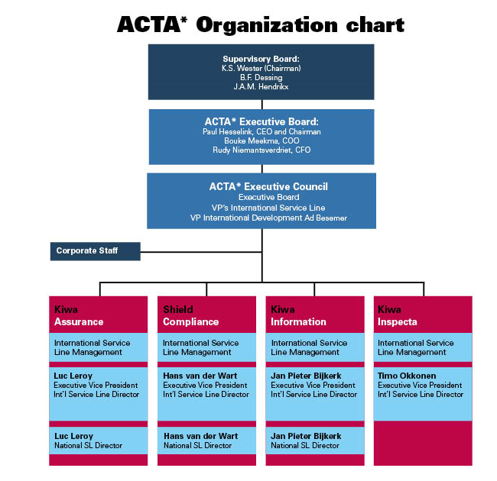
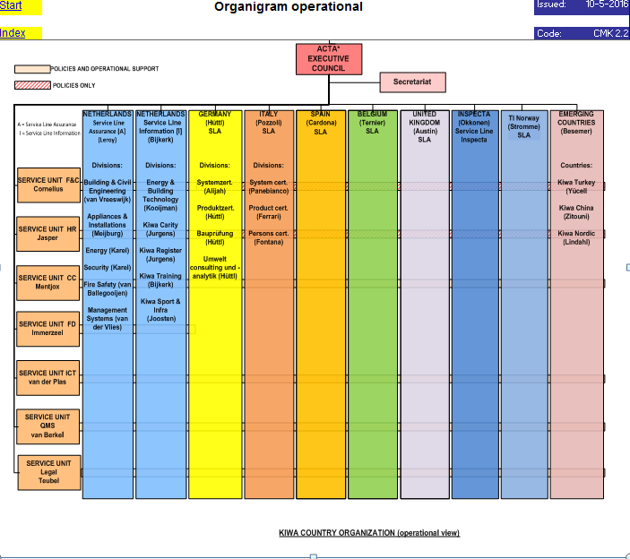
- Organisation Chart of ExCB and ExTL

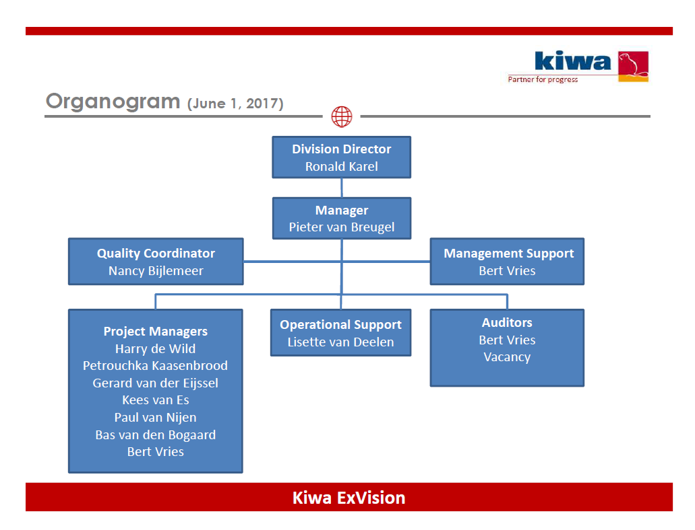
- Accreditation Certificate for Product Certification

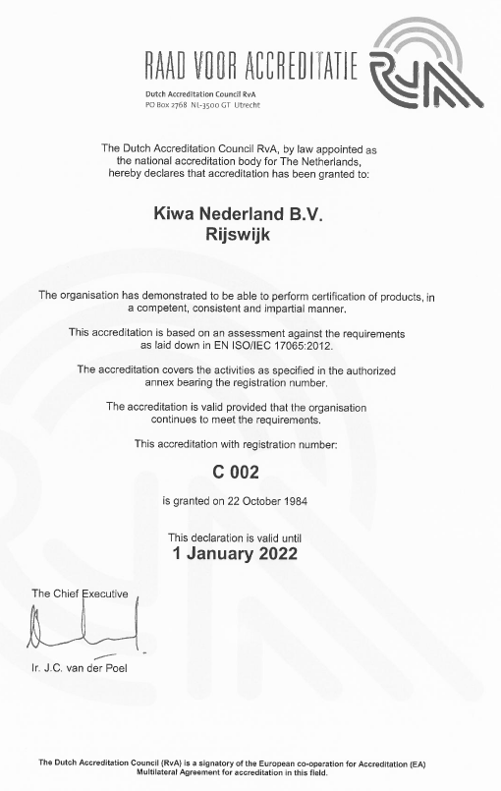
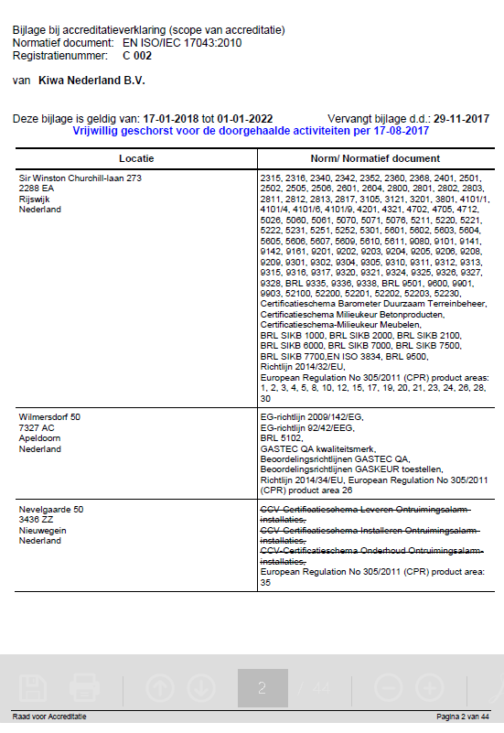

- Accreditation Certificate to ISO/IEC 17025

