INTERNATIONAL ELECTROTECHNICAL COMMISSION SYSTEM FOR CERTIFICATION TO STANDARDS RELATING TO EQUIPMENT FOR USE IN EXPLOSIVE ATMOSPHERES (IECEx SYSTEM)

TITLE: IECEx Assessment Report for the acceptance of Shanghai Inspection and Testing Institute of Instruments and Automatic Systems Co., Ltd. (SITIIAS) /National Supervision and Inspection Centre for Explosion Protection and Safety of Instrumentation (NEPSI) Inc, an Accepted Ex Test Laboratory, ExTL, to also become an Accepted Ex Certification Body, ExCB, within the IECEx Equipment Scheme , 02.
Circulated to: Ex Management Committee, ExMC

INTRODUCTION

This document contains the IECEx Assessment Report for the acceptance of Shanghai Inspection and Testing Institute of Instruments and Automatic Systems Co., Ltd. (SITIIAS) /National Supervision and Inspection Centre for Explosion Protection and Safety of Instrumentation (NEPSI)Inc, which is currently an Accepted Ex Test Laboratory, ExTL, to also become an Accepted Ex Certification Body, ExCB, within the IECEx Equipment Scheme, 02.

Please consider this assessment report and return the completed voting form, separate Word document, to the

IECEx Secretary by- 2018 04 23

Your speedy response to the voting process will be very much appreciated.

Chris Agius
IECEx Secretariat

IECEx Secretariat  Australia Square  Level 33, 264 George Street  Sydney NSW 2000  Australia | Tel: +61 2 4628 4690  Fax: +61 2 46 27 5285  Email: info@iecex.com

IEC System for certification to standards relating to equipment for use in Explosive Atmospheres (IECEx System)

IECEx Assessment Report Form

IECEx Assessment Report Form for use by IECEx Assessment Teams to report Assessments conducted according to the IECEx Assessment Procedures of

- Operational Document IECEx OD003-2 for the Certified Equipment Scheme
- Operational Document IECEx OD316-5 for the Certified Service Facility Scheme
- Operational Document IECEx OD422 for the IECEx Conformity Mark Licensing System

IECEx ExCB assessment report for

Shanghai Inspection and Testing Institute of Instruments and Automatic Systems Co., Ltd. (SITIIAS) /National Supervision and Inspection Centre for Explosion Protection and Safety of Instrumentation (NEPSI)

INTERNATIONAL
ELECTROTECHNICAL
COMMISSION

CONTENTS
1 Assessment information 5
1.1 Type of Body covered by this assessment: 5
1.2 Type of assessment: 5
1.3 Details of body 5
1.3.1 Country 5
1.3.2 Name of body 5
1.3.3 Name and title of nominated principal contact 5
1.4 Assessment information 5
1.4.1 Members of the assessment team 5
1.4.2 Place(s) of assessment 5
1.4.3 Assessment date(s) 5
1.5 Application information and background information on the assessment 6
1.6 Scopes 6
1.6.1 ExCB scope for equipment certification scheme 6
1.6.2 ExTL scope 7
2 Common information 7
2.1 Legal entity of body 7
2.2 Financial support 8
2.3 History 8
2.4 Documentation 8
2.4.1 Quality manual 8
2.4.2 Procedures 8
2.4.3 Work instructions 8
2.4.4 Records (including test records where relevant) 9
2.4.5 Document change control 9
2.5 Confidentiality 9
2.6 Communication with public and customers (Hard copy and Electronic) 9
2.7 Recognitions and agreements 9
2.8 Internal audit 9
2.9 Management review 9
2.10 Contracting, subcontracting and witness testing 9
2.10.1 Contracting 9
2.10.2 Subcontracting 9
2.10.3 Witness testing 10
2.11 Training and competence 10
2.12 Complaints and appeals (including appeals to IECEx) 10
2.13 Impartiality 10
2.14 Commenting on ExTAG Documents 10
2.15 Special facts to be noted 10
2.16 Supporting documentation 10
2.17 Recommendations 11
3 ExCB for IECEx Certified Equipment Scheme 12
3.1 Assessment references 12
3.1.1 General references 12
3.1.2 Additional references applied for this assessment 12
3.2 Candidate ExCB persons interviewed 12
3.3 Associated ExTL(s) 13
3.4 Associated certification functions 13
3.5 National marks and certificates 13
3.6 Standards accepted 13
3.7 National differences to IEC standards 13
3.8 Organisation 13
3.8.1 Names, titles and experience of the senior executives 13
3.8.2 Name, title and experience of the quality management representative 13
3.8.3 Name and title of signatories for certification 14
3.8.4 Other employees in ExCB activity 14
3.9 Organizational structure 14
3.10 Indemnity insurance 14
3.11 Resources 15
3.12 Committees 15
3.13 Certification operations 15
3.13.1 National approval/certification methods 15
3.13.2 Certification policy 15
3.13.3 Application for certification 15
3.13.4 Certification decision 15
3.13.5 Suspension and cancellation of certificates 15
3.14 Certificates issued 15
3.15 National accreditation 17
3.16 Assessment of manufacturers and issue of QARs 17
3.17 Comments 18
4 Annexes 19
Annex A Overall Organisation Chart 20
Annex B Organisation Chart of ExCB 21
Annex C Authorisation Certificate to operate a CB (incl. Ex) 22
Annex D Accreditation Certificate for ISO/IEC 17025 23
Annex E Authorisation Certificate to operate a CB (incl. Ex) 24
Annex F Certificate to ISO 9001 25

Assessment information

Type of Body covered by this assessment:
ExCB for IECEx Certified Equipment Scheme | ✓
ExTL for IECEx Certified Equipment Scheme
ExCB for IECEx Certified Service Facilities Scheme
ExCB for IECEx Conformity Mark Licensing System

NOTE 1 ExCB - IECEx Certification Body
NOTE 2 ExTL - IECEx Testing Laboratory

Type of assessment:
Pre-assessment for candidate body
Initial assessment for candidate body | ✓
Surveillance
Re-assessment
Scope extension

Details of body

Country
People's Republic of China

Name of body
Shanghai Inspection and Testing Institute of Instruments and Automatic Systems Co., Ltd. (SITIIAS) /National Supervision and Inspection Centre for Explosion Protection and Safety of Instrumentation (NEPSI)
103 Cao Bao Road, Shanghai 200233, PEOPLE'S REPUBLIC OF CHINA

Name and title of nominated principal contact
Name | Title | E-mail address
Xu Jianping | Managing Director  Director of NEPSI | xujianping@nepsi.org.cn

Assessment information

Members of the assessment team
Name | Role
Heinz Berger | IECEx Lead Assessor
Herbert Peters | IECEx Technical Assessor

Place(s) of assessment
103 Cao Bao Road, Shanghai 200233, P.R. of China

Assessment date(s)
January 17th and 18th, 2018

Application information and background information on the assessment
The application from NEPSI to act as an IECEx Certification Body (ExCB), endorsed by the CN IECEx Member Body, was placed on September 19, 2017.

Scopes

ExCB scope for equipment certification scheme
Number | Title | Within Existing scope as an ExTL
IEC 60079-0  Edition 7.0 | Explosive atmospheres - Part 0: Equipment - General requirements | YES
IEC 60079-1  Edition 7.0 | Explosive atmospheres - Part 1: Equipment protection by flameproof  enclosures “d” | YES
IEC 60079-2  Edition 6.0 | Explosive atmospheres - Part 2: Equipment protection by pressurized  enclosure «p» | YES
IEC 60079-5  Edition 4.0 | Explosive atmospheres - Part 5: Equipment protection by powder filling «q» | YES
IEC 60079-6  Edition 4.0 | Explosive atmospheres - Part 6: Equipment protection by oil immersion «o» | YES
IEC 60079-7  Edition 5.0 | Explosive atmospheres - Part 7: Equipment protection by increased  safety "e" | YES
IEC 60079-11  Edition 6.0 | Explosive atmospheres - Part 11: Equipment protection by intrinsic safety “i” | YES
IEC 60079-13  Edition 1.0 | Explosive atmospheres -  Part 13: Equipment protection by pressurized room 'p' | YES
IEC 60079-15  Edition 5.0 | Explosive atmospheres – Part 15: Equipment protection by type of protection "n" | YES
TR 60079-16  Edition 1.0 | Electrical apparatus for explosive gas atmospheres- Part 16: Artificial ventilation for the protection of analyser(s) houses | YES
IEC 60079-18  Edition 4.0 | Explosive atmospheres – Part 18: Equipment protection by encapsulation “m” | YES
IEC 60079-25  Edition 2.0 | Explosive atmospheres – Part 25: Intrinsically safe electrical systems | YES
IEC 60079-26  Edition 3.0 | Explosive atmospheres - Part 26: Equipment with equipment protection  level (EPL) Ga | YES
*IEC 60079-27  Edition 2.0 | Explosive atmospheres – Part 27: Fieldbus intrinsically safe concept (FISCO) | YES
IEC 60079-28  Edition 2.0 | Explosive atmospheres - Part 28: Protection of equipment and transmission systems using optical radiation | YES
IEC 60079-29-1  Edition 1.0 | Explosive atmospheres - Part 29-1: Gas detectors – Performance requirements of detectors for flammable gases | YES
IEC/IEEE 60079-30-1  Edition 1.0 | Explosive atmospheres – Part 30-1: Electrical resistance trace heating – General and testing requirements | YES
IEC 60079-31  Edition 2.0 | Explosive atmospheres – Part 31: Equipment dust ignition protection by enclosure "t" | YES
IEC 60079-33  Edition 1.0 | Explosive atmospheres – Part 33: Equipment protection by special protection “s” | Awaiting scope extension. To wait for results from separate mid-term assessment and future voting by ExMC
IS0 80079-36  Edition 1.0 | Explosive atmospheres - Part 36: Non-electrical equipment for explosive atmospheres – Basic method and requirements | Awaiting scope extension. To wait for results from separate mid-term assessment and future voting by ExMC
ISO 80079-37  Edition 1.0 | Explosive atmospheres - Part 37: Non-electrical equipment for explosive atmospheres – Non electrical type of protection constructional safety ”c” control of ignition source ”b”, liquid immersion ”k” | Awaiting scope extension. To wait for results from separate mid-term assessment and future voting by ExMC
*IEC 61241-0  Edition 1.0 | Electrical apparatus for use in the presence of combustible dust - Part 0: General requirements | YES
*IEC 61241-1  Edition 1.0 | Electrical apparatus for use in the presence of combustible dust - Part 1: Protection by enclosure “tD” | YES
*IEC 61241-4  Edition 1.0 | Electrical apparatus for use in the presence of combustible dust - Part 4: Protection by pressurization "pD" | YES
*IEC 61241-11  Edition 1.0 | Electrical apparatus for use in the presence of combustible dust – Part 11: Protection by intrinsic safety 'iD' | YES
*IEC 61241-18  Edition 1.0 | Electrical apparatus for use in the presence of combustible dust - Part 18: Protection by encapsulation "mD" | YES
*IEC 62086-1  Edition 1 | Part 1: General and testing requirements - Electrical apparatus for explosive gas atmospheres – Electrical resistance trace heating | YES
IECEx DS2015/001A  2015 10 09 | Equipment assemblies | Confirmed capability

Note: exclude the Group Ⅰequipment.
NOTE 1 Standards shown with an asterisk (*) are superseded standards
NOTE 2 Unless otherwise indicated, earlier editions of standards (even if with a different number) are considered to be covered in the above scope for the purposes of the assessment.
NOTE 3 The above list highlights any extension of scope in the list above for new standards or later editions of standards already in scope.

ExTL scope
The ExTL scope is the same as for the ExCB. A separate application for scope extension to cover IEC 60079-33 and ISO 80079-36 and ISO 80079-37 are being dealt with as part of a separate mid term assessment of the ExTL function.

Common information

Legal entity of body
SITIIAS Co., Ltd is a state-owned enterprise with the status of an independent legal entity, providing services of calibration, verification, testing, certification, and standardization for the relevant electrical apparatus, including instruments, luminaries, electrical motors, control panels etc.

Their registration number is 91310104754347246Q and is valid with no time limitation. This document was issued on 25.7.2017 because of the change to Co. Ltd.

National Supervision and Inspection Centre for Explosion Protection and Safety of Instrumentation (NEPSI) is part of the SITIIAS Co., Ltd. in the field of explosion protection.
CNCA (Certification and Accreditation Administration of the PRC) gave permission to SITIIAS Co. Ltd. to act as certification body with document CNAC-R-2016-230, first issued on 4.5.2016, revised on 4.9.2017 (introduction of Co. Ltd.) and validity until 4.5.2022.
The address at which it carries out its operations is at 103, Cao Bao Road, Shanghai, 200233, P. R. of China

Financial support
All the assets at SITIIAS remain the property of the Government, and its operation is financed from its services of testing, verification, inspection, national certification and standardization work. Sometimes they can get investment from local or central government in order to support research work.

History
SITIIAS was established by merging of different testing labs in 1999 with the approval of the State Bureau of Machinery Industry. It was registered as an independent legal enterprise in September 2003. In 2017, it changed its name to “Shanghai Inspection and Testing Institute of Instruments and Automation System Co., Ltd”. In 1979 the formation of the Ex laboratory began and was completed in 1985. In 1986, NEPSI was approved and authorized by the former Ministry of Labour.

SITIIAS/NEPSI was accredited to Guide 25 in 1987 and subsequently to ISO/IEC 17025 in 1999. In 2004 it was accredited to ISO/IEC17020. See ANNEX 4 for the certificate. In 2005, SITIIAS/NEPSI became IECEx Testing Laboratory. In 2016, SITIIAS was authorized by CNCA to act as Certification Body.

Documentation

Quality manual
The quality system of SITIIAS/NEPSI consist of four levels:

Level 1: Quality Manual 01 (RG01-XX)

Level 2: Procedure 02 (documents RG02-XX)

Level 3: Work instruction 03 (document RJ03-01 for Ex products)

Level 4: Quality records/forms 04 (RJ04-01 for Ex Auditing → QAR)

Quality manual for certification SITIIAS-RG01-01 describes the activities as ExCB and related technical activities towards certification.

The Quality manual as well documents from different levels were reviewed during the assessment and found to meet the requirements of the IECEx.

Procedures
There are 19 procedures relevant to certification.
Procedures RG02-12 (control of certification process), RG02-18 (submission of information by the certification body) and RG02-05 (management of records and archives) were reviewed in detail during the assessment and found to meet the requirements of the IECEx.

Work instructions
Work instructions concerning IECEx Scheme 02 are combined (e.g. DS, OD, CN special requirements) in procedure RG03-01.
The procedure was reviewed and found to meet the requirements of IECEx.

Records (including test records where relevant)
See clause 2.4.2. Covered by RG02-05, management of records, and found to meet IECEx requirements.

Document change control
SITIIAS-RG02-04 ”Procedure for document control” describes control and procedure to change documents. The procedure was checked and found to meet the IECEx requirements.

Confidentiality
Confidentiality is covered in SITIIAS-RG02-02” Procedure for management of confidentiality”. All staff involved in the ExCB signed a document regarding impartiality, honesty, and confidentiality. During the assessment, all declarations were checked and found to meet the IECEx requirements.

Communication with public and customers (Hard copy and Electronic)
The website www.nepsi.org.cn provides information. A brochure is available as well.

Recognitions and agreements
SITIIAS/NEPSI has cooperation agreement with many Ex bodies. For example, PTB, LCIE, KTL, KOSHA, TUV NORD, TIIS, LOM, DEKRA, SIRA, INERIS, SGS BASEEFA, KGS, NANIO CCVE, TestSafe and KEMA.

Internal audit
Internal audit is covered by SITIIAS-G02-06” Procedure for internal audit”. The internal audit for ExCB (CN national until the clearance as IECEx CB) is done at least once a year by the Quality Manager and other internal auditors. All audit records are retained. The last audit was conducted in November 17th, 2017. The internal audit procedure and the records for 2017 were reviewed and found to meet the requirements.

Management review
The last management review took place on January 10th, 2018. Senior members of the organization attended the meeting. An agenda was forwarded to members beforehand and minutes of the meeting were issued. The minutes of this meeting were discussed and found to meet the IECEx requirements. The minutes of this meeting were reviewed and found to meet the requirements of the IECEx.

Contracting, subcontracting and witness testing

Contracting
No contracting of ExCB functions

Subcontracting
The following tests are, or may be, subcontracted by the body:
Standard | Clause | Test
IEC 60079-0:2017 | 26.10 | Resistance to UV light
IEC 60079-0:2017 | 6.3.5 | Sulphur dioxide test for Level of Protection “eb” for the connection of bi-pin lamp caps to lamp holders
More details, including bodies to whom tests will be subcontracted, details of accreditation of those bodies and details of how the subcontracted bodies are checked, are included in the site assessment report OD 006. The contract with this subcontractor was reviewed as well as the accreditation documents and found to meet the requirements of the IECEx.

Witness testing
OD 024 issues were discussed during the assessment and found that the procedures are understood. NEPSI does presently not have a contract according to OD24.

Training and competence
The main procedure for training is SITIIAS-G02-19” Procedure for personnel training”. This procedure lists the steps for personnel to be trained. SITIIAS-RG02-03 “Procedure for management of personnel” provides judgement for personnel competencies, including who can make those decisions. There are lists with signatures showing the relevant competencies. Finally, there is a skill matrix covering the various techniques broken in testing, verification, ExTR review, QAR reviewer and certification decision. The training records for 2017 were reviewed as well as the training plan for 2018 and found to meet the requirements of the IECEx.
Details of staff competencies are included in the site assessment report OD 006 (competence matrix).

Complaints and appeals (including appeals to IECEx)
Customer complaints are in procedure SITIIAS-RG02-09. This includes the process that would be used if the complaint happened.
A survey is also made of customers each year, seeking their feedback. The form is available to customers on the website. The results are scored, and an average calculated to rate the service. From the survey in the year of 2017 the rating was 98.25%. No complaint about Ex testing was found in the past year.

Impartiality
Confidentiality is covered in SITIIAS-G02-05” Procedure for the Protecting of Confidentiality and Proprietary Rights” and SITIIAS-RG02-01” Procedure for management of Impartiality”. All staffs have signed regarding impartiality, honesty, and confidentiality of their work. During the assessment, the list and several signed documents were checked. It was found to meet the IECEx requirements.

Commenting on ExTAG Documents
Instructions for commenting on ExTAG documents are in the SITIIAS-RG02-18 “Procedure for management of information submission as certification body”. SITIIAS/NEPSI provided evidence of discussing ExTAG Decision Sheets internally and providing feedback to the IECEx secretariat.

Special facts to be noted
None

Supporting documentation
Copies of additional supporting information for this assessment have been provided to the applicant and the IECEx Secretariat. These are included in a site assessment report or provided separately and include:

- Site Assessment Report
- Details of issues raised and how these have been resolved
- Checklist for ISO/IEC 17065
- Assessors’ notes
- Other

Recommendations
Based on the initial assessment performed on January 17th and 18th, 2018, SITIIAS/NEPSI is recommended for acceptance in the IECEx scheme as:
- An ExCB in the IECEx Certified Equipment Scheme
This is according to the scope of the standards listed in this document.

Heinz Berger | Herbert Peters
IECEx Lead Assessor | IECEx Assessor
Date: January 18th, 2018

ExCB for IECEx Certified Equipment Scheme

Assessment references

General references
- IECEx02 IECEx Certified Equipment Scheme covering equipment for use in explosive atmospheres – Rules of Procedure
- OD003-2 Assessment, surveillance assessment and re-assessment of ExCBs and ExTLs operating in the IECEx 02, IECEx Certified Equipment Scheme
- ISO/IEC 80079-34 Edition 1, Explosive atmospheres – Part 34: Application of quality systems for equipment manufacture
- OD009 Issuing of CoCs, ExTRs and QARs
- IECEx Document OD 025 Guidelines on the Management of Assessment and Surveillance programs for the assessment of Manufacturer’s Quality Systems in accordance with the IECEx Scheme
- OD0026 IECEx Certified Equipment Scheme – Guidelines for the qualification of Lead Auditor and Auditors, in accordance with the IECEx System
- ISO/IEC 17065: 2012, Edition 1, General requirements for bodies operating product certification systems Conformity assessment — Requirements for bodies certifying products, processes and services
- IECEx Technical Capability Document (TCD)
- ExTAG decision sheets (DSs)
NOTE The latest editions of the above documents were applied

Additional references applied for this assessment
NOTE To be added by assessment team. For example ODs for non-electrical or Ex s where applicable.
OD 280 IECEx Certified Equipment Scheme –Guide to Certification of Non-electrical Equipment and Protective Systems
OD 233 IECEx Certified Equipment Scheme - Assessment of Ex “s" Equipment
OD 203 Guidance on the definition of ‘manufacturer’ in relation to trade agents’ and ‘local assemblers’
OD 033 IECEx Operations Manual – IECEx Unit Verification Certificates

Candidate ExCB persons interviewed
Name | Position
Xu Jianping | Managing Director  Director of NEPSI
Xin Leifu | Deputy general manager, Head of certification department
Lu Qiao | International affair manager, Deputy head of certification department
Yao Zhihong | Quality Manager
Ge Qing | Deputy director of NEPSI
Huang Yongwei | Head of Lab I
Yang Deshuang | Head of Lab II
Hu Jie | Head of Inspection Department
Zhao Hong | Deputy Head of Lab I
Jin Zhaohui | Deputy Head of Lab II
Xu Mengjia | Engineer
Li Hangchuan | Engineer, Deputy Head of Marketing Department
Jiang Xuqiang | Engineer
Shi Lei | Engineer
Yu Chen | Quality Manager Assistant

Associated ExTL(s)
SITIIAS/NEPSI is integral with the ExCB but yet maintain separation between Testing and Certification decisions as required by ISO/IEC 17065.

SITIIAS/NEPSI has been accepted in the IECEx Scheme as an ExTL in 2005. It is located at the same address as the ExCB.

Associated certification functions
In China, SITIIAS/NEPSI is authorized by Certification and Accreditation Administration of the People’s Republic of China (CNCA) as Certification Body and accredited by the China National Accreditation Service for Conformity Assessment (CNAS) as Testing (No L0130 to ISO/IEC 17025) and Inspection Body (ISO/IEC 17020) with the right to certify Ex equipment for the Chinese Market.
SITIIAS/NEPSI also holds an accreditation for ISO/IEC 9001 and. See Annex D for the certificate.

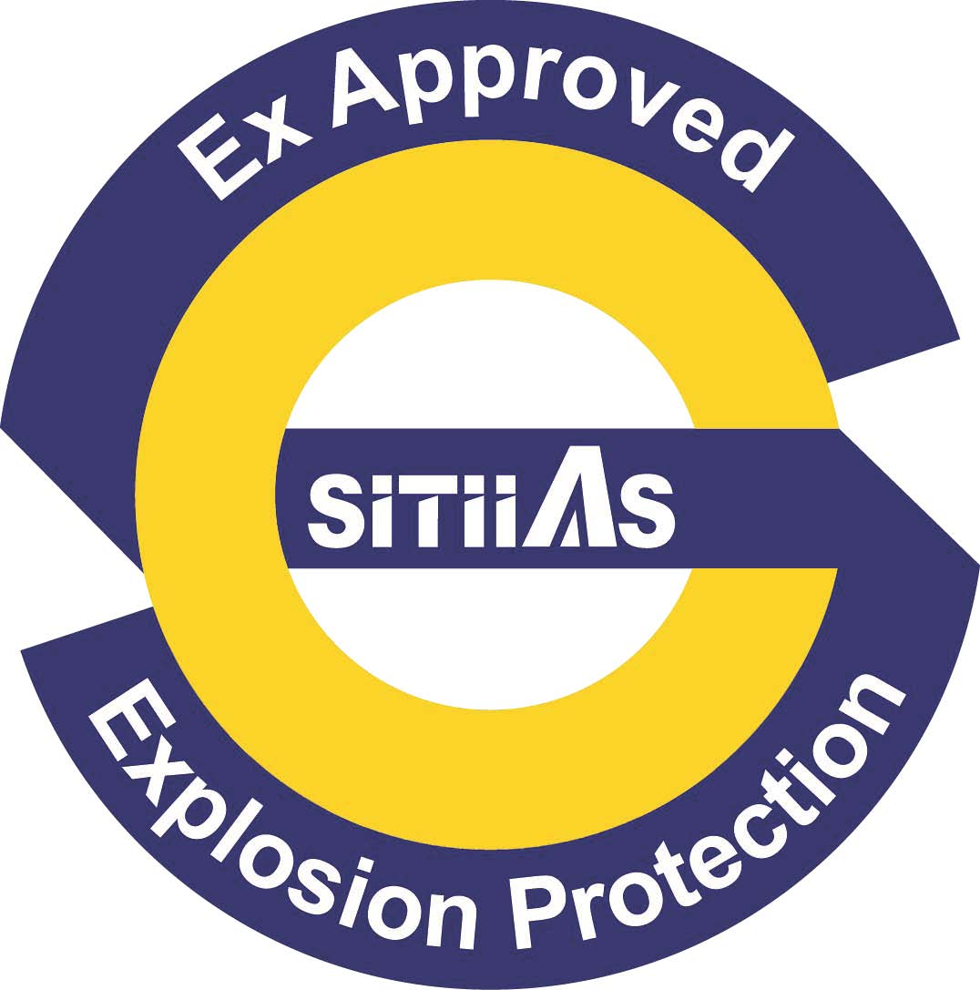
National marks and certificates
The NEPSI Logo and SITIIAS approval mark are used on certified products. Certificates of compliance are issued authorizing the clients to use the applicable mark.

Standards accepted
See clause 1.6 of this report

National differences to IEC standards
National differences to IEC standards are those for the Chinese differences listed in the latest version of the IECEx Scheme Bulletin.

Organisation
See ANNEX A and B for the organization charts.

Names, titles and experience of the senior executives

Name | Title | Experience
Xu Jianping | Managing Director  Director of NEPSI | 34 years at SITIIAS and in Ex field

Name, title and experience of the quality management representative

Name | Title | Experience
Yao Zhihong | Quality Manager | 34 years at SITIIAS, 18 years in current position

Name and title of signatories for certification

Name | Title | Comments
Xu Jianping | Managing Director  Director of NEPSI | 34 years at SITIIAS and in Ex field
Xin Leifu | Deputy general manager, Head of certification department | 10 years at SITIIAS and in Ex field

Other employees in ExCB activity

Name | Title | Responsibility and Experience in Ex
Xin Leifu | Deputy general manager, Head of certification department | Final Reviewer  10 years at SITIIAS and in Ex field
Lu Qiao | International affair manager, Deputy head of certification department | Final Reviewer, QAR Reviewer, Ex TR Reviewer Lead auditor  20 years at SITIIAS and in Ex field
Yao Zhihong | Quality Manager | QAR Reviewer, Lead Auditor  34 years at SITIIAS and 10 years in Ex field
Ge Qing | Deputy director of NEPSI | Final Reviewer, Ex TR Reviewer  35 years at SITIIAS and in Ex field
Huang Yongwei | Head of Lab I | Ex TR Reviewer  27 years at SITIIAS and in Ex field
Yang Deshuang | Head of Lab II | Ex TR Reviewer  21 years at SITIIAS and in Ex field
Hu Jie | Head of Inspection Department | QAR Reviewer, Lead Auditor  18 years at SITIIAS and in Ex field
Zhao Hong | Deputy Head of Lab I | Auditor  16 years at SITIIAS and in Ex field
Jin Zhaohui | Deputy Head of Lab II | Auditor  16 years at SITIIAS and in Ex field
Xu Mengjia | Engineer | Auditor  7 years at SITIIAS and in Ex field
Li Hangchuan | Engineer, Deputy Head of Marketing Department | Auditor  14 years at SITIIAS and in Ex field
Jiang Xuqiang | Engineer | Auditor  12 years at SITIIAS and 14 years in Ex field
Shi Lei | Engineer | Auditor  12 years at SITIIAS and in Ex field

Organizational structure
See Annex A for the organization chart.

Indemnity insurance
SITIIAS/NEPSI holds indemnity insurance from the People Insurance Company of China Limited with validity to November 15th, 2018. The number is 31001700091367. It can be renewed every year.

Resources
SITIIAS/NEPSI are very well resourced with appropriate facilities, comprehensive procedures, and competent staff for carrying out activities for the standards.
SITIIAS/NEPSI employs about 114 people in total, in which 34 personnel professionally working on testing and assessment of equipment for use in explosive atmospheres, 11 personnel working in the Certification Body. And all the rests, mainly working for the tests of climate, vibration, electric safety, and the evaluation of reliability and functional safety. The ExCB is supported by administration personnel. Parts of those support the testing of NEPSI, for example, thermal endurance test, IP test and vibration tests etc.

Committees (such as governing or advisory boards)
SITIIAS-RG02-01 “Procedure for management of Impartiality”. SITIIAS-RG05-01 “Regulation for the Impartiality Committee”

The Impartiality Committee is comprised of representatives from industry, certification body, consumers, users, and others. The committee is responsible for providing guidance and advice on the formulation of policies relating to impartiality of the conformity assessment activities of SITIIAS/NEPSI.
The committees meet once a year. The last combined Certification & Impartiality meeting took place on October 11, 2017. The minutes were viewed, and the topics covered found to meet the requirements of ISO/IEC 17065 and SITIIAS/NEPSI quality management system.
The confidentiality declarations of all board members were reviewed as well as the minutes of the last meeting and found to meet the requirements of the IECEx.

Certification operations

National approval/certification methods
SITIIAS/NEPSI maintains national certification methods according to Chinese regulation covering all the types of protection for Ex electrical equipment and non-electrical equipment.

Certification policy
SITIIAS/NEPSI has quality policy as follows:
Earnest service, Impartial Assessment, All-round development, Continual Improvement
The quality policy has been described in the Quality Manual.

Application for certification
SITIIAS-RG02-13 “Procedure for certification application, acceptance and contract management”. The application form was reviewed and found to meet the requirements of the IECEx. The updated application form was reviewed (Chinese and English) and found to meet the requirements of the IECEx.

Certification decision
SITIIAS-RG02-14 “Procedure for certification review and certification decision”. The procedure was reviewed and found to meet the requirements of the IECEx.

Suspension and cancellation of certificates
SITIIAS-RG02-16 “Procedure for issuance, maintaining, surveillance, renewal, modification, extension, reduction, suspension, reinstatement, withdrawal and cancel of the certificates”. The procedure was reviewed and found to meet the requirements of the IECEx.

Certificates issued
Number of certificates issued under for the preceding four years for each type of protection. For new applications these should be for national or regional schemes.
Standard numbers | Type of protection or other identifying information | Number of issued certificates (for last 4 years) |  |  |  | Total
60079-0 | Explosive atmospheres -  Part 0: Equipment - General requirements | --- | --- | --- | ---
60079-1 | Explosive atmospheres -  Part 1: Equipment protection by flameproof enclosures 'd' | 761 | 693 | 765 | 895 | 3114
60079-2 | Explosive atmospheres -  Part 2: Equipment protection by pressurized enclosures 'p' | 26 | 30 | 11 | 70 | 137
60079-5 | Explosive atmospheres -  Part 5: Equipment protection by powder filling 'q' | 7 | 6 | 10 | 6 | 29
60079-6 | Explosive atmospheres -  Part 6: Equipment protection by oil immersion 'o' | 0 | 0 | 0 | 0 | 0
60079-7 | Explosive atmospheres -  Part 7: Equipment protection by increased safety 'e' | 240 | 69 | 482 | 500 | 1291
60079-11 | Explosive atmospheres -  Part 11: Equipment protection by intrinsic safety 'i' | 528 | 377 | 625 | 793 | 2323
60079-13 | Construction and use of rooms or buildings protected by pressurization  Part 13 | 0 | 0 | 0 | 0 | 0
60079-15 | Explosive atmospheres -  Part 15: Equipment protection by type of protection 'n' | 72 | 78 | 49 | 89 | 288
TR 60079-16 | Artificial ventilation for the protection of analyser(s) houses  Part 16 | 0 | 0 | 0 | 0 | 0
60079-18 | Electrical apparatus for explosive gas atmospheres -  Part 18: Construction, test and marking of type of protection encapsulation 'm' electrical apparatus | 72 | 83 | 71 | 107 | 333
60079-25 | Explosive atmospheres -  Part 25: Intrinsically safe systems | 0 | 0 | 0 | 0 | 0
60079-26 | Explosive atmospheres -  Part 26: Equipment with equipment protection level (EPL) Ga | 355 | 424 | 258 | 257 | 1294
60079-27 | Explosive atmospheres -  Part 27: Fieldbus intrinsically safe concept (FISCO) | 0 | 0 | 0 | 0 | 0
60079-28 | Explosive atmospheres -  Part 28: Protection of equipment and transmission systems using optical radiation | 1 | 6 | 4 | 2 | 13
60079-29-1 | Explosive atmospheres - Part 29-1:  Gas detectors - Performance requirements of detectors for flammable gases | 3 | 0 | 0 | 0 | 3
60079-30-1 | Explosive atmosphere -  Part 30-1: Electrical resistance trace heating - General and testing requirements | 0 | 0 | 0 | 1 | 1
60079-31 | Explosive atmosphere -  Part 31: Equipment dust ignition protection by enclosure "t" | 32 | 10 | 7 | 2 | 51
61241-0 | Electrical apparatus for use in the presence of combustible dust -  Part 0: General requirements | --- | --- | --- | --- | 0
61241-1 | Electrical apparatus for use in the presence of combustible dust -  Part 1: Protection by enclosures 'tD' | 0 | 0 | 247 | 223 | 470
61241-1-1 | Electrical apparatus for use in the presence of combustible dust -  Part 1: Electrical apparatus protected by enclosures and surface temperature limitation - Specification for apparatus | 0 | 0 | 0 | --- | 0
61241-4 | Electrical apparatus for use in the presence of combustible dust -  Part 4: Type of protection 'pD' | 0 | 0 | 1 | 1 | 2
61241-11 | Electrical apparatus for use in the presence of combustible dust -  Part 11: Protection by intrinsic safety 'iD' | 0 | 0 | 67 | 68 | 135
61241-18 | Electrical apparatus for use in the presence of combustible dust -  Part 18: Protection by encapsulation 'mD' | 0 | 1 | 4 | 9 | 14
62086-1 | Electrical apparatus for explosive gas atmospheres –  Electrical resistance trace heating – Part 1: General and testing requirements | 0 | 0 | 0 | 0 | 0
IEC 60079-33  Edition 1.0 | Explosive atmospheres – Part 33: Equipment protection by special protection “s” | 0 | 0 | 0 | 2 | 2
IS0 80079-36  Edition 1.0 | Explosive atmospheres - Part 36: Non-electrical equipment for explosive atmospheres – Basic method and requirements | 0 | 0 | 2 | 3 | 5
ISO 80079-37  Edition 1.0 | Explosive atmospheres - Part 37: Non-electrical equipment for explosive atmospheres – Non electrical type of protection constructional safety ”c” control of ignition source ”b”, liquid immersion ”k” | 0 | 0 | 2 | 3 | 5
NOTE Above include certificates to Chinese standards, which mostly is equivalent to IEC standards.

National accreditation
SITIIAS/NEPSI is authorized by Certification and Accreditation Administration of the People’s Republic of China (CNCA) as Certification Body. The application to be accredited as Certification Body has been submitted to the China National Accreditation Service for Conformity Assessment (CNAS). The site assessment is expected to be organized in the coming months. Until accreditation has been obtained an annual surveillance by IECEx will be required.

Assessment of manufacturers and issue of QARs
SITIIAS-RJ04-01 Working instruction for factory auditing provides guidance for manufacturer’s assessment and issuing of QAR. The procedure was reviewed and found to meet the requirements of the IECEx. The following QARs (on national level) were reviewed and found to meet the requirements of the IECEx:
No. J17-004-RZ-GJ, No. J17-005-RZ-GJ, No. J17-006-RZ-GJ.

Comments (including issues found during assessment)
The scope extensions for standards IEC 80079-36, IEC 80079-37 and IEC 60079-33 were handled during the midterm assessment and not with this assessment. Results of the midterm assessment will be used.
During the technical competence check of the candidate ExCB issues were found in test reports. All issues were resolved to the satisfaction of the assessment team.

Annexes
- Overall Organisation Chart
- Organisation Chart of ExCB
- Authorisation Certificate to operate a CB (incl. Ex)
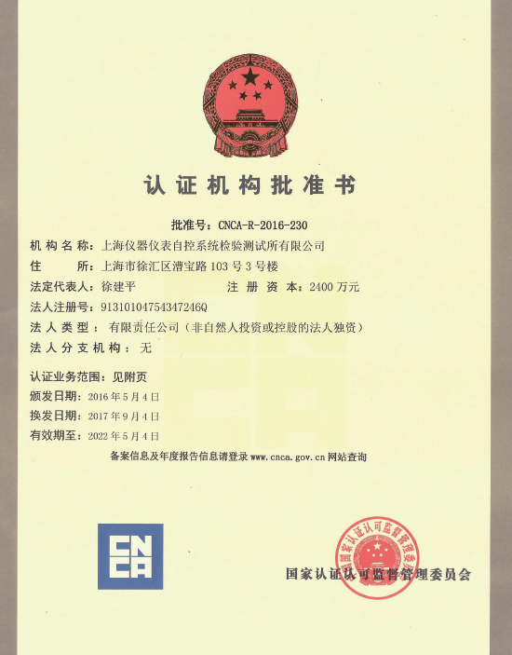
- Accreditation Certificate for ISO/IEC 17025

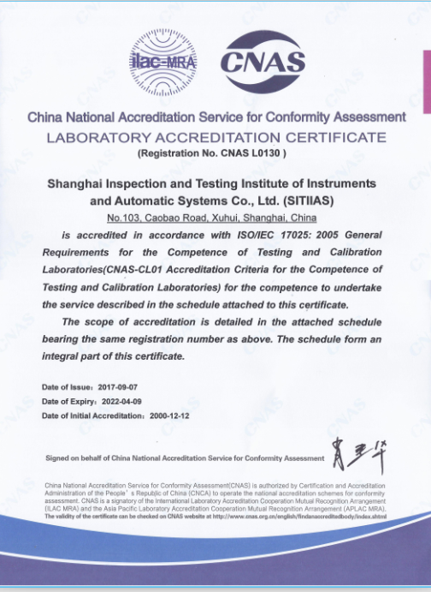

Annex E
Authorisation Certificate to operate a CB (incl. Ex)
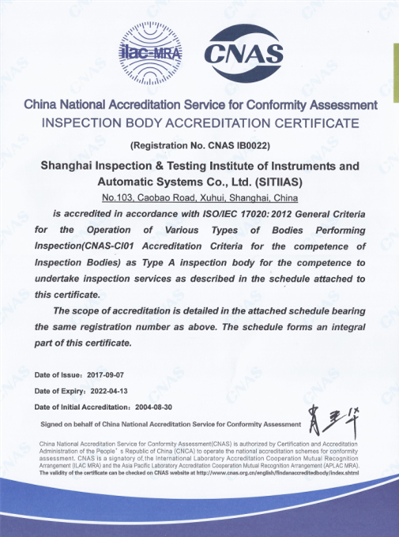

Annex F
Certificate to ISO 9001
