INTERNATIONAL ELECTROTECHNICAL COMMISSION SYSTEM FOR
CERTIFICATION TO STANDARDS RELATING TO EQUIPENT FOR USE
IN EXPLOSIVE ATMOSPHERES (IECEx SYSTEM)

Title: Scope Extension Assessment Report for LCIE, an Accepted ExCB and ExTL within the IECEx System, Equipment Scheme 02, to include IEC TS 60079-46, ISO 80079-36 and ISO 80079-37 in their scope.

To: Members of the IECEx Management Committee, ExMC

Introduction

Following an application for a scope extension by LCIE, to include IEC TS 60079-46, ISO 80079-36 and ISO 80079-37 within their scope, a special site assessment visit was arranged and conducted.

This report details the assessment findings of this scope extension with the IECEx
Assessment Team recommending the acceptance of the above scope extension.

It is now hereby submitted for voting by ExMC.

Please consider the report and return the completed voting form, separate Word
Document, to the Secretariat Chris Agius by 2018 08 17

Your speedy response to the voting process will be very much appreciated.

Chris Agius

IECEx Secretary

Address:  IECEx Secretariat  Australia Square  Level 33, 264 George Street  Sydney NSW 2000  Australia | Tel: +61 2 4628 4690  Fax: +61 2 46 27 5285  Email: chris.agius@iecex.com

IEC System for certification to standards relating to equipment for use in Explosive Atmospheres (IECEx System)

IECEx Assessment Report Form

IECEx Assessment Report Form for use by IECEx Assessment Teams to report Assessments conducted according to the IECEx Assessment Procedures of

- Operational Document IECEx OD 003-2 for the Certified Equipment Scheme
- Operational Document IECEx OD 016 for the Certified Service Facility Scheme
- Operational Document IECEx OD 022 for the IECEx Conformity Mark Licensing System

IECEx ExCB/ExTL assessment report for
LCIE

INTERNATIONAL
ELECTROTECHNICAL
COMMISSION

CONTENTS

1 Assessment information 5
1.1 Type of Body covered by this assessment: 5
1.2 Type of assessment: 5
1.3 Details of body 5
1.3.1 Country 5
1.3.2 Name of body 5
1.3.3 Name and title of nominated principal contact 5
1.4 Assessment information 5
1.4.1 Members of the assessment team 5
1.4.2 Place(s) of assessment 5
1.4.3 Assessment date(s) 5
1.5 Scope 5
1.5.1 ExCB scope for equipment certification scheme 5
1.5.2 ExTL scope 5
1.5.3 ExCB scope for Service Facilities Scheme 6
1.5.4 ExCB scope for ExMark Scheme 6
2 Common information 6
2.1 Legal entity of body 6
2.2 Financial support 6
2.3 History 6
2.4 Documentation 6
2.4.1 Quality manual 6
2.4.2 Procedures 6
2.4.3 Work instructions 6
2.4.4 Records (including test records where relevant) 6
2.4.5 Document change control 6
2.5 Confidentiality 6
2.6 Publications (Hard cover and Electronic) 6
2.7 Recognition and agreements 6
2.8 Internal audit and periodic management review 7
2.9 Contracting, subcontracting, use of other labs and use of other locations 7
2.10 Training and competence 7
2.11 Complaints and appeals (including appeals to IECEx) 7
2.12 Special facts to be noted 7
2.12.1 Supporting documentation 7
2.13 Recommendations 7
3 ExCB for IECEx Certified Equipment Scheme 8
3.1 Assessment references 8
3.2 ExCB persons interviewed 8
3.3 Associated ExTL(s) 8
3.4 Associated certification functions 8
3.5 National marks and certificates 8
3.6 Standards accepted 8
3.7 National differences to IEC standards 9
3.8 Organisation 9
3.8.1 Names, titles and experience of the senior executives 9
3.8.2 Name, title and experience of the quality management representative 9
3.8.3 Name and title of signatories for certification 9
3.8.4 Other employees in ExCB activity 9
3.9 Organizational structure 9
3.10 Administration 9
3.10.1 Administrative structure 9
3.10.2 Indemnity insurance 9
3.11 Resources 9
3.12 Committees (such as governing or advisory boards) 9
3.13 Certification operations 10
3.13.1 National approval/certification methods 10
3.13.2 Certification policy 10
3.13.3 Application for certification 10
3.13.4 Certification decision 10
3.14 Certificates issued 10
3.15 National accreditation 10
3.16 Assessment of manufacturers and issue of QARs 10
3.17 Comments (including issues found during assessment) 10
4 ExTL for IECEx Certified Equipment Scheme 11
4.1 Assessment references 11
4.2 ExTL persons interviewed 11
4.3 Associated ExCB(s) 11
4.4 Organisation 11
4.4.1 Names, titles and experience of the senior executives 11
4.4.2 Name, title and experience of the quality management representative 11
4.4.3 Other employees in ExTL activity 11
4.5 Organizational structure 11
4.6 Resources 11
4.7 Test reports issued 12
4.8 National accreditation 12
4.9 Calibration 12
4.10 Proficiency 12
4.11 Comments (including issues found during assessment) 12
Annex A Overall Organisation Chart of LCIE 13
Annex B Accreditation Certificate for ISO/IEC 17065 14
Annex C Accreditation Certificate for ISO/IEC 17025 16

Assessment information

Type of Body covered by this assessment:
ExCB for IECEx Certified Equipment Scheme | ✓
ExTL for IECEx Certified Equipment Scheme | ✓
ExCB for IECEx Certified Service Facilities Scheme
ExCB for IECEx Conformity Mark Licensing System

NOTE 1 ExCB - IECEx Certification Body
NOTE 2 ExTL - IECEx Testing Laboratory

Type of assessment:
Pre-assessment for candidate body
Initial assessment for candidate body
Surveillance
Re-assessment
Scope extension | ✓

Details of body

Country
FRANCE

Name of body
LCIE

Name and title of nominated principal contact
Name | Title | E-mail address
Marie-Elisabeth d'Ornano | Director of Certification | marie-elisabeth.dornano@lcie.fr

Assessment information

Members of the assessment team
Name | Role (modify as necessary)
Ron Webb | Lead assessor

Place(s) of assessment
LCIE – 33 Avenue du General Leclerc, FR 92260 Fontenay-aux-Roses, France

Assessment date(s)
31 May 2018

Scope

ExCB scope for equipment certification scheme
Number | Title | Scope
ISO 80079-36 Ed. 1 | Explosive atmospheres - Part 36: Non-electrical equipment for explosive atmospheres – Basic method and requirements | Extension
ISO 80079-37 Ed. 1 | Explosive atmospheres - Part 37: – Non-electrical equipment for explosive atmospheres - Non electrical type of protection constructional safety "c", control of ignition source "b", liquid immersion "k" | Extension
IEC TS 60079-46, Ed 1 | Explosive atmospheres - Part 46: Equipment assemblies | Extension

ExTL scope
The ExTL scope is the same as for the ExCB.

ExCB scope for Service Facilities Scheme
Not in scope

ExCB scope for ExMark Scheme
While a full re-assessment is planned for later this year, this assessment focused on the scope extension for ISO 80079 and IEC 60079-46 only.

Common information

Legal entity of body
While a full re-assessment is planned for later this year, this assessment focused on the scope extension for ISO 80079 and IEC 60079-46 only.

Financial support
While a full re-assessment is planned for later this year, this assessment focused on the scope extension for ISO 80079 and IEC 60079-46 only.

History
While a full re-assessment is planned for later this year, this assessment focused on the scope extension for ISO 80079 and IEC 60079-46 only.

Documentation

Quality manual
While a full re-assessment is planned for later this year, this assessment focused on the scope extension for ISO 80079 and IEC 60079-46 only. The quality manual has been updated to reflect OD280 for non-electrical equipment and assemblies.

Procedures
While a full re-assessment is planned for later this year, this assessment focused on the scope extension for ISO 80079 and IEC 60079-46 only. Specific procedures have been created for the non-electrical tests, even though these are very similar to the electrical ones.

Work instructions
While a full re-assessment is planned for later this year, this assessment focused on the scope extension for ISO 80079 and IEC 60079-46 only. Specific work instructions have been created for the non-electrical tests.

Records (including test records where relevant)
While a full re-assessment is planned for later this year, this assessment focused on the scope extension for ISO 80079 and IEC 60079-46 only.

Document change control
While a full re-assessment is planned for later this year, this assessment focused on the scope extension for ISO 80079 and IEC 60079-46 only.

Confidentiality
While a full re-assessment is planned for later this year, this assessment focused on the scope extension for ISO 80079 and IEC 60079-46 only.

Publications (Hard cover and Electronic)
While a full re-assessment is planned for later this year, this assessment focused on the scope extension for ISO 80079 and IEC 60079-46 only.

Recognition and agreements
While a full re-assessment is planned for later this year, this assessment focused on the scope extension for ISO 80079 and IEC 60079-46 only.

Internal audit and periodic management review
While a full re-assessment is planned for later this year, this assessment focused on the scope extension for ISO 80079 and IEC 60079-46 only. It was confirmed that the procedures also cover the new Standards listed under the scope extension request.

Contracting, subcontracting, use of other labs and use of other locations
While a full re-assessment is planned for later this year, this assessment focused on the scope extension for ISO 80079 and IEC 60079-46 only. No further subcontracting is made.

Training and competence
Competency records are maintained for those members of staff involved in non-electrical assessments and assemblies. Interviews were undertaken with staff to ensure that they had the required level of understanding. Training records for each staff member are comprehensive.

Complaints and appeals (including appeals to IECEx)
While a full re-assessment is planned for later this year, this assessment focused on the scope extension for ISO 80079 and IEC 60079-46 only.

Special facts to be noted

Supporting documentation
Copies of additional supporting information for this assessment have been provided to the applicant and the IECEx Secretariat. These are included in a site assessment report and include:
- Completed Technical Capability Document (TCD) for the 80079-36 and 80079-37 parts
- Assessor’s notes

Recommendations
Based on the assessment performed on 31 May 2018, LCIE is recommended for continued acceptance in the IECEx scheme as an ExCB and an ExTL with the following scope extension:

  - IEC 60079-46, ISO 80079-36 and ISO 80079-37
This is according to the scope of the standards listed in this document including the extension of scope.

Ron Webb
Lead Assessor
Date: 31 May 2018

ExCB for IECEx Certified Equipment Scheme

Assessment references
- IECEx02 IECEx Certified Equipment Scheme covering equipment for use in explosive atmospheres – Rules of Procedure
- OD003-2 Assessment, surveillance assessment and re-assessment of ExCBs and ExTLs operating in the IECEx 02, IECEx Certified Equipment Scheme
- OD005-2 IECEx Quality System Requirements for Manufacturers – Part 2: Audit Checklist. (This is available in a Word format for use by ExCBs)
- ISO/IEC 80079-34 Edition 1, Explosive atmospheres – Part 34: Application of quality systems for equipment manufacture
- OD009 Issuing of CoCs, ExTRs and QARs
- IECEx Document OD 025 Guidelines on the Management of Assessment and Surveillance programs for the assessment of Manufacturer’s Quality Systems in accordance with the IECEx Scheme
- OD0026 IECEx Certified Equipment Scheme – Guidelines for the qualification of Lead Auditor and Auditors, in accordance with the IECEx System
- ISO/IEC 17065, General requirements for bodies operating product certification systems
- IECEx Document OD17 Drawing and documentation guidance
- IECEx Technical Capability Documents (TCD)
- ExTAG decision sheets (DSs)
- OD 280 IECEx Certified Equipment Scheme – Guide to Certification of Non-electrical Equipment and Protective Systems
NOTE The latest editions of the above documents were applied

ExCB persons interviewed
Name | Position
Julien Gauthier | Certification Officer
Jérôme Reysson | Unit Manager
Mihai Demeter | Assessment Officer
Gaétan Arcana | Assessment Officer

Associated ExTL(s)
The ExTL is integral with the ExCB.

Associated certification functions
LCIE provides ATEX certificates in accordance with ATEX Directive 2014/34/EU and their operations are accredited to IEC/ISO 17065 by the National Accreditation Body.
LCIE is a Notified Body according to the ATEX directive 2014/34/EU.

National marks and certificates
LCIE ATEX certificates are accepted by the European commission and by European state regulators.

Standards accepted
Refer to OD 001 for the current scope. See clause 1.5 of this report for scope extension.

National differences to IEC standards
National differences to IEC standards are those differences listed in the latest version of the IECEx Scheme Bulletin.

Organisation

Names, titles and experience of the senior executives

Name | Title | Experience in Ex
Marie-Elisabeth Dornano | Director of Certification | 5 years

Name, title and experience of the quality management representative

Name | Title | Experience
Marc Lescure | Quality Manager | 25+ years

Name and title of signatories for certification

Name | Title | Comments
Marie-Elisabeth Dornano | Director of Certification
Julien Gauthier | Certification Officer
Didier Bourges | Manager of Certification Operations

Other employees in ExCB activity
Name | Title | Responsibility and Experience in Ex
As listed in the TCD

Organizational structure
See Annex A

Administration

Administrative structure
Sufficient administrative assistance is provided

Indemnity insurance
While a full re-assessment is planned for later this year, this assessment focused on the scope extension for ISO 80079 and IEC 60079-46 only.

Resources
Error: Reference source not found has an adequate number of staff for the current level of business. There are several experienced staff in Ex activities. This finding is based on interviews with persons involved in the assessment to ISO 80079-36 and 37 which showed they had sufficient knowledge of techniques used for the ignition hazard assessment.
The laboratory and offices are located in building which provides an adequate environment for the work. The testing equipment is suitable for the range of tests carried out in house.

Committees (such as governing or advisory boards)
While a full re-assessment is planned for later this year, this assessment focused on the scope extension for ISO 80079 and IEC 60079-46 only.

Certification operations

National approval/certification methods
While a full re-assessment is planned for later this year, this assessment focused on the scope extension for ISO 80079 and IEC 60079-46 only.

Certification policy
While a full re-assessment is planned for later this year, this assessment focused on the scope extension for ISO 80079 and IEC 60079-46 only.

Application for certification
While a full re-assessment is planned for later this year, this assessment focused on the scope extension for ISO 80079 and IEC 60079-46 only. It was confirmed that the procedures also cover the new Standards listed under the scope extension request.

Certification decision
While a full re-assessment is planned for later this year, this assessment focused on the scope extension for ISO 80079 and IEC 60079-46 only. It was confirmed that the procedures also cover the new Standards listed under the scope extension request.

Certificates issued
Number of certificates issued under since the introduction of ATEX Directive 2014/34/EU.
Standard numbers | Type of protection or other identifying information | Number of issued certificates (for last 2 years)
13463 series | Non-electrical equipment for use in potentially explosive atmospheres (ATEX) | 52
80079 series | Non-electrical equipment for use in potentially explosive atmospheres (ATEX) | 4

The above table represents significant experience to date with certification to non-electrical standards.

National accreditation
LCIE has French Accreditation by Cofrac to ISO/IEC 17065 as a certification body. The certificate is shown at Annex B of this report.
The link to the Cofrac accreditation site is: http://www.cofrac.fr/annexes/sect5/5-0014.pdf
The scope of this accreditation includes the national scheme for Ex Certificates which complies with the ATEX Directive 2014/34/EU.

Assessment of manufacturers and issue of QARs
LCIE has a procedure to addresses assessments of manufacturers. The report format includes all requirements from the IECEx Scheme together with ATEX requirements including ISO 80079-36 and ISO 80079-37.

For IECEx certification schemes a set of documented procedures is in place to enable surveillance to be carried out in accordance with the criteria of the certification systems.

Comments (including issues found during assessment)
The staff interviewed had a good understanding of the non-electrical standards ISO 80079-36 and ISO 80079-37 due to their experience with the EN13463-xx series, which were used as a basis for development of ISO 80079-36 and ISO 80079-37

ExTL for IECEx Certified Equipment Scheme

Assessment references
- IECEx02 IECEx Certified Equipment Scheme covering equipment for use in explosive atmospheres – Rules of Procedure
- IECEx OD003-2 Assessment, surveillance assessment and re-assessment of ExCBs and ExTLs operating in the IECEx 02, IECEx Certified Equipment Scheme
- IECEx OD009 Issuing of CoCs, ExTRs and QARs
- ISO/IEC 17025:2005 Edition 2, General requirements for the competence of testing and calibration laboratories
- IECEx Document OD17 Drawing and documentation guidance
- IECEx Technical Capability Documents (TCD)
- ExTAG decision sheets (DSs)
- OD 280 IECEx Certified Equipment Scheme – Guide to Certification of Non-electrical Equipment and Protective Systems
NOTE The latest editions of the above documents were applied.

ExTL persons interviewed
Name | Position
Julien Gauthier | Certification Officer
Jérôme Reysson | Unit Manager
Mihai Demeter | Assessment Officer
Gaétan Arcana | Assessment Officer

Associated ExCB(s)
The ExTL is integral with the ExCB

Organisation

Names, titles and experience of the senior executives

Marie-Elisabeth Dornano | Director of Certification | 5 years

Name, title and experience of the quality management representative

Name | Title | Experience
Marc Lescure | Quality Manager | 25+ years

Other employees in ExTL activity

Name | Title/responsibility | Experience in Ex and Ex h
As listed in the TCD

Organizational structure
See Annex A

Resources
LCIE has about 18 employees in the Ex operation.

Test reports issued
Number of test reports (ExTRs) issued under for the preceding years for each type of protection corresponds to the number of certificates issued shown in 3.14
Regarding Scope Extension for ISO 80079-36 and ISO 80079-37, the assessment team interviewed the relevant staff and found them to have a thorough understanding of the Standards and the assessment required.
A review of files relating to non-electrical Ex equipment (under the ATEX Directive) was also undertaken during the assessment and found to be satisfactory and complete with evidence that the concepts were well understood by the Staff.
The principle of risk assessment is also well understood

National accreditation
LCIE has accreditation from the French Accreditation body Cofrac according to ISO/IEC 17025:2005. A copy of the accreditation is attached at Annex C.
The link to the the Cofrac Accreditation site is: http://www.cofrac.fr/annexes/sect1/1-0311.pdf
The 17025 accreditation scope of LCIE include EN 13463 series which are the previous and European version of ISO 80079-36 and -37.

Calibration
The majority of test equipment is sent out for calibration by an external calibration facility. These calibration facilities are 17025 accredited.

Proficiency
LCIE partakes in the Proficiency testing organised by PTB.

Comments (including issues found during assessment)
Minor issues were found which were cleared to the satisfaction of the assessment team quickly during the visit.
These included the correct use of the ignition hazard assessment form.

- Overall Organisation Chart of LCIE

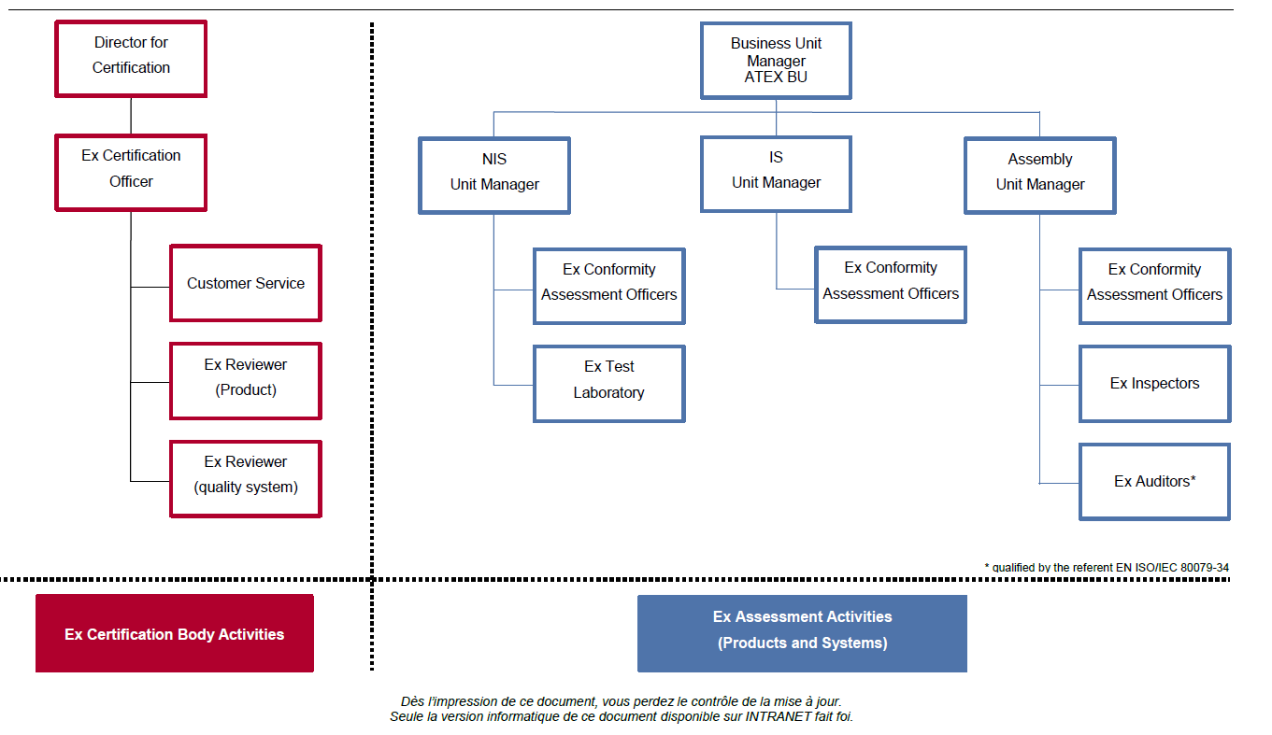
- Accreditation Certificate for ISO/IEC 17065
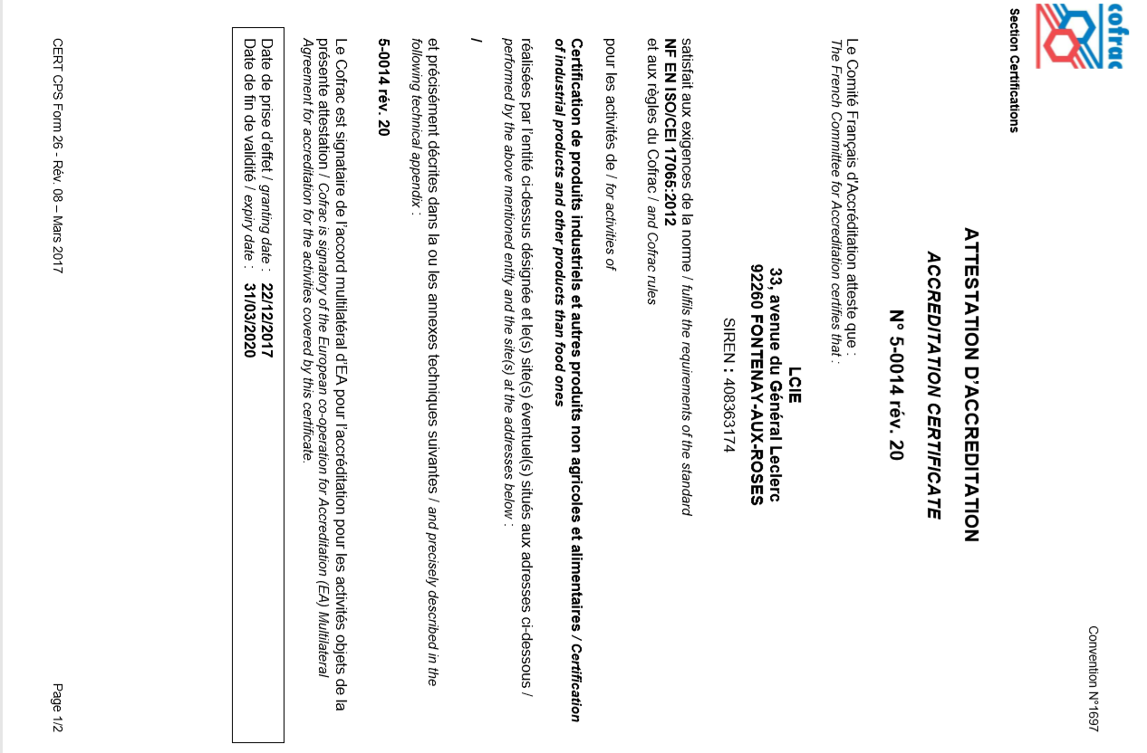
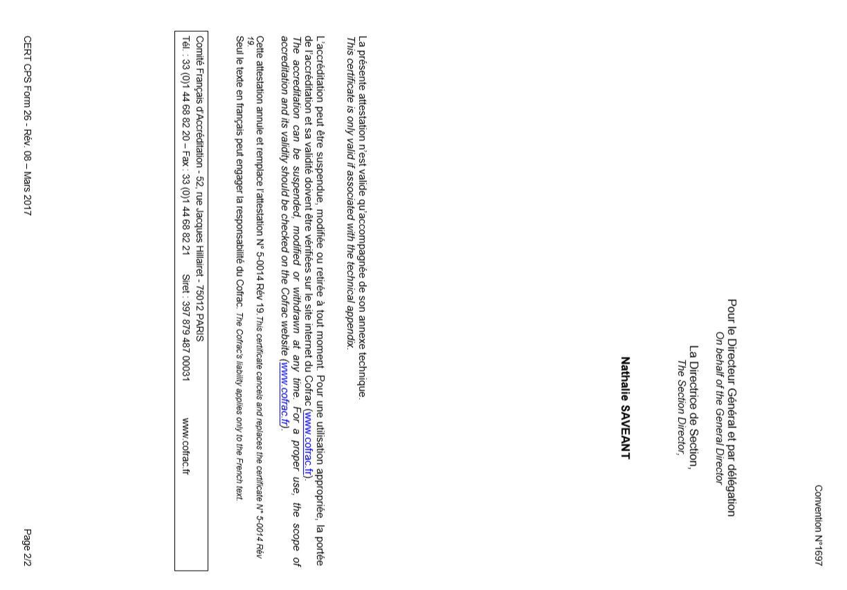

- Accreditation Certificate for ISO/IEC 17025
