INTERNATIONAL ELECTROTECHNICAL COMMISSION (IEC) SYSTEM
FOR CERTIFICATION TO STANDARDS RELATING TO EQUIPMENT FOR
USE IN EXPLOSIVE ATMOSPHERES (IECEx SYSTEM)

Ex Management Committee, ExMC

TITLE: IECEx System Report Card - 2018

INTRODUCTION

The Secretariat has prepared this document as an annual Report Card to IECEx Members on both the state of the IECEx System and progress on a number of matters since the 2017 IECEx ExMC meeting in Washington DC, such as:

- IECEx System Membership
- Statistics of issued IECEx Certificates of Conformity, ExTRs, QARs, FARs and PCARs
- Review of the IECEx System including review of Certificates and supporting documents
- Finances
- Promotional Activities
- Secretariat and General Technical Administration activities
- Inclusion of new item “Outline of activities/Decisions of the IECEx Executive”

This document is issued for information to members and is listed on the IECEx 2018 ExMC meeting agenda for noting and any necessary discussion.

Address:  IECEx Secretariat  Level 33, Australia Square  264 George Street  Sydney NSW 2000  Australia | Contact Details:  Tel: +61 2 4628 4690  Fax: +61 2 4627 5285  e-mail: info@iecex.com  http://www.iecex.com
IECEx System Report Card - 2018

- General Overview

Discussions and decisions from the 2017 series of IECEx Meetings in Washington DC set the tone and direction for further development, growth and expansion of the IECEx System and its Schemes.

The Secretariat is pleased to report on the following key points concerning IECEx operation since the 2017 IECEx meetings in Washington DC:

- At the time of preparing this report, Israel is recorded as the most recent Country to join IECEx and there is continued interest from various countries including Austria and Ireland
- Operation of the IECEx Certified Service Facilities Scheme, now starting to take traction, with 267 Certificates issued to date since Scheme commencement in late 2007
- Operation of the IECEx Certificate of Personal Competence (CoPC) Scheme also gaining traction with 2059 Certificates issued to date since Scheme commencement in late 2010. Of the 2059 issued Certificates, 246 have been issued already in 2018.
- Increased use of IECEx Unit Verification Certificates
- Promotion of the Publication from the United Nations, UNECE, Common Regulatory Objective for the Ex Sector continues to support IECEx
- Additional enhancements to the IECEx On-Line Certificate of Conformity System, to provide additional tools for ExCBs to assist in their management of surveillance activities of issued Certificates
- Additional Search Tools to the On-Line Certificate System, for both the Public viewer and ExCBs
- The marked increase in the demand and issue of IECEx Certificates of Conformity and Reports, as reported in 2008, 2009, 2010, 2011, 2012, 2013, 2014, 2015, 2016 and 2017, continues in 2018 with year on year growth being maintained.
- Continued processing of Scope extensions from ExTLs and ExCBs
- Promotion at Regional and International forums
- Greater involvement by industry, end-users and regulators
- An increase in the number of day to day industry inquiries being directed at the IECEx Secretariat – this is reflected in the increased e-mail traffic of the Secretariat
- Work on the expansion and update of the “IECEx Website” @ www.iecex.com

- Membership

IECEx System Membership, as of 30th June 2018 stands at:

- 33 Countries as members of the IECEx Management Committee, ExMC

- With four separate Certification Schemes
  - IECEx Certified Equipment Scheme (Rules = IECEx 02)
  - IECEx Certified Service Facilities Scheme (Rules = IECEx 03)
  - IECEx Conformity Mark Licensing System (Regulations = IECEx 04)
  - IECEx Certification of Personnel Competencies (CoPC) Scheme
(Rules = IECEx 05)
and the IECEx Recognised Training Provider Program (RTPP)

- IECEx Certified Equipment Scheme
  - 57 Accepted ExCBs (+ 5 Applicants)
  - 68 Accepted ExTLs (+ 5 Applicants)

- IECEx Certified Service Facilities Scheme
  - 16 Accepted ExCBs (+ 2 Applicants)

- IECEx Conformity Mark Licensing System
  - 16 Accepted License issuing ExCBs

- IECEx Certification of Personnel Competencies (CoPC) Scheme
  - 14 Accepted ExCBs (+ 2 Applicants)

- IECEx Recognised Training Provider Program (RTPP)
  - 20 Recognised Training Providers (RTPs) (+ 3 Applicants)

- Statistics – Certificates, Licenses and Reports

At 30th June 2018 there were 75,701 Issued IECEx Reports, Certificates and Licenses across all the following four IECEx Schemes compared with 65,490 for the same time last year (30th June 2017) – this represents an overall growth of 15.6%.

- The IECEx Certified Equipment Scheme, IECEx 02 (see Table 1A)
- The IECEx Certified Service Facilities Scheme, IECEx 03. (see Table 2)
- The IECEx Conformity Mark Licensing System, IECEx 04 (see Table 3)
- The IECEx Certification of Personnel Competencies (CoPC) Scheme, IECEx 05 (see Table 4)

The figure “Totals”, in Table 1A, show the total number of combined Equipment CoCs (Certificates of Conformity), ExTRs (IECEx Test Reports) and QARs (IECEx Quality Audit Reports) issued under the IECEx Certified Equipment Scheme. Table 1B shows a comparison between new Certificates (Issue 0) compared to supplementary issues of existing Certificates (i.e. changes to existing certificates, Issue 1 and above).

Figure 1A provides an overview trend of the number of Certificates and Reports issued under the IECEx 02 Scheme (Certified Equipment Scheme), while Figure 2 provides a breakdown of the percentage weighting of CoCs compared to ExTRs and QARs issued over the life of the IECEx System.

The conclusion drawn from these statistics is that the IECEx Certified Equipment Scheme is still experiencing significant and sustained growth. The following factors are seen as facilitating this growth:
- Penetration of new markets, such as the Gulf Region
- Industry’s recognition of the value that certification under an Internationally accepted Regime brings to risk mitigation as part of their compliance regime
- The increasing involvement by industry in the management and operation of IECEx
- The credibility of the IECEx System based on compliance to IEC Standards, a common assessment system for all ExCBs and ExTLs, and ongoing surveillance;
- Increased awareness and recognition of IECEx as “world's best practice” via the formal endorsement by the UNECE, as per new United Nations approved CRO publication, March 2011
- One set of operational procedures and reporting formats (i.e. the IECEx way of Ex Certification);
- The transparency of IECEx activities provided by the IECEx website and On-Line CoC system;
- A greater level of industry understanding of the IECEx system by way of promotion of IECEx by IECEx Officers and Members;
- A growing international awareness of the value of structured International Conformity Assessment Systems such as IECEx;
- The value of networking among all Ex experts including ExCBs and ExTLs and associated technical discussion forums provided, e.g. ExTAG;
- A dedicated technical Secretariat
3.1 IECEx 02 – IECEx Certified Equipment Scheme

Year ending Figures IECEx 02 Certified Equipment Scheme

Table 1A- Total number of IECEx Equipment CoCs and Reports issued
Total number of IECEx Equipment CoCs
Issued In  the Year of | CoCs | ExTRs | QARs | Total  CoCs & Reports | Drafts CoCs in the  System
2001 | 0 | 2 | 0 | 2 | 0
2002 | 0 | 4 | 0 | 4 | 0
2003 | 12 | 10 | 1 | 23 | 10
2004 | 98 | 61 | 43 | 202 | 115
2005 | 262 | 133 | 154 | 549 | 225
2006 | 563 | 909 | 387 | 1859 | 360
2007 | 931 | 906 | 386 | 2223 | 431
2008 | 1258 | 1166 | 350 | 2774 | 499
2009 | 1490 | 1347 | 712 | 3549 | 618
2010 | 2070 | 1897 | 947 | 4914 | 675
2011 | 2626 | 2143 | 966 | 5735 | 1000
2012 | 2680 | 2301 | 1019 | 6000 | 1150
2013 | 3104 | 2783 | 1027 | 6914 | 1286
2014 | 3562 | 3265 | 1246 | 8073 | 1461
2015 | 3904 | 3655 | 1353 | 8912 | 1583
2016 | 4093 | 3819 | 1459 | 9371 | 1921
2017 | 4129 | 3781 | 1949 | 9859 | 2048
@ 30 June 2018 | 2121 | 1963 | 654 | 4738
Totals | 32903 | 30145 | 12653 | 75701

Unit Verification Certificates
One hundred and fifty nine (159) IECEx Equipment Unit Verification Certificates have been issued since the 30th June 2017

Table 1B – Issue 0 CoCs (New Certificates as opposed to up issues)
expressed as % of all CoCs (Equipment Scheme)
Issue 0 CoCs expressed as % of all CoCs

Issued in the Year of | # All CoCs | # “Issue 0”  CoCs | “Issue 0” as % of all CoCs
2008 | 1258 | 693 | 55.1%
2009 | 1490 | 799 | 53.6%
2010 | 2070 | 1032 | 49.9%
2011 | 2626 | 1158 | 44.1%
2012 | 2680 | 1172 | 43.7%
2013 | 3104 | 1337 | 43.1%
2014 | 3562 | 1517 | 42.6%
2015 | 3904 | 1668 | 42.7 %
2016 | 4093 | 1721 | 42.0 %
2017 | 4129 | 1582 | 38.3 %
YTD @ 30 June 2018 | 2121 | 823 | 38.8 %

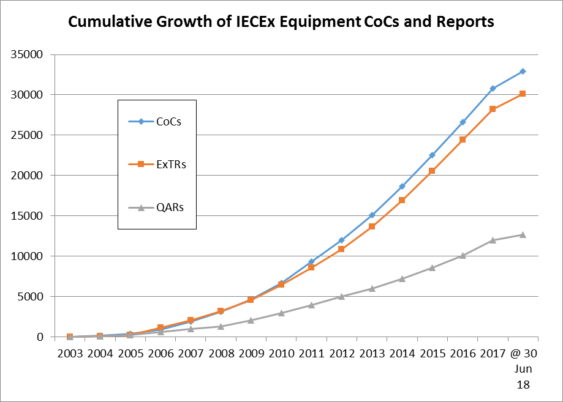
Figure 1A – Cumulative Growth of Issued IECEx CoCs, ExTRs and QARs for the IECEx Certified Equipment Scheme

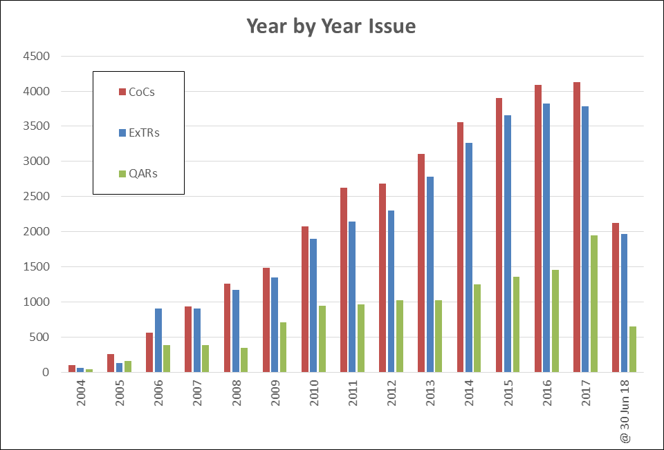

Figure 1B – Year-by-Year Growth of Issued IECEx CoCs, ExTRs and QARs for the IECEx Certified Equipment Scheme

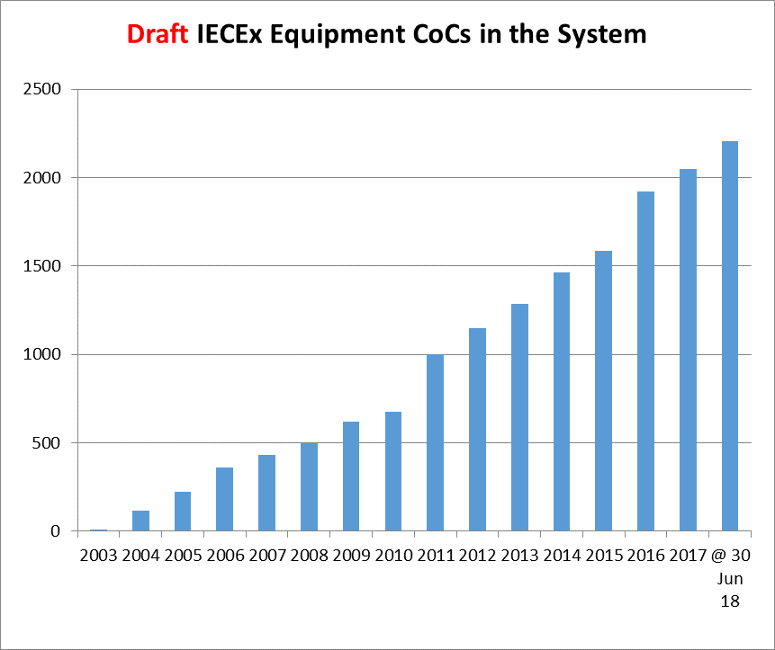

Figure 1C – Comparison of draft IECEx Equipment CoCs in the On-line System as indicative of future year on year growth of the Scheme

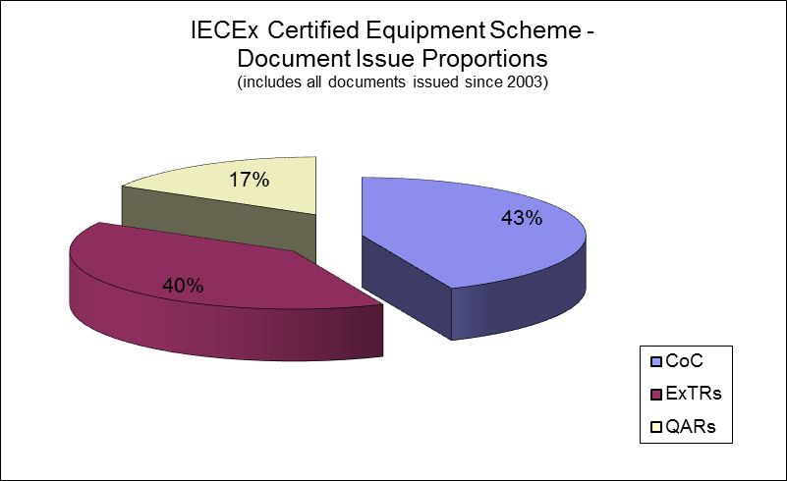

Figure 2 – CoCs, ExTRs, QARs Percentages

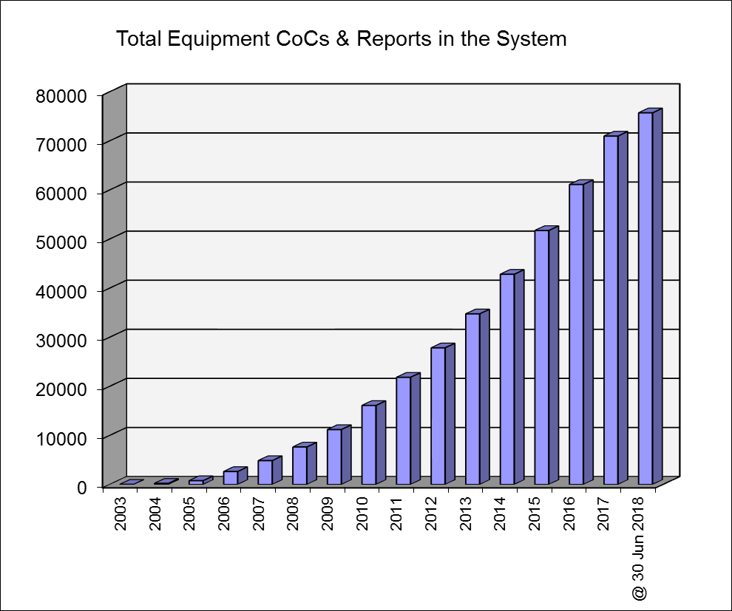

Figure 3 - Total IECEx Equipment Scheme CoCs, ExTRs and QARs at each Year end and to 30 June 2018.

3.2 IECEx 03 – IECEx Certified Service Facilities Scheme

Table 2 – Year End Figures IECEx 03 Certified Service Facilities Scheme

Total number of Certified Services CoCs issued
(commenced end 2007)

Issue In the Year of | CoCs | FARs | Total | Drafts in System
2007 | 3 | 4 | 7 | 0
2008 | 12 | 47 | 59 | 0
i2009 | 15 | 33 | 48 | 9
2010 | 26 | 42 | 68 | 7
2011 | 31 | 53 | 84 | 8
2012 | 21 | 22 | 43 | 9
2013 | 26 | 61 | 87 | 12
2014 | 23 | 65 | 88 | 1
2015 | 27 | 41 | 68 | 6
2016 | 24 | 47 | 71 | 10
2017 | 33 | 65 | 98 | 19
@ 30 Jun 18 | 20 | 34 | 54 | 17
Totals | 261 | 514 | 775

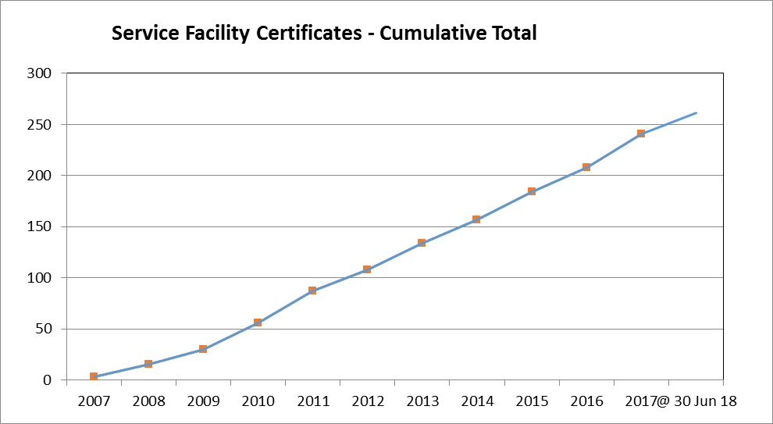

Figure 4A – Cumulative Total of IECEx Certified Service Facility Certificates at each Year end and to 30 June 2018

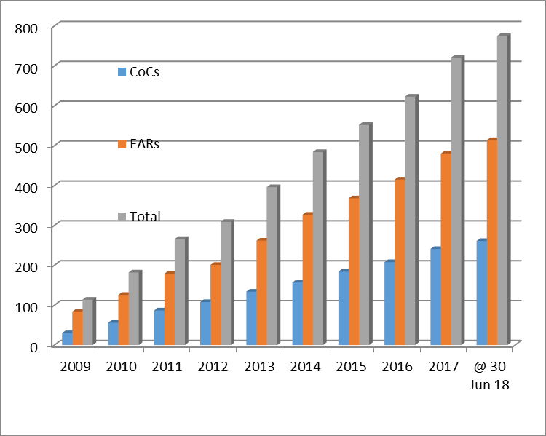

Figure 4B – Year-By-Year Growth of IECEx Certified Service Facility Certificates at each Year end and to 30 June 2018

3.3 IECEx 04 – IECEx Conformity Mark Licensing System

Table 3 – Year End Figures IECEx 04 Conformity Mark Licenses

Total number Conformity Mark Licenses issued
(System commenced 2009)
Issue in the Year of | Licenses | Number of CoCs attached to Licenses | Total Drafts in System
2009 | 4 | 10 | 0
2010 | 3 | 34 | 2
2011 | 7 | 83 | 3
2012 | 7 | 71 | 8
2013 | 2 | 2 | 9
2014 | 5 | 17 | 9
2015 | 2 | 2 | 9
2016 | 4 | 15 | 9
2017 | 0 | 0 | 9
YTD @ 30 June 2018 | 1 | 1 | 9
Totals | 35 | 235

3.4 IECEx 05 – Certificate of Personnel Competence Scheme

Table 4 – Year End Figures IECEx 05 Personnel Competence

Total number CoPC Certificates issued
(Scheme commenced late 2010)

Issue in the Year of | CoPC & EFOC Certificates | Total Drafts in System
2010 | 5 | 0
2011 | 59 | 0
2012 | 89 | 0
2013 | 169 | 3
2014 | 360 | 1
2015 | 327 | 8
2016 | 371 | 11
2017 | 403 | 17
YTD @ 30 June 2018 | 246 | 59
Totals | 2029

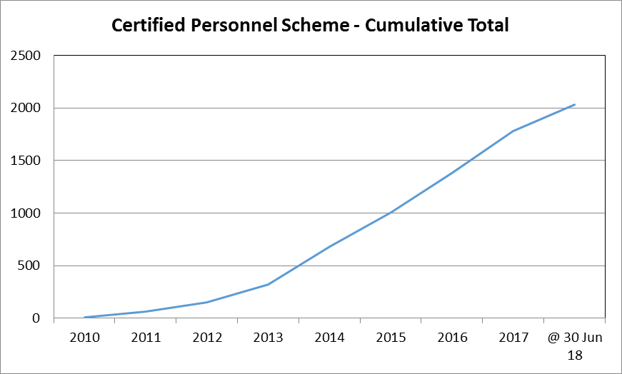

Figure 5A – Cumulative Total of IECEx Certified Personnel Certificates (CoPCs) at each Year end and to 30 June 2018

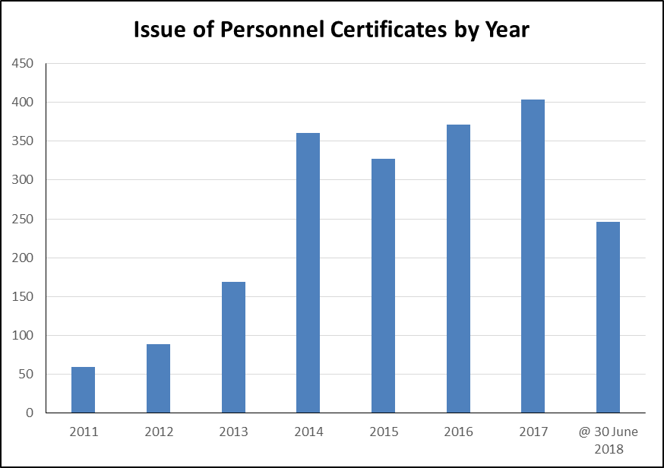

Figure 5B – Year-by-Year Growth of IECEx Certified Personnel Certificates (CoPCs) at each Year end and to 30 June 2018

- Surveillance of the IECEx System
To ensure integrity of the System a range of measures and activities are undertaken within IECEx – these include:
- Initial Assessment and qualification of all ExTLs and ExCBs seeking to join IECEx
- Surveillance of all ExTLs and ExCBs (annual confirmation of accreditation for those with accreditation and annual site visits for those without accreditation)
- Re-assessment applied to all ExTLs and ExCBs involving assessment on site to review Testing/Certification facilities, capabilities, practices and review of Certificates, ExTRs and QARs files
- Mid-Term Surveillance Assessments (introduced in 2014) involving sample reviews of ExTRs and QARs
- In-built security features of the IECEx On-Line Certificate system - ie. ExCBs can only issue Certificates covering Standards within their scope
- IT Tools to aid in the management control of issued CoCs, ExTRs, QARs, FARs and PCARs
- “Out of Date” QAR listing to assist ExCBs manage and control the on-going surveillance due dates plus an Administrator feature for the Secretariat to monitor performance of all ExCBs.
- Review of On-Line System for new Certificates issued in 2017 and 2018 YTD – the results of this review are outlined in 4.1 following.

4.1 Review of Online CoCs, ExTRs and QARs for second half of 2017 and 2018 Year to Date (2018 YTD)

Introduction
Separate to the sites assessment visits for Initial, Surveillance, Re-Assessment and Mid-Term purposes, the Secretariat also conducts regular reviews of online IECEx Equipment Certificates of Conformity. Since the 2017 meetings in Washington DC, random sampling of approximately 15% of all certificates originally issued or updated by ExCBs for the IECEx Certified Equipment, IECEx Certified Service Facility and IECEx Certified Person schemes was conducted as detailed below.

Objective
The objective of the Secretariat’s on-line review is to conduct a Quality check that the information on the sampled Certificates is correct and complete as compared to a defined criteria which include the following:

For Certified Equipment Certificates:
- Date of issue appropriate (i.e. not showing in the future)
- A Test Report number and File Reference included.
- Manufacturer name detail is consistent with their other certificates
- Manufacturer’s site street (not a PO Box) address given
- Any attached Annex has a reference to the CoC number
- Referenced Annexes are attached
- Conditions of Certification listed for “X” type Certificates
- Equipment description is clear and sufficiently detailed
- No major editorial mistakes (including linking to a draft ExTR)
- Correct links to valid ExTR and QAR
- Linked QAR is current
- Manufacturer on CoC matches ExTR
- Manufacturer on CoC matches QAR and QAR covers all manufacturing locations
- Standards listed on CoC matches Standards (including Edition #) on ExTR
- Scope of Certificate matches QAR and ExTR ExCB capability.
- Type of Protection Concept on CoC matches standards and QAR
- Where more than 1 issue exists that they are linked and changes explained on CoC
- Statement of Limitations is included in CoC for Component certificates (“U” type)
- Unit Verification Certificates have been denoted with “V” and include Serial #(s)

For IECEx Certified Service Facility Certificates:
- CoC Date of Issue OK (not into the future)
- CoC and FAR addresses for applicant are valid (not PO Box)
- Scope of Services is valid
- Listed FAR is valid (ie. Is relevant and not expired)
- FAR Facility same as audited site
- FAR Details of change are specified (where appropriate)
- FAR specifies issuing ExCB
- CoC linked to multiple FARs (with some expired)

For IECEx Certified Person Certificates:
- Name on CoPC same as on PCAR
- CoPC is current / valid
- Scope of Competence Units same on CoPC as on PCAR
- Listed PCAR is valid (ie. Not expired)
- Photograph is “recognizable”
- CoC linked to draft PCAR

Certificates and Reports reviewed
The following quantities of IECEx Certificates (representing an approximate sample of 15% of issued Certificates) selected at random from all those published in the second half of 2017 and 2018 YTD were audited against the elements listed above:
- 862 x issued IECEx Equipment CoCs
- 28 x IECEx Service Facility CoCs (with zero issues found)
- 98 x IECEx Certified Person CoCs (with issues found with 3 (incorrect up-issue process))

The results of the audit of IECEx Certified Equipment Scheme Certificates follow:

Item | Previously observed Certificate Deficiency as Review Criteria  for issued Certified Equipment Certificates reviewed. | # of CoCs with Deficiency
A | Date of issue NOT appropriate (i.e. showing in the future) | 0
B | A Test Report number or File Reference NOT included | 0
C | Manufacturer name detail NOT consistent with their other certificates | 0
D | Full Manufacturer’s site street address NOT provided (eg. a PO Box used) | 2
E | Attached Annex(es) do NOT reference the CoC number | 1
F | Referenced Annexes are NOT attached | 0
G | “Specific Conditions of Use” details NOT specified for “X” type Certificates | 7
H | Equipment description is NOT clear and sufficiently detailed | 8
I | Major editorial mistakes | 4
J | CoC is NOT correctly linked to valid ExTR and/or QAR (main issue observed was linking of an issued CoC to a draft ExTR) | 1
K | Linked QAR is NOT current | 4
L | Manufacturer on CoC does NOT match ExTR details | 1
M | Manufacturer on CoC does NOT match QAR details and/or QAR(s) does NOT cover all manufacturing locations listed on CoC | 6
N | Standards listed on CoC do NOT match Standards (including Edition #) on ExTR (main issue observed was CoC citing later Edition than ExTR) | 16
O | Scope of Certificate exceeds QAR and ExTR issuing ExCB’s capability | 0
P | Type of Protection Concept on CoC does NOT match standards and QAR | 2
Q | CoC Issues subsequent to Issue 0 are NOT linked and/or details of changes between Issues are NOT detailed on subsequent CoC | 2
R | “Statement of Limitations” details NOT included in CoC for Component certificates (“U” type) | 6
S | Unit Verification Certificates have NOT been denoted with “V” and/or do NOT include Serial #(s) for certified units of product | 0

In summary:
- Issued IECEx Certified Equipment Certificates with zero issues = 800
- Issued IECEx Certified Equipment Certificates with one issue = 60
- Issued IECEx Certified Equipment Certificates with multiple issues = 2
- % of IECEx Certified Equipment Certificates audited with at least one issue = 6.9%
- % of IECEx Certified Equipment Certificates audited with multiple issues = < 1%

Action by Secretariat:
The Secretariat have referred issues raised to the respective ExCBs for whom have been responsive to correct the issues raised. Some of the issues raised have led to inclusion in the ExTAG training session and discussions for 2018.

Conclusion
The results of this review show a slight improvement than for the same period in 2017 (where 7.7% of Equipment Certificates audited had one issue) and identifies a number of areas that require additional attention. The ExCBs observed to have issues with particular Certified Equipment Certificates have been very responsive in addressing these and proactive in taking action to prevent future recurrence.

In addition, the Secretariat is assisting ExCBs with general housekeeping of the IECEx on-line database including management of out of date QARs and deleting obsolete draft certificates and ExTRs. If quality issues are identified with ExCBs CoCs/QARs being developed, then a report is generated and provided to the Lead Assessor prior to surveillance or re-assessment audits so these items can be investigated further.

- IECEx Achievements since 2017 IECEx Meetings
Significant achievements since the 2017 ExMC Meeting include:

- Revised System + Scheme Rules
Document No. | Title
IECEx 01-S  Ed 1.0 | IECEx Supplement (Ed 1.0) to IEC CA 01
IECEx 02  Ed 6.1 | IEC System for Certification to Standards relating to Equipment for use in Explosive Atmospheres (IECEx System)IECEx Certified Equipment Scheme covering equipment for use in explosive atmospheres – Rules of Procedure
IECEx 03-0  Ed 1.0 | IECEx Certified Service Facilities Scheme Part 0: General Rules of Procedure
IECEx 03-2  Ed 1.1 | IECEx Certified Service Facilities Scheme – Part 2: Selection of Ex equipment and design of Ex installations – Rules of Procedure
IECEx 03-3  Ed 1.1 | IECEx Certified Service Facilities Scheme – Part 3: Ex installation and initial inspection – Rules of Procedure
IECEx 03-4  Ed 2.0 | IECEx Certified Service Facilities Scheme – Part 4: Ex inspection and maintenance – Rules of Procedure
IECEx 03-5  Ed 1.1 | IECEx Certified Service Facilities Scheme – Part 5: Repair, overhaul and reclamation of Ex equipment – Rules of Procedure
IECEx 05  Ed 4.1 | IEC System for Certification to Standards relating to Equipment for use in Explosive Atmospheres (IECEx System) IECEx Scheme for Certification of Personnel Competence for Explosive Atmospheres – Rules of Procedure

- New and Updated Publications of IECEx Operational Documents and Guides
Document No. | Title
IECEx OD 002 Ed 1.0 | Tasks and responsibilities delegated to the IECEx Executive
IECEx OD 003-1 Ed 2.0 | Assessment Procedures for IECEx acceptance of Candidate Accepted Certification Bodies (ExCBs) and Ex Testing Laboratories (ExTLs) –  Part 1: Appointment and Surveillance of IECEx appointed Assessors
IECEx OD 003-1 Ed 3.0 | Assessment Procedures for IECEx acceptance of Candidate Accepted Certification Bodies (ExCBs) and Ex Testing Laboratories (ExTLs) –  Part 2: Assessment, surveillance assessment and re-assessment of ExCBs and ExTLs operating in the IECEx 02, IECEx Certified Equipment Scheme.
IECEx OD 009 Ed 4.1 | Operational Document - Procedures for the Issuing of IECEx Certificates of Conformity, IECEx Test Reports and IECEx Quality Assessment Reports.
IECEx OD 010-2 Ed 2.0 | Operational Document - Guidance for the development, compilation, issuing and receipt of ExTRs Part 2: Procedures and guidance.
IECEx OD 011-1 Ed 5.1 | Guidance on Use of the IECEx Internet based "On-Line" Certificate of Conformity System Part 1: General requirements
IECEx OD 024 Ed 2.0 | IECEx Rules of Procedure covering testing, or witnessing testing at a manufacturer’s or user’s facility
IECEx OD 025 Ed 3.1 | Guidelines on the Management of Assessment and Surveillance programs for the assessment of Manufacturer’s Quality System, in accordance with the IECEx Scheme
IECEx OD 026 Ed 3.0 | Guidelines for the qualification of Lead Auditor and Auditors, in accordance with the IECEx System.
IECEx OD 202 Ed 2.0 | IECEx Testing and Assessment Group (ExTAG) IECEx Proficiency Testing Program.
IECEx OD 204 Ed 1.0 | Mid-term Assessment Report Form according to Section 3 of IECEx Operational Document OD 003-2
IECEx OD 205 Ed 1.0 | IECEx Checklist for the Review of IECEx CoCs, ExTRs, QARs
IECEx OD 206 Ed 1.0 | IECEx Assessment Feedback Form
IECEx OD 207 Ed 1.0 | Guidance on the Retention of Records
IECEx OD 208 Ed 1.0 | IECEx Certified Equipment Scheme – IECEx Quality System Requirements for Manufacturers – Audit Checklist Ed 1.0
IECEx OD 209 Ed 1.0 | Requirements and Guidelines for the Suspension, Cancellation and Reinstatement of Certificates of Conformity
IECEx OD 313-4 Ed 2.0 | IECEx Certified Service Facilities Scheme – Part 4: Ex inspection and maintenance - Assessment and Certification of Service Facilities providing Ex installations related services – Procedures
IECEx OD 314-4 Ed 2.0 | IECEx Certified Service Facilities Scheme – Part 4: Ex inspection and maintenance  Quality Management System requirements for IECEx Service Facilities providing Ex installations related services
IECEx OD 316-4 Ed 2.0 | IECEx Certified Service Facilities Scheme –Part 4: Ex inspection and maintenance Assessment procedures for IECEx acceptance of Candidate Certification Bodies(ExCBs) for the purpose of issuing IECEx Certificates to Ex Service Facilities providing Ex installations related services
IECEx OD 316-5 Ed 1.1 | IECEx Certified Service Facilities Scheme – Part 5: Repair, overhaul and reclamation of Ex equipment. Assessment procedures for IECEx acceptance of Candidate Certification Bodies (ExCBs) for the purpose of issuing IECEx Certificates to Ex Service Facilities involved in the repair, overhaul and reclamation of Ex equipment
IECEx OD 501 Ed 3.1 | IECEx Scheme for Certification of Personnel Competence for Explosive Atmospheres – Assessment procedures for IECEx acceptance of Certification Bodies (ExCBs) for the purpose of issuing and maintaining IECEx Certificates of Personnel Competence (CoPCs)
IECEx OD 503 Ed 4.1 | IECEx Scheme for Certification of Personnel Competence for Explosive Atmospheres - ExCB Procedures for issuing and maintaining IECEx Certificates of Personnel Competencies
IECEx OD 506 Ed 1.1 | Guidance on the use of the IECEx Certificates of Personnel Competence Scheme’s Assessment Question Bank by ExCBs
IECEx OD 507 Ed 1.0 | Check list for assessment to ISO/IEC 17024: 2012
IECEx OD 521 Ed 3.0 | IECEx Scheme for Certification of Personnel Competence for Explosive Atmospheres - IECEx Recognised Training Provider Program

- 2018 series of IECEx Operational Meetings
The 2018 series of IECEx Operational Meetings were held in Weimar, Germany over 18th to 22nd June 2018 hosted by Germany National Committee Deutsches Komitee der IEC/IECEx and R. Stahl. The meetings schedule is outlined below:

Monday  18th June | Tues  19th June | Wed  20th June | Thurs  21st June | Fri  22nd June
 | ExSFC WG5 | ExMC WG1 and WG5 | ExPCC | ExMC WG13
 | ExSFC |  |  | IECEx  EXECUTIVE
 |  |  | Cybersecurity Workshop
 | ExMarkCo | ExPCC WG2 | ExMC WG4
ExTAG WG6 | ExMC WG2 | ExPCC WG3

Outcomes from these meetings serve as input to the 2018 ExMC and ExTAG meetings.

- Scheme Promotional Activities
As part of the IECEx promotion and marketing strategy, the IECEx Executive and Secretariat continue in delivering presentations at key events in addition to supporting IECEx experts in their national and regional promotion of IECEx. The following are examples of recent or upcoming promotional activities of the IECEx System:
- Industry Seminar, Jakarta, Indonesia – January 2018
- 2018 PCIC Middle East participation and presentation – February 2018
- Attendance at and Presentation to IEC TC31 CAG Meeting, Split – April 2018
- 2018 IECEx International Conference, Split, Croatia – April 2018
- 2018 IECEx International Conference, Jakarta, Indonesia – August 2018
- Presentation at PETRONAS Electrical Engineers Forum – August 2018
- Presentation at Hazardous Area Conference, Melbourne Australia – Sept 2018
- 2019 PCIC Middle East participation and presentation – February 2019
- IECEx RTP Forum, Netherlands - April 2019
- Monthly news articles in all IEC e-Tech on-line magazines, library maintained at http://www.iecex.com/news_releases.htm
- Regular news articles published in HazardEx prepared by IECEx experts including Thorsten Arnhold, Ron Sinclair, Jim Munro and others

The 2018 IECEx International Conference held in partnership with the United Nations, UNECE and the Croatian Standards Institute is worth special mention and we are pleased to report on the successful event that was held on 23rd April 2018 at the Le Meridien Hotel in Split, Croatia following the TC31 Meetings series. Our thanks to Mr Kelava and the staff of Fiditas for their assistance with organizing this event that was attended by 136 delegates and generously supported by nine sponsors.

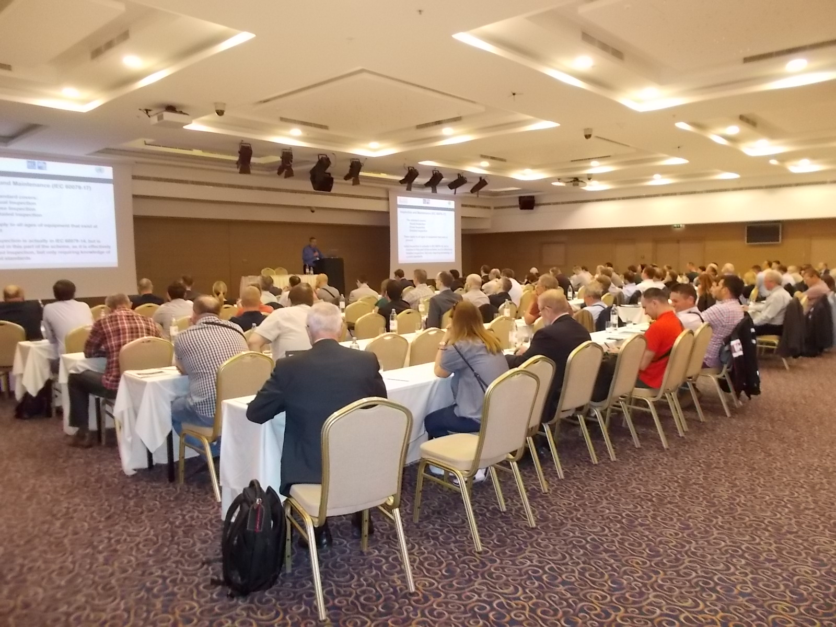

There were excellent presentations given, ranging from Regulations, Standards, Conformity Assessment to practical applications of Standards and IECEx and included end user feedback. An overview presentation from the SC31J Chair Neil Dennis on TC 31 Standards and current and possible future work was well received. A representative from the United Nations, UNECE delivered a presentation on why UNECE endorses International Standards such as those from IEC TC 31 and the IECEx Schemes.

The conference website is maintained throughout 2018 with pdf copies of presentations available for download along with the list of sponsors.

This has been the fifth such event ran by IECEx and provides an excellent promotional opportunity for IEC, IECEx and the many companies and persons that hold IECEx Certification.

At the time of preparing this report planning was underway for the sixth IECEx International Conference and the second for 2018 to be held in Jakarta, Indonesia on 8th & 9th August for an expected 250 delegates.

The IECEx Chairman, Executive and Secretariat remain available to provide any additional information on these items or assistance with the preparation of any presentations that Members may be involved with.

- Secretariat and General Technical Administration
7.1 Day to day duties of the Technical Secretariat can be broadly categorized as:
- Processing applications and managing assessments of new bodies and re-assessment of existing bodies
- Processing the applications of Scope extensions, e.g. new editions of Standards and other changes, e.g. name changes of existing bodies along with their maintenance via surveillance and re-assessments
- Support to ExCBs in the day to day use of the IECEx On-Line CoC System
- Revision and up-dating of IECEx Schemes rules and Operational Documents and forms
- IECEx Schemes development and Growth across all IECEx Schemes
- In conjunction with Chairman and Officers, IECEx System regular reporting to CAB and participation in CAB Working Groups
- Respond to general inquiries coming directly from industry (increasing)
- Day to day management of System finances, in conjunction with Treasurer and Executive

In noting the above, the Secretariat wishes to draw Members attention to the increased demands on the Secretariat in dealing with inquiries concerning Ex Certification and Approvals being received direct from the market.

The Secretariat Team consists of a mix of both Technical and Administrative Staff to cover the day to day management, technical and admin support required to maintain functioning of the IECEx System.

  - As an indicator of the IECEx System development and growth, since the first Report card issued in 2008 IECEx Paris meetings, the following additional statistics are provided:
General items prepared and issued according to the day to day management and operation of the IECEx System are provided below with a comparison to the figures reported at the 2009, 2010, 2011, 2012, 2013, 2014, 2015, 2016 and 2017 presented in ExMC/544/R, and ExMC/621/R, ExMC/699/R, ExMC/749/R, ExMC/859/R, ExMC/938/R, ExMC/1008/R, ExMC/1159/R and ExMC/1234/R

ITEM | 2011  (ExMC/699/R) | 2012  (ExMC/749/R) | 2013  (ExMC/859/R) | 2014  (ExMC/938/R) | 2015  (ExMC/1008/R) as updated for full year | 2016 (ExMC/1159/R) as updated for full year | 2017  (ExMC/1234/R) as updated for the full year | 2018 @ 30 June
Committee Documents Prepared and Issued¹ | 148 | 152 | 153 | 168 | 167 | 184 | 192 | 62
Operational Documents  (new or revised) | 13 | 5 | 18 | 21 | 11 | 8 | 21 | 4
ExTAG Decision Sheets Issued | 6 | 6 | 11 | 5 | 19 | 2 | 6 | 1
IECEx Guides (new or Revised) | 1 | 3 | 0 | 4 | 0 | 1 | 3 | 0
IECEx Scheme Rules  (new or revised) | 3 | 2 | 5 | 3 | 2 | 2 | 8 | 0
Others, e.g. News articles | 32 | 23 | 11 | 17 | 15 | 12 | 17 | 7
Total IECEx Items issued ² | 203 | 191 | 198 | 218 | 214 | 209 | 247 | 74
¹ Comprises ExMC, ExTAG, ExMarkCo, ExPCC
² Total excludes other items such as reports to CAB and participation in CAB and related Working Groups

7.3 E-mail Traffic, handled by Secretariat (excluding those dealt with by IECEx Chairman, Officers, WG Conveners, Members and Assessors):
The following level of e-mail traffic was handled by the IECEx Secretariat and does not include additional mails dealt with by the IECEx Chairman, Officers and Assessors. These figures are provided as a guide to IECEx Members of the levels of IECEx activity and show a constant level of e-mails in comparison with 2009, 2010, 2011, 2012, 2013, 2014, 2015, 2016, 2017 and 2018 figures.

ITEM | 2011  (ExMC/699/R) | 2012  (ExMC/749/R) | 2013  (ExMC/859/R) | 2014  (ExMC/938/R) | 2015  (ExMC/1008/R) as updated for the full year | 2016 (ExMC/1159/R) as updated for the full year | 2017 | 2018 @ 30 June
Total E-mail Traffic of the IECEx Secretariat | 18,880 | 19,660 | 21,055 | 22,812 | 23,106 | 24,872 | 26,783 | 13,842
* Out of office or other miscellaneous e-mails have been filtered and are excluded from above figures

7.4 Management of Assessments + Applications for Scope extensions – all IECEx Schemes.

ITEM | 2010  (ExMC/621/R) | 2011  (ExMC/699/R) | 2012  (ExMC/749/R) | 2013  (ExMC/859/R) as updated for the full year | 2014  (ExMC/938/R) as updated for the full year | 2015  (ExMC/1008/R) as updated for the full year | 2016  (ExMC/1159/R) as updated for the full year | 2017 + YTD Jun 2018
Site assessments | 14 | 17 | 23 | 19 | 25 | 31 | 12 | 53
Scope extensions | 42 | 89  Standards  / Units  43 Applications | 81  Standards  / Units  38  Applications | 61  Standards  / Units  30  Applications | 46  Standards  / Units  28  Applications | 188  Standards  / Units  104  Applications | 28  Standards  / Units  14  Applications | 206  Standards  / Units  67  Applications
Mid-term Surveillance  Audits |  |  |  |  | 6 | 13 | 4 | 17

The above Table outlines the number of IECEx site Assessments conducted on Ex Certification Bodies and Ex Test Laboratories for Initial, Surveillance, Re-assessments and Mid-term purposes.

Following the ExMC Decision during the 2013 Fortaleza meeting to introduce a “mid- term” surveillance audits of ExCBs and ExTLs, the IECEx Secretariat commenced the implementation of this decision during 2014 using procedures and criteria detailed in IECEx Operational Document OD 003-2. Members are reminded that these mid-term surveillance audits are focused on the re-assuring of confidence in the technical capability of the Test Lab and Certification Body by focusing the assessment on issued ExTRs and QARs as well as the Certificates issued. The main purpose is to establish whether or not the scheduled five year re-assessment should be brought forward on the basis of any issues identified OR that it may remain as originally scheduled.

The Secretariat is pleased to report on the excellent cooperation with ExCBs and ExTLs noting that of the Mid-term assessments conducted to date there are no issues raised that require notification to ExMC other than to advise that following Mid-term surveillance visits the technical assessors have not raised any major issues that bring into question either the on-going acceptance of the ExTL or ExCB nor the need to bring forward the five year planned re-assessment. Other Mid-term assessments are currently underway.

- Finances
8.1 Overview
The sound financial performance of IECEx is reported in the 2017 Audited Accounts, ExMC/1362/DV. In summary income and expenditure were generally according to the approved 2017 Budget, with a final result to achieve an annual Surplus of CHF 162’944 being above budget predictions. The IECEx General Reserve at end of 2017 now sits at CHF 2’075’980.

8.2 Invoices Issued / Processed since 2017 ExMC Meeting
The day to day management of financial management activities for the IECEx system are detailed in the following table of invoices and statements being issued as well as monitoring the receipt of payments

Documents | Reported  for 2013 | Reported for 2014 | Reported for 2015 | Reported for 2016 | Reported for 2017 | Reported for 2018 YTD
Invoices issued – MB Annual Fees | 33 | 33 | 36 | 37 | 40 | 40
Statements Issued – CoC Fees | 83 | 89 | 100 | 108 | 109 | 55
Invoices Issued – CoC Fees | 75 | 76 | 86 | 92 | 92 | 46
Invoices Issued – Application Fees | 2 | 6 | 19 | 15 | 7 | 2
Invoices Issued – Assessment Fees | 14 | 18 | 48 | 35 | 40 | 14
Invoices Issued – Conference Sponsor | 0 | 0 | 0 | 0 | 13 | 9
Invoices Issued – RTP Annual Fees | 0 | 0 | 0 | 0 | 12 | 16
Invoices processed / Central Approval – Assessor Charges | 50 | 55 | 53 | 50 | 72 | 23
TOTAL Invoices issued and processed | 257 | 277 | 342 | 337 | 385 | 205

In noting the following:
- overall response to on-time payment of invoices by Members generally good

We are pleased to advise that there are no specific issues concerning finance at this time. A further update report will be given during the 2018 ExMC meeting by the Treasurer.

9 IECEx Executive – Activities and Decisions between meetings
According to Members of the IECEx Executive are shown at https://www.iecex.com/information/executive/ in accordance with the IECEx Basic Rules (IEC CA 01 + IECEx 01-S).

The IECEx Executive provide immediate support to the IECEx Executive Secretary and Secretariat in the day to day operation of the IECEx System and its Schemes along with making operational decisions as delegated to them by the ExMC. Their task and responsibilities are detailed in IECEx Operational Document OD 002 available at https://www.iecex.com/publications/operational-od/

Matters dealt with by the IECEx Executive since the 2017 ExMC Washington meeting are covered by the IECEx Executive Report, ExMC/1415/R with the following items highlighted below:-

- Review of Actions items from 2017 ExMC meeting
- Oversight of publication of OD 002 “Tasks and Responsibilities of the IECEx Executive
- Conversion of ExMC WG4 to a permanent Group regarding IECEx Assessments, document ExMC/1376/DV to be considered by ExMC
- Regulatory matters and a proposal from DE to re-activate ExMC WG8
- Review of IECEx Finances and preparation of a preliminary Draft 2020 Budget ExMC/1404/CD and review of OD 019 fees ExMC/1280A/DV for consideration by ExMC
- Consideration and support for investigating possible cooperation with OIML and formation of a Joint WG
- Oversight of Committees reporting to ExMC
- Consideration of Promotional activities

A separate report on the activities of the IECEx Executive are contained in ExMC/1415/R listed for noting and discussion at the 2018 ExMC Cannes meeting.

No other decisions outside those detailed above and in their roles and responsibilities were taken since the 2017 ExMC meeting.

10. Concluding Remarks
IECEx continues to enjoy significant and sustained growth in both exposure and demand for its services. Despite impressive annual growth and the following indicators of continued growth in the future:
- Growth in number of Certificates and Reports
- Growth in income, mainly from certificate fees

IECEx continues to maintain a conservative approach to budgetary planning.

The instant and “On-Line” nature of the IECEx Certification system based on electronic format master controlled certificates coupled with the increased industry involvement in the Scheme’s operation are seen as a significant drivers of interest and demand for IECEx. It is worth noting that Certificates issued by ALL IECEx Certifiers are found in the one single location as opposed to the need to search individual ExCB websites.

The continued growth and success of IECEx is founded on the solid participation by various sectors of industry in the day to day management of the IECEx System via participation in ExMC, its Committees and the various Working Groups. Over recent years we have seen a growing level of this industry participation, especially from end-users and also regulators as well as manufacturers and Ex repairers. This participation and contribution is a key ingredient to the success that the IECEx community continues to enjoy.

While acknowledging the growth in demand for IECEx Services, maintaining credibility of the IEC and IECEx Brand is paramount and is on “top of mind” of both the IECEx Executive and the Secretariat.

To this point the Secretariat acknowledges, with gratitude, the diligent leadership of the IECEx Chairman, supported by the IECEx Executive along with Conveners of the many expert Working Groups and their experts all of whom are vital to enable IECEx to continue in its quest to serve the international Ex community.

Chris Agius
IECEx Executive Secretary
July 2018

