INTERNATIONAL ELECTROTECHNICAL COMMISSION (IEC) SCHEME
FOR CERTIFICATION TO STANDARDS RELATING TO EQUIPMENT FOR
USE IN EXPLOSIVE ATMOSPHERES (IECEx SCHEME)

Title: IECEx On-Line QAR Management System: ExCBs-QARs out of date and ExCBs-CoCs with QARs out of date.

Circulation: All ExCBs, IECEx Executive

IECEx SECRETARIAT NOTICE

IECEx Certification Bodies, ExCBs are reminded of their obligations according to the IECEx 02 Rules and Procedures, to ensure that surveillance audits of manufacturers are conducted within the maximum duration set by the Rules (also note ExTAG/164/Inf). Therefore, it is expected that ExCBs maintain their own programme of scheduled surveillance audits.

To aid in this process the IECEx On-line website provides separate listings of the following:

- ExCBs, QARs out of date
- ExCBs, CoCs with QARs out of date

These listing will be available to each ExCB when logged on to the On-Line system with either of the existing two logons under the “view by” menu as shown below.

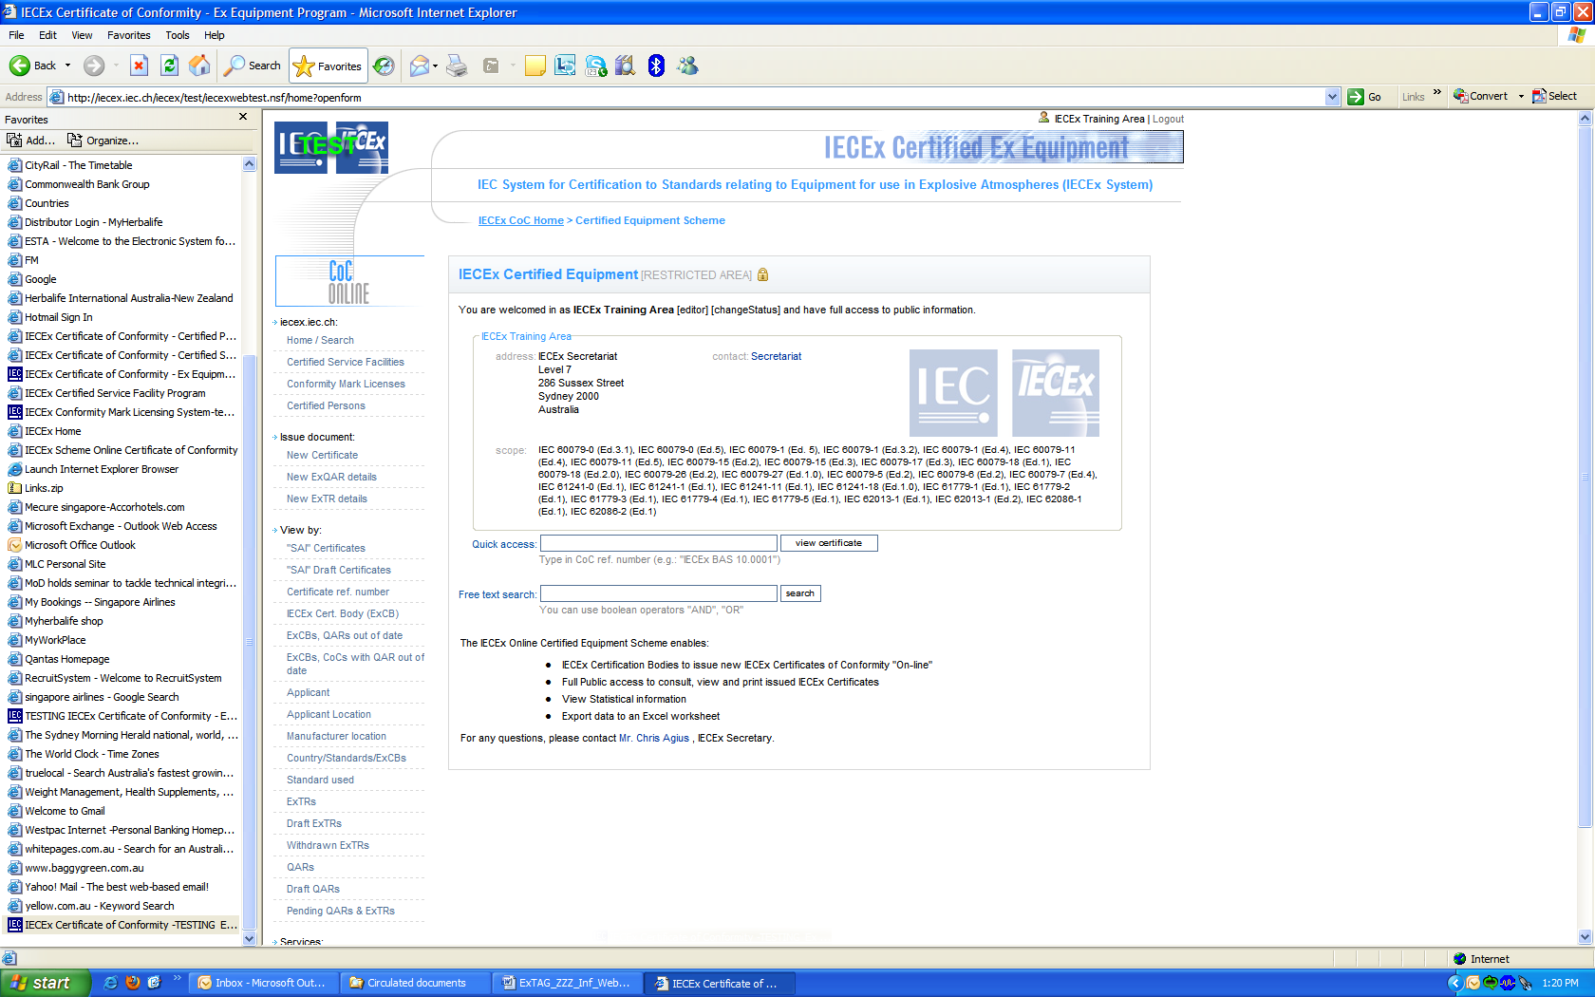

Example.

When “ExCB, QARs out of date” is clicked a Listing similar to the following will appear showing the out of date QAR and its “Valid until date”.

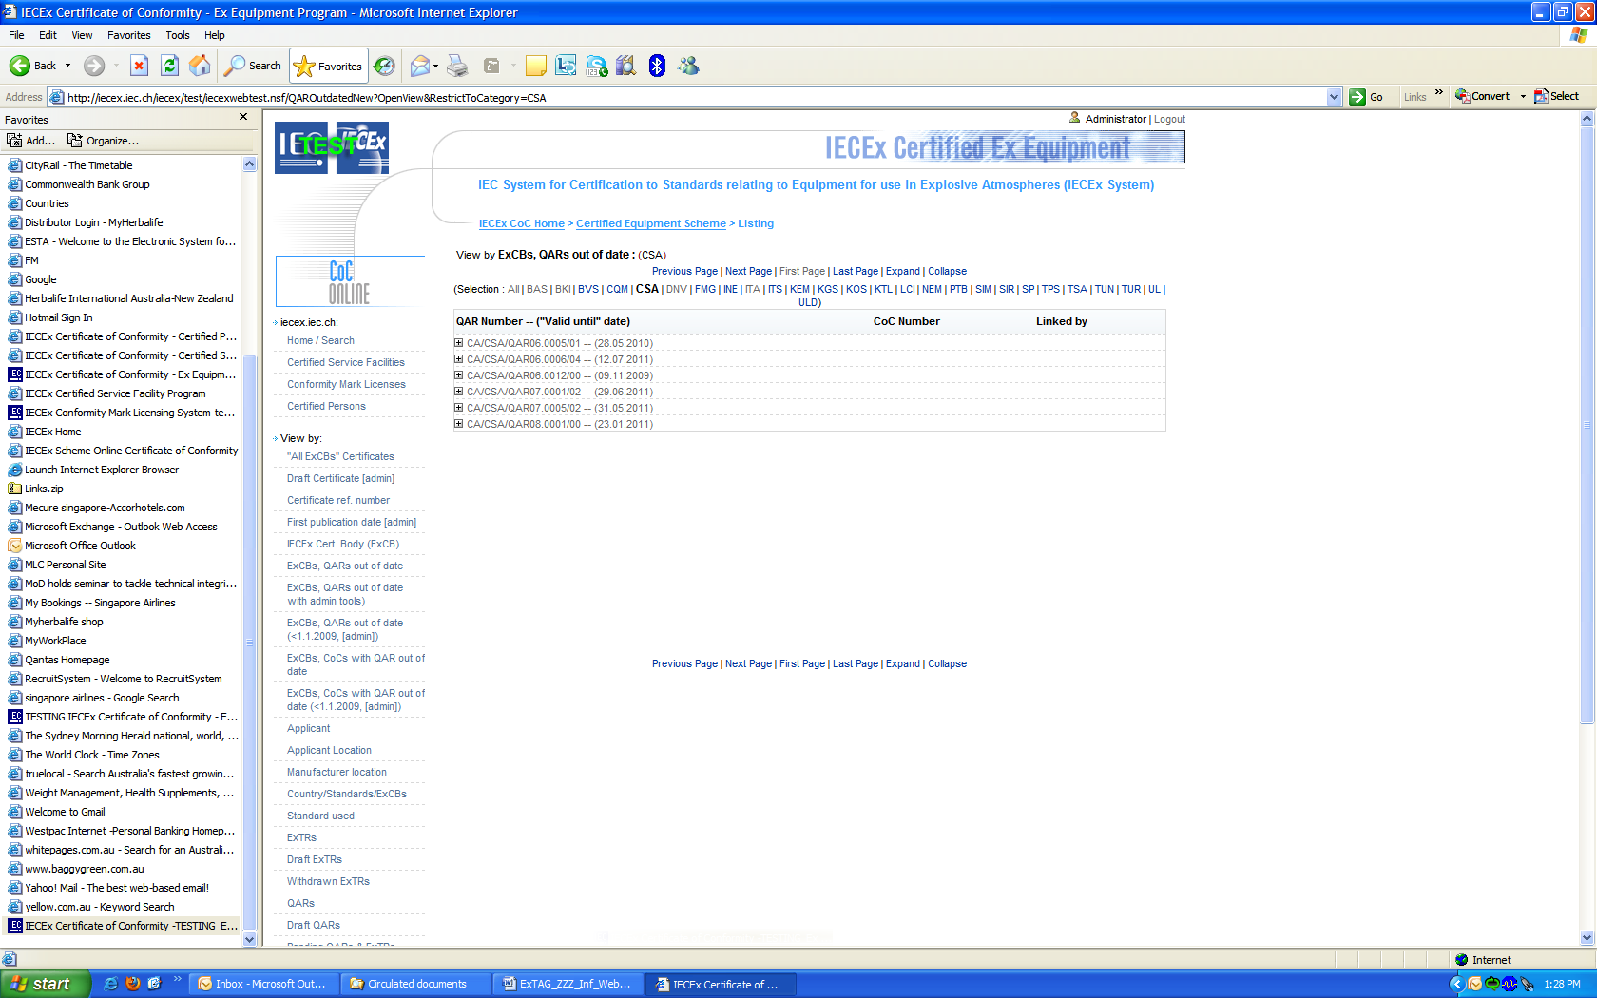

When the + is clicked the following appears showing the associated CoCs numbers.

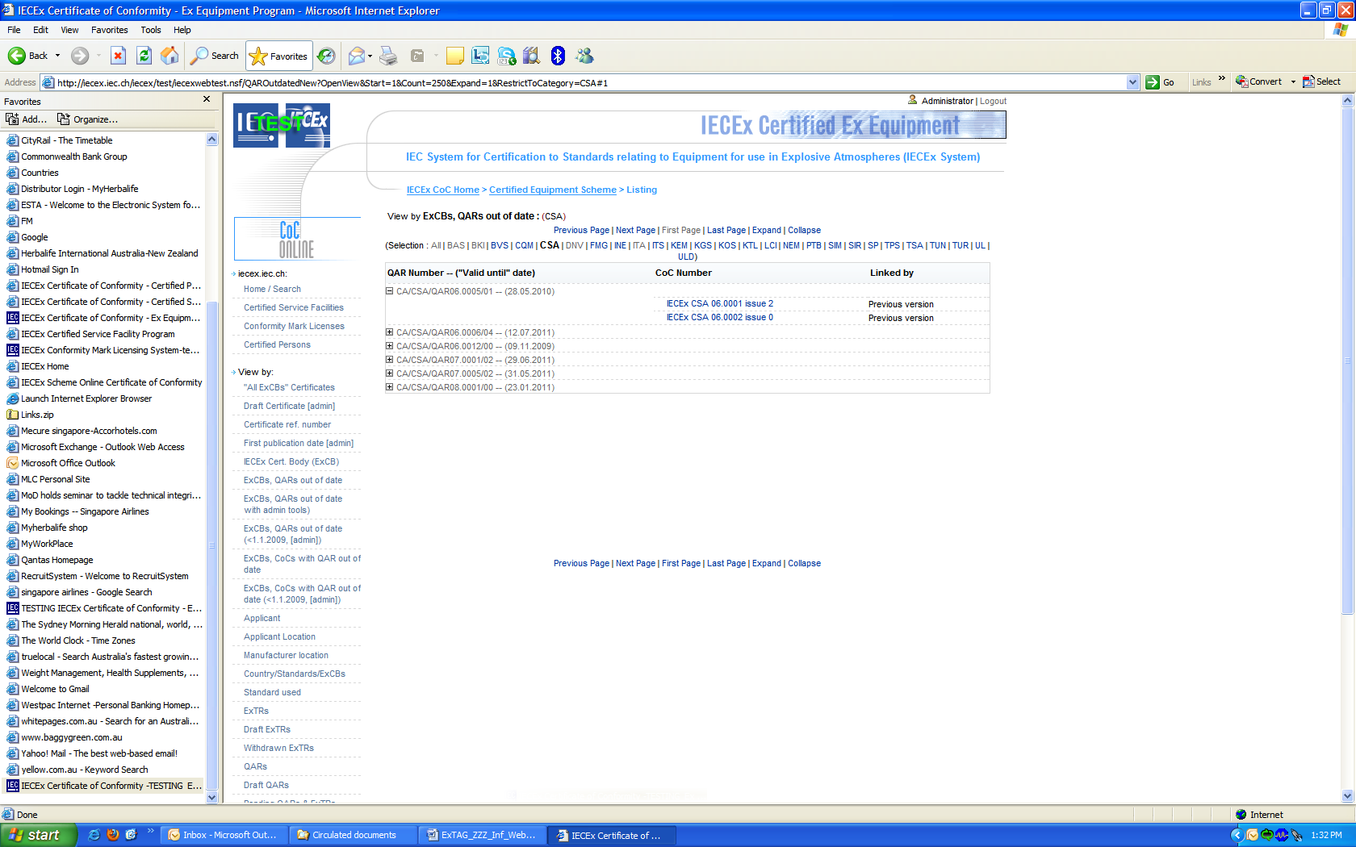

All ExCBs are requested to routinely review their list of out of date QARs and arrange for the surveillance audits of manufacturers (where these have not been done), as a priority and then update the on-line QAR as soon as possible. The Secretariat monitors the trend of out of date QARs and associated CoCs not linked to valid QARs so they can escalate this matter to the ExCBs Management and if necessary to include in future Re-Assessments audits of ExCBs.

When the QAR is updated to be no longer out of date, it will be removed from the “QAR, out of date” list automatically.

Note: It is noted that some QARs will never be updated. The reasons for this include the following:
- The CoC has been cancelled.
- Another ExCB has taken over the surveillance of the manufacturer.
- The ExCB has raised another QAR to supersede the original QAR.
- There may be other reasons.
In such cases the ExCB is requested to advise the IECEx Secretariat and if it can be shown that the QAR will never be updated the Secretariat can remove it from the “QAR, out of date” list.

When the “ExCBs, CoCs with QARs out of date” is clicked a list similar to the following will appear showing a list of CoCs as follows:

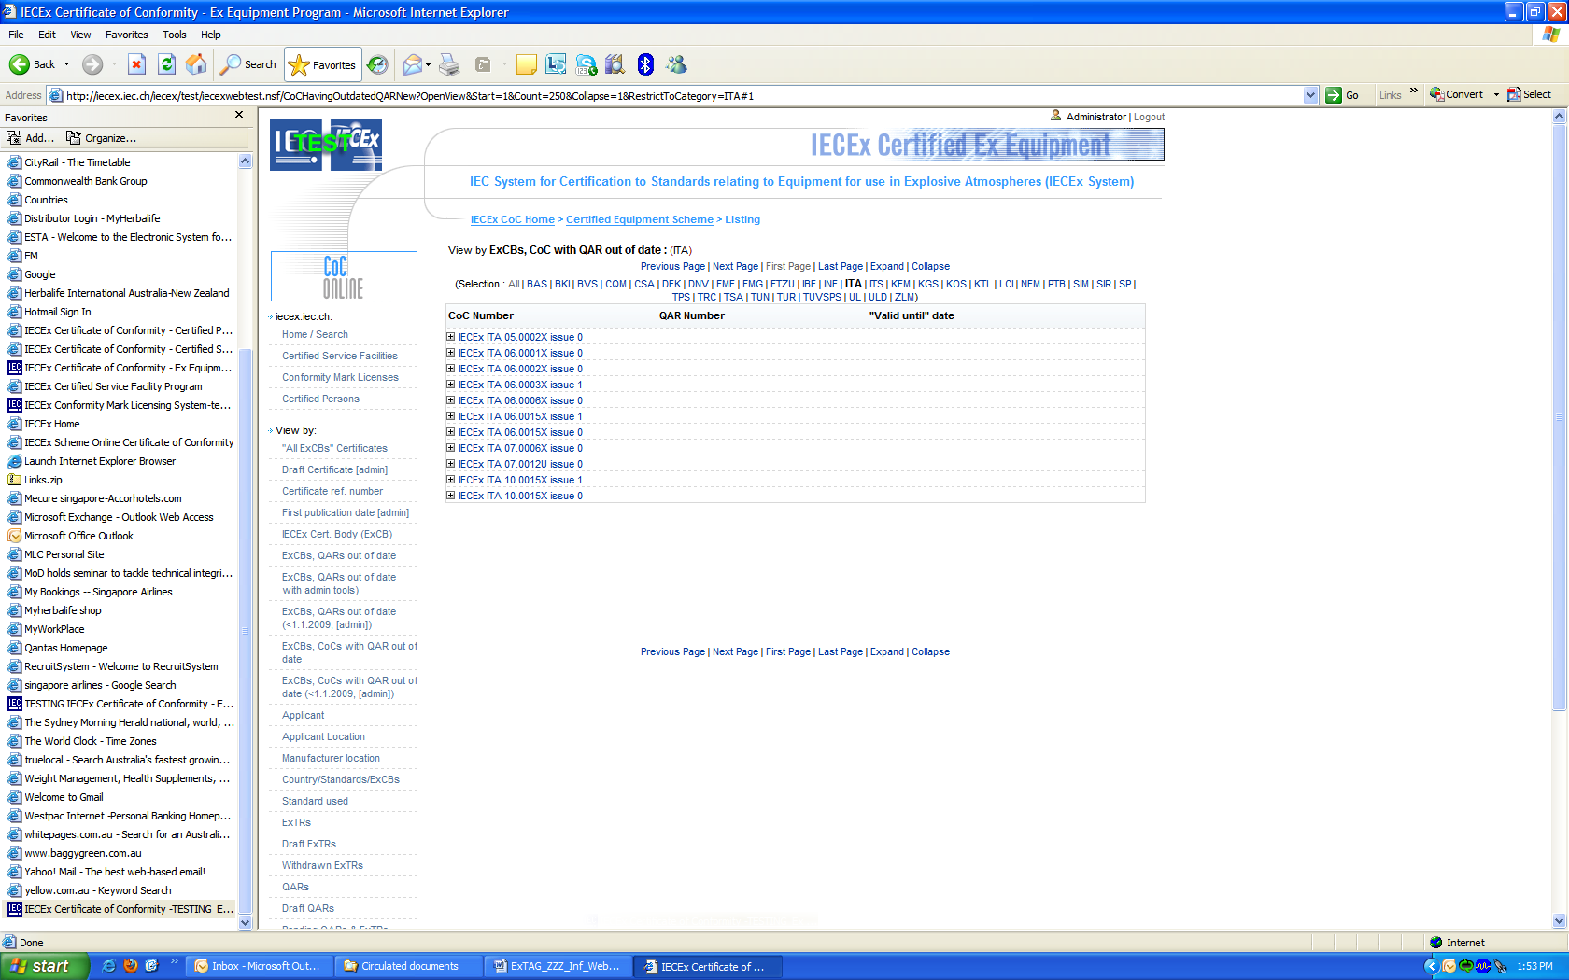

When the + is clicked the following appears showing the associated QARs and their Valid until date.

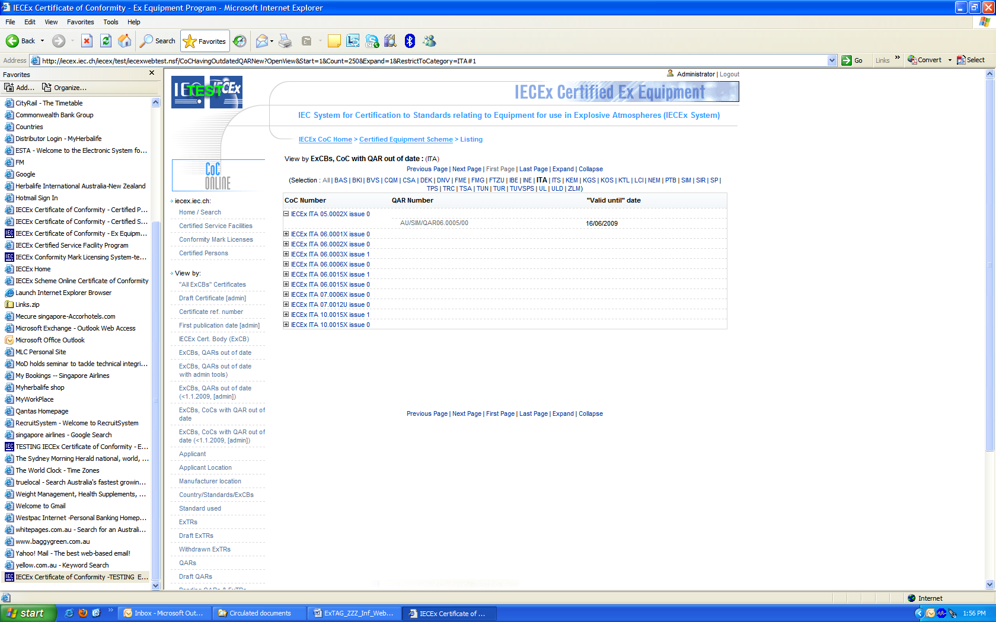

Again when the QAR is updated, to be no longer out of date, the associated CoC will be removed from the “ExCBs, CoCs with QARs out of date” list automatically.

Note: A CoC may have multiple QARs attached and more than one QAR may need to be updated before the CoC is removed from the list.

We would therefore request ExCBs to note the following:

- It is the responsibility of the ExCB to monitor ‘QARS out of date’ and CoCs with QARs of date. The ExCB should have a management process to track QARs they have issued so scheduling can be maintained with manufacturers. The Secretariat will also monitor to prompt when necessary that ExCBs must take action to manage QARs and CoCs.

- As part of the CoC system housekeeping all ExCBs are requested to routinely review all the QARs in the listing and arrange for the surveillance audits of manufacturers (where these have not been done), as a priority and then update the on-line QAR as soon as possible. Advise the IECEx Secretariat of those they believe will not be updated.

- ExCBs are requested to regularly review the list and arrange for all surveillance audits to be conducted as they are due. QAR information to be kept updated.

- The Secretariat will provide more detail advice to individual ExCBs if requested. Any such request may be initially directed to the following:

IECEx Secretariat E-mail: info@iecex.com

We thank all ExCBs for their prompt assistance and cooperation to date and their understanding of the value in maintaining an up to date On-Line Certificate System and at all times. Please do not hesitate to contact the Secretariat for any assistance.

Address:  Secretary IECEx  Level 33 Australia Square  264 George Street  Sydney, NSW 2000 | IECEx Secretariat  Contact Details:  Tel: +61 2 4628 4690  e-mail: info@iecex.com  http://www.iecex.com

