INTERNATIONAL ELECTROTECHNICAL COMMISSION (IEC) SYSTEM
FOR CERTIFICATION TO STANDARDS RELATING TO EQUIPMENT FOR USE
IN EXPLOSIVE ATMOSPHERES (IECEx SYSTEM)

Title: Report from Tim Krause, Convenor ExTAG WG 10, Proficiency Testing
Circulated to: Ex Testing and Assessment Group (ExTAG)

INTRODUCTION

This document is a report prepared by Tim Krause the Convenor of ExTAG WG10, Proficiency Testing. The report will be presented by Mr. Tim Krause during the ExTAG 2018 Cannes Meeting for discussion and consideration.

Julien Gauthier
ExTAG Secretary

Address:  IECEx Secretariat  Level 33 Australia Square  264 George Street  Sydney NSW 2000  Australia  Web: www.iecex.com | ExTAG Secretary  Mr Julien Gauthier  LCIE S.A.  33 Avenue du General Leclerc  92260 Fontenay-aux-Roses  FRANCE  Tel: +33 1 40 95 55 26  Fax: +33 1 40 95 89 37  Email : julien.gauthier@fr.bureauveritas.com

Report by the convenor of ExTAG WG 10 “Proficiency Testing”, Tim Krause, for the ExTAG Meeting in Cannes 2018

- News about the PTB Ex PT Scheme

The first phase (Phase I) of the current programs/test rounds of cycle 2017/2018 “Explosion Pressure – Test Round 2017” (EP2017) and “Pressurized Enclosure – Test Round 2017” (PE) is completed and the interim reports have been published. The second phase (Phase II; “improvement loop”) is currently running and will end with the final report in September for program “EP2017” and in December for program “PE”. The cycle 2017/2018 ends at the end of the year 2018. There are currently seven programs available:

- Spark Ignition – Test Round 2010
- Flame Transmission – Test Round 2013
- Temperature Classification – Test Round 2013
- Electrostatic Charge – Test Round 2015
- Intrinsic Safety – Test Round 2015
- Explosion Pressure – Test Round 2017
- Pressurized Enclosure – Test Round 2017

The test samples for programs “Spark Ignition” and “Temperature Classification” are running out slowly. To ensure that each available program can be performed by any accepted ExTL or applicant ExTL, PTB as the Proficiency Testing Provider holds back three test samples for each of these programs for using them as short-term items on loan. This guarantees that the programs are available until new test samples have been produced or the mentioned programs have been replaced by new programs. It is planned to develop a new “Intrinsic Safety” program to replace the program “Spark Ignition – Test Round 2010” soon.

- Status of the current programs 2017/2018 “Explosion Pressure” (EP2017) and “Pressurized Enclosure” (PE)

Description of program “EP2017”: For the program “Explosion Pressure - Test Round 2017” the general routine procedure is described by the standard “Explosive atmospheres - Part 1: Equipment protection by flameproof enclosures "d"” - IEC 60079-1, Edition 7.0. An essential characteristic for the testing and assessment of the explosion protection is the ability of the enclosure to withstand pressure (clause 15.2.). This is of decisive importance for the design and construction of “d” products. Therefore, the explosion pressure (reference pressure) has been selected as the quantity to be compared in the program “Explosion Pressure - Test Round 2017”.
The explosion pressure is determined with the Test Sample “EP” for two different configurations (single chamber and combination of two chambers with orifice), two different ambient temperatures (normal temperature and ambient temperature of -40 °C) and two different explosive mixtures (ethylene & hydrogen) selected according to IEC 60079-1.
On the basis of two configurations of the Test Sample “EP” two explosive mixtures, two ambient temperatures and five ignitions each, a total of 40 explosion tests must be performed by each participant for the program “Explosion Pressure”.
Status of program “EP2017”: A total of 70 Ex laboratories have registered for the program. 16 ExTLs or applicant ExTLs have not yet registered although they have the standard IEC 60079-1 in scope.
The schedule of the program was slightly delayed until the end of Phase I. Meanwhile, the schedule is back on time. Phase I of the program is completed and the interim report was published in June 2018. The corresponding PT Workshop was held at PTB in June 2018 with 80 participants. Currently, Phase II of the program runs, the schedule of the program is on time. The deadline for repeating the tests and uploading the results of Phase II is the 31st of August 2018. The final report will be published in September 2018. Publishing the final report is also the completion of program “Explosion Pressure - Test Round 2017”.

Description of the program “PE”: For the program “Pressurized Enclosure - Test Round 2017” the general routine procedure is described by the standard “Explosive atmospheres – Part 2: Equipment protection by pressurized enclosure “p”” - IEC 60079-2 Edition 6. This type of ignition protection prevents the formation of explosive atmosphere inside an enclosure by maintaining an internal overpressure against the surrounding atmosphere. This can be achieved by means of an ignition protective gas and, if necessary, supplying the interior of the housing with ignition protection gas in such a way that the dilution of combustible mixtures is reached. The measurement of dilution and determination of gas concentration is therefore an important aspect of testing pressurized enclosures and thus the quantity to be compared for the program “PE”.
The test method for program “PE” consists of three parts:

1. Determination of maximum leakage rate at the maximum overpressure according to IEC 60079-2, Clause 16.3.

2. Filling with CO₂ until concentration of 70 % is reached at each measuring point. Rinsing with air until concentration of CO₂ is less than 0.25 % (IEC 60079-2, Clause A.2) according to IEC 60079-2, Clause 16.4.

3. Filling with He until concentration of 70 % is reached at each measuring point. Rinsing with air until concentration of He is less than 1 % (IEC 60079-2, Clause A.2) according to IEC 60079-2, Clause 16.4.

Status of program “PE”: A total of 62 Ex laboratories have registered for the program. 15 ExTLs or applicant ExTLs have not yet registered although they have the standard IEC 60079-2 in scope.
The original schedule of the program was delayed. Due to the high complexity of the test samples and the resulting high expenses of the homogeneity tests, the shipment was delayed by approximately three months. The schedule has been updated and new deadlines have been set. Phase I of the program is completed and the interim report was published in July 2018. The corresponding PT Workshop was held at PTB in June 2018 with 75 participants.
Since the program “Pressurized Enclosure – Test Round 2017” was the first proficiency testing program in the field of pressurized enclosures and dilution measurements according to IEC 60079-2, the provider has received lots of questions regarding the procedure and the equipment from the participants. Furthermore, the ongoing discussion within the internal group of PTB experts and with the participants during Phase I showed certain weaknesses of the procedure and potential for improvement. That is why Phase I serves as a pilot phase and it was decided that all participants shall repeat the test for Phase II with some modifications and improvement of the test sample as well as documentation. These modifications support the program understanding and increase comparability. The modifications are described in the updated procedure instruction.
- Results of the current PTB Ex PT Programs “EP2017” and “PE”
A small excerpt of the results (from the final report) of program “EP2017” is shown in Figure 1:

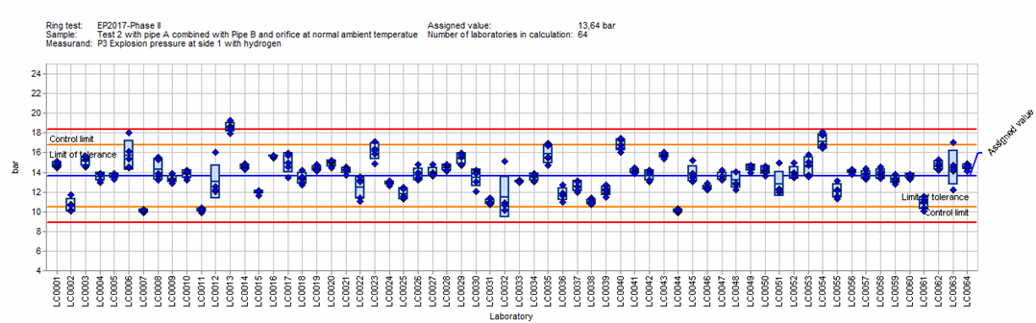
Figure 1: Participant's results with warning and action limits for explosion pressure measurement in accordance to IEC 60079-1 for Configuration b); Hydrogen, Side 1 at normal ambient temperature
It can be seen that 64 participants have performed the measurement for Configuration b) with hydrogen, measuring on Side 1 at normal ambient temperature. Three participants got results outside the two times standard deviation of the assigned value (z – score) which shall be considered to give a “warning signal”. One participants got results outside the three times standard deviation of the assigned value (z – score) which shall be considered to give an “action signal”.
A small excerpt of the results (from the interim report) of program “PE” is shown in Figure 2:

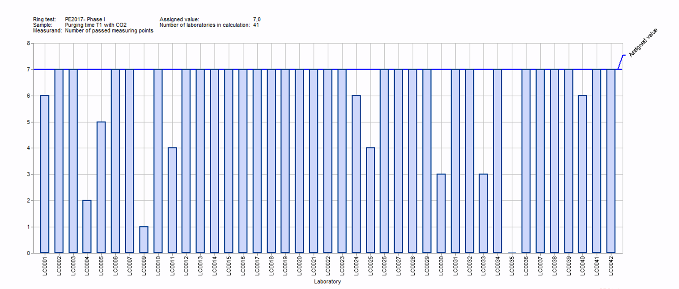
Figure 2: Participant's results showing the number of passed measuring points of purging time T1 with CO₂
It can be seen that 41 participants have performed the test for purging time T1 with CO₂. 30 laboratories achieved exactly the assigned value. In reflecting the complexity of the program and especially the test sample, the results are very satisfying, but showing still an improvement potential for several laboratories. The performance of Phase II will provide further knowledge in this regard.

- PTB Ex PT Workshops 2018

The workshops took place from 11 to 14 June 2018 with a total of around 90 participants at PTB. The topics were associated with the current programs “Explosion Pressure – Test Round 2017” and “Pressurized Enclosure – Test Round 2017”. The structure of the workshops consisted, as usual, of a theory day and a practice day for each program.

- New PT programs of the PTB Ex PTS for the cycle 2019/2020

Suggestions for programs may be made by the Ex PTP Provider based on questionnaires circulated under the participating laboratories, by proposals of the ExTAG WG 10 “Proficiency Testing” or by other experts. The Ex PTP Provider will then take a decision on the programs to provide, taking those suggestions and any recommendations by ExTAG into account.

- Any other business

Agenda of the next ExTAG WG10 meeting

Date and time: Monday, 17 September 2018, 17:00 hrs – 18:30 hrs
Venue: Pullman Hotel (note venue)
Number of participants: About 10 people

1. News about the PTB Ex PT Scheme
2. Status of the current programs 2017/2018 “Explosion Pressure” (EP) and “Pressurized Enclosure” (PE)
3. Results of the PTB Ex PT Programs “EP2017” and “PE”
4. PTB Ex PT Workshops 2018
5. New PT programs of the PTB Ex PTS for the cycle 2019/2020
6. Any other business

