INTERNATIONAL ELECTROTECHNICAL COMMISSION (IEC) SYSTEM FOR CERTIFICATION TO STANDARDS RELATING TO EQUIPMENT FOR USE IN EXPLOSIVE ATMOSPHERES (IECEx SYSTEM)

Title: ExTAG/534/CD Draft ExTAG Decision Sheet -Measurement of Pressure of several intercommunicating compartments in Ex d products.

Circulated to: ExTAG – IECEx Testing and Assessment Group

INTRODUCTION

This document, ExTAG/534/CD Draft ExTAG Decision Sheet Measurement of Pressure of several intercommunicating compartments in Ex d products has been prepared by CQST, CN.

ExTAG/534/CD has been prepared for 6 weeks circulation comment period, with preliminary discussion to be held during the ExTAG Cannes, France, Meeting.

Please submit comments using the comments table, a separate document by –

2018 10 22

Christine Kane

Julien Gauthier

Julien Gauthier
ExTAG Secretary

Address:  IECEx Secretariat  Level 33 Australia Square  264 George Street  Sydney NSW 2000  Australia  Web: www.iecex.com | ExTAG Secretary  Mr Julien Gauthier  LCIE S.A.  33 Avenue du General Leclerc  92260 Fontenay-aux-Roses  FRANCE  Tel: +33 1 40 95 55 26  Fax: +33 1 40 95 89 37  Email : julien.gauthier@fr.bureauveritas.com

COLLECTION OF IECEx / ExTAG DECISIONS

Standard:  IEC 60079-1: 2014(Ed 7) | Clauses:  12.3, 15.1
Subject: Measurement of Pressure of several intercommunicating compartments in Ex d products  Status of document: Draft | Key words:  - Pressure Measurement  - Pressure Piling  - Intercommunicating compartment | Date: September 2018  Originator of proposal: China-CQST

Background:

Some Ex d products have more than one intercommunicating compartments, usually the connection between compartments are achieved by terminal blocks or cables sealed with setting compound. See Figure 1. In 60079-1 clause 12.3, it indicates:
When an enclosure contains several intercommunicating compartments, or when it is subdivided because of the disposition of the internal parts, pressures and rates of rise of pressure greater than normal may be produced.
Such phenomena shall be precluded as far as possible by the construction. If it is impossible to avoid these phenomena, the resulting higher stresses shall be taken into account in the construction of the enclosure.
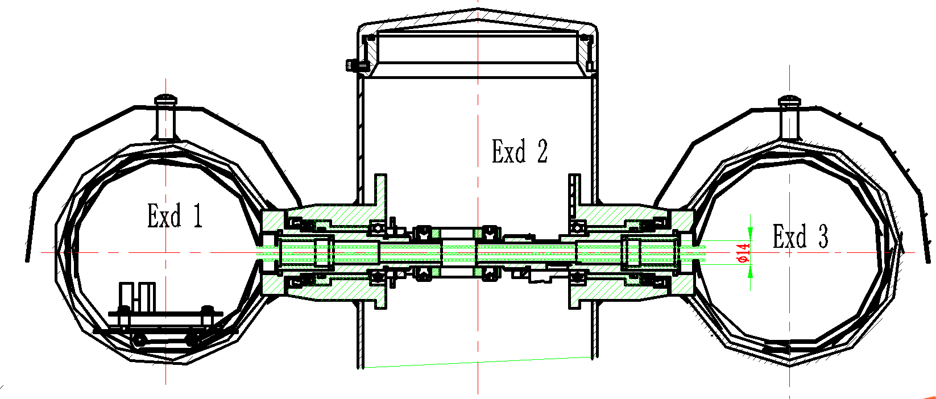
Figure 1

Usually certification staff will recommend to separate the three intercommunicating compartments into three Ex d chambers and evaluated separately, the encapsulation length shall be no less than 20mm.see Figure 2
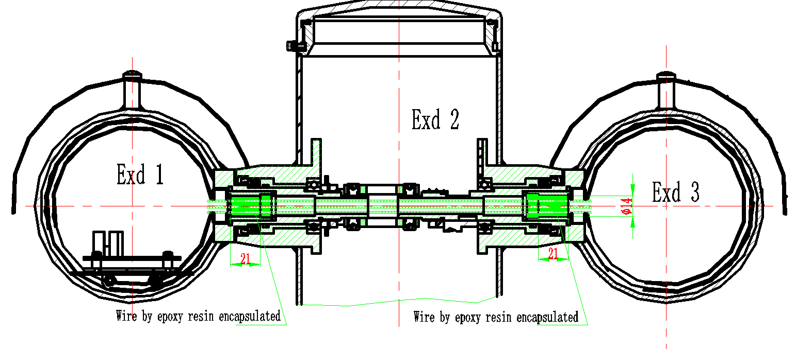

Figure 2

In some conditions, encapsulation of cables is a complex process and the quality is not stable, the manufacturer’s do not want this kind of structure.

QUESTION: Is it possible to test the product with several intercommunicating compartments?

ANSWER:
We suggest that the three connected compartments shall be physically separated by means terminal block, setting compound or other applicable ways, we do the reference pressure determination on three compartments respectively.

