INTERNATIONAL ELECTROTECHNICAL COMMISSION SYSTEM FOR CERTIFICATION TO STANDARDS RELATING TO EQUIPMENT FOR USE IN EXPLOSIVE ATMOSPHERES (IECEx SYSTEM)

TITLE: IECEx Assessment Report for the acceptance of KOMERI Ex Testing Laboratory, KR, as an IECEx Test Laboratory, ExTL, within the IECEx System.
Circulated to: Ex Management Committee, ExMC

INTRODUCTION

This document contains the IECEx Assessment Report for the acceptance of KOMERI Ex Testing Laboratory, KR,as an IECEx Test Laboratory, ExTL, within the
IECEx System.

This document is hereby submitted for ExMC approval via correspondence using the IECEx on-line voting system. ExMC Members are requested to submit their vote via the IECEx On-line Ballot System by the closing date 2018 12 27.

Please refer to OD 050 for guidance on the “IECEx On-line voting system.”

Chris Agius
IECEx Secretariat

Address:  Level 33, Australia Square  264 George Street  Sydney NSW 2000  Australia | Contact Details:  Tel: +61 2 46 28 4690  Fax: +61 2 46 27 5285  e-mail:chris.agius@iecex.com  http://www.iecex.com

IEC System for certification to standards relating to equipment for use in Explosive Atmospheres (IECEx System)

IECEx Assessment Report Form

IECEx Assessment Report Form for use by IECEx Assessment Teams to report Assessments conducted according to the IECEx Assessment Procedures of

- Operational Document IECEx OD003-2 for the Certified Equipment Scheme
- Operational Document IECEx OD316-5 for the Certified Service Facility Scheme
- Operational Document IECEx OD422 for the IECEx Conformity Mark Licensing System

IECEx ExCB/ExTL assessment report for KOMERI Ex Testing Laboratory

INTERNATIONAL
ELECTROTECHNICAL
COMMISSION

CONTENTS
1 Assessment information 5
1.1 Type of Body covered by this assessment: 5
1.2 Type of assessment: 5
1.3 Details of body 5
1.3.1 Country 5
1.3.2 Name of body 5
1.3.3 Name and title of nominated principal contact 5
1.4 Assessment information 5
1.4.1 Members of the assessment team 5
1.4.2 Place(s) of assessment 5
1.4.3 Assessment date(s) 5
1.5 Application information and background information on the assessment 5
1.6 Scopes 6
1.6.1 ExCB scope for equipment certification scheme 6
1.6.2 ExTL scope 6
1.6.3 ExCB scope for Service Facilities Scheme 6
1.6.4 ExCB scope for ExMark Scheme 6
2 Common information 7
2.1 Legal entity of body 7
2.2 Financial support 7
2.3 History 7
2.4 Documentation 8
2.4.1 Quality manual 8
2.4.2 Procedures 8
2.4.3 Work instructions 8
2.4.4 Records (including test records where relevant) 8
2.4.5 Document change control 8
2.5 Confidentiality 8
2.6 Communication with public and customers (Hard copy and Electronic) 8
2.7 Recognitions and agreements 8
2.8 Internal audit 9
2.9 Management review 9
2.10 Contracting, subcontracting and witness testing 9
2.10.1 Contracting 9
2.10.2 Subcontracting 9
2.10.3 Witness testing 9
2.11 Training and competence 10
2.12 Complaints and appeals (including appeals to IECEx) 10
2.13 Impartiality 10
2.14 Commenting on ExTAG Documents 10
2.15 Supporting documentation 10
2.16 Recommendations 10
3 ExTL for IECEx Certified Equipment Scheme 11
3.1 Assessment references 11
3.1.1 General references 11
3.1.2 Additional references applied for this assessment 11
3.2 Candidate ExTL persons interviewed 11
Researcher/Engineer which is used later in the document. 11
3.3 Associated ExCB(s) 11
3.4 Organisation 11
3.4.1 Names, titles and experience of the senior executives 11
3.4.2 Name, title and experience of the quality management representative 12
3.4.3 Other employees in ExTL activity 12
3.5 Organizational structure 12
3.6 Resources 12
3.7 Test reports issued 12
3.8 National accreditation 13
3.9 Calibration 13
3.10 Tests witnessed during the assessment visit 13
3.11 Participation in IECEx Proficiency Testing Programs 13
3.12 Comments (including issues found during assessment) 14
4 Annexes 15
Annex A Overall Organisation Chart 16
Annex B Organisation Chart of ExTL 17
Annex C Accreditation Certificate for ISO/IEC 17025 18

Assessment information

Type of Body covered by this assessment:
ExCB for IECEx Certified Equipment Scheme
ExTL for IECEx Certified Equipment Scheme | ✓
ExCB for IECEx Certified Service Facilities Scheme
ExCB for IECEx Conformity Mark Licensing System

NOTE 1 ExCB - IECEx Certification Body
NOTE 2 ExTL - IECEx Testing Laboratory

Type of assessment:
Pre-assessment for candidate body
Initial assessment for candidate body | ✓
Surveillance
Re-assessment
Scope extension

Details of body

Country
Republic of Korea

Name of body
KOMERI Ex Testing Laboratory

Name and title of nominated principal contact
Name | Title | E-mail address
Gyuhong Kang | General manager | kang@komeri.re.kr

Assessment information

Members of the assessment team
Name | Role
Katy Holdredge | IECEx Lead Assessor
Lucy Lu | IECEx Assessor

Place(s) of assessment
Korea Marine Equipment Research Institute  Ulsan Regional Division | 5, Techno saneop-ro 55beon-gil, Nam-gu, Ulsan, 44776, Korea
It was noted that KOMERI's quality documents are kept in Busan and used electronically at the Ulsan Testing Laboratory.

Assessment date(s)
2018-07-09 to 2018-07-11 plus post site assessment review of updated documentation.

Application information and background information on the assessment
Information relevant to the Secretariat review process: Application form plus information as required by IECEx 02.

Scopes

ExCB scope for equipment certification scheme
KOMERI Ex Testing Laboratory is using DNV PreSafe as their ExCB that has the following standards with their scope, among others.
Number | Title | Comments, e.g. if scope change
IEC 60079-0  Edition 7.0 | Explosive atmospheres - Part 0: Equipment - General requirements
IEC 60079-1  Edition 7.0 | Explosive atmospheres - Part 1: Equipment protection by flameproof  enclosures “d”
IEC 60079-2  Edition 6.0 | Explosive atmospheres - Part 2: Equipment protection by pressurized  enclosure «p»
IEC 60079-7  Edition 5.1 | Explosive atmospheres - Part 7: Equipment protection by increased  safety "e"
IEC 60079-11  Edition 6.0 | Explosive atmospheres - Part 11: Equipment protection by intrinsic safety “i”

ExTL scope
KOMERI Ex Testing Laboratory requested the following standards in their scope:
Number | Title | Comments, e.g. if scope change
IEC 60079-0  Edition 7.0 | Explosive atmospheres - Part 0: Equipment - General requirements | Edition 6.0 in ISO/IEC 17025 scope, which is considered technically equivalent.
IEC 60079-1  Edition 7.0 | Explosive atmospheres - Part 1: Equipment protection by flameproof  enclosures “d”
IEC 60079-2  Edition 6.0 | Explosive atmospheres - Part 2: Equipment protection by pressurized  enclosure «p»
IEC 60079-7  Edition 5.1 | Explosive atmospheres - Part 7: Equipment protection by increased  safety "e" | Edition 5.0 in ISO/IEC 17025 scope, which is considered technically equivalent.
IEC 60079-11  Edition 6.0 | Explosive atmospheres - Part 11: Equipment protection by intrinsic safety “i”

ExCB scope for Service Facilities Scheme
Not applicable

ExCB scope for ExMark Scheme
Not applicable

Common information

Legal entity of body
KOMERI is a foundation and is registered as a professional production technology institute under National law (Article 42 of the Ministry of Commerce, Industry and Energy (MOCOE)) as of 2001-12-18. A copy of the certificate, available in the Korean language, was viewed.
KOMERI's head office is located in Busan, Korea, but the testing laboratories in the area of Ex are fully located in Ulsan.

Financial support
KOMERI is funded by R&D projects and testing & certification. KOMERI has an insurance certificate issued by Samsung for 9,420,000 Won valid until 2019-04-27.

History
2001 Acquired the permission for incorporation from the Ministry of Commerce, Industry and Energy (MOCIE)
2003 Designated as internationally certified KOLAS testing body (Echo-sounder)
2004 Began construction of Yeongdo Research Center (Yeongdo, Busan) and Noksan Research Center
2005 Acquired the certification for internationally certified test institution for KOLAS (explosion-proof/sound effect)
Completion of the Marin Electronic Equipment Testing/Certification Center (in Noksan Industrial Complex)
2008 Designated as internationally certified test institution for KOLAS (electromagnetic compatibility)
Opening of the Marine Electronics Equipment Test & Certification Center
Designated as internationally certified test institution for KOLAS (industrial electric machinery, sound effects, vibration and fire)
2009 Entered into agreement on industry-research consortium & Designated as 2009 excellent test/inspection institution for KOLAS
2010 Re-recognized as internationally certified test institution for KOLAS (home electronic devices)
2011 Designated as British LR-authorized testing authority Designated as authorized KOLAS testing authority (shipbuilding)
2012 Expanded KOLAS certification scope (temperature and humidity)
Signed a MOU with KRH
2014 Designated as an authorized UL testing body
2015 Designated as an authorized RRR testing body
Signed a MOU with KOTICA
Designated as insulation of sound performance testing and noise measurements ship agencies
Designated as test laboratory for USCG
2016 Designated as test laboratory for UL (Underwriters Laboratories)
2018 Acquired the certification for internationally certified test institution for KOLAS (Ulsan division: explosion-proof type, electric motor, high voltage)

Documentation

Quality manual
KOMERI has a quality manual, document nos. KOMERI-M-XX, composed of 24 sections including topics such as their quality policy, management system, document management, improvement and corrective action, among others. The quality manual meets the requirements of the IECEx.

Procedures
KOMERI has 27 procedures, document nos. KOMERI-P-XX, including topics such as confidentiality, internal audit, management review, test equipment management, among others. There were some issues related to insufficient procedures for internal audits, management review, and staff competency which were revised to the satisfaction of the assessment team and now meet the requirements of the IECEx.

Work instructions
KOMERI has 20 work instructions, document nos. KOMERI-I-XX, including topics such as measurement uncertainty, IECEx TL, among others, as well as KOMERI-O-16 for testing instructions. There were some issues related to insufficient work instructions, including working with the ExCB, responsibilities for agreements under IECEx OD024, commenting on ExTAG DS, and testing requirements, which were revised to the satisfaction of the assessment team and now meet the requirements of the IECEx.

Records (including test records where relevant)
KOMERI defines their requirements in KOMERI-M-12, Records Management, and KOMERI-P-12, Record Management Procedure. Records related to test reports are stored electronically and were able to be retrieved. It was unclear which records were being stored in the Record Management Procedure, this was revised to the satisfaction of the assessment team and now meet the requirements of the IECEx.

Document change control
KOMERI defines their requirements in KOMERI-P-03, Document and material management procedure, date of revision 2017-11-23 (rev. 26). There is an External Document (Material Registration Register KOMERI-P-03-04 used for verifying that there have been no revisions to the standards. KOMERI’s document change control meets the requirements of the IECEx.

Confidentiality
(For staff, contractors and members of advisory bodies)
KOMERI defines their requirements in KOMERI-P-02, Confidentiality, date of revision 2017-11-23 (rev. 7). Two signed copies of KOMERI-P-01-03, Pledge, were viewed and found to meet the requirements of IECEx.

Communication with public and customers (Hard copy and Electronic)
KOMERI has two main websites http://www.komeri.re.kr/ and http://eng.komeri.re.kr/ as well as their KOMERI Brochure, available in both Korean and English.

Recognitions and agreements
KOMERI has the following recognitions and agreements:
KOLAS (Korea Laboratory Accreditation Scheme) accredited to ISO/IEC 17025:2005
- Explosion proof is included in 3.006 “Electrical equipment for industrial”
Letter of Intent (LoI) dated 2017-09-18 for IECEx ExCB/ExTL with DNV Presafe was viewed.
KOMERI is also ISO/IEC 17065 accredited as a certification body by KOLAS for areas not related to explosion-protection.
KOMERI has agreements with the following ATEX Notified Bodies: ECM (Italy), Eurofins (Italy) and KRH (Greece).

Internal audit
KOMERI has been performing internal audits one or more times per year by certified persons for checking quality management and bi-annual regular audit according to IEC 17025:2005 and quality manual of KOMERI. The last internal audit was completed 2017-10-11 to 2017-10-13 and included standards under Electrical Equipment for Industrial 03.006, which includes standards for explosive atmospheres. There were two issues found for 03.006 (2017-30 and -31), one was related to the scope of the test range listed in their ISO/IEC 17025 and the other was related to the frequency of gas detection monitoring. The staff used to conduct internal audits are listed in KOMERI-P-13-01; these records are kept hard copy at their Busan facility, but were available electronically in Ulsan.
Related documents include KOMERI-M-13, Internal audit manual, date of revision 2011-06-16 (rev. 22) and KOMERI-P-13, Internal audit procedure, date of revision 2016-05-11 (rev. 12).
The internal audit procedure did not cover IECEx, this was revised to the satisfaction of the audit team and meets the requirements of the IECEx.

Management review
KOMERI has two documents related to management review, KOMERI-M-14, Management review manual, date of revision 2011-06-16 (rev. 22) and KOMERI-P-14, Management review procedure, date of revision 2016-05-11 (rev. 7). The last management review was conducted on 2018-02-12 and included discussion of the audits conducted by the Korean member body, Korean Agency for Technology and Standards (KATS), in preparation for submittal as an IECEx TL. The General Manager, Mr. Gyu-Hong Kang, was present.
The manual and procedure related to management review did not require the General Manager, responsible for the management of the IECEx ExTL to attend. The documents were revised to the satisfaction of the assessment team and now meet the requirements of the IECEx.

Contracting, subcontracting and witness testing

Contracting
KOMERI will not contract work under the IECEx; all tests will be performed by the ExTL.

Subcontracting
KOMERI will not subcontract work under the IECEx; all tests will be performed by the ExTL.
KOMERI does have a policy, KOMERI-M-04, Request, Bidding and Review of Contract, and procedure, KOMERI-P-06, Consignment of a test, related to subcontracting for other areas of work outside of IECEx.

Witness testing
KOMERI has instructions related to witness testing under the IECEx, KOMERI-I-19 IECEx TL instruction, issued 2018-03-02 (rev. 1). There was an issue related to responsibilities for agreements under IECEx OD 024 for witness testing. The instructions were revised to the satisfaction of the audit team and now meet the requirements of the IECEx, specifically IECEx OD 024.

Training and competence
KOMERI has two documents related to training and competence, KOMERI-M-16, Employees, dated 2013-09-25 (rev. 23) and KOMERI-P-15, Training and qualification management procedure dated 2016-11-29 (rev. 20). The staff competency matrix and related procedure was not controlled within the quality system, this was revised to the satisfaction of the assessment team and now meet the requirements of the IECEx.
Details of staff competencies are included in the site assessment report F-004.

Complaints and appeals (including appeals to IECEx)
KOMERI has two documents related to complaints and appeals, KOMERI-M-08, Claims, date of issue 2018-06-15 (rev. 23) and KOMERI-P-08, Services and claims treatment procedure, date of issue 2017-11-23 (rev. 12), which meet the requirements of the IECEx.

Impartiality
KOMERI has defined their impartiality requirements in KOMERI-P-01, Organization Management Procedure (Cl. 4.4), date of issue 2018-06-25 (rev. 66), which meet the requirements of the IECEx.

Commenting on ExTAG Documents
KOMERI has a documented procedure/work instruction to address responding on documents from ExTAG, IECEx TL Instruction, KOMERI-I-19, date of issue 2018-03-02 (rev. 1). There was no person defined as responsible for commenting on ExTAG documents, this was revised to the satisfaction of the audit team and now meet the requirements of the IECEx.

Supporting documentation
Copies of additional supporting information for this assessment have been provided to the applicant and the IECEx Secretariat. These are included in a site assessment report or provided separately and include:
- Details of issues raised and how these have been resolved
- Checklist for ISO/IEC 17025
- Completed Technical Capability Document (TCD)
- Photos of the facilities/tests witnessed are included in the above TCD
- Assessors’ notes

Recommendations
Based on the assessment performed on 2018-07-09 - 2018-07-11, and follow-up activities KOMERI is recommended for acceptance as an ExTL in the IECEx scheme according to the scope of the standards listed in this document, and, on the basis that they work closely with their associated ExCB, DNV Presafe, in the determination of testing plans, compliance with construction requirements and completion of the ExTRs.
In addition, it is recommended that a surveillance assessment visit be conducted not more than 1 year after acceptance prior to moving to the 5 year re-assessment program.

Katy Holdredge | Lucy Lu
IECEx Lead Assessor | IECEx Assessor

Date: 2018-11 12

ExTL for IECEx Certified Equipment Scheme

Assessment references

General references
- IECEx 02 IECEx Certified Equipment Scheme covering equipment for use in explosive atmospheres – Rules of Procedure
- IECEx OD003-2 Assessment, surveillance assessment and re-assessment of ExCBs and ExTLs operating in the IECEx 02, IECEx Certified Equipment Scheme
- IECEx OD009 Issuing of CoCs, ExTRs and QARs
- ISO/IEC 17025:2005 Edition 2, General requirements for the competence of testing and calibration laboratories
- IECEx Technical Capability Document (TCD)
- ExTAG decision sheets (DSs)
- OD 202 IECEx Certified Equipment Scheme – IECEx Proficiency Testing Program
NOTE The latest editions of the above documents were applied.

Additional references applied for this assessment
None.

Candidate ExTL persons interviewed

Researcher/Engineer which is used later in the document.
Name | Position
Gyuhong Kang | General Manager
Sung-Su Choi | Senior Researcher
Kyung-Min Kim | Quality manager
Sun-Kwon Lee | Technical Manager
Minuk Yoo | Senior Researcher
Seung-Min Son | Researcher
Jeonghoon Park | Researcher
Jinhong Lim | Researcher
Seong-Jin Ko | Researcher
Uinam Son | Researcher

Associated ExCB(s)
KOMERI will use DNV PreSafe as the associated ExCB.

Organisation

Names, titles and experience of the senior executives

Name | Title | Experience
Kyung Min Kim | Quality manager | 9 years

Name, title and experience of the quality management representative

Name | Title | Experience
Kyung Min Kim | Quality manager | 9 years

Other employees in ExTL activity

Name | Title/responsibility | Experience in Ex
Gyuhong Kang | General manager/Manager | 3 years, IECEx CoPC
Sunkwon Lee | Center manager/Technical manager, engineer | 3 years, IECEx CoPC
Minuk Yoo | Senior researcher/Engineer | 2 years, IECEx CoPC
Seongmin Son | Researcher/Engineer | 1 year
Sungjin Ko | Researcher/Engineer | 1 year
Jinhong Lim | Researcher/Engineer | 1 year
Jeonghoon Park | Researcher/Engineer | 1 year
Uinam Son | Researcher/Engineer | 1 year
Heesu Kim | Researcher/Engineer | 1 year

Organizational structure
Refer to Annex A of this document.

Resources
KOMERI has sufficient equipment, test facilities and staff for the requested scope.
Komeri are very well resourced with appropriate facilities, comprehensive procedures, and competent staff for carrying out activities for the standards.

Test reports issued
Number of test reports (ExTRs) issued under for the preceding four years for each type of protection. For new applications these should be for national or regional schemes and for currently accepted bodies IECEx ExTRs should be shown (test reports for other schemes may also be shown):
Standard numbers | Type of protection or other identifying information | Number of issued reports (ExTRs) (for last 4 years) |  |  |  | Total
 |  | 2014 | 2015 | 2016 | 2017 | -
60079-0 | General requirements | - | 5 | 12 | - | 17
60079-1 | flameproof enclosures “d” | - | 2 | 12 | 17 | 31
60079-2 | pressurized enclosure "p" | - | - | 1 | 1 | 2
60079-7 | increased safety ''e'' | - | - | 2 | 1 | 3
60079-11 | intrinsic safety "i" | - | - | 1 | - | 1
60079-15 | type of protection "n" | - | - | 1 | - | 1
60079-18 | encapsulation “m” | - | - | 1 | - | 1
60079-31 | protection by enclosure "t" | - | - |  | 1 | 1
EN 13463-1 | Basic method and requirements | - | - | 3 | 2 | 5
NOTE 1 Above include reports to IEC 60079-0 unless otherwise shown

National accreditation
KOMERI is ISO/IEC 17025:2005 accredited by Korea Laboratory Certification Scheme (KOLAS), which is a signatory of the ILAC mutual recognition agreement and includes all standards requested in their scope along with the Korean and EN equivalents. Their current certificate expires on January 3, 2020.

Calibration
KOMERI has four documents related to calibration, KOMERI-M-19, Equipment, date of issue 2013-09-25 (rev. 32), KOMERI-M-20, Traceability, KOMERI-P-19, date of issue 2013-09-25 (rev. 23), Test equipment management, date of issue 2018-02-02 (rev. 31) and KOMERI-P-20, Measurement traceability and calibration, date of issue 2017-11-23 (rev. 10). There is one piece of equipment calibrated internally, their dynamometer for large motors as there are currently no external providers in Korea that can offer this service. There was no calibration or validation for some of the equipment/control system used for IEC 60079-1 testing this was revised to the satisfaction of the audit team and now meet the requirements of the IECEx.

Tests witnessed during the assessment visit
The following tests were witnessed during the assessment visit:
Standard and edition | Clause number | Test | Comments
IEC 60079-0  Edition 6.0 | 26.5.1 | Temperature measurement on the general junction box | None
IEC 60079-7  Edition 5.0 | 6.8 | Temperature measurement on the general junction box | None
IEC 60079-0  Edition 6.0 | 26.4.5 | Degree of protection by enclosure (IP54) | None
IEC 60079-0  Edition 6.0 | 26.14 | Measurement of capacitance | None
IEC 60079-1  Edition 7.0 | 15.2.2 | Determination of reference pressure | None
IEC 60079-1  Edition 7.0 | 15.2.3 | Overpressure test | None
IEC 60079-2  Edition 6.0 | 16.3 | Leakage test | None
IEC 60079-7  Edition 5.0 | 6.1 | Dielectric strength | None
IEC 60079-11  Edition 6.0 | 10.1 | Spark ignition test | None
IEC 60079-11  Edition 6.0 | 10.8 | Type test for diode safety barrier and safety shunt | None

Participation in IECEx Proficiency Testing Programs
Program: PTB Ex PT Scheme
Year(s) of participation | IECEx Proficiency Testing program | General information about results
2017 - 2018 | Explosion Pressure | Very good results, no action or warning signals
2017 - 2018 | Pressurized Enclosure | Results have been submitted to PTB, no report available from PTB at this time

Comments (including issues found during assessment)
KOMERI has the necessary staff, equipment and facilities for their scope. There were some issues related to the following topics:
- Insufficient policies/procedures/work instructions, e.g., for working with ExCB, internal audits, management review, staff competency, testing; and
- Insufficient calibration.
All issues were revised to the satisfaction of the audit team and now meet the requirements of the IECEx.

Annexes
See Contents.

- Overall Organisation Chart
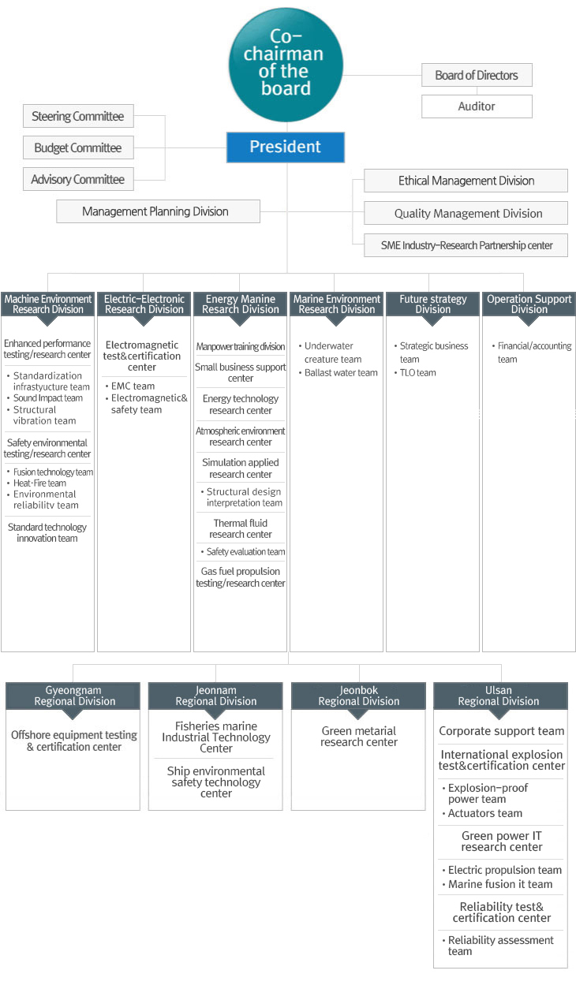
- Organisation Chart of ExTL

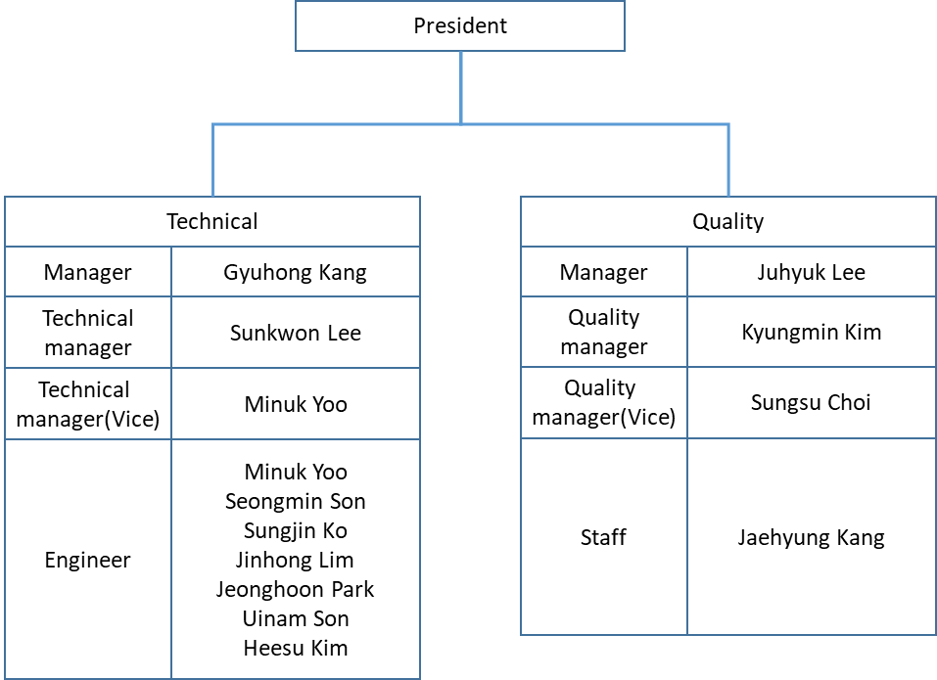

- Accreditation Certificate for ISO/IEC 17025

