INTERNATIONAL ELECTROTECHNICAL COMMISSION SYSTEM FOR CERTIFICATION TO STANDARDS RELATING TO EQUIPMENT FOR USE IN EXPLOSIVE ATMOSPHERES (IECEx SYSTEM)

TITLE: Re-assessment and Scope Extension Report for the continued acceptance of IMQ S.p.A, Italy, an Accepted Certification Body, (ExCB), and an Accepted Ex Testing Laboratory (ExTL) within the IECEx System, Equipment Scheme 02, to include IEC/TS 60079-46, ISO 80079-36 and ISO 80079-37 and in their scope.

Circulation to: Members of the IECEx Management Committee, ExMC

INTRODUCTION

In accordance with the 5 year re-assessment plan for the surveillance and monitoring of bodies within the IECEx System, the following document contains the IECEx Re-assessment and Scope Extension Report for the continued acceptance of IMQ S.p.A, Italy, as an Accepted Certification Body (ExCB) and an Accepted Ex Testing Laboratory (ExTL) within the IECEx System, Equipment Scheme 02.

During the re-assessment the IECEx Assessment Team took the opportunity to also assess IMQ S.p.A’s facilities, equipment and competence to undertake testing and certification to the Standards –

- IEC/TS 60079-46 Explosive atmospheres - Part 46: Equipment assemblies

- ISO 80079-36 Explosive atmospheres - Part 36: Non-electrical equipment for
explosive atmospheres - Basic method and requirements

- ISO 80079-37 Explosive atmospheres - Part 37: Non-electrical equipment for
explosive atmospheres - Non electrical type of protection constructional safety
"c", control of ignition source "b", liquid immersion "k"

This document is hereby submitted for ExMC approval via correspondence using the IECEx on-line voting system. ExMC Members are requested to submit their vote via the IECEx On-line Ballot System by the closing date 2019 01 16.

Please refer to OD 050 for guidance on the “IECEx On-line voting system.”

Chris Agius

IECEx Secretariat

IECEx Secretariat  Australia Square  Level 33, 264 George Street  Sydney NSW 2000  Australia | Tel: +61 2 4628 4690  Fax: +61 2 4625 3480  Email: chris.agius@iecex.com

IEC System for certification to standards relating to equipment for use in Explosive Atmospheres (IECEx System)

IECEx Assessment Report Form

IECEx Assessment Report Form for use by IECEx Assessment Teams to report Assessments conducted according to the IECEx Assessment Procedures of

- Operational Document IECEx OD003-2 for the Certified Equipment Scheme
- Operational Document IECEx OD316-5 for the Certified Service Facility Scheme
- Operational Document IECEx OD422 for the IECEx Conformity Mark Licensing System

IECEx ExCB/ExTL assessment report for IMQ S.p.A

INTERNATIONAL
ELECTROTECHNICAL
COMMISSION

CONTENTS
1 Assessment information 6
1.1 Type of Body covered by this assessment: 6
1.2 Type of assessment: 6
1.3 Details of body 6
1.3.1 Country 6
1.3.2 Name of body 6
1.3.3 Name and title of nominated principal contact 6
1.4 Assessment information 6
1.4.1 Members of the assessment team 6
1.4.2 Place(s) of assessment 6
1.4.3 Assessment date(s) 6
1.5 Application information and background information on the assessment 6
1.6 Scopes 7
1.6.1 ExCB scope for equipment certification scheme 7
1.6.2 ExTL scope 7
1.6.3 ExCB scope for Service Facilities Scheme 7
1.6.4 ExCB scope for ExMark Scheme 7
2 Common information 8
2.1 Legal entity of body 8
2.2 Financial support 8
2.3 History 8
2.4 Documentation 8
2.4.1 Quality manual 8
2.4.2 Procedures 8
2.4.3 Work instructions 9
2.4.4 Records (including test records where relevant) 9
2.4.5 Document change control 9
2.5 Confidentiality 9
2.6 Communication with public and customers (Hard copy and Electronic) 9
2.7 Recognitions and agreements 9
2.8 Internal audit 9
2.9 Management review 9
2.10 Contracting, subcontracting and witness testing 9
2.10.1 Contracting 9
2.10.2 Subcontracting 9
2.10.3 Witness testing 9
2.11 Training and competence 10
2.12 Complaints and appeals (including appeals to IECEx) 10
2.13 Impartiality 10
2.14 Commenting on ExTAG Documents 10
2.15 Special facts to be noted 10
2.15.1 Scope extension for ISO 80079-36 and 37 10
2.15.2 Scope extension for IEC TS 60079-46 10
2.16 Supporting documentation 10
2.17 Recommendations 10
3 ExCB for IECEx Certified Equipment Scheme 12
3.1 Assessment references 12
3.1.1 General references 12
3.1.2 Additional references applied for this assessment 12
3.2 ExCB persons interviewed 12
3.3 Associated ExTL(s) 12
3.4 Associated certification functions 12
3.5 National marks and certificates 12
3.6 Standards accepted 12
3.7 National differences to IEC standards 12
3.8 Organisation 13
3.8.1 Names, titles and experience of the senior executives 13
3.8.2 Name, title and experience of the quality management representative 13
3.8.3 Name and title of signatories for certification 13
3.8.4 Other employees in ExCB activity 13
3.9 Organizational structure 13
3.10 Administration 13
3.10.1 Administrative structure 13
3.10.2 Indemnity insurance 13
3.11 Resources 13
3.12 Committees (such as governing or advisory boards) 13
3.13 Certification operations 14
3.13.1 National approval/certification methods 14
3.13.2 Certification policy 14
3.13.3 Application for certification 14
3.13.4 Certification decision 14
3.13.5 Suspension and cancellation of certificates 14
3.14 Certificates issued 14
3.15 National accreditation 15
3.16 Assessment of manufacturers and issue of QARs 15
3.17 Comments (including issues found during assessment) 15
4 ExTL for IECEx Certified Equipment Scheme 16
4.1 Assessment references 16
4.1.1 General references 16
4.1.2 Additional references applied for this assessment 16
4.2 ExTL persons interviewed 16
4.3 Associated ExCB(s) 16
4.4 Organisation 16
4.4.1 Names, titles and experience of the senior executives 16
4.4.2 Name, title and experience of the quality management representative 16
4.4.3 Other employees in ExTL activity 17
4.5 Organizational structure 17
See Organization Charts in Annex A and Annex B. 17
4.6 Resources 17
4.7 Test reports issued 17
4.8 National accreditation 17
4.9 Calibration 18
4.10 Uncertainty 18
4.11 Tests witnessed during the assessment visit 18
4.12 Participation in IECEx Proficiency Testing Programs 18
4.13 Comments (including issues found during assessment) 19
Annex A IMQ Overall Organisation Chart 20
Annex B IMQ Organisation Chart of ExCB and ExTL 21
Annex C Accreditation Certificate for ISO/IEC 17065 22
Annex D Accreditation Certificate for ISO/IEC 17025 23

Assessment information

Type of Body covered by this assessment:
ExCB for IECEx Certified Equipment Scheme | ✓
ExTL for IECEx Certified Equipment Scheme | ✓
ExCB for IECEx Certified Service Facilities Scheme
ExCB for IECEx Conformity Mark Licensing System

NOTE 1 ExCB - IECEx Certification Body
NOTE 2 ExTL - IECEx Testing Laboratory

Type of assessment: <retain appropriate marks>
Pre-assessment for candidate body
Initial assessment for candidate body
Surveillance
Re-assessment | ✓
Scope extension | ✓

Details of body

Country
Italy

Name of body
IMQ S.p.A

Name and title of nominated principal contact
Name | Title | E-mail address
Mauro Casari | Certification Sector (Voluntary marks) Manager;  IMQ ExCB Manager | Mauro.casari@imq.it

Assessment information

Members of the assessment team
Name | Role
Ron Webb | Lead Assessor
Allan Odgen | Expert Assessor

Place(s) of assessment
Via Quintiliano, 43 - 20138 Milano (MI) | Italy

Assessment date(s)
11-14 December 2017, 14 November 2018 (RJW only for follow-up reviews)

Application information and background information on the assessment
Date of application: Extension Application dated 11 December 2017

Scopes

ExCB scope for equipment certification scheme
Number | Title | Comments
IEC 60079-0  Edition 7 | Explosive atmospheres - Part 0: Equipment - General requirements | In scope
IEC 60079-1  Edition 7 | Explosive atmospheres - Part 1: Equipment protection by flameproof enclosures “d” | In scope
IEC 60079-5  Edition 4 | Explosive atmospheres - Part 5: Equipment protection by powder filling «q» | In scope
IEC 60079-7  Edition 5 | Explosive atmospheres - Part 7: Equipment protection by increased  safety "e" | In scope
IEC 60079-11  Edition 6 | Explosive atmospheres - Part 11: Equipment protection by intrinsic safety “i” | In scope
IEC 60079-15  Edition 5 | Explosive atmospheres – Part 15: Equipment protection by type of protection "n" | In scope
IEC 60079-18  Edition 4 | Explosive atmospheres – Part 18: Equipment protection by encapsulation “m” | In scope
IEC 60079-26  Edition 3 | Explosive atmospheres - Part 26: Equipment with equipment protection level (EPL) Ga | In scope
IEC 60079-28  Edition 2 | Explosive atmospheres - Part 28: Protection of equipment and transmission systems using optical radiation | In Scope
IEC 60079-31  Edition 2 | Explosive atmospheres – Part 31: Equipment dust ignition protection by enclosure "t" | In scope
ISO 80079-36  Edition1 | Explosive atmospheres - Part 36: Non-electrical equipment for explosive atmospheres – Basic method and requirements | SCOPE EXTENSION
ISO 80079-37  Edition1 | Explosive atmospheres - Part 37: Non-electrical equipment for explosive atmospheres – Non electrical type of protection constructional safety ”c” control of ignition source ”b”, liquid immersion ”k” | SCOPE EXTENSION
*IEC 61241-0  Edition 1 | Electrical apparatus for use in the presence of combustible dust - Part 0: General requirements | In scope
*IEC 61241-11  Edition 1 | Electrical apparatus for use in the presence of combustible dust – Part 11: Protection by intrinsic safety 'iD' | In scope
DS 2015/001A | IECEx Assessment and Certification of Equipment assemblies | In scope
IEC TS 60079-46  Edition1 | Explosive atmospheres - Part 46: Equipment assemblies | SCOPE EXTENSION
NOTE 1 Standards shown with an asterisk (*) are superseded standards
NOTE 2 Unless otherwise indicated, earlier editions of standards (even if with a different number) are considered to be covered in the above scope for the purposes of the assessment.
NOTE 3 The above list highlights any extension of scope in the list above for new standards or later editions of standards already in scope.

ExTL scope
The ExTL scope is the same as for the ExCB.

ExCB scope for Service Facilities Scheme
Not in scope

ExCB scope for ExMark Scheme
Not in scope

Common information

Legal entity of body
ISTITUTO ITALIANO DEL MARCHIO DI QUALITÀ S.p.A. (shortly IMQ S.p.A.)
Legal form: Joint-stock company with a sole shareholder

Financial support
IMQ S.p.A. is self-financing with the proceeds from its conformity assessment activities, and other minor services. IMQ balance sheet (annual report) makes evidence of financial resources. In accordance with Art. 21 of the Statute, the financial year ends on 31 December of each year. The proposed operating budget is presented for approval to the Board of Directors and, if approved, be submitted to shareholders for approval.
The accounting audit, in accordance with Art. 19 of the Statute, is carried out by an external company auditor.

History
IMQ S.p.A. is a company with sole shareholder: IMQ Group S.r.l. constituted in November 2015.
IMQ Group S.r.l. exercises functions of leadership and strategic direction of the subsidiaries and/or affiliates, ensuring their operational, administrative and financial coordination. In addition, with respect to and for the benefit of the same Company, provides instrumentals services such as personnel management, investments, technology resources, legal services.
IMQ Group S.r.l. is a company with sole shareholder – the Italian Quality Mark Institute Association (IMQ Association).

The IMQ Association is a non-profit association founded in 1951, under the patronage of the National Research Council (CNR) and on the initiative of entities:
- Comitato Elettrotecnico Italiano (CEI);
- Associazione Elettrotecnica ed Elettronica Italiana (AEI), now Associazione Italiana di
Elettrotecnica, Elettronica, Automazione, Informatica e Telecomunicazioni (AEIT);
- Ente Nazionale per l'Energia Elettrica (ENEL), ora ENEL S.p.A.;
- Associazione Nazionale Industrie Elettrotecniche ed Elettroniche (ANIE), ora Federazione
Nazionale delle Imprese Elettrotecniche ed Elettroniche (ANIE).

IMQ Association was recognized with DPR n. 134 of January 20, 1971.
Its operation is regulated by the Statute, which was amended in the course of the shareholders' meeting on April 29, 1999. The amendments provide in particular, art. 2-Purpose, IMQ can handle binding-either directly or by resolution of the Board of Directors-the conformity assessment activities of the intermediary service enabled products and systems, including regulated activities and acquire stakes in companies, bodies or associations, already formed or under constitution, with relation to the social aim.
The constitution of IMQ S.p.A. has been given in the General Assembly of the Association held April 29, 1999, IMQ and occurred on September 7, 1999. With effect from 1 January 2000, the IMQ Association has assigned to IMQ S.p.A. the operations as well as personnel, property, tangible and intangible assets, investments, receivables and payables.

Documentation

Quality manual
IMQ Management System Manual Certification and Inspection activities (MQ C&I Rev.2 2018-08-1)
IMQ Management System Manual Testing and Calibration activities (MQ T&C Rev.4 2018-06-22) These were reviewed and found to meet the requirements of the IECEx.

Procedures
IMQ have a comprehensive set of procedures in the PS-** and PG-** series. These were reviewed and found to meet the requirements of the IECEx.

Work instructions
Operating instructions issued by EG0043 Sector were reviewed and found to comply with IECEx requirements

Records (including test records where relevant)
All records are retained electronically in accordance with IECEx System Rules and Requirements. Records are made in both electronic and hard copy but the ‘official’ documents are in hard copy. Hard copy documents for review were requested and easily found.

Document change control
According to internal procedure PG-401

Confidentiality
According to IMQ Ethical Code also available on Web site:
http://www.imq.it/export/sites/default/en/doc/Codice_etico_IMQ-EN.pdf
This was viewed and seen to meet the requirements of the IECEx.

Communication with public and customers (Hard copy and Electronic)
According to that shown on Web site
http://www.imq.it/en/

Recognitions and agreements
As shown on IMQ Web site:
http://www.imq.it/en/chi_siamo/accreditamenti.html
http://www.imq.it/en/chi_siamo/notifiche.html

Internal audit
Internal Audit n. 17/2018 (B16) dated 2018-10-04/24
The records were viewed, and one observation was found relating to the organisation chart of the scheme. The issue was dealt with satisfactorily

Management review
Management Review dated 2018-05-24
The review input document was viewed and found to have included reference to IECEx activities.

Contracting, subcontracting and witness testing

Contracting
IMQ have a contract with a single organisation for training and other functions connected with IECEx work. This contract was reviewed and found to be acceptable. Confidentiality and impartiality were evident from the contract.

Subcontracting
IMQ have subcontract agreements with several laboratories. Details are given in the site assessment report. All the contracts were viewed and found to be acceptable.

Witness testing
Manufacturer’s Laboratories can be used for testing, witnessed by IMQ personnel, according to OD024. Three contracts were seen and have been registered with the IECEx Secretariat.

Training and competence
Appropriately competent staff were confirmed by way of both technical interview and witnessing of tests being conducted as part of the site assessment visit along with verification of a documented skills/competency matrix

Complaints and appeals (including appeals to IECEx)
There have not been any complaints or appeals for the IECEx scheme. If there were any they would be managed according to PG-402 and IO-IMQ-014 both meet the IECEx requirements.

Impartiality
All staff have signed confidentiality agreements on start of employment. Impartiality has been addressed by all staff having received a ‘Code of Ethics’ document and acknowledged its receipt.
Procedure PG-028 refers to impartiality and the duties of the safeguarding committee

Commenting on ExTAG Documents
Staff are made aware of ExTAG documents and appropriate input is made where relevant.

Special facts to be noted

Scope extension for ISO 80079-36 and 37
Interviews with staff members regarding mechanical Ex equipment showed a good understanding of the concepts c, b and k. Although no certificates had been prepared, several ATEX certificates using the earlier EN13463 series of standards were viewed.

Scope extension for IEC TS 60079-46
Although ExTAG Decision Sheet 2015/001A, is already in IMQ’s Scope, it is limited to only Electrical equipment or assemblies that include Electrical items but does not cover mechanical items. IEC/TS 60079-46 covers assemblies incorporating both electrical and mechanical items, it is necessary that IMQ have capability to test and certify to ISO 80079-36 and -37. Therefore, IMQ has also requested that their scope extension include ISO 80079-36 and -37.

Supporting documentation
Copies of additional supporting information for this assessment have been provided to the IMQ ExCB and ExTL and the IECEx Secretariat. These are included in a site assessment report or provided separately and include:

- Details of issues raised and how these have been resolved
- Checklist for ISO/IEC 17065
- Checklist for ISO/IEC 17025
- Completed Technical Capability Document (TCD) including photos of the facilities
- Assessors’ notes

Recommendations
Based on the assessment performed on 11-14 December 2017 and in the subsequent surveillance visit on 14 November 2018, IMQ S.p.A.is recommended for continued acceptance in the IECEx scheme as:
- An ExCB in the IECEx Certified Equipment Scheme
- An ExTL in the IECEx Certified Equipment Scheme
This is according to the scope of the standards listed in this document (including the extension of scope).
As the Accredia accreditation does not cover all the standards in scope, IMQ will be subject to annual surveillance.
Ron Webb | Allan Ogden
IECEx Lead Assessor | IECEx Expert Assessor
Date: 27 November 2018

ExCB for IECEx Certified Equipment Scheme

Assessment references

General references
- IECEx02 IECEx Certified Equipment Scheme covering equipment for use in explosive atmospheres – Rules of Procedure
- OD003-2 Assessment, surveillance assessment and re-assessment of ExCBs and ExTLs operating in the IECEx 02, IECEx Certified Equipment Scheme
- ISO/IEC 80079-34 Edition 1, Explosive atmospheres – Part 34: Application of quality systems for equipment manufacture
- OD009 Issuing of CoCs, ExTRs and QARs
- IECEx Document OD 025 Guidelines on the Management of Assessment and Surveillance programs for the assessment of Manufacturer’s Quality Systems in accordance with the IECEx Scheme
- OD026 IECEx Certified Equipment Scheme – Guidelines for the qualification of Lead Auditor and Auditors, in accordance with the IECEx System
- ISO/IEC 17065: 2012, Edition 1, General requirements for bodies operating product certification systems Conformity assessment — Requirements for bodies certifying products, processes and services
- IECEx Technical Capability Document (TCD)
- ExTAG decision sheets (DSs)
NOTE The latest editions of the above documents were applied

Additional references applied for this assessment
- OD 280:2016 IECEx Certified Equipment Scheme – Guide to Certification of Non-Electrical Equipment and Protective Systems

ExCB persons interviewed
Name | Position
Mr. Mauro Casari | IMQ ExCB Manager
Mr. Paolo Paraboschi | IMQ Ex Project Manager
Mr. Marco Piazza | IMQ Ex Certification specialist

Associated ExTL(s)
The ExTL is integral with the ExCB

Associated certification functions
External associated certification functions not present.

National marks and certificates
EU Type Examination Certificates, issued according to EU Directive 2014/34/EU.

Standards accepted
See clause 1.6 of this report

National differences to IEC standards
National differences to IEC standards are those for the European differences listed in the latest version of the IECEx Scheme Bulletin.

Organisation
See Organization chart in Annexes A and B.

Names, titles and experience of the senior executives

Name | Title | Experience
Mr. Mauro Casari | IMQ ExCB Manager | >6 years in Ex

Name, title and experience of the quality management representative

Name | Title | Experience
Mr. Stefano Sibilio | Quality Department Manager | 6 years at IMQ, 17 years in the Conformity Assessment field

Name and title of signatories for certification

Name | Title | Comments
Mr. Mauro Casari | IMQ ExCB Manager | >7 years in Ex
Mr. Giorgio Belussi | Project management and certification unit | <1 year

Other employees in ExCB activity

Name | Title | Responsibility and Experience in Ex
Mr. Marco Piazza | IMQ Ex specialist | Application review  Final check review prior to certificates signature
Mr. Paolo Paraboschi | IMQ Ex Project Manager | General overview and coordination of Ex activities, in collaboration with ExTL Manager and IMQ Ex Specialist

Organizational structure
See Organization Charts in Annex A and Annex B.

Administration

Administrative structure
Adequate administration is available

Indemnity insurance
IMQ has also entered into a professional indemnity insurance to cover all activities contained in the Statute.
Ceilings: 10 million euro per accident and 15 million euro per insurance year.
Territorial extension: effective worldwide.

Resources
IMQ has appropriate facilities, equipment and trained personnel to fulfil their IECEx scope.

Committees (such as governing or advisory boards)
Committee for the Safeguarding of Impartiality (CSI) and Technical Committee (CT), according to internal procedure PG-028.

Certification operations

National approval/certification methods
According to PS-771, related to Directive 2014/34/EU (Atex) activities.

Certification policy
IMQ adopts quality, environmental, health and safety and information security management systems aimed at all levels of the organization, in order to ensure that the relevant issues are addressed in an appropriate manner and in compliance with legislative and regulatory requirements.
IMQ considers the quality management aimed at improving performance, the environmental protection, the health and safety of its workers and the security of information as priority factors for the achievement of corporate objectives and establishes the following Policy for Quality, Environment, Occupational Health and Safety and Information Security, appropriate to the nature of the processes found in IMQ and to the relevance of the risks related to the activities carried out.
The priority is shown also on IMQ Web site: http://www.imq.it/export/sites/default/en/doc/POLICY_FOR_QUALITY.pdf

Application for certification
Application form no. 1215, and related annexes no. 1215B1, 1215B2, 1215B3, 1215B4, 1215B5, 1215B6, 1215B7.

Certification decision
Following completion of the ExTR and the draft certificate the documents are passed to the certification department for the Decision. Procedure PS-107 refers and meets the requirements of the IECEx.

Suspension and cancellation of certificates
According to internal procedure PS-107 “Management of IMQ participation in the IECEx System”

Certificates issued
Number of certificates issued under for the preceding five years for each type of protection: inclusive of revisions.
Standard numbers | Type of protection or other identifying information | Number of issued certificates (for last 5 years)
Standard numbers | Type of protection or other identifying information | 2018 | 2017 | 2016 | 2015 | 2014 | Total
IEC 60079-1 | Equipment protection by flameproof enclosures "d" | 5 | 7 | 14 | 6 | 7 | 39
IEC 60079-5 | Equipment protection by powder filling «q» | 0 | 0 | 0 | 0 | 0 | 0
IEC 60079-7 | Equipment protection by increased safety "e" | 10 | 18 | 13 | 16 | 10 | 67
IEC 60079-11 | Equipment protection by intrinsic safety "i" | 5 | 7 | 8 | 5 | 5 | 30
IEC 60079-15 | Equipment protection by type of protection "n" | 2 | 5 | 1 | 0 | 0 | 8
IEC 60079-18 | Equipment protection by encapsulation "m" | 3 | 4 | 1 | 4 | 2 | 14
IEC 60079-26 | Equipment with equipment protection level (EPL) Ga | 0 | 1 | 2 | 0 | 1 | 4
IEC 60079-28 | Protection of equipment and transmission systems using optical radiation | 0 | 0 | 0 | 0 | 0 | 0
IEC 60079-31 | Equipment dust ignition protection by enclosure "t" | 7 | 16 | 20 | 15 | 10 | 68
NOTE Above include certificates to IEC 60079-0 unless otherwise shown

National accreditation
ACCREDIA accreditations for product certification and testing as shown on the certificates included as Annexes C and D

Assessment of manufacturers and issue of QARs
According to internal procedures and PS-006 “General criteria for the use and recognition of external testing laboratories” and PS-107 “Management of IMQ participation in the IECEx System”. Sample QAR reports were viewed and found to be acceptable.

Comments (including issues found during assessment)
Issues were found relating to the procedures covering certification and actual practice. Also with regards to selection of test items and understanding of the requirements of the standards. Detailed information on this is shown in the site assessment report.
All issues were subsequently resolved to the satisfaction of the assessment team

ExTL for IECEx Certified Equipment Scheme

Assessment references

General references
- IECEx02 IECEx Certified Equipment Scheme covering equipment for use in explosive atmospheres – Rules of Procedure
- IECEx OD003-2 Assessment, surveillance assessment and re-assessment of ExCBs and ExTLs operating in the IECEx 02, IECEx Certified Equipment Scheme
- IECEx OD009 Issuing of CoCs, ExTRs and QARs
- ISO/IEC 17025:2005 Edition 2, General requirements for the competence of testing and calibration laboratories
- IECEx Technical Capability Document (TCD)
- ExTAG decision sheets (DSs)
- OD 202 IECEx Certified Equipment Scheme – IECEx Proficiency Testing Program
NOTE The latest editions of the above documents were applied.

Additional references applied for this assessment
- OD 280:2016 IECEx Certified Equipment Scheme – Guide to Certification of Non-Electrical Equipment and Protective Systems
.

ExTL persons interviewed
Name | Position
Manuela Grassi | ExTL Manager
Fabio Pezzoli | Ex testing engineer, ExTR compiler
Gianluigi Bianchi (now left IMQ) | Ex testing engineer, ExTR compiler
Giovanni D’Ambrosio | Ex testing engineer, ExTR compiler
Mr. Paolo Paraboschi | IMQ Ex Project Manager
Roberto Sidoti | Chemical specialist
Paola Giannetta | Photometric specialist
Emanuela Franchina | Laser specialist
Francesco Esposito | Technical Adviser

Associated ExCB(s)
The ExTL is integral with the ExCB

Organisation

Names, titles and experience of the senior executives

Name | Title | Experience
Mauro Casari | Certification Sector (Voluntary marks) Manager | 31 years at IMQ

Name, title and experience of the quality management representative

Name | Title | Experience
Stefano Sibilio | Quality Department Manager | 7 years at IMQ, 18 years in the Conformity Assessment field

Other employees in ExTL activity

Name | Title/responsibility | Experience in Ex
Gianluigi Bianchi | Ex testing engineer, ExTR compiler | >3 years
Giovanni D’Ambrosio | Ex testing engineer, ExTR compiler | >3 years
Fabio Pezzoli | Ex testing engineer, ExTR compiler | >3 years
Fabrizio Massei (New staff member) | Ex testing engineer, ExTR compiler | 6 year
Norberto Messa (New staff member) | Ex testing engineer | >1 year

Organizational structure

See Organization Charts in Annex A and Annex B.

Resources
The physical resources, test environment and the personnel were considered adequate for the work to be carried out.

Test reports issued
Number of test reports (ExTRs) issued under for the preceding four years for each type of protection. For new applications these should be for national or regional schemes and for currently accepted bodies IECEx ExTRs should be shown (test reports for other schemes may also be shown): inclusive of revisions
Standard numbers | Type of protection or other identifying information | Number of issued reports (ExTRs) (for last 5 years)
Standard numbers | Type of protection or other identifying information | 2018 | 2017 | 2016 | 2015 | 2014 | Total
IEC 60079-1 | Equipment protection by flameproof enclosures "d" | 5 | 7 | 14 | 6 | 7 | 39
IEC 60079-5 | Equipment protection by powder filling «q» | 0 | 0 | 0 | 0 | 0 | 0
IEC 60079-7 | Equipment protection by increased safety "e" | 11 | 19 | 14 | 20 | 10 | 74
IEC 60079-11 | Equipment protection by intrinsic safety "i" | 8 | 6 | 8 | 5 | 5 | 32
IEC 60079-15 | Equipment protection by type of protection "n" | 2 | 7 | 1 | 0 | 0 | 10
IEC 60079-18 | Equipment protection by encapsulation "m" | 3 | 4 | 1 | 5 | 2 | 15
IEC 60079-26 | Equipment with equipment protection level (EPL) Ga | 0 | 1 | 3 | 0 | 1 | 5
IEC 60079-28 | Protection of equipment and transmission systems using optical radiation | 0 | 1 | 0 | 0 | 0 | 1
IEC 60079-31 | Equipment dust ignition protection by enclosure "t" | 7 | 18 | 18 | 19 | 9 | 71
NOTE Above include reports to IEC 60079-0

National accreditation
ACCREDIA accreditations for product certification and testing as shown on the certificates attached as Annexes C and D. As the Accredia accreditation does not cover all the standards in scope, IMQ will be subject to annual surveillance.

Calibration
This is carried out according to internal procedure PG-037. Discussions with the Manager of the calibration department showed that the calibration system was under control. Sample equipment calibration records were viewed and found to be satisfactory, both for internal and external calibrations. All the instruments are logged on a database and on a monthly basis an e-mail is sent out requesting the equipment requiring calibration to be returned so that it can be dealt with.

Uncertainty
Uncertainty budgets were viewed and discussed with the Manager of the calibration department. This is considered to be effectively controlled.

Tests witnessed during the assessment visit
The following tests were witnessed during the assessment visit:
Standard and edition | Clause number | Test | Comments
IEC 60079-11: 2011, Ed 6 | 10.5.2 a)  10.5.3 b) | Electrolyte leakage test for cells and batteries  Surface temperature of cells and batteries | OK  OK
IEC 60079-11: 2011, Ed 6 | 10.5.3 a) | Open circuit voltage and maximum current | OK
IEC 60079-0: 2011, Ed 6 | 26.13 | Surface resistance | OK
IEC 60529: 1992 +A2 | 13.4 | Dust test IP5X/6X | OK
IEC 60079-0 Ed 6 | 26.5.1.1 | Temperature rise on luminaire | OK
IEC 60079-1 Ed 7 | 15.2.2 | Reference pressure for IIC | OK
IEC 60079-11, Ed 6 | 10.1 | Spark test apparatus operation | OK
ISO 80079-36, | Annex D | Transferred charge test | OK
All tests were performed satisfactorily.

Participation in IECEx Proficiency Testing Programs
Program: PTB Ex PT Scheme
IECEx Proficiency Testing program | Program years | Results in relation to assigned value
Program 1  "Explosion pressure" | 2011-2012 | within 2σ
Program 3  "Flame Transmission" | 2013-2014 | within 2σ
Program 4  "Temperature Classification" | 2013-2014 | within 2σ
Program 5  "Electrostatic Charge" | 2015-2016 | within 2σ
Program 6  “Intrinsic Safety” | 2015-2016 | PTB Workshop have shown large scope for interpretation of standard and summarized that best practice is not possible.
Program 7  “Explosion Pressure” | 2017-2018 | within 2σ
Program 8  “Pressurized Enclosure” | 2017-2018 | In progress

Comments (including issues found during assessment)
- The hydrogen/methane test gas for flameproof testing was not available or included in the test record sheet.
- The spark test equipment was not available.
- There was some lack of understanding in the detail of test requirements for certain products.
- The dust chamber procedure was of date and did not provide a good dust cloud.
Detailed information on all issues is shown in the site assessment report.
All issues were subsequently resolved to the satisfaction of the assessment team

- IMQ Overall Organisation Chart

- IMQ Organisation Chart of ExCB and ExTL

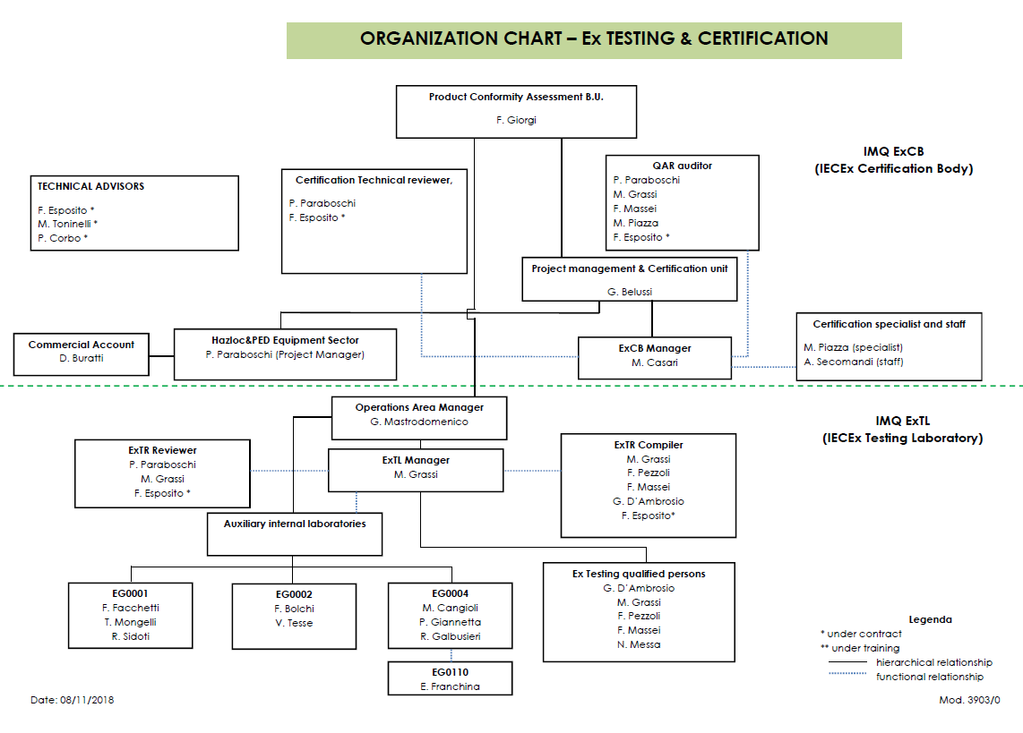
- Accreditation Certificate for ISO/IEC 17065

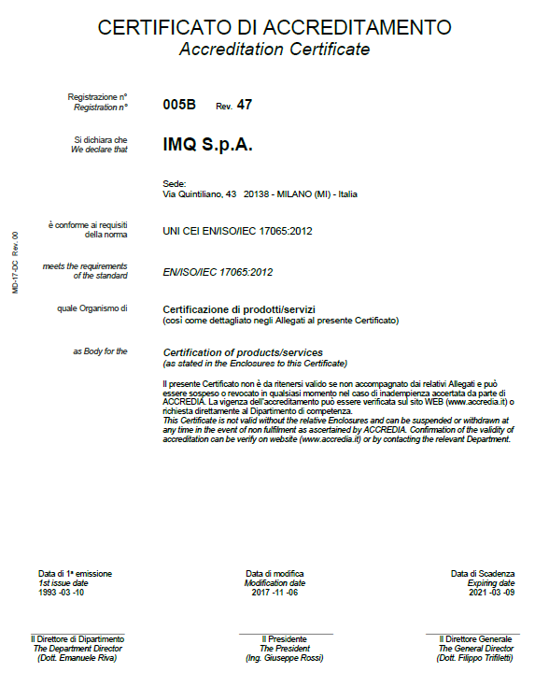
- Accreditation Certificate for ISO/IEC 17025

