**INTERNATIONAL ELECTROTECHNICAL COMMISSION SYSTEM FOR**

**CERTIFICATION TO STANDARDS RELATING TO EQUIPENT FOR USE**

**IN EXPLOSIVE ATMOSPHERES (IECEx SYSTEM)**

**Title: Scope Extension Assessment Report for INERIS, an Accepted ExCB and ExTL within the IECEx System, Equipment Scheme 02, to include IEC 60079-33, and IEC 60079-29-1 in their scope.**

**To: Members of the IECEx Management Committee, ExMC**

**Introduction**

Following an application for a scope extension by INERIS, to include

* IEC 60079-33, Explosive atmospheres - Part 33: Equipment protection by special protection 's'.

and

* IEC 60079-29-1 Explosive atmospheres - Part 29-1: Gas detectors - Performance requirements of detectors for flammable gases

within their scope, a special site assessment visit was arranged and conducted.

This report details the assessment findings of this scope extension with the IECEx

Assessment Team recommending the acceptance of the above scope extension.

It is now hereby submitted for voting by ExMC.

***This document is hereby submitted for ExMC approval via correspondence using the IECEx on-line voting system.  ExMC Members are requested to submit their vote via the IECEx On-line*** [***Ballot System***](https://www.iecex.com/ballot) ***by the closing date 2019 08 12***

*Please refer to OD 050 for guidance on the “IECEx On-line voting system.”*

*Chris Agius*

**IECEx Secretary**

|  |  |
| --- | --- |
| **Address:**  **IECEx Secretariat**  **Australia Square**  **Level 33, 264 George Street**  **Sydney NSW 2000**  **Australia** | **Tel: +61 2 4628 4690**  **Fax: +61 2 46 27 5285**  **Email: chris.agius@iecex.com** |

IEC System for certification to standards relating to equipment for use in Explosive Atmospheres (IECEx System)

IECEx Assessment Report Form

IECEx Assessment Report Form for use by IECEx Assessment Teams to report Assessments conducted according to the IECEx Assessment Procedures of

1. Operational Document IECEx OD 003-2 for the Certified Equipment Scheme
2. Operational Document IECEx OD 016 for the Certified Service Facility Scheme
3. Operational Document IECEx OD 022 for the IECEx Conformity Mark Licensing System

IECEx ExCB/ExTL assessment report for

INERIS

INTERNATIONAL  
ELECTROTECHNICAL  
COMMISSION

CONTENTS

(Update when report is complete – by right click, Update field, Update entire table)

1 Assessment information 5

1.1 Type of Body covered by this assessment: 5

1.2 Type of assessment: 5

1.3 Details of body 5

1.3.1 Country 5

1.3.2 Name of body 5

1.3.3 Name and title of nominated principal contact 5

1.4 Assessment information 5

1.4.1 Members of the assessment team 5

1.4.2 Place(s) of assessment 5

1.4.3 Assessment date(s) 5

1.5 Scope 5

1.5.1 Standards ExCB and ExTL scope for equipment certification scheme 5

**1.5.2 ExTL scope** 7

2 Common information 8

2.1 Legal entity of body 8

2.2 Financial support 8

2.3 History 8

2.4 Documentation 8

2.4.1 Quality manual 8

2.4.2 Procedures 8

2.4.3 Work instructions 8

2.4.4 Records (including test records where relevant) 8

2.4.5 Document change control 8

2.5 Confidentiality 8

2.6 Publications (Hard cover and Electronic) 8

2.7 Recognition and agreements 8

2.8 Internal audit and periodic management review 8

2.9 Contracting, subcontracting, use of other labs and use of other locations 8

2.10 Training and competence 8

2.11 Complaints and appeals (including appeals to IECEx) 9

2.12 Special facts to be noted 9

2.12.1 Supporting documentation 9

2.13 Recommendations 9

3 ExCB for IECEx Certified Equipment Scheme 10

3.1 Assessment references 10

3.2 ExCB persons interviewed 10

3.3 Associated ExTL(s) 10

3.4 Associated certification functions 10

3.5 National marks and certificates 10

3.6 Standards accepted 10

3.7 National differences to IEC standards 10

3.8 Organisation 11

3.8.1 Names, titles and experience of the senior executives 11

3.8.2 Name, title and experience of the quality management representative 11

3.8.3 Name and title of signatories for certification 11

3.8.4 Other employees in ExCB activity 11

3.9 Organizational structure 11

3.10 Administration 11

3.10.1 Administrative structure 11

3.10.2 Indemnity insurance 11

3.11 Resources 11

3.12 Committees (such as governing or advisory boards) 12

3.13 Certification operations 12

3.13.1 National approval/certification methods 12

3.13.2 Certification policy 12

3.13.3 Application for certification 12

3.13.4 Certification decision 12

3.14 Certificates issued 12

3.15 National accreditation 12

3.16 Assessment of manufacturers and issue of QARs 12

3.17 Comments (including issues found during assessment) 12

4 ExTL for IECEx Certified Equipment Scheme 13

4.1 Assessment references 13

4.2 ExTL persons interviewed 13

4.3 Associated ExCB(s) 13

4.4 Organisation 13

4.4.1 Names, titles and experience of the senior executives 13

4.4.2 Name, title and experience of the quality management representative 13

4.4.3 Other employees in ExTL 13

4.5 Organizational structure 14

4.6 Resources 14

4.7 Test reports issued 14

4.8 National accreditation 14

4.9 Calibration 14

4.10 Proficiency 14

4.11 Tests witnessed 14

4.12 Comments (including issues found during assessment) 15

Annex A Overall Organisation Chart of INERIS 16

Annex B Accreditation Certificate for ISO/IEC 17065 (relevant page only) 18

Annex C Accreditation Certificate for ISO/IEC 17025 (relevant pages only) 19

# Assessment information

## Type of Body covered by this assessment:

|  |  |
| --- | --- |
| ExCB for IECEx Certified Equipment Scheme | ✓ |
| ExTL for IECEx Certified Equipment Scheme | ✓ |
| ExCB for IECEx Certified Service Facilities Scheme |  |
| ExCB for IECEx Conformity Mark Licensing System |  |

## 

## Type of assessment: <retain appropriate marks>

|  |  |
| --- | --- |
| Pre-assessment for candidate body |  |
| Initial assessment for candidate body |  |
| Surveillance |  |
| Re-assessment |  |
| Scope extension | ✓ |

## Details of body

### Country

FRANCE

### Name of body

INERIS - Institut National de l'Environnement Industriel et des Risques

### Name and title of nominated principal contact

|  |  |  |
| --- | --- | --- |
| **Name** | **Title** | **E-mail address** |
| Thierry Houeix | Ex Certification Officer | [Thierry.Houeix@ineris.fr](mailto:Thierry.Houeix@ineris.fr) |

## Assessment information

### Members of the assessment team

|  |  |
| --- | --- |
| **Name** | **Role (modify as necessary)** |
| Ron Webb | Lead assessor |

### Place(s) of assessment

Parc Technologique ALATA F-60550 Verneuil-en-Halatte, France

### Assessment date(s)

14-15 May 2018

## Scope

### Standards ExCB and ExTL scope for equipment certification scheme

| Number | Title | Comments, e.g. if scope change |
| --- | --- | --- |
| IEC 60079-0 Ed. 7 | Explosive atmospheres - Part 0: Equipment - General requirements | No change |
| IEC 60079-1 Ed.7 | Explosive atmospheres - Part 1: Equipment protection by flameproof enclosures “d” | No change |
| IEC 60079-2 Ed.6 | Explosive atmospheres - Part 2: Equipment protection by pressurized enclosure “p” | No change |
| IEC 60079-5 Ed.3 | Explosive atmospheres - Part 5: Equipment protection by powder filling “q” | No change |
| IEC 60079-6 Ed.4 | Explosive atmospheres - Part 6: Equipment protection by oil immersion “o” | No change |
| IEC 60079-7 Ed.5.1 | Explosive atmospheres - Part 7: Equipment protection by increased safety "e" | No change |
| IEC 60079-11Ed. 6 | Explosive atmospheres - Part 11: Equipment protection by intrinsic safety “i” | No change |
| IEC 60079-13 Ed.1 | Explosive atmospheres - Part 13: Equipment protection by pressurized room “p” | No change |
| IEC 60079-15 Ed.5 | Explosive atmospheres – Part 15: Equipment protection by type of protection "n" | No change |
| IEC 60079-18 Ed.4.1 | Explosive atmospheres – Part 18: Equipment protection by encapsulation “m” | No change |
| IEC 60079-25 Ed.2 | Explosive atmospheres – Part 25: Intrinsically safe electrical systems | No change |
| IEC 60079-26 Ed.3 | Explosive atmospheres - Part 26: Equipment with equipment protection level (EPL) Ga | No change |
| IEC 60079-28 Ed.2 | Explosive atmospheres - Part 28: Protection of equipment and transmission systems using optical radiation | No change |
| IEC 60079-29-1 Ed. 2 | Explosive atmospheres - Part 29-1: Performance requirements of detectors for flammable gases | Scope  Extension |
| IEC 60079-31Ed.2 | Explosive atmospheres – Part 31: Equipment dust ignition protection by enclosure "t" | No change |
| IEC 60079-33 Ed. 1 | Explosive atmospheres - Part 33: Equipment protection by special protection “s” | Scope  Extension |
| IEC TS 60079-46 Ed. 1 | Explosive atmospheres - Part 46: Equipment Assemblies | No change |
| *IEC 61241-0 Ed. 1 | Electrical apparatus for use in the presence of combustible dust - Part 0: General requirements | No change |
| *IEC 61241-1 Ed. 1 | Electrical apparatus for use in the presence of combustible dust – Part 1: Protection by enclosures “tD” | No change |
| *IEC 61241-1-1 Ed.2 | Electrical apparatus for use in the presence of combustible dust – Part 1-1: Electrical apparatus protected by enclosures and surface temperature limitation - Specification for apparatus | No change |
| *IEC 61241-4 Ed.1 | Electrical apparatus for use in the presence of combustible dust – Part 4: Protection by pressurisation “pD” | No change |
| *IEC 61241-11 Ed.1 | Electrical apparatus for use in the presence of combustible dust – Part 11: Protection by intrinsic safety “pD” | No change |
| *IEC 61241-18 Ed.1 | Electrical apparatus for use in the presence of combustib  le dust – Part 18: Protection by encapsulation “mD” | No change |
| ISO 80079-36 Ed.1 | Explosive atmospheres – Part 36: Non-electrical equipment for explosive atmospheres -– Basic method and requirements | No change |
| ISO 80079-37 Ed.1 | Explosive atmospheres - Part 37: Non-electrical equipment for explosive atmospheres - Non electrical type of protection constructional safety “c”, control of ignition source “b" and liquid immersion “k | No change |
| DS 2015/001A | IECEx Assessment and Certification of Equipment assemblies | No change |

**1.5.2 ExTL scope**

The ExTL scope is the same as for the ExCB.

# Common information

## Legal entity of body

Not relevant as this is a scope extension assessment. This was covered in the reassessment visit carried out on 18-20 November 2015, ExMC/1103/DV.

## Financial support

Not relevant as this is a scope extension assessment. This was covered in the reassessment visit carried out on 18-20 November 2015, ExMC/1103/DV.

## History

Not relevant as this is a scope extension assessment. This was covered in the reassessment visit carried out on 18-20 November 2015, ExMC/1103/DV.

## Documentation

### Quality manual

Not relevant as this is a scope extension assessment. This was covered in the reassessment visit carried out on 18-20 November 2015, ExMC/1103/DV.

### Procedures

The procedures reviewed during the reassessment carried out on 18-20 November 2015, have been updated to include reference to OD233 for Ex s.

### Work instructions

Not relevant as this is a scope extension assessment. This was covered in the reassessment visit carried out on 18-20 November 2015, ExMC/1103/DV.

### Records (including test records where relevant)

Not relevant as this is a scope extension assessment. This was covered in the reassessment visit carried out on 18-20 November 2015, ExMC/1103/DV.

### Document change control

Not relevant as this is a scope extension assessment. This was covered in the reassessment visit carried out on 18-20 November 2015, ExMC/1103/DV.

## Confidentiality

Not relevant as this is a scope extension assessment. This was covered in the reassessment visit carried out on 18-20 November 2015, ExMC/1103/DV.

## Publications (Hard cover and Electronic)

Not relevant as this is a scope extension assessment. This was covered in the reassessment visit carried out on 18-20 November 2015, ExMC/1103/DV.

## Recognition and agreements

Not relevant as this is a scope extension assessment. This was covered in the reassessment visit carried out on 18-20 November 2015, ExMC/1103/DV.

## Internal audit and periodic management review

Not relevant as this is a scope extension assessment. This was covered in the reassessment visit carried out on 18-20 November 2015, ExMC/1103/DV.

## Contracting, subcontracting, use of other labs and use of other locations

Subcontract agreements for some of the tests for gas detectors were viewed. These include the air velocity test, vibration test and the EMC test. The agreements were acceptable and sample test reports were seen to be acceptable.

## Training and competence

A matrix of competency for the gas detectors was available and indicated appropriate competency. The gas detector lab has been operating for over 20 years. Interviews were undertaken with staff to ensure that they had the required level of understanding. These are included in a TCD document which is held by the Secretariat.

## Complaints and appeals (including appeals to IECEx)

Not relevant as this is a scope extension assessment. This was covered in the reassessment visit carried out on 18-20 November 2015, ExMC/1103/DV.

## Special facts to be noted

### Supporting documentation

Copies of additional supporting information for this assessment have been provided to the applicant and the IECEx Secretariat. These are included in a site assessment report and include:

* Details of issues raised and how these have been resolved
* Completed Technical Capability Document (TCD) including the IEC 60079-33 and IEC 60079-29-1
* Assessors’ notes

## Recommendations

Based on the assessment performed on 14-15 May 2018, INERIS and follow up actions, is recommended for scope extension in the IECEx scheme as an ExCB and an ExTL for the following additional Standards:

* + IEC 60079-33, and IEC 60079-29-1

This is according to the scope of the standards listed in this document including the extension of scope.

|  |
| --- |
| Ron Webb |
| Lead Assessor |

Date: 25 June 2019

# ExCB for IECEx Certified Equipment Scheme

## Assessment references

1. IECEx02 IECEx Certified Equipment Scheme covering equipment for use in explosive atmospheres – Rules of Procedure
2. OD003-2 Assessment, surveillance assessment and re-assessment of ExCBs and ExTLs operating in the IECEx 02, IECEx Certified Equipment Scheme
3. OD005-2 IECEx Quality System Requirements for Manufacturers – Part 2: Audit Checklist. (This is available in a Word format for use by ExCBs)
4. ISO/IEC 80079-34 Edition 1, Explosive atmospheres – Part 34: Application of quality systems for equipment manufacture
5. OD009 Issuing of CoCs, ExTRs and QARs
6. IECEx Document OD 025 Guidelines on the Management of Assessment and Surveillance programs for the assessment of Manufacturer’s Quality Systems in accordance with the IECEx Scheme
7. OD0026 IECEx Certified Equipment Scheme – Guidelines for the qualification of Lead Auditor and Auditors, in accordance with the IECEx System
8. ISO/IEC 17065, General requirements for bodies operating product certification systems
9. IECEx Document OD17 Drawing and documentation guidance
10. IECEx Technical Capability Documents (TCD)
11. ExTAG decision sheets (DSs)
12. OD 233: IECEx Certified Equipment Scheme - Assessment of Ex “s" Equipment

NOTE The latest editions of the above documents were applied

## ExCB persons interviewed

|  |  |
| --- | --- |
| Name | Position |
| Thierry Houeix | Ex Certification officer |
| Olivier Cottin | Head of Ex Certification Unit |

## Associated ExTL(s)

The ExTL is integral with the ExCB.

## Associated certification functions

INERIS provides ATEX certificates in accordance with ATEX Directive 2014/34/EU and their operations are accredited to IEC/ISO 17065 by the National Accreditation Body, Cofrac.

INERIS is a Notified Body according to the ATEX directive 2014/34/EU. Their Notified Body number is 0080.

## National marks and certificates

INERIS ATEX certificates are accepted by the European commission and by European state regulators.

## Standards accepted

See clause 1.5.1 of this report.

## National differences to IEC standards

National differences to IEC standards are those for the European Group differences listed in the latest version of the IECEx Scheme Bulletin.

## Organisation

### Names, titles and experience of the senior executives

|  |  |  |
| --- | --- | --- |
| Name | Title | Experience |
| Dominique Charpentier | Certification division manager | 29 years, 11 in Ex |
| Thierry Houeix | Ex Certification Officer | 23 years in Ex |
| Olivier Cottin | Head of Ex Certification Unit | 15 years in Ex |
|  |  |  |

### Name, title and experience of the quality management representative

|  |  |  |
| --- | --- | --- |
| **Name** | **Title** | **Experience** |
| Eric Morvan | Quality Manager | 10+ years |

### Name and title of signatories for certification

|  |  |  |
| --- | --- | --- |
| Dominique Charpentier | Certification division manager | 29 years, 11 in Ex |
| Thierry Houeix | Ex Certification Officer | 23 years in Ex |
| Olivier Cottin | Head of Ex Certification Unit | 15 years in Ex |

### Other employees in ExCB activity

|  |  |  |
| --- | --- | --- |
| Name | Title | Responsibility and Experience in Ex |
| Olivier Mirabel | Factory auditor | 13 years |
| Eric Faé | Project Manager & Factory auditor | 16 years |
| Claude | Project Manager | 25 years |
| Florian Boquillet | Project Manager& Factory auditor | 3 years |
| Benjamin Goy | Project Manager& Factory auditor | 7 years |
| James Jessu | Project Manager | 15 years |
| Fabio Morara | Project Manager | 7 years |

## Organizational structure

See Annex A

## Administration

### Administrative structure

Sufficient administrative assistance is provided.

### Indemnity insurance

Not relevant as this is a scope extension assessment. This was covered in the reassessment visit carried out on 18-20 November 2015, ExMC/1103/DV.

## Resources

INERIS has an adequate number of staff for the current level of business. There are a numerous experienced staff in Ex and gas detector activities.

Interviews with staff showed that they had a good understanding of the standards forming the basis of this scope extension

At least three staff members are identified as independent verifiers for IEC 60079-33.

The laboratory and offices provide an adequate environment for the work.

## Committees (such as governing or advisory boards)

Not relevant as this is a scope extension assessment. This was covered in the reassessment visit carried out on 18-20 November 2015, ExMC/1103/DV.

## Certification operations

### National approval/certification methods

INERIS is recognised under the National accreditation systems and schemes. It has procedures for compliance with IECEx Rules and Operational Documents.

### Certification policy

Not relevant as this is a scope extension assessment. This was covered in the reassessment visit carried out on 18-20 November 2015, ExMC/1103/DV.

### Application for certification

Not relevant as this is a scope extension assessment. This was covered in the reassessment visit carried out on 18-20 November 2015, ExMC/1103/DV.

### Certification decision

Not relevant as this is a scope extension assessment. This was covered in the reassessment visit carried out on 18-20 November 2015, ExMC/1103/DV.

## Certificates issued

Number of certificates issued under for the preceding four years for each type of protection. (National Certificates)

| **Standard numbers** | **Type of protection or other identifying information** | **Number of issued certificates (for last 4 years)** |
| --- | --- | --- |
|  | Special protection using the EHSRs of the ATEX Directive | 4 |
| EN 60079-29-1 | Gas detector performance | 8 |

Previous reports show certificates

## National accreditation

INERIS has French accreditation to ISO/IEC 17065 as a certification body from Cofrac. The certificate number is N° 5-0045 rév. 16 and is valid until 31.12.2020 and a copy is shown at Annex B of this report. The link to the Cofrac accreditation site is:

<https://www.cofrac.fr/annexes/sect5/5-0045.pdf>

The scope of this accreditation includes the national scheme for Ex Certification which conforms to the ATEX Directive 2014/34/EU.

## Assessment of manufacturers and issue of QARs

For IECEx certification schemes a set of documented procedures is in place to enable surveillance to be carried out in accordance with the criteria of the certification systems.

## Comments (including issues found during assessment)

None

# ExTL for IECEx Certified Equipment Scheme

## Assessment references

1. IECEx02 IECEx Certified Equipment Scheme covering equipment for use in explosive atmospheres – Rules of Procedure
2. IECEx OD003-2 Assessment, surveillance assessment and re-assessment of ExCBs and ExTLs operating in the IECEx 02, IECEx Certified Equipment Scheme
3. IECEx OD009 Issuing of CoCs, ExTRs and QARs
4. ISO/IEC 17025:2005 Edition 2, General requirements for the competence of testing and calibration laboratories
5. IECEx Document OD17 Drawing and documentation guidance
6. IECEx Technical Capability Documents (TCD)
7. ExTAG decision sheets (DSs)
8. OD 233: IECEx Certified Equipment Scheme - Assessment of Ex “s" Equipment

NOTE The latest editions of the above documents were applied.

## ExTL persons interviewed

|  |  |
| --- | --- |
| **Name** | **Position** |
| GOY Benjamin | Assessment Team Leader |
| TRUCHOT Benjamin | Technical manager |
| DEBUY Véronique | Head of Laboratory |
| LEPINE Nicolas | Test Engineer |
| KASPRZYCKI Sabine | Test Engineer |
| MORIN Jean-Charles | Test Engineer |

## Associated ExCB(s)

The ExCB is integral with the ExTL

## Organisation

### Names, titles and experience of the senior executives

| **Name** | **Title** | **Experience** |
| --- | --- | --- |
| Bernard Piquette | Accidental Risk Division Manager & ExTL Manager | 35 years in Ex |
| Thierry Delbaere | Head of Ex Lab Unit & ExTL Deputy Manager | 13 years in Ex |

### Name, title and experience of the quality management representative

|  |  |  |
| --- | --- | --- |
| **Name** | **Title** | **Experience** |
| Eric Morvan | Quality Manager | 10+ years |
| Stephanie Lemaire | Quality Assurance Manager  for ATEX and IECEx Testing  Laboratory | 17 years |

### Other employees in ExTL

|  |  |
| --- | --- |
| GOY Benjamin | Assessment Team Leader |
| TRUCHOT Benjamin | Technical manager |
| DEBUY Véronique | Head of Laboratory |
| LEPINE Nicolas | Test Engineer |
| KASPRZYCKI Sabine | Test Engineer |
| MORIN Jean-Charles | Test Engineer |

## Organizational structure

See Annex A

## Resources

INERIS has an adequate number of staff for the current level of business. There are a numerous experienced staff in Ex and gas detector activities.

Interviews with staff showed that they had a good understanding of the standards forming the basis of this scope extension

At least three staff members are identified as independent verifiers for IEC 60079-33.

The laboratory and offices provide an adequate environment for the work. The testing equipment is suitable for the range of tests carried out for the scope extensions.

## Test reports issued

Number of test reports (ExTRs) issued under for the preceding years for each type of protection corresponds to the number of certificates issued shown in 3.14

Regarding Scope Extension for IEC 60079-33 and IEC 60079-29-1, the assessment team interviewed the relevant staff and found them to have a thorough understanding of the Standards and the assessment required.

A review of three files relating to special protection equipment (using the EHSRs of the ATEX Directive) was undertaken during the assessment and found to be satisfactory.

The principle of risk assessment is also well understood

## National accreditation

INERIS has accreditation from COFRAC: Certificate No 1-0157 to NF EN ISO/IEC 17025 which expires **31/08/2019**. A copy of the accreditation is attached at Annex C.

As IEC 60079-33 is not included INERIS’ current accreditation a Surveillance Assessment will be required unless the Standard is included in their August 2019 Accreditation.

The link to the Cofrac site is:

[https://www.cofrac.fr/annexes/sect1/1-0157.pdf](%20https://www.cofrac.fr/annexes/sect1/1-0157.pdf)

## Calibration

Test equipment is either sent out for calibration by an external calibration facility or calibrated internally to defined procedures. The external calibration facilities are 17025 accredited.

## Proficiency

INERIS partakes in the Proficiency testing organised by PTB.

## Tests witnessed

A test for response time of a gas sensor was demonstrated. This involved placing the sensor (which had a sealed cap on the sensing element) in a chamber which could be filled with the required gas mixture. The cap on the sensor was then removed and the sensor output monitored and recorded. The test was carried out in a fully acceptable manner.

## Comments (including issues found during assessment)

Minor issues were found which were cleared to the satisfaction of the assessment team quickly during the visit.

These included:

* Incorporation of OD233 into the quality system
* Finalization of the TCD, which was resolved during May 2019

1. **Annexes**
2. Overall Organisation Chart of INERIS

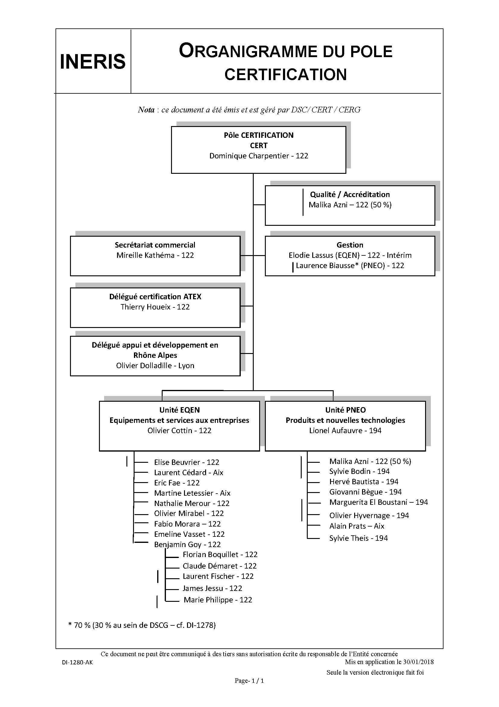

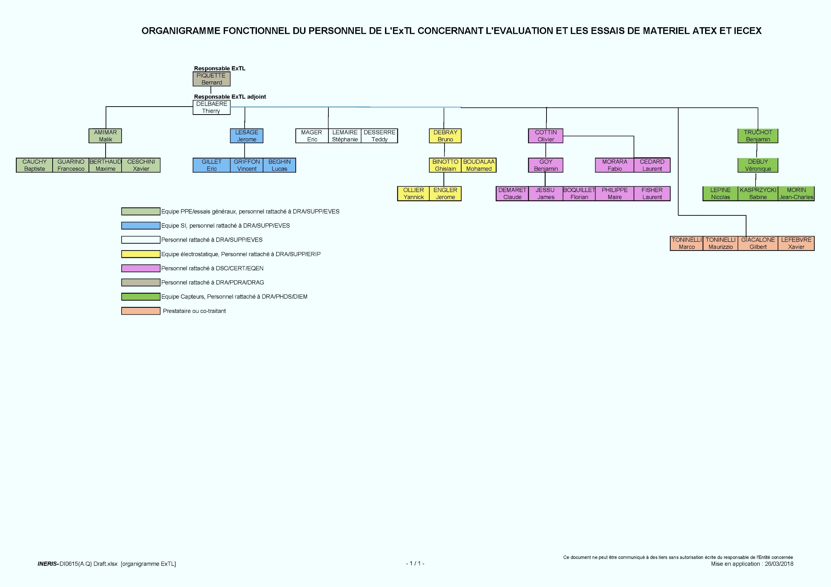

1. Accreditation Certificate for ISO/IEC 17065  
   (relevant page only)

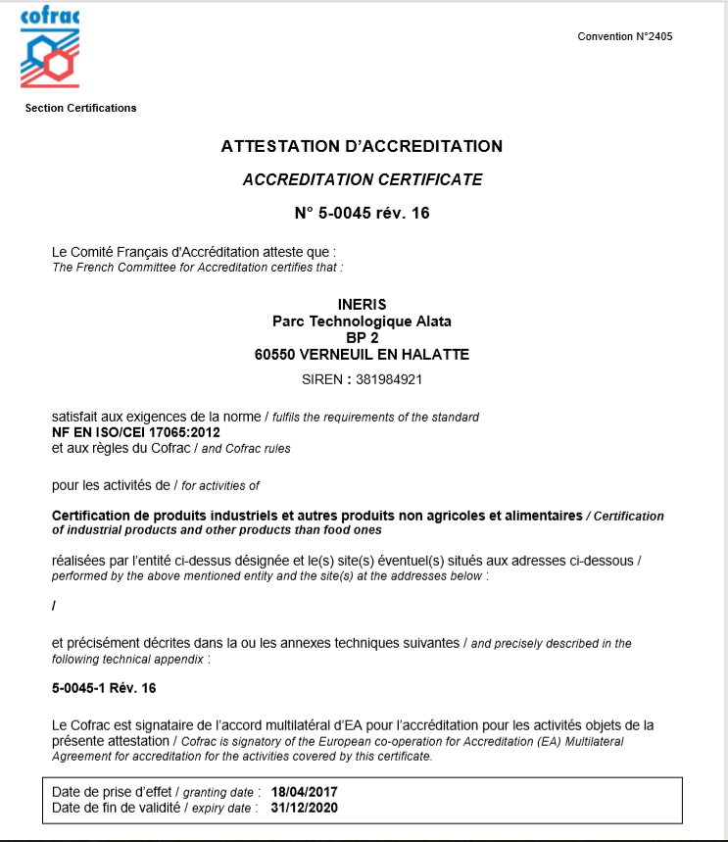

1. Accreditation Certificate for ISO/IEC 17025  
   (relevant pages only)

