INTERNATIONAL ELECTROTECHNICAL COMMISSION SCHEME FOR
CERTIFICATION TO STANDARDS RELATING TO EQUIPMENT FOR USE
IN EXPLOSIVE ATMOSPHERES (IECEx SYSTEM)

IECEx ASSESSMENT REPORT

Title: Re-assessment and Scope Extension Report for Korea Testing Laboratory, KTL, KR, to include IEC 60079-28 Ed.2 in their scope

Introduction

In accordance with the 5 year re-assessment plan for the surveillance and monitoring of bodies within the IECEx System, the following document contains the IECEx Re-assessment and Scope Extension Report for the continued acceptance of Korea Testing Laboratory, KTL KR, as an Accepted Certification Body (ExCB) and an Accepted Ex Testing Laboratory (ExTL) within the IECEx System, Equipment Scheme 02.

During the re-assessment the IECEx Assessment Team took the opportunity to also assess KTL’s facilities, equipment and competence to undertake testing and certification to the Standard –

IEC 60079-28 Edition 2.0
Explosive atmospheres - Part 28: Protection of equipment and transmission systems using optical radiation

This scope extension to include IEC 60079-28 Ed.2 is hereby submitted for ExMC approval, via correspondence, using the IECEx on-line voting system. ExMC Members are requested to submit their vote via the IECEx On-line Ballot System by the closing date 2019 08 22

Please refer to OD 050 for guidance on the “IECEx On-line voting system.”

Chris Agius

IECEx Secretariat

Address:  Level 33, Australia Square  264 George Street  Sydney NSW 2000  Australia | Contact Details:  Tel: +61 2 46 28 4690  Fax: +61 2 46 27 5285  e-mail:chris.agius@iecex.com  http://www.iecex.com

IEC System for certification to standards relating to equipment for use in Explosive Atmospheres (IECEx System)

IECEx Assessment Report Form

IECEx Assessment Report Form for use by IECEx Assessment Teams to report Assessments conducted according to the IECEx Assessment Procedures of

- Operational Document IECEx OD003-2 for the Certified Equipment Scheme
- Operational Document IECEx OD316-5 for the Certified Service Facility Scheme
- Operational Document IECEx OD422 for the IECEx Conformity Mark Licensing System

IECEx ExCB/ExTL assessment report for KTL

INTERNATIONAL
ELECTROTECHNICAL
COMMISSION

CONTENTS
1 Assessment information 6
1.1 Type of Body covered by this assessment: 6
1.2 Type of assessment: 6
1.3 Details of body 6
1.3.1 Country 6
1.3.2 Name of body 6
1.3.3 Name and title of nominated principal contact 6
1.4 Assessment information 6
1.4.1 Members of the assessment team 6
1.4.2 Place(s) of assessment 6
1.4.3 Assessment date(s) 6
1.5 Application information and background information on the assessment 6
1.6 Scope 7
1.6.1 ExCB scope for equipment certification scheme 7
1.6.2 ExTL scope 7
1.6.3 ExCB scope for Service Facilities Scheme 7
1.6.4 ExCB scope for ExMark Scheme 7
2 Common information 8
2.1 Legal entity of body 8
2.2 Financial support 8
2.3 History 8
2.4 Documentation 8
2.4.1 Quality manual 8
2.4.2 Procedures 8
2.4.3 Work instructions 8
2.4.4 Records (including test records where relevant) 8
2.4.5 Document change control 9
2.5 Confidentiality 9
2.6 Communication with public and customers (Hard copy and Electronic) 9
2.7 Recognitions and agreements 9
2.8 Internal audit 9
2.9 Management review 9
2.10 Contracting, subcontracting and witness testing 9
2.10.1 Contracting 9
2.10.2 Subcontracting 9
2.10.3 Witness testing 9
2.11 Training and competence 10
2.12 Complaints and appeals (including appeals to IECEx) 10
2.13 Impartiality 10
2.14 Commenting on ExTAG Documents 10
2.15 Special facts to be noted 10
2.16 Supporting documentation 10
2.17 Recommendations 10
3 ExCB for IECEx Certified Equipment Scheme 11
3.1 Assessment references 11
3.1.1 General references 11
3.1.2 Additional references applied for this assessment 11
3.2 Candidate ExCB persons interviewed 11
3.3 Associated ExTL(s) 11
3.4 Associated certification functions 11
3.5 National marks and certificates 11
3.6 Standards accepted 11
3.7 National differences to IEC standards 11
3.8 Organisation 12
3.8.1 Names, titles and experience of the senior executives 12
3.8.2 Name, title and experience of the quality management representative 12
3.8.3 Name and title of signatories for certification 12
3.8.4 Other employees in ExCB activity 12
3.9 Organizational structure 12
3.10 Indemnity insurance 12
3.11 Resources 12
3.12 Committees (such as governing or advisory boards) 12
3.13 Certification operations 12
3.13.1 National approval/certification methods 12
3.13.2 Certification policy 13
3.13.3 Application for certification 13
3.13.4 Certification decision 13
3.13.5 Suspension and cancellation of certificates 13
3.14 Certificates issued 13
3.15 National accreditation 13
3.16 Assessment of manufacturers and issue of QARs 14
3.17 Comments (including issues found during assessment) 14
4 ExTL for IECEx Certified Equipment Scheme 15
4.1 Assessment references 15
4.1.1 General references 15
4.1.2 Additional references applied for this assessment 15
4.2 Candidate ExTL persons interviewed 15
4.3 Associated ExCB(s) 15
4.4 Organisation 15
4.4.1 Names, titles and experience of the senior executives 15
4.4.2 Name, title and experience of the quality management representative 15
4.4.3 Other employees in ExTL activity 16
4.5 Organizational structure 16
4.6 Resources 16
4.7 Test reports issued 16
4.8 National accreditation 16
4.9 Calibration 16
4.10 Tests witnessed during the assessment visit 17
4.11 Participation in IECEx Proficiency Testing Programs 17
Comments (including issues found during assessment) 17
Annex A Overall Organisation Chart of KTL 18
Annex B Organisation Chart of ExCB and ExTL 19
Annex C Accreditation Certificate for ISO/IEC 17065 20
Annex D Accreditation Certificate for ISO/IEC 17025 21

Assessment information

Type of Body covered by this assessment:
ExCB for IECEx Certified Equipment Scheme | ✓
ExTL for IECEx Certified Equipment Scheme | ✓
ExCB for IECEx Certified Service Facilities Scheme
ExCB for IECEx Conformity Mark Licensing System

NOTE 1 ExCB - IECEx Certification Body
NOTE 2 ExTL - IECEx Testing Laboratory

Type of assessment:
Pre-assessment for candidate body
Initial assessment for candidate body
Surveillance
Re-assessment | ✓
Scope extension | ✓

Details of body

Country
Republic of Korea

Name of body
KTL

Name and title of nominated principal contact
Name | Title | E-mail address
Jun-Gu Kang | Director, Machinery Convergence Technology Centre | kang@ktl.re.kr

Assessment information

Members of the assessment team
Name | Role
Ron Webb | IECEx Lead Assessor
Gordana Ostojic | IECEx Assessor

Place(s) of assessment
87 Digital-ro, 26 gil, Guro-gu, Seoul, Korea 152-718 | 723, Haean-ro, Sangnok-gu, Ansan-si Gyeonggi-do 426-910 Korea

Assessment date(s)
28 October to 1 November 2018

Application information and background information on the assessment
Information relevant to the Secretariat review process:
Application for scope extension received by the Secretariat for IEC 60079-28 Ed.2 which was included as part of this re-assessment.

Scope

ExCB scope for equipment certification scheme
Number | Title | Comments, eg if scope change
IEC 60079-0  Edition 7.0 | Explosive atmospheres - Part 0: Equipment - General requirements | In scope
IEC 60079-1  Edition 7.0 | Explosive atmospheres - Part 1: Equipment protection by flameproof  enclosures “d” | In scope
IEC 60079-2  Edition 6.0 | Explosive atmospheres - Part 2: Equipment protection by pressurized  enclosure «p» | In scope
IEC 60079-5  Edition 4.0 | Explosive atmospheres - Part 5: Equipment protection by powder filling «q» | In scope
IEC 60079-6  Edition 4.0 | Explosive atmospheres - Part 6: Equipment protection by liquid immersion «o» | In scope
IEC 60079-7  Edition 5.0 | Explosive atmospheres - Part 7: Equipment protection by increased  safety "e" | In scope
IEC 60079-11  Edition 6.0 | Explosive atmospheres - Part 11: Equipment protection by intrinsic safety “i” | In scope
IEC 60079-15  Edition 5.0 | Explosive atmospheres – Part 15: Equipment protection by type of protection "n" | In scope
IEC 60079-18  Edition 4.0 | Explosive atmospheres – Part 18: Equipment protection by encapsulation “m” | In scope
IEC 60079-26  Edition 3.0 | Explosive atmospheres - Part 26: Equipment with equipment protection level (EPL) Ga | In scope
IEC 60079-28  Edition 2.0 | Explosive atmospheres - Part 28: Protection of equipment and transmission systems using optical radiation | Scope extension
IEC 60079-31  Edition 2.0 | Explosive atmospheres – Part 31: Equipment dust ignition protection by enclosure "t" | In scope
NOTE 2 Unless otherwise indicated, earlier editions of standards (even if with a different number) are considered to be covered in the above scope for the purposes of the assessment.
NOTE 3 The above list highlights any extension of scope in the list above for new standards or later editions of standards already in scope.

ExTL scope
The ExTL scope is the same as for the ExCB.

ExCB scope for Service Facilities Scheme
Not applicable

ExCB scope for ExMark Scheme
Not applicable

Common information

Legal entity of body
Testing Laboratory (KTL) is a non-profit affiliated organization under the Ministry of Trade, Industry and Energy founded to provide public safety performing certification, product testing, factory inspection and calibration services to clients.

Financial support
KTL is funded by the Korean Government and exempted from taxation on any profits, having the financial stability and resources required for its operation.

History
KTL was founded in April 1966, originally named as Korea Fine Instrument Center (Article 41 of the Promotion of the Industrial Technology Innovation Law and the Decree 7494 in the Civil Law), and it is registered to the Taxation Department of Korea under the registration number 113-82-06228.
As a third party testing and certification institute in Korea, KTL was officially appointed as a National Certification Body under the “Industrial safety & Health Law” since Jan 21, 1998. Ever since its foundation KTL has been working constantly and mainly for the safety of electrical and electronic apparatuses for use in explosive atmospheres.
Also KTL has participated in wide range of national and international scheme such as IECEE CB Scheme and IECQ Scheme since 1990.

Documentation

Quality manual
KTL has a top level Quality Manual covering the higher level requirements of the scheme and below it are additional manuals containing procedures which also meet the IECEx scheme’s requirements.

Procedures
There are several manuals that come under the quality manual and also various procedures. Relevant ones include; QM002 Manual for Testing and Inspection Service, QM003 Quality Manual for QMS Certification, QM005 Product Certification Manual, QM008 Calibration Manual.

Work instructions
At the next level are quality guidelines and internal procedures.

Records (including test records where relevant)
Where relevant procedures include a statement about the retention times that are to be applied the documents are produced in accordance with those procedures.
The procedures ensure that all records related to IECEx activities are maintained with a retention time of 10 years. The assessment team examined the systems for retaining records and was satisfied that the requirements of ISO/IEC 17065 and IECEx were met.
All quality documents are created electronically.
Test records are created in hard copy with a copy in electronic form.
Archive documents are stored on the local server.
Disposal of hard copy is by shredding on site.

Document change control
Document control is covered by procedure P101. In general only electronic documents produced in the system are regarded as controlled documents. However, where required it is possible for hard copies of documents to be controlled by agreement with the quality manager.
There is a company-wide system for control of external documents such as IEC standards and IECEx procedures in the quality system.

Confidentiality
Each employee is required to ensure confidentiality of the customer’s information.
This is addressed in procedure P105. They are required to sign an agreement covering confidentiality and conflict of interest.
Examples of such signed agreements for staff and committee members were viewed

Communication with public and customers (Hard copy and Electronic)
There are publications that are issued covering and promoting the activities of KTL. There is a website. https://www.ktl.re.kr

Recognitions and agreements
KTL has 140 MOUs from 54 countries. They include DEKRA (Netherlands), TUV
Rhineland (Germany), NEPSI (China), LCIE (France), NEMKO (Norway), DNV (Norway), INERIS (France), PTB (Germany), SIRA (GB) and TIIS (Japan).

Internal audit
An internal audit of the Ex department was carried out between 11 September 2017 and 22 September 2017. The report was reviewed. A corrective action in respect of removing superseded documentation was raised. This was cleared by 22 January 2018.

Management review
A management review meeting was held on 18 December 2017 and the results were viewed. Representatives from the ExCB and the ExTL were present

Contracting, subcontracting and witness testing

Contracting
There is a procedure for using contractors, but this is not used by the Ex department. Therefore there is no contracting or subcontracting of IECEx Testing activities.

Subcontracting
There is a procedure for using sub-contractors, but this is not used by the Ex department. Therefore there is no contracting or subcontracting of IECEx Testing activities.

Witness testing
• When off-site and witness testing is done, or proposed to be done, OD024 is referenced and incorporated in procedure G516-04. A checklist is incorporated as part of the procedure
• A testing agreement template is available
• For witness testing (only) - according to 6.3.5 of OD024 - Registration of the manufacturer or user test facility has been made with the IECEx Secretariat and updating of the current information in the Register
• That ExTRs reviewed clearly indicate when there has been witness testing done

Training and competence
Training records were kept in hard copy and were viewed. 12 different records of IECEx training were kept. Training documentation in the form of PowerPoint slides and IECEx rules translated into Korean were available. Training dates and attendees were recorded.
Details of staff competencies were viewed in a PowerPoint presentation.

Complaints and appeals (including appeals to IECEx)
Procedure P115 covers general complaints. There is a specific document, P516, clause 11 covering IECEx and this addresses customer complaints.

Impartiality
Procedure P120 covers impartiality and each staff member has to sign a declaration. Copies of signed declarations were seen. P120 also indicates KTL’s commitment to impartiality.

Commenting on ExTAG Documents
There is a documented procedureTP251/00 which addresses responses required on documents from ExTAG for comment. A hardcopy file was seen.

Special facts to be noted
None

Supporting documentation
Copies of additional supporting information for this assessment have been provided to the applicant and the IECEx Secretariat. These are included in a site assessment report or provided separately and include:
- Details of issues raised and how these have been resolved
- Checklist for ISO/IEC 17065
- Checklist for ISO/IEC 17025
- Completed Technical Capability Document (TCD)
- Photos of the facilities/tests witnessed are included in the above TCD
- Assessors’ notes
- Other

Recommendations
Based on the assessment performed between 29 October and 1 November 2018, and clearance of the issues found, KTL is recommended for continued acceptance in the IECEx scheme as:
- An ExCB in the IECEx Certified Equipment Scheme
- An ExTL in the IECEx Certified Equipment Scheme
This is according to the scope of the standards listed in this document (including the extension of scope).

Ron Webb | Gordana Ostojic
IECEx Lead Assessor | IECEx Assessor
Date:4th July 2019

ExCB for IECEx Certified Equipment Scheme

Assessment references

General references
- IECEx02 IECEx Certified Equipment Scheme covering equipment for use in explosive atmospheres – Rules of Procedure
- OD003-2 Assessment, surveillance assessment and re-assessment of ExCBs and ExTLs operating in the IECEx 02, IECEx Certified Equipment Scheme
- ISO/IEC 80079-34 Edition 1, Explosive atmospheres – Part 34: Application of quality systems for equipment manufacture
- OD009 Issuing of CoCs, ExTRs and QARs
- IECEx Document OD 025 Guidelines on the Management of Assessment and Surveillance programs for the assessment of Manufacturer’s Quality Systems in accordance with the IECEx Scheme
- OD0026 IECEx Certified Equipment Scheme – Guidelines for the qualification of Lead Auditor and Auditors, in accordance with the IECEx System
- ISO/IEC 17065: 2012, Edition 1, General requirements for bodies operating product certification systems Conformity assessment — Requirements for bodies certifying products, processes and services
- IECEx Technical Capability Document (TCD)
- ExTAG decision sheets (DSs)
NOTE The latest editions of the above documents were applied

Additional references applied for this assessment
none

Candidate ExCB persons interviewed
Name | Position
Dong-jin Kim | Senior Engineer
Yong-ho Song | Lead Auditor
Eui-sung Lee | Researcher

Associated ExTL(s)
The ExTL is integral with the ExCB

Associated certification functions
KTL operate as a National Certification Body

National marks and certificates
KTL can offer the mark and associated certificates for Korea.

Standards accepted
See clause 1.6 of this report

National differences to IEC standards
National differences to IEC standards are those for the Korean differences listed in the latest version of the IECEx Scheme Bulletin.

Organisation

Names, titles and experience of the senior executives

Name | Title
Jung Donghee | CEO

Name, title and experience of the quality management representative

Name | Title | Experience
Andres Park | Quality Manager | 4 years as QM

Name and title of signatories for certification

Name | Title | Comments
Jong-koo Park | Director of Certification | 4 years as CB Manager

Other employees in ExCB activity

Name | Title | Responsibility and Experience in Ex
Dong-jin Kim | Senior Engineer | 1 year
Kang, Jun-gu | Chief researcher | 25 year
Song Yong-ho | Engineer | 4 year
Lee Eui-Sung | Engineer | 5 year

Organizational structure
See Annex A

Indemnity insurance
There is an insurance policy for professional indemnity insurance which was viewed. It has a single limit of 500,000 USD and a total of 5,000,000 USD per year

Resources
The operation is well resourced with appropriate facilities, procedures and experienced staff for their certification operations.

Committees (such as governing or advisory boards)
Procedure P194 covers the relevant committees. There is a Certification Assessment Committee and testing and research assessment committee. The Certification Assessment Committee comprises representatives from academia, customer organizations, industry, outside experts and relevant persons from KTL. Its minimum number is 8 and the Chairman is appointed by the President of KTL. It is responsible for policy matters related to certification and also acts as an appeals committee.

Certification operations

National approval/certification methods
KTL also operate as a National Testing Laboratory

Certification policy
There is a quality policy which is to ‘Provide a comprehensive testing and certification organization with global competitiveness’.
The IECEx certification policy/procedure is described in Procedure P516 for the IECEx Certification Service, and is based on document IECEx OD 009

Application for certification
This is covered in Clause 8 of P516. Applications come through the Customer Service Team, but there will often have been discussions with the applicant by technical staff prior to this.

Certification decision
The decision is taken by ExCB manager and is recorded in the checklist contained in P516.

Suspension and cancellation of certificates
There are procedures within P516 to cover the withdrawal and cancellation of certificates

Certificates issued
Number of certificates issued under for the preceding four years for each type of protection.

Standard numbers | Type of protection or other identifying information | Number of issued certificates (for last 4 years) |  |  |  | Total
Standard numbers | Type of protection or other identifying information | 2015 | 2016 | 2017 | 2018 | Total
60079-1 | d | 10 | 11 | 10 | 24 | 55
60079-2 | p |  | 1 | 2 |  | 3
60079-7 | e | 3 |  | 6 |  | 9
60079-11 | i | 7 | 4 | 5 | 3 | 19
60079-1,7 | d, e | 2 | 3 | 4 | 4 | 13
60079-1,11 | d, i | 1 |  |  | 1 | 2
60079-1,7,18 | d, e, m |  | 1 | 2 |  | 3
60079-1,31 | d, t |  | 2 | 6 | 3 | 11
60079-7,31 | e. t |  | 2 |  | 3 | 5
60079-1,7,31 | d, e, t |  | 2 |  | 1 | 3
60079-1,2,11 | d, p, i |  |  | 1 |  | 1
60079-7,18 | e, m |  |  | 1 |  | 1
60079-7,11,31 | e, i, t |  |  |  | 1 | 1

NOTE Above include certificates to IEC 60079-0 unless otherwise shown

National accreditation
KTL is officially appointed by the Government as a National Certification Body under the “Industrial safety & Health Law”). KTL is accredited as a certification body for a local IAF scheme called Korea Accreditation System (KAS) for ISO/IEC 17065. This covers equipment for use in explosive atmospheres.

Assessment of manufacturers and issue of QARs
The procedures for assessment of manufacturers are covered in G516. This refers to OD009 and OD 025. There is one qualified auditor and one in training. Both were interviewed. There have been 8 QARs issued in 2018 and 21 issued in 2017.

Comments (including issues found during assessment)
No issues raised requiring corrective action

ExTL for IECEx Certified Equipment Scheme

Assessment references

General references
- IECEx02 IECEx Certified Equipment Scheme covering equipment for use in explosive atmospheres – Rules of Procedure
- IECEx OD003-2 Assessment, surveillance assessment and re-assessment of ExCBs and ExTLs operating in the IECEx 02, IECEx Certified Equipment Scheme
- IECEx OD009 Issuing of CoCs, ExTRs and QARs
- ISO/IEC 17025:2005 Edition 2, General requirements for the competence of testing and calibration laboratories
- IECEx Technical Capability Document (TCD)
- ExTAG decision sheets (DSs)
- OD 202 IECEx Certified Equipment Scheme – IECEx Proficiency Testing Program
NOTE The latest editions of the above documents were applied.

Additional references applied for this assessment
NOTE To be added by assessment team. For example ODs for non-electrical or Ex s where applicable.

ExTL persons interviewed
Name | Position
Kang Jun-gu | Manager
Min Yeong-seung | Principal Researcher
Lee Sang-chul | Senior Researcher
Choi Yong-won | Principal Researcher
Yang Doek-gi | Researcher
Eom Tae-gyu | Researcher
Cho Hyung-ik | Researcher
Chae Hee-dong | Researcher

Associated ExCB(s)
The ExCB is integral with the ExTL

Organisation

Names, titles and experience of the senior executives

Name | Title
Jung Donghee | CEO

Name, title and experience of the quality management representative

Name | Title | Experience
Andres Park | Quality Manager | 4 years as QM

Other employees in ExTL activity
See 4.2

KTL maintain a competency matrix to show competent staff for each standard.
This is included in the Site report

Organizational structure
See annex B

Resources
KTL has two well equipped operation premises, one in Seoul running as Headquarters, and the other in Ansan which was initiated in 2003. The main operation of the ExTL is currently centralized in Seoul.

Test reports issued
Number of test reports (ExTRs) issued under for the preceding four years for each type of protection.
Standard numbers | Type of protection or other identifying information | Number of issued reports (ExTRs) (for last 4 years) |  |  |  | Total
 |  | 2015 | 2016 | 2017 | 2018
60079-1 | d | 10 | 11 | 10 | 24 | 55
60079-2 | p |  | 1 | 2 |  | 3
60079-7 | e | 3 |  | 6 |  | 9
60079-11 | i | 7 | 4 | 5 | 3 | 19
60079-1,7 | d, e | 2 | 3 | 4 | 4 | 13
60079-1,11 | d, i | 1 |  |  | 1 | 2
60079-1,7,18 | d, e, m |  | 1 | 2 |  | 3
60079-1,31 | d, t |  | 2 | 6 | 3 | 11
60079-7,31 | e. t |  | 2 |  | 3 | 5
60079-1,7,31 | d, e, t |  | 2 |  | 1 | 3
60079-1,2,11 | d, p, i |  |  | 1 |  | 1
60079-7,18 | e, m |  |  | 1 |  | 1
60079-7,11,31 | e, i, t |  |  |  | 1 | 1
NOTE 1 Above include reports to IEC 60079-0 unless otherwise shown
NOTE 2 Where the number of reports is low, assessors are expected to carefully check current capability and document the process in this report.

National accreditation
Accreditation has been granted for the testing by KOLAS. The certificate and scope is shown in Annex D. The accreditation covers both the Seoul and Ansan sites. The full IECEx scope is covered by the KOLAS accreditation.
NOTE The national accreditation is checked annually by the IECEx Secretariat.

Calibration
Within KTL, there is a Standards & Measurement Centre in Ansan acting as a comprehensive calibration laboratory accredited by KOLAS since April 2001. The corresponding procedures are well documented, and the testing equipment and measuring instruments at KTL are mainly calibrated by the Centre. Examples of calibration certificates were sighted and seen to be satisfactory.
Some equipment, including the optical radiation sensors and pressure transducers, are calibrated by external Calibration Laboratories. Copies of the relevant Certificates were sighted and found to be satisfactory

Tests witnessed during the assessment visit
The following tests were witnessed during the assessment visit:
Standard and edition | Clause number | Test | Comments
IEC 60079-1, Ed 7 | 15.2.2 | • Flameproof pressure determination (for Group IIC) | Acceptable
IEC 60079-11, ed 6 | 10.1 | • Use of spark test apparatus, | Acceptable
IEC 60079-18 Ed 4 | 8.1 | • Encapsulation, water absorption and dielectric strength | Acceptable, subject to updating of the procedure
IEC 60079-28, Ed 2 | 5.2.2.2  5.2.2.3 | • Optical radiation, power measurement and irradiance measurement | Acceptable
IEC 60079-0, Ed 7 | 26.13  26.17 | • Electrostatic measure, surface resistance and transferred charge | Acceptable
IEC 60079-0, Ed 7 | 26.5.1 | • Temperature rise, | Acceptable
IEC 60079-0, Ed 7 | 26.4.5 | • IP6X/5X test | Acceptable

Participation in IECEx Proficiency Testing Programs
Program: PTB Ex PT Scheme. KTL also participate in the IECEE Proficiency programs.
NOTE It is anticipated that the assessment team will be provided with information on the performance of the body in completed PTB Ex PT Scheme programs.
IECEx Proficiency Testing program | Program years | Participated?  Y/N | Comments
Program 1 "Explosion pressure" | 2011-2012 | N
Program 2 "Spark ignition" | 2011-2012 | N
Program 3 "Flame Transmission" | 2013-2014 | Y | acceptable
Program 4 "Temperature Classification" | 2013-2014 | Y | acceptable
Program 5 "Electrostatic Charge" | 2015-2016 | N
Program 6 "Intrinsic Safety" | 2015-2016 | Y | acceptable
Program 7 "Explosion Pressure" | 2017-2018 | N
Program 8 "Pressurized Enclosure" | 2017-2018 | Y | ongoing

Comments (including issues found during assessment)
Issues were found with the identification of samples and the storage of relevant data. Also, some procedures needed updating to correctly describe the process.
These were all cleared to the satisfaction of the assessment team.
- Overall Organisation Chart of KTL
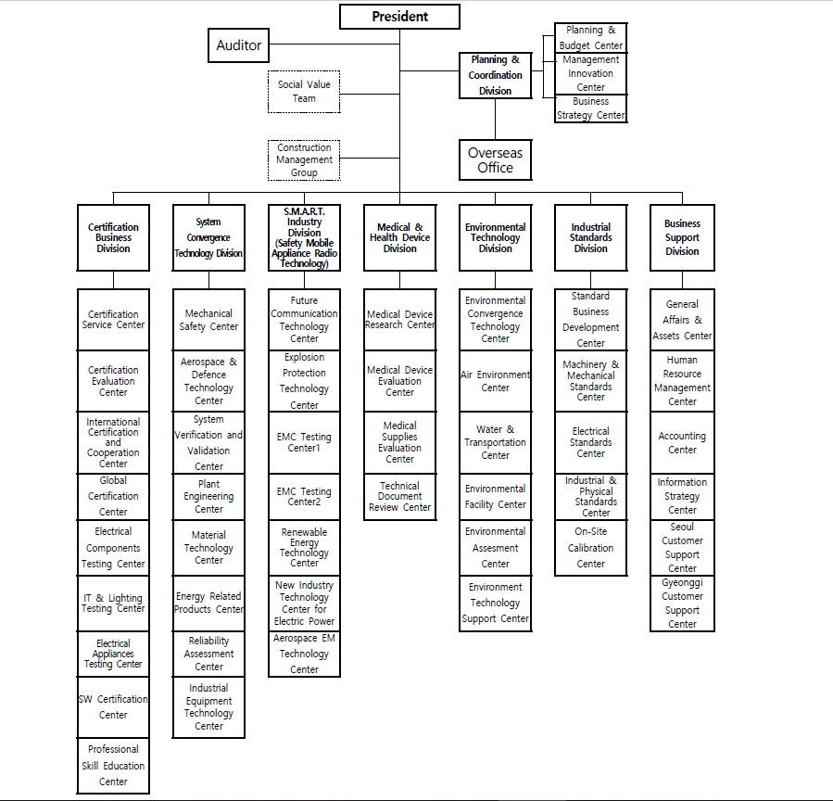
- Organisation Chart of ExCB and ExTL
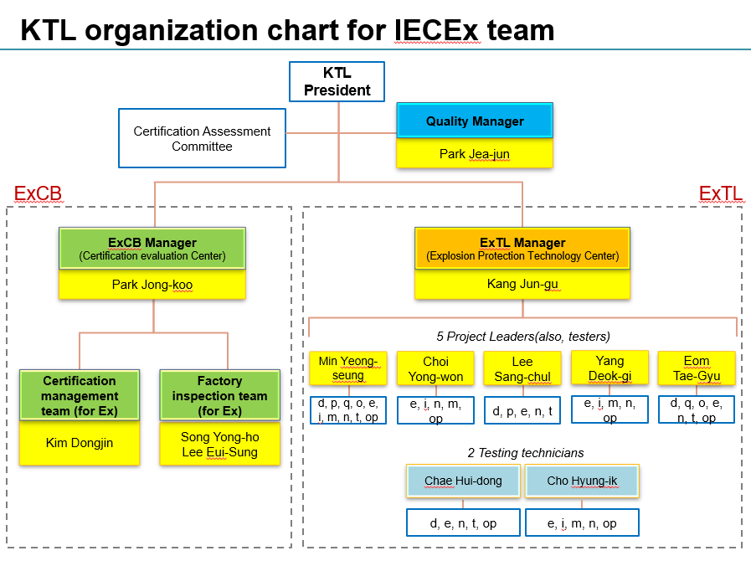
- Accreditation Certificate for ISO/IEC 17065
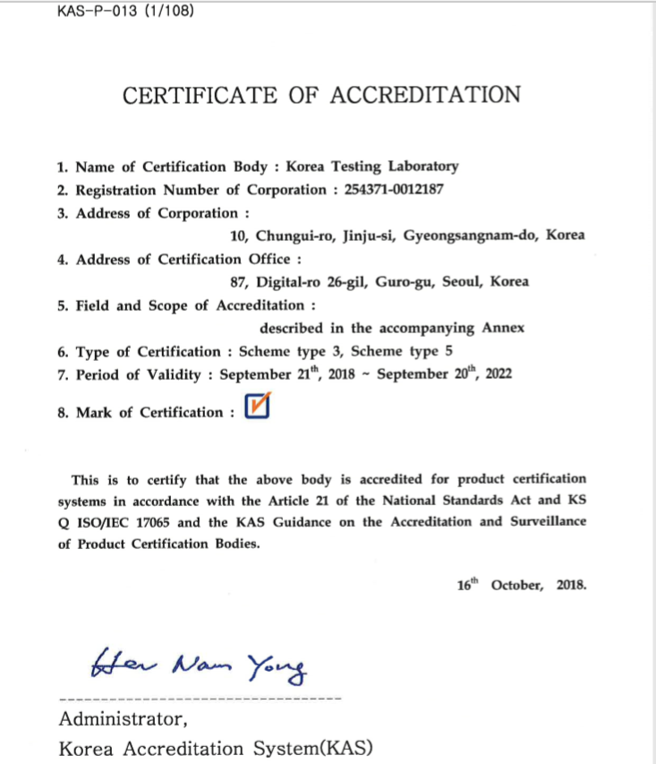
- Accreditation Certificate for ISO/IEC 17025

