**INTERNATIONAL ELECTROTECHNICAL COMMISSION SCHEME FOR  
CERTIFICATION TO STANDARDS RELATING TO EQUIPMENT FOR USE  
IN EXPLOSIVE ATMOSPHERES (IECEx SYSTEM)**

**Title: IECEx Assessment Report of UL do Brasil Certificações for acceptance of a scope extension within the IECEx 05 Certificate of Personnel Competencies Scheme (CoPC)**

**Introduction**

This document contains the IECEx Assessment Report for the acceptance of a scope extension for UL do Brasil Certificações, BR, to include the following Units within their scope-

* Ex 003 - Install explosion-protected equipment and wiring systems
* Ex 007 - Perform visual & close inspection of electrical installations in or associated with explosive atmospheres
* Ex 008 - Perform detailed inspection of electrical installations in or associated with explosive atmospheres

A site assessment was arranged with Mr Thierry Houeix as the IECEx Assessor, who has produced this report recommending acceptance of the above scope extension.

***This scope extension, to include Units Ex 003, 007 and 008 in UL do Brasil Certificações’ scope, is hereby submitted for ExMC approval, via correspondence, using the IECEx on-line voting system.  ExMC Members are requested to submit their vote via the IECEx On-line*** [***Ballot System***](https://www.iecex.com/ballot) ***by the closing date 2019 08 24***

***Please refer to OD 050 for guidance on the “IECEx On-line voting system.”***

***Chris Agius***

**IECEx Secretariat**

|  |  |
| --- | --- |
| **Address:**  **Level 33, Australia Square**  **264 George Street**  **Sydney NSW 2000**  **Australia** | **Contact Details:**  **Tel: +61 2 46 28 4690**  **Fax: +61 2 46 27 5285**  **e-mail:chris.agius@iecex.com**  **<http://www.iecex.com>** |

|  |  |
| --- | --- |
|  | ASSESSMENT REPORT |
|  |  |
| **BODY UNDER ASSESSMENT:** | **UL do Brasil Certificações** **Avenida Engenheiro Luis Carlos Berrini, 105 – 24 Andar 04571-010 – Brooklin – São Paul** **Brasil** |
| **SITE(S)**  **ASSESSED:** | **Escola Senai Antonio Souza Noschese Av. Senador Feijo 421 11015-505 – Vila Matias – Santos – SP – Brasil** |

|  |  |
| --- | --- |
| **IECEx SITE RE-ASSESSMENT TEAM:** | **Thierry Houeix – Lead Assessor (FR – INERIS)** |
| **REPRESENTATIVE/S OF BODY:** | **Eduardo Galera** |
| **DATE(S) OF SITE RE-ASSESSMENT:** | **27-28 November 2018** |
| **SCOPE:** | **Current Scope = Units Ex000, Ex001,**  **Scope extension = Ex003, Ex 007, and Ex008** |

**IECEx 05 Certification of Personnel Competencies (CoPC)**

**ASSESSMENT REPORT of**

**UL do Brasil Certificações**

**NEW IECEx APPLICANT BODY EXISTING IECEx CERTIFICATION BODY**

**X**

**(ExCB)**

Top of Form

|  |  |  |
| --- | --- | --- |
| **ASSESSMENT TYPE:** | **ATTACHMENTS** | **No. of Pages** |
| Application: | Application Form - UL do Brasil Certificações – UL is already accepted as ExCB for IECEx 05 scheme and Units Ex000 and Ex001.  Extension for other units have requested but the scope has been reduced during the assessment to Units Ex000, Ex001, Ex003, Ex 007, and Ex008.  The extension for Unit Ex 004 has been postponed. | 4 |
| Surveillance: | Scope extension |  |
| Re-Assessment: |  |  |
| Other: |  |  |
| Assessment duration: | 2 days on-site 27-28 November 2018 plus post assessment activities |  |
|  |  |  |
| **RECOMMENDATION BY IECEx ASSESSOR(S)**  (Select one item only) | 🞎 That Acceptance be granted  🞎 That Acceptance be withheld/suspended  🞎 That Acceptance continues  🗹 That Acceptance be granted/continued conditional on Non Compliance/Matters raised, having agreed corrective action and time scales to rectify the System within and agreed time agreed by the Assessors | |

Bottom of Form

# SCOPE ASSESSED

UL do Brasil Certificações have been assessed according to the requirements of IECEx05 – Certification of Personnel Competencies [CoPC] for the following Units of Competency:

**Current Scope:**

Unit Ex 000 – Basic Knowledge

Unit Ex 001 – Apply basic principles of protection in explosive atmospheres

**Scope extension being sought:**

Unit Ex 003 – Install explosion-protected equipment and wiring systems

Unit Ex 005 – Overhaul and repair of explosion-protected equipment

Unit Ex 006 – Test electrical installations in or associated with explosive atmospheres

Unit Ex 007 – Perform visual and close inspection of electrical installations in or associated with explosive atmospheres

Unit Ex 008 – Perform detailed inspection of electrical installations in or associated with explosive atmospheres

Unit Ex 009 – Design electrical installations in or associated with explosive atmospheres

Unit Ex 010 – Perform audit inspection of electrical installations in or associated with explosive atmospheres

**SECTION 1. GENERAL INFORMATION**

* 1. **Name of Body:**

UL do Brasil Certificações   
Avenida Engenheiro Luis Carlos Berrini, 105 – 24 Andar  
04571-010 – Brooklin – São Paul  
Brasil

* 1. **CURRENT IECEx PARTICIPATION:**

UL do Brasil Certificações is an existing ExCB in IECEx System.

* 1. **DETAILS OF RE-ASSESSMENT TEAM:**

Thierry Houeix – Lead Assessor

* 1. **DATES OF ASSESSMENT:**

The on-site assessment visit was conducted on 27-28 November 2018.

On November 27, 2018 the assessment took place at Escola Senai Antonio Souza Noschese facilities where the practical assessment will be performed and on November 28, 2018 at UL do Brasil Certificações.

The site assessment covered both the requirements for surveillance and a scope extension application to add the following Units

* Ex 003 - Install explosion-protected equipment and wiring systems
* Ex 007 - Perform visual & close inspection of electrical installations in or associated with explosive atmospheres
* Ex 008 - Perform detailed inspection of electrical installations in or associated with explosive atmospheres
  1. **LOCATION OF ASSESSMENT:**

November 27, 2018:  
Av. Senador Feijo 421

11015-505 – Vila Matias – Santos – SP – Brasil

November 28, 2018:

Avenida Engenheiro Luis Carlos Berrini, 105 – 24 Andar

04571-010 – Brooklin – São Paulo – Brasil

* 1. **RESOURCES FOR IECEx 05 CERTIFICATION ACTIVITIES:**

The Assessment team have assessed and verified the availability of competent technical staff, support staff and facilities to undertake the full scope of IECEx 05 certification activities for Units Ex000, Ex001, Ex003, Ex 007, and Ex008.

At the conclusion of the site assessment there were issues raised requiring attention by UL do Brasil Certificações . These issues have been included in the confidential report submitted and reviewed by the Secretariat. Follow up actions by UL do Brasil Certificações to address these issues was reviewed by the Assessor with the Assessor finding all actions satisfactory to enable all items raised to be closed and to recommend both on-going acceptance and acceptance of the scope extension

**SECTION 2. ASSESSMENT - SUMMARY OF RESULTS**

| **IECEx CoPC SCHEME REQUIREMENTS** | | | **Findings** | **COMMENTS AND REFERENCE TO ATTACHMENTS** |
| --- | --- | --- | --- | --- |
| **IECEx 05 requirements** | Confirmation of Scope of IECEx Acceptance or scope of application, (for new applicant) | | COMPLIES | The UL do Brasil Scope refers directly to the Scope of IECEx05 and has embraced all 4 of the Operational Documents. |
| Confirmation that details in original application are still current (for new application) | | COMPLIES | The details of this surveillance and scope extension assessment were confirmed at the opening meeting. |
| Confirm currency and scope of accreditation (ISO/IEC 17024) applicable | | COMPLIES | UL do Brasil does not have accreditation to ISO/IEC 17024. Therefore this IECEx assessment includes assessment to ISO/IEC 17024. The subsequent assessment has verified compliance. This compliance is verified following assessment of UL LLC as the application for UL do Brasil depends entirely on compliance of UL LLC Systems. |
| Clause 9.1 | (a) in a participating country | COMPLIES | Brazil is a participating country in the IECEx System. |
| (b) operate recognized certification scheme | COMPLIES | UL do Brasil already participate in the IECEx Equipment Certification Scheme as an ExCB on both product and personnel schemes. |
| (c) competence demonstrated by assessment | COMPLIES | IECEx Assessment included technical reviews of UL do Brasil staff for competence to evaluate to OD 504 relevant to the Units of Competence Ex000, Ex001, Ex003, Ex007 and Ex008 |
| Assessment facilities considered by Assessment team to be appropriate and adequate for assessment of Units, according to OD 504? | | COMPLIES | The UL do Brasil Competence Procedures define the requirements for the knowledge skills assessment and examination including the procedures for conducting assessment and examinations. These were assessed by the assessment team and found to be satisfactory. See summary of results for OD504 for further detail. The procedures reviewed are identical to those of UL LLC except for the quotation procedure, this does not affect the process of Assessment and are therefore considered to comply with the requirements |
| Confirmation of which location is the official ExCB location, where more than 1 location is identified?  an official ExCB location is one where the following are conducted:   * applications received, * contract review (review of application) * assignment of application to ExCB staff * review of exam/assessments * decision to issue Certificate   (Contact IECEx Secretary for any questions) | | COMPLIES | UL do Brasil Avenida Engenheiro Luis Carlos Berrini, 105 – 24º Andar Brooklin – CEP 04571-010, Sao Paulo, SP Brasil |
| **ISO/IEC 17024 Assessment**–Satisfactorily Completed (for bodies without acceptable national Accreditation) | | | COMPLIES | As UL do Brasil does not have accreditation to ISO/IEC 17024, assessment to ISO/IEC 17024 was conducted as part of this assessment.  The assessment team confirmed that the UL do Brasil Quality Manual and associated Procedures, forms and Instructions comply with all aspects of ISO/IEC 17024 and IECEx requirements and these procedures are identical to and controlled by UL LLC. |

|  |  |  |  |
| --- | --- | --- | --- |
| **IECEx Operational Document**  **Requirements** | **OD 502** | COMPLIES |  |
| **OD 503** | COMPLIES |  |
| **OD 504**  (Review of ExCB assessment criteria including question bank, mapped against Competency Units of OD 504) | COMPLIES |  |

**Additional Remarks concerning requirements** (if any)

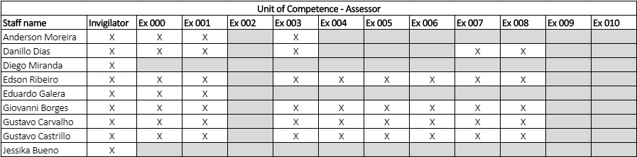

Organization Chart.

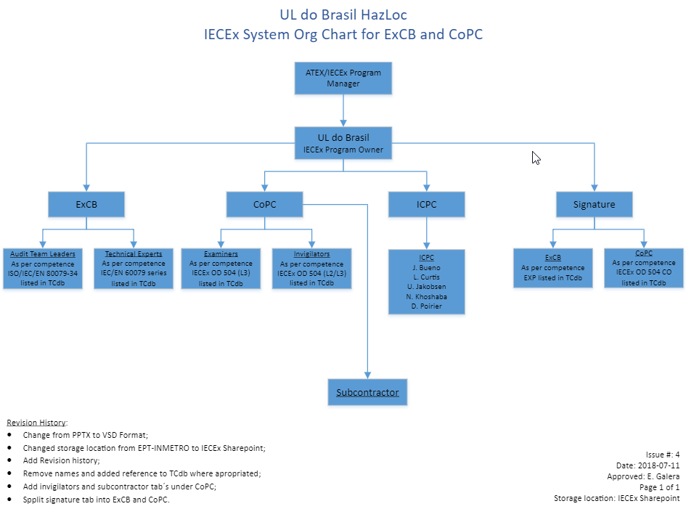

**Conclusion of Site Assessment**

The purpose of the site assessment was to verify compliance with the requirements of the IECEx Scheme for the initial acceptance of an Ex Certification Body (ExCB).

The site assessment forms part of the overall evaluation of the body by the IECEx Management Committee, ExMC and was conducted in accordance with the IECEx Scheme Assessment Procedures, IECEx OD 501.

Report of the on-site assessment team is as follows:

UL do Brasil make use of assessment facilities at SENAI, which is a training centre, with the assessment considering the separation between training and certification according to ISO/IEC 17024 as well as the suitability of the facilities, with the following observations noted:

1. SENAI is a Training Center since 1942. It is a private company but organized and managed by the State of São Paulo. Since 2015, SENAI propose training according to IECEx 05, IEC 60079-14, -17 and -19.
2. SENAI had 6238 employees in 2016. All the trainings are regarding industrial areas. SENAI has 94 schools and 74 mobile schools.
3. SENAI has the tools to check who the trainers for a specific candidate was.
4. The two Examiners from SENAI are Marcelo Machedo and Fernando Marquesto
5. There are also three invigilators who are the two examiners + Marcelo Coelio.
6. It was also noted that when the training has been performed by SENAI, the examiner will be one of the assessors from UL do Brasil
7. There is a note in clause 5.2.3 of the OD507: *IECEx Note: A Trainer shall not examine those they have trained .*UL do Brasil cover this aspect in their 00-CB-P0880 document which complies with ISO/IEC 17024.
8. Some observations were noted and are listed below.
9. All issues requiring resolution have been resolved before issuing the report.

Observations

The observations are as follows:

1. It is recommended that ULBR check during the Application review that the candidate has an authorization or certificate confirming that he can work on High Voltage, when this is applicable.
2. It was stated that ULBR will update its website in order to inform the future candidate about the different units that ULBR can propose and the limitation which can be used. Today, it has been noted that ULBR do not propose any limitation for Unit Ex001.

In addition, a review of the certification files was also performed and while found to be in line with IECEx requirements, the following items were raised:

1. 🡺 It is recommended to make a difference between the Application Review which is required before to send the Formal quotation and the Contract Review which is required to accept the job.

2. 🡺 It is recommended when units Ex 003, Ex007 and Ex008 is applied to specify the list of standards used only and not all, eg:

* Ex003 IEC 60079-14
* Ex007 and/or Ex008: IEC 60079-14 and -17

Target date for resolution of issues

All items raised have now been resolved and closed.

Actions after visit

No further visit has been required

Recommendation by IECEx Assessor(s) after all issues resolved

It is recommended for UL do Brasil Certificações for continued acceptance as ExCB regarding IECEx 05 and with the extensions of 3 Ex units in order to have the Units Ex000, Ex001, Ex003, Ex 007, and Ex008 in their scope.

Thierry Houeix

Lead Assessor

June 2019