INTERNATIONAL ELECTROTECHNICAL COMMISSION (IEC) SYSTEM FOR CERTIFICATION TO STANDARDS RELATING TO EQUIPMENT FOR USE IN EXPLOSIVE ATMOSPHERES (IECEx SYSTEM)

Title: ExTAG/540B/CD - Revised Draft ExTAG Decision Sheet – Smartphone or a tablet containing a LED to support a camera function.

Circulated to: ExTAG – IECEx Testing and Assessment Group

INTRODUCTION

This document, ExTAG/540BCD Revised Draft ExTAG Decision Sheet - Smartphone or a tablet containing a LED to support a camera function, has been prepared by the originator PTB, DE, taking into account comment received on ExTAG/540A/CD Draft, as recorded in ExTAG/585/CC ExTAG Decision Sheet - Smartphone or a tablet containing a LED to support a camera function, which it now replaces .

ExTAG/540B/CD has been listed for finalisation during the 2019 ExTAG Dubai meeting. Minor Changes to the version A are shown with the tracking tool.

Julien Gauthier

Julien Gauthier
ExTAG Secretary

Address:  IECEx Secretariat  Level 33 Australia Square  264 George Street  Sydney NSW 2000  Australia  Web: www.iecex.com | ExTAG Secretary  Mr Julien Gauthier  LCIE S.A.  33 Avenue du General Leclerc  92260 Fontenay-aux-Roses  FRANCE  Tel: +33 1 40 95 55 26  Fax: +33 1 40 95 89 37  Email : julien.gauthier@fr.bureauveritas.com

Standard:  IEC 60079-0 7th edition | Clauses:  21.1  26.4.2 | Draft Decision Sheet:  ExTAG/540B /CD
Subject:  Impact test  Status of document:  Draft | Key words:  - Ex Equipment  - Smartphone  - Tablet  - Luminaire  - Impact test | Date: August 2019  Originator of proposal:  PTB  TC/SC involved:  TC31 WG22
Background

In the 7th edition of IEC 60079-0, modifications have been made to the impact values in Table 15 (formally Table 13 in the 6th Edition). The impact requirements for luminaires have been relocated to Table 15 from clause 21.1 and the following highlighted new definitions have been added to the table.
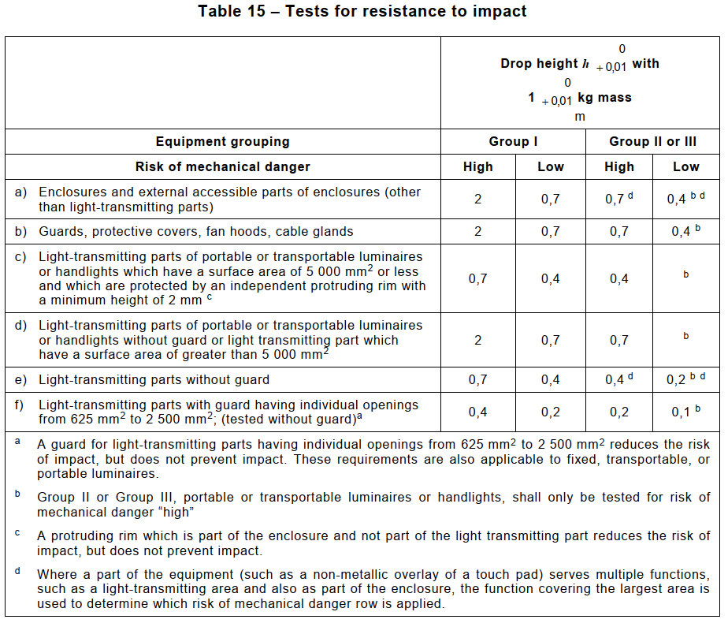
The highlighted requirements have been copied from IEC 60079-7:2015 Table 14 without mentioning in the table “The significance of the changes between IEC Standard, IEC 60079-0, Edition 6 (2011) and IEC 60079-0, Edition 7 (2017)”.
Copying this requirement into IEC 60079-0 is a major technical change, because this is now applicable to all Type of Protection portable luminaires and not to those in Type of Protection Ex e only.

Question
Is a smartphone or a tablet containing a LED to support a camera function considered a luminaire in the sense of IEC 60079-0?
Answer
Where there is no “torch” or “flashlight” function, or if that function has been technically disabled, a smartphone or a tablet containing a LED to support a camera function is a portable or transportable Ex Equipment, as the integral LED has only an auxiliary function and where the main function of the equipment is not to be a luminaire. Thus, it is not considered as a portable or transportable luminaire and the impact requirements for luminaires, such as footnote b of table 15, are not applicable.

However, where the LED can serve as a “torch” or “flashlight”, or when this function is not technically disabled, the requirements for portable luminaires or handlights, such as footnote b of table 15, are applicable to the LED part only.

