INTERNATIONAL ELECTROTECHNICAL COMMISSION (IEC) SYSTEM FOR CERTIFICATION TO STANDARDS RELATING TO EQUIPMENT FOR USE IN EXPLOSIVE ATMOSPHERES (IECEx SYSTEM)

Title: ExTAG/560A/CD – Revised Draft ExTAG Decision Sheet – Infallible Shunt Safety Assemblies for voltage limitation of intrinsically safe equipment

Circulated to: ExTAG – IECEx Testing and Assessment Group

INTRODUCTION

This document, ExTAG/560ACD Revised Draft ExTAG Decision Sheet - Infallible Shunt Safety Assemblies for voltage limitation of intrinsically safe equipment, has been prepared by the originator ExTC, AU, taking into account comment received on ExTAG/560/CD, and as recorded in ExTAG/589/CC. Changes to the original version are shown in red text .

ExTAG/560A/CD has been listed for finalisation during the 2019 ExTAG Dubai meeting.

Christine Kane

For

Julien Gauthier
ExTAG Secretary

Address:  IECEx Secretariat  Level 33 Australia Square  264 George Street  Sydney NSW 2000  Australia  Web: www.iecex.com | ExTAG Secretary  Mr Julien Gauthier  LCIE S.A.  33 Avenue du General Leclerc  92260 Fontenay-aux-Roses  FRANCE  Tel: +33 1 40 95 55 26  Fax: +33 1 40 95 89 37  Email : julien.gauthier@fr.bureauveritas.com

COLLECTION OF IECEx / ExTAG DECISIONS

Standard:  IEC 60079-11:2011 (Ed 6) | Clauses:  8.7.1 | Draft Decision Sheet:
Subject:  Infallible Shunt Safety Assemblies for voltage limitation of intrinsically safe equipment.  Status of document:  Draft | Key words:  - Infallible Shunt safety assemblies  - Infallible Voltage limitation | Date: 2019-06-01  Originator of proposal: ExTC Australia  TC/SC involved:  IEC/TC 31/SC31G
Background: The IEC 60079-11:2011 Clause 8.7.1 refers to shunt safety assemblies which are allowed to be considered as infallible in the following manner:
- Not to fail to open circuit
- Voltage to be that of the highest voltage shunt path

Paragraph 2 of this Clause allows that where diodes or Zener diodes are used as the shunt components in an infallible shunt safety assembly, they shall form at least two parallel paths of diodes.
There has been a request to clarify if the two paths can be made up of components other than just diodes or Zener diodes?
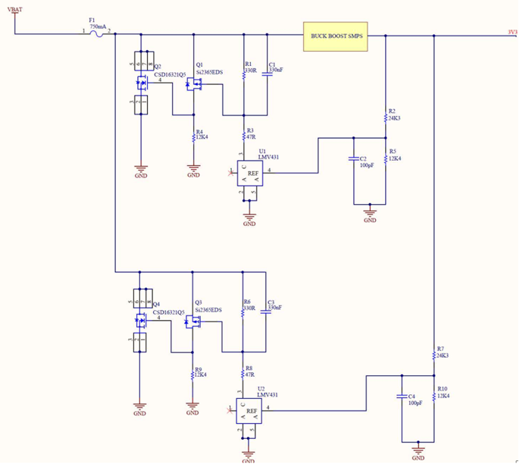
For example, as shown in Fig 1, if the two shunt paths were each made of a voltage divider acting on a voltage reference, with the signal amplified and then acting on a shunt FET
(Path 1: R2/R5, U1, Q1, Q2.
Path 2: R7/R10, U2, Q3, Q4)

Fig 1

Question: Where a shunt safety assembly is being considered, if the shunt components are not diodes or Zener diodes (as in the example above), how many parallel paths are required for infallibility against open circuit and voltage limitation?

Answer: In the case where the shunt components are not just diodes or Zener diodes, three paths of adequately rated components with suitable segregation and connections are required for infallibility against open circuit and voltage limitation. Therefore the circuit shown is not satisfactory for Ex ia requirements, and it needs another path of voltage divider acting on a voltage reference, with the signal amplified and then acting on a shunt FET.

However, it shall be noted that in the case where the input and output circuits are intrinsically safe or where it can be shown that they cannot be subjected to transients from the power supply network, then Clause 7.5.2 of the Standard applies and only two devices as shown in the example are allowable to be considered as an infallible assembly.

Explanation: Clause 8.7.1 2nd paragraph allowed two or greater parallel paths of diodes or Zener diodes for infallibility due to the likely failure mode of diodes or Zener diodes being a short. Since one shorted diode would cause the voltage to be lowered, regardless of further faults being applied, the assembly would result in a lower voltage to the subsequent circuit connected to the assembly.

However, in the Fig 1, an open circuit failure of R2, fault of U1, fault of Q1 would all result in the Q2 not being able to lower the voltage of the assembly. A second fault of R7, or U2, or Q3 would then allow the complete assembly to fail to lower the voltage. Since Ex ia requires application of two faults, this assembly will not lower the voltage and hence not in compliance with Clause 5.2 Level of protection “ia”.

Clause 7.5.2 3rd paragraph mentions that if the input and output circuits are intrinsically safe or free of transients from the power supply network, then controllable semiconductors such as transistors may be used for shunt voltage limiting, and two devices are considered to be an infallible assembly. This can be applied only in case the voltage, current, capacitance and inductance at VBAT are already intrinsically safe.

