INTERNATIONAL ELECTROTECHNICAL COMMISSION SYSTEM FOR
CERTIFICATION TO STANDARDS RELATING TO EQUIPENT FOR USE
IN EXPLOSIVE ATMOSPHERES (IECEx SYSTEM)

NOTICE OF MEETING
IECEx 2020 SERIES OF MEETINGS
TO BE HELD IN CANADA

Dear Madam/Sir

Further to previous information we are pleased to inform that QPS under the endorsement of the Canadian IECEx Member Body have confirmed an offer to host the 2020 Annual meetings of the IECEx (namely ExMC and ExTAG).

We are advised that QPS plan to host the meetings at Niagara Falls from 27th September to 2nd October 2020

Details relating to accommodation bookings, general information and meeting registration will be available via the IECEx Web Site in due course.

I extend our appreciation to both QPS as host and SCC as the Canadian IECEx Member Body for this confirmation.

Kind regards
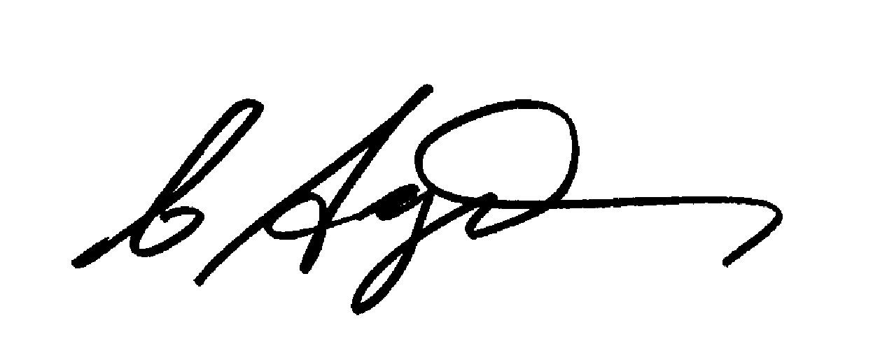
Chris Agius
IECEx Secretariat

Address:  Level 33, Australia Square  264 George Street  Sydney NSW 2000  Australia | Contact Details:  Tel: +61 2 4628 4690  Fax: +61 2 4627 5285  e-mail:chris.agius@iecex.com  http://www.iecex.com

