INTERNATIONAL ELECTROTECHNICAL COMMISSION SYSTEM FOR CERTIFICATION TO STANDARDS RELATING TO EQUIPMENT FOR USE IN EXPLOSIVE ATMOSPHERES (IECEx SYSTEM)

TITLE: Re-assessment and Scope Extension Report for the continued acceptance of Eurofins Product Testing Italy S.r.l, IT, an Accepted Ex Certification Body(ExCB) and an Accepted Ex Testing Laboratory (ExTL) within the IECEx System, Equipment Scheme 02, to include IEC 60079-28, IEC 80079-36, IEC 80079-37 and IEC/TS 60079-46, in their scope.

Circulation to: Members of the IECEx Management Committee, ExMC

INTRODUCTION

In accordance with the 5 year re-assessment plan for the surveillance and monitoring of bodies within the IECEx System, the following document contains the IECEx Re-assessment and Scope Extension Report for the continued acceptance of Eurofins Product Testing Italy S.r.l an Accepted Ex Certification Body and an Accepted Ex Testing Laboratory (ExTL) within the IECEx System, Equipment Scheme 02.

During the re-assessment the IECEx Assessment Team took the opportunity to also assess Eurofins Product Testing Italy S.r.l, IT, equipment and competence to undertake testing and certification for the following extension of scope –

Standard | Edition |  | Title
IEC 60079-28 | Edition 2.1 | Explosive atmospheres - Part 28: Protection of equipment and transmission systems using optical radiation
IS0 80079-36 | Edition 1.0 | Explosive atmospheres - Part 36: Non-electrical equipment for explosive atmospheres – Basic method and requirements
ISO 80079-37  Edition 1.0 | Edition 1.0 | Explosive atmospheres - Part 37: Non-electrical equipment for explosive atmospheres – Non electrical type of protection constructional safety ”c” control of ignition source ”b”, liquid immersion ”k”
IEC TS 60079-46 | Edition 1.0 | Equipment assemblies

This document is hereby submitted for ExMC approval via correspondence using the IECEx on-line voting system. ExMC Members are requested to submit their vote via the IECEx On-line Ballot System by the closing date 2020 04 04

Please refer to OD 050 for guidance on the “IECEx On-line voting system.”
Chris Agius
IECEx Secretariat

IECEx Secretariat  Australia Square  Level 33,  264 George Street  Sydney NSW 2000 Australia | Tel: +61 2 4628 4690  Fax: +61 2 4625 3480  Email: chris.agius@iecex.com
IEC System for certification to standards relating to equipment for use in Explosive Atmospheres (IECEx System)

IECEx Assessment Report Form

IECEx Assessment Report Form for use by IECEx Assessment Teams to report Assessments conducted according to the IECEx Assessment Procedures of

- Operational Document IECEx OD003-2 for the Certified Equipment Scheme
- Operational Document IECEx OD316-5 for the Certified Service Facility Scheme
- Operational Document IECEx OD422 for the IECEx Conformity Mark Licensing System

IECEx ExCB/ExTL assessment report for Eurofins Product Testing Italy S.r.l.

INTERNATIONAL
ELECTROTECHNICAL
COMMISSION

CONTENTS

1 Assessment information 6
1.1 Type of Body covered by this assessment: 6
1.2 Type of assessment: 6
1.3 Details of body 6
1.3.1 Country 6
1.3.2 Name of body 6
1.3.3 Name and title of nominated principal contact 6
1.4 Assessment information 6
1.4.1 Members of the assessment team 6
1.4.2 Place(s) of assessment 6
1.4.3 Assessment date(s) 6
1.5 Application information and background information on the assessment 6
1.6 Scopes 7
1.6.1 ExCB scope for equipment certification scheme 7
1.6.2 ExTL scope 8
1.6.3 ExCB scope for Service Facilities Scheme 8
1.6.4 ExCB scope for ExMark Scheme 8
2 Common information 9
2.1 Legal entity of body 9
2.2 Financial support 9
2.3 History 9
2.4 Documentation 10
2.4.1 Quality manual 10
2.4.2 Procedures 10
2.4.3 Work instructions 10
2.4.4 Records (including test records where relevant) 11
2.4.5 Document change control 11
2.5 Confidentiality 11
2.6 Communication with public and customers (Hard copy and Electronic) 11
2.7 Recognitions and agreements 11
2.8 Internal audit 11
2.9 Management review 11
2.10 Contracting, subcontracting and witness testing 11
2.10.1 Contracting 11
2.10.2 Subcontracting 12
2.10.3 Witness testing 12
2.11 Training and competence 12
2.12 Complaints and appeals (including appeals to IECEx) 12
2.13 Impartiality 13
2.14 Commenting on ExTAG Documents 13
2.15 QARs out of date 13
2.16 Special facts to be noted 13
2.17 Supporting documentation 13
2.18 Recommendations 13
3 ExCB for IECEx Certified Equipment Scheme 15
3.1 Assessment references 15
3.1.1 General references 15
3.1.2 Additional references applied for this assessment 15
3.2 Candidate ExCB persons interviewed 15
3.3 Associated ExTL(s) 15
3.4 Associated certification functions 15
3.5 National marks and certificates 15
3.6 Standards accepted 15
3.7 National differences to IEC standards 16
3.8 Organisation 16
3.8.1 Names, titles and experience of the senior executives 16
3.8.2 Name, title and experience of the quality management representative 16
3.8.3 Name and title of signatories for certification 16
3.8.4 Other employees in ExCB activity 16
3.9 Organizational structure 16
3.10 Indemnity insurance 16
3.11 Resources 17
3.12 Committees (such as governing or advisory boards) 17
3.13 Certification operations 17
3.13.1 National approval/certification methods 17
3.13.2 Certification policy 17
3.13.3 Application for certification 17
3.13.4 Certification decision 17
3.13.5 Suspension and cancellation of certificates 17
3.14 Certificates issued 18
3.15 National accreditation 18
3.16 Assessment of manufacturers and issue of QARs 18
3.17 Comments (including issues found during assessment) 19
4 ExTL for IECEx Certified Equipment Scheme 20
4.1 Assessment references 20
4.1.1 General references 20
4.1.2 Additional references applied for this assessment 20
4.2 Candidate ExTL persons interviewed 20
4.3 Associated ExCB(s) 20
4.4 Organisation 20
4.4.1 Names, titles and experience of the senior executives 20
4.4.2 Name, title and experience of the quality management representative 20
4.4.3 Other employees in ExTL activity 21
4.5 Organizational structure 21
4.6 Resources 21
4.7 Test reports issued 21
4.8 National accreditation 22
4.9 Calibration 22
4.10 Tests witnessed during the assessment visit 22
4.11 Participation in IECEx Proficiency Testing Programs 22
4.12 Comments (including issues found during assessment) 22
Annex A Overall Organisation Chart 23
Annex B Organisation Chart of ExCB and ExTL 25
Annex C Accreditation Certificate for ISO 17065 26
Annex D Accreditation Certificate for ISO 17025 28

Assessment information

Type of Body covered by this assessment:
ExCB for IECEx Certified Equipment Scheme | ✓
ExTL for IECEx Certified Equipment Scheme | ✓
ExCB for IECEx Certified Service Facilities Scheme
ExCB for IECEx Conformity Mark Licensing System

NOTE 1 ExCB - IECEx Certification Body
NOTE 2 ExTL - IECEx Testing Laboratory

Type of assessment:
Pre-assessment for candidate body
Initial assessment for candidate body
Surveillance
Re-assessment | ✓
Scope extension | ✓

Details of body

Country
Italy

Name of body
Eurofins Product Testing Italy S.r.l.(formerly known asEurofins Tech S.r.l.

Name and title of nominated principal contact
Name | Title | E-mail address
Dionisio Bucchieri | Technical responsible IECEx | dionisiobucchieri@eurofins.com

Assessment information

Members of the assessment team
Name | Role
Ron Webb | IECEx Lead Assessor
Lucy Lu | IECEx Assessor

Place(s) of assessment
Via Cuorgné, n. 21, 10156 Torino (ITALY)

Assessment date(s)
29 to 31 July and 1 August 2019

Application information and background information on the assessment
Information relevant to the Secretariat review process:; ExMC/251B/Q Scope extension sent to Assessment team.

Scopes

ExCB scope for equipment certification scheme
Number | Title | Comments, eg if scope change
IEC 60079-0  Edition 7.0 | Explosive atmospheres - Part 0: Equipment - General requirements | Existing
IEC 60079-1  Edition 7.0 | Explosive atmospheres - Part 1: Equipment protection by flameproof enclosures “d” | Existing
IEC 60079-2  Edition 6.0 | Explosive atmospheres - Part 2: Equipment protection by pressurized enclosure «p» | Existing
IEC 60079-7  Edition 5.0 | Explosive atmospheres - Part 7: Equipment protection by increased safety "e" | Existing
IEC 60079-11  Edition 6.0 | Explosive atmospheres - Part 11: Equipment protection by intrinsic safety “i” | Existing
IEC 60079-15  Edition 5.0 | Explosive atmospheres – Part 15: Equipment protection by type of protection "n" | Existing
IEC 60079-18  Edition 4.0 | Explosive atmospheres – Part 18: Equipment protection by encapsulation “m” | Existing
IEC 60079-25  Edition 2.0 | Explosive atmospheres – Part 25: Intrinsically safe electrical systems | Existing
IEC 60079-26  Edition 3.0 | Explosive atmospheres - Part 26: Equipment with equipment protection level (EPL) Ga | Existing
IEC 60079-28  Edition 2.0 | Explosive atmospheres - Part 28: Protection of equipment and transmission systems using optical radiation | Extension
IEC 60079-31  Edition 2.0 | Explosive atmospheres – Part 31: Equipment dust ignition protection by enclosure "t" | Existing
IS0 80079-36  Edition 1.0 | Explosive atmospheres - Part 36: Non-electrical equipment for explosive atmospheres – Basic method and requirements | Extension
ISO 80079-37  Edition 1.0 | Explosive atmospheres - Part 37: Non-electrical equipment for explosive atmospheres – Non electrical type of protection constructional safety ”c” control of ignition source ”b”, liquid immersion ”k” | Extension
IEC TS 60079-46 | Equipment assemblies | Extension
NOTE 1 Standards shown with an asterisk (*) are superseded standards
NOTE 2 Unless otherwise indicated, earlier editions of standards (even if with a different number) are considered to be covered in the above scope for the purposes of the assessment.
NOTE 3 The above list highlights any extension of scope in the list above for new standards or later editions of standards already in scope.

ExTL scope
The ExTL scope is the same as for the ExCB.

ExCB scope for Service Facilities Scheme
Not included

ExCB scope for ExMark Scheme
Not included

Common information

Legal entity of body
Eurofins Product Testing Italy S.r.l.

Financial support
Supported by fees charged to customers.

History
Modulo Uno srl was born in Turin in 1970 as a Company of professionals, made up of a group of engineers and teachers of the Polytechnic University and the Faculty of Physics of the University and operated, at the beginning, as a support to the industry in acoustic and vibration subjects.

Modulo Uno srl in 1978 expanded its activities to the safety at workplaces, also taking care of injuries and fire prevention.

Modulo Uno srl in 1983 becomes a limited liability company integrating its technical staff in order to provide to the customers a complete service in the field of environmental protection and industrial health.

Modulo Uno srl In 1994, becomes notified body (n. 0496) For the Machinery Directive (89/392/EEC and subsequent amendments)

Modulo Uno srl in 1995 becomes a notified body (n. 0496) Directive for personal protective equipment (89/686/EEC)

Modulo Uno srl in 1997 became a Competent Body for the EMC Directive 89/336/EEC.

Modulo Uno Srl built 1998, together with Det Norske Veritas Italy Srl, (company operating mainly in the fields of the voluntary product certification and of quality systems certification) the consortium "DNV-MODULO UNO" which has, as statutory object, the development of activities of product certification according to current laws, and, in particular, activities of certification of products, materials and structure, according to European directives for the CE marking. In this consortium, Modulo Uno Srl has transferred the authorizations and notifications.

In 2003 the Consortium DNV-Modulo Uno becomes notified body the 94/9/EC Atex Directive.
In September 2004 Modulo Uno S.r.l. changes the company structure in Modulo Uno S.p.A. .

In October 2008 the Eurofins Group, world leader in the field of tests, measurements and analysis, integrates in its organization Modulo Uno SpA

Eurofins - Modulo Uno S.p.A. in 2008 becomes a Notified Body for the EMC Directive with the EC number n. 2049.

Eurofins - Modulo Uno S.p.A. and DNV Italy Srl in 2009 commonly agree do not proceed with the common activity but to continue independently in the field of compulsory marking.

Eurofins - Modulo Uno S.p.A. in 2009 is the EC Notified Body with number 2049 for
various directives (see Section XVI of this PART 1 of the Manual) and operates on the basis of ministerial authorizations, specific to each directive.

In February 2010, the Eurofins Group identifies in Eurofins Modulo Uno SpA the company in charge to carry on the Notified body activities in Italy; following to this decision it acquires the business and the Notified Body of Eurofins-Biolab SpA and, in 2013, its number (n. 0477) for all directives.

In 2013 the company also get the recognition for the IECEx scheme. Tasks, structure, requirements and operational aspects of the Body are described in the Articles and in the quality manual of EPT prepared in accordance with:
PART 0: ISO 9001;
PART 1: EN 17065, EN ISO/IEC 17020, EN ISO/IEC 17021-1;
PART 2: EN ISO/IEC 17025.

From 29/04/2014 the company name Eurofins - Modulo Uno SpA changes in Eurofins TECH srl (Testing, Energy, and Health Certification), remaining unchanged the organization, staff, equipment for the certification process, test and inspection.

From 11/12/2014 the company name Eurofins TECH Srl changes in Eurofins Product Testing Italy Srl without changes in testing and certification activities.

Documentation

Quality manual
The quality system is described in the Eurofins Product Testing Italy Srl quality manual and is based ISO 17065, ISO 17025, ISO 17021 and ISO 9001. It contains all necessary policies and procedures relevant to the testing and certification processes and in specific way for the IECEx scheme.

The Quality Manual is divided into three part:
- General Part – PART 0
- Certification and inspection – PART 1
- Laboratory – PART 2

The quality manuals are written and controlled by the quality department. Their release are performed by the Managing director (approval). The distribution of the documents and the implementation is under the responsibility of the quality manager. The quality manual is stored on the server, no paper copies exist. All technicians (internal and external) have access to the relevant parts which apply to their field of working.

Procedures
All the procedures for the operation of certification and laboratory, including granting, maintaining, extending, suspending, withdrawing and cancelling certificates are well documented in the procedure CP IOP 02 and in the manual Parte 2 - LM mdq 2002 34.

It is noted that the reference to IECEx rules, procedures and operational documents have also been made within section ATEX for the laboratory procedures and certification procedure CP IECEX 20 02 - IECEX procedure.

All the decisions on certification process are taken by the Delivery Committee (CP IOP 02).

Work instructions
Certification procedures are included in the management system, giving detailed information for the implementation of critical certification activities within the scope of ATEX/IECEx accreditation CP IECEX 20 02 - IECEX procedure.

Records (including test records where relevant)
The control of quality records is laid down in the quality manual PART 1 CP.mdq.2001.45 point X.3.
All IECEx records are stored electronically.
The detail was seen, and examples of quality records are well maintained with a minimum period of 15 years. A specific procedure M1 OPE 05 defines the method of secure disposal of all records.

Document change control
All documents developed by the quality manager and relevant key persons are always reviewed and approved prior to publication. The details of document control including data are also covered by the procedure M1.GES.02.18 Control of documents

Confidentiality
Confidentiality is applied within Eurofins Product testing Italy Srl.
All the employees including all the members of delivery committee have signed a specific statement on confidentiality and conflict of interest (CP MOD 095 06 - Confidentiality statement).
In addition control and security of access to the premises and the data on the servers is also maintained: see the procedure M1 OPE 38 09 COMPANY PREMISES ACCESS.

Communication with public and customers (Hard copy and Electronic)
All information about Eurofins Product Testing Italy S.r.l. activities can be found on the website http://tech.eurofins.it/

Recognitions and agreements
Eurofins Product Testing Italy Srl has agreements and recognitions including:
- Notified Body under ATEX, Machinery, Lift, Pressure Equipment, Noise Emission, Medical Device, Electromagnetic Compatibility, Radio equipment Directive and Personnel Protective Equipment and Product Construction Regulation
- Certification body for quality System management according ISO 13485
- Accredited lab for many standards by ACCREDIA DL
- IECEx for Equipment scheme

Internal audit
Internal audits are carried out in accordance with the procedures M1 GES 04 15 Internal audit. This covers a series of audits through the last year with coverage of all the quality elements and activities. All upcoming audits are planned in file 2018-06 audit plan year 2019.
The last internal audit for the IECEx activity (included as part of the ATEX audit) was carried out in April 2019. The report was viewed, with no findings, and found to meet the requirements of the IECEx.

Management review
A management review is conducted annually.
The last one was performed on 2019-01-21. A very comprehensive report was viewed.

Contracting, subcontracting and witness testing

Contracting
There is a contract with an engineer at Eurofins Shanghai, to work with local customers. This engineer helps with Chinese customers and organises the necessary tests according to EPT instructions and procedures and prepares the test report. This is then reviewed by Eurofins Product Testing Italy S.r.l. and, if acceptable, the report is issued.

Subcontracting
The following tests are, or may be, subcontracted by the body:
Standard | Clause | Test
IEC 60079-0 | 26.10 | Resistance to UV light
IEC 60079-1 | B.1.3 | Sintered metal elements - Density
IEC 60079-1 | B.1.4 | Sintered metal elements – Open porosity and / or fluid permeability
IEC 60079-7 | 6.2.3.1 | Stator winding insulation
IEC 60079-7 | 6.2.3.2 | Cage rotor
IEC 60079-28 | 5.2.3 | Pulsed radiation
More details, including bodies to whom tests will be subcontracted, details of accreditation of those bodies and details of how the subcontracted bodies are checked, are included in the site assessment report. A review of the controls over subcontracting revealed that IECEx requirements are met.

Witness testing
When witness testing is needed a visit is made to the client/user and an agreement set up. The requirements of OD024 are used in the relevant procedure CP.IOP.03.06..

Training and competence
Competence is registered in a competence matrix for certification activities and other competence matrix for specific test for the laboratory activities. The documents are updated annually or during the year if required.
Allegato 03 rev38 Elenco abilitazioni 2019-05-15 – laboratory activities
Elenco delle abilitazioni ver 46 – certification activities
Matrice competenza ATEX Rev00 – specific for ATEX and IECEX certification matrix competence.
The contracted engineer from China is also included on the appropriate matrix.
Training is also recorded on appropriate documents
Details of staff competencies are included in the site assessment report.

Complaints and appeals (including appeals to IECEx)
Appeals, complaints and disputes are managed:
Manual Parte 1 - CP mdq 2001 45 (certification)
Manual Parte 2 - LM mdq 2002 35 (laboratory)
Product Regulation rev. 19
IECEX Rules for the product certification rev03
M1.GES.05.14 - REMARKS Management
All the complaints are recorded by the quality manager and managed together with the certification and laboratory manager and the technician involved in the complaint.
If the complaint is found to be correct the analysis is performed by competent people not involved in the certification or testing activities under check.
No complaints have been received for IECEx work.

Impartiality
This point is managed:
Manual Part 1 - CP mdq 2001 45 (certification)
Manual Part 2 - LM mdq 2002 35 (laboratory)
Annual report 2019 for Independence and impartiality of Eurofins
M1.GES.09.16 RISK ASSESSMENT AND ORGANIZATIONAL MODEL FOR THE MANAGEMENT OF IMPARZIALITY AND INDEPENDENCE
M1.GES.01 - Annex 01 – Risk analysis for the laboratory activities

Every staff member has to sign a statement CP MOD 095 06 - Confidentiality and Impartiality statement.

All new staff will be trained during an initial training in this matter in order to know the quality system document and commitment.

Commenting on ExTAG Documents
ExTAG documents are reviewed by a group of staff members and then mailed to all relevant staff. Once a consensus has been reached, if an answer is required, a response is made to the IECEx.

QARs out of date
Procedure CP ATEX 13.11 has been updated to cover out of date QARs

Special facts to be noted
None

Supporting documentation
Copies of additional supporting information for this assessment have been provided to the applicant and the IECEx Secretariat. These are included in a site assessment report or provided separately and include:
- Details of issues raised and how these have been resolved
- Checklist for ISO/IEC 17065
- Checklist for ISO/IEC 17025
- Completed Technical Capability Document (TCD)
- Photos of the facilities/tests witnessed are included in the above TCD
- Assessors’ notes

Recommendations
Based on the assessment performed on 29, 30, 31 July 2019 and 1 August 2019, Eurofins Product Testing Italy S.r.l. is recommended for continued acceptance in the IECEx scheme as:
- An ExCB in the IECEx Certified Equipment Scheme
- An ExTL in the IECEx Certified Equipment Scheme
This is according to the scope of the standards listed in this document including the extension of scope,.

Ron Webb | Lucy Lu
IECEx Lead Assessor | IECEx Assessor
Date: January 2020

ExCB for IECEx Certified Equipment Scheme

Assessment references

General references
- IECEx02 IECEx Certified Equipment Scheme covering equipment for use in explosive atmospheres – Rules of Procedure
- OD003-2 Assessment, surveillance assessment and re-assessment of ExCBs and ExTLs operating in the IECEx 02, IECEx Certified Equipment Scheme
- ISO/IEC 80079-34 Edition 1, Explosive atmospheres – Part 34: Application of quality systems for equipment manufacture
- OD009 Issuing of CoCs, ExTRs and QARs
- IECEx Document OD 025 Guidelines on the Management of Assessment and Surveillance programs for the assessment of Manufacturer’s Quality Systems in accordance with the IECEx Scheme
- OD0026 IECEx Certified Equipment Scheme – Guidelines for the qualification of Lead Auditor and Auditors, in accordance with the IECEx System
- ISO/IEC 17065: 2012, Edition 1, General requirements for bodies operating product certification systems Conformity assessment — Requirements for bodies certifying products, processes and services
- IECEx Technical Capability Document (TCD)
- ExTAG decision sheets (DSs)
NOTE The latest editions of the above documents were applied

Additional references applied for this assessment
a) OD 280 IECEx Certified Equipment Scheme – Guide to Certification of Non-electrical Equipment and Protective Systems.

Candidate ExCB persons interviewed
Name | Position
Paolo Dentis | Responsible for Laboratory
Dionisio Bucchieri | Responsible for IECEx
Gianluigi Bianchi | ATEX/IECEx expert
Omar Galasso | ATEX/IECEx expert
Claudio Cafaro | ATEX/IECEx expert
Claudio Massa | ATEX/IECEx expert

Associated ExTL(s)
Eurofins Product Testing Italy S.r.l.
Via Cuorgné n. 21 – 10156 Torino (ITALY)

Associated certification functions
Eurofins Product Testing Italy S.r.l. is Notified Body under the ATEX Directive and covers all annexes of 2014/34/EU with the number NB 0477 (see NANDO web site).

National marks and certificates
No national certificates issued for Ex products.

Standards accepted
See clause 1.6 of this report

National differences to IEC standards
National differences to IEC standards are those differences listed in the latest version of the IECEx Scheme Bulletin.

Organisation
See the Organizational chart rev 24/06/2019

Names, titles and experience of the senior executives

Name | Title | Experience
Paolo Trisoglio | Managing Director | Not relevant in Ex

Name, title and experience of the quality management representative

Name | Title | Experience
Vanessa Lipparini | QA representative | Not relevant in Ex
Paolo Dentis | Laboratory Manager and deputy QA representative | 14 years in Ex

Name and title of signatories for certification

Name | Title | Comments
Dionisio Bucchieri | Technical responsible IECEx | 19 years in Ex

Other employees in ExCB activity

Name | Title | Responsibility and Experience in Ex
Gianluigi Bianchi | ATEX/IECEx expert | Approval of ExTRs as CB  15 years in Ex
Claudio Massa | ATEX/IECEx expert | QARs 10 years in Ex
Omar Galasso | ATEX/IECEx expert | QARs 6 years in EX
Claudio Cafaro | ATEX/IECEx expert | QARs 8 years in EX
Fabrizio Bellini | ATEX/IECEx expert | QARs 12 years in EX
Teddy Wang | ATEX/IECEx expert | QARs 6 years in EX

Organizational structure
See the Organizational chart rev 24/06/2019
See chart as Annex A and Annex B

Indemnity insurance
Indemnity insurance:
CERTIFICATE OF INSURANCE - POLICY N. 110-01325685-14023
THIRD PARTY LIABILITY and PROFESSIONAL LIABILITY for € 5.000.000,00 per occurrence/insurance year
POLICY TERRITORY WORLDWIDE

Resources
Eurofins Product Testing Italy S.r.l. employs 26 peoples at its head offices and laboratory in Torino – Via Cuorgné n. 21 10156 Torino ITALY.
The qualification activities with necessary resources include staff in certification and in testing activities. There are a total of 9 people in the ExCB and ExTL.
Eurofins Product Testing Italy S.r.l. currently have 5 qualified IECEx QA auditors.

Committees (such as governing or advisory boards)
The Delivery committee has the responsibility in order to deliver the certification activities.
Eurofins Product Testing Italy S.r.l. has the Committee for the Impartiality Safeguard where are included the representative of the category: manufacturer, authority and Consumer.
The Committee for the Impartiality Safeguard (CSdI) has the specific regulation CP OPE 19 08 “Committee for the Impartiality Safeguard regulation”.
The CSdI meets once a year or upon request
Certification policy, processes and fees matters are normally verified and confirmed by the CSdI committee.

Certification operations

National approval/certification methods
Eurofins Product Testing Italy S.r.l. operates as a Notified Body under EU directives and regulations.
For the specific ATEX directive in the field of testing and certification of electrical and non-electrical equipment used in explosive atmospheres.

Certification policy
The quality policy statement of the body is involved in the quality manual and meets the principles of the IECEx System.
The quality policy is published in the web site.
The quality policy is in revision 08 of the 15/05/2019

Application for certification
This process of certification ExCB is covered in procedure IECEX 20 03 “IECEX procedure”
The application forms and information about services are available at Eurofins Product Testing Italy Srl Website. (http://tech.eurofins.it/)

Certification decision
The certification decision is made by the Delivery Committee; the certification process is explained in the CP IOP 02 procedure and in the Quality Manual part 2 CP.mdq.2001.45.
The members of the Delivery Committee are indicated in the COMPOSITION OF THE COMMITTEE FOR RESOLUTION OF CERTIFICATION rev. 11

Suspension and cancellation of certificates
Suspension and cancellation of certificates will be done according:
Manual Part 1 - CP mdq 2001 45 (certification)
Product Regulation rev. 19
IECEX Rules for the product certification rev03

Certificates issued
Number of certificates issued under for the preceding four years for each type of protection.
Standard numbers | Type of protection or other identifying information | Number of issued certificates (for last 4 years) |  |  |  | Total
 |  | 2016 | 2017 | 2018 | 2019/02
IEC 60079-0 | General | 21 | 34 | 27 | 13 | 95
IEC 60079-1 | “d” | 13 | 20 | 15 | 10 | 58
IEC 60079-2 | “p” | 0 | 2 | 1 | 0 | 3
IEC 60079-7 | “e” | 3 | 17 | 8 | 4 | 32
IEC 60079-11 | “i” | 6 | 8 | 8 | 4 | 26
IEC 60079-15 | “n” | 3 | 2 | 4 | 0 | 9
IEC 60079-18 | “m” | 2 | 4 | 4 | 1 | 11
IEC 60079-31 | “t” | 16 | 21 | 19 | 9 | 65
IEC 60079-25 | Extension - Intrinsically safe electrical systems | 0 | 0 | 0 | 0 | 0
IEC 60079-26 | Extension - EPL Ga |  | 1 | 1 |  | 2
IEC 60079-28 * | Extension - “op” – Optical radiation |  | 1 | 4 |  | 5
ISO 80079-36 * | Extension - Basic method and requirements | 1 | 5 | 6 | 3 | 15
ISO 80079-37 * | Extension - "c", "b", "k" | 1 | 5 | 6 | 3 | 15
IEC 60079-46 * | assemblies
NOTE 1 Above include certificates to IEC 60079-0 unless otherwise shown
Note 2 Standards with an asterisk are for ATEX work

National accreditation
National accreditation has been granted by ACCREDIA.
The certificate is against ISO 17065, ISO 17021 and ISO 17025.
The current certificate is included as Annex C and Annex D.

Assessment of manufacturers and issue of QARs
Eurofins Product Testing Italy S.r.l. issues quality assessment reports for IECEx and ATEX certification purposes:
Table – Certification IECEx issue for year

Year | Certificate | ExTR | ExQAR
2014 | 7 | 10 | 5
2015 | 10 | 21 | 8
2016 | 21 | 22 | 11
2017 | 34 | 38 | 21
2018 | 25 | 32 | 20
2019/06 | 13 | 14 | 9

Directive | Certification path | 2014 | 2015 | 2016 | 2017 | 2018 | 2019/06
ATEX | modulo A+ (annex VIII) | 24 | 40 | 36 | 38 | 22 | 16
ATEX | modulo B (annex III) | 27 | 35 | 51 | 46 | 37 | 16
ATEX | modulo C (annex VI) | 2 | 4 | 3 | 0 | 1 | 0
ATEX | modulo D (annex IV) | 2 | 17 | 11 | 14 | 12 | 7
ATEX | modulo E (annex VII) | 4 | 8 | 1 | 0 | 0 | 0
ATEX | modulo F (annex V) | 11 | 5 | 25 | 2 | 2 | 5
ATEX | modulo G (annex IX) | 37 | 13 | 7 | 12 | 13 | 10
ATEX | Total ATEX | 107 | 122 | 134 | 112 | 87 | 54

Eurofins Product Testing Italy S.r.l. performs factory production control on about 40 manufacturers. The assessments are repeated every 12 months.

Comments (including issues found during assessment)
Issues involved the following:
- Registration of OD024 clients with the Secretariat
- Incorporation of reference to OD280 into the procedure for non-electrical equipment
- Procedure for monitoring QARs
- Details on specific conditions for safe use

ExTL for IECEx Certified Equipment Scheme

Assessment references

General references
- IECEx02 IECEx Certified Equipment Scheme covering equipment for use in explosive atmospheres – Rules of Procedure
- IECEx OD003-2 Assessment, surveillance assessment and re-assessment of ExCBs and ExTLs operating in the IECEx 02, IECEx Certified Equipment Scheme
- IECEx OD009 Issuing of CoCs, ExTRs and QARs
- ISO/IEC 17025:2005 Edition 2, General requirements for the competence of testing and calibration laboratories
- IECEx Technical Capability Document (TCD)
- ExTAG decision sheets (DSs)
- OD 202 IECEx Certified Equipment Scheme – IECEx Proficiency Testing Program
NOTE The latest editions of the above documents were applied.

Additional references applied for this assessment
- OD 280 IECEx Certified Equipment Scheme – Guide to Certification of Non-electrical Equipment and Protective Systems.

Candidate ExTL persons interviewed
Name | Position
Dionisio Bucchieri | Technical responsible IECEx
Gianluigi Bianchi | ATEX/IECEx expert
Omar Galasso | ATEX/IECEx expert
Claudio Cafaro | ATEX/ IECEx lab responsible
Claudio Massa | ATEX/IECEx expert
Luca Bruno | ATEX/IECEx expert

Associated ExCB(s)
Eurofins Product Testing Italy S.r.l.

Organisation
See chart as Annex A and Annex B

Names, titles and experience of the senior executives

Name | Title | Experience
Paolo Trisoglio | Managing Director | None relevant to Ex

Name, title and experience of the quality management representative

Name | Title | Experience
Paolo Dentis | Laboratory Manager and QA representative | 14 years in Ex
Vanessa Lipparini | QA representative | Minimal Ex knowledge

Other employees in ExTL activity

Name | Title/responsibility | Experience in Ex
Claudio Cafaro | Technician IECEx laboratory | 8 years in Ex
Dionisio Bucchieri | Technical responsible IECEx | 19 years in Ex
Gianluigi Bianchi | Technician IECEx | 15 years in Ex
Claudio Massa | Technician IECEx | 10 years in Ex
Omar Galasso | Technician IECEx laboratory | 6 years in Ex
Luca Bruno | Technician IECEx laboratory | 4 years in Ex
Enrico Martino | Technician IECEx laboratory | 5 years in Ex
Fabrizio Bellini | Technician IECEx laboratory | 12 years in Ex
Teddy Wang | Engineer | 6 years in Ex

Organizational structure
See chart as Annex A and Annex B

Resources
Eurofins Product Testing Italy S.r.l. employs 26 peoples at its head offices and laboratory in Torino – Via Cuorgné n. 21 10156 Torino ITALY.
The qualification activities with necessary resources include staff in certification and in testing activities. There are a total of 9 people in the ExCB and ExTL.
Eurofins Product Testing Italy S.r.l. currently have 5 qualified IECEx QA auditors.

Test reports issued
Number of test reports (ExTRs) issued under for the preceding four years for each type of protection.
Standard numbers | Type of protection or other identifying information | Number of issued reports (ExTRs) (for last 4 years) |  |  |  | Total
 |  | 2016 | 2017 | 2018 | 2019/06
IEC 60079-0 | General | 32 | 38 | 22 | 3 | 95
IEC 60079-1 | “d” | 23 | 23 | 13 | 1 | 60
IEC 60079-2 | “p” | 1 | 2 | 0 | 0 | 3
IEC 60079-7 | “e” | 13 | 17 | 3 | 2 | 35
IEC 60079-11 | “i” | 9 | 9 | 5 | 2 | 25
IEC 60079-15 | “n” | 4 | 2 | 3 | 0 | 9
IEC 60079-18 | “m” | 5 | 5 | 3 | 0 | 13
IEC 60079-31 | “t” | 26 | 23 | 15 | 0 | 64
IEC 60079-25 | Intrinsically safe electrical systems | 1 |  |  |  | 1
IEC 60079-26 * | Extension - EPL Ga | 2 | 2 | 1 |  | 5
IEC 60079-28 * | Extension - “op” – Optical radiation | 5 | 4 | 7 | 1 | 17
ISO 80079-36 * | Extension - Basic method and requirements | 1 | 7 | 7 |  | 15
ISO 80079-37 * | Extension - "c", "b", "k" | 1 | 7 | 7 |  | 1
IEC TS 60079-46 * | Equipment assemblies
NOTE 1 Above include reports to IEC 60079-0 unless otherwise shown
Note 2 Standards with an asterisk are for ATEX work

National accreditation
National accreditation is granted by ACCREDIA.
The current certificate is against ISO/IEC 17025: 2005. Eurofins Product Testing Italy S.r.l. are undergoing transition to ISO/IEC 17025: 2017 and have been assessed by Accredia to the revised standard. This has yet to be finalised. The current certificate is included as Annex D and includes an extension, pending completion of the transition. Revised scope held at secretariat issued 2020 0122.

Calibration
The calibration processes is well documented in Parte 2 - LM mdq 2002 35
The software TQTARA is used to verify the expiry date
The testing equipment and measuring instruments are mainly calibrated by Accredia accredited calibration laboratories. Some are internally calibrated.

Tests witnessed during the assessment visit
The following tests were witnessed during the assessment visit:
Standard and edition | Clause number | Test | Comments
IEC 60079-1 ed 7 | 15.2.2.1 | Flameproof explosion pressure determination (for Group IIC) | satisfactory
IEC 60079-1 ed 7 | 15.4.3.1 | Thermal test on a breathing and draining device | satisfactory
IEC 60079-0 ed 7 | 26.13 | Electrostatic measure of surface resistance | satisfactory
IEC 60079-0 ed 7 | 26.5.1.3 | Temperature rise, on a luminaire | satisfactory
IEC 60079-11 ed 6 | 10.1.3 | spark test apparatus | satisfactory
IEC 60079-11 ed 6 | 10.5.2 / 10.5.3 | battery discharge test for peak current and temperature | satisfactory
IEC 60079-18 ed 4 | 8.1.1 / 8.1.2 | Encapsulation, water absorption and dielectric strength test | satisfactory
IEC 60079-0 ed 7 | 26.4.5.1 | IP6X test | satisfactory
IEC 60079-0 ed 7 | 26.4.5.1 | IPX6 test | satisfactory
IEC 60079-28 ed 2 | 5.2.2.3 | optical irradiance measurement on an LED | satisfactory
ISO 80079-36 ed 1 | Annex D | charge transfer test | satisfactory

Participation in IECEx Proficiency Testing Programs
Program: PTB Ex PT Scheme
Year(s) of participation | IECEx Proficiency Testing program | General information about results
2018 | Reference pressure | satisfactory
2018 | pressurized enclosure | satisfactory
2019 | Tests of Enclosures | On going
2019 | Battery Testing | On going

Comments (including issues found during assessment)
- Some of the work instructions required additional detail
- One item of equipment was out of calibration.
- Overall Organisation Chart
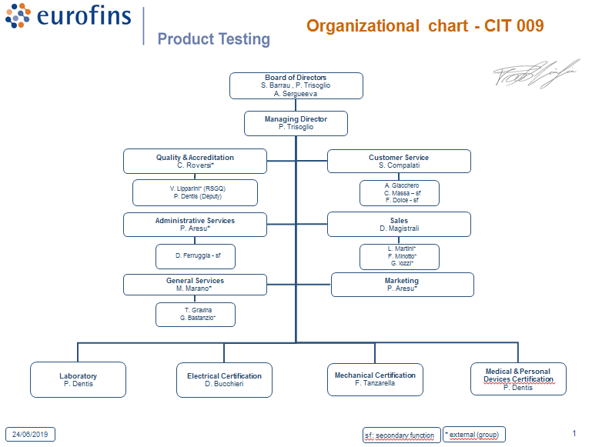

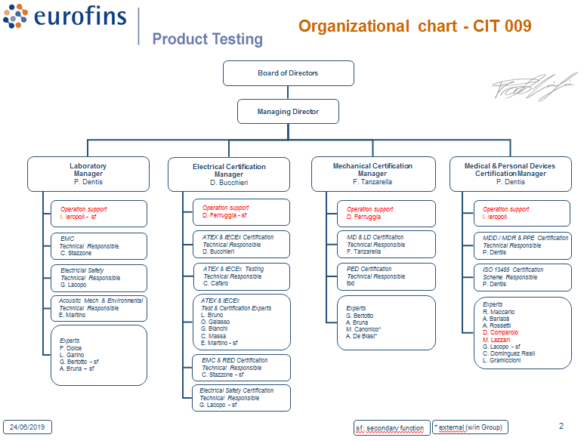

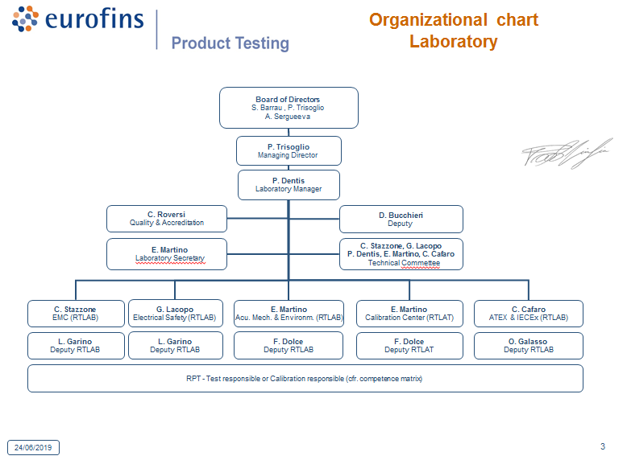
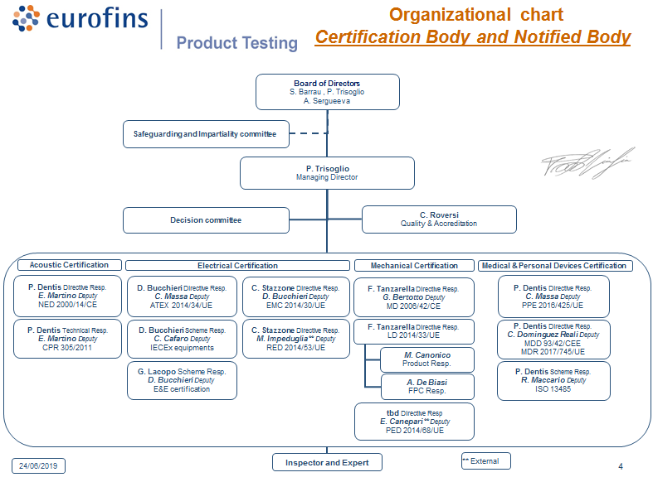
- Organisation Chart of ExCB and ExTL

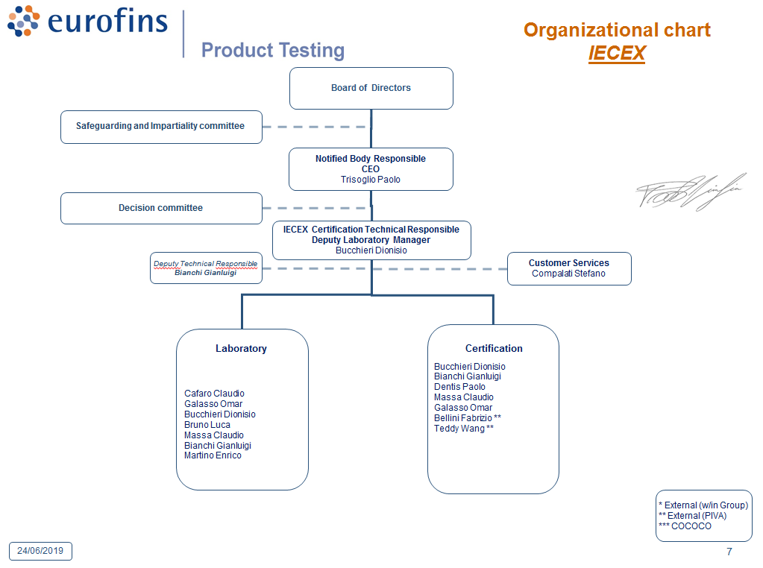
- Accreditation Certificate for ISO 17065
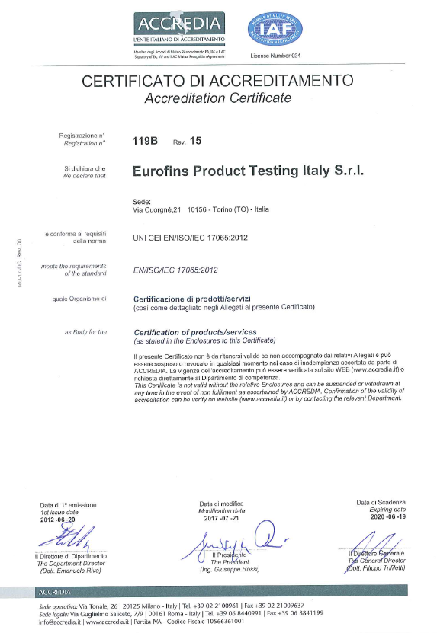
ANNEX C
Accreditation Certificate for ISO 17021

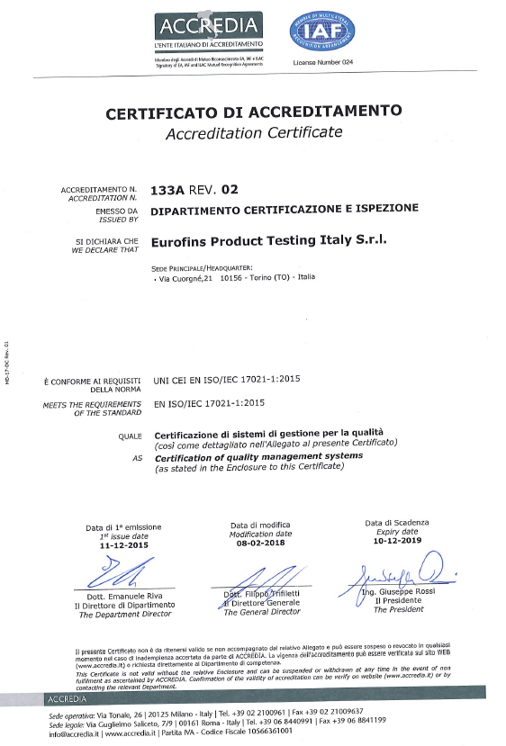

- Accreditation Certificate for ISO 17025

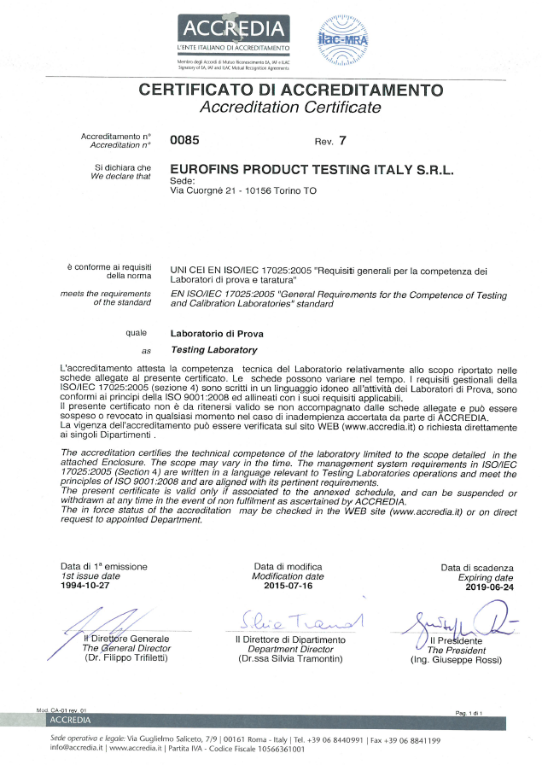

Annex D
Accreditation Certificate for ISO 17025

Extension of the accreditation ISO 17025 until to 22/10/2019

