**INTERNATIONAL ELECTROTECHNICAL COMMISSION SYSTEM FOR CERTIFICATION TO STANDARDS RELATING TO EQUIPMENT FOR USE IN EXPLOSIVE ATMOSPHERES (IECEx SYSTEM)**

**TITLE: Re-assessment and Scope Extension Report for the continued acceptance of** **Eurofins Electric & Electronic Product Testing AG, an Accepted Certification Body (ExCB), in the IECEx Equipment Scheme 02 and the IECEx Service Facilities Scheme, 03, and an Accepted Ex Testing Laboratory (ExTL) within the Equipment Scheme 02.**

**Circulation to: Members of the IECEx Management Committee, ExMC**

**INTRODUCTION**

In accordance with the 5 year re-assessment plan for the surveillance and monitoring of bodies within the IECEx System, the following document contains the IECEx Re-assessment and Scope Extension Report for the continued acceptance of Eurofins Electric & Electronic Product Testing AG, an Accepted Certification Body (ExCB), in the IECEx Equipment Scheme 02and the IECEx Service Facilities Scheme, 03, and an Accepted Ex Testing Laboratory (ExTL) within the Equipment Scheme 02

During the re-assessment the IECEx Assessment Team took the opportunity to also assess *Eurofins Electric & Electronic Product Testing AG* facilities, equipment and competence to undertake testing and certification to the Standards –

|  |  |
| --- | --- |
| IEC 60079-6  Edition 4.0 | Explosive atmospheres - Part 6: Equipment protection by liquid immersion "o" |
| IEC TS 60079-40  Edition 1.0 | Explosive atmospheres-Part 40: Requirements for process sealing between flammable process fluids and electrical systems |

The report is hereby submitted for voting by the ExMC.

***This document is hereby submitted for ExMC approval via correspondence using the IECEx on-line voting system.  ExMC Members are requested to submit their vote via the IECEx On-line*** [***Ballot System***](https://www.iecex.com/ballot) ***by the closing date 2020 06 26***

***Please refer to OD 050 for guidance on the “IECEx On-line voting system.”***

***Chris Agius***

**IECEx Secretariat**

|  |  |
| --- | --- |
| **IECEx Secretariat**  **Australia Square**  **Level 33, 264 George Street**  **Sydney NSW 2000**  **Australia** | **Tel: +61 2 4628 4690**  **Fax: +61 2 4625 3480**  **Email: info@iecex.com** |

IEC System for certification to standards relating to equipment for use in Explosive Atmospheres (IECEx System)

IECEx Assessment Report Form

IECEx Assessment Report Form for use by IECEx Assessment Teams to report Assessments conducted according to the IECEx Assessment Procedures of

1. Operational Document IECEx OD003-2 for the Certified Equipment Scheme
2. Operational Document IECEx OD316-5 for the Certified Service Facility Scheme
3. Operational Document IECEx OD422 for the IECEx Conformity Mark Licensing System

IECEx ExCB/ExTL assessment report for

Eurofins Electrosuisse Product Testing AG

Luppmenstrasse 3

8320 Fehraltorf

SWITZERLAND

INTERNATIONAL  
ELECTROTECHNICAL  
COMMISSION

CONTENTS

1 Assessment information 6

1.1 Type of Body covered by this assessment: 6

1.2 Type of assessment: 6

1.3 Details of body 6

1.3.1 Country 6

1.3.2 Name of body 6

1.3.3 Name and title of nominated principal contact 6

1.4 Assessment information 6

1.4.1 Members of the assessment team 6

1.4.2 Place(s) of assessment 6

1.4.3 Assessment date(s) 6

1.5 Application information and background information on the assessment 6

1.6 Scopes 7

1.6.1 ExCB scope for equipment certification scheme 7

1.6.2 ExTL scope 8

1.6.3 ExCB scope for Service Facilities Scheme 8

1.6.4 ExCB scope for ExMark Scheme 8

2 Common information 9

2.1 Legal entity of body 9

2.2 Financial support 9

2.3 History 9

2.4 Documentation 9

2.4.1 Quality manual 9

2.4.2 Procedures 9

2.4.3 Work instructions 9

2.4.4 Records (including test records where relevant) 10

2.4.5 Document change control 10

2.5 Confidentiality 10

2.6 Communication with public and customers (Hard copy and Electronic) 10

2.7 Recognitions and agreements 10

2.8 Internal audit 10

2.9 Management review 10

2.10 Contracting, subcontracting and witness testing 10

2.10.1 Contracting 10

2.10.2 Subcontracting 10

2.10.3 Witness testing 11

2.11 Training and competence 11

2.12 Complaints and appeals (including appeals to IECEx) 11

2.13 Impartiality 11

2.14 Commenting on ExTAG Documents 11

2.15 Special facts to be noted 11

2.16 Supporting documentation 11

2.17 Recommendations 12

3 ExCB for IECEx Certified Equipment Scheme 13

3.1 Assessment references 13

3.1.1 General references 13

3.1.2 Additional references applied for this assessment 13

3.2 Candidate ExCB persons interviewed 13

3.3 Associated ExTL(s) 13

3.4 Associated certification functions 14

3.5 National marks and certificates 14

3.6 Standards accepted 14

3.7 National differences to IEC standards 14

3.8 Organisation 14

3.8.1 Names, titles and experience of the senior executives 14

3.8.2 Name, title and experience of the quality management representative 14

3.8.3 Name and title of signatories for certification 14

3.8.4 Other employees in ExCB activity 14

3.9 Organizational structure 14

3.10 Indemnity insurance 14

3.11 Resources 15

3.12 Committees (such as governing or advisory boards) 15

3.13 Certification operations 15

3.13.1 National approval/certification methods 15

3.13.2 Certification policy 15

3.13.3 Application for certification 15

3.13.4 Certification decision 15

3.13.5 Suspension and cancellation of certificates 15

3.14 Certificates issued 16

3.15 National accreditation 16

3.16 Assessment of manufacturers and issue of QARs 16

3.17 Comments (including issues found during assessment) 16

4 ExTL for IECEx Certified Equipment Scheme 17

4.1 Assessment references 17

4.1.1 General references 17

4.1.2 Additional references applied for this assessment 17

4.2 Candidate ExTL persons interviewed 17

4.3 Associated ExCB(s) 17

4.4 Organisation 17

See chart as Annex A and Annex B 17

4.4.1 Names, titles and experience of the senior executives 17

4.4.2 Name, title and experience of the quality management representative 17

4.4.3 Other employees in ExTL activity 18

4.5 Organizational structure 18

4.6 Resources 18

4.7 Test reports issued 18

4.8 National accreditation 18

4.9 Calibration 19

4.10 Tests witnessed during the assessment visit 19

4.11 Participation in IECEx Proficiency Testing Programs 19

4.12 Comments (including issues found during assessment) 20

5 ExCB for Certified Service Facilities Scheme 21

5.1 Assessment references 21

5.2 Candidate ExCB persons interviewed 21

5.3 Organisation 21

See chart as Annex C and Annex D 21

5.3.1 Names, titles and experience of the senior executives 21

5.3.2 Name, title and experience of the quality management representative 21

5.3.3 Name and title of signatories for certification 21

5.3.4 Other employees in ExCB activity 21

5.4 Organizational Structure 21

5.5 Resources 21

5.6 Certification operations 22

5.6.1 National approval/certification Methods 22

5.6.2 Application for certification 22

5.6.3 Withdrawal and cancellation of certificates 22

5.7 Statistics 22

5.8 National accreditation 22

5.9 Comments (including issues found during assessment) 22

Annex A Overall Organisation Chart 23

Annex B Organisation Chart of ExCB and ExTL 24

Annex C Accreditation Certificate for ISO/IEC 17065:2012 25

Annex D Accreditation Scope for ISO/IEC 17025:2017 29

# Assessment information

## Type of Body covered by this assessment:

|  |  |
| --- | --- |
| ExCB for IECEx Certified Equipment Scheme | ✓ |
| ExTL for IECEx Certified Equipment Scheme | ✓ |
| ExCB for IECEx Certified Service Facilities Scheme | ✓ |
| ExCB for IECEx Conformity Mark Licensing System |  |

NOTE 1 ExCB - IECEx Certification Body

NOTE 2 ExTL - IECEx Testing Laboratory

## Type of assessment:

|  |  |
| --- | --- |
| Pre-assessment for candidate body |  |
| Initial assessment for candidate body |  |
| Surveillance |  |
| Re-assessment | ✓ |
| Scope extension | ✓ |

## Details of body

### Country

Switzerland

### Name of body

Eurofins Electrosuisse Product Testing AG now as from Sept 2019 Eurofins Electric & Electronic Product Testing AG

### Name and title of nominated principal contact

|  |  |  |
| --- | --- | --- |
| Name | Title | E-mail address |
| Jürg Rellstab | Head of Certification | juergrellstab@eurofins.ch |

## Assessment information

### Members of the assessment team

|  |  |
| --- | --- |
| Name | Role |
| Ron Webb | IECEx Lead Assessor |
| Eduardo Galera | IECEx Assessor |

### Place(s) of assessment

|  |  |
| --- | --- |
| Luppmenstrasse 3, 8320 Fehraltorf | Switzerland |

### Assessment date(s)

2019-08-20 to 22

## Application information and background information on the assessment

Information relevant to the Secretariat review process: no new application

## Scopes

### ExCB scope for equipment certification scheme

| Number | Title | Comments, eg if scope change |
| --- | --- | --- |
| IEC 60079-0  Edition 7.0 | Explosive atmospheres - Part 0: Equipment - General requirements | Existing |
| IEC 60079-1  Edition 7.0 | Explosive atmospheres - Part 1: Equipment protection by flameproof  enclosures “d” | Existing |
| IEC 60079-2  Edition 6.0 | Explosive atmospheres - Part 2: Equipment protection by pressurized  enclosure «p» | Existing |
| IEC 60079-5  Edition 4.0 | Explosive atmospheres - Part 5: Equipment protection by powder filling «q» | Existing |
| IEC 60079-6  Edition 4.0 | Explosive atmospheres - Part 6: Equipment protection by liquid  immersion "o" | Scope extension |
| IEC 60079-7  Edition 5.0 | Explosive atmospheres - Part 7: Equipment protection by increased  safety "e" | Existing |
| IEC 60079-11  Edition 6.0 | Explosive atmospheres - Part 11: Equipment protection by intrinsic safety “i” | Existing |
| IEC 60079-15  Edition 5.0 | Explosive atmospheres – Part 15: Equipment protection by type of protection "n" | Existing |
| IEC 60079-18  Edition 4.0 | Explosive atmospheres – Part 18: Equipment protection by encapsulation “m” | Existing |
| IEC 60079-26  Edition 3.0 | Explosive atmospheres - Part 26: Equipment with equipment protection level (EPL) Ga | Existing |
| IEC 60079-28  Edition 2.0 | Explosive atmospheres - Part 28: Protection of equipment and transmission systems using optical radiation | Existing |
| IEC 60079-31  Edition 2.0 | Explosive atmospheres – Part 31: Equipment dust ignition protection by enclosure "t" | Existing |
| IS0 80079-36  Edition 1.0 | Explosive atmospheres - Part 36: Non-electrical equipment for explosive atmospheres – Basic method and requirements | Existing |
| ISO 80079-37  Edition 1.0 | Explosive atmospheres - Part 37: Non-electrical equipment for explosive atmospheres – Non electrical type of protection constructional safety ”c” control of ignition source ”b”, liquid immersion ”k” | Existing |
| IEC TS 60079-40  Edition 1.0 | Explosive atmospheres-Part 40: Requirements for process sealing between flammable process fluids and electrical systems | Scope extension |
| *IEC 61241-0  Edition 1.0 | Electrical apparatus for use in the presence of combustible dust - Part 0: General requirements | Existing |
| *IEC 61241-1  Edition 1.0 | Electrical apparatus for use in the presence of combustible dust - Part 1: Protection by enclosure “tD” | Existing |
| *IEC 61241-4  Edition 1.0 | Electrical apparatus for use in the presence of combustible dust - Part 4: Protection by pressurization "pD" | Existing |
| *IEC 61241-11  Edition 1.0 | Electrical apparatus for use in the presence of combustible dust – Part 11: Protection by intrinsic safety 'iD' | Existing |
| *IEC 61241-18  Edition 1.0 | Electrical apparatus for use in the presence of combustible dust - Part 18: Protection by encapsulation "mD" | Existing |
| IEC/TS 60079-46 | Explosive atmospheres - Part 46: Equipment assemblies | Existing |
| IECEx DS2015/001A  2015 10 09 | Equipment assemblies | Existing |

NOTE 1 Unless otherwise indicated, earlier editions of standards (even if with a different number) are considered to be covered in the above scope for the purposes of the assessment.

NOTE 2 The above list highlights any extension of scope in the list above for new standards or later editions of standards already in scope.

### ExTL scope

The ExTL scope is the same as for the ExCB with the exception of IEC 60079-6.

### ExCB scope for Service Facilities Scheme

|  |  |
| --- | --- |
| 60079-19  Edition 3 | Explosive atmospheres – Part 19: Equipment repair, overhaul and reclamation |
| **Plus the following types of protection** | **ID** |
| Flameproof Enclosure "d" | d |
| Increased Safety "e" | e |
| Type of Protection "n" | n |
| Intrinsic Safety "i" | i |
| Oil Filled "o" | - |
| Pressurisation "p" | p |
| Dusts to IEC 60079-31 "t" | - |
| Dusts to IEC 61241-1 "tD" | tD |
| Dusts to IEC 61241-1-1 "DIP" | DIP |
| Other | m |

### ExCB scope for ExMark Scheme

Not included in the scope.

# Common information

## Legal entity of body

Eurofins Electrosuisse Product Testing AG now Eurofins Electric & Electronic Product Testing AG

## Financial support

No financial support; self-financing

## History

The SEV association was founded in 1889 in the form of a registered society in accordance with Article 60 of the Swiss Civil Code, and started their testing activities in 1901. Currently around 4300 professionals and 1750 companies and institutions are members of the association. After being located in Zurich, SEV moved in1994 to Fehraltorf (20 km east of Zurich), where the laboratories and all testing equipment was completely renewed. SEV changed its name to Electrosuisse in 2002.

As an accredited certification body by Swiss Accreditation Service (SAS), Electrosuisse is the recognized professional organization for electrical-, energy- and information technology, offering services for the whole of the electrical sector. Electrosuisse is a member of IECEE-CB scheme since 1961 and member of the European CENELEC Certification Agreement (CCA Scheme) since 1973 and ATEX Notified Body NB 1258 since 2004.

Eurofins bought the business unit “Testing and Certification” from Electrosuisse in June 2017 and founded the new company Eurofins Electrosuisse Product Testing AG. As from September 2019 Eurofins Electric & Electronic Product Testing AG.

## Documentation

### Quality manual

The quality system is described in the Eurofins Electrosuisse Product Testing AG quality manual and is based ISO/IEC 17065 and ISO/IEC 17025. It contains all necessary policies and procedures relevant to the testing and certification processes.

The Eurofins Electrosuisse Quality Manual is divided into:

* General Management Handbook, (MHB)
* Process Handbooks VHB-PQ for testing and VHB-ZP for certification

The quality manuals are written by the quality manager in close co-operation with the relevant business sections. Their control and release are performed by the Managing director. The distribution of the documents and the implementation is under the responsibility of the quality manager. The quality manual is stored on the server, no paper copies exist. This version is always the latest and consequently the valid one. All staff has access to the relevant parts which apply to their field of working.

### Procedures

All the procedures for the operation of certification body, including granting, maintaining, extending, suspending, withdrawing and cancelling certificates are well documented in the process handbook VHB-ZP. It is noted that the reference to IECEx rules, procedures and operational documents have also been made within section 5 of the handbook, and the certification policy is based on the document IECEx OD 009. All the decisions on certification process are taken by the head of product certification. A certification committee is in place and get in action in case of complains and serious troubles between customers and certification body.

### Work instructions

A series of certification instructions/procedures is included in the management system, giving detailed information for the implementation of critical certification activities within the scope of ATEX/IECEx accreditation.

### Records (including test records where relevant)

The control of quality records is laid down in the main quality manual MHB 51.01. The detailed procedure was sighted and examples of quality records are well maintained with a minimum period of 10 years. A method of secure disposal for records that are no longer required is available.

### Document change control

All documents developed by the quality manager and relevant key persons are always reviewed and approved prior to publication via Intranet. The details of document control including data are also covered by the procedure MHB 51.01and meet the requirements of IECEx.

## Confidentiality

Confidentiality is applied within Eurofins Electrosuisse. It is addressed in the procedure MHB 11.02 of main quality manual (MHB 01.01). All the employees including all the members of certification committee (ZA) are required to sign a letter with statement on confidentiality and conflict of interest. In addition, control and security of access to the premises and the data on the servers is also maintained.

## Communication with public and customers (Hard copy and Electronic)

All information about Eurofins’s activities can be found on the website at https://www.eurofins.ch/de/unser-angebot/pruefung-zertifizierung/.

## Recognitions and agreements

Eurofins Electrosuisse has agreements and recognitions including:

- Notified Body under ATEX Directive

- IECEE for CB Scheme

- ETICS for CENELEC Certification Agreement (CCA) Scheme

- ETICS for ENEC Scheme

- IECEx for Equipment and Service Facility scheme

## Internal audit

Internal audits are carried out in accordance with the management procedures MBH 22.02. This covers a series of audits through the last year with coverage of all the quality elements and departments/activities. All upcoming audits are planned in file MHB T22.02-2/3/4.

The last internal audit for the Ex section was on 8 August 2019 and resulted in 6 NCRs and 1 Observation. These have been closed.

## Management review

The Management review is intended to be conducted annually. The last review was carried out on 30 September covering 2018. For the next management review, Urban Strebel (team leader explosion protection) will represent his area.

## Contracting, subcontracting and witness testing

### Contracting

Contract with Eurofins Shanghai using Engineer, Teddy Wang for qualification work. Teddy helps to approach Chinese customers and does the preparation of the test report. Eurofins Shanghai is a CNAS accredited test laboratory for electrical safety.

There is a QAR auditor in USA who also works as a contractor.

### Subcontracting

The following tests are, or may be, subcontracted by the body:

|  |  |  |
| --- | --- | --- |
| Standard | Clause | Test |
| IEC 60079-28: Protection of equipment and transmission systems using optical radiation | Clause 6 | Ignition test |
| IEC 60079-0 | 26.10 | UV resistance |
| IEC 60079-0 / IEC 60079-1 | 25 / 14 | Mechanical measurements |

More details, including bodies to whom tests will be subcontracted, details of accreditation of those bodies and details of how the subcontracted bodies are checked, and are included in the site assessment report.

### Witness testing

Procedure VHB-STS 41.03 covers external tests, including witness testing. It makes reference to OD 024. This procedure has been used on several occasions.

A sample agreement was sighted and found to have been completed correctlyand in compliance with the requirements of the IECEx.

## Training and competence

Training is recorded in the administrative software and the training log of each employee. Competence is registered in a competence matrix and updated during annual discussion between employers and employees. Records of training were sighted and are in compliance with the requirements of the IECEx..

Details of staff competencies are included in the site assessment report.

## Complaints and appeals (including appeals to IECEx)

Appeals, complaints and disputes are brought to the certification body’s management and are subjected to the procedures outlined in the document “Basic provisions CERTIFEL certification system”. When no solution is achieved by the management, Customer complaints and appeals also can be forwarded to the certification committee (ZA) where a final decision will be made. Appeals to the IECEx are also possible according to CERTIFEL Nationales Zertifizierungssystem der Eurofins Electric & Electronic Product Testing AG

## Impartiality

This issue is stressed in MHB “AA31.02-2 Verhaltensregeln”. Every staff member has to sign a letter confirming the knowledge of AA31.02-2 Verhaltensregeln. All new staff will be trained during an initial training in this matter.

Samples of signed documents were sighted and found to be acceptable and in compliance with the requirements of the IECEx.

## Commenting on ExTAG Documents

Communication of ExTAG documents is described in “20.02 Zusammenarbeit mit CBTL ExTL ATF MTF”. All persons involved get the ExTAG’s draft directly from IECEx and can send their comments to the secretariat should they have any

## Special facts to be noted

None

## Supporting documentation

Copies of additional supporting information for this assessment have been provided to the applicant and the IECEx Secretariat. These are included in a site assessment report or provided separately and include:

* Details of issues raised and how these have been resolved
* Checklist for ISO/IEC 17065
* Checklist for ISO/IEC 17025
* Completed Technical Capability Document (TCD)
* Photos of the facilities/tests witnessed are included in the above TCD
* Assessors’ notes

## Recommendations

Based on the assessment performed on 20. to 22.08.2019, Eurofins Electrosuisse Product Testing AG is recommended for continued acceptance in the IECEx scheme as:

* An ExCB in the IECEx Certified Equipment Scheme
* An ExTL in the IECEx Certified Equipment Scheme
* An ExCB in the IECEx Certified Service Facilities Scheme

This is according to the scope of the standards listed in this document including the extension of scope.

|  |  |
| --- | --- |
| Ron Webb | Eduardo Galera |
| IECEx Lead Assessor | IECEx Assessor |

Date: May 2020

# ExCB for IECEx Certified Equipment Scheme

## Assessment references

### General references

1. IECEx02 IECEx Certified Equipment Scheme covering equipment for use in explosive atmospheres – Rules of Procedure
2. OD003-2 Assessment, surveillance assessment and re-assessment of ExCBs and ExTLs operating in the IECEx 02, IECEx Certified Equipment Scheme
3. ISO/IEC 80079-34 Edition 1, Explosive atmospheres – Part 34: Application of quality systems for equipment manufacture
4. OD009 Issuing of CoCs, ExTRs and QARs
5. IECEx Document OD 025 Guidelines on the Management of Assessment and Surveillance programs for the assessment of Manufacturer’s Quality Systems in accordance with the IECEx Scheme
6. OD0026 IECEx Certified Equipment Scheme – Guidelines for the qualification of Lead Auditor and Auditors, in accordance with the IECEx System
7. ISO/IEC 17065: 2012, Edition 1, General requirements for bodies operating product certification systems Conformity assessment — Requirements for bodies certifying products, processes and services
8. IECEx Technical Capability Document (TCD)
9. ExTAG decision sheets (DSs)

NOTE The latest editions of the above documents were applied

### Additional references applied for this assessment

1. OD 280 IECEx Certified Equipment Scheme – Guide to Certification of Non-electrical Equipment and Protective Systems.

NOTE To be added by assessment team. For example ODs for non-electrical or Ex s where applicable.

## Candidate ExCB persons interviewed

|  |  |
| --- | --- |
| Name | Position |
| Martin Plüss | Certification Engineer |
| Jürg Rellstab | Head Certification |

## Associated ExTL(s)

Eurofins Electrosuisse Product Testing AG

Luppmenstrasse 3

8320 Fehraltorf

SWITZERLAND

EUROFINS MET Laboratories Inc.

914 W Patapsco Ave,

Baltimore MD 21230

United States of America

EUROFINS MET Laboratories Inc.

13501 McCallen Pass

Austin, TX 78753

United States of America

## Associated certification functions

Eurofins Electrosuisse is Notified Body NB 1258 under the ATEX Directive and covers all annexes of 2014/34/EU.

## National marks and certificates

There are no national certificates issued for Ex products.

## Standards accepted

See clause 1.6 of this report

## National differences to IEC standards

National differences to IEC standards are those for the European differences listed in the latest version of the IECEx Scheme Bulletin. IEC 60079 series have no group differences in Europe.

## Organisation

### Names, titles and experience of the senior executives

|  |  |  |
| --- | --- | --- |
| Name | Title | Experience |
| Jürg Rellstab | Head of Product Certification | 16 years in Certification, 14 years at Electrosuisse |

### Name, title and experience of the quality management representative

|  |  |  |
| --- | --- | --- |
| Name | Title | Experience |
| Philipp Haller | Head of Quality Management | 2 years |

### Name and title of signatories for certification

|  |  |  |
| --- | --- | --- |
| Name | Title | Comments |
| Jürg Rellstab | Head of Product Certification |  |
| Martin Plüss | Certification Engineer |  |

### Other employees in ExCB activity

|  |  |  |
| --- | --- | --- |
| Name | Title | Responsibility and Experience in Ex |
| Hans-Peter Leserf | Project manager | Deputy for Martin Plüss |

## Organizational structure

See chart as Annex A and Annex B

## Indemnity insurance

Indemnity insurance is provided by Basel Insurance company with a cover of 10 million Swiss Francs.

## Resources

Eurofins Electrosuisse employs 80 people at its head offices in Fehraltorf and at its location in Rossens, Rorschach, Zürich and Neuenhof. The qualification activities with necessary resources include about 65 staff in total, with about 60 for testing activities.

There are a total of 5 personnel in the ExCB and 4 in the ExTL. Eurofins currently have 4 qualified IECEx QA auditors by using staff from the ExTL and 2 qualified auditors in other Eurofins companies.

## Committees (such as governing or advisory boards)

The certification committee (ZA) of Eurofins Electrosuisse with 12 members is elected by Eurofins Electrosuisse Managment. The members are from the certification committee and includes representatives from industry, manufacturer, consumer and Eurofins Electrosuisse management. The certification committee meets once a year or upon request. Certification policy, processes and fees matters are normally verified and confirmed by the certification committee.

## Certification operations

### National approval/certification methods

Electrosuisse operates as a Notified Body under EU ATEX directive in the field of testing and certification of electrical and non-electrical equipment used in explosive atmospheres. The national CERTIFEL Eurofins Electrosuisse scheme isn’t used for certification of products used in explosive atmosphere.

### Certification policy

The quality policy statement of the body is included in the quality manual and meets the principles of the IECEx System.

### Application for certification

This process is covered in MHB 41.04. The application forms (quotation ticket) and information about services are available at Eurofins Website.

[EUROFINS](https://www.eurofins.com/industrial/services/testing/explosive-atmosphere/)

### Certification decision

The certification decision is made by two persons from the ExCB. VHB-ZP 21.20 describes the process of certification and is in compliance with the requirements of the IECEx.

### Suspension and cancellation of certificates

Suspension and cancellation of certificates will be done according “VHB-ZP 21.22 Subprozess IECEx Missbrauch und Löschung”.

## Certificates issued

Number of certificates issued under for the preceding four years for each type of protection. For new applications these should be for national or regional schemes and for currently accepted bodies IECEx certificates should be shown (certificates for other schemes aren’t shown):

|  |  |  |  |  |  |  |
| --- | --- | --- | --- | --- | --- | --- |
| Standard numbers | Type of protection or other identifying information | Number of issued IECEx certificates (for last 4 years) | | | | Total |
|  |  | 2015 | 2016 | 2017 | 2018 |  |
| IEC 60079-0 | General | 53 | 45 | 36 | 59 | 193 |
| IEC 60079-1 | “d” | 12 | 5 | 9 | 16 | 42 |
| IEC 60079-2 | “p” | 2 | 0 | 0 | 0 | 2 |
| IEC 60079-5 | “q” | 0 | 0 | 1 | 1 | 2 |
| IEC 60079-6 | “o” | 0 | 0 | 0 | 0 | 0 |
| IEC 60079-7 | “e” | 20 | 14 | 6 | 15 | 55 |
| IEC 60079-11 | “i” | 22 | 22 | 25 | 26 | 95 |
| IEC 60079-15 | “n” | 4 | 6 | 0 | 5 | 15 |
| IEC 60079-18 | “m” | 6 | 0 | 2 | 15 | 23 |
| IEC 60079-26 | EPL | 19 | 18 | 16 | 12 | 65 |
| IEC 60079-28 | “op” | 2 | 1 | 1 | 12 | 16 |
| IEC 60079-31 | “t” | 9 | 10 | 8 | 21 | 48 |
| ISO 80079-36 | “h” | 0 | 0 | 1 | 4 | 5 |
| ISO 80079-37 | “h” | 0 | 0 | 1 | 4 | 5 |

**NOTE Above include certificates to IEC 60079-0 unless otherwise shown**

## National accreditation

National accreditation has been granted by Swiss Accreditation Service (SAS). The certificate is against ISO/IEC 17065. The current certificate is included as Annex C.

NOTE The national accreditation is checked annually by the IECEx Secretariat.

## Assessment of manufacturers and issue of QARs

Eurofins Electrosuisse issues around 20 quality assessment reports for IECEx/ATEX certification purposes per year. More than 40 manufacturers depend on Eurofins Electrosuisse quality assessments. Assessments are repeated all 18 months for manufacturer with ISO 9001 and all 12 months for the others.

There is a procedure VHB-ZP 21.22 for monitoring QARs and this identifies the need to address QARs out of date. The IECEx website does, however, have some issues where it shows a particular QAR being out of date when it is in fact up to date.

Letters sent to clients with out of date QARs were seen and this shows that the process is being used.

## Comments (including issues found during assessment)

Issues found concerned internal audits and management reviews and updating of the competency matrix.

All issues were cleared to the satisfaction of the assessment team.

# ExTL for IECEx Certified Equipment Scheme

## Assessment references

### General references

1. IECEx02 IECEx Certified Equipment Scheme covering equipment for use in explosive atmospheres – Rules of Procedure
2. IECEx OD003-2 Assessment, surveillance assessment and re-assessment of ExCBs and ExTLs operating in the IECEx 02, IECEx Certified Equipment Scheme
3. IECEx OD009 Issuing of CoCs, ExTRs and QARs
4. ISO/IEC 17025:2005 Edition 2, General requirements for the competence of testing and calibration laboratories
5. IECEx Technical Capability Document (TCD)
6. ExTAG decision sheets (DSs)
7. OD 202 IECEx Certified Equipment Scheme – IECEx Proficiency Testing Program

NOTE The latest editions of the above documents were applied.

### Additional references applied for this assessment

1. OD 280 IECEx Certified Equipment Scheme – Guide to Certification of Non-electrical Equipment and Protective Systems.

## Candidate ExTL persons interviewed

|  |  |
| --- | --- |
| Name | Position |
| Urban Strebel | Head of Laboratory/Qualification Engineer/QA assessor |
| Christian Ettlin | Qualification Engineer/QA assessor |
| Thomas Köhntopp | Qualification Engineer/QA assessor |
| Francois Meili | Qualification Engineer/QA assessor |

## Associated ExCB(s)

Eurofins Electrosuisse Product Testing AG

## Organisation

### See chart as Annex A and Annex B

### Names, titles and experience of the senior executives

|  |  |  |
| --- | --- | --- |
| Name | Title | Experience |
| Jürg Rellstab | Head of Certification | 16 years in Certification, 14 years at Electrosuisse |

### Name, title and experience of the quality management representative

|  |  |  |
| --- | --- | --- |
| Name | Title | Experience |
| Philipp Haller | Head of Quality Management | 2 years |

### Other employees in ExTL activity

|  |  |  |
| --- | --- | --- |
| Name | Title/responsibility | Experience in Ex |
| Urban Strebel | Head of Laboratory/Qualification Engineer | 5 years |
| Christian Ettlin | Qualification Engineer | 8 years |
| Thomas Köhntopp | Qualification Engineer | 4 years |
| Francois Meili | Qualification Engineer | 1 year |

## Organizational structure

See chart as Annex A and Annex B

## Resources

Eurofins Electrosuisse employs 80 people at its head offices in Fehraltorf and at its location in Rossens, Rorschach, Zürich and Neuenhof. The qualification activities with necessary resources include about 65 staff in total, with about 60 for testing activities.

There are a total of 5 personnel in the ExCB and 4 in the ExTL. Eurofins currently have 4 qualified IECEx auditors by using staff from the ExTL and 2 qualified auditors in other Eurofins companies.

## Test reports issued

Number of test reports (ExTRs) issued under for the preceding four years for each type of protection.

|  |  |  |  |  |  |  |
| --- | --- | --- | --- | --- | --- | --- |
| Standard numbers | Type of protection or other identifying information | Number of issued certificates (for last 4 years) | | | | Total |
|  |  | 2015 | 2016 | 2017 | 2018 |  |
| IEC 60079-0 | General | 53 | 45 | 36 | 59 | 193 |
| IEC 60079-1 | “d” | 12 | 5 | 9 | 16 | 42 |
| IEC 60079-2 | “p” | 2 | 0 | 0 | 0 | 2 |
| IEC 60079-5 | “q” | 0 | 0 | 1 | 1 | 2 |
| IEC 60079-7 | “e” | 20 | 14 | 6 | 15 | 55 |
| IEC 60079-11 | “i” | 22 | 22 | 25 | 26 | 95 |
| IEC 60079-15 | “n” | 4 | 6 | 0 | 5 | 15 |
| IEC 60079-18 | “m” | 6 | 0 | 2 | 15 | 23 |
| IEC 60079-26 | EPL | 19 | 18 | 16 | 12 | 65 |
| IEC 60079-28 | “op” | 2 | 1 | 1 | 12 | 16 |
| IEC 60079-31 | “t” | 9 | 10 | 8 | 21 | 48 |
| ISO 80079-36 | “h” | 0 | 0 | 1 | 4 | 5 |
| ISO 80079-37 | “h” | 0 | 0 | 1 | 4 | 5 |

**NOTE 1 Above include reports to IEC 60079-0 unless otherwise shown**

**NOTE 2 Where the number of reports is low, assessors are expected to carefully check current capability and document the process in this report.**

## National accreditation

National accreditation has been granted by Swiss Accreditation Service (SAS). The current certificate is against ISO/IEC 17025:2017. The current scope is included as Annex D

|  |
| --- |
|  |

This accreditation was against the ISO/IEC 17025:2005 at the time of the assessment but transition to the 2017 edition has been completed and has been assessed by SAS. The current scope document is included as annex D. IEC 60079-40 is not included in the scope, but the tests required are adequately covered by the other standards already on scope. Annual surveillance is therefore not considered necessary

NOTE The national accreditation is checked annually by the IECEx Secretariat.

## Calibration

The calibration processes is well documented with identifications of MHB 37.01 and VHB-EB. The testing equipment and measuring instruments at Electrosuisse are mainly outsourced to be calibrated. Some are internally calibrated.

## Tests witnessed during the assessment visit

The following tests were witnessed during the assessment visit:

|  |  |  |  |
| --- | --- | --- | --- |
| Standard and edition | Clause number | Test | Comments |
| IEC 60079-0 ed 7  ISO 80079-36 | 26.17  Annex D | transferred charge test | satisfactory |
| IEC 60079-0 ed 7 | 26.13 | Surface resistance test | satisfactory |
| IEC 60079-1 ed 7 | 15.3 | Flameproof flame transmission test (for Group IIC) | satisfactory |
| IEC 60079-1 ed 7 | 15.2.2 | Flameproof pressure determination (for Group IIC) | satisfactory |
| IEC 60079-0 ed 7 | 26.4.5 | IP6X/5X test | satisfactory |
| IEC 60079-31 ed 2 | 6.1.1.3 | Pressure test for Ex t | satisfactory |
| IEC 60079-0 ed 7  IEC 60079-1 ed 7 | 25  14  Not included in TCD because there is no listing for this clause no. although it is in the Standard | Measurement of dimensions of flameproof equipment and creepage and clearance distances | satisfactory |
| IEC 60079-18 ed 4 | 8.1.1  8.1.2 | Encapsulation, water absorption and dielectric strength test | satisfactory |
| IEC 60079-11 ed 6 | 10.1 | Use of spark test apparatus | satisfactory |
| IEC 60079-11 ed 6 | 10,5.2 | Electrolyte leakage test for a cell or a battery | satisfactory |
| IEC 60079-0 ed 7 | 26.5.1.3  Not included in TCD because there is no listing for this clause no. although it is in the Standard | Temperature rise, | satisfactory |
| IEC 60079-28 ed 2 |  | Optical radiation | satisfactory |

## Participation in IECEx Proficiency Testing Programs

Program: PTB Ex PT Scheme

|  |  |  |  |
| --- | --- | --- | --- |
| IECEx Proficiency Testing program | Program years | Participated? Y/N/NA | Comments |
| Program 1 "Explosion pressure" | 2011-2012 | N |  |
| Program 2 "Spark ignition" | 2011-2012 | N |  |
| Program 3 "Flame Transmission" | 2013-2014 | Y | acceptable |
| Program 4 "Temperature Classification" | 2013-2014 | Y | acceptable |
| Program 5 "Electrostatic Charge" | 2015-2016 | Y | acceptable |
| Program 6 "Intrinsic Safety" | 2015-2016 | Y | acceptable |
| Program 7 "Explosion Pressure" | 2017-2018 | Y | acceptable |
| Program 8 "Pressurized Enclosure" | 2017-2018 | Y | acceptable |
| Tests of enclosures | 2019-2020 | Y | Waiting to start |
| Battery testing | 2019-2020 | Y | Waiting to start |

## Comments (including issues found during assessment)

Issues concerning calibration marking were cleared to the satisfaction of the assessment team.

# ExCB for Certified Service Facilities Scheme

## Assessment references

1. IECEx 03 IECEx Certified Service Facilities Scheme covering repair and overhaul of Ex equipment – Rules of Procedure
2. IECEx OD316-5 IECEx Operations Manual – IECEx Certified Service Facilities Scheme – Part 5: Repair, overhaul and reclamation of Ex equipment. Assessment procedures for IECEx acceptance of Candidate Certification Bodies (ExCBs) for the purpose of issuing IECEx Certificates to Ex Service Facilities involved in the repair, overhaul and reclamation of Ex equipment
3. ISO/IEC 17065: 2012, Edition 1, General requirements for bodies operating product certification systems Conformity assessment — Requirements for bodies certifying products, processes and services
4. IEC 60079-19 Explosive atmospheres – Part 19: Equipment repair, overhaul and reclamation

NOTE The latest editions of the above documents were applied

## Candidate ExCB persons interviewed

|  |  |
| --- | --- |
| Name | Position |
| Christian Ettlin | Qualification Engineer |
| Jürg Rellstab | Head of Certification |

## Organisation

### See chart as Annex C and Annex D

### Names, titles and experience of the senior executives

|  |  |  |
| --- | --- | --- |
| Name | Title | Experience |
| Christian Ettlin | Qualification Engineer | 2 years |

### Name, title and experience of the quality management representative

|  |  |  |
| --- | --- | --- |
| Name | Title | Experience |
| Philipp Haller | Head of Quality Management | 1 year |

### Name and title of signatories for certification

|  |  |  |
| --- | --- | --- |
| Name | Title | Comments |
| Jürg Rellstab | Head of Product Certification |  |
| Martin Plüss | Certification Engineer |  |

### Other employees in ExCB activity

|  |  |  |
| --- | --- | --- |
| Name | Title/responsibility | Experience in Ex |
| Hans-Peter Leserf | Project manager | 10 years |

## Organizational Structure

See annex E and F

## Resources

Eurofins Electrosuisse employs 80 people at its head offices in Fehraltorf and at its location in Rossens, Rorschach, Zürich and Neuenhof. The qualification activities with necessary resources include about 65 staff in total, with about 60 for testing activities. There are a total of 5 personnel in the ExCB and 4 in the ExTL. Eurofins currently have 4 qualified IECEx auditors by using staff from the ExTL.

## Certification operations

### National approval/certification Methods

There are no national certificates issued for Ex products.

### Application for certification

This process is covered in MHB 41.04. The application forms (quotation ticket) and information about services are available at Eurofins Website. (https://www.eurofins.ch/de/unser-angebot/pruefung-zertifizierung/informationen/quotation-ticket/)

### Withdrawal and cancellation of certificates

Suspension and cancellation of certificates will be done according “VHB-ZP 21.22 Subprozess IECEx Missbrauch und Löschung”.

## Statistics

Detail experience in assessment and certification of Ex related Service Facilities for the Ex Protection under this application during the past 2 years:

flameproof d 1

increased safety e 1

type of protection n 1

intrinsic safety I 0

oil immersion o 0

pressurization p 1

apparatus for Dusts t, tD and DIP 0

other

## National accreditation

See annex C and D

## Comments (including issues found during assessment)

none

1. Overall Organisation Chart

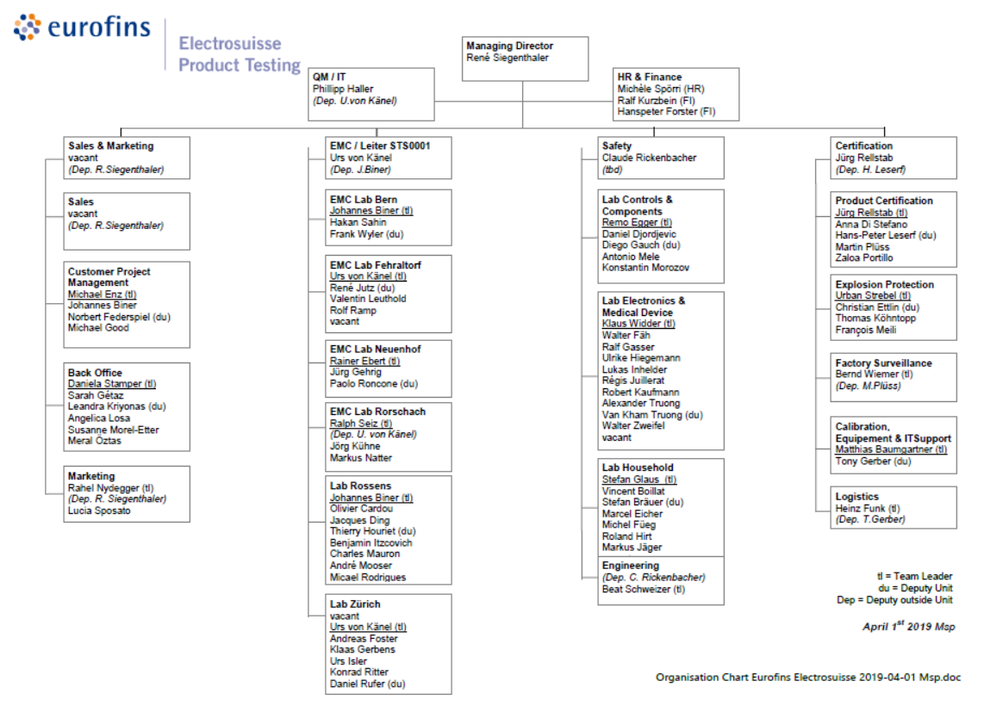

1. Organisation Chart of ExCB and ExTL

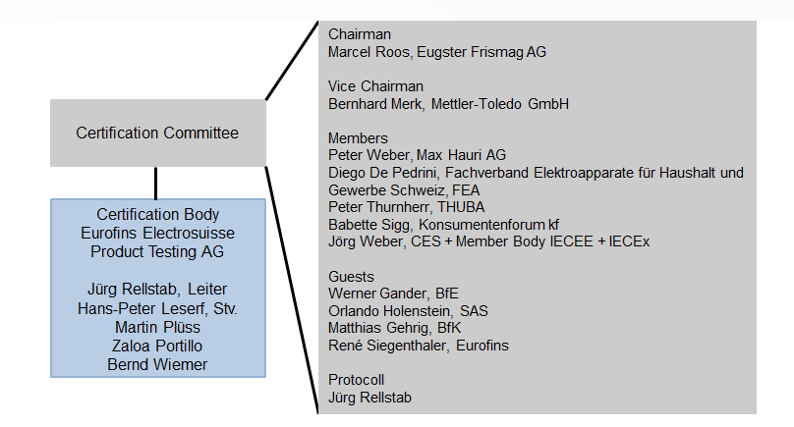

**ExTL**

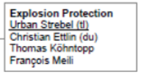

1. 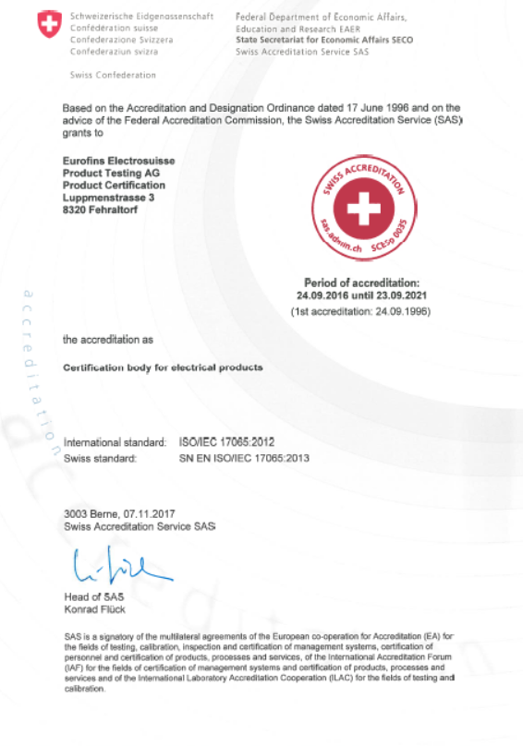  
   Accreditation Certificate for ISO/IEC 17065:2012

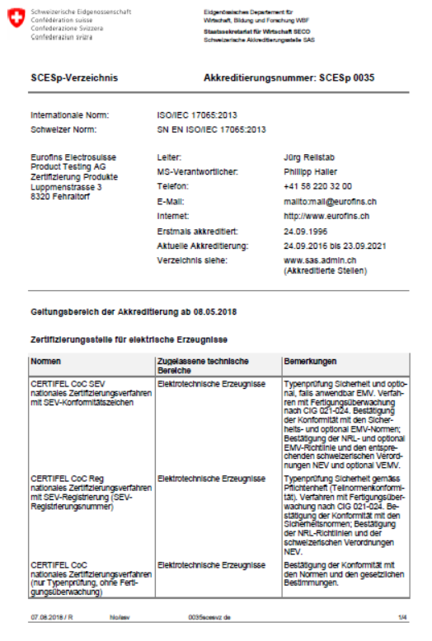

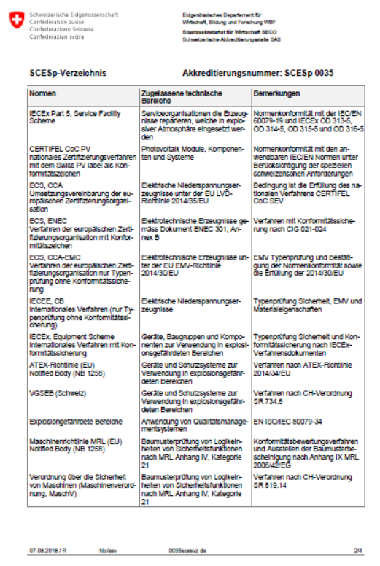

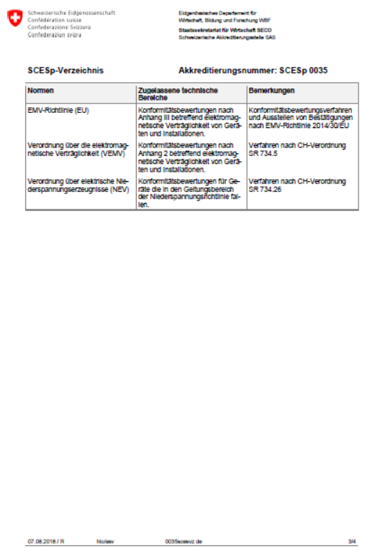

1. Accreditation Scope for ISO/IEC 17025:2017

