**INTERNATIONAL ELECTROTECHNICAL COMMISSION SYSTEM FOR CERTIFICATION TO STANDARDS RELATING TO EQUIPMENT FOR USE IN EXPLOSIVE ATMOSPHERES (IECEx SYSTEM)**

**TITLE: Re-assessment and Scope Extension Report for the continued acceptance of** **Laboratoire Central des Industries Electriques - LCIE, an Accepted Certification Body (ExCB), in the IECEx Equipment Scheme 02, and an Accepted ExCB within the Conformity Mark Licensing System, 04, as well as an Accepted Ex Testing Laboratory (ExTL) within the Equipment Scheme 02.**

**Circulation to: Members of the IECEx Management Committee, ExMC**

**INTRODUCTION**

In accordance with the 5 year re-assessment plan for the surveillance and monitoring of bodies within the IECEx System, the following document contains the IECEx Re-assessment and Scope Extension Report for the continued acceptance of Laboratoire Central des Industries Electriques - LCIE, an Accepted Certification Body (ExCB), in the IECEx Equipment Scheme 02, and an Accepted ExCB within the Conformity Mark Licensing System, 04, as well as an Accepted Ex Testing Laboratory (ExTL) within the Equipment Scheme 02.

During the re-assessment the IECEx Assessment Team took the opportunity to also assess Laboratoire Central des Industries Electriques – LCIE, facilities, equipment and competence to undertake testing and certification to the Standards –

|  |  |
| --- | --- |
| IEC 60079-28  Edition 2.0 | Explosive atmospheres - Part 28: Protection of equipment and transmission systems using optical radiation |

The report is hereby submitted for voting by the ExMC.

***This document is hereby submitted for ExMC approval via correspondence using the IECEx on-line voting system.  ExMC Members are requested to submit their vote via the IECEx On-line*** [***Ballot System***](https://www.iecex.com/ballot) ***by the closing date 2020 09 14***

***Please refer to OD 050 for guidance on the “IECEx On-line voting system.”***

***Chris Agius***

**IECEx Secretariat**

|  |  |
| --- | --- |
| **IECEx Secretariat**  **Australia Square**  **Level 33, 264 George Street**  **Sydney NSW 2000**  **Australia** | **Tel: +61 2 4628 4690**  **Fax: +61 2 4625 3480**  **Email: info@iecex.com** |

IEC System for certification to standards relating to equipment for use in Explosive Atmospheres (IECEx System)

IECEx Assessment Report Form

IECEx Assessment Report Form for use by IECEx Assessment Teams to report Assessments conducted according to the IECEx Assessment Procedures of

1. Operational Document IECEx OD003-2 for the Certified Equipment Scheme
2. Operational Document IECEx OD316-5 for the Certified Service Facility Scheme
3. Operational Document IECEx OD422 for the IECEx Conformity Mark Licensing System

IECEx ExCB/ExTL assessment report for LCIE

INTERNATIONAL  
ELECTROTECHNICAL  
COMMISSION

CONTENTS

1 Assessment information 6

1.1 Type of Body covered by this assessment: 6

1.2 Type of assessment: 6

1.3 Details of body 6

1.3.1 Country 6

1.3.2 Name of body 6

1.3.3 Name and title of nominated principal contact 6

1.4 Assessment information 6

1.4.1 Members of the assessment team 6

1.4.2 Place(s) of assessment 6

1.4.3 Assessment date(s) 6

1.5 Application information and background information on the assessment 6

1.6 Scopes 7

1.6.1 ExCB scope for equipment certification scheme 7

1.6.2 ExTL scope 8

1.6.3 ExCB scope for Service Facilities Scheme 8

1.6.4 ExCB scope for ExMark Scheme 8

2 Common information 9

2.1 Legal entity of body 9

2.2 Financial support 9

2.3 History 9

2.4 Documentation 9

2.4.1 Quality manual 9

2.4.2 Procedures 9

2.4.3 Work instructions 9

2.4.4 Records (including test records where relevant) 9

2.4.5 Document change control 9

2.5 Confidentiality 9

2.6 Communication with public and customers (Hard copy and Electronic) 10

2.7 Recognitions and agreements 10

2.8 Internal audit 10

2.9 Management review 10

2.10 Contracting, subcontracting and witness testing 10

2.10.1 Contracting 10

2.10.2 Subcontracting 10

2.10.3 Witness testing 10

2.11 Training and competence 10

2.12 Complaints and appeals (including appeals to IECEx) 11

2.13 Impartiality 11

2.14 Commenting on ExTAG Documents 11

2.15 Special facts to be noted 11

2.16 Supporting documentation 11

2.17 Recommendations 11

3 ExCB for IECEx Certified Equipment Scheme 12

3.1 Assessment references 12

3.1.1 General references 12

3.1.2 Additional references applied for this assessment 12

3.2 ExCB persons interviewed 12

3.3 Associated ExTL(s) 12

3.4 Associated certification functions 12

3.5 National marks and certificates 12

3.6 Standards accepted 12

3.7 National differences to IEC standards 13

3.8 Organisation 13

3.8.1 Names, titles and experience of the senior executives 13

3.8.2 Name, title and experience of the quality management representative 13

3.8.3 Name and title of signatories for certification 13

3.8.4 Other employees in ExCB activity 13

3.9 Organizational structure 13

3.10 Indemnity insurance 13

3.11 Resources 13

3.12 Scope Extension for IEC 60079-28: Ed 2 13

3.13 Committees (such as governing or advisory boards) 14

3.14 Certification operations 14

3.14.1 National approval/certification methods 14

3.14.2 Certification policy 14

3.14.3 Application for certification 14

3.14.4 Certification decision 14

3.14.5 Suspension and cancellation of certificates 14

3.15 Certificates issued 14

3.16 National accreditation 15

3.17 Assessment of manufacturers and issue of QARs 15

3.18 Comments (including issues found during assessment) 15

4 ExTL for IECEx Certified Equipment Scheme 16

4.1 Assessment references 16

4.1.1 General references 16

4.1.2 Additional references applied for this assessment 16

4.2 ExTL persons interviewed 16

4.3 Associated ExCB(s) 16

4.4 Organisation 16

4.4.1 Names, titles and experience of the senior executives 16

4.4.2 Name, title and experience of the quality management representative 16

4.4.3 Other employees in ExTL activity 16

4.5 Organizational structure 16

4.6 Resources 16

4.7 Scope Extension for IEC 60079-28: Ed 2 17

4.8 Test reports issued 17

4.9 National accreditation 17

4.10 Calibration 17

4.11 Tests witnessed during the assessment visit 17

4.12 Participation in IECEx Proficiency Testing Programs 18

4.13 Comments (including issues found during assessment) 18

5 IECEx Conformity Mark Licensing System 19

5.1 Assessment references 19

5.2 Comments (including issues found during assessment) 19

Annex A Overall Organisation Chart 20

Annex B Organisation Chart of ExCB and ExTL 21

Annex C Accreditation Certificate for ISO/IEC 17065 22

Annex D Accreditation Certificate for ISO/IEC 17025 24

# Assessment information

## Type of Body covered by this assessment:

|  |  |
| --- | --- |
| ExCB for IECEx Certified Equipment Scheme | ✓ |
| ExTL for IECEx Certified Equipment Scheme | ✓ |
| ExCB for IECEx Certified Service Facilities Scheme |  |
| ExCB for IECEx Conformity Mark Licensing System | ✓ |

NOTE 1 ExCB - IECEx Certification Body

NOTE 2 ExTL - IECEx Testing Laboratory

## Type of assessment:

|  |  |
| --- | --- |
| Pre-assessment for candidate body |  |
| Initial assessment for candidate body |  |
| Surveillance |  |
| Re-assessment | ✓ |
| Scope extension | ✓ |

## Details of body

### Country

France

### Name of body

Laboratoire Central des Industries Electriques - LCIE

### Name and title of nominated principal contact

|  |  |  |
| --- | --- | --- |
| Name | Title | E-mail address |
| Marie-Elisabeth d'Ornano | Director of Certification | marie-elisabeth.dornano@lcie.fr |

## Assessment information

### Members of the assessment team

|  |  |
| --- | --- |
| Name | Role |
| Ron Webb | IECEx Lead Assessor |
| Herbert Peters | IECEx Assessor |

### Place(s) of assessment

|  |
| --- |
| 33 Avenue du General Leclerc, FR 92260, Fontenay-aux-Roses, France |

### Assessment date(s)

20-22 November 2018 and 11 June 2020 (remote assessment used for follow up)

## Application information and background information on the assessment

Information relevant to the Secretariat review process: ExMC/251B/Q Scope Extension.

## Scopes

### ExCB scope for equipment certification scheme

| Number | Title | Comments, eg if scope change |
| --- | --- | --- |
| IEC 60079-0  Edition 6.0 | Explosive atmospheres - Part 0: Equipment - General requirements | In scope |
| IEC 60079-1  Edition 7.0 | Explosive atmospheres - Part 1: Equipment protection by flameproof  enclosures “d” | In scope |
| IEC 60079-2  Edition 6.0 | Explosive atmospheres - Part 2: Equipment protection by pressurized  enclosure «p» | In scope |
| IEC 60079-5  Edition 3.0 | Explosive atmospheres - Part 5: Equipment protection by powder filling «q» | In scope |
| IEC 60079-6  Edition 3.0 | Explosive atmospheres - Part 6: Equipment protection by oil immersion «o» | In scope |
| IEC 60079-7  Edition 5.0 | Explosive atmospheres - Part 7: Equipment protection by increased  safety "e" | In scope |
| IEC 60079-11  Edition 6.0 | Explosive atmospheres - Part 11: Equipment protection by intrinsic safety “i” | In scope |
| IEC 60079-13  Edition 1.0 | Explosive atmospheres -  Part 13: Equipment protection by pressurized room 'p' | In scope |
| IEC 60079-15  Edition 4.0 | Explosive atmospheres – Part 15: Equipment protection by type of protection "n" | In scope |
| IEC 60079-18  Edition 4.0 | Explosive atmospheres – Part 18: Equipment protection by encapsulation “m” | In scope |
| IEC 60079-25  Edition 1.0 | Explosive atmospheres – Part 25: Intrinsically safe electrical systems | In scope |
| IEC 60079-26  Edition 3.0 | Explosive atmospheres - Part 26: Equipment with equipment protection  level (EPL) Ga | In scope |
| *IEC 60079-27  Edition 1.0 | Explosive atmospheres – Part 27: Fieldbus intrinsically safe concept (FISCO) | In scope |
| IEC 60079-28  Edition 2.0 | Explosive atmospheres - Part 28: Protection of equipment and transmission systems using optical radiation | Scope extension |
| IEC 60079-30-1  Edition 2.0 | Explosive atmospheres – Part 30-1: Electrical resistance trace heating – General and testing requirements | In scope |
| IEC 60079-31  Edition 2.0 | Explosive atmospheres – Part 31: Equipment dust ignition protection by enclosure "t" | In scope |
| IS0 80079-36  Edition 1.0 | Explosive atmospheres - Part 36: Non-electrical equipment for explosive atmospheres – Basic method and requirements | In scope |
| ISO 80079-37  Edition 1.0 | Explosive atmospheres - Part 37: Non-electrical equipment for explosive atmospheres – Non electrical type of protection constructional safety ”c” control of ignition source ”b”, liquid immersion ”k” | In scope |
| IEC TS 60079-46  Edition 1.0 | Explosive atmospheres-Part 46: Assemblies | In scope |
| *IEC 61241-0  Edition 1.0 | Electrical apparatus for use in the presence of combustible dust - Part 0: General requirements | In scope |
| *IEC 61241-1  Edition 1.0 | Electrical apparatus for use in the presence of combustible dust - Part 1: Protection by enclosure “tD” | In scope |
| *IEC 61241-1-1 Edition 1.0 | Electrical apparatus protected by enclosures and surface temperature limitation - Specification for apparatus | In scope |
| *IEC 61241-4  Edition 1.0 | Electrical apparatus for use in the presence of combustible dust - Part 4: Protection by pressurization "pD" | In scope |
| *IEC 61241-11  Edition 1.0 | Electrical apparatus for use in the presence of combustible dust – Part 11: Protection by intrinsic safety 'iD' | In scope |
| *IEC 61241-18  Edition 1.0 | Electrical apparatus for use in the presence of combustible dust - Part 18: Protection by encapsulation "mD" | In scope |
| IECEx DS2015/001A  2015 10 09 | Equipment assemblies | In scope |
| IEC 62086-1  Edition 1 | General and testing requirements - Electrical apparatus for explosive gas atmospheres – Electrical resistance trace heating | In scope |

NOTE 1 Standards shown with an asterisk (*) are superseded standards

NOTE 2 Unless otherwise indicated, earlier editions of standards (even if with a different number) are considered to be covered in the above scope for the purposes of the assessment.

NOTE 3 The above list highlights any extension of scope in the list above for new standards or later editions of standards already in scope.

### ExTL scope

The ExTL scope is the same as for the ExCB. The ExTL is an integral part of the same Organisation but there is sufficient separation between testing and the certification decision.

### ExCB scope for Service Facilities Scheme

Not in scope

### ExCB scope for ExMark Scheme

Full scope as shown for ExCB above.

# Common information

## Legal entity of body

Laboratoire Central des Industries Electriques – LCIE, operating under Bureau Veritas is a legally registered company of France. This was confirmed during the assessment.

## Financial support

LCIE derives its funds from charging for its testing and certification services on a commercial fee for service basis

## History

LCIE S.A has been functioning in France for more than 30 years, operating under the laws of France as an authorised body to issue conformity certificates for Ex equipment. When LCIE S.A became registered as a company in 1996, it absorbed the certification services previously under the control of UTE. (Union Technique de I'Electricite acting in the field of ATEX on behalf of AFNOR). On 5th March 2000, LCIE S.A. came under new ownership when it was purchased by Bureau Veritas.

## Documentation

### Quality manual

A review of the LCIE Quality Manual revealed that the QA system addressed IECEx requirements and is under the surveillance of the accreditation by COFRAC

### Procedures

There is a generic set of quality procedures for all of LCIE

Below these there are specific procedures for Certification and Testing including some for the ‘ATEX department’ (which covers IECEx)

These were reviewed and found to meet the requirements of IECEx.

### Work instructions

There are specific work instructions for testing and certification in the ‘ATEX department’.

### Records (including test records where relevant)

Since September 2015, all opened projects are under the file director, electronic management system. Prior to this files are retained in hard copy.

Signatures on test reports and the certificate, if necessary, are made electronically. This was demonstrated.

All records are retained for at least 10 years after cancellation of certification. Procedure reference PG16 covers this. This is in compliance with the requirements of the IECEx

### Document change control

The LCIE Document Control System provides for review and then approval of documents prepared by LCIE Staff. The document change control system also addresses the changes that occur within the IECEx system with the latest editions of IECEx Documents retained on the LCIE Intranet as well as a clear statement requiring that Staff check the status of any revisions by visiting the IECEx website.

## Confidentiality

LCIE Management and Staff are bound by Confidentiality and Conflict of Interest Agreements. Signed copies of the form by various LCIE Staff were noted and viewed during the assessment and were in compliance with the IECEx requirements

## Communication with public and customers (Hard copy and Electronic)

Information regarding LCIE and its services can be viewed on the website.

<http://www.lcie.com/en/>

## Recognitions and agreements

LCIE thru their BV organisation enjoy various agreements and recognitions including being an ATEX NB in the Ex field and operating to other IEC CA Schemes.

## Internal audit

Each year there is a plan for internal audits. The ATEX/IECEx certification department was carried out 21 December 2017 by Marc Lescure. There was one issue regarding impartiality when using OD 024. This was cleared by updating CERT-ATEX-FORM 22 Rev 00. LCIE is in compliance with the requirements of the IECEx.

## Management review

This is carried out once a year with the last meeting being on 19 March 2019 and it was attended by the required staff. A further management review was on 7 May 2020 (remotely) and is in compliance with the requirements of the IECEx.

‘ATEX’ was mentioned and this includes IECEx.

## Contracting, subcontracting and witness testing

### Contracting

Four contract staff are used for Quality audits, (QARs) as necessary. Three are Bureau Veritas employees at other sites and one is independent. The records showing impartiality and competence were sighted for the independent contractor. These were found to be acceptable and meeting the requirements of IECEx.

There is a specific consultant used for intrinsic safety. The contract, CV and impartiality (code of ethics) signed documents were sighted and found to be acceptable. The competence is recorded on the LCIE matrix.

### Subcontracting

Although LCIE can carry out all the required tests, they do have subcontract agreements with two IECEx laboratories to carry out tests when necessary.

More details, including bodies to whom tests will be subcontracted, are included in the site assessment report.

### Witness testing

LCIE make use of the OD 024 procedure for use of testing at other locations. The procedure is contained in document CERT-ATEX-12 EN.

* For witness testing (only) - according to 6.3.5 of OD024 - Registration of the manufacturer or user test facility has been made with the IECEx Secretariat to allow updating of the current information in the Register. This action was confirmed.
* ExTRs reviewed clearly indicated when there has been witness testing done.

LCIE is in compliance with the requirements of the IECEx.

## Training and competence

LCIE operate a structured and proven system of training and qualification of staff for the various elements of the testing and certification process.

Each staff member is given training appropriate to the testing they will be undertaking. This was demonstrated by way of a PowerPoint presentation covering certification activities.

Details of staff competencies are included in the site assessment report.

Training records were viewed for ExTL, ExCB and QA staff and were in compliance with the IECEx requirements.

## Complaints and appeals (including appeals to IECEx)

LCIE operate a system for dealing with Complaints and appeals, it includes provision for appeals to the IECEx after the LCIE appeal process has been exhausted.

## Impartiality

This is covered by the signing of the conflict of interest document mentioned in 2.5 and is in compliance with the requirements of the IECEx.

## Commenting on ExTAG Documents

This is included in procedure CERT-ATEX-12 EN. The ExTL representative obtains input from within LCIE and makes comment as necessary.

## Special facts to be noted

None

## Supporting documentation

Copies of additional supporting information for this assessment have been provided to the applicant and the IECEx Secretariat. These are included in a site assessment report or provided separately and include:

* Details of issues raised and how these have been resolved
* Checklist for ISO/IEC 17065
* Checklist for ISO/IEC 17025
* Completed Technical Capability Document (TCD)
* Photos of the facilities/tests witnessed are included in the above TCD

## Recommendations

Based on the assessment performed on 20-22 November 2018, and subsequently by remote assessment on 11 June 2020, LCIE is recommended for continued acceptance in the IECEx scheme as:

* An ExCB in the IECEx Certified Equipment Scheme
* An ExTL in the IECEx Certified Equipment Scheme
* An ExCB in the IECEx Conformity Mark Licensing System

This is according to the scope of the standards listed in this document including the extension of scope to include IEC 60079-28.

|  |  |
| --- | --- |
| Ron Webb | Herbert Peters |
| IECEx Lead Assessor | IECEx Assessor |

Date: 28 June 2020

# ExCB for IECEx Certified Equipment Scheme

## Assessment references

### General references

1. IECEx02 IECEx Certified Equipment Scheme covering equipment for use in explosive atmospheres – Rules of Procedure
2. OD003-2 Assessment, surveillance assessment and re-assessment of ExCBs and ExTLs operating in the IECEx 02, IECEx Certified Equipment Scheme
3. ISO/IEC 80079-34 Edition 1, Explosive atmospheres – Part 34: Application of quality systems for equipment manufacture
4. OD009 Issuing of CoCs, ExTRs and QARs
5. IECEx Document OD 025 Guidelines on the Management of Assessment and Surveillance programs for the assessment of Manufacturer’s Quality Systems in accordance with the IECEx Scheme
6. OD0026 IECEx Certified Equipment Scheme – Guidelines for the qualification of Lead Auditor and Auditors, in accordance with the IECEx System
7. ISO/IEC 17065: 2012, Edition 1, General requirements for bodies operating product certification systems Conformity assessment — Requirements for bodies certifying products, processes and services
8. IECEx Technical Capability Document (TCD)
9. ExTAG decision sheets (DSs)

NOTE The latest editions of the above documents were applied

### Additional references applied for this assessment

1. OD 280 IECEx Certified Equipment Scheme – Guide to Certification of Non-electrical Equipment and Protective Systems.

## ExCB persons interviewed

|  |  |
| --- | --- |
| Name | Position |
| Julien Gauthier | Certification Officer |
| Kathy Millet | Reviewer |
| Pablo Santos-Alvarez | Reviewer |
| Pierre Ruse | Reviewer |

## Associated ExTL(s)

The ExTL is integral with the ExCB.

## Associated certification functions

LCIE provides ATEX certificates in accordance with ATEX Directive 2014/34/EU and their operations are accredited to IEC/ISO 17065 by the National Accreditation Body, Cofrac. The Cofrac certificate is included as Annex C

LCIE is a Notified Body according to the ATEX directive 2014/34/EU.

## National marks and certificates

LCIE do not have a mark for Ex certification.

## Standards accepted

See clause 1.6 of this report

## National differences to IEC standards

National differences to IEC standards are those differences listed in the latest version of the IECEx Scheme Bulletin.

## Organisation

### Names, titles and experience of the senior executives

|  |  |  |
| --- | --- | --- |
| Name | Title | Experience |
| Marie-Elisabeth D’ornano | Director of Certification | 5 years |

### Name, title and experience of the quality management representative

|  |  |  |
| --- | --- | --- |
| Name | Title | Experience |
| Marc Lescure | Quality Manager | 25+ years |

### Name and title of signatories for certification

|  |  |  |
| --- | --- | --- |
| Name | Title | Comments |
| Marie-Elisabeth D’ornano | Director of Certification | Also Decision Maker |
| Julien Gauthier | Certification Officer | Also Decision Maker |
| Didier Bourges | Manager of Certification Operations | Also Decision Maker |
| Jérôme Reysson | Certification Officer | Also Decision Maker |

### Other employees in ExCB activity

|  |  |
| --- | --- |
| Name | Title |
| Mihai Demeter | Reviewer |
| Karim Ikhlef | Reviewer |
| Mathieu Leste | Reviewer |
| Kathy Millet | Reviewer |
| Pierre Ruse | Reviewer |
| Pablo Santos-Alvarez | Reviewer |

## Organizational structure

Included as Annex A

## Indemnity insurance

Sight was made of the insurance certificate which covered professional indemnity up to 1,000,000 Euro. This policy is renewed annually with a validity until 31st December of each year.

## Resources

LCIE has an adequate number of staff for the current level of business. There are several experienced staff in Ex activities.

The laboratory and offices are located in a building which provides an adequate environment for the work. The testing equipment is suitable for the range of tests carried out.

## Scope Extension for IEC 60079-28: Ed 2

Interviews with the staff showed that they had a good understanding of the standard. A dedicated test room was viewed, and an effective demonstration of irradiance made. The equipment used was seen to be calibrated.

## Committees (such as governing or advisory boards)

There is a ‘Comite de la direction de la certification’ which last met on 2 October 2018 A copy of the minutes was reviewed and found to be in compliance with the IECEx requirements This committee covers all of the activities of LCIE, including IECEx, and meets annually. This committee also covers impartiality.

## Certification operations

### National approval/certification methods

LCIE issue EU Type Examination certificates under ATEX

### Certification policy

There is a general Quality Policy statement. The first paragraph states:

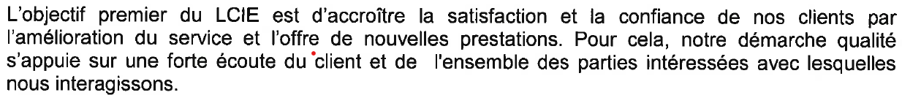

The full policy is available on the LCIE website.

<https://www.lcie.fr/317-nous-connaitre/politique-qualite.html>

### Application for certification

There is an application form on the LCIE website. This was viewed and found to be acceptable.

### Certification decision

The certification decision is made after the report has been reviewed. This decision is made by one of four decision makers (see 3.8.3) and meets the requirements of the IECEx.

### Suspension and cancellation of certificates

There is a procedure for cancellation or suspension of issued certificates.

The procedure is CERT-ATEX-12 EN and this meets the requirements of the IECEx

## Certificates issued

Number of certificates issued under for the preceding four years for each type of protection.

| Standard numbers | Type of protection or other identifying information | Number of issued certificates (for last 4 years) | | | | Total |
| --- | --- | --- | --- | --- | --- | --- |
| 2015 | 2016 | 2017 | 2018 |
| 60079-1 | Ex d | 74 | 48 | 39 | 52 | 213 |
| 60079-2 | Ex p | 3 | 2 | 1 | 0 | 6 |
| 60079-5 | Ex q | 1 | 0 | 0 | 0 | 1 |
| 60079-6 | Ex o | 2 | 1 | 12 | 0 | 15 |
| 60079-7 | Ex e | 51 | 37 | 37 | 43 | 168 |
| 60079-11 | Ex i | 54 | 49 | 48 | 31 | 182 |
| 60079-13 | Ex p | 0 | 0 | 2 | 0 | 2 |
| 60079-15 | Ex n | 41 | 14 | 11 | 10 | 76 |
| 60079-18 | Ex m | 5 | 8 | 7 | 11 | 31 |
| 60079-31 | Ex t | 78 | 67 | 36 | 65 | 246 |
| 60079-46* | Assemblies | NA | NA | NA | 0 | 0 |
| 80079-36* | Ex h | NA | NA | NA | 0 | 0 |
| 80079-37* | Ex h | NA | NA | NA | 0 | 0 |

**NOTE Above include certificates to IEC 60079-0 unless otherwise shown**

*scope extended in September 2018

## National accreditation

LCIE are accredited by Cofrac according to ISO/IEC 17065. The certificate is included as Annex C and is valid until 28 February 2025.

NOTE The national accreditation is checked annually by the IECEx Secretariat.

## Assessment of manufacturers and issue of QARs

Interview was made with one of the QAR auditors and showed that an acceptable knowledge of ISO/IEC 80079-34 was evident. Review of two QAR reports and supporting documentation showed that an effective audit had been made.

## Comments (including issues found during assessment)

Some minor issues that arose during the assessment were cleared immediately. These were mainly typographical errors.

Other procedural issues, including those related QAR procedures, were cleared subsequent to the visit to the satisfaction of the assessment team

Several iterations of the information needed to clear the issues were made but only deemed completed following the 11th June 2020 remote assessment. Given the changes made it is recommended that a surveillance visit be made after 1 year.

# ExTL for IECEx Certified Equipment Scheme

## Assessment references

### General references

1. IECEx02 IECEx Certified Equipment Scheme covering equipment for use in explosive atmospheres – Rules of Procedure
2. IECEx OD003-2 Assessment, surveillance assessment and re-assessment of ExCBs and ExTLs operating in the IECEx 02, IECEx Certified Equipment Scheme
3. IECEx OD009 Issuing of CoCs, ExTRs and QARs
4. ISO/IEC 17025:2005 Edition 2, General requirements for the competence of testing and calibration laboratories
5. IECEx Technical Capability Document (TCD)
6. ExTAG decision sheets (DSs)
7. OD 202 IECEx Certified Equipment Scheme – IECEx Proficiency Testing Program

NOTE The latest editions of the above documents were applied.

### Additional references applied for this assessment

1. OD 280 IECEx Certified Equipment Scheme – Guide to Certification of Non-electrical Equipment and Protective Systems.

## ExTL persons interviewed

|  |  |
| --- | --- |
| Name | Position |
| Kathy Millet | Unit manager (intrinsic systems) |
| Pablo Santos-Alvarez | Unit manager (non-intrinsic systems) |
| Mihai Demeter | Unit manager |

## Associated ExCB(s)

The ExCB is integral with the ExTL

## Organisation

### Names, titles and experience of the senior executives

|  |  |  |
| --- | --- | --- |
| Name | Title | Experience |
| Marie-Elisabeth D’ornano | Director of Certification | 5 years |

### Name, title and experience of the quality management representative

|  |  |  |
| --- | --- | --- |
| Name | Title | Experience |
| Marc Lescure | Quality Manager | 25+ years |

### Other employees in ExTL activity

Other employees are indicated in the TCD and also identified on the competency matrix

## Organizational structure

See Annex B

## Resources

The laboratory has a sufficient number of qualified staff and equipment to carry out the tests required.

## Scope Extension for IEC 60079-28: Ed 2

Interviews with the staff showed that they had a good understanding of the standard. A dedicated test room was viewed, and an effective demonstration of irradiance made. The equipment used was seen to be calibrated.

## Test reports issued

Number of test reports (ExTRs) issued under for the preceding four years for each type of protection.

|  |  |  |  |  |  |  |
| --- | --- | --- | --- | --- | --- | --- |
| Standard numbers | Type of protection or other identifying information | Number of issued reports (ExTRs) (for last 4 years) | | | | Total |
| 60079-1 | Ex d | 71 | 43 | 36 | 44 | 194 |
| 60079-2 | Ex p | 5 | 2 | 2 | 1 | 10 |
| 60079-5 | Ex q | 1 | 0 | 0 | 0 | 1 |
| 60079-6 | Ex o | 3 | 1 | 1 | 0 | 5 |
| 60079-7 | Ex e | 52 | 32 | 28 | 40 | 152 |
| 60079-11 | Ex i | 54 | 37 | 37 | 31 | 159 |
| 60079-13 | Ex p | 0 | 0 | 2 | 0 | 2 |
| 60079-15 | Ex n | 42 | 13 | 11 | 12 | 78 |
| 60079-18 | Ex m | 5 | 2 | 8 | 11 | 26 |
| 60079-31 | Ex t | 73 | 49 | 33 | 57 | 212 |
| 60079-46* | Assemblies | 0 | 0 | 0 | 0 | 0 |
| 80079-36* | Ex h | 0 | 0 | 0 | 0 | 0 |
| 80079-37* | Ex h | 0 | 0 | 0 | 0 | 0 |

**NOTE Above include reports to IEC 60079-0 unless otherwise shown**

*scope extended in September 2018

## National accreditation

LCIE have national accreditation from Cofrac according to ISO/IEC 17025. The 2005 version was current at the time of the visit. Transition to the 2017 version has now been made and the certification is valid until 3110 2022.

As LCIE accreditation from Cofrac does not at this time list IEC 60079-28 they will therefore be subject to Annual Surveillance.

The certificate is included as Annex D.

## Calibration

Equipment is either sent to an accredited test/verification laboratory or calibrated in house. View of several certificates showed that this was being carried out in an acceptable manner. The calibration database is interrogated monthly to identify equipment where the validity is soon to expire.

## Tests witnessed during the assessment visit

The following tests were witnessed during the assessment visit

| Standard and edition | Clause number | Test | Comments |
| --- | --- | --- | --- |
| IEC 60079-1: Ed 7 | 15.2.2 | Flameproof pressure determination | OK |
| IEC 60079-11: Ed 6 | 10.1 | Use of spark test apparatus | OK |
| IEC 60079-11: Ed 6 | 10.5 | temperature rise test on battery for is | OK |
| IEC 60079-0: Ed 6 | 26.13 | Electrostatic measure, surface resistance | OK |
| IEC 60079-28: Ed 2 | 5.2.2.3 | Ex op is measurement of Optical irradiance | OK |
| IEC 60079-2: Ed 6 | 16.3.1 and 16.5.2.1 | Ex p leakage and purging using PTB artefact | OK |
| IEC 60079-0: Ed 6 | 26.5.1.1 | Temperature rise test | OK |
| ISO 80079-36:Ed 1 | Annex D | Transferred charge | OK |

## Participation in IECEx Proficiency Testing Programs

Program: PTB Ex PT Scheme

|  |  |  |
| --- | --- | --- |
| IECEx Proficiency Testing program | Program years | Other comments, including whether results are considered satisfactory |
| Program 3 "Flame Transmission" | 2013-2014 | Satisfactory |
| Program 5 "Electrostatic Charge" | 2015-2016 | satisfactory |
| Program 7 "Explosion Pressure" | 2017-2018 | Satisfactory |
| Program 8 "Pressurized Enclosure" | 2017-2018 | Satisfactory |
| Program "Tests of Enclosures" | 2019-2020 | Satisfactory |
| Program "Battery Testing" | 2019-2020 | Satisfactory |

## Comments (including issues found during assessment)

Issues were found regarding selection of items for test, some test procedures and acceptance of manufacturer’s results.

Several iterations of the information needed to clear the issues were made but only completed on 20 September 2019.   As a result, a follow up assessment was conducted on 11 June 2020 conducted remotely according to IECEx OD 060, which enabled closure of open items. It is recommended that a surveillance visit be made after 1 year to confirm that the issues and the means of clearing them are in fact working.

# IECEx Conformity Mark Licensing System

## Assessment references

1. IECEx04 IECEx Certified Equipment Scheme covering equipment for use in explosive atmospheres – IECEx Conformity Mark Licensing System – Regulations
2. IECEx04A IECEx Certified Equipment Scheme covering equipment for use in explosive atmospheres – Guidance for making applications for and use of IECEx Conformity Mark
3. OD022 IECEx Certified Equipment Scheme covering equipment for use in explosive atmospheres – Rules and Procedures for the granting of Licenses to issue and use the IECEx Conformity Mark
4. OD023 IECEx Certified Equipment Scheme covering equipment for use in explosive atmospheres – Terms and Conditions for use of the IECEx Conformity Mark

NOTE The latest editions of the above documents were applied

## Comments (including issues found during assessment)

LCIE have a process for IECEx Conformity Mark License that is in compliance with the IECEx System requirements.  LCIE have three active clients for their mark license. The details are reviewed annually and records were sighted.

There were no issues found for the Conformity Mark License System IECEx 04.

1. Overall Organisation Chart

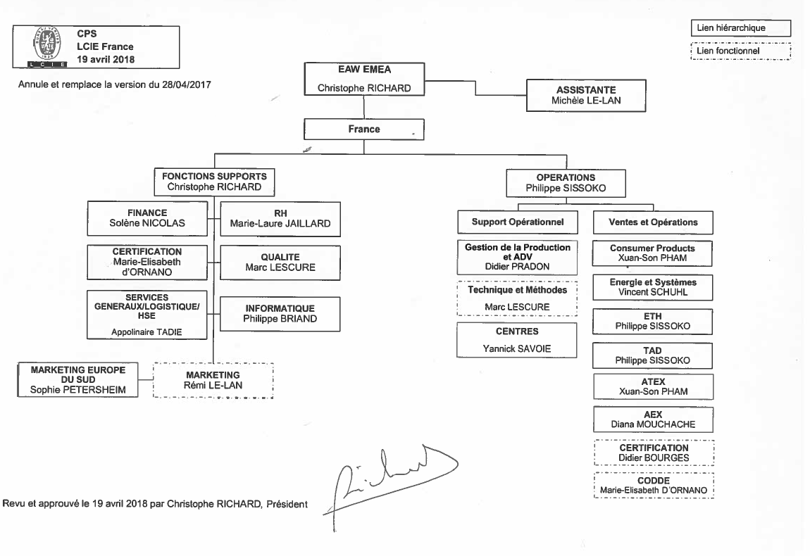

1. Organisation Chart of ExCB and ExTL

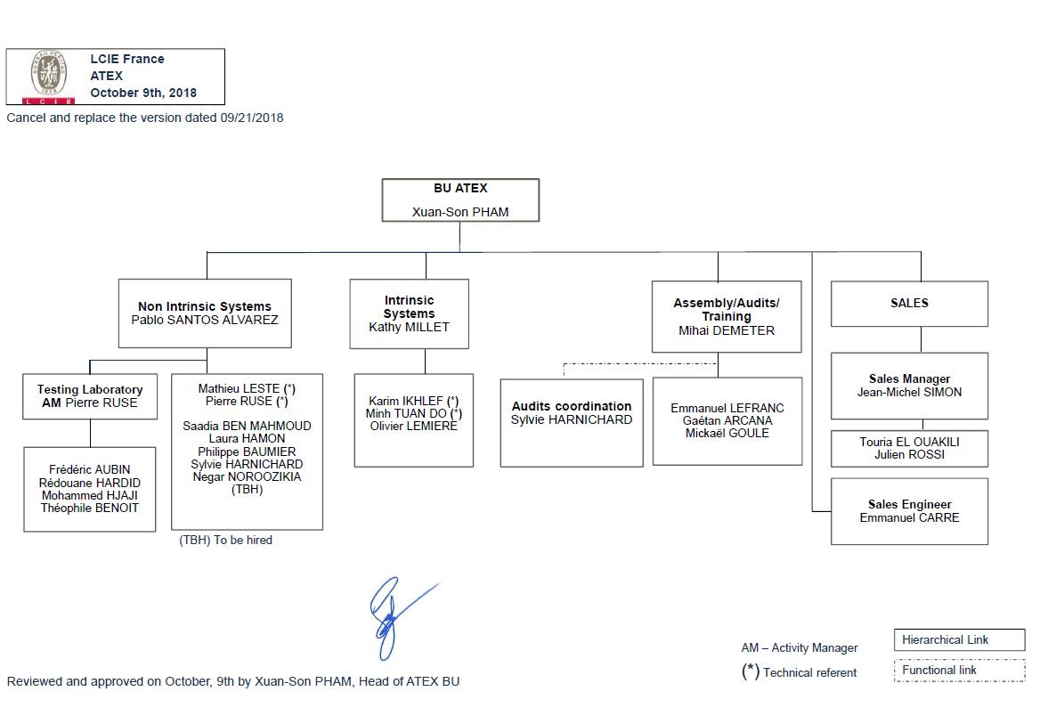

1. Accreditation Certificate for ISO/IEC 17065

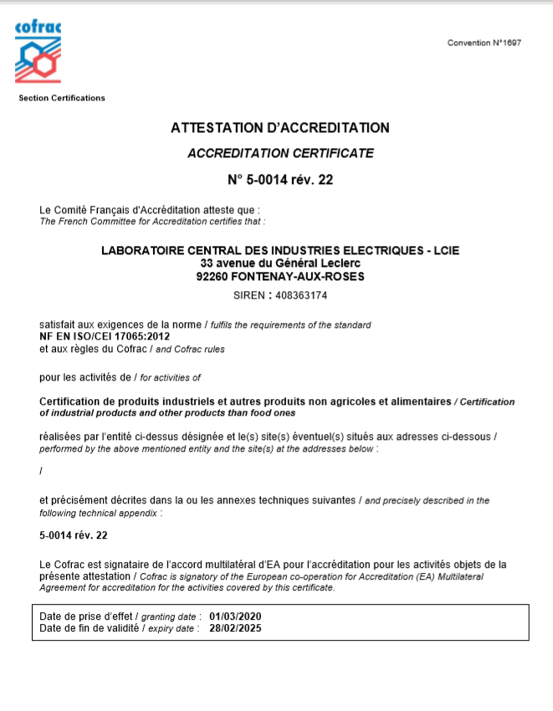

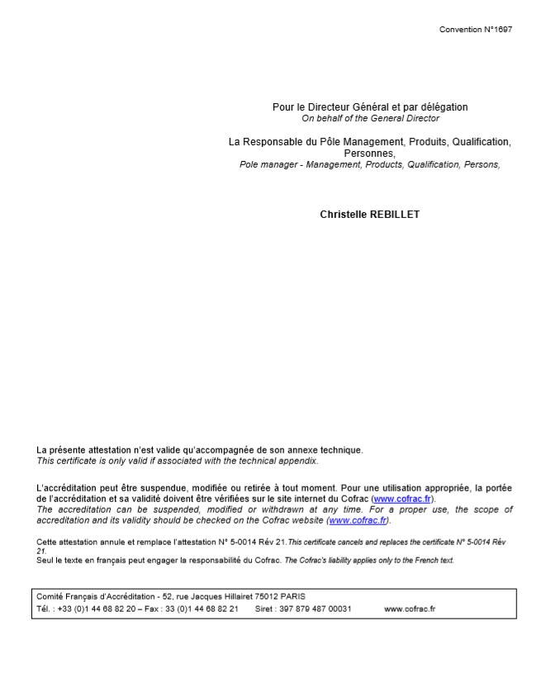

1. Accreditation Certificate for ISO/IEC 17025

