INTERNATIONAL ELECTROTECHNICAL COMMISSION (IEC) SYSTEM
FOR CERTIFICATION TO STANDARDS RELATING TO EQUIPMENT FOR USE
IN EXPLOSIVE ATMOSPHERES (IECEx SYSTEM)

Title: Report from Tim Krause, Convenor ExTAG WG 10, Proficiency Testing
Circulated to: Ex Testing and Assessment Group (ExTAG)

INTRODUCTION

This document, ExTAG/611/R is a report prepared by Tim Krause the Convenor of ExTAG WG10, Proficiency Testing. The report will be presented by Mr. Tim Krause during the ExTAG 2020 IECEx Annual Meetings (to be held remotely) for discussion and consideration.

IECEx Secretariat

Visiting address:  IECEx Secretariat  Level 33, Australia Square  264 George Street  Sydney NSW 2000  Australia | Contact Details:  Tel: +61 2 4628 4690  Fax: +61 2 4627 5285  E-mail: info@iecex.com  http://www.iecex.com

Report by the convenor of ExTAG WG 10 “Proficiency Testing”, Tim Krause, for the Annual ExTAG Meetings 2020 (to be held remotely).

- News about the IECEx/PTB Ex PT Scheme

The first phase (Phase I) of the current programs/test rounds of cycle 2019/2020 “Tests of Enclosures – Test Round 2019” (TE2019) and “Battery Testing – Test Round 2019” (BT2019) is completed and the interim reports have been published. The second phase (Phase II; “improvement loop”) is currently running and will end with the final reports in October 2020. The cycle 2019/2020 ends at the end of the year 2020. There have been ten program test rounds completed to date, with the latest test round ending 2020:

- Explosion Pressure – Test Round 2010
- Spark Ignition – Test Round 2010
- Flame Transmission – Test Round 2013
- Temperature Classification – Test Round 2013
- Electrostatic Charge – Test Round 2015
- Intrinsic Safety – Test Round 2015
- Explosion Pressure – Test Round 2017
- Pressurized Enclosure – Test Round 2017
- Tests of Enclosures – Test Round 2019
- Battery Testing – Test Round 2019

- Status of the current programs 2019/2020 “Tests of Enclosures” (TE2019) and “Battery Testing” (BT2019)

Description of program “TE2019”: For the program “Tests of Enclosures (“TE”) - Test Round 2019” the general routine procedure is described by the standard “Explosive atmospheres - Part 0: Equipment – General requirements” - IEC 60079-0, Edition 7.0 and “Degrees of protection provided by enclosures (IP Code)” - IEC 60529, Edition 2.2.

Enclosures used in the field of explosion protection must meet certain criteria and be subjected to certain tests. These tests are defined in the standards mentioned above. Essential characteristics for testing and assessing explosion protection are tests on enclosures for resistance to impact and for protection of the equipment inside the enclosure against ingress of solid foreign objects (dust) and water. Therefore, compliance with the degree of protection (IP) has been selected as the characteristic of interest which is to be compared in the program “Tests of Enclosures - Test Round 2019”. Next to this characteristic of interest, other aspects like “how to perform the thermal endurance test” and the comparison of test conditions during the performance of tests will be analyzed. Due to the better practicability of the program, a selection of enclosure tests is carried out which are partly shortened or modified compared to the require-ments of the standards.

The workload to perform this program is approximately 3 working days (separated by additional waiting periods due to thermal endurance tests and IP testing).
Status of program “TE2019”: A total of 90 Ex laboratories are registered for the program. 78 out of 80 IECEx laboratories are registered. The non-registration of the 2 remaining IECEx laboratories has been agreed with the IECEx secretariat (not part of the scope of the IECEx laboratory) or is currently being followed up. 74 out of 78 registered IECEx laboratories have uploaded results in Phase I and are included in the interim report.
The schedule was slightly delayed until the end of Phase I due to the situation around COVID-19. Meanwhile, the schedule is back on time. Phase I of the program is completed and the interim report was published in June 2020. The corresponding PT workshop planned for May 2020 was postponed to January 2021 due to the COVID-19 situation. Currently, Phase II of the program runs, the schedule of the program is on time. The deadline for repeating the tests and uploading the results of Phase II is the 30th of September 2020. The final report will be published in October 2020. Publishing the final report is also the completion of program “Tests of Enclosures - Test Round 2019”.

Description of program “BT2019”: For the program “Battery Testing (“BT”) - Test Round 2019” the general routine procedure is described by the standard “Explosive atmospheres - Part 11: Equipment protection by intrinsic safety “I”” - IEC 60079-11 Edition 6.

The constantly advancing digitalization and networking of processes and applications in the field of explosion protection is leading to new challenges regarding mobility. As a result, the number of batteries and cells that supply energy for mobile devices is also rising significantly. These batteries and cells are often used in devices of the type of protection “intrinsic safety” and must be tested in accordance with the standard mentioned above. Essential characteristics for testing and assessing explosion protection are the maximum surface temperature and the internal resistance of batteries and cells. Therefore, the maximum surface temperature and the internal resistance have been selected as the measurands/characteristics of interest which are to be compared in the program “Battery Testing - Test Round 2019”.

The test sample is a long-lasting primary cell with type IEC LR6. Based on the one-way test for each battery, 13 samples for each phase (a total of 26 samples for Phase I and Phase II) are provided by the coordinator at the beginning of the program. To ensure comparability and homogeneity, a sufficient number of samples is tested by the coordinator regarding statistical requirements to estimate the characteristics of the whole population.

Time required for the performance of the program is approximately 3 working days.

Status of program “BT2019”: A total of 81 Ex laboratories have registered for the program. 74 out of 80 IECEx laboratories are registered. The non-registration of the 6 remaining IECEx laboratories has been agreed with the IECEx secretariat (not part of the scope of the IECEx laboratory) or is currently being followed up. 69 out of 74 registered IECEx laboratories have uploaded results in Phase I and are included in the interim report.
The schedule was slightly delayed until the end of Phase I due to the situation around COVID-19. Meanwhile, the schedule is back on time. Phase I of the program is completed and the interim report was published in May 2020. The corresponding PT workshop planned for May 2020 was postponed to January 2021 due to the COVID-19 situation. Currently, Phase II of the program runs, the schedule of the program is on time. The deadline for repeating the tests and uploading the results of Phase II is the 30th of September 2020. The final report will be published in October 2020. Publishing the final report is also the completion of program “Battery Testing - Test Round 2019”.
- Results of the current IECEx/PTB Ex PT Programs “TE2019” and “BT2019”
A small excerpt of the results (from the interim report) of program “TE2019” is shown in Figure 1:
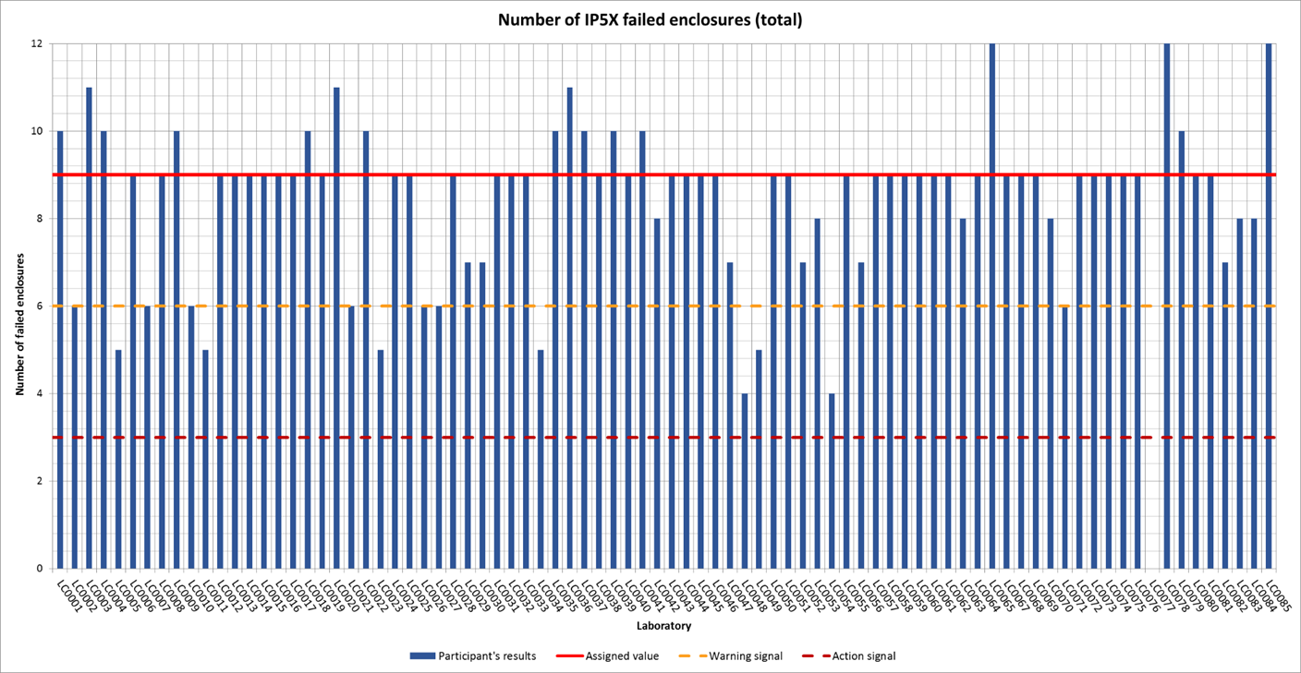
Figure 1: Participant's results with warning and action limits for IP Test in accordance to chapter 13/14 of IEC 60529, Edition 2.2 - Protection against dust (IP 5X)
It can be seen that 84 participants (LC0066 has delivered no results for IPX5 test) have performed the IPX5 test. 7 participants got a result x in the range 6 > x ≥ 3 which is considered to give a warning signal. One participant got a result x in the range 3 > x ≥ 0 which is considered to be unacceptable (or action signal). The laboratories with warning signals and action signals can use Phase II to repeat the tests and to improve the results.
A small excerpt of the results (from the interim report) of program “BT2019” is shown in Figure 2:
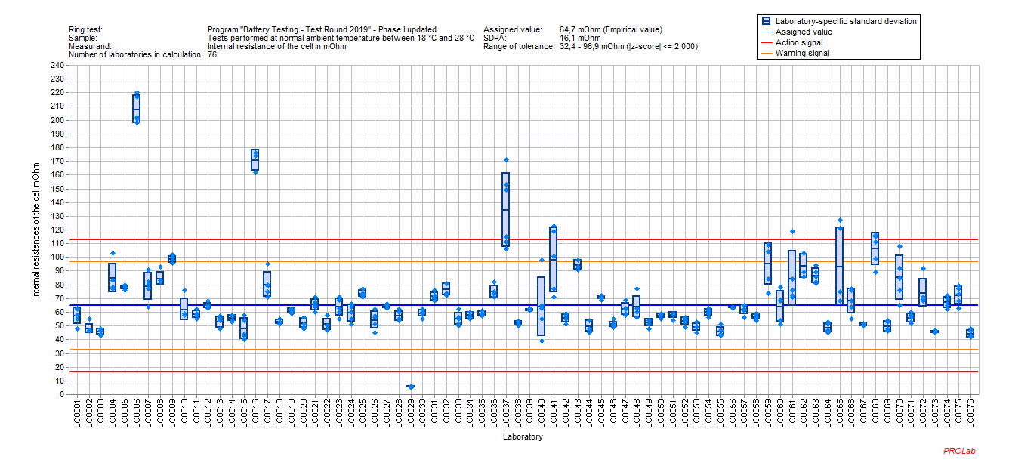Figure 2: Participant's results for internal resistances of cells with warning and action limits for the short-circuit measurement at normal ambient temperature
It can be seen that 76 participants have performed the determination of internal resistances. 3 participants got results outside the two times standard deviation of the assigned value (z – score) which shall be considered to give a “warning signal”. 4 participants got results outside the three times standard deviation of the assigned value (z – score) which shall be considered to give an “action signal”. The laboratories with warning signals and action signals can use Phase II to repeat the tests and to improve the results.
- PTB Ex PT Workshops 2020

The two planned PTB Ex PT Workshops in China at NEPSI (from May 13 to May 14, 2020) and in Germany at PTB (from May 25 to May 28, 2020) had to be postponed due to the situation around COVID-19. The postponement dates are as follows:

- Shortened PTB Ex PT Workshops 2020 in China at NEPSI: Wednesday, 11th of November 2020 to Thursday, 12th of November 2020

- PTB Ex PT Workshops 2020/2021 in Germany at PTB: Monday, 25th of January 2021 to Thursday, 28th of January 2021

The structure of the workshops consists, as usual, of a theory part and a practice part for each program.

A possible cancellation, further postponement or reorganization of the workshops to a web conference due to the ongoing difficulties around COVID-19 are discussed and will be communicated as soon as possible.

- New PT programs of the IECEx/PTB Ex PTS for the cycle 2021/2022

Suggestions for programs may be made by the IECEx PTS Provider based on questionnaires circulated under the participating laboratories, by proposals of the ExTAG WG 10 “Proficiency Testing” or by other experts. The IECEx PTS Provider will then take a decision on the programs to provide, taking those suggestions and any recommendations by ExTAG into account. At present, a survey is being conducted on proposed topics for new programs.

- Any other business

Agenda of the next ExTAG WG10 meeting

Date and time: To be determined
Venue: Remote meeting
Number of participants: About 10 people

1. News about the IECEx/PTB Ex PT Scheme
2. Status of the current programs 2019/2020 “Tests of Enclosures” (TE2019) and “Battery Testing” (BT2019)
3. Results of the current IECEX/PTB Ex PT Programs “TE2019” and “BT2019”
4. PTB Ex PT Workshops 2020
5. New PT programs of the IECEx/PTB Ex PTS for the cycle 2021/2022
6. Any other business

