INTERNATIONAL ELECTROTECHNICAL COMMISSION SCHEME
FOR CERTIFICATION TO STANDARDS RELATING TO EQUIPMENT FOR
USE IN EXPLOSIVE ATMOSPHERES (IECEx SCHEME)

Title: DRAFT: IECEx Guide – Guidance for making Applications for and Use of IECEx Conformity Mark

Circulated to: Members of the IECEx Conformity Mark Committee, ExMarkCo

INTRODUCTION

This Draft IECEx Guide has been prepared by the IECEx Secretariat to assist Applicant Manufacturers seeking to apply for an IECEx Conformity Mark License, under the IECEx Conformity Mark Licensing System, IECEx 04. This document outlines the application process with explanations of the various stages and references to the various IECEx Operational Documents and Internet website. This document also provides guidance for conditions of use and application of the IECEx Conformity Mark.

This Draft Guide is issued for consideration by ExMarkCo members at the 12 March 2008 meeting.

Address:  IECEx Secretariat  SAI Global Building  286 Sussex Street  Sydney NSW 2000  Australia | Contact Details:  Tel: +61 2 8206 6940  Fax: +61 2 8206 6272  e-mail: chris.agius@iecex.com  http://www.iecex.com

INTERNATIONAL ELECTROTECHNICAL COMMISSION SCHEME
FOR CERTIFICATION TO STANDARDS RELATING TO EQUIPMENT FOR
USE IN EXPLOSIVE ATMOSPHERES (IECEx SCHEME)

DRAFT: IECEx Guide – Guidance for making Applications for and the Use of IECEx Conformity Mark

INTRODUCTION

The IECEx Scheme is the Scheme of the IEC for Conformity Assessment to Standards relating to Equipment for Use in Explosive Atmospheres, as provided for in accordance with Article 2 of the IEC Statutes and Rules, 2001 edition, (incorporating amendments approved by Council in 2004 and 2005).
The IECEx facilitates the operation of certification programs in strict accordance with the IECEx Scheme Basic Rules, IECEx 01, as approved by the IEC Conformity Assessment Board (CAB). The IECEx, through the IECEx Management Committee (ExMC) approves the appointment of Certification Bodies that may operate in the IECEx Scheme. These Certification Bodies are known as ExCBs and take the sole decision when issuing Certificates of Conformity under the IECEx Certified Equipment Program (IECEx 02 Scheme).

The objective of the IECEx Scheme is to facilitate international trade in equipment intended for use in explosive atmospheres (referred to as Ex equipment) and services related to that industry. It is a voluntary certification scheme intended to facilitate global trade by;
- Reducing testing and certification costs to manufacturer
- Reducing barriers to entry in to established and emerging market places
- Reduced time to market
- International confidence in the assessment process of Ex products and services
- One international database listing of all issued reports, certificates and licences.
The final objective of the IECEx Scheme is world-wide acceptance of one standard, one certificate and one mark.
While the IECEx Certificates of Conformity, issued by ExCBs, provide evidence of conformity, there is a need to display such conformance through the use of an “IECEx Conformity Mark”.
The use of Marks on products and packaging and other material, to demonstrate conformity is widespread. The IECEx Conformity Mark is a single Global Mark that is intended to negate the need for separate individual Marks being used. The growing industry support and use of the IECEx Scheme has fuelled the demand for an International Mark in this field.
The Ex Mark provides greater assurance and ultimately enhanced confidence for governments, safety regulators, and industry that the equipment being operated, repaired or supplied for use in explosive atmospheres meets the worlds most respected and vigorous safety standards as established by the IEC.

This document provides guidance for applicants of IECEx Conformity Mark Licenses (e.g. manufactures), as well as guidance on the use of the Marks on products and packaging and other material. It shows the steps and processes required for manufacturers to gain and use an IECEx Conformity Mark License.
Note: The details of the rules and process are given in other IECEx documents available from the IECEx Internet website or the IECEx Secretariat via the IEC Central Office, www.iecex.com. These will be referred to in the text.

Document History

Date | Summary
2008 XX | Original Issue (Version 1)

Address:  IECEx Secretariat  286 Sussex Street  Sydney NSW 2000  Australia | Tel: +61 2 8206 6940  Fax: +61 2 8206 6272  Email: chris.agius@iecex.com  Internet: www.iecex.com

Overview
This guide has been prepared to assist manufacturers understand that while technically rigorous, the process of achieving an IECEx Conformity Mark License is rather straightforward.
Gaining an IECEx Conformity Mark License and Using the Mark on products and packaging and other material demonstrates to users and consumers that:
- Product compliance with the requirements of the relevant IEC Standard(s) without any national differences and/or Essential Differences in Requirements (EDRs), and with other IECEx recognized normative documents, approved by the IECEx Management Committee; and
- The manufacturer is operating a dedicated quality management system, meeting the specific IECEx requirements; and
- The manufacturer is under on-going surveillance by an Internationally assessed and recognised IECEx Certification Body
As proof of this achievement the International IECEx Conformity Mark Licensing Schedule is on FULL public display via the IECEx Official Internet Website.

How does the application process work?
Applicant applies to a Conformity Mark Licensing System authorised ExCB
Refer to HYPERLINK "http://www.iecex.com" www.iecex.com under “Information > ExCBs”
ExCB assesses the applicant to ensure control of the usage of the Mark in accordance with IECEx 04, OD022 & OD023

Application successful
-
Licence issued
by the ExCB

Who do you apply to?
Applications for an IECEx Conformity Mark License, under the IECEx Conformity Mark Licensing System, are lodged directly with IECEx Certification Bodies (ExCBs) whom themselves have successfully undertaken the IECEx Peer Assessment Program for acceptance into the IECEx System.
A full and up to date listing of ExCBs approved to operate under the IECEx Scheme is maintained on the IECEx website (www.iecex.com).
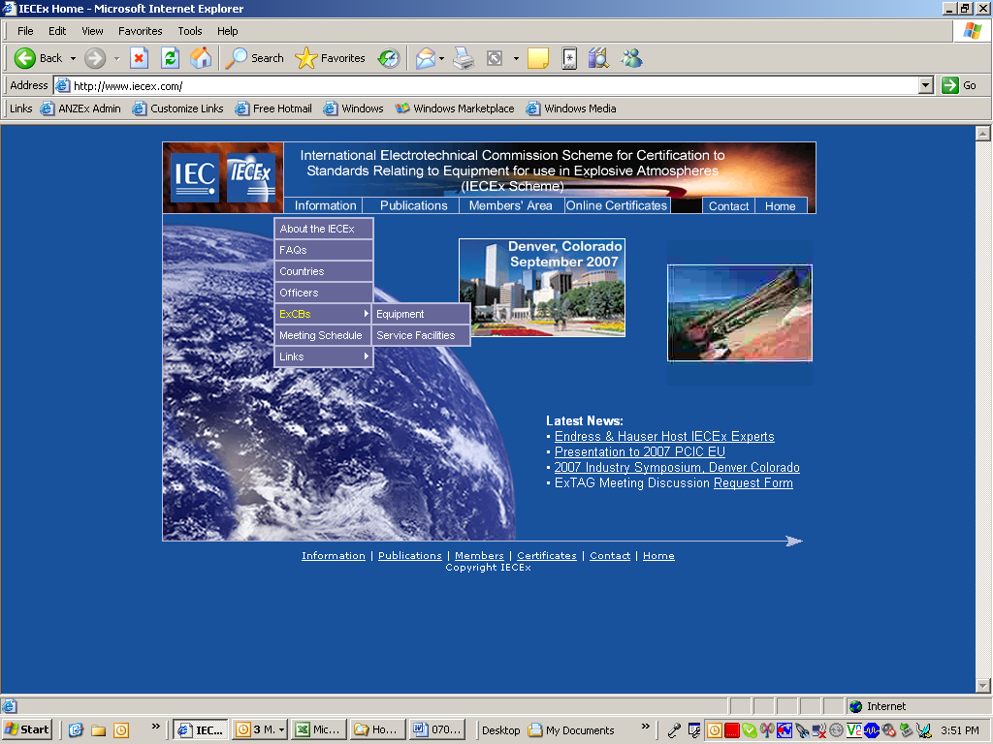
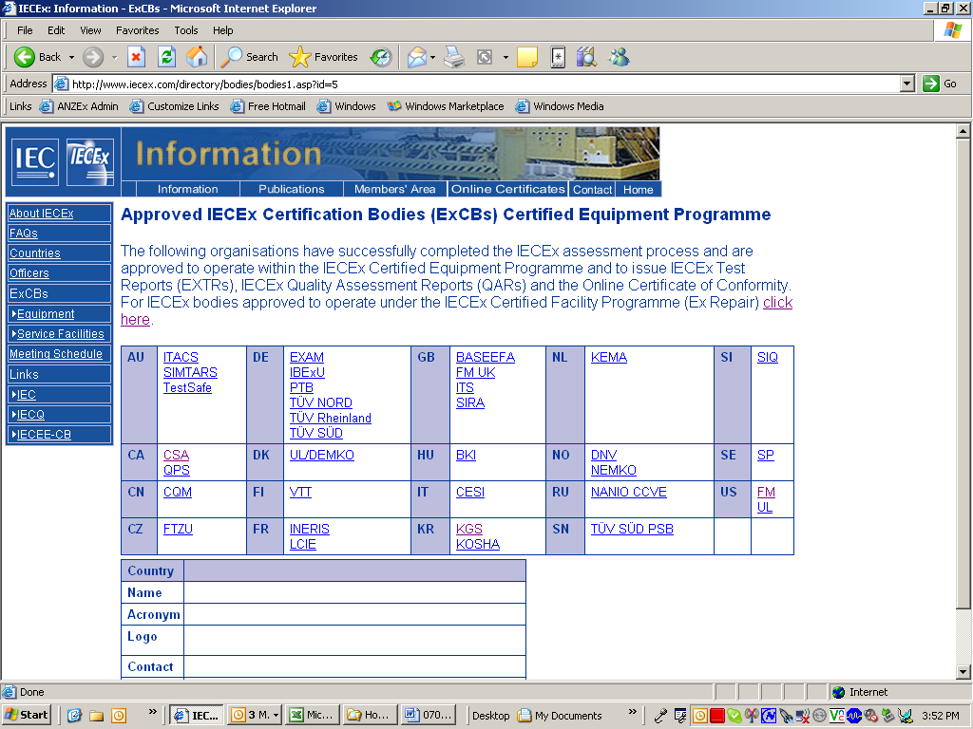

Where do I find the Rules and Procedures for the Licensing System?
The IECEx Conformity Mark Licensing System – Regulations document IECEx 04 & operational documents OD022 & OD023; can be found on the IECEx website (www.iecex.com).
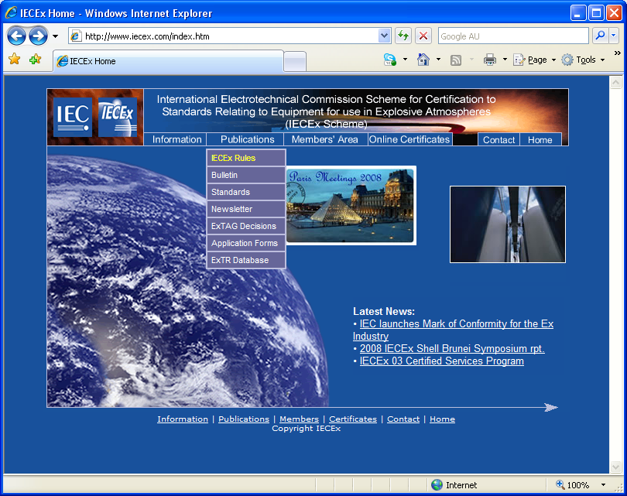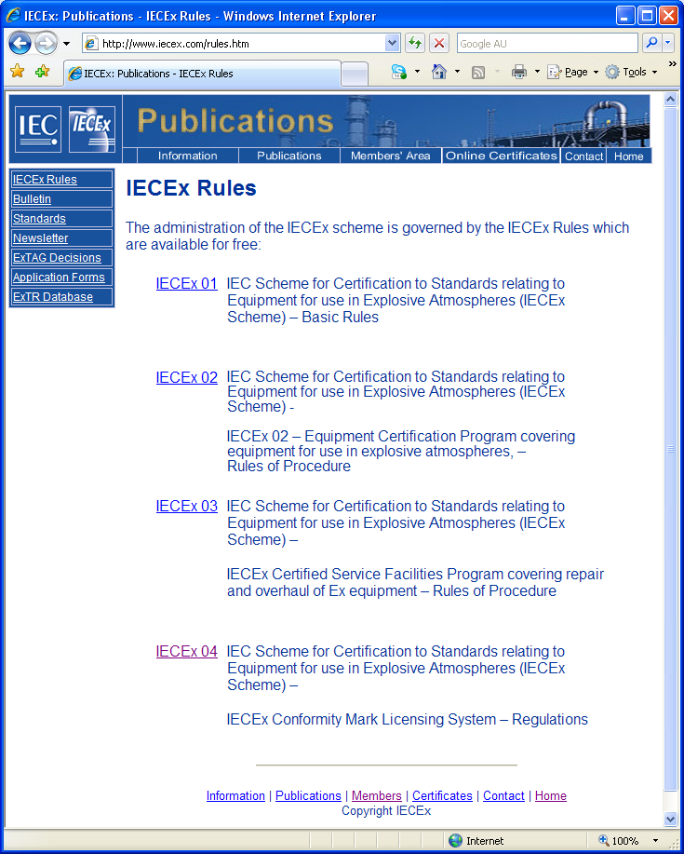

Making an application
The application for IECEx Conformity Mark License begins with contacting the ExCB, as required by the IECEx Rules, IECEx 04. A special form may not be necessary, but the following information will generally be required by the ExCB.
- Letter formally requesting an IECEx Conformity Mark License.
- Exact details of the nominated products (including valid IECEx Certificate of Conformity Numbers) to be covered by the License
- Exact details on how each nominated product is to be marked with the Mark; including documentation, packaging and promotional material as well as usage in catalogues and on websites
- Demonstration that the manufacturer’s quality management system details how they protect the use of the IECEx Mark, such as:
  - A policy that the IECEx Mark shall only be used and associated with Ex products covered by an IECEx Certificate of Conformity, listed on the IECEx Mark License Schedule and in accordance with IECEx rules and operational documents (e.g. IECEx 04, OD022 & OD023)
  - Defined procedures for the design and release of promotional material, including website to ensure the above policy is maintained and which position in the organisation shall have this responsibility and authority
- The manufacture shall ensure that all requirements of the IECEx Conformity Mark Licensing System Rules and Procedures have been met.
The ExCB will estimate the time and cost to complete the License application.

IECEx Conformity Mark

Master symbol for photographic reproduction
The Mark includes the IEC logo and an Identification Code to identify both the License Number and the Certification Body which has granted the License to use the Mark
The IECEx Conformity Mark reproduced below may be used for photographic reproduction
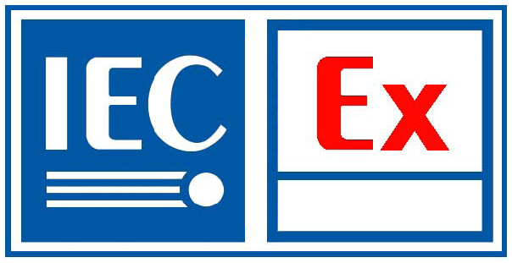 Area for Identification Code issued by the ExCB to Licensee
NOTE The pictogram shown above is for illustrative purposes only.

Proportional dimensions of the symbol
All reproductions of the IECEx Conformity Mark shall comply with the dimensional and colour proportions as determined by the IECEx Management Committee and specified by the ExCB issuing the IECEx Conformity Mark License.

Available electronic formats
The Mark is available in a verity of different electronic file formats including but not limited to *.dwg, *.dxf, *.ps, and *.jpg, these are available from the IECEx Conformity Mark License issuing ExCBs.

Use of the Mark
The Mark shall only be placed on such products, or their documentation, packaging and promotional material, which are covered by a valid IECEx Certificate of Conformity, as listed on the issued IECEx Conformity Mark License Schedule.
The Mark shall remain traceable at all times; the Identification Code shall appear with the IECEx Conformity Mark, wherever it is used.
The Mark shall not be used for any purpose other than to indicate that all the requirements of the Mark Licensing System are being met.

Use: - Product marking:
- The Mark shall in principle be placed on the product itself in close proximity to the IECEx certification marking or on a label directly affixed to the product. If this is not practical, the Mark may be placed on the product packaging, a label attached to the product, the Instructions for use or other accompanying documentation refer 2.4.2.
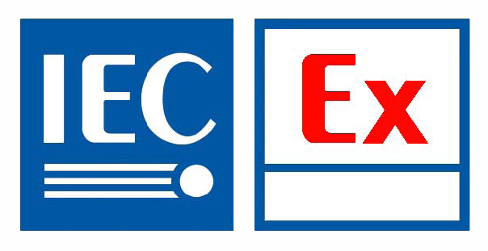
- The Mark may be of the following form:
NOTE The pictograms shown above are for illustrative purposes only.
- The Mark may be enlarged or reduced arbitrarily in the same form and ratio, provided that the letters and identification code remain well legible, however, not smaller than 8 x 15 mm.
- It is not authorised to modify the colour of the Mark. Use of black and white (or an appropriate contrasting colour) is permitted, Example Figure 1.
Note Use of an appropriate contrasting colour shall only be upon agreement by the ExCB issuing the IECEx Conformity Mark License. In all cases the Mark shall remain well legible.
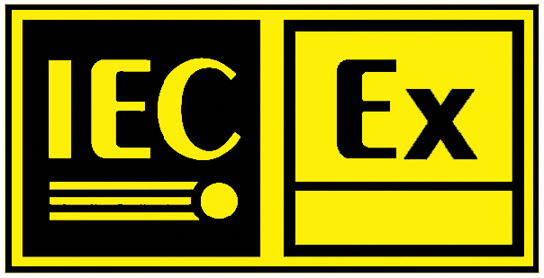 NOTE The pictogram shown above is for illustrative purposes only.
Figure 1 – Example of a contrasting colour being used.

Use: - Documentation, Packaging and Promotional Material:
- The Mark may be affixed to the product packaging, or used in Instructions for use, or other accompanying documentation.
- The Mark may only be used in advertising where there is a clear association with the products covered under the Mark License as issued by an ExCB approved by the IEC to issue a Mark License.
- The Mark may only be used in catalogues and on websites where there is a clear association with the products covered under the Mark License as issued by an ExCB approved by the IEC to issue a Mark License.
- The Mark may be of the following form:
NOTE The pictograms shown above are for illustrative purposes only.
- The Mark may be enlarged or reduced arbitrarily in the same form and ratio, provided that the letters and identification code remain well legible, however, not smaller than 10 x 20 mm.
- It is not authorised to modify the colour of the Mark. Use of black and white is permitted.

Use: - IECEx Certified Services Program: Product marking i.e. Documentation, Reports
- The Mark may only be used on printed matter such as letter/report headings and envelopes, or published otherwise, where there is a clear direct association with the Service(s) (scope) covered under the IECEx Certified Services Program Certificate of Conformity as issued by an ExCB, in all circumstances.
- It is not authorised to affix the Mark on repaired or overhauled products (equipment) or to make use of the Mark in advertisements for products or services.
- The Mark may be of the following form:
NOTE The pictograms shown above are for illustrative purposes only.
- The Mark may be enlarged or reduced arbitrarily in the same form and ratio, provided that the letters and identification code remain well legible, however, not smaller than 10 x 20 mm.
- It is not authorised to modify the colour of the Mark. Use of black and white is permitted.

What will my IECEx Conformity Mark License look like?
NOTE The pictograms shown above are for illustrative purposes only, the format may change without notice.

How will the IECEx Conformity Mark License be available?
The IECEx Conformity Mark License will be available live on the “Online Certificates” database. www.iecex.com
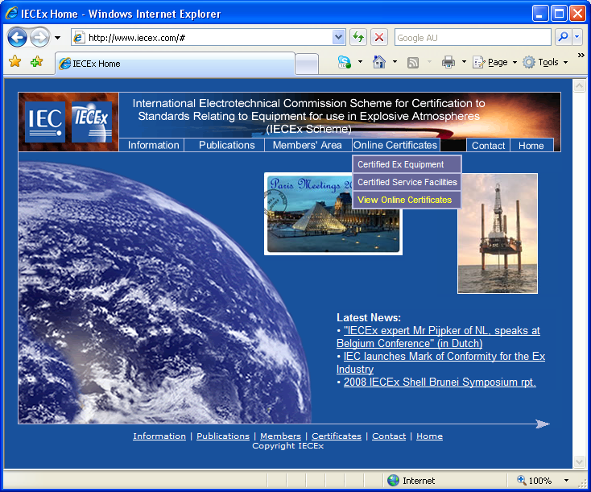
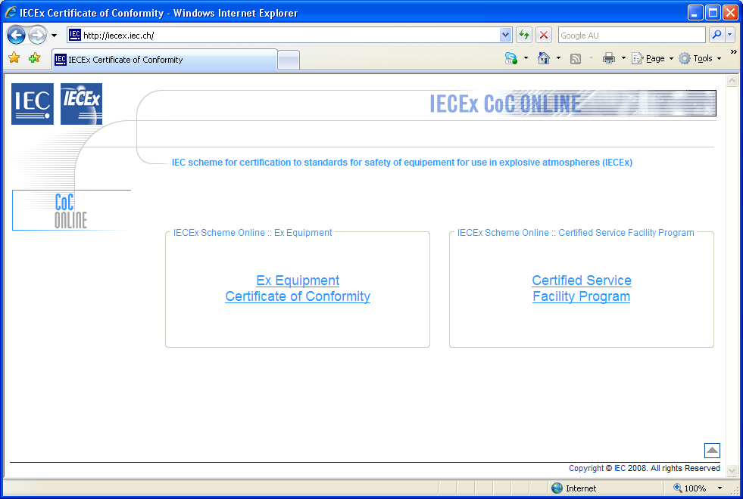

Frequently Asked Questions
“Is the IECEx scheme mandatory?”
No, it is a voluntary scheme, but the end results are such that manufactures with the capabilities of international trade should seriously consider the advantages of such a scheme.
“Is the IECEx Conformity Mark mandatory?”
No, it is a voluntary marking system.
“Can we mark our entire Ex product range we manufacture?”
Yes, provided that each and every product is covered by a valid IECEx Certificate of Conformity and these IECEx CoCs are listed on the IECEx Conformity Mark License Schedule.
“Is it allowable to place the Mark on our catalogue? (e.g. at the top of page of products listed)”
Yes, provided that each product in the list is covered by a valid IECEx Certificate of Conformity and listed on the IECEx Conformity Mark License Schedule.
However if the list contains products which are either
- not covered by a valid IECEx Certificate of Conformity, or
- have not been nominated and therefore covered by an IECEx Conformity Mark License Schedule
then the Mark shall be used in a way that does not associate the Mark with such products.

“Is it possible to use the Mark on our name plates (certificate marking plates)?”
Yes, providing that the manufacture holds a valid IECEx Certificate of Conformity (CoC) for the product, and that the Manufacturer holds an IECEx Conformity Mark License, with that CoC listed in the Mark License Schedule.
“Are there any rules as to where the Mark must be applied?
No, the Mark is a voluntary marking system. There is guidance as to where the Mark may be placed, however all details of the use and placement of the Mark must be approved by the ExCB issuing the IECEx Confomity Mark License.
“Is the IEC now a certifier? I.e. like other third-party notify bodies PTB, TUV, CESI, SIRA etc.”
No! IEC is not a certifier but owns the Mark whom it allows Approved Certification bodies such as those listed on the IECEx website the right to issue the Mark Licenses to manufactures meeting the IECEx requirements.
“As an IECEx Certified Service Facility can we use the IECEX Mark on motors we repair in accordance with our scope?”
No, The IECEx Mark can only be used on Ex equipment covered by an IECEx Certificate of Conformity (CoC) that is New not repaired, otherwise there is confusion, does the Mark apply because the motor as newly built or as a repaired item.

Marks Committee ACTION!!
Items for future action and consideration

OD022/V1 – currently states in clause 2.1 ExCB Requirements - b)
“The ExCB may only accept an application from a holder of an IECEx Certificate of Conformity (CoC) issued, in accordance with the IECEx Rules of Procedures IECEx 02, the agreement with IEC and where the IECEx CoC has been issued by the ExCB;”

- This clause currently can be interpreted that only the same ExCB who has issued the IECEx CoC can accept an application from an applicant. Clarification or rewording is required.
- This clause also currently restricts the use of the Mark to the IECEx Certified Equipment Program. Addition of IECEx Rules of Procedures IECEx 03 is required.

OD023/V1 – currently states in “Introduction” second para
“It is a requirement of IECEx 04 and OD 022 that a holder of an IECEx Conformity Mark Licence must hold a valid IECEx Certificate of Conformity, issued and maintained in accordance with IECEx 02.”
- This clause also seems to restricts the use of the Mark to the IECEx Certified Equipment Program. Addition of IECEx Rules of Procedures IECEx 03 is required.

