**INTERNATIONAL ELECTROTECHNICAL COMMISSION SYSTEM FOR CERTIFICATION TO STANDARDS RELATING TO EQUIPMENT FOR USE IN EXPLOSIVE ATMOSPHERES (IECEx SYSTEM)**

### Title: Report from Dr Martin Thedens, Chair of the IEC Technical Committee 31- EQUIPMENT FOR EXPLOSIVE ATMOSPHERES

To: Members of the IECEx Management Committee, ExMC

**INTRODUCTION**

This document contains a report from the IEC Technical Committee 31- EQUIPMENT FOR EXPLOSIVE ATMOSPHERES Chair, Dr Martin Thedens, to the 2020 ExMC meeting.

***Chris Agius***

**Chris Agius**

**IECEx Secretariat**

|  |  |
| --- | --- |
| **ADDRESS:**  IECEx Secretariat  Standards Australia Building  286 Sussex Street  Sydney NSW 2000, Australia | **CONTACT DETAILS:**  Tel: +61 2 8206 6940  Fax: +61 2 8206 6272  e-mail: chris.agius@iecex.com  *http://www.iecex.com* |

**INTERNATIONAL ELECTROTECHNICAL COMMISSION**

**TECHNICAL COMMITTEE 31: EQUIPMENT FOR EXPLOSIVE ATMOSPHERES**

**Report from IEC TC 31 to IECEx ExMC Meeting 2020**

**Introduction**

This report covers the activities of IEC TC 31 since the last meeting of IECEx ExMC in September 2019.

**Activities during the past year**

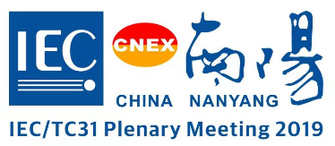The plenary meeting of TC 31 was held on the 31st of October and 1st of November 2019 in Nanyang, PR of China. There were over 50 delegates representing 18 countries attending the meeting. Other meetings of TC 31 and its subcommittees were held in Nanyang immediately prior to the plenary. The report of the plenary meeting was circulated as 31/1514/RM.

Some outcomes of the plenary meeting were:

* TC 31 supports the request of WG 22 to publish a Corrigendum for Ed.7 of IEC 60079-0 to reintroduce a lost paragraph in Cl. 26.5.1.1 addressing the correction of temperature measurements to the maximum rated ambient temperature which was inadvertently removed from Editions 6 and 7.  
  🡺 *IEC 60079-0:2017/COR1:2020 published in January 2020.*
* TC 31 supports the draft ISH for Ed. 7 IEC 60079-1 prepared by AHG 53 (Task: To make recommendations about the use of thread forms other than metric and NPT for enclosure entries).  
  🡺 *IEC 60079-1:2014/ISH1:2020 published in June 2020.*
  + *The restriction to only metric and NPT regarding threaded entries for flameproof enclosures does represent a major technical change between IEC 60079-1:2014 (Edition 7) and IEC 60079-1:2007 (Edition 6).*
  + *A thread adapter may use thread forms other than metric and NPT.*
* TC 31 decides to establish an Advisory Group as requested by the 2019 Plenary of SC 31J to look at the Specific Conditions of Use in TC 31 standards and the guidance provided in the TC 31 Good Working Practice. The membership should have representation from all subcommittees with a focus on end users. (Task: To review and support the development of requirements for Specific Conditions of Use associated with TC 31 equipment standards.)
* TC 31 decides to convert the next edition of IEC TS 60079-43 to a standard without changing the title at this time.
* TC 31 thanks Mr Mark Coppler for his excellent job as Chair of TC 31 for the last 6 years.

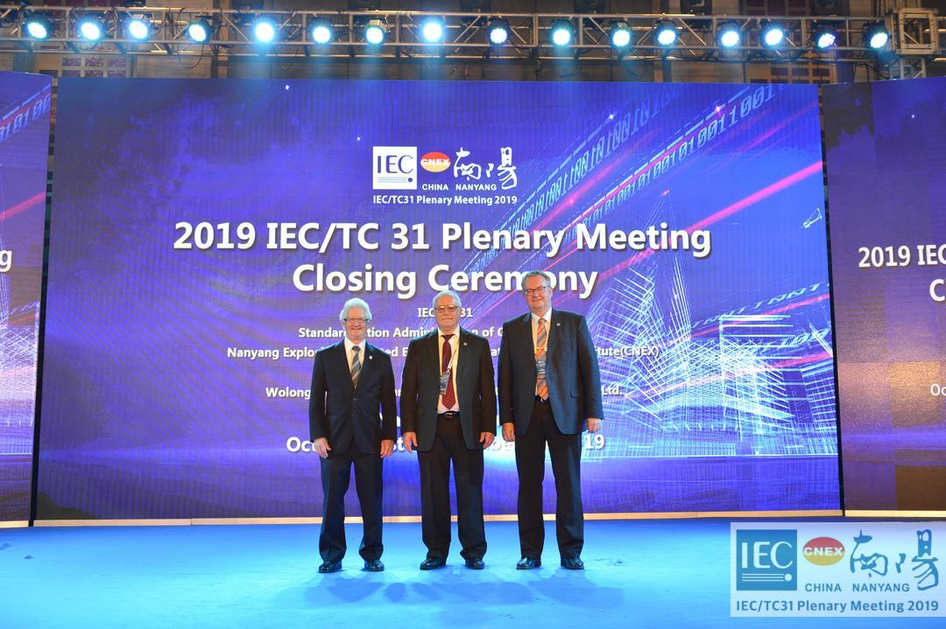

A meeting of the TC 31 Chair’s Advisory Group was planned for Northbrook, IL (USA), in April 2020. Due to the Corona pandemic, it was decided to postpone this meeting to October 2020 and thus, to have no plenary meetings of TC 31 and it’s SCs in 2020. This CAG meeting is now planned as an online session beginning of November 2020.

**Future TC 31 meetings**

Next meetings of Working Groups, Maintenance Teams, Project Teams of TC 31 and it’s SCs are planned for April 2021 in Northbrook, IL (USA) followed by a face-to-face meeting of the TC 31 Chair’s Advisory Group

The next plenary meeting of TC 31 is scheduled for October 2021, hopefully in conjunction with the GM of the IEC in Dubai (UAE). Other meetings of TC 31 Working Groups, Maintenance Teams, Project Teams and subcommittees are planned to be held prior to the plenary.

As always, we invite IECEx to make a presentation to these groups as part of the agenda.

**Standards and associated documents issued recently**

The following are documents that have been published over the past 12 months through September 2020:

|  |  |  |  |
| --- | --- | --- | --- |
| **Number** | **Ed.** | **Date** | **Title** |
| IEC 60079-11:2011/ISH5:2019 | 6.0 | 2019-08-29 | Interpretation Sheet 5 - Explosive atmospheres - Part 11: Equipment protection by intrinsic safety |
| IEC 60079-19:2019 | 4.0 | 2019-10-18 | Explosive atmospheres - Part 19: Equipment repair, overhaul and reclamation |
| ISO 80079-36:2016/COR1:2019 | 1.0 | 2019-10-22 | Corrigendum 1 -  Explosive atmospheres - Part 36: Non-electrical equipment for explosive atmospheres - Basic method and requirements |
| IEC 60079-28:2015/ISH1:2019 | 2.0 | 2019-11-14 | Interpretation Sheet 1 - Explosive atmospheres - Part 28: Protection of equipment and transmission systems using optical radiation |
| IEC 62990-1:2019/COR1:2019 | 1.0 | 2019-12-04 | Corrigendum 1 -  Workplace atmospheres - Part 1: Gas detectors - Performance requirements of detectors for toxic gases |
| IEC 60079-11:2011/ISH6:2019 | 6.0 | 2019-12-13 | Interpretation sheet 6 - Explosive atmospheres - Part 11: Equipment protection by intrinsic safety |
| IEC 60079-0:2017/COR1:2020 | 7.0 | 2020-01-20 | Corrigendum 1 –  Explosive atmospheres - Part 0: Equipment - General requirements |
| IEC 60079-6:2015/AMD1:2020 | 4.0 | 2020-02-24 | Amendment 1 -  Explosive atmospheres - Part 6: Equipment protection by liquid immersion |
| IEC 60079-14:2013/ISH2:2020 | 5.0 | 2020-03-13 | Interpretation sheet 2 - Explosive atmospheres - Part 14: Electrical installations design, selection and erection |
| IEC 60079-29-1:2016/AMD1:2020 | 2.0 | 2020-03-24 | Amendment 1 -  Explosive atmospheres - Part 29-1: Gas detectors - Performance requirements of detectors for flammable gases |
| IEC 60079-1:2014/ISH1:2020 | 7.0 | 2020-05-28 | Interpretation sheet 1 - Explosive atmospheres - Part 1: Equipment protection by flameproof enclosures |
| IEC 60079-25:2020 | 3.0 | 2020-06-26 | Explosive atmospheres - Part 25: Intrinsically safe electrical systems |

**Documents nearing completion**

The following documents were nearing completion (i.e. at FDIS or CDV stage complete and FDIS circulation soon), circulated since September 2019:

|  |  |  |
| --- | --- | --- |
| **Document Number** | **Date of circulation** | **Title** |
| 31/1529/CDV | 2020-03-06 | IEC 60079-26 ED4  Explosive atmospheres – Part 26: Equipment with separation elements or combined Levels of Protection |
| 31J/307/FDIS | 2020-07-24 | IEC 60079-10-1 ED3  Explosive atmospheres - Part 10-1: Classification of areas - Explosive gas atmospheres |
| 31G/323/DTS | 2020-08-14 | IEC TS 60079-47 ED1  Explosive atmospheres - Part 47: Equipment protection by 2-Wire Intrinsically Safe Ethernet concept (2-WISE) |

**Matters likely to be of interest to IECEx**

* Change of Officers of TC 31 and it’s SCs:
  + new Chair of IEC SC 31G since August 2020: Günter Gabriel (DE)
  + new Chair of IEC TC 31 since August 2020: Dr. Martin Thedens (DE)
  + new Vice-Chair of IEC SC 31M since September 2020: Thierry Houeix (FR)
* New Maintenance Team in TC 31: JMT 62784 “Particular requirements for vacuum cleaners and dust extractors providing equipment protection level Dc” as a joint MT with SC 61J “Electrical motor-operated cleaning appliances for commercial use”. Convenor is Charalambos Freed (GR); he is also Secretary of SC 61J.
* Status of project IEC TS 60079-44 ED1 “Explosive atmospheres – Part 44 - Personal Competence”: 2nd CD (31/1544/CD) were circulated on 2020-06-05, with a closing date for comments on 2020-08-28. 🡪 42 pages of comments! Thus, I am expecting a 3rd CD.
* The Liaison Officer of TC 31 to IECEx and Convenor of the JWG 50 “Standards coordination with IECEx” is our Immediate Past Chair of the IEC TC 31 Mark Coppler, as before.

**Conclusion**

This report summarizes the more significant events and standard developments of the past year. We welcome your guidance and suggestions for continued cooperation between TC 31 and IECEx.

Dr Martin Thedens

Chair IEC Technical Committee 31