**INTERNATIONAL ELECTROTECHNICAL COMMISSION (IEC) SYSTEM FOR CERTIFICATION TO STANDARDS RELATING TO EQUIPMENT FOR USE IN EXPLOSIVE ATMOSPHERES (IECEx SYSTEM)**

**Title: ExTAG/637/CD – Draft ExTAG Decision Sheet - Overpressure test for flameproof enclosures**

**Circulated to: ExTAG – IECEx Testing and Assessment Group**

**INTRODUCTION**

This document, *ExTAG/637/CD* *Draft ExTAG Decision Sheet - Overpressure test for flameproof enclosures,*has been prepared for consideration by ExTAG.

In accordance with OD 035 this document is issued for a six week comment period.

Please submit comments on this new Draft DS using the comments table, a separate document, by –

**20210315**

to

[**Christine Kane**](mailto:christine.kane@iecex.com)

ExTAG Secretariat

|  |
| --- |
| **Address:**  **IECEx Secretariat**  **Level 33 Australia Square**  **264 George Street**  **Sydney NSW 2000**  **Australia**  **Web:** **www.iecex.com** |

COLLECTION OF IECEx / ExTAG DECISIONS

|  |  |  |
| --- | --- | --- |
| Standard:  IEC 60079-1:2014 | **Clauses:**  15.2.1  (16.5) |  |
| **Subject:**  Overpressure test for flameproof enclosures  **Status of document:**  Draft | **Key words:**  Overpressure Test | Date: January 2021 **Originator of proposal:**  CNEX-Global BV |

**Background:**

Clause 15.2.1 of IEC 60079-1:2014 states:

*The tests are considered satisfactory if the enclosure suffers no permanent deformation or damage invalidating the type of protection. In addition, the joints shall in no place have been permanently enlarged.*

For many flameproof enclosures, the flameproof enclosure is formed by two or more enclosure parts that are connected together with fasteners.

Example:

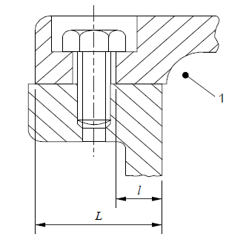A base and cover using fasteners (cover bolts) to connect both parts to each other. The base has threaded holes for the fasteners, the cover has unthreaded holes.

The flameproof joint is situated between the base and the cover and the joint is

kept in place by the fasteners that are screwed into the threaded holes in the

base.

(IEC 60079-1 figure 3).

**QUESTION:**

Is the reference to ‘*the enclosure*’ in clause 15.2.1 meant to include the individual enclosure parts, including the threaded holes for the enclosure fasteners and the threading on the enclosure fasteners?

**ANSWER:**

Yes.

The reference to ‘*the enclosure*’ in clause 15.2.1 is meant to include the individual enclosure parts, and the threaded holes for the flameproof enclosure fasteners, and the threading on the enclosure fasteners.

Therefore, overpressure tests on flameproof enclosures must be done in a way that ensures that also threaded holes for enclosure fasteners are subjected to the overpressure.