**INTERNATIONAL ELECTROTECHNICAL COMMISSION SYSTEM FOR CERTIFICATION TO STANDARDS RELATING TO EQUIPMENT FOR USE IN EXPLOSIVE ATMOSPHERES (IECEx SYSTEM)**

**TITLE: Re-assessment and Scope Extension Report for the continued acceptance of Korea Occupational Safety and Health Agency (KOSHA) an Accepted Ex Certification Body (ExCB) and an Accepted Ex Testing Laboratory (ExTL) within the IECEx System, Equipment Scheme 02, to include IEC 60079-28, in their scope.**

**Circulation to: Members of the IECEx Management Committee, ExMC**

**INTRODUCTION**

In accordance with the 5 year re-assessment plan for the surveillance and monitoring of bodies within the IECEx System, the following document contains the IECEx Re-assessment and Scope Extension Report for the continued acceptance of Korea Occupational Safety and Health Agency (KOSHA) an Accepted Ex Certification Body and an Accepted Ex Testing Laboratory (ExTL) within the IECEx System, Equipment Scheme, 02.

During the re-assessment the IECEx Assessment Team took the opportunity to also assess

Korea Occupational Safety and Health Agency (KOSHA) equipment and competence to undertake testing and certification for the following extension of scope –

|  |  |  |  |  |
| --- | --- | --- | --- | --- |
| **Standard** | | **Edition** | | **Title** |
| IEC 60079-28 | | Edition 2.0 | Explosive atmospheres - Part 28: Protection of equipment and transmission systems using optical radiation (ExTL only) |

***Members are requested to vote on the acceptance of the above scope extension***

***This document is hereby submitted for ExMC approval via correspondence using the IECEx on-line voting system.  ExMC Members are requested to submit their vote via the IECEx On-line*** [***Ballot System***](https://www.iecex.com/ballot) ***by the closing date 2021 05 21***

***Please refer to OD 050 for guidance on the “IECEx On-line voting system.”***

***Chris Agius***

**IECEx Secretariat**

|  |  |
| --- | --- |
| **IECEx Secretariat**  **Australia Square**  **Level 33,**  **264 George Street**  **Sydney NSW 2000 Australia** | **Tel: +61 2 4628 4690**  **Fax: +61 2 4625 3480**  **Email: info@iecex.com** |

IEC System for certification to standards relating to equipment for use in Explosive Atmospheres (IECEx System)

IECEx Assessment Report Form, F-003

IECEx assessment report form for use by IECEx assessment teams to report assessments conducted according to the relevant IECEx assessment procedures of:

Operational Document IECEx OD 003-2 for the Certified Equipment Scheme

Operational Document IECEx OD 316-* for the Certified Service Facility Scheme

Operational Document IECEx OD 422 for the IECEx Conformity Mark Licensing System

Operational Document IECEx OD 501 for the Personnel Competence Scheme

IECEx ExCB/ExTL assessment report for KOSHA

INTERNATIONAL  
ELECTROTECHNICAL  
COMMISSION

CONTENTS

(Update when report is complete – by right click, Update field, Update entire table)

1 Assessment information 6

1.1 Type of body covered by this assessment: 6

1.2 Type of assessment: 6

1.3 Details of body 6

1.3.1 Country 6

1.3.2 Name of body 6

1.3.3 Name and title of nominated principal contact 6

1.4 Assessment information 6

1.4.1 Members of the assessment team 6

1.4.2 Place(s) of assessment 6

1.4.3 Assessment date(s) 6

1.5 Application information and background information on the assessment 6

1.6 Scopes 7

1.6.1 ExCB scope for equipment certification scheme 7

1.6.2 ExTL scope 7

2 Common information 8

2.1 Legal entity of body 8

2.2 Financial support 8

2.3 History 8

2.4 Documentation 8

2.4.1 Quality manual 8

2.4.2 Procedures 8

2.4.3 Work instructions 8

2.4.4 Records (including test records where relevant) 8

2.4.5 Document change control 8

2.5 Confidentiality 8

2.6 Communication with public and customers (Hard copy and Electronic) 8

2.7 Recognitions and agreements 8

2.8 Internal audit 9

2.9 Management review 9

2.10 Contracting, subcontracting and witness testing 9

2.10.1 Contracting 9

2.10.2 Subcontracting 9

2.10.3 Off-site and Witness testing 9

2.11 Training and competence 9

2.12 Complaints and appeals (including appeals to IECEx) 9

2.13 Impartiality 9

2.14 Active involvement in development of Decision Sheets 9

2.15 Special facts to be noted 9

2.16 Supporting documentation 9

2.17 Recommendations 10

3 ExCB for IECEx Certified Equipment Scheme 11

3.1 Assessment references 11

3.1.1 General references 11

3.1.2 Additional references applied for this assessment 11

3.2 Candidate ExCB persons interviewed 11

3.3 Associated ExTL(s) 11

3.4 Associated certification functions 11

3.5 National marks and certificates 11

3.6 Standards accepted 11

3.7 National differences to IEC standards 12

3.8 Organisation 12

3.8.1 Names, titles and experience of the senior executives 12

3.8.2 Name, title and experience of the quality management representative 12

3.8.3 Name and title of signatories for certification 12

3.8.4 Other employees in ExCB activity 12

3.9 Organizational structure 12

3.10 Indemnity insurance 12

3.11 Resources 12

3.12 Committees (such as governing or advisory boards) 12

3.13 Certification operations 12

3.13.1 National approval/certification methods 12

3.13.2 Certification policy 13

3.13.3 Application for certification 13

3.13.4 Certification decision 13

3.13.5 Suspension and cancellation of certificates 13

3.14 Certificates issued 13

3.15 National accreditation 13

3.16 Assessment of manufacturers and issue of QARs 13

3.17 Comments (including issues found during assessment) 14

4 ExTL for IECEx Certified Equipment Scheme 15

4.1 Assessment references 15

4.1.1 General references 15

4.1.2 Additional references applied for this assessment 15

4.2 Candidate ExTL persons interviewed 15

4.3 Associated ExCB(s) 15

4.4 Organisation 15

4.4.1 Names, titles and experience of the senior executives 15

4.4.2 Name, title and experience of the quality management representative 15

4.4.3 Other employees in ExTL activity 15

4.5 Organizational structure 16

4.6 Resources 16

4.7 Test reports issued 16

4.8 National accreditation 16

4.9 Calibration 16

4.10 Tests witnessed during the assessment visit 17

4.11 Participation in IECEx Proficiency Testing Programs 17

4.12 Comments (including issues found during assessment) 17

Annex A Scope for IECEx Certified Equipment Scheme 18

A.1 Current standards 18

A.2 Superseded standards 18

Annex B Overall Organisation Chart 20

Overall Organization Chart(KOSHA) 20

Annex C Organisation Chart of ExCB/ExTL 22

Annex D Accreditation Certificate for ISO/IEC 17025 23

# Assessment information

## Type of body covered by this assessment:

|  |  |
| --- | --- |
| ExCB for IECEx Certified Equipment Scheme | ✓ |
| ExTL for IECEx Certified Equipment Scheme | ✓ |
| ATF for IECEx Certified Equipment Scheme |  |
| ExCB for IECEx Certified Service Facilities Scheme |  |
| ExCB for IECEx Conformity Mark Licensing System |  |
| ExCB for IECEx Certification of Personnel Competency Scheme |  |

NOTE 1 ExCB - IECEx Certification Body

NOTE 2 ExTL - IECEx Testing Laboratory

NOTE 3 ATF - Additional Testing Facility

## Type of assessment:

|  |  |
| --- | --- |
| Pre-assessment for candidate body |  |
| Initial assessment for candidate body |  |
| Surveillance |  |
| Re-assessment | ✓ |
| Scope extension | ✓ |

## Details of body

### Country

Republic of Korea

### Name of body

KOSHA

### Name and title of nominated principal contact

|  |  |  |
| --- | --- | --- |
| Name | Title | E-mail address |
| Mr. Jung Il Kang | Senior manager | [koshaex@kosha.or.kr](mailto:koshaex@kosha.or.kr) |

## Assessment information

### Members of the assessment team

|  |  |
| --- | --- |
| Name | Role |
| Ron Webb | IECEx Lead Assessor |

### Place(s) of assessment

|  |  |
| --- | --- |
| 400 Jongga-ro, Jung-gu, Ulsan, 44429, Republic of Korea |  |

### Assessment date(s)

1-5 February 2021, remote, in accordance with OD060

## Application information and background information on the assessment

The reassessment and scope extension was carried out in accordance with OD060

## Scopes

### ExCB scope for equipment certification scheme

The scope for the ExCB is shown in Annex A and below

|  |  |  |
| --- | --- | --- |
| IEC 60079-28  Edition 2.0 | Explosive atmospheres - Part 28: Protection of equipment and transmission systems using optical radiation | Scope extension |

### ExTL scope

The ExTL scope is the same as for the ExCB.

# Common information

## Legal entity of body

KOSHA was established in 1987 with legal authority for the “Korea Industrial Safety Corporation Act”. Under KOSHA, the Occupational Safety and Health Certification Institute (OSHCI) was established in 2017, mainly serving for safety certification & assessment. There has been no change in legal status since last re-assessment.

## Financial support

As a government organization KOSHA has the full financial support from the government.

## History

See 2.1

## Documentation

### Quality manual

KOSHA has a comprehensive quality manual and supporting procedures. It is noted that the Quality Manual has been updated on 28 December 2020, and found to be satisfactory.

### Procedures

The comprehensive supporting procedures (23 in total) were found to be in place and to meet IECEx requirements.

### Work instructions

In Ex field, there are 73 working instructions, the majority of which were updated on 5 March 2018 were sighted during the re-assessment

### Records (including test records where relevant)

Records are kept in hard copy. They are retained according to procedure P019, section 4, permanently or for 5 years

Records are securely disposed of by means of a contracted organization

### Document change control

Documents are all subject to a change control procedure P019 that includes regular checks of those being used in the workplace.

## Confidentiality

All KOSHA staff and the members of Certification Committee, including the committee members from social organization are subjected to strict confidentiality requirements of procedure P002.

## Communication with public and customers (Hard copy and Electronic)

KOSHA publishes a Brochure in English periodically for introduction of KOSHA’s activities. Further detailed information including service description can also be found at their website at [www.kosha.or.kr](https://d.docs.live.net/c307de0f41062051/Documents/IECEx/2021%20KOSHA%20RA/Working%20docs/www.kosha.or.kr)

## Recognitions and agreements

KOSHA holds various MOUs with 15 organisations including NEMKO, PTB, TIIS etc.

## Internal audit

As part of the KOSHA Quality Management System, KOSHA conduct internal audit and periodic management review as scheduled. The last internal audit for the Ex department was carried out on 8 December 2020.

## Management review

KOSHA conduct a management review in the first quarter according to the procedure P023. The last review meeting was held on 17 March 2020. This covered the IECEx activities.

## Contracting, subcontracting and witness testing

KOSHA has a procedure P009 for subcontracting of explosion protection testing and calibration, but this is not used at present.

### Contracting

No contracting

### Subcontracting

KOSHA only utilizes ExTL’s test report.

### Off-site and Witness testing

KOSHA conducts the test according to the procedure P024 of off-site and witness testing based on IECEx OD 024.

## Training and competence

The staff training at KOSHA is periodically provided according to procedure P004 as well as specific development plans. All members of staff are responsible for maintaining their own training records and are recoded in the intranet.

## Complaints and appeals (including appeals to IECEx)

KOSHA operate an appeals procedure handling customer complains in accordance with clause 3 of P016 of their Manual which was updated on 13 Jan 2021. This procedure includes reference to the IECEx appeals procedure as a further option for manufacturers. There have not been any complaints in connection with the IECEx.

## Impartiality

KOSHA guarantees the fairness of work and secures the reliability of the results in accordance with the P001 impartiality management procedure.

## Active involvement in development of Decision Sheets

When decisions are made by the KOSHA IECEx committee, all staffs share the decision sheets and their opinions.

## Special facts to be noted

None

## Supporting documentation

Copies of additional supporting information for this assessment have been provided to the applicant and the IECEx Secretariat. These are included in a site assessment report or provided separately and include:

* Details of issues raised and how these have been resolved
* Checklist for ISO/IEC 17065
* Checklist for ISO/IEC 17025
* Completed Technical Capability Document (TCD)
* Photos of the facilities/tests witnessed are included in the above TCD
* Information on competencies
* Information on contracting/subcontracting
* Assessors’ notes

## Recommendations

Based on the assessment performed on 1-5 February 2021, and corrective actions received 23-25 February 2021, KOSHA is recommended for continued acceptance in the IECEx scheme as:

* An ExCB in the IECEx Certified Equipment Scheme
* An ExTL in the IECEx Certified Equipment Scheme

This is according to the scope of the standards listed in this document including the extension of scope.

|  |
| --- |
| Ron Webb |
| IECEx Lead Assessor |

Date: March 2021

# ExCB for IECEx Certified Equipment Scheme

## Assessment references

### General references

1. IECEx 02 IECEx Certified Equipment Scheme covering equipment for use in explosive atmospheres – Rules of Procedure
2. IECEx OD003-2 Assessment, surveillance assessment and re-assessment of ExCBs and ExTLs operating in the IECEx 02, IECEx Certified Equipment Scheme
3. ISO/IEC 80079-34 Explosive atmospheres – Part 34: Application of quality systems for equipment manufacture
4. IECEx OD 009 Issuing of CoCs, ExTRs and QARs
5. IECEx OD 025 Guidelines on the Management of Assessment and Surveillance programs for the assessment of Manufacturer’s Quality Systems in accordance with the IECEx Scheme
6. IECEx OD 026 IECEx Certified Equipment Scheme – Guidelines for the qualification of Lead Auditor and Auditors, in accordance with the IECEx System
7. ISO/IEC 17065 General requirements for bodies operating product certification systems Conformity assessment — Requirements for bodies certifying products, processes and services
8. IECEx OD 107 Harmonised check list for certification bodies ISO/IEC 17065
9. IECEx OD 060 IECEx Guide for Business Continuity – Management of Extraordinary Circumstances or Events Affecting IECEx Certification Schemes and Activities
10. IECEx Technical Capability Document (TCD)
11. ExTAG decision sheets (DSs)

NOTE The latest editions of the above documents were applied, unless otherwise specified

### Additional references applied for this assessment

None

## Candidate ExCB persons interviewed

|  |  |
| --- | --- |
| Name | Position |
| Mr. Bong Ho, Kim | Director |
| Mr. Lae Hun, Jang | Certification Manager |
| Mr. Yong Tae, Kim | Quality Manager |

## Associated ExTL(s)

The TL is integral with the CB

## Associated certification functions

KOSHA holds national authorization for the many varying activities, including Ex certification. However KOSHA does not have national accreditation according to ISO/IEC 17065, and KOSHA agree to bear an annual surveillance under the IECEx System.

## National marks and certificates

KOSHA are authorised to issue national certification using the KCs mark.

## Standards accepted

See Annex A

## National differences to IEC standards

National differences to IEC standards are those for the Republic of Korea differences listed in the latest version of the IECEx System Bulletin.

## Organisation

### Names, titles and experience of the senior executives

|  |  |  |
| --- | --- | --- |
| Name | Title | Experience (years) |
| Mr. Bong Ho, Kim | Director | 28 years |
| Mr. Lae Hun, Jang | Certification Manager | 20 years |
| Mr. Yong Tae, Kim | Quality Manager | 15 years |

### Name, title and experience of the quality management representative

|  |  |  |
| --- | --- | --- |
| Name | Title | Experience (years) |
| Mr. Lae Hun, Jang | Certification Manager | 20 years |

### Name and title of signatories for certification

|  |  |  |
| --- | --- | --- |
| Name | Title | Comments |
| Mr. Lae Hun, Jang | Certification Manager | 20 years |

### Other employees in ExCB activity

|  |  |  |
| --- | --- | --- |
| Name | Title | Experience in Ex (years) |
| Mr. Gyeong Jin, Oh | Assistant Manager | 1 years |

## Organizational structure

Included as Annexes B and C

## Indemnity insurance

KOSHA has indemnity insurance with value of KRW 800,000,000, which is worldwide and is valid until 28 June 2021. The current certificate was viewed and seen to be satisfactory.

## Resources

KOSHA have adequate, competent, staffing for the IECEx certification process. The ExCB has the appropriate resources of competent staff and appropriate procedures to be able to certify to IEC 60079-28.

## Committees (such as governing or advisory boards)

The procedure P011 sets out the Process for the Certification Committee along with the function listed in Clause 2 on Page 2 of P011. The procedure indicates that KOSHA operate a Certification Committee consisting of 9 members as follows:

- Chief of the Centre for safety Certification and Assessment

- Chief of Quality Assurance

- Chief of Testing Team

- Chief of Ex Certification

And the rest of the members are from testing agency, university and safety institute.

## Certification operations

### National approval/certification methods

KOSHA are recognised under the National system with systems and procedures that comply with IECEx Rules and Operational Documents. Relevant procedures include clear references to IECEx Operational Documents including OD 009.

### Certification policy

KOSHA has a Policy statement in Clause 4.2.1 (1) of M Quality Manual and meets IECEx Rules and Procedures.

### Application for certification

There is a procedure for issuing of an IECEx CoC. The application package for IECEx Certification including the KOSHA Website have been updated to ensure applicants for IECEx Certification are fully aware of the steps and rules required in order to achieve IECEx Certification.

### Certification decision

The detailed procedures for certification decision are addressed in the body’s Quality Manual. It was reviewed and found to meet the requirements of the IECEx System.

### Suspension and cancellation of certificates

Procedures for the suspension and cancellation of certificates are covered by the Quality Management system procedures in clause 4.3.7 of P094, and found to comply with the requirements of IECEx Rules and Operational Documents.

## Certificates issued

Number of certificates issued under for the preceding two years for each type of protection.

|  |  |  |  |  |
| --- | --- | --- | --- | --- |
| Standard numbers | Type of protection or other identifying information | Number of issued certificates (for last 2 years) | | Total |
| 2019 | 2020 |
| 60079-0 | General requirements | Included as appropriate | |  |
| 60079-1 | d | 118 | 123 | 241 |
| 60079-2 | p | 17 | 24 | 41 |
| 60079-5 | q | 0 | 0 | 0 |
| 60079-6 | o | 0 | 0 | 0 |
| 60079-7 | e | 80 | 89 | 169 |
| 60079-11 | i | 66 | 60 | 126 |
| 60079-15 | n | 16 | 18 | 34 |
| 60079-18 | m | 0 | 1 | 1 |
| 60079-31 | Dust | 86 | 85 | 171 |
| Others | d+p, p+e….etc | 270 | 374 | 644 |

As the number of IECEx Certificates is rather low, Certificates issued for National Certification are included in the numbers above**.**

## National accreditation

KOSHA does not retain accreditation certification for ISO/IEC17065 and therefore is subject to annual surveillance under the IECEx System.

## Assessment of manufacturers and issue of QARs

The procedures for assessment of manufacturers are contained in P 094 Explosion protected equipment certification procedure. The relevant operational documents and relevant procedures are also used. Procedures related to OD060 are contained in P 096 Follow-up management procedure.

NOTE Include information about how the ExCB applies the provisions of OD 060 if applicable.

## Comments (including issues found during assessment)

Issues were found regarding incorporation of some of the ODs into the Quality system.

These were all cleared to the satisfaction of the assessment team.

# ExTL for IECEx Certified Equipment Scheme

## Assessment references

### General references

1. IECEx02 IECEx Certified Equipment Scheme covering equipment for use in explosive atmospheres – Rules of Procedure
2. IECEx OD003-2 Assessment, surveillance assessment and re-assessment of ExCBs and ExTLs operating in the IECEx 02, IECEx Certified Equipment Scheme
3. IECEx OD009 Issuing of CoCs, ExTRs and QARs
4. ISO/IEC 17025 General requirements for the competence of testing and calibration laboratories
5. IECEx OD 018 Harmonised check list for testing and calibration laboratories ISO/IEC 17025
6. IECEx TCD 60079, ISO 80079 Series and ISO 16852 Technical Capability Document
7. ExTAG decision sheets (DSs)
8. IECEx OD 202 IECEx Certified Equipment Scheme – IECEx Proficiency Testing Program

NOTE The latest editions of the above documents were applied, unless otherwise specified.

### Additional references applied for this assessment

NOTE To be added by assessment team. For example, ODs for non-electrical or Ex s where applicable

## ExTL persons interviewed

|  |  |
| --- | --- |
| Name | Position |
| Mr. Kab Dong, Youn | ExTL Deputy Director |
| Mr. Jeong Il, Kang | Senior Manager |
| Mr. Ki Ho, Lee | Manager |
| Mr. Myung Gwan, Kim | Manager |
| Mr. Boo Seok, Kang | Assistant Manager |
| Mr. Seung Ho, Han | Assistant Manager |

## Associated ExCB(s)

The CB is integral with the TL

## Organisation

### Names, titles and experience of the senior executives

|  |  |  |
| --- | --- | --- |
| Name | Title | Experience (years) |
| Mr. Bong Ho, Kim | Director | 28 years |
| Mr. Kab Dong, Youn | Testing Manager | 28 years |
| Mr. Yong Tae, Kim | Quality Manager | 15 years |

### Name, title and experience of the quality management representative

|  |  |  |
| --- | --- | --- |
| Name | Title | Experience (years) |
| Mr. Lae Hun, Jang | Certification Manager | 20 years |

### Other employees in ExTL activity

|  |  |  |
| --- | --- | --- |
| Name | Title/responsibility | Experience in Ex (years) |
| Mr. Jeong Il, Kang | Senior Manager | 8 years |
| Mr. Ki Ho, Lee | Manager | 5 years |
| Mr. Myung Gwan, Kim | Manager | 3 years |
| Mr. Boo Seok, Kang | Assistant Manager | 1 year |
| Mr. Seung Ho, Han | Assistant Manager | 1 year |

## Organizational structure

Included as Annexes B and C

## Resources

KOSHA have adequate facilities, equipment and competent staff to operate as an IECEx ExTL. The ExTL has the appropriate resources of competent staff and appropriate procedures to be able to certify to IEC 60079-28.

## Test reports issued

Number of test reports (ExTRs) issued under for the preceding two years for each type of protection.

|  |  |  |  |  |
| --- | --- | --- | --- | --- |
| Standard numbers | Type of protection or other identifying information | Number of issued reports (ExTRs) (for last 2 years) | | Total |
|  |  |
| 60079-0 | General requirements | Included as appropriate | |  |
| 60079-1 | d | 118 | 123 | 241 |
| 60079-2 | p | 17 | 24 | 41 |
| 60079-5 | q | 0 | 0 | 0 |
| 60079-6 | o | 0 | 0 | 0 |
| 60079-7 | e | 80 | 89 | 169 |
| 60079-11 | i | 66 | 60 | 126 |
| 60079-15 | n | 16 | 18 | 34 |
| 60079-18 | m | 0 | 1 | 1 |
| 60079-31 | Dust | 86 | 85 | 171 |
| Others | d+p, p+e….etc | 270 | 374 | 644 |

As the number of IECEx ExTRs is rather low, test reports used for National standards (which are based on earlier versions of IEC standards) are included in the numbers above.

## National accreditation

KOSHA are accredited to ISO/IEC 17025 by KOLAS. The scope of accreditation covers the standards listed in Annex A. The current certificate is included as Appendix B. The scope as depicted on the Schedule to the certificate refers to Ministry of Employment and Labour 2020-33(2020.01.15) Part 7. ‘A safety certification standards of Ex apparatus and parts’. Examination of the Ministry of Employ and Labour 2020-33(2020.01.15) notification identified the relevant Ex concepts which aligned with the Scope in Annex A.

The national accreditation certification for ISO/IEC 17025 is shown in Annex D.

NOTE The national accreditation is checked annually by the IECEx Secretariat.

## Calibration

There is a documented procedure (P006) for dealing with calibration of testing and equipment and measuring instruments. The equipment and instruments at KOSHA are mainly outsourced to be calibrated. There are approximately 117 items that are in the calibration system.

Examples of calibration certificates were reviewed, and found to be satisfactory.

## Tests witnessed during the assessment

The following tests were witnessed remotely during the assessment:

A mobile phone was used to view tests as they were performed. Instructions were given to the test staff to view details of the tests, calibration labels etc.

|  |  |  |  |
| --- | --- | --- | --- |
| Standard and edition | Clause number | Test | Comments |
| IEC 60079-1:2014 | 15.2.2.2 | Reference pressure IIC | calibrated O2 analyser and transducers  acetylene 14% in a small enclosure, acceptable |
| IEC 60079-0:2018 | 26.13 | Surface resistance | Stripes painted on flat surface using template, calibrated resistance meter used, method acceptable |
| IEC 60079-0:2018 | 26.17 | transferred charge | method demonstrated, calibrated coulomb meter, acceptable |
| IEC 60079-28 | 5.2.2.2 and 5.2.2.3 | optical power  optical irradiance | power and irradiance measurement demonstrated on a small position sensor, acceptable |
| IEC 60079-11 | 10.1.3.1 | STA Calibration | STA demonstrated with 21% hydrogen. 95mH inductance checked before test. 24V, 30mA ignition at 284 revolutions, acceptable |
| IEC 60079-18 | 8.1.2 | dielectric test after water absorption | 2 different samples of elastomeric material tested. One passed the test, one failed at <4kV. Acceptable |
| IEC 60079-18 | 8.2.8 | sealed devices | 25 deg C to 50 deg C. Small relay No bubbles Acceptable |

## Participation in IECEx Proficiency Testing Programs

Program: PTB Ex PT Scheme

|  |  |  |  |
| --- | --- | --- | --- |
| **IECEx Proficiency Testing program** | **Program years** | **Participated?**  **Y/N/NA** | **Other comments, including whether results are considered satisfactory** |
| Program 1 "Explosion pressure" | 2011-2012 | y | satisfactory |
| Program 2 "Spark ignition" | 2011-2012 | Y | satisfactory |
| Program 3 "Flame Transmission" | 2013-2014 | N |  |
| Program 4 "Temperature Classification" | 2013-2014 | N |  |
| Program 5 "Electrostatic Charge" | 2015-2016 | Y | satisfactory |
| Program 6 "Intrinsic Safety" | 2015-2016 | Y | satisfactory |
| Program 7 "Explosion Pressure" | 2017-2018 | Y | satisfactory |
| Program 8 "Pressurized Enclosure" | 2017-2018 | Y | satisfactory |
| Battery Testing | 2019-2020 | Y | satisfactory |
| Tests of Enclosures | 2019-2020 | Y | satisfactory |

## Comments (including issues found during assessment)

Issues were found relating to information in the test reports and one of the certificates

These were subsequently cleared to the satisfaction of the assessment team

1. Scope for IECEx Certified Equipment Scheme
   1. Current standards

| Number | Title | Comments |
| --- | --- | --- |
| IEC 60079-0  Edition 7.0 | Explosive atmospheres - Part 0: Equipment - General requirements | In scope |
| IEC 60079-1  Edition 7.0 | Explosive atmospheres - Part 1: Equipment protection by flameproof  enclosures “d” | In scope |
| IEC 60079-2  Edition 6.0 | Explosive atmospheres - Part 2: Equipment protection by pressurized  enclosure “p’ | In scope |
| IEC 60079-5  Edition 4.0 | Explosive atmospheres - Part 5: Equipment protection by powder filling “q” | In scope |
| IEC 60079-6  Edition 4.0 | Explosive atmospheres - Part 6: Equipment protection by oil immersion “o” | In scope |
| IEC 60079-7  Edition 5.0 | Explosive atmospheres - Part 7: Equipment protection by increased  safety "e" | In scope |
| IEC 60079-11  Edition 6.0 | Explosive atmospheres - Part 11: Equipment protection by intrinsic safety “i” | In scope |
| IEC 60079-15  Edition 5.0 | Explosive atmospheres – Part 15: Equipment protection by type of protection "n" | In scope |
| IEC 60079-18  Edition 4.0 | Explosive atmospheres – Part 18: Equipment protection by encapsulation “m” | In scope |
| IEC 60079-26  Edition 3.0 | Explosive atmospheres - Part 26: Equipment with equipment protection level (EPL) Ga | In scope |
| IEC 60079-28  Edition 2.0 | Explosive atmospheres - Part 28: Protection of equipment and transmission systems using optical radiation | Scope extension |
| IEC/IEEE 60079-30-1  Edition 1.0 | Explosive atmospheres – Part 30-1: Electrical resistance trace heating – General and testing requirements | In scope |
| IEC 60079-31  Edition 2.0 | Explosive atmospheres – Part 31: Equipment dust ignition protection by enclosure "t" | In scope |

* 1. Superseded standards

The following superseded standards may form part of a body’s scope, generally for historical reasons.

| Number | Title | Comments |
| --- | --- | --- |
| IEC 61241-0  Edition 1.0 | Electrical apparatus for use in the presence of combustible dust - Part 0: General requirements | In scope |
| IEC 61241-1  Edition 1.0 | Electrical apparatus for use in the presence of combustible dust - Part 1: Protection by enclosure “tD” | In scope |
| IEC 61241-4  Edition 1.0 | Electrical apparatus for use in the presence of combustible dust - Part 4: Protection by pressurization "pD" | In scope |

1. Overall Organisation Chart

Overall Organization Chart (KOSHA)

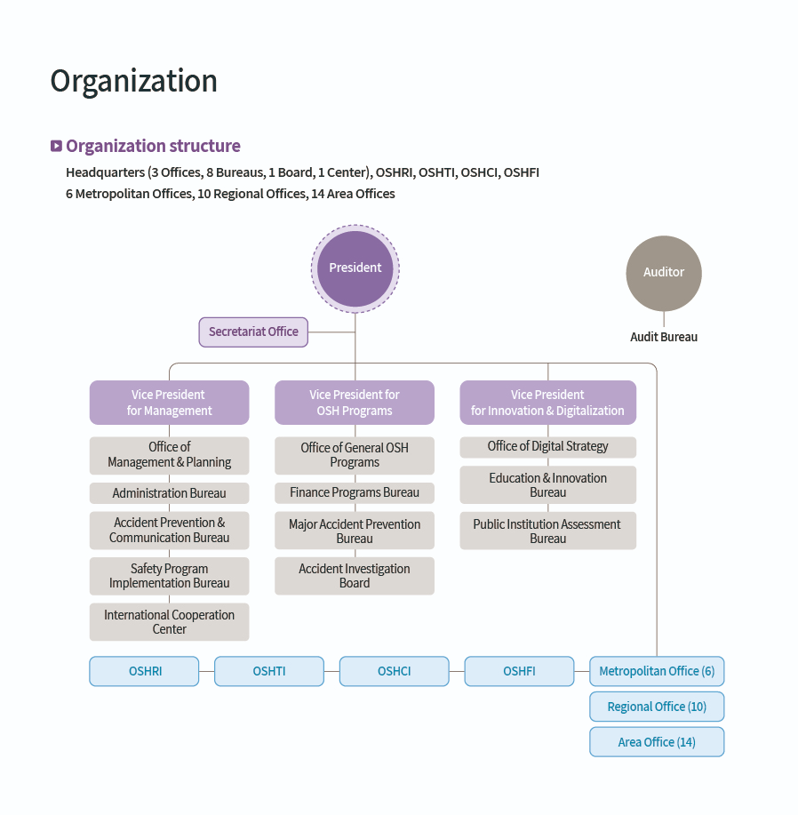

Overall Organization Chart(OSHCI)

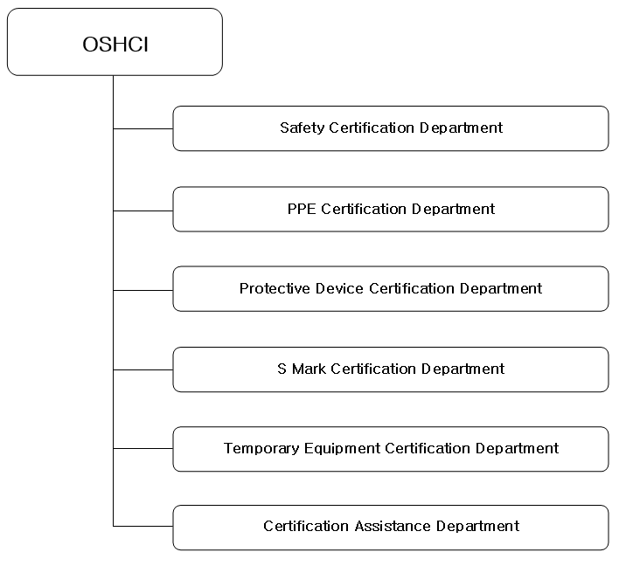

1. Organisation Chart of ExCB/ExTL

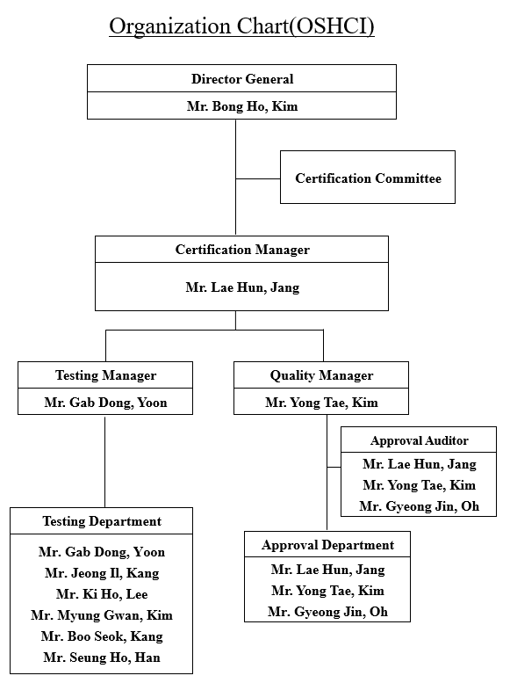

1. Accreditation Certificate for ISO/IEC 17025

