|  |
| --- |
|  |

**INTERNATIONAL ELECTROTECHNICAL COMMISSION IEC SYSTEM FOR CERTIFICATION TO STANDARDS RELATING TO EQUIPMENT FOR USE IN EXPLOSIVE ATMOSPHERES (IECEx SYSTEM)**

**TITLE: Proposal from IECEx ExPCC WG4 for establishment of an IECEx Record of Training Register**

**Circulation to: Members of the IECEx Management Committee, ExMC**

**INTRODUCTION**

This document contains details of a proposal from ExPCC Working Group #4 to establish an online IECEx Register of Training.

This idea was first raised at the inaugural IECEx RTP Forum in 2019 and further discussed and endorsed during the 2021 ExPCC WG4 meeting and the 2021 RTP Forum. The 2021 RTP Forum also established a small task group that is currently discussing the details of how the proposed register would operate, its format and what other tools would be needed to support it (this will likely include a template, as mentioned in the current version of IECEx OD 521, for all RTPs to use to provide a record of training to trainees).

The members of the ExPCC have been consulted on this proposal and in the absence of objections from ExPCC members, ExMC members are now requested to provide an in-principle-approval for this concept proposal so that work can continue as outlined in the Project Plan on page 3 following.

**IECEx Secretariat**

|  |  |
| --- | --- |
| **IECEx Secretariat**  **Australia Square**  **Level 33, 264 George Street**  **Sydney NSW 2000**  **Australia** | **Tel: +61 2 4628 4690**  **Fax: +61 2 46 27 5285**  **Email: info@iecex.com** |

**IECEx RECORD OF TRAINING**

***PROPOSAL ELEMENTS***

**WHAT**

* A display of some basic details of IECEx RTP provided training attended in the last 3 years as a register entry ‘validity period’
* Data will be automatically removed at the end of the ‘validity period’ (noting that the trainees need to understand that this will happen via the RTP’s application form)
* Display of detail based on a standardized list of a maximum of 20 training topics that will use the text title and Unit # (for example Ex 002) of the related IECEx CoPC Units of Competence and can also be ‘split’ into levels of full or Conditional training [where the training provided on a topic is incomplete, partial, customized or has limitations by equipment type, voltage, etcetra]. Input of data could be a tick box for each topic.
* Details to include:
  + The RTP that provided the training for the person
  + An automatically assigned Registration # for each Trainee
  + Trainee Name
  + Trainee’s company or employer (optional field of database)
  + Trainee’s contact details (if they agree to this) such as email address
  + Date(s) of completion Training if multiple courses attended on different dates
  + Topics of Training attended
* One entry for each person for each training course with ability to sort and filter register rows to show the full history for a particular person
* Data entry to be able to be done manually AND via CSV import from a locked format Excel worksheet

**WHY**

* Provides a recognition of effort made by trainees to start ‘the pathway to certification’
* A useful tool for ExCBs‘ marketing efforts (if listed trainees agree to be contacted by an ExCB either directly or via the RTP) >>> need to check privacy law provisions and restrictions

**WHERE**

* On [www.iecex.com](http://www.iecex.com) on the RTP page in a format similar to the new Offsite Testing Register and in a position that is obvious but does not override the list of RTPs

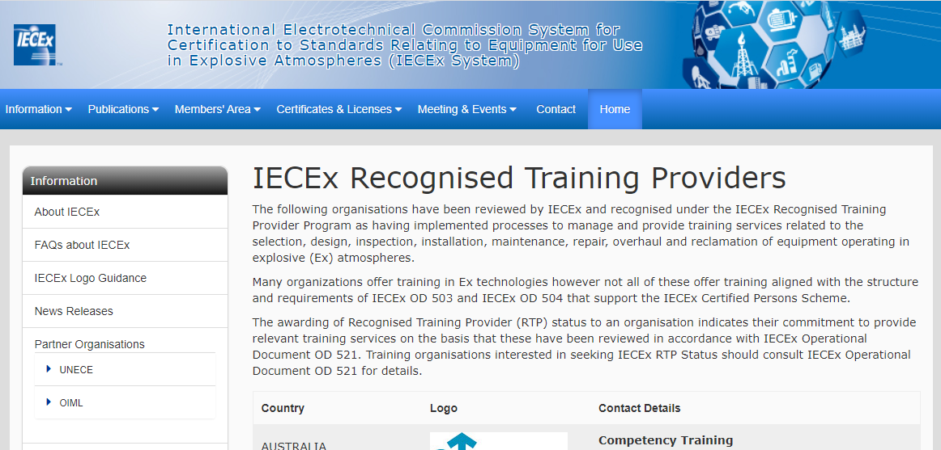

**WHO**

* Participating RTPs will be provided with secure access to enable initial addition of data and to add extra data to the register (for example to add extra course details to a row already listed for a trainee each trainee should only have one row but may have a table in the row to show multiple training course details of dates, topics etc)
* IECEx Secretariat will gave Administrator access (incl. rights to add, edit or delete data) and will provide access to participating RTPs

**FINANCES**

* Initial development and ongoing hosting costs to be borne by IECEx System
* All RTPs to pay an annual fee irrespective of their participation in or use of the register (this fee will be used to recover costs of development and hosting) as part of an increased RTP Annual Fee (from current CHF 500 to an amount that provides a 3 year payback of development costs and as a maximum addition of CHF 250 per year)

**OTHER CONSIDERATIONS & ASPECTS**

* Must NOT be seen by the market as an alternative to IECEx CoPC & EFOC Certification – therefore needs to have a clear disclaimer – for example:

*Listing in this register is ONLY an indication that the person has attended training provided by an IECEx Recognised Training Provider.*

*Listed trainees should not be seen as having been assessed for competence to the requirements of IECEx OD 504 for “IECEx CoPC Certification”.*

*Training attended can serve as preparation for certification under the IECEx Certificate of Personnel Competence Scheme BUT this is not a list of persons that have achieved IECEx certificate of competence nor is it a qualification to conduct work in hazardous areas. More information about IECEx certification can be downloaded as IECEx Guide 05A from* [*https://www.iecex.com/publications/guides/*](https://www.iecex.com/publications/guides/)

**PROJECT PLAN**

**PROCESS & TIMETABLE**

1. Discuss at June 2021 RTP Forum and if agreed as drafted above > = DONE
2. ExPCC will consider (via correspondence) the proposal and if agreed >> = DONE
3. The ExMC will (via correspondence if not at 2021 ExMC meeting in Sept 2021) consider the proposal ***IN PRINCIPLE*** and if agreed
4. Prepare specification and seek costing for development
5. IECEx Executive approves expenditure for development
6. Development
7. Launch
8. RTPs provided with access to commence data entry