**INTERNATIONAL ELECTROTECHNICAL COMMISSION IEC SYSTEM FOR**

**CERTIFICATION TO STANDARDS RELATING TO EQUIPMENT FOR USE IN**

**EXPLOSIVE ATMOSPHERES (IECEx SYSTEM)**

**TITLE: Scope Extension Assessment Report for, QPS Evaluation Services Inc. QPS, an Accepted ExCB and an Accepted ExTL within the IECEx System, Equipment Scheme 02, to include, IEC TS 60079-46, ISO 80079-36 and ISO 80079-37 in their scope.**

**Circulated To: Members of the IECEx Management Committee, ExMC**

**Introduction**

QPS Evaluation Services Inc, an Accepted ExCB and an Accepted ExTL within the IECEx System, Equipment Scheme 02, has applied to include the following Standards within their scope. A special site assessment was arranged and conducted, using the remote assessment provisions of OD 060.

IEC TS 60079-46 Ed. 1.0 Explosive atmospheres - Part 46: Equipment assemblies

IS0 80079-36 Ed. 1.0 Explosive atmospheres - Part 36: Non-electrical equipment for explosive atmospheres – Basic method and requirements

ISO 80079-37 Ed. 1.0 Explosive atmospheres - Part 37: Non-electrical equipment for explosive atmospheres – Non electrical type of protection constructional safety ”c” control of ignition source ”b”, liquid immersion ”k”

This report details the assessment findings of this scope extension with the IECEx

Assessment Team recommending the acceptance of the above scope extension.

***This document is hereby submitted for ExMC approval via correspondence using the IECEx on-line voting system.  ExMC Members are requested to submit their vote via the IECEx On-line*** [***Ballot System***](https://www.iecex.com/ballot) ***by the closing date******2021 09 03***

*Please refer to OD 050 for guidance on the “IECEx On-line voting system.”*

*Chris Agius*

**IECEx Secretary**

|  |  |
| --- | --- |
| **IECEx Secretariat**  **Australia Square**  **Level 33, 264 George Street**  **Sydney NSW 2000**  **Australia** | **Tel: +61 2 4628 4690**  **Fax: +61 2 46 27 5285**  **Email: info@iecex.com** |

IEC System for certification to standards relating to equipment for use in Explosive Atmospheres (IECEx System)

IECEx Assessment Report Form, F-003

IECEx assessment report form for use by IECEx assessment teams to report assessments conducted according to the relevant IECEx assessment procedures of:

Operational Document IECEx OD 003-2 for the Certified Equipment Scheme

Operational Document IECEx OD 316-* for the Certified Service Facility Scheme

Operational Document IECEx OD 422 for the IECEx Conformity Mark Licensing Scheme

Operational Document IECEx OD 501 for the Personnel Competence Scheme

IECEx ExCB/ExTL assessment report for QPS Evaluation Services Inc. (QPS)

INTERNATIONAL  
ELECTROTECHNICAL  
COMMISSION

CONTENTS

1 Assessment information 5

1.1 Type of body covered by this assessment: 5

1.2 Type of assessment: 5

1.3 Details of body 5

1.3.1 Country 5

1.3.2 Name of body 5

1.3.3 Name and title of nominated principal contact 5

1.4 Assessment information 5

1.4.1 Members of the assessment team 5

1.4.2 Place(s) of assessment 5

1.4.3 Assessment date(s) 5

1.5 Application information and background information on the assessment 6

1.6 Scopes 6

1.6.1 ExCB scope for equipment certification scheme 6

1.6.2 ExTL scope 6

2 Common information 7

2.1 Legal entity of body 7

2.2 Financial support 7

2.3 History 7

2.4 Documentation 7

2.4.1 Quality manual 7

2.4.2 Procedures 7

2.4.3 Work instructions 7

2.4.4 Records (including test records where relevant) 7

2.4.5 Document change control 7

2.5 Confidentiality 7

2.6 Communication with public and customers (Hard copy and Electronic) 7

2.7 Recognitions and agreements 7

2.8 Internal audit 7

2.9 Management review 7

2.10 Contracting, subcontracting and witness testing 7

2.11 Off-site and Witness testing 7

2.12 Training and competence 8

2.13 Complaints and appeals (including appeals to IECEx) 8

2.14 Impartiality 8

2.15 Active involvement in development of Decision Sheets 8

2.16 Special facts to be noted 8

2.17 Supporting documentation 8

2.18 Recommendations 8

3.1.1 General References 9

3.1.2 Additional references applied for this assessment 9

3.2 Candidate ExCB persons interviewed 9

3.3 Associated ExTL(s) 9

3.4 Associated certification functions 9

3.5 National marks and certificates 9

3.6 Standards accepted 9

3.7 National differences to IEC standards 9

3.8 Organisation 10

3.8.1 Names, titles and experience of the senior executives 10

3.8.2 Name, title and experience of the quality management representative 10

3.8.3 Name and title of signatories for certification 10

3.8.4 Other employees in ExCB activity 10

3.9 Organizational structure 10

3.10 Indemnity insurance 10

3.11 Resources 10

3.12 Committees (such as governing or advisory boards) 10

3.13 Certification operations 11

3.13.1 National approval/certification methods 11

3.13.2 Certification policy 11

3.13.3 Application for certification 11

3.13.4 Certification decision 11

3.13.5 Suspension and cancellation of certificates 11

3.14 Certificates issued (for scope extension standards) 11

3.15 National accreditation 11

3.16 Assessment of manufacturers and issue of QARs 11

3.17 Comments (including issues found during assessment) 11

4 ExTL for IECEx Certified Equipment Scheme 12

4.1 Assessment references 12

4.1.1 General references 12

4.1.2 Additional references applied for this assessment 12

4.2 Candidate ExTL persons interviewed 12

4.3 Associated ExCB(s) 12

4.4 Organisation 12

4.4.1 Names, titles and experience of the senior executives 12

4.4.2 Name, title and experience of the quality management representative 12

4.4.3 Other employees in ExTL activity 12

4.5 Organizational structure 13

4.6 Resources 13

4.7 Test reports issued (for scope extension standards) 13

4.8 National accreditation 13

4.9 Calibration 13

4.10 Tests witnessed during the assessment visit 13

4.11 Participation in IECEx Proficiency Testing Programs 13

4.12 Comments (including issues found during assessment) 13

Annex A Scope for IECEx Certified Equipment Scheme 14

A.1 Current standards 14

*A.2* *Superseded standards* 15

Annex B Overall Organisation Chart 16

Annex C Organisation Chart of ExCB/ExTL 17

Annex D Accreditation Certificate for ISO/IEC 17065 18

Annex E Accreditation Certificate for ISO/IEC 17025 19

# Assessment information

## Type of body covered by this assessment:

|  |  |
| --- | --- |
| ExCB for IECEx Certified Equipment Scheme |  |
| ExTL for IECEx Certified Equipment Scheme |  |
| ATF for IECEx Certified Equipment Scheme |  |
| ExCB for IECEx Certified Service Facilities Scheme |  |
| ExCB for IECEx Conformity Mark Licensing System |  |
| ExCB for IECEx Certification of Personnel Competency Scheme |  |

NOTE 1 ExCB - IECEx Certification Body

NOTE 2 ExTL - IECEx Testing Laboratory

NOTE 3 ATF - Additional Testing Facility

## Type of assessment:

|  |  |
| --- | --- |
| Pre-assessment for candidate body |  |
| Re-assessment for candidate body |  |
| Surveillance |  |
| Re-assessment |  |
| Scope extension |  |

## Details of body

### Country

Canada

### Name of body

QPS Evaluation Services Inc

### Name and title of nominated principal contact

|  |  |  |
| --- | --- | --- |
| Name | Title | E-mail address |
| Nick Maalouf | Vice President, QA & External Affairs | nmaalouf@qps.ca |

## Assessment information

### Members of the assessment team

|  |  |
| --- | --- |
| Name | Role |
| Ron Webb | IECEx Lead Assessor |

### Place(s) of assessment

|  |
| --- |
| 81 Kelfield St, Unit 8, Toronto, Ontario M9W 5A3. Canada |

### Assessment date(s)

3rd March 2021. This scope extension assessment was conducted as a remote assessment under the provisions of IECEx OD 060.

## Application information and background information on the assessment

Scope extension requested by way of completed ExMC/251B/Q form dated January 12th, 2021

|  |  |  |  |  |
| --- | --- | --- | --- | --- |
| **Standard** | | **Edition** | | **Title** |
| IS0 80079-36 | | Edition 1.0 | Explosive atmospheres - Part 36: Non-electrical equipment for explosive atmospheres – Basic method and requirements |
| ISO 80079-37  Edition 1.0 | | Edition 1.0 | Explosive atmospheres - Part 37: Non-electrical equipment for explosive atmospheres – Non electrical type of protection constructional safety ”c” control of ignition source ”b”, liquid immersion ”k” |
| IEC TS 60079-46 | | Edition 1.0 | Equipment assemblies |

## Scopes

### ExCB scope for equipment certification scheme

The scope for the ExCB is shown in Annex A.

### ExTL scope

The ExTL scope is the same as for the ExCB

# Common information

## Legal entity of body

Not relevant as this is a scope extension assessment. This was covered in the re-assessment

refer to Re-assessment Report ExMC/1303/DV.

## Financial support

Not relevant as this is a scope extension assessment. This was covered in the re-assessment refer to Re-assessment Report ExMC/1303/DV.

## History

Not relevant as this is a scope extension assessment. This was covered in the re-assessment refer to Re-assessment Report ExMC/1303/DV.

## Documentation

### Quality manual

No specific changes for non electrical equipment and assemblies

### Procedures

No specific procedures for non electrical equipment and assemblies

### Work instructions

No specific work instructions for non electrical equipment and assemblies

### Records (including test records where relevant)

Not relevant as this is a scope extension assessment. This was covered in the re-assessment refer to Re-assessment Report ExMC/1303/DV.

### Document change control

Not relevant as this is a scope extension assessment. This was covered in the re-assessment refer to Re-assessment Report ExMC/1303/DV.

## Confidentiality

Not relevant as this is a scope extension assessment. This was covered in the re-assessment

refer to Re-assessment Report ExMC/1303/DV.

## Communication with public and customers (Hard copy and Electronic)

Not relevant as this is a scope extension assessment. This was covered in the re-assessment refer to Re-assessment Report ExMC/1303/DV.

## Recognitions and agreements

Not relevant as this is a scope extension assessment. This was covered in the re-assessment refer to Re-assessment Report ExMC/1303/DV.

## Internal audit

Not relevant as this is a scope extension assessment. This was covered in the re-assessment refer to Re-assessment Report ExMC/1303/DV.

## Management review

Not relevant as this is a scope extension assessment. This was covered in the re-assessment refer to Re-assessment Report ExMC/1303/DV.

## Contracting, subcontracting and witness testing

Not relevant as this is a scope extension assessment. This was covered in the re-assessment refer to Re-assessment Report ExMC/1303/DV.

## Off-site and Witness testing

Not relevant as this is a scope extension assessment. This was covered in the re-assessment refer to Re-assessment Report ExMC/1303/DV.

## Training and competence

Details of staff competencies were viewed and found to be acceptable

## Complaints and appeals (including appeals to IECEx)

Not relevant as this is a scope extension assessment. This was covered in the re-assessment refer to Re-assessment Report ExMC/1303/DV.

## Impartiality

Not relevant as this is a scope extension assessment. This was covered in the re-assessment refer to Re-assessment Report ExMC/1303/DV.

## Active involvement in development of Decision Sheets

Not relevant as this is a scope extension assessment. This was covered in the re-assessment refer to Re-assessment Report ExMC/1303/DV.

## Special facts to be noted

None other than those mentioned throughout the report.

## Supporting documentation

Copies of additional supporting information for this assessment have been provided to the applicant and the IECEx Secretariat. These are provided separately and include:

* Completed Technical Capability Document (TCD)
* Information on competencies

## Recommendations

Based on the assessment performed on 3rd March 2021, QPS is recommended for continued acceptance in the IECEx scheme as:

* An ExCB in the IECEx Certified Equipment Scheme
* An ExTL in the IECEx Certified Equipment Scheme

This is according to the scope of the standards listed in this document including the extension of scope.

|  |
| --- |
| Ron Webb |
| IECEx Lead Assessor |

**3. ExCB for IECEx Certified Equipment Scheme**

**3.1** **Assessment references**

### General References

1. IECEx 02 IECEx Certified Equipment Scheme covering equipment for use in explosive atmospheres – Rules of Procedure
2. IECEx OD003-2 Assessment, surveillance assessment and re-assessment of ExCBs and ExTLs operating in the IECEx 02, IECEx Certified Equipment Scheme
3. ISO/IEC 80079-34 Explosive atmospheres – Part 34: Application of quality systems for equipment manufacture
4. IECEx OD 009 Issuing of CoCs, ExTRs and QARs
5. IECEx OD 025 Guidelines on the Management of Assessment and Surveillance programs for the assessment of Manufacturer’s Quality Systems in accordance with the IECEx Scheme
6. IECEx OD 026 IECEx Certified Equipment Scheme – Guidelines for the qualification of Lead Auditor and Auditors, in accordance with the IECEx System
7. ISO/IEC 17065 General requirements for bodies operating product certification systems Conformity assessment — Requirements for bodies certifying products, processes and services
8. IECEx OD 107 Harmonised check list for certification bodies ISO/IEC 17065
9. IECEx OD 060 IECEx Guide for Business Continuity – Management of Extraordinary Circumstances or Events Affecting IECEx Certification Schemes and Activities
10. IECEx Technical Capability Document (TCD)
11. ExTAG decision sheets (DSs)

NOTE The latest editions of the above documents were applied, unless otherwise specified

### Additional references applied for this assessment

1. OD 280 IECEx Certified Equipment Scheme – Guide to Certification of Non-electrical Equipment and Protective Systems

## Candidate ExCB persons interviewed

|  |  |
| --- | --- |
| Name | Position |
| Dave Adams | Manager, Hazardous Locations (Ex equipment) Department |
| Rob Kohuch | Senior Engineer |

## Associated ExTL(s)

The QPS ExTL is integral with the ExCB

## Associated certification functions

Not relevant as this is a scope extension assessment. This was covered in the re-assessment refer to Re-assessment Report ExMC/1303/DV.

## National marks and certificates

Not relevant as this is a scope extension assessment. This was covered in the re-assessment refer to Re-assessment Report ExMC/1303/DV.

## Standards accepted

See Annex A.

## National differences to IEC standards

National differences to IEC standards are those listed in the latest version of the IECEx System Bulletin.

## Organisation

### Names, titles and experience of the senior executives

|  |  |  |
| --- | --- | --- |
| Name | Title | Experience (years) |
| Nick Maalouf | VP/QA and Regulatory | 15 years at QPS, 30 plus years in Ex |

### Name, title and experience of the quality management representative

|  |  |  |
| --- | --- | --- |
| Name | Title | Experience (years) |
| Dori O’Kane | QA Manager | 23 years at QPS, 23 years in QA |
| Alfonso Mattucci | Accreditation Manager | 13 years at QPS, 5 years in Ex |

### Name and title of signatories for certification

|  |  |  |
| --- | --- | --- |
| Name | Title | Comments |
| Dave Adams | Manager, Hazardous Locations (Ex equipment) Department | 9 years at QPS, 35 plus years in Ex |

### Other employees in ExCB activity

|  |  |  |
| --- | --- | --- |
| Name | Title | Experience in Ex (years) |
| Dave Adams | Manager, Hazardous Locations | 9 years at QPS, 35 plus years in Ex, Signatory, Senior Technical Engineer |
| Rob Kohuch | Senior Engineer | 10 years at QPS, 15 years in Ex, Lead Technical Engineer, QAR Auditor |
| Kerry Nice | Engineer | 15 years at QPS, 10 years in Ex, IS Expert |
| Alenko Vranes | Engineer | 7 years at QPS, 20 years in Ex, Ex d Expert |
| Alfonso Mattucci | QC Engineer | 13 years at QPS, 2 years in Ex, Lead Auditor (non-technical), QA/QC |
| Jeff Olson (sub contractor0 | Contractor as Auditor | 4 years for QPS, 35 years in Ex, QAR auditor |

## Organizational structure

See Annex B

## Indemnity insurance

Not relevant as this is a scope extension assessment. This was covered in the re-assessment refer to Re-assessment Report ExMC/1303/DV.

## Resources

Adequate personnel resources were available. Staff with knowledge of the standards are identified.

## Committees (such as governing or advisory boards)

Not relevant as this is a scope extension assessment. This was covered in the re-assessment refer to Re-assessment Report ExMC/1303/DV.

## Certification operations

### National approval/certification methods

Not relevant as this is a scope extension assessment. This was covered in the re-assessment refer to Re-assessment Report ExMC/1303/DV.

### Certification policy

Not relevant as this is a scope extension assessment. This was covered in the re-assessment refer to Re-assessment Report ExMC/1303/DV.

### Application for certification

Not relevant as this is a scope extension assessment. This was covered in the re-assessment refer to Re-assessment Report ExMC/1303/DV.

### Certification decision

Not relevant as this is a scope extension assessment. This was covered in the re-assessment refer to Re-assessment Report ExMC/1303/DV.

### Suspension and cancellation of certificates

Not relevant as this is a scope extension assessment. This was covered in the re-assessment refer to Re-assessment Report ExMC/1303/DV.

## Certificates issued (for scope extension standards)

No specific certificates have been issued by QPS, for the Standards requested in the scope extension, but they have been involved in several certification projects for non-electrical equipment through one of the UK Notified bodies (now called Approved Bodies) for ATEX, and have demonstrated experience in these areas.

## National accreditation

The national accreditation certification for ISO/IEC 17065 is shown in Annex D.

## Assessment of manufacturers and issue of QARs

Not relevant as this is a scope extension assessment. This was covered in the re-assessment.

## Comments (including issues found during assessment)

Staff interviewed showed a good understanding of the scope extension standards

# ExTL for IECEx Certified Equipment Scheme

## Assessment references

### General references

1. IECEx02 IECEx Certified Equipment Scheme covering equipment for use in explosive atmospheres – Rules of Procedure
2. IECEx OD003-2 Assessment, surveillance assessment and re-assessment of ExCBs and ExTLs operating in the IECEx 02, IECEx Certified Equipment Scheme
3. IECEx OD009 Issuing of CoCs, ExTRs and QARs
4. ISO/IEC 17025 General requirements for the competence of testing and calibration laboratories
5. IECEx OD 018 Harmonised check list for testing and calibration laboratories ISO/IEC 17025
6. IECEx TCD 60079, ISO 80079 Series and ISO 16852 Technical Capability Document
7. ExTAG decision sheets (DSs)
8. IECEx OD 202 IECEx Certified Equipment Scheme – IECEx Proficiency Testing Program

NOTE The latest editions of the above documents were applied, unless otherwise specified.

### Additional references applied for this assessment

1. OD 280 IECEx Certified Equipment Scheme – Guide to Certification of Non-electrical Equipment and Protective Systems

## Candidate ExTL persons interviewed

|  |  |
| --- | --- |
| Name | Position |
| Dave Adams | Manager, Hazardous Locations |
| Rob Kohuch | Senior Engineer |
| Alenko Vranes | Test Engineer |

## Associated ExCB(s)

The QPS ExCB is integral with the ExTL.

## Organisation

### Names, titles and experience of the senior executives

|  |  |  |
| --- | --- | --- |
| Name | Title | Experience (years) |
| Nick Maalouf | VP/QA and Regulatory | 15 years at QPS, 30 plus years in Ex |

### Name, title and experience of the quality management representative

|  |  |  |
| --- | --- | --- |
| Name | Title | Experience (years) |
| Dori O’Kane | QA Manager | 23 years at QPS, 20 years in QA  \] |
| Alfonso Mattucci | Accreditation Manager | 13 years at QPS, 2 years in Ex |

### Other employees in ExTL activity

| Name | Title/responsibility | Experience in Ex (years) |
| --- | --- | --- |
| Kerry Nice | Senior Lab Engineer | 15 years at QPS, 13 years in Ex, IS Expert |
| Alenko Vranes | Engineer | 7 years at QPS, 23 years in Ex, Ex d Expert |
| Edelma Yanes Leon | Engineer | 6 years at QPS, 6 years in Ex, Project engineer |
| William Liang | Engineer | 7 years at QPS, 10 years in Ex, Project engineer |
| Jimmy Lu | Engineer | 3 years in QPS, 10 years in Ex, Project engineer |
| Rafael Colon | Engineer | 15 years at QPS, 15 years in Ex, Unit Verification of Assemblies |

## Organizational structure

See Annex C

## Resources

Adequate equipment and personnel resources were available to cover the scope extension standards.

## Test reports issued (for scope extension standards)

No specific test reports have been issued by QPS, for the Standards requested in the scope extension, but they have been involved in several certification projects for non-electrical equipment through one of the UK Notified bodies (now called Approved Bodies) for ATEX, and have demonstrated experience in these areas.

## National accreditation

The national accreditation certification for ISO/IEC 17025 is shown in Annex E. However, as the Standards requested in the Scope Extension are not at present included in QPS current accreditation an Annual Surveillance will be required.

## Calibration

Not relevant as this is a scope extension assessment. This was covered in the re-assessment refer to Re-assessment Report ExMC/1303/DV.

## Tests witnessed during the assessment visit

As the tests are predominantly based on the IEC 60079 series it was not considered necessary to witness any tests. However, the TCD for the scope extension standards has been completed and reviewed during the Assessment.

## Participation in IECEx Proficiency Testing Programs

Not relevant as this is a scope extension assessment. This was covered in the re-assessment refer to Re-assessment Report ExMC/1303/DV.

## Comments (including issues found during assessment)

Staff interviewed showed a good understanding of the scope extension standards

1. Scope for IECEx Certified Equipment Scheme
   1. Current standards

| Number | Title | Comments |
| --- | --- | --- |
| IEC 60079-0  Edition 7.0 | Explosive atmospheres - Part 0: Equipment - General requirements | In scope |
| IEC 60079-1  Edition 7.0 | Explosive atmospheres - Part 1: Equipment protection by flameproof  enclosures “d” | In scope |
| IEC 60079-2  Edition 6.0 | Explosive atmospheres - Part 2: Equipment protection by pressurized  enclosure “p’ | In scope |
| IEC 60079-5  Edition 4.0 | Explosive atmospheres - Part 5: Equipment protection by powder filling “q” | In scope |
| IEC 60079-6  Edition 4.0 | Explosive atmospheres - Part 6: Equipment protection by oil immersion “o” | In scope |
| IEC 60079-7  Edition 5.0 | Explosive atmospheres - Part 7: Equipment protection by increased  safety "e" | In scope |
| IEC 60079-11  Edition 6.0 | Explosive atmospheres - Part 11: Equipment protection by intrinsic safety “i” | In scope |
| IEC 60079-13  Edition 2.0 | Explosive atmospheres -  Part 13: Equipment protection by pressurized room "p" and artificially ventilated room "v" | In scope |
| IEC 60079-15  Edition 5.0 | Explosive atmospheres – Part 15: Equipment protection by type of protection "n" | In scope |
| IEC 60079-18  Edition 4.0 | Explosive atmospheres – Part 18: Equipment protection by encapsulation “m” | In scope |
| IEC 60079-25  Edition 2.0 | Explosive atmospheres – Part 25: Intrinsically safe electrical systems | In scope |
| IEC 60079-26  Edition 3.0 | Explosive atmospheres - Part 26: Equipment with equipment protection level (EPL) Ga | In scope |
| IEC 60079-28  Edition 2.0 | Explosive atmospheres - Part 28: Protection of equipment and transmission systems using optical radiation | In scope |
| IEC 60079-29-1  Edition 2.0 | Explosive atmospheres - Part 29-1: Gas detectors – Performance requirements of detectors for flammable gases | In scope |
| IEC/IEEE 60079-30-1  Edition 1.0 | Explosive atmospheres – Part 30-1: Electrical resistance trace heating – General and testing requirements | In scope |
| IEC 60079-31  Edition 2.0 | Explosive atmospheres – Part 31: Equipment dust ignition protection by enclosure "t" | In scope |
| IEC 60079-35-1  Edition 1.0 | Explosive atmospheres – Part 35-1: Caplights for use in mines susceptible to firedamp – General requirements – Construction and testing in relation to the risk of explosion | In scope |
| IS0 80079-36  Edition 1.0 | Explosive atmospheres - Part 36: Non-electrical equipment for explosive atmospheres – Basic method and requirements | Scope Extension |
| ISO 80079-37  Edition 1.0 | Explosive atmospheres - Part 37: Non-electrical equipment for explosive atmospheres – Non electrical type of protection constructional safety ”c” control of ignition source ”b”, liquid immersion ”k” | Scope Extension |
| IEC TS 60079-40  Edition 1.0 | Explosive atmospheres - Part 40: Requirements for process sealing between flammable process fluids and electrical systems | In scope |
| IEC TS 60079-46  Edition 1.0 | Explosive atmospheres – Part 46 - Equipment assemblies | Scope Extension |

* 1. *Superseded standards*

The following superseded standards may form part of a body’s scope, generally for historical reasons.

| Number | Title | Comments |
| --- | --- | --- |
| IEC 60079-27  Edition 2.0 | Explosive atmospheres – Part 27: Fieldbus intrinsically safe concept (FISCO) | In scope |
| IEC 61241-0  Edition 1.0 | Electrical apparatus for use in the presence of combustible dust - Part 0: General requirements | In scope |
| IEC 61241-1  Edition 1.0 | Electrical apparatus for use in the presence of combustible dust - Part 1: Protection by enclosure “tD” | In scope |
| IEC 62013-1  Edition 2.0 | Caplights for use in mines susceptible to firedamp - Part 1: General requirements - Construction and testing in relation to the risk of explosion | In scope |
| IEC 62013-2  Edition 2.0 | Caplights for use in mines susceptible to firedamp - Part 2: Performance and other safety-related matters | In scope |
| IECEx DS2015/001A  2015 10 09 | Equipment assemblies | In scope |

1. Overall Organisation Chart

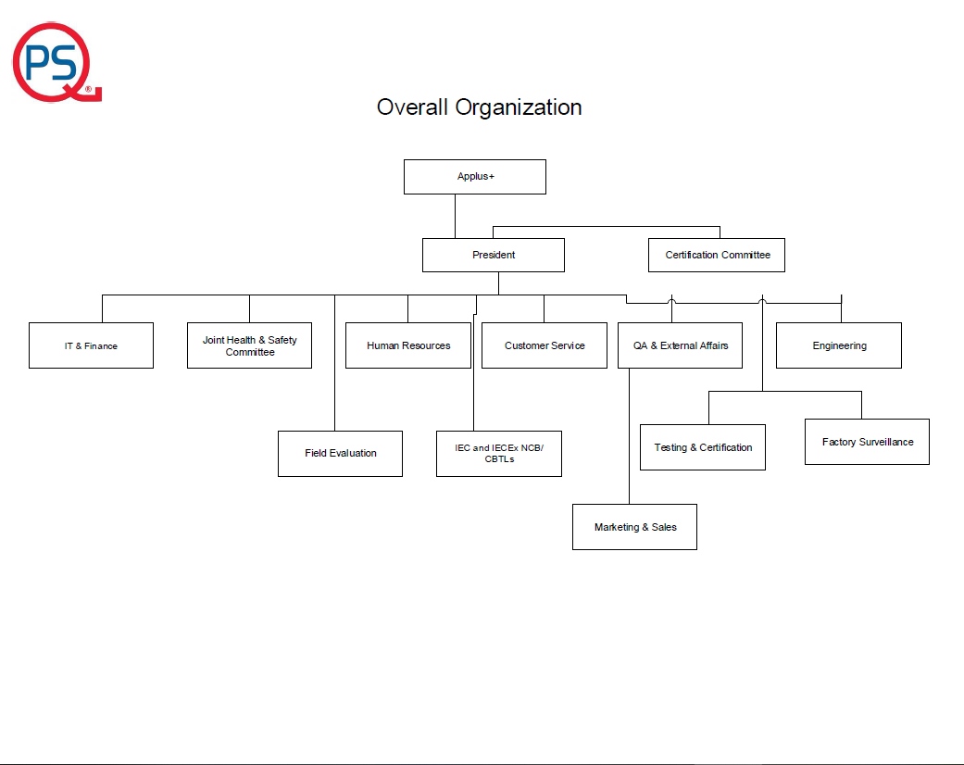

1. Organisation Chart of ExCB/ExTL

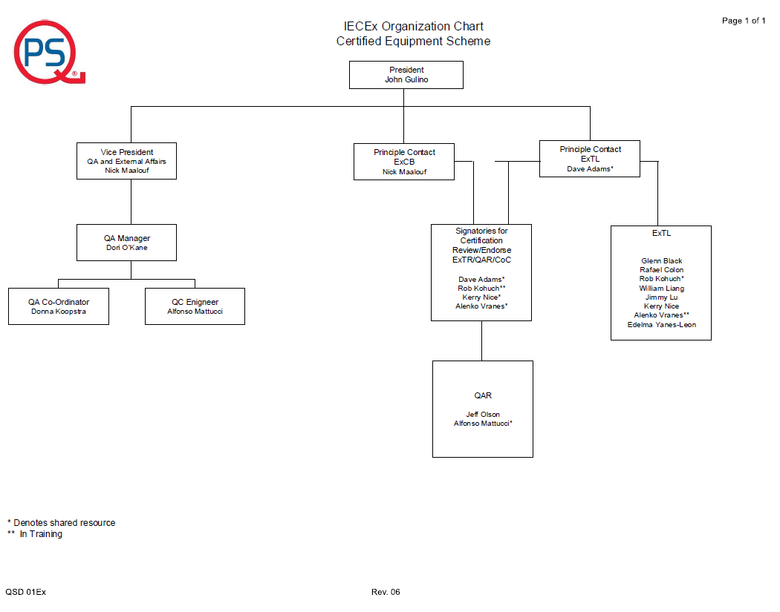

1. Accreditation Certificate for ISO/IEC 17065

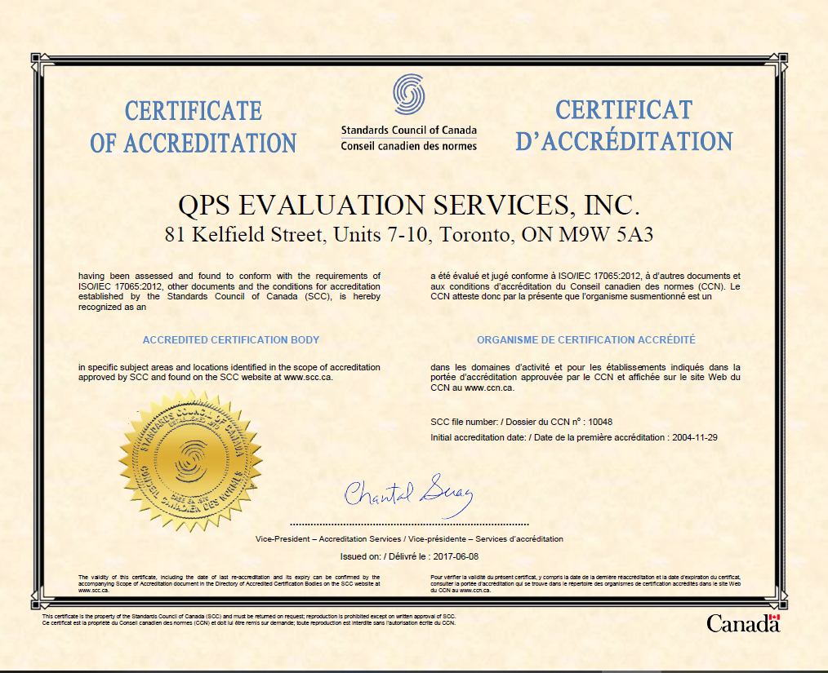

1. Accreditation Certificate for ISO/IEC 17025

