**INTERNATIONAL ELECTROTECHNICAL COMMISSION SYSTEM FOR CERTIFICATION TO STANDARDS RELATING TO EQUIPMENT FOR USE IN EXPLOSIVE ATMOSPHERES (IECEx SYSTEM)**

**TITLE: IECEx Assessment Report for the acceptance of PCEC (Tianjin) Certification Services Co., Ltd, an Accepted Ex Test Laboratory, ExTL, to also become an Accepted Ex Certification Body, ExCB, within the IECEx Equipment Scheme, 02.**

**Circulated to: Ex Management Committee, ExMC**

**INTRODUCTION**

This document contains the IECEx Assessment Report for the acceptance of PCEC (Tianjin) Certification Services Co., Ltd, which is currently an Accepted Ex Test Laboratory, ExTL, to also become an Accepted Ex Certification Body, ExCB, within the IECEx Equipment Scheme, 02.

ExMC Members are requested to consider this Report and the recommendation of the IECEx Assessor for the acceptance of PCEC (Tianjin) Certification Services Co., Ltd as an ExCB for the IECEx 02.

***This document is hereby submitted for ExMC approval via correspondence using the IECEx on-line voting system.  ExMC Members are requested to submit their vote via the IECEx On-line*** [***Ballot System***](https://www.iecex.com/ballot) ***by the closing date 20210926***

***Please refer to OD 050 for guidance on the “IECEx On-line voting system.”***

*Chris Agius*

**IECEx Secretariat**

|  |  |
| --- | --- |
| **IECEx Secretariat**  **Australia Square**  **Level 33, 264 George Street**  **Sydney NSW 2000**  **Australia** | **Tel: +61 2 4628 4690**  **Fax: +61 2 46 27 5285**  **Email: info@iecex.com** |

IEC System for certification to standards relating to equipment for use in Explosive Atmospheres (IECEx System)

IECEx Assessment Report

IECEx assessment report form for use by IECEx assessment teams to report assessments conducted according to the relevant IECEx assessment procedures of:

Operational Document IECEx OD 003-2 for the Certified Equipment Scheme

IECEx ExCB assessment report for

PCEC (Tianjin) Certification Services Co., Ltd

INTERNATIONAL  
ELECTROTECHNICAL  
COMMISSION

CONTENTS

1 Assessment information 5

1.1 Type of body covered by this assessment: 5

1.2 Type of assessment: 5

1.3 Details of body 5

1.3.1 Country 5

1.3.2 Name of body 5

1.3.3 Name and title of nominated principal contact 5

1.4 Assessment information 5

1.4.1 Members of the assessment team 5

1.4.2 Place(s) of assessment 5

1.4.3 Assessment date(s) 6

1.5 Application information and background information on the assessment 6

1.6 Scopes 6

1.6.1 ExCB scope for equipment certification scheme 6

1.6.2 ExTL scope 6

1.6.3 ATF Scope 6

1.6.4 ExCB scope for Service Facilities Scheme 6

1.7 ExCB scope for Conformity Mark Licensing Scheme 6

1.8 ExCB scope for IECEx Personnel Competence Scheme 6

2 Common information 7

2.1 Legal entity of body 7

2.2 Financial support 7

2.3 History 7

2.4 Documentation 7

2.4.1 Quality manual 7

2.4.2 Procedures 7

2.4.3 Work instructions 7

2.4.4 Records (including test records where relevant) 7

2.4.5 Document change control 8

2.5 Confidentiality 8

2.6 Communication with public and customers (Hard copy and Electronic) 8

2.7 Recognitions and agreements 8

2.8 Internal audit 8

2.9 Management review 8

2.10 Contracting, subcontracting and witness testing 9

2.10.1 Contracting 9

2.10.2 Subcontracting 9

2.10.3 Off-site and Witness testing 9

2.11 Training and competence 9

2.12 Complaints and appeals (including appeals to IECEx) 9

2.13 Impartiality 9

2.14 Active involvement in development of Decision Sheets 9

2.15 Special facts to be noted 9

2.16 Supporting documentation 9

2.17 Recommendations 10

3 ExCB for IECEx Certified Equipment Scheme 11

3.1 Assessment references 11

3.1.1 General references 11

3.1.2 Additional references applied for this assessment 11

3.2 Candidate ExCB persons interviewed 11

3.3 Associated ExTL(s) 11

3.4 Associated certification functions 11

3.5 National marks and certificates 12

3.6 Standards accepted 12

3.7 National differences to IEC standards 12

3.8 Organisation 12

3.8.1 Names, titles and experience of the senior executives 12

3.8.2 Name, title and experience of the quality management representative 12

3.8.3 Name and title of signatories for certification 12

3.8.4 Other employees in ExCB activity 12

3.9 Organizational structure 12

3.10 Indemnity insurance 13

3.11 Resources 13

3.12 Committees (such as governing or advisory boards) 13

3.13 Certification operations 13

3.13.1 National approval/certification methods 13

3.13.2 Certification policy 13

3.13.3 Application for certification 13

3.13.4 Certification decision 13

3.13.5 Suspension and cancellation of certificates 14

3.14 Certificates issued 14

3.15 National accreditation 14

3.16 Assessment of manufacturers and issue of QARs 14

3.17 Comments (including issues found during assessment) 14

4 ExTL for IECEx Certified Equipment Scheme 15

5 ATF for IECEx Certified Equipment Scheme 15

6 ExCB for Certified Service Facilities Scheme 15

7 IECEx Conformity Mark Licensing Scheme 15

8 ExCB for IECEx Personnel Competence Scheme 15

9 Annexes 15

Annex A Scope for IECEx Certified Equipment Scheme 16

A.1 Current standards 16

A.2 Superseded standards 17

Annex B Overall Organisation Chart 18

Annex C Organisation Chart of ExCB 19

Annex D Accreditation Certificate for ISO/IEC 17065 20

Annex E Business Licence as Certifying Body 21

# Assessment information

## Type of body covered by this assessment:

|  |  |
| --- | --- |
| ExCB for IECEx Certified Equipment Scheme |  |
| ExTL for IECEx Certified Equipment Scheme |  |
| ATF for IECEx Certified Equipment Scheme |  |
| ExCB for IECEx Certified Service Facilities Scheme |  |
| ExCB for IECEx Conformity Mark Licensing System |  |
| ExCB for IECEx Certification of Personnel Competency Scheme |  |

NOTE 1 ExCB - IECEx Certification Body

NOTE 2 ExTL - IECEx Testing Laboratory

NOTE 3 ATF - Additional Testing Facility

## Type of assessment:

|  |  |
| --- | --- |
| Pre-assessment for candidate body |  |
| Initial assessment for candidate body |  |
| Surveillance |  |
| Re-assessment |  |
| Scope extension |  |

## Details of body

### Country

P.R. China

### Name of body

PCEC (Tianjin) Certification Services Co., Ltd

### Name and title of nominated principal contact

|  |  |  |
| --- | --- | --- |
| Name | Title | E-mail address |
| Mrs Yin Hong | General Manager | yinhong@pcec.com.cn |

## Assessment information

### Members of the assessment team

|  |  |
| --- | --- |
| Name | Role |
| Ajay Maira | IECEx Lead Assessor |
|  |  |

### Place(s) of assessment

|  |  |
| --- | --- |
| No. 85-1, No. 3 Road Hongqiao District Tianjin Post code:300131  P.R. China | Assessment was carried out remotely by web  conference with off-site review of documents in  accordance with OD 060 IECEx Guide for  Business Continuity – Management of  Extraordinary Circumstances or Events Affecting  IECEx Certification Schemes and Activities |

### Assessment date(s)

2021-07-06 to 2021-07-13

## Application information and background information on the assessment

PCEC Tianjin as a candidate CB was founded in October 15, 2018. The business licence issued by local government is provided in Annex E.

The candidate CB established and maintained documentation procedure according to ISO/IEC 17065 since the date of foundation.

The candidate CB is accredited by CNAS (IAF member of the People’s Republic of China) as a product certification body. The certificate is provided in Annex D.

The Certification Body is part of an Institute that also has an IECEx Testing Laboratory operating from the same premises. The agreement between the certification body and testing laboratory has been established on January 1, 2019. The scope of technical Standards is appropriate.

The personnel at PCEC Tianjin have extensive experience from their work history, which includes working in Chinese certification bodies CQM and the IECEx test laboratory. PCEC has operated as an ExTL since 2005, working with CQM as the associated ExCB.

PCEC Tianjin have established a quality management system with adequate procedures, record control, access to competent personnel to conduct Ex manufacturer assessment, review of test reports, and to arrive at an appropriate decision for issuing Ex certificates.

This is their initial application for consideration as an IECEx Certifying body. It was recommended that the assessment be conducted by a single Lead Assessor, to be performed according to IECEx OD 060 by web conferencing means. The remote assessment included the confirmation of application of the latest standards.

.

## Scopes

### ExCB scope for equipment certification scheme

The scope of the IEC Standards for the ExCB is shown in Annex A. This aligns with the scope of the associated ExTL.

### ExTL scope

The scope of this report does not include an assessment of the ExTL. However, it was checked that all the Standards listed for the scope of the ExCB in Annex A are available in the scope of the associated ExTL.

### ATF Scope

The scope of this assessment did not include ATF.

### ExCB scope for Service Facilities Scheme

The scope of this assessment did not include Service Facilities Scheme.

## ExCB scope for Conformity Mark Licensing Scheme

The scope of this assessment did not include Conformity Mark Licensing Scheme.

## ExCB scope for IECEx Personnel Competence Scheme

The scope of this assessment did not include IECEx Personnel Competence Scheme.

# Common information

## Legal entity of body

The business licence issued by local government is provided in Annex E.

## Financial support

The body is established as a self-financing commercial business with revenue from the fees and services charged to customers.

## History

While PCEC Tianjin as a candidate CB was founded in October 15, 2018, it has a long history as part of an institution.

The Centre Tech Tianjin Chemical Research and Design Institute Co Ltd is a large organisation founded in 1958 providing services in waste water treatment and chemicals. Within the institute is “Supervision & Test Centre of Ex-products of China Petroleum & Chemical Industry (PCEC)” that obtained acceptance in as an IECEx TL in 2010.

The candidate CB established a certification body “PCEC (Tianjin) Certification Services Co., Ltd” that has now sought acceptance as an IECEx CB.

## Documentation

### Quality manual

The Quality Manual “Management Manual ZCXH/M-2018” for the certification body is a well presented manual that sets out the description of all the major requirements for the certification body and summarises the processes used to provide all aspects for the Ex certification services to be delivered and found to meet the requirements of the IECEx.

### Procedures

A comprehensive set of procedures were available, and though these were in Mandarin language, pertinent clauses were translated during the audit. These were found to be practical and met the IECEx requirements. The overall procedure ZCXH/ZY-05-2018 provides the information to process applications for manufacturers to obtain IECEx equipment Test Reports, Quality Assessment Reports, IECEx certification. This includes charging a surcharge where manufacturers are located in non IECEx member countries.

Application forms, evaluation records, authorities and responsibilities are referred to in this procedure.

Processes for all other aspects of the quality system at PCEC Tianjin were provided in other procedures, which include management system requirements, document control and record storing, internal audits, corrective and preventive action.

### Work instructions

PCEC quality management system does not set out use of work instructions separately from procedures. The procedures contain sufficient detail for the processes to be followed and records to be prepared and stored, and were found to meet the requirements of the IECEx.

### Records (including test records where relevant)

PCEC have a mainly paper based record retainment system. Records were readily retrieved during the audit.

All job related records are filed with project numbers, and quality system records are filed under the generic headings such as ‘NS’ for ‘Internal Audits’ etc.

Records are stored according to ZCXH/ZY-05-2018 Clause 5.4 for at least 10 years.

For the purpose of this audit, the forms for application from manufacturers, review of application forms, preparation of test plans, forms used for test report preparation, audit report preparation, certificate preparation, review and decision were checked. These were found to comply with IECEx OD 207 Guidance on retention of records.

### Document change control

The Management Manual ZCXH/M-2018 sets out the document change control requirements. Intranet is available with password control for access to the up-to-dated copies of all documents in the quality system to the users, and history of previous documents is held if required in the General Management office as superseded copies.

All Standards are held in a designated computer accessible on the intranet with a password. IECEx Decision Sheets and Operational Documents are similarly controlled. Every 3 months, the Quality Manager updates the documents showing the latest versions of the documents, using the procedure FB/Z-GD0-008-2016.

## Confidentiality

Staff, contractors and members of advisory bodies sign a form “Confidentiality Commitment”. It covers the requirements for confidentiality, impartiality, independence, and acknowledgement of having been provided the relevant PCEC Quality documentation. A number of contracts concerning confidentiality were checked and found to meet the requirements.

## Communication with public and customers (Hard copy and Electronic)

Application form to be used are available ZCXH/ZY-05-T01 "IECEx Equipment Certification Program Application", with adequate information on how to submit the application form. The website link [www.pcec.com.cn](http://www.pcec.com.cn/) is available with the requisite information.

While the internal document ZCXH ZY-05-2018 provides details for internal processes to be followed, the public is generally directed to IECEx Rules and OD’s for the methods to obtain certification.

A formal agreement “Certification contract” with relevant terms and conditions were checked during the audit and found suitable. During progress of the file in “Certification File” with the Application Number (typical number such as “A0202103000179”. When completed, it is stored with the IECEx certificate number.

## Recognitions and agreements

The accreditations for PCEC Tianjin to function as a certifying body under the National schemes is set out in Sections 3.13.1 of this report.

Agreement between PCEC as an IECEx certifying body and PCEC as an IECEx Test Laboratory were reviewed during the audit. The current agreement for PCEC to operate as an ExTL with CQM as ExCB within the IECEx Scheme is also noted.

## Internal audit

Internal audit procedure ZCXH P-06-2018 was available. The use of the procedure was checked by reviewing the audit report dated 2021-05-21. The details completed were satisfactory. The concept of vertical audits was discussed, with the correct understanding of reviewing one report as an example, and checking the sequence of all the processes that were applied. The audits are being conducted on an annual cycle.

## Management review

The relevant Management Review procedure was checked by reviewing the report ZCXH/GLPS-001-2021 conducted on 2021-01-08 and found to be appropriate and found completed correctly.

## Contracting, subcontracting and witness testing

### Contracting

The Management Manual ZCXH/M-2018 provides for the use of contractors.

However, presently there are no contractors for the Ex certification functions.

### Subcontracting

Testing is carried out at the associated integral Ex Testing Laboratory of PCEC.

### Off-site and Witness testing

Where the test item requires that the tests are to be carried out outside the associated ExTL’s laboratory, the procedure ZCXH ZD-19-2018 describes the use of OD 024, the agreement and involvement of the IECEx CB and the customer. It includes the requirements of the IECEx CB to register the site of the testing via the OD 024 On-Line Testing Register.

The test report notes the fact of testing having been carried out outside the normal laboratory premises, when applicable, according to IECEx OD 024.

## Training and competence

The Management Manual ZCXH/M-2018 refers to training and currency of competency. Authorisation and performance evaluation are included in the same procedure.

The list of personnel involved in conformity assessment including review of application, review of technical report, certificate preparation, conducting assessment and preparation of QAR, review of QAR, final decision and publishing of IECEx certificate, are summarised in register Annex Y_CB Competence Matrix IECEx_ 2020.

## Complaints and appeals (including appeals to IECEx)

The Management Manual ZCXH/M-2018 refers to complaints and appeals, and covers the process from identifying and receiving a complaint, assignment of suitable personnel to action the complaint, action taken and informing the customer. “ZCXH/P-04-2018 Quality record control procedure” provides for the retention of records pertaining to the complaints and appeals.

The manufacturer requesting certification signs the “Certification Contract” ZCXH/ZY-05-T06 that provides for the process for the manufacturer to lodge an appeal.

## Impartiality

The Quality Manual and the Quality Policy provide a focus on impartiality by PCEC Tianjin. The Risk Analysis is provided in ZCXH/P-22-2018 that provides an assessment of factors that may affect impartiality. Mitigation process includes training, signing of agreements with the customer, staff, contractors, and use of an independent Impartiality Committee that meets and makes recommendations according to the procedure ZCXH P-21-2018.

## Active involvement in development of Decision Sheets

Procedure ZCXH/ZY-05-2018 refers to commenting on IECEx Decision Sheets and the responsibility to vote on IECEx MC matters when PCEC has been admitted as an IECEx CB.

## Special facts to be noted

None, other than those identified throughout this report.

## Supporting documentation

Copies of additional supporting information for this assessment have been provided to the applicant and the IECEx Secretariat. These are included in a site assessment report or provided separately and include:

* Details of issues raised and how these have been resolved
* Checklist for ISO/IEC 17065
* Information on competencies
* Information on contracting/subcontracting
* Assessors’ notes

## Recommendations

Based on the assessment performed on 2021-07-06 to 2021-07-13 with subsequent discussions and changes in procedures with training provided to the staff, PCEC Tianjin is recommended for acceptance in the IECEx scheme as:

* An ExCB in the IECEx Certified Equipment Scheme

This is according to the scope of the standards listed in this document.

|  |  |
| --- | --- |
| Ajay Maira |  |
| IECEx Lead Assessor |  |

Date: 2021-08-12

# ExCB for IECEx Certified Equipment Scheme

## Assessment references

### General references

1. IECEx 02 IECEx Certified Equipment Scheme covering equipment for use in explosive atmospheres – Rules of Procedure
2. IECEx OD003-2 Assessment, surveillance assessment and re-assessment of ExCBs and ExTLs operating in the IECEx 02, IECEx Certified Equipment Scheme
3. ISO/IEC 80079-34 Explosive atmospheres – Part 34: Application of quality systems for equipment manufacture
4. IECEx OD 009 Issuing of CoCs, ExTRs and QARs
5. IECEx OD 025 Guidelines on the Management of Assessment and Surveillance programs for the assessment of Manufacturer’s Quality Systems in accordance with the IECEx Scheme
6. IECEx OD 026 IECEx Certified Equipment Scheme – Guidelines for the qualification of Lead Auditor and Auditors, in accordance with the IECEx System
7. ISO/IEC 17065 General requirements for bodies operating product certification systems Conformity assessment — Requirements for bodies certifying products, processes and services
8. IECEx OD 107 Harmonised check list for certification bodies ISO/IEC 17065
9. IECEx OD 060 IECEx Guide for Business Continuity – Management of Extraordinary Circumstances or Events Affecting IECEx Certification Schemes and Activities
10. IECEx Technical Capability Document (TCD)
11. ExTAG decision sheets (DSs)

NOTE The latest editions of the above documents were applied, unless otherwise specified

### Additional references applied for this assessment

1. OD 280 IECEx Certified Equipment Scheme –Guide to Certification of Non-Electrical Equipment and Protective Systems
2. OD 233 IECEx Certified Equipment Scheme - Assessment of Ex “s" Equipment

## Candidate ExCB persons interviewed

|  |  |
| --- | --- |
| Name | Position |
| Mr Mu YuQiang | Certification Quality Department and Manufacturer Audit |
| Ms Yang Jinnan | Verification and Audit  International Department |
| Mr Shang Zhikui | Quality Manager |
| Mr Liu Bing | ExTL Technical Manager |
| Mr Pang JianJun | Vice-General Manager |
| Mr Qiao Qin | Verification and Audit  International Department  (Translation) |

## Associated ExTL(s)

PCEC has an integral testing laboratory at the same site. It had been accepted as an IECEx test laboratory in 2005 (ExMC/282/DV).

## Associated certification functions

PCEC have obtained approval as a Chinese certifying body to provide auditing and certification under the CCC scheme.

## National marks and certificates

The CCC certificates are national certification. PCEC Tianjin have achieved accreditation from CNAS. This body conducts annual audits and also witness manufacturer audits conducted by PCEC.

Methods used to provide national accreditation (CCC) based on IECEx assessment and test results has been addressed in procedure “ZCXH/Z-03-2018 Product Certification Process Operation Guide".

## Standards accepted

See Annex A

## National differences to IEC standards

National differences to IEC standards are those for the CCC scheme are listed in the latest version of the IECEx System Bulletin.

## Organisation

### Names, titles and experience of the senior executives

|  |  |  |
| --- | --- | --- |
| Name | Title | Experience (years) |
| Mrs Yin Hong | General Manager | 17 years |
| Mr Shang ZhiKui | Quality Manager | 34 years |
| Mr Pang JianJun | Vice-General Manager | 30 years |

### Name, title and experience of the quality management representative

|  |  |  |
| --- | --- | --- |
| Name | Title | Experience (years) |
| Mr Shang Zhikui | Quality Manager | 34 years |

### Name and title of signatories for certification

|  |  |  |
| --- | --- | --- |
| Name | Title | Comments |
| Mrs Yin Hong | General Manager | QAR, Certificate review and issue |
| Mr Mu YuQiang | Certification Quality Department | QAR, Certificate review |

### Other employees in ExCB activity

|  |  |  |
| --- | --- | --- |
| Name | Title | Experience in Ex (years) |
| Ms Yang Jinnan | Verification and Audit  International Department | 22 years |
| Mr Qiao Qin | Verification and Audit  International Department  (Translation) | 13 years |
|  |  |  |

## Organizational structure

The organisation structure has been presented in Management Manual ZCXH/M-2018 and also the Qualification Matrix showing the roles, competencies and authorities are in register Annex Y_CB Competence Matrix IECEx_ 2020.

## Indemnity insurance

Indemnity insurance policy GI_1677202D121700001 issued on 2020-12-17 was presented at the assessment. It is renewed every year.

## Resources

The certification body functions have been resourced by experienced staff of PCEC Tianjin. These include contact with manufacturers, administration, issuing of information to integral ExTL and reviewing the test reports, conducting regular manufacturer quality assessments as scheduled in the Audit register on the PCEC ERP system, reviewing the QARs issued by other IECEx CB’s using IECEx website, and participation in certification scheme activities.

Procedure ZCXH/ZY-05-2018 provides for the requirements of Ex manufacturer assessments in accordance with IECEx requirements.

## Committees (such as governing or advisory boards)

PCEC have established an independent Impartiality Committee to review their certification functions and offer inputs to the risks on impartiality, independence and confidentiality. A record of the meeting held on 2020-09-12 was reviewed.

## Certification operations

### National approval/certification methods

PCEC have a well prepared documented procedure ZCXH ZD-19-2018 that sets out their methods to provide certificates and QARs. It covers the complete cycle of receipt of application, discussion with the integral ExTL, issue of quotation, preparation of the test plan, receipt and review of the completed Ex test report, implementation of manufacturer assessment and review of QAR, review of certificate draft and issue, with subsequent implementation of the surveillance assessment of the manufacturer. The requirements to issue Unit Verification certificates were addressed too.

### Certification policy

The Quality Policy in the Management Manual was provided and was reviewed for adequacy to provide certification under the IECEx 02 Certified Equipment Scheme. The policy provides for impartiality, management responsibility, maintenance of independence and confidentiality, using documented certification schemes.

### Application for certification

Application form ZCXH/ZY-05-T01 is available in the Quality System and will be placed on the PCEC website. It was reviewed for completeness of information required to prepare a quotation to certification, including statutory signature from the manufacturer with declaration of their responsibility and ownership of their design.

A test plan is prepared by the ExCB in association with the ExTL, as provided in the procedure ZCXH ZD-19-2018.

### Certification decision

The procedure ZCXH ZD-19-2018 sets out the requirements of review of ExTR, ExQAR and the necessary documents from the manufacturer for the authorised personnel listed in register Annex Y_CB Competence Matrix IECEx_ 2020 to make the certification decision.

A certificate review form ZCXH/ZY-05-T06 was provided and it covers the essential items in the IECEx certificate that shall be reviewed prior to the certificate decision. The form is called up in the procedure ZCXH ZD-19-2018.

Control over the documents submitted by the manufacturer for compliance assessments is established by rubber stamp on the paper copy of the relevant drawings that are listed in the Ex test report, and forwarding to the manufacturer as a basis of manufacture of certified products.

### Suspension and cancellation of certificates

The requirements and conditions for suspension and cancellation of certificates is provided in the procedure ZCXH ZD-19-2018 and also in the agreement with the manufacturer in ZCXH/ZY-05-T01.

## Certificates issued

PCEC have issued national CCC certificates (see table below),

|  |  |  |  |
| --- | --- | --- | --- |
| Standard numbers | Type of protection or other identifying information | Number of issued certificates (for last 2 years) | |
| 2019 | 2020 |
| IEC 60079-1 | Types of protection ‘d’ | 137 | 426 |
| IEC 60079-2 | Types of protection ‘p’ | 1 | 1 |
| IEC 60079-7 | Types of protection ‘e’ | 72 | 124 |
| IEC 60079-11 | Types of protection ‘i’ | 33 | 246 |
| IEC 60079-15 | Type of protection ‘n’ | 7 | 4 |
| IEC 60079-18 | Type of protection ‘m’ | 12 | 17 |
| IEC 60079-31 | Type of protection ‘t’ | 85 | 167 |
| IEC 61241-11 | Types of protection ‘iD’ | 5 | 17 |

NOTE Above include certificates to IEC 60079-0

## National accreditation

The national accreditation certification for ISO/IEC 17065 obtained from CNAS is shown in Annex D. The scope of Standards is extensive and includes the Standards listed in Annex A. The detailed list has been provided to IECEx secretariat.

National accreditation will be limited to CCC scheme. Discussions were held and confirmed that IECEx scheme will not be under the CNAS national accreditation, in accordance with the IECEx document ExMC/1606/Inf.

## Assessment of manufacturers and issue of QARs

PCEC have a panel of well qualified assessors to conduct manufacturer quality system assessments. A sample of a completed QAR was provided at this assessment. Evidence of compliance for the various clauses of the QAR were found completed satisfactorily. The panel of assessors were interviewed and discussions on further enhancement of assessments were readily adopted.

Application of OD 060 for extraordinary circumstances was provided in procedure ZCXH/ZY-05-2018 and found in compliance to manage such circumstances.

## Comments (including issues found during assessment)

PCEC submitted a comprehensive application. Further documents were sought prior to the assessment dates and these were found well prepared and some English translations were available. During the assessment, several clarifications were sought, included clarification on the scope of the Standards, introduction of a non-compliance register to summarise action on complaints, revisions to the Ex certification application form, revisions to the certification procedure. All issues were cleared to the satisfaction of the assessor.

# ExTL for IECEx Certified Equipment Scheme

Not in the scope of this assessment.

# ATF for IECEx Certified Equipment Scheme

Not in the scope of this assessment.

# ExCB for Certified Service Facilities Scheme

Not in the scope of this assessment.

# IECEx Conformity Mark Licensing Scheme

Not in the scope of this assessment.

# ExCB for IECEx Personnel Competence Scheme

Not in the scope of this assessment.

# Annexes

See Contents.

1. Scope for IECEx Certified Equipment Scheme
   1. Current standards

| **Number** | **Title** |  |
| --- | --- | --- |
| IEC 60079-0  Edition 7.0 | Explosive atmospheres -  Part 0: Equipment - General requirements |  |
| IEC 60079-1  Edition 7.0 | Explosive atmospheres -  Part 1: Equipment protection by flameproof enclosures 'd' |  |
| IEC 60079-2  Edition 6.0 | Explosive atmospheres -  Part 2: Equipment protection by pressurized enclosures 'p'f |  |
| IEC 60079-5  Edition 4.0 | Explosive atmospheres -  Part 5: Equipment protection by powder filling 'q' |  |
| IEC 60079-6  Edition 4.1 | Explosive atmospheres -  Part 6: Equipment protection by oil immersion 'o' |  |
| IEC 60079-7  Edition 5.1 | Explosive atmospheres -  Part 7: Equipment protection by increased safety 'e' |  |
| IEC 60079-11  Edition 6.0 | Explosive atmospheres -  Part 11: Equipment protection by intrinsic safety 'i' |  |
| IEC 60079-13  Edition 2.0 | Explosive atmospheres –  Part 13: Equipment protection by pressurized room "p" |  |
| IEC 60079-15  Edition 5.0 | Explosive atmospheres –  Part 15: Equipment protection by type of protection "n" |  |
| TR 60079-16  Edition 1.0 | Electrical apparatus for explosive gas atmospheres -  Part 16: Artificial ventilation for the protection of analyser (s) houses |  |
| IEC 60079-18  Edition 4.1 | Explosive atmospheres –  Part 18: Equipment protection by encapsulation "m" |  |
| IEC 60079-25  Edition 3.0 | Explosive atmospheres –  Part 25: Intrinsically safe electrical systems |  |
| IEC 60079-26  Edition 3.0 | Explosive atmospheres -  Part 26: Equipment with equipment protection level (EPL) Ga |  |
| IEC 60079-28  Edition 2.0 | Explosive atmospheres -  Part 28: Protection of equipment and transmission systems using optical radiation |  |
| IEC/IEEE 60079-30-1  Edition 1.0 | Explosive atmospheres -  Part 30-1: Electrical resistance trace heating - General and testing requirements |  |
| IEC 60079-31  Edition 2.0 | Explosive atmospheres -  Part 31: Equipment dust ignition protection by enclosure "t" |  |
| IEC 60079-33  Edition 1.0 | Equipment protection by special protection 's' |  |
| IS0 80079-36  Edition 1.0 | Non-electrical equipment for explosive atmospheres - Basic method and requirements |  |
| ISO 80079-37  Edition 1.0 | Non-electrical equipment for explosive atmospheres - Non electrical type of protection constructional safety "c", control of ignition source "b", liquid immersion "k" |  |

* 1. Superseded standards

The following superseded standards may form part of a body’s scope, generally for historical reasons.

| Number | Title | Comments |
| --- | --- | --- |
| IEC 60079-27  Edition 2.0 | Explosive atmospheres – Part 27: Fieldbus intrinsically safe concept (FISCO) |  |
| IEC 61241-0  Edition 1.0 | Electrical apparatus for use in the presence of combustible dust - Part 0: General requirements |  |
| IEC 61241-1  Edition 1.0 | Electrical apparatus for use in the presence of combustible dust - Part 1: Protection by enclosure “tD” |  |
| IEC 61241-4  Edition 1.0 | Electrical apparatus for use in the presence of combustible dust - Part 4: Protection by pressurization "pD" |  |
| IEC 61241-11  Edition 1.0 | Electrical apparatus for use in the presence of combustible dust – Part 11: Protection by intrinsic safety 'iD' |  |
| IEC 61241-18  Edition 1.0 | Electrical apparatus for use in the presence of combustible dust - Part 18: Protection by encapsulation "mD" |  |

1. Overall Organisation Chart

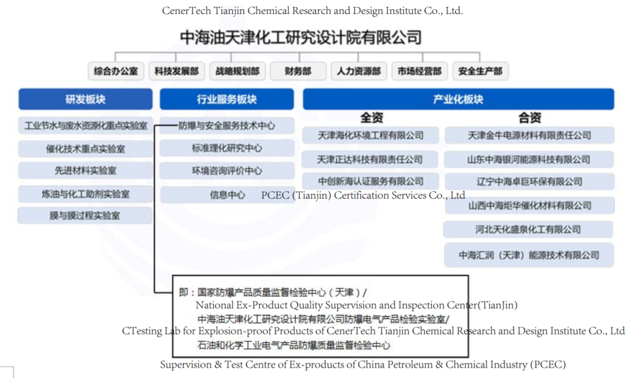

1. Organisation Chart of ExCB

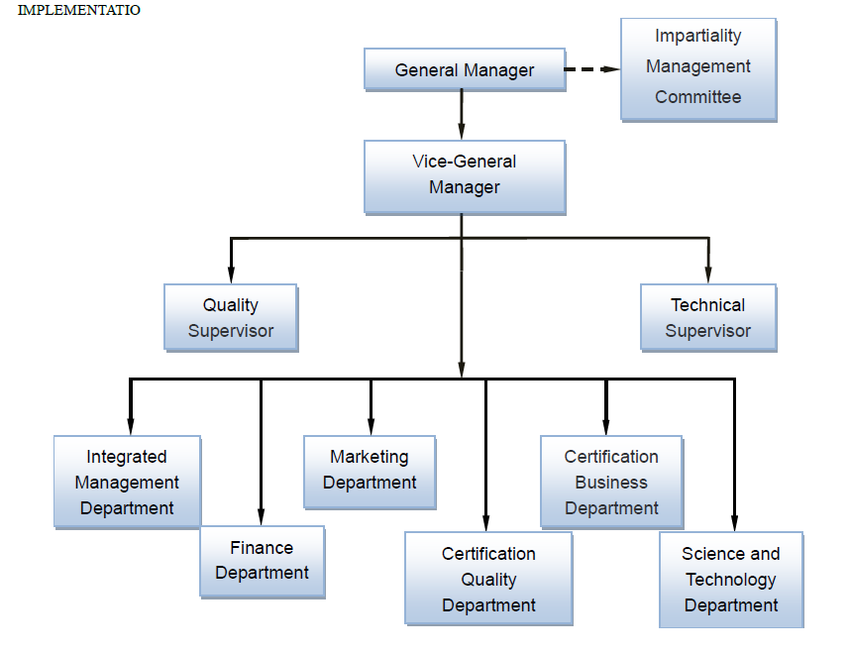

1. Accreditation Certificate for ISO/IEC 17065

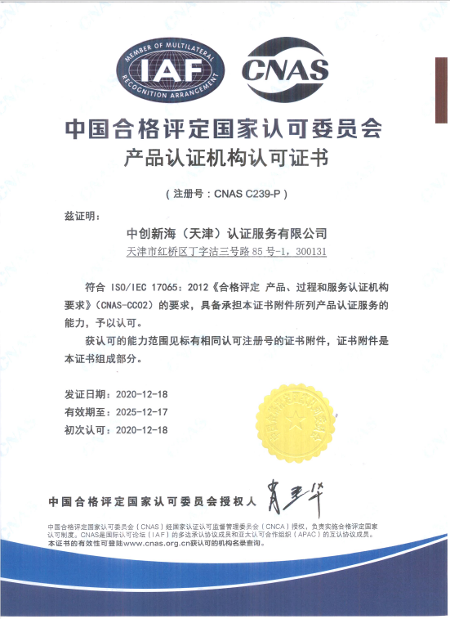

1. Business Licence as Certifying Body

 