**INTERNATIONAL ELECTROTECHNICAL COMMISSION (IEC) SYSTEM FOR CERTIFICATION TO STANDARDS RELATING TO EQUIPMENT FOR USE IN EXPLOSIVE ATMOSPHERES (IECEx SYSTEM)**

**Title: Discussion Document – Increasing Ambient Temperatures**

**Circulated to: ExTAG – IECEx Testing and Assessment Group**

**INTRODUCTION**

This document, prepared by Mr Justin Gavranich of Ex Testing and Certification AU, after consultation with a number of interested parties from AU, TC31 and IECEx, is presented as a discussion paper for the purposes of starting a discussion within the ExTAG on possible future impacts that changes in ambient temperatures, arising from effects of climate changes, may have on the testing and certification of Ex Equipment.

ExTAG Members are requested to note this document and be prepared for a brief discussion during the 2021 ExTAG meeting.

|  |
| --- |
| **Address:**  **IECEx Secretariat**  **Level 33 Australia Square**  **264 George Street**  **Sydney NSW 2000**  **Australia**  **Web:** **www.iecex.com** |

**ExTAG Discussion Paper:** **Increasing Ambient Temperatures**

**Question:** Considering global climate change, is -20°C to +40°C sufficient as a default ambient temperature range for IECEx certified Ex equipment?

**Background:**

Heatwaves and peak ambient temperatures are not new, but the global climate data shows that the peaks, frequency and duration of these events has increased. (1) (2). These trends are set to continue with the latest IPCC report indicating the global climate is on a worst-case trajectory for future projections. We are already seeing temperatures well above 40°C for longer periods in many parts of the world where such temperatures were unrecorded a few years ago.

The IEC is working towards the United Nations Sustainable Development Goals noting that International Standards and conformity assessment should play a significant role. Considering SDG 13 for taking action to combat the impacts of climate change, the IEC has identified that the IECEx as a conformity assessment scheme as able to support this goal.

The suggestion is that both IEC TC 31 and IECEx play a role in preparing the market for these challenges rather than be unprepared for questions that may arise in the future. The issue is also noted for discussion in IEC TC 31 to consider future changes in standards prepared by TC 31.

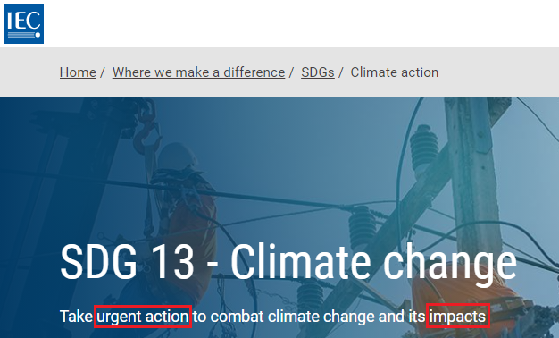

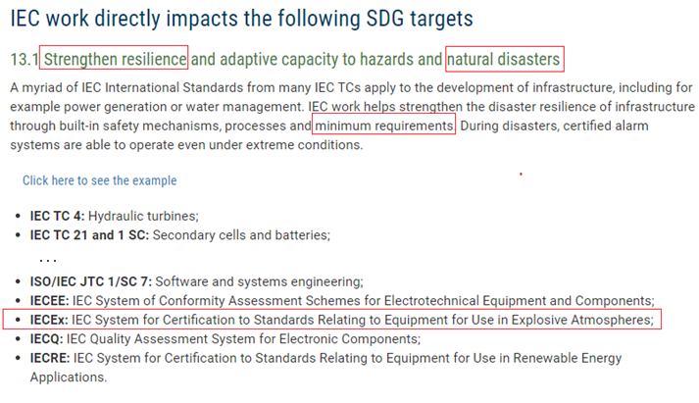

Extracts from IEC Website (3)

Recent Heatwave Examples:

|  |  |
| --- | --- |
|  | 2021 Heatwave in Northwestern USA and Western Canada - Air temperature anomalies across North America on June 27, 2021, compared to 2014–2020 baseline (4) |
| Climate analyser  2021 Heatwave in Northwestern USA and Western Canada (5) | |

While many parts of the world are experiencing temperatures approaching 50 °C the trend is still upwards, and more parts of the world are likely to exceed this in the next few years. Middle Eastern and North African countries, China, Australia and even the USA have already recorded ambient temperatures above 50 °C.

IEC 60079-0 Edition 7.0:

The scope specifies the standard atmospheric conditions for temperature as -20°C to +60 °C.

Clause 5.1.1 details the normal ambient temperature range as -20°C to +40°C which does not require marking. Equipment specified with an ambient temperature outside of this range is considered to be special and is required to be marked accordingly.

**Initial Discussions points:**

* Significant quantity of Ex equipment marked with an IECEx certificate number may be operating outside of the assessed ambient temperature range during heatwave events.

Who will be bearing the responsibility if things go wrong at increasing rates?

Will the market confidence in the IECEx 02 scheme be affected?

* ExTAG could consider specifying a minimum recommended ambient temperature range of -20°C to +50°C via an ExTAG Decision sheet (non-mandatory to remain compliant with IEC 60079-0).
* An option could be included on all ExCB application forms “IECEx minimum recommended Ambient Temperature -20°C to +50°C”
* ExTAG could consider requiring the ambient temperature to be displayed on all new IECEx COC even when it is -20°C to +40°C.
* ExTAG could consider revising the structure of the IECEx COC to display the ambient temperature of the equipment more consistently via a special field in the IECEx online COC system.
* What are the market trends? Is the market already heading in the direction? Valuable trend data might be a percentage of new COC issued over past 5 years exceeding the default ambient temperature range of -20°C to +40°C. Is it possible for the IECEx secretariat collate some data for further discussion and potentially passing this onto TC 31?

# Bibliography

1. *IPCC, 2021: Summary for Policymakers. In: Climate Change 2021: The Physical Science Basis. Contribution of Working Group I to the Sixth Assessment Report of the Intergovernmental Panel on Climate Change.* **Masson-Delmotte, V., P. Zhai, A. Pirani, S. L. Connors, C. Péan, S. Berger, N. Caud, Y. Chen, L. Goldfarb, M. I. Gomis, M. Huang, K. Leitzell, E. Lonnoy, J.B.R. Matthews, T. K. Maycock, T. Waterfield, O. Yelekçi, R. Yu and B. Zhou eds.** s.l. : Cambridge University Press, 2021.

2. *Heatwaves intensification in Australia: A consistent trajectory across past, present and future,.* **Ralph Trancoso, Jozef Syktus, Nathan Toombs, David Ahrens, Kenneth Koon-Ho Wong, Ramona Dalla Pozza.** s.l. : Science of The Total Environment, 2020, Science of The Total Environment Volume 742, Vol. Volume 742. ISSN 0048-9697.

3. **IEC Website.** SDG 13 - Climate change. *International Electrotechnical Commission.* [Online] 2021. [Cited: August 17, 2021.] https://www.iec.ch/sdg/sdg13 .

4. **NASA Earth Observatory image by Joshua Stevens, using GEOS-5 data from the Global Modeling and Assimilation Office at NASA GSFC, and data courtesy of Joalda Morancy/NASA/JPL-Caltech and the ECOSTRESS science team. Story by Kathryn Hansen.** Exceptional Heat Hits Pacific Northwest. *The Earth Observatory.* [Online] 2021. [Cited: August 17, 2021.] https://earthobservatory.nasa.gov/images/148506/exceptional-heat-hits-pacific-northwest?src=ve.

5. **World Meteorological Organization (WMO).** News: June ends with exceptional heat,"[Data/Image] from Climate Reanalyzer (https://ClimateReanalyzer.org), Climate Change Institute, University of Maine, USA.". *World Meteorological Organization (WMO).* [Online] 2021. [Cited: August 17, 2021.] https://public.wmo.int/en/media/news/june-ends-exceptional-heat.