**INTERNATIONAL ELECTROTECHNICAL COMMISSION SYSTEM FOR CERTIFICATION TO STANDARDS RELATING TO EQUIPMENT FOR USE IN EXPLOSIVE ATMOSPHERES (IECEx SYSTEM)**

**TITLE: Re-assessment Report for the continued acceptance of China National Quality Supervision and Test Centre for Explosion Protected Electrical Products (CQST), CN, an Accepted ExTL within the IECEx Equipment Scheme 02.**

**Circulation to: Members of the IECEx Management Committee, ExMC**

**INTRODUCTION**

In accordance with the 5 year re-assessment plan for the surveillance and monitoring of bodies within the IECEx System, the following document contains the IECEx Re-assessment Report for the continued acceptance of China National Quality Supervision and Test Centre for Explosion Protected Electrical Products (CQST), CN, an Accepted ExTL in the IECEx Scheme, IECEx 02.

This report is hereby submitted for endorsement during the ExMC 2022 Meeting.

***Chris Agius***

**IECEx Secretariat**

|  |  |
| --- | --- |
| **IECEx Secretariat**  **Australia Square**  **Level 33, 264 George Street**  **Sydney NSW 2000**  **Australia** | **Tel: +61 2 4628 4690**  **Fax: +61 2 4625 3480**  **Email: chris.agius@iecex.com** |

IEC System for certification to standards relating to equipment for use in Explosive Atmospheres (IECEx System)

IECEx Assessment Report Form, F-003

IECEx assessment report form for use by IECEx assessment teams to report assessments conducted according to the relevant IECEx assessment procedures of:

Operational Document IECEx OD 003-2 for the Certified Equipment Scheme

Operational Document IECEx OD 316-* for the Certified Service Facility Scheme

Operational Document IECEx OD 422 for the IECEx Conformity Mark Licensing Scheme

Operational Document IECEx OD 501 for the Personnel Competence Scheme

IECEx ExTL assessment report for

China National Quality Supervision and Test Centre for Explosion Protected Electrical Products (CQST)

INTERNATIONAL  
ELECTROTECHNICAL  
COMMISSION

CONTENTS

(Update when report is complete – by right click, Update field, Update entire table)

1 Assessment information 5

1.1 Type of body covered by this assessment: 5

1.2 Type of assessment: 5

1.3 Details of body 5

1.3.1 Country 5

1.3.2 Name of body 5

1.3.3 Name and title of nominated principal contact 5

1.4 Assessment information 5

1.4.1 Members of the assessment team 5

1.4.2 Place(s) of assessment 5

1.4.3 Assessment date(s) 6

1.5 Application information and background information on the assessment 6

1.6 Scopes 6

1.6.1 ExCB scope for equipment certification scheme 6

1.6.2 ExTL scope 6

1.6.3 ATF Scope 6

1.6.4 ExCB scope for Service Facilities Scheme 6

1.7 ExCB scope for Conformity Mark Licensing Scheme 6

1.8 ExCB scope for IECEx Personnel Competence Scheme 6

2 Common information 7

2.1 Legal entity of body 7

2.2 Financial support 7

2.3 History 7

2.4 Documentation 7

2.4.1 Quality manual 7

2.4.2 Procedures 7

2.4.3 Work instructions 7

2.4.4 Records (including test records where relevant) 8

2.4.5 Document change control 8

2.5 Confidentiality 8

2.6 Communication with public and customers (Hard copy and Electronic) 8

2.7 Recognitions and agreements 8

2.8 Internal audit 8

2.9 Management review 9

2.10 Contracting, subcontracting and witness testing 9

2.10.1 Contracting 9

2.10.2 Subcontracting 9

2.10.3 Off-site and Witness testing 9

2.11 Training and competence 9

2.12 Complaints and appeals (including appeals to IECEx) 9

2.13 Impartiality 9

2.14 Active involvement in development of Decision Sheets 9

2.15 Special facts to be noted 10

2.16 Supporting documentation 10

2.17 Recommendations 10

3 ExCB for IECEx Certified Equipment Scheme 11

4 ExTL for IECEx Certified Equipment Scheme 12

4.1 Assessment references 12

4.1.1 General references 12

4.1.2 Additional references applied for this assessment 12

4.2 Candidate ExTL persons interviewed 12

4.3 Associated ExCB(s) 12

4.4 Organisation 12

4.4.1 Names, titles and experience of the senior executives 12

4.4.2 Name, title and experience of the quality management representative 14

4.4.3 Other employees in ExTL activity 15

4.5 Organizational structure 15

4.6 Resources 15

4.7 Test reports issued 15

4.8 National accreditation 16

4.9 Calibration 16

4.10 Tests witnessed during the assessment visit 16

4.11 Participation in IECEx Proficiency Testing Programs 17

4.12 Comments (including issues found during assessment) 17

5 ATF for IECEx Certified Equipment Scheme 18

6 ExCB for Certified Service Facilities Scheme 18

7 IECEx Conformity Mark Licensing Scheme 18

8 ExCB for IECEx Personnel Competence Scheme 18

9 Annexes 18

Annex A Scope for IECEx Certified Equipment Scheme 19

A.1 Current standards 19

A.2 Superseded standards 20

Annex B Overall Organisation Chart 21

Annex C Organisation Chart of ExCB/ExTL 22

Annex D Accreditation Certificate for ISO/IEC 17065 23

Annex E Accreditation Certificate for ISO/IEC 17025 27

Annex F Accreditation Certificate for ISO/IEC 17024 28

# Assessment information

## Type of body covered by this assessment:

|  |  |
| --- | --- |
| ExCB for IECEx Certified Equipment Scheme |  |
| ExTL for IECEx Certified Equipment Scheme |  |
| ATF for IECEx Certified Equipment Scheme |  |
| ExCB for IECEx Certified Service Facilities Scheme |  |
| ExCB for IECEx Conformity Mark Licensing System |  |
| ExCB for IECEx Certification of Personnel Competency Scheme |  |

NOTE 1 ExCB - IECEx Certification Body

NOTE 2 ExTL - IECEx Testing Laboratory

NOTE 3 ATF - Additional Testing Facility

## Type of assessment:

|  |  |
| --- | --- |
| Pre-assessment for candidate body |  |
| Initial assessment for candidate body |  |
| Surveillance |  |
| Re-assessment |  |
| Scope extension |  |

## Details of body

### Country

People's Republic of China

### Name of body

This re-assessment was for the ExTL: China National Quality Supervision and Test Centre for Explosion Protected Electrical Products (CQST).

### Name and title of nominated principal contact

|  |  |  |
| --- | --- | --- |
| Name | Title | E-mail address |
| Mr. Jun Wang | Director of CQST | wangjun@cn-ex.com |

## Assessment information

### Members of the assessment team

|  |  |
| --- | --- |
| Name | Role |
| Ajay Maira | IECEx Lead Assessor |

### Place(s) of assessment

|  |  |
| --- | --- |
| 20 North Zhongjing Road  Nanyang City  Henan Province  People's Republic of China | **By remote using webconferencing** |

### Assessment date(s)

16 to 23 March 2021

## Application information and background information on the assessment

Desk top review was conducted by IECEx secretariat prior to this assessment. It was recommended that the re-assessment be conducted by a single Lead Assessor with prior experience with the test facility, and performed according to IECEx OD 060 by web conferencing means. The assessment included the confirmation of the application of the latest standards requested by the test laboratory.

## Scopes

### ExCB scope for equipment certification scheme

The associated ExCB is: Nanyang Explosion Protected Electrical Apparatus Research Institute Co., Ltd (CNE). The scope of the Standards within the scope of the ExCB is shown in Annex A. CNE is owned by the same organisation as CQST, and is located at the same premises as CQST.

### ExTL scope

The scope of the ExTL CQST is the same as for the ExCB CNE and is shown in Annex A.

### ATF Scope

Not applicable

### ExCB scope for Service Facilities Scheme

Not applicable

## ExCB scope for Conformity Mark Licensing Scheme

Not applicable.

## ExCB scope for IECEx Personnel Competence Scheme

Not applicable

# Common information

## Legal entity of body

CQST has presented a Business License issued by National Enterprise Credit Information Publicity System ([www.gsxt.gov.cn](http://www.gsxt.gov.cn)) showing the legal name of CQST “Nanyang Explosion Protected Electrical Apparatus Research Institute Company Limited” at No. 20 North Zhongjing Road, Nanyang City, Henan, China with Uniform Social Credit Code 9141130041904693X0 as a Limited Liability Company with term of validity Sep 30, 2006 to Sep 29, 2038.

The scope includes explosion-proof safety inspection, testing and certification.

## Financial support

The operation is completely self-supporting by the income from testing.

## History

In 1958 the predecessor of CNE/CQST was founded in northeast China as Research House of Ex-motor of First Machinery Industrial Department. In 1970, it moved to Nanyang as the Nanyang Explosion Protected Electrical Apparatus Research Institute (CNEx), becoming a State owned explosion protection research institute and establishing an Ex-Testing Station. In 1977, the first formal China National Standards (GB-1336-77) were drawn up. In 1995, Ex-Testing Station of CNEx was approved as China National Test Center for Explosion Protected Electrical Products (CQST), representing China to carry out science research, testing, certification, quality supervision and other management functions. In 1999 CQST was recommended as China ExTL for the IECEx Scheme by General Administration of Quality Supervision, Inspection and Quarantine of the People’s Republic of China (AQSIQ). In 2007, Nanyang Key Laboratory of Explosion Protection & Fire Prevention was set up, which takes the legal entity of CQST.

In 2010, CQST was accepted as an IECEx TL with the associated IECEx CB being CQM. In 2018, CNE which has the same ownership as CQST was accepted as an IECEx CB. CNE is currently under annual IECEx surveillance, while CQST has the 5 yearly re-assessment cycle.

## Documentation

### Quality manual

CQST has a comprehensive manual CNEX CQST-QM-2018 addressing all the elements of ISO/IEC 17025:2017 and IECEx requirements. The quality system consists of the following levels:

* Quality Manual (CQST-QM)
* Procedures (CQST-QP)
* Working Instruction (CQST-ZD)

There are supporting Technical Records and Forms (CQST-TR) and Management Records and Forms (CQST-MR)

All levels were partially reviewed during the assessment. The requirements of IECEx are met.

### Procedures

Procedures are described in CQST-QP-documents. These are listed in CQST-QM-0.1-2018. Several procedures were reviewed during the assessment and found to meet the requirements of IECEx.

### Work instructions

CQST has operation instructions (Working Instruction) for the technical work. These are listed in CQST-QM-0.1-2018. A sample of the operation instructions were used and checked during the witness testing and found to meet the requirements of IECEx.

### Records (including test records where relevant)

CQST retain detailed test records on file. Requirements are covered in Procedure for Control Recording CQST-QP-11-2018. A sample of completed records were reviewed in detail during the assessment and found to meet the requirements of IECEx.

.

### Document change control

Document change control is covered in CQST-QP-03-2018. Each document has an issue number. All documents reviewed were in compliance with the CQST procedure.

An assigned person collects IEC standards and IECEx information. They also receive notification of new or changed documents from CQM.

## Confidentiality

Confidentiality is described in procedure CQST-QP-01-2018. Each member of staff signs a

confidentiality agreement. The were found to meet the requirements of the IECEx.

## Communication with public and customers (Hard copy and Electronic)

This is generally through the CQST website (<http://www.china-ex.com/english>) with subsequent communication by email ([cqst@cn-ex.com](mailto:cqst@cn-ex.com)) and phone (+86 377 63258564).

## Recognitions and agreements

CQST has signed a Product Testing Implementation agreement with Presafe/DNV/Nemko Norway for acceptance of test and manufacturer audit results.

It is an associated ExTL for CNEX Global.

CQST has a signed contract with CQM China Quality Mark Certification Group Co Ltd Beijing for obtaining IECEx certification activities.

CQST (and also CNE) have signed Memorandum of Understanding with UL for acceptance of test data.

CQST has signed Memorandum of Understanding with TestSafe Australia for acceptance of test data.

CQST has signed Memorandum of Understanding with Ineris France for acceptance of test data.

CQST has signed a Product Testing Implementation agreement with VTT Finland for acceptance of test and manufacturer audit results.

CQST has signed agreement with Nanio-CCVE Russia for acceptance of test data.

CNE has signed agreements with SGS Baseefa to provide training and accept auditor reports for obtaining CCC Ex product certificates.

CQST has signed a mutual agreement with SIRA for acceptance of test results.

## Internal audit

Internal audit is covered by procedure CQST-QP-12-2018. The Quality Manual specifies that audit to be conducted once a year. There is a plan for the audits that covers all the main requirements of ISO/IEC17025 and each of the areas of CQST. Detailed technical procedure audits are also carried out. A summary is produced of the audits indicating where the need for corrective action has been identified. An example report of an internal audit on Ex d motor conducted on 2020-04-10 was sighted. Audit of clauses of 17025 conducted n 2020-09-24 was also sighted. Non-conformance reports were completed. NCR register was available.The internal audit plan was found to meet the requirements of the IECEx.

## Management review

Management review is covered in procedure CQST-QP-13-2018. The review is presided over by the Director. The minutes for meeting of 2021-02-02 were sighted.

The records included minutes, with agenda including results of external audits, and recommendations for improvements in the organizational structure to improve speed of delivery of services.

## Contracting, subcontracting and witness testing

### Contracting

CQST does not use any external contractors.

### Subcontracting

CQST does not use any subcontracting for IECEx testing.

### Off-site and Witness testing

The procedure is provided in CNEX CQST-QP-23-2018 Edition 9. Witness Testing Agreement template CNEx-CB-AG-… was available. Example of an agreement dated 2019-03-01 was sighted. IECEx OD 024 is referenced and incorporated in the procedure. Contracts are put into place with the manufacturer and information is updated in the register maintained by IECEx secretariat. The IECEx test report template indicates when there has been witness testing.

## Training and competence

The laboratory is well resourced with skilled and competent staff working in excellent facilities and comprehensive procedures.

Document CQST_Competence Matrix IECEx_2017.11.07 Final shows the competence of the staff at CQST and CNE to carry out their assigned scope and competencies.

Details of staff competencies are included in the site assessment report.

## Complaints and appeals (including appeals to IECEx)

CNEX CQST-QP-07-2018 is the procedure for complaints. The procedure was reviewed and found to meet the requirements of the IECEx. If an appeal is made by the applicant / manufacturer and is not able to be resolved using the Quality system, the complainant has the right for the appeal to be made to the independent Impartiality Committee of CNE. No complaint was received concerning IECEx

## Impartiality

CNEX CQST-QM-0.4-2018 is the procedure for Declaration of Impartiality and ensures full impartiality and credibility of the provided service. A completed form signed by several staff was provided as evidence.

## Active involvement in development of Decision Sheets

Staff are well versed in the application of IECEx Decision Sheets during their test and report preparation. Draft TAG decision sheets are circulated amongst the concerned staff and responses are directed towards the China government organisation CQM for discussion amongst all Chinese ExTesting laboratories and the formed opinion is then sent back to IECEx by CNE.

Several examples of ExTAG decision sheets proposed by CQST were provided as evidence f the involvement. “Flowchart for ExTAG Decision Sheet circulation inside CNEX” CQST-MR-GJ-001-A1-2021” has been provided.

## Special facts to be noted

This IECEx assessment examined several issued IECEx test reports, as was required within the scope of the ExTL assessment of CQST, but additionally also examined IECEx certificates issued by CNE based on the reports prepared by CQST.

## Supporting documentation

Copies of additional supporting information for this assessment have been provided to the applicant and the IECEx Secretariat. These are included in a site assessment report or provided separately and include:

* Details of issues raised and how these have been resolved
* Checklist for ISO/IEC 17065
* Checklist for ISO/IEC 17025
* Completed Technical Capability Document (TCD)
* Photos of the facilities/tests witnessed are included in the above TCD
* Information on competencies
* Assessors’ notes
* Other

## Recommendations

Based on the assessment performed on 16 to 23 March 2021, CQST is recommended for continued acceptance in the IECEx scheme as:

* An ExTL in the IECEx Certified Equipment Scheme

This is according to the scope of the standards listed in this document (including the extension of scope).

|  |  |  |
| --- | --- | --- |
| Ajay Maira |  |  |
| IECEx Lead Assessor |  |  |

Date: 2021-08-26

# ExCB for IECEx Certified Equipment Scheme

While the associated IECEx CB, CNE, is owned by the same body as the IECEx TL CQST, this assessment did not include the IECEx CB as that is subject to annual assessment, as agreed between IECEx Secretariat and CQST

However, it was noted that CNEX does have accreditation as a Product Certification Body (Registration No. CNAS C208-P) from China National Accreditation Service for Conformity Assessment, a recognised body that is member of IAF.

# ExTL for IECEx Certified Equipment Scheme

## Assessment references

### General references

1. IECEx02 IECEx Certified Equipment Scheme covering equipment for use in explosive atmospheres – Rules of Procedure
2. IECEx OD003-2 Assessment, surveillance assessment and re-assessment of ExCBs and ExTLs operating in the IECEx 02, IECEx Certified Equipment Scheme
3. IECEx OD009 Issuing of CoCs, ExTRs and QARs
4. ISO/IEC 17025 General requirements for the competence of testing and calibration laboratories
5. IECEx OD 018 Harmonised check list for testing and calibration laboratories ISO/IEC 17025
6. IECEx TCD 60079, ISO 80079 Series and ISO 16852 Technical Capability Document
7. ExTAG decision sheets (DSs)
8. IECEx OD 202 IECEx Certified Equipment Scheme – IECEx Proficiency Testing Program

NOTE The latest editions of the above documents were applied, unless otherwise specified.

### Additional references applied for this assessment

1. OD 280 IECEx Certified Equipment Scheme –Guide to Certification of Non-Electrical Equipment and Protective Systems
2. OD 233 IECEx Certified Equipment Scheme - Assessment of Ex “s" Equipment
3. IECEx OD 060 IECEx Guide for Business Continuity – Management of Extraordinary Circumstances or Events Affecting IECEx Certification Schemes and Activities

## ExTL persons interviewed

|  |  |
| --- | --- |
| Name | Position |
| Zhang Lixiao (Lily) | Manager of Ex apparatus test lab |
| Hou Yandong (Richard) | Vice Director |
| Liu Ya (Alex) | Project Engineer |
| Ma Quiju (Julia) | Manager of motor test lab |

## Associated ExCB(s)

The IECEx TL CQST has the following associated IECEx CB’s:

* CNEx (CNE) which has the same location and ownership as CQST. This is the primary ExCB
* CNEX Global B.V. located in Arnhem, Netherlands
* CQM China Quality Mark Certification Group Co. Ltd, located in Beijing, China

## Organisation

### Names, titles and experience of the senior executives

| Name | Title | Experience (years) |
| --- | --- | --- |
| Wang Jun | Director of CQST | 31 years  4 years for Ex motor design;  4 years for inspection and test in  CQST;  4 years for standardization and  international certification;  19 years (up to now) director of CQST |
| Wu Jianguo | Executive Vice Director of CQST,  Technical responsible person | 42 years  8 years for science and technology  research work in Ex station;  8 years for manager of Electric &  Environment Test lab;  1 year manager of MC in CQST;  22 years deputy director of CQST |
| Mu Dayu | Vice director of CQST,  Quality responsible person | 30 years  1 year for motor production;  12 years for design and inspection of  Ex apparatus;  3 years for manager of Ex test lab;  14 years (up to now) for vice director of CQST, quality responsible |
| Yang Li | Vice director of CQST | 32 years  12 years for inspection and test in  motor test lab;  4 years vice manager of motor test lab;  3 years manager of motor;  14 years for vice director of CQST |
| Hou Yandong | Vice director of CQST | 24 years  4 years for inspector in Ex test lab;  3 years vice manager of Ex test lab;  12 years for manager of Ex test lab;  5 years for vice director of CQST |
| Kou Xiaoguang | Vice director of CQST,  Manager of international service office | 35 years  4 years for inspector of Ex motor;  5 years for science and technology research work in CQST;  8 years for translation work and vice director in IC of CNEx;  15 years (up to now) for manager of international service office in CQST;  4 year for vice director of CQST |
| Jin Kai | Manager of Management office | 10 years  7 years for management work in MC  office of CQST;  3 year (up to now) for manager of MC office |
| Ma Qiuju | Manager of motor test lab | 19 years  4 years as an inspector in motor test  Lab;  9 years as an engineer in international service office;  6 years for manager of motor test lab |
| Zhang Lixiao | Manager of Ex apparatus test lab | 22 years  8 years as an inspector in Ex apparatus test lab;  8 years as an engineer in international service office;  6 years for manager of motor test lab |
| Wang Xitong | Manager of Ex instrument & meter test lab | 17 years  4 years for inspector in Ex instrument  test lab;  3 years for motor test;  2 years for vice manager of motor test lab;  2 years for manager of Ex appliance  and Environment test lab;  6 years as manager of Ex instrument & meter test lab |
| Wang Sunwu | Manager of Science & Research Section | 29 years  1 year for motor production;  12 years for design and inspection of  Ex apparatus;  3 years for manager of Ex test lab;  7 years (up to now) as manager of test facilities management office |
|  |  |  |

### Name, title and experience of the quality management representative

|  |  |  |
| --- | --- | --- |
| Name | Title | Experience (years) |
| Mu Dayu | Vice director of CQST,  Quality responsible person | 28 years  1 year for motor production;  12 years for design and inspection of  Ex apparatus;  3 years for manager of Ex test lab;  12 years (up to now) for vice director of CQST, quality responsible |

### Other employees in ExTL activity

| Name | Title/responsibility | Experience in Ex (years) |
| --- | --- | --- |
| Wang Jun | Director | 31 years |
| Wu Jianguo | Executive Vice Director | 42 years |
| Mu Dayu | Vice Director, Quality Director | 30 years |
| Yang Li | Vice Director | 32 years |
| Hou Yandong | Vice Director | 24 years |
| Kou Xiaoguang (Alice) | Vice Director,  Manager of international service office | 35 years |
| Cheng Shuguang | Vice Director | 28 years |
| Ma Qiuju | Manager of motor test lab | 19 years |
| Xue Ji | Vice Manager of motor test lab | 42 years |
| Wei Lin | Vice Manager of motor test lab | 33 years |
| Li Yuen | Project Engineer | 16 years |
| Chen Rui | Project Engineer | 23 years |
| Song Zahra | Inspection worker | 28 years |
| Xie Xiaochuan | Inspection worker | 9 years |
| Zhou Guo | Inspector | 5 years |
| Hu Yingzhen | Inspector | 5 years |
| Zhang Yu | Inspector | 7 years |
| Li Tongxin | Inspector | 27 years |
| Li Yang | Inspector | 8 years |

## Organizational structure

Annex B shows the organisation block structure and the organisational structure of CQST.

## Resources

CQST has the complete set of test equipment to cover all the tests in the Standards listed in their scope. The infrastructure has been planned adequately to allow heavy equipment to be lifted using overhead cranes. Gas pipe lines, for flammable as well as oxygen, compressed air, are sufficiently identified and laid out. Exhaust lines from all the Ex d test vessels are vented out and above the roof height. Laboratories for IP testing, mechanical testing, environmental climatic chambers, light emissions, spark testing are all well-furnished. 28 experienced staff work in the laboratories and there are a total of 103 staff at the site.

## Test reports issued

Number of test reports (ExTRs) issued under for the preceding two years for each type of protection are provided in the table below.

| Standard numbers | Type of protection or other identifying information | Number of issued reports (ExTRs) (for last 2 years) | | Total |
| --- | --- | --- | --- | --- |
| 2019 | 2020 |
| IEC 60079-1 | Flameproof | 2 | 5 | 7 |
| IEC 60079-2 | Pressurization | 0 | 0 | 0 |
| IEC 60079-7 | Increased safety | 0 | 10 | 10 |
| IEC 60079-11 | Intrinsic safety | 0 | 1 | 1 |
| IEC 60079-15 | Non-sparking | 0 | 1 | 1 |
| IEC 60079-28 | Op is | 1 | 0 | 1 |
| IEC 60079-31 | Dust | 3 | 1 | 4 |

## National accreditation

China National Quality Supervision and Test Centre for Explosion Protected Electrical Products (CQST) has national accreditation through CNAS for their Chinese equivalent Standards to the IEC Standards.

The national accreditation certification for ISO/IEC 17025 is shown in Annex E. The full scope of Standards is an extensive document that has been provided to IECEx secretariat.

## Calibration

The equipment is maintained under calibration using an annual schedule “CQST equipment calibration schedule”. All test equipment examined during the lab tour and witness testing were found adequately calibrated. The calibration procedure was reviewed and found to meet IECEx requirements**.**

## Tests witnessed during the assessment visit

The following tests were witnessed during the assessment visit:

|  |  |  |  |
| --- | --- | --- | --- |
| Standard and edition | Clause number | Test | Comments |
| IEC 60079-1 Ed 7.0 | 15.2.2 | Explosion Pressure determination using Hydrogen / Ethylene | Satisfactory. No issues noted |
| IEC 60079-11 Ed 6.0 | 10.1.5 | Spark Test for IIC using resistor, capacitor | Satisfactory. No issues noted |
| IEC 60079-0 Ed 7.0 | 26.4.5 | IP6X test | Satisfactory after minor maintenance on vacuum system leakage |
| IEC 60079-0 Ed 7.0 | 26.4.5 | IPX6 test | Satisfactory. No issues noted |
| IEC 60079-7 Ed 5.0 | A.2 | Ex e motor Temperature Rise | Satisfactory. No issues noted |
| IEC 60079-28 Ed 2.0 | 5.2.2.2 | Optical Radiation of a laser device | Satisfactory. No issues noted |
| IEC 60079-2 Ed 6.0 | A.2 | Ex p  Purging of enclosure Test | Satisfactory. No issues noted |
| IEC 60079-0 Ed 7.0 | 26.14 | Electrostatic charge transfer testing. | Satisfactory after minor corrections to test record |

## Participation in IECEx Proficiency Testing Programs

Program: PTB Ex PT Scheme

|  |  |  |
| --- | --- | --- |
| Year(s) of participation | IECEx Proficiency Testing program | General information about results |
| 2015 | Electrostatic Charge | Participated. Satisfactory |
| 2015 | Intrinsic Safety | Participated. Satisfactory |
| 2017 | Explosion pressure | Participated. Satisfactory |
| 2017 | Pressurized Enclosure | Participated. Satisfactory |
| 2019 | Tests for Enclosures | Participated. Satisfactory |
| 2019 | Battery Testing | Participated. Satisfactory |

Detailed analysis of the results are provided in the Site Assessment report.

## Comments (including issues found during assessment)

CQST shows a very high technical capability, in terms of availability of the appropriate test equipment, environmental conditions, staff competence. They have issued a large number of Ex reports and certificates for types of protection ‘d’, ‘e’ and relatively lesser certificates for ‘i’.

Technical issues raised, which included the shape of the new impact head in IEC 60079-0:2017, a check of system leakages in the dust ingress test equipment, obtaining a high resolution thermal imaging camera for small component temperature rise measurement, were understood and acted upon very promptly, showing the commitment of the organisation to produce IECEx reports and certificates at a high quality level.

# ATF for IECEx Certified Equipment Scheme

**Not applicable for ExTL**

# ExCB for Certified Service Facilities Scheme

**Not applicable for ExTL**

# IECEx Conformity Mark Licensing Scheme

Not applicable

# ExCB for IECEx Personnel Competence Scheme

Not applicable

# Annexes

1. Scope for IECEx Certified Equipment Scheme

**CQST as ExTL:**

* 1. Current standards

| **Number** | **Title** | **Comments, e.g. if scope change** |
| --- | --- | --- |
| IEC 60079-0  Edition 7.0 | Explosive atmospheres - Part 0: Equipment - General requirements | Y |
| IEC 60079-1  Edition 7.0 | Explosive atmospheres - Part 1: Equipment protection by flameproof  enclosures “d” | Y |
| IEC 60079-2  Edition 6.0 | Explosive atmospheres - Part 2: Equipment protection by pressurized  enclosure «p» | Y |
| IEC 60079-5  Edition 4 | Explosive atmospheres - Part 5: Equipment protection by powder filling «q» | Y |
| IEC 60079-6  Edition 4.1 | Explosive atmospheres - Part 6: Equipment protection by oil immersion «o» | Y |
| IEC 60079-7  Edition 5.1 | Explosive atmospheres - Part 7: Equipment protection by increased  safety "e" | Y |
| IEC 60079-11  Edition 6.0 | Explosive atmospheres - Part 11: Equipment protection by intrinsic safety “i” | Y |
| IEC 60079-13  Edition 2.0 | Explosive atmospheres -  Part 13: Equipment protection by pressurized room 'p' | Y |
| IEC 60079-15  Edition 5.0 | Explosive atmospheres – Part 15: Equipment protection by type of protection "n" | Y |
| IEC TR 60079-16  Edition 1.0 | Electrical apparatus for explosive gas atmospheres -  Part 16: Artificial ventilation for the protection of analyser (s) houses | Y |
| IEC 60079-18  Edition 4.1 | Explosive atmospheres – Part 18: Equipment protection by encapsulation “m” | Y |
| IEC 60079-25  Edition 3.0 | Explosive atmospheres – Part 25: Intrinsically safe electrical systems | Y |
| IEC 60079-26  Edition 4.0 | Explosive atmospheres - Part 26: Equipment with equipment protection  level (EPL) Ga | Y |
| IEC 60079-27  Edition 2.0 | Explosive atmospheres - Part 27: Fieldbus intrinsically safe concept (FISCO) | Y |
| IEC 60079-28  Edition 2.0 | Explosive atmospheres - Part 28: Protection of equipment and transmission systems using optical radiation | Y |
| IEC/IEEE 60079-30-1  Edition 1.0  (which includes IEC 60079-30-1) | Explosive atmospheres – Part 30-1: Electrical resistance trace heating – General and testing requirements | Y |
| IEC 60079-31  Edition 2.0 | Explosive atmospheres – Part 31: Equipment dust ignition protection by enclosure "t" | Y |
| IEC 60079-33  Edition 1.0 | Explosive atmospheres – Part 33: Equipment protection by special protection “s” | Y |
| IS0 80079-36  Edition 1.0 | Explosive atmospheres - Part 36: Non-electrical equipment for explosive atmospheres – Basic method and requirements | Y |
| ISO 80079-37  Edition 1.0 | Explosive atmospheres - Part 37: Non-electrical equipment for explosive atmospheres – Non-electrical type of protection constructional safety “c” control of ignition source “b”, liquid immersion “k” | Y |
| IEC TS 60079-46  Edition 1.0 | Explosive atmospheres – Part 46 - Equipment assemblies | Y |

* 1. Superseded standards

The following superseded standards may form part of a body’s scope, generally for historical reasons.

| Number | Title | Comments |
| --- | --- | --- |
| IEC 61241-0  Edition 1.0 | Electrical apparatus for use in the presence of combustible dust - Part 0: General requirements | Y |
| IEC 61241-1  Edition 1.0 | Electrical apparatus for use in the presence of combustible dust - Part 1: Protection by enclosure “tD” | Y |
| IEC 61241-4  Edition 1.0 | Electrical apparatus for use in the presence of combustible dust - Part 4: Protection by pressurization "pD" | Y |
| IEC 61241-11  Edition 1.0 | Electrical apparatus for use in the presence of combustible dust – Part 11: Protection by intrinsic safety 'iD' | Y |
| IEC 61241-18  Edition 1.0 | Electrical apparatus for use in the presence of combustible dust - Part 18: Protection by encapsulation "mD" | Y |
| IEC 62013-1  Edition 2.0 | Caplights for use in mines susceptible to firedamp - Part 1: General requirements - Construction and testing in relation to the risk of explosion | Y |
| IEC 62086-1  Edition 1 | Part 1: General and testing requirements - Electrical apparatus for explosive gas atmospheres – Electrical resistance trace heating | Y |
| IECEx DS2015/001A  2015 10 09 | Equipment assemblies | Y |

1. Overall Organisation Chart

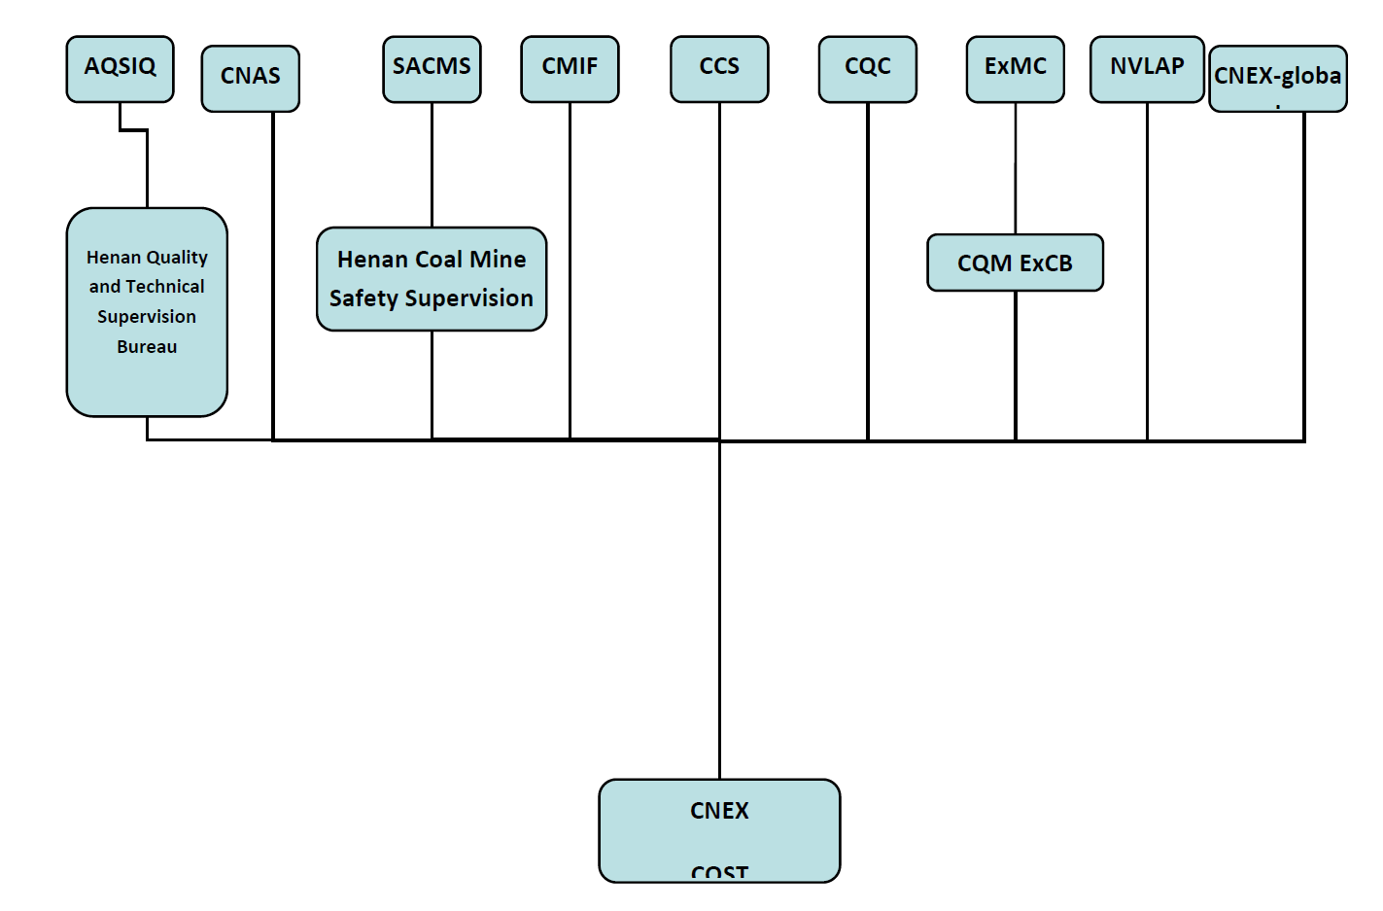

1. Organisation Chart of ExCB/ExTL

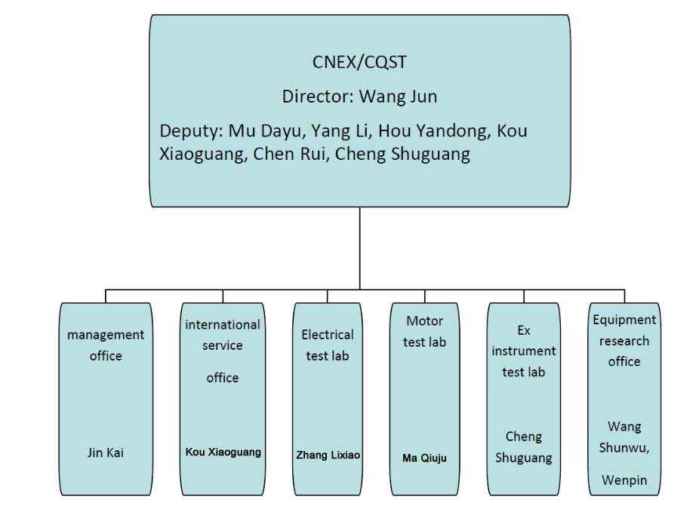

1. Accreditation Certificate for ISO/IEC 17065

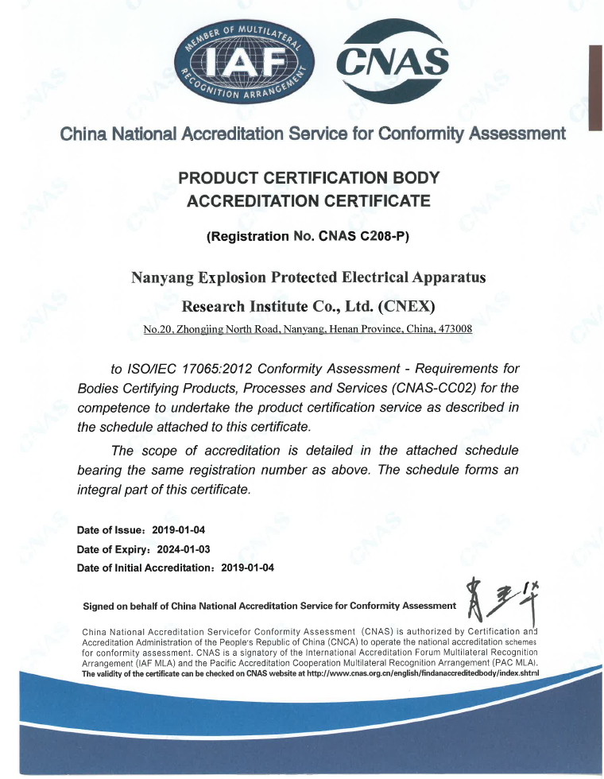

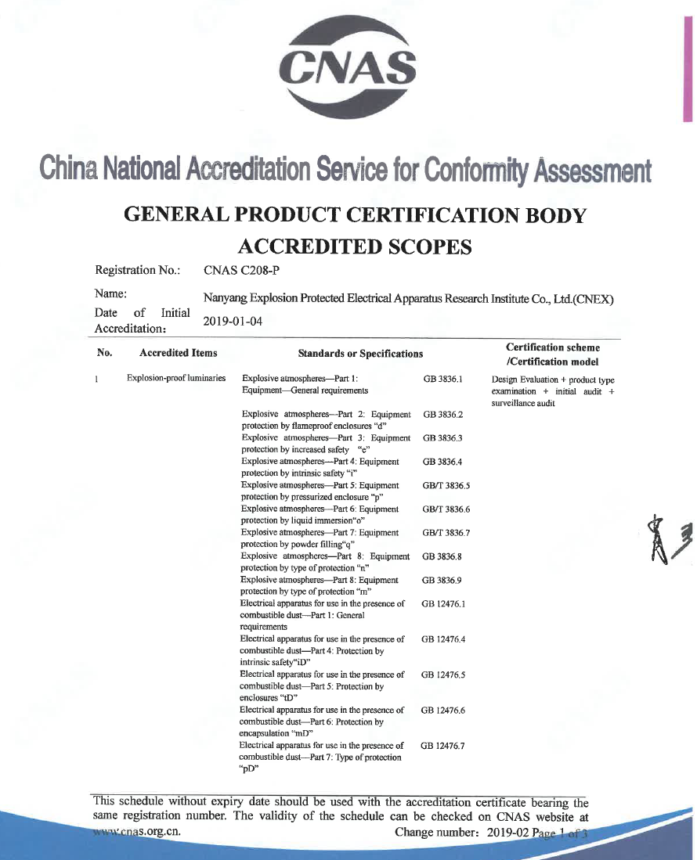

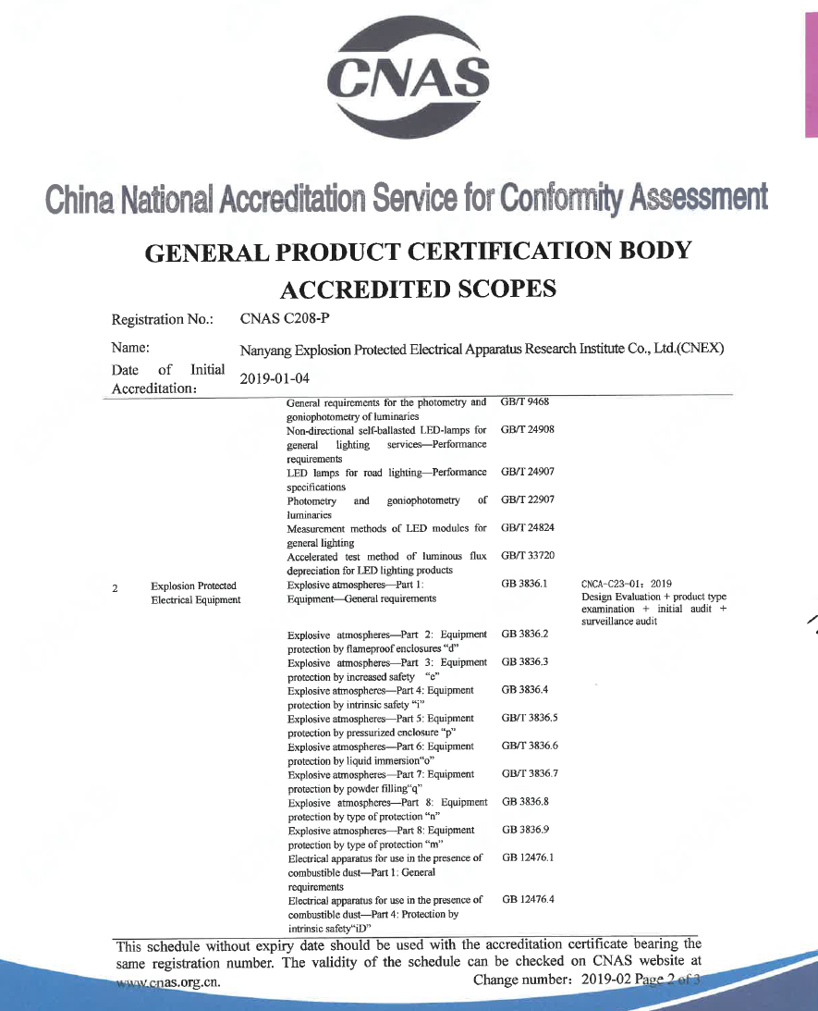

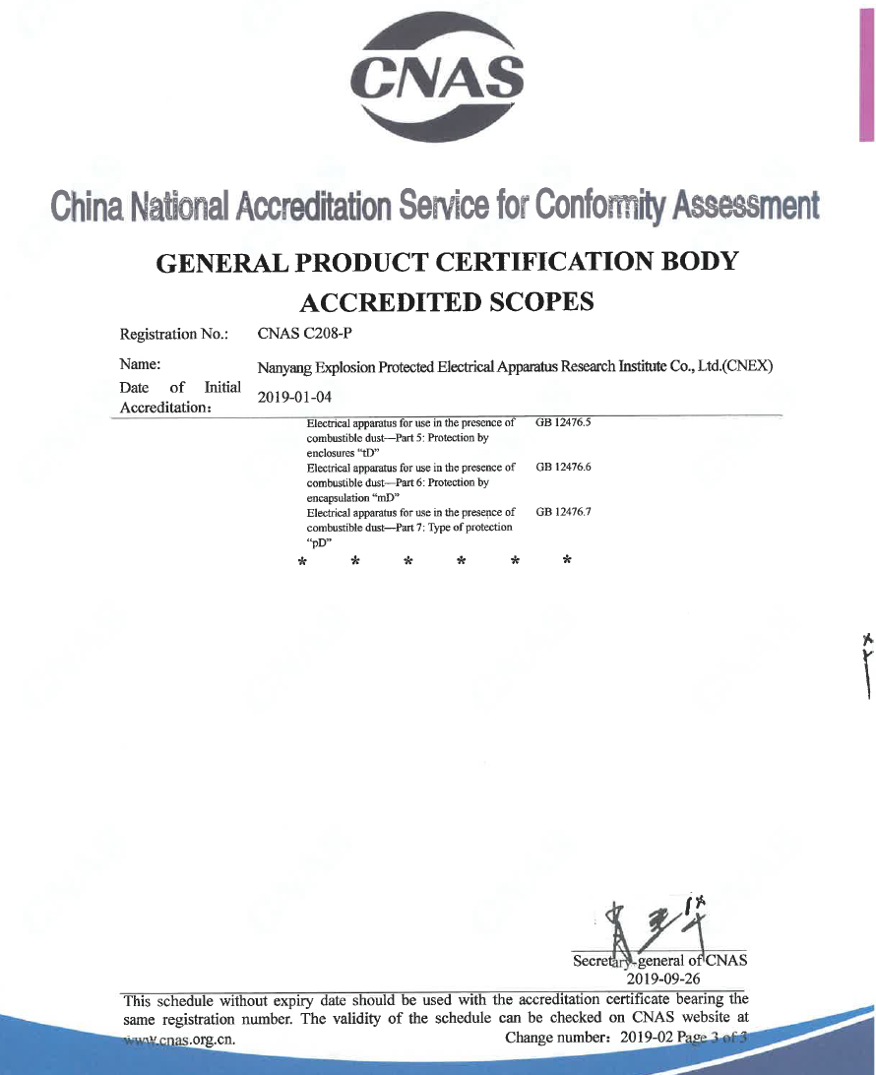

1. Accreditation Certificate for ISO/IEC 17025

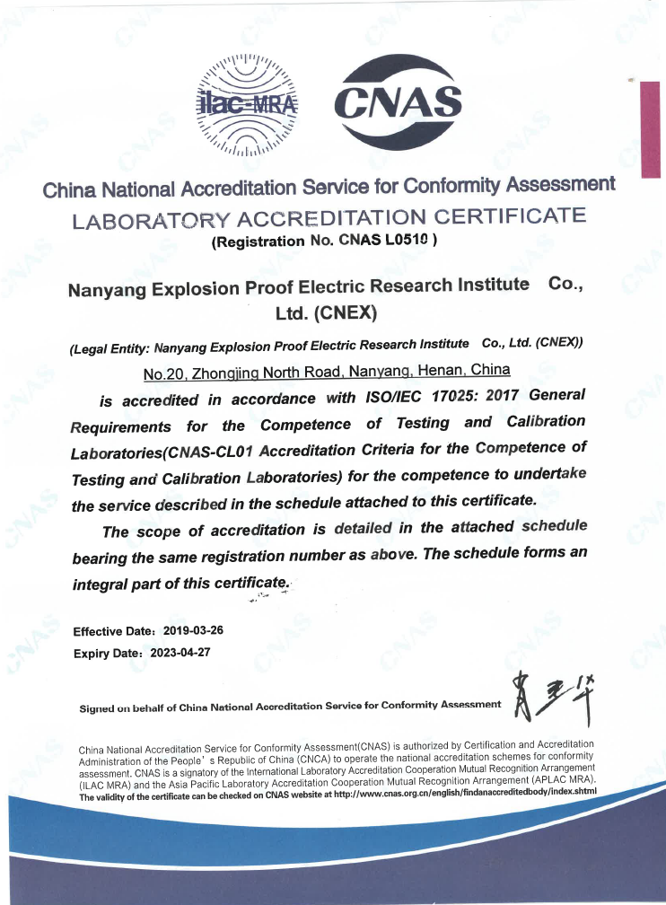

1. Accreditation Certificate for ISO/IEC 17024

**Not applicable for ExTL**