INTERNATIONAL ELECTROTECHNICAL COMMISSION (IEC) SYSTEM FOR CERTIFICATION TO STANDARDS RELATING TO EQUIPMENT FOR USE IN EXPLOSIVE ATMOSPHERES (IECEx SYSTEM)

Title: Special Assessment for Underwriters Laboratories of Canada Inc, as an Additional Testing Facility (ATF) operating under the UL LLC, ExTL, USA.

Circulation to: ExMC – IECEx Management Committee

INTRODUCTION

The IECEx Secretariat has received an application from UL LLC, USA, to conduct IECEx testing at Underwriters Laboratories of Canada Inc, under the IECEx Additional Testing Facilities (ATF) arrangements. Underwriters Laboratories of Canada Inc will operate under the control and direction of UL LLC, ExTL, USA, using procedures, or, procedures approved by UL LLC.

In accordance with IECEx 02 the IECEx Secretariat arranged for a special assessment to be performed by an IECEx Lead Assessor. The special assessment is treated as an extension of scope for UL LLC, USA, to include the new ATF location, in Canada.

This document is hereby submitted for ExMC approval via correspondence using the IECEx on-line voting system. ExMC Members are requested to submit their vote via the IECEx On-line Ballot System by the closing date 2021 12 17

Please refer to OD 050 for guidance on the “IECEx On-line voting system.”

Chris Agius

IECEx Secretariat

IECEx Secretariat  Australia Square  Level 33,  264 George Street  Sydney NSW 2000  Australia | Tel: +61 2 4628 4690  Fax: +61 2 4625 3480  Email:info@iecex.com

IEC System for certification to standards relating to equipment for use in Explosive Atmospheres (IECEx System)

IECEx Assessment Report Form, F-003

IECEx assessment report form for use by IECEx assessment teams to report assessments conducted according to the relevant IECEx assessment procedures of:

Operational Document IECEx OD 003-2 for the Certified Equipment Scheme

Operational Document IECEx OD 316-* for the Certified Service Facility Scheme

Operational Document IECEx OD 422 for the IECEx Conformity Mark Licensing Scheme

Operational Document IECEx OD 501 for the Personnel Competence Scheme

IECEx ATF assessment report for

Underwriters Laboratories of Canada Inc.
1040 Parsons RD SW
Edmonton, AB
T6X0J4

INTERNATIONAL
ELECTROTECHNICAL
COMMISSION

CONTENTS
1 Assessment information 5
1.1 Type of body covered by this assessment: 5
1.2 Type of assessment: 5
1.3 Details of body 5
1.3.1 Country 5
1.3.2 Name of body 5
1.3.3 Name and title of nominated principal contact 5
1.4 Assessment information 5
1.4.1 Members of the assessment team 5
1.4.2 Place(s) of assessment 5
1.4.3 Assessment date(s) 6
1.5 Application information and background information on the assessment 6
1.6 Scope 6
1.6.1 ATF Scope 6
2 Common information 7
2.1 Legal entity of body 7
2.2 Financial support 7
2.3 History 7
2.4 Documentation 7
2.4.1 Quality manual 7
2.4.2 Procedures 7
2.4.3 Work instructions 7
2.4.4 Records (including test records where relevant) 8
2.4.5 Document change control 8
2.5 Confidentiality 8
2.6 Communication with public and customers (Hard copy and Electronic) 8
2.7 Recognitions and agreements 8
2.8 Internal audit 8
2.9 Management review 9
2.10 Contracting, subcontracting and witness testing 9
2.10.1 Contracting 9
2.10.2 Subcontracting 9
2.10.3 Off-site and Witness testing 9
2.11 Training and competence 9
2.12 Complaints and appeals (including appeals to IECEx) 9
2.13 Impartiality 10
2.14 Active involvement in development of Decision Sheets 10
2.15 Special facts to be noted 10
2.16 Supporting documentation 10
2.17 Recommendations 10
3 ATF for IECEx Certified Equipment Scheme 11
3.1 Assessment references 11
3.1.1 General references 11
3.1.2 Additional references applied for this assessment 11
3.2 Candidate ATF persons interviewed 11
3.3 Associated ExTL 11
3.4 Organisation 11
3.4.1 Names, titles and experience of the senior executives 11
3.4.2 Name, title and experience of the quality management representative 11
3.4.3 Other employees in ATF activity 11
3.5 Organizational structure 11
3.6 Resources 12
3.7 Test reports issued 12
3.8 National accreditation 12
3.9 Calibration 12
3.10 Tests witnessed during the assessment visit 13
3.11 Participation in IECEx Proficiency Testing Programs 13
3.12 Comments (including issues found during assessment) 13
4 Annexes 14
A.1 Current standards 14
A.2 Superseded standards 15
Annex B Overall Organisation Chart 16
Annex C Organisation Chart of ATF 17
Annex D Accreditation Certificate for ISO/IEC 17025 18

Assessment information

Type of body covered by this assessment:

ExCB for IECEx Certified Equipment Scheme
ExTL for IECEx Certified Equipment Scheme
ATF for IECEx Certified Equipment Scheme
ExCB for IECEx Certified Service Facilities Scheme
ExCB for IECEx Conformity Mark Licensing System
ExCB for IECEx Certification of Personnel Competency Scheme

NOTE 1 ExCB - IECEx Certification Body
NOTE 2 ExTL - IECEx Testing Laboratory
NOTE 3 ATF - Additional Testing Facility

Type of assessment:

Pre-assessment for candidate body
Initial assessment for candidate body
Surveillance
Re-assessment
Scope extension

Details of body

Country
Canada

Name of body
Underwriters Laboratories of Canada Inc.

Name and title of nominated principal contact
Name | Title | E-mail address
Terry Paltzat | Sr. Laboratory Technician | Terry.paltzat@ul.com

Assessment information

Members of the assessment team
Name | Role
Marino Kelava | IECEx Lead Assessor

Place(s) of assessment
Due to the travel restrictions related to COVID-19, the assessment is remotely carried out by using Microsoft Teams. IECEx OD-060 was applied for this assessment.
Underwriters Laboratories of Canada Inc. | 1040 Parsons RD SW  Edmonton, AB  T6X0J4

Assessment date(s)
October 12th to 15th and October 18th to 19th 2021

Application information and background information on the assessment
Underwriters Laboratories of Canada Inc. in Edmonton is assessed as ATF to UL LLC ExTL from Northbrook US.

Due to problems with travelling caused by the COVID-19, it was decided to do a remote assessment in accordance with OD 060. The platform Microsoft Teams. Some bandwidth problems were encountered. These occasionally impacted on the time needed, mainly due to conversation needing to be repeated, but did not materially impact on the outcomes. The process was found to provide sufficient evidence to be able to make a recommendation, but there were some aspects that could not meet the standards of on-site assessment, for example the difficulty reviewing hard copy documents, the loss of ability to independently look around a test area and the difficultly in observing very small things.

Scope

ATF Scope
The scope for the ATF is shown in Annex A.

Common information

Legal entity of body
Underwriters Laboratories of Canada Inc. is a legal body registered in Canada, which is a fully-owned subsidiary of Underwriters Laboratories Inc. UL's Corporate Headquarters in Northbrook, IL, USA.

Financial support
Underwriters Laboratories of Canada Inc. (ULC) operates on a customer fee for service arrangement.

History
ULC is an independent product safety testing and certification organization founded in 1920, whose corporate mission is to serve the public by testing products for safety. ULC's principal activity is investigating the safety of many kinds of products, including electrical and electronic equipment and products, mechanical products, building materials, construction systems, fire protection equipment, burglary protection systems and equipment, and marine products. ULC also devotes its resources to the development of ULC Standards for Safety.
Underwriters Laboratories Inc. is the top level parent company in the UL Family of Companies. The ULC ATF operations in Canada are part of Underwriters Laboratories of Canada Inc. which is a fully-owned subsidiary of Underwriters Laboratories Inc. UL's Corporate Headquarters in Northbrook, IL, USA.

Documentation

Quality manual
UL LLC has a comprehensive quality management system for the schemes that they operate.
IECEx Certified Equipment Scheme, Policy-ULID-004414 (DCS:00-GC-P0871), Global Certification Compliance Manual, Policy-ULID-004123 (DCS:00-CB-P0854), and UL LLC Certification Body Compliance Manual Policy-ULID-004128 (DCS:00-CB-P0860), are the top level policies supporting the Certified Equipment Scheme and contain references to ISO/IEC 17065 and ISO/IEC 17025 respectively and IECEx Rules and Operational Documents. The policies fulfil the requirements of the IECEx system.
The Quality Manual as well related documents from different levels were reviewed during the assessment and found to meet the requirements of the IECEx and ISO/IEC 17025.

Procedures
UL LLC has a comprehensive range of procedures covering aspects of the certification and testing operations. The main procedure related to the activity of the ATF is the IECEx System, ATEX & INMETRO Product Certification Procedure, Standard Operation Procedures-ULID-000350 (DCS:00-IC-S0052). There is one procedure specific to the ATF, Edmonton Sample Handling Process, Standard Operation Procedures-ULID-002196 (DCS:05-LO-S0851).
Quality procedures were reviewed during the assessment and found to meet the requirements of the IECEx. Complete list of quality procedures relevant for the operation of the ATF is contained in the ISO/IEC 17025 checklist and in the TCD document.

Work instructions
In performing tests as required under the IECEx, ATF strictly follows work instructions created and maintained by the UL LLC ExCB/ExTL.
UL LLC has a comprehensive range of work instructions covering aspects of the certification and testing operations. A number of such work instructions covering tests were reviewed during witness testing and was found to meet the requirements of the IECEx.
A list of work instructions relevant for the operation of the ATF is contained in the TCD.

Records (including test records where relevant)
Records are retained electronically in accordance with IECEx Certified Equipment Scheme, Policy-ULID-004414 (DCS:00-GC-P0871), and the relevant procedure described in 2.4.2, which include storage location, protection, minimum retention time and disposition, if applicable. The majority of all IECEx documentation is retained for 10 years from date of cancellation of the IECEx CoC.

Document change control
All documents needed for the operation of ATF in the IECEx System Scheme 02 are managed by the parent ExTL.
Document change control is covered by Standard Operation Procedures-ULID-001013 (DCS:00-QA-S0003), Document Management SOP and the Global Forms Management Process (Standard Operation Procedures-ULID-001017 (DCS:00-QA-S0026)) and fulfil the requirements of the IECEx system.

Confidentiality
All files, records, and communications maintained by UL are private and confidential. Procedures for safeguarding confidentiality of information are included in the UL Standards of Business Conduct, Policy-ULID-000516 (DCS:00-LE-P0001), and in the Confidential Information and Trade Secrets Policy, Policy-ULID-000520 (DCS:00-LE-P0400), and records of employee commitment to abide by these requirements are described in the Record of Agreements Pertaining to Confidentiality, Conflict of Interest, Business Ethics, and Other Policies, Standard Operation Procedures-ULID-000207 (DCS:00-HR-S0052) and information contained in applications for employment.
Evidence of agreements were viewed and considered in compliance with the requirements of the IECEx.

Communication with public and customers (Hard copy and Electronic)
UL has a website for communicating with the public and customers with a specific area focused on Hazardous Locations (Hazardous Locations | UL). UL also has an app, UL HazLoc, which is publicly available in six languages and includes information relevant to the IECEx.
UL also has hard copy publications, such as the HazLoc Educational Poster, which is distributed to clients, trade shows, etc.

Recognitions and agreements
There is an Inter-company Accreditation Agreement (IAA) between UL LLC and ULC Inc. dated July 1, 2015. The UL Edmonton lab is part of the Underwriters Laboratories of Canada Inc. (ULC) legal entity.
Inter-company Accreditation Agreement (IAA) was viewed and considered in compliance with the requirements of the IECEx.

Internal audit
The first internal audit of the ATF was covered by the internal pre-assessment on June 2, 2021 as described in Requirements for UL IECEx System Additional Testing Facilities (ATF), Standard Operation Procedures-ULID-004267 (DCS:00-EX-S0850).
The Internal Quality Audits (IQA) department with input from the IECEx Program Owner plans and conducts annual audits in accordance with the Audit Policy, Policy-ULID-001011 (DCS:00-QA-P0028), and the Internal Audits Procedure, Standard Operation Procedures-ULID-001014 (DCS:00-QA-S0004).
Internal audit plan was viewed and considered in compliance with the requirements of the IECEx.

Management review
The management review for UL Edmonton is conducted annually in accordance with the Laboratory Management Review Policy, Policy-ULID-000492 (DCS:00-LC-P0040). The report from the last management review was reviewed and found to be in compliance with the requirements of the ISO/IEC 17025 and IECEx.
In addition, UL LLC holds a management review annually in accordance with IECEx System Management Review Procedures, Standard Operation Procedures-ULID-004272 (DCS:00-EX-S0858). The output of the UL Edmonton management review will be used as input to the UL LLC management review upon acceptance as an IECEx ATF.

Contracting, subcontracting and witness testing

Contracting
Not applicable for ATF.

Subcontracting
Not applicable for ATF.

Off-site and Witness testing
Not applicable for ATF.

Training and competence
Maintenance of External Documents Related to the IECEx System, Standard Operation Procedures-ULID-004270 (DCS:00-EX-S0856), covers training requirements for new editions of ExTAG DS and standards.
Training and competence requirements were verified as per the document Standard Operation Procedures-ULID-004267 (DCS:00-EX-S0850), ‘Requirements for UL IECEx System Additional Testing Facilities (ATF)’ for ATF staff.
The Staff Qualification Requirements for the IECEx System, ATEX Directive and INMETRO Certification Services, Standard Operation Procedures-ULID-000372 (DCS:00-IC-S0431), details additional criteria for staff, including the ExCB, and information on training records.
Formal authorizations of personnel are recorded in UL LLC’s Technical Competency Database (TCD) and the IECEx ATF Organizational Chart. Qualification requirement for Laboratory testing staff were verified as per document Form-ULID-000604 (DCS:00-LO-F0852) – ‘Laboratory Personnel Training Plan and Record – Testing Function’. Documents fulfil the requirements of the IECEx. Details of staff competencies are included in the site assessment report.

Complaints and appeals (including appeals to IECEx)
Complaints and appeals from customers are made as described in UL Certification Body Compliance Manual, Policy-ULID-004128 (DCS:00-CB-P0860), which fulfils the IECEx requirements.
Internal complaints related to ATFs are handled in accordance with the Laboratory Complaint Policy, Policy-ULID-000493 (DCS:00-LC-P0046), and the record is stored on OneDrive for the Edmonton lab.

Impartiality
Procedure for Impartiality Policy is described in document number Policy-ULID-004142 (DCS:00-CE-P0852), which fulfils the IECEx requirements.
The risks to impartiality for the Edmonton lab are saved on Sharepoint and are in accordance with the requirements of ISO/IEC 17025 and the IECEx.

Active involvement in development of Decision Sheets
Not applicable to ATF.

Special facts to be noted
None.

Supporting documentation
Copies of additional supporting information for this assessment have been provided to the applicant and the IECEx Secretariat. These are included in a site assessment report or provided separately and include:
- Details of issues raised and how these have been resolved
- Checklist for ISO/IEC 17025
- Completed Technical Capability Document (TCD)
- Photos of the facilities/tests witnessed are included in the above TCD
- Information on competencies
- Assessors’ notes
- Information on registration for participation in PTB PTP Enclosures program 2019

Recommendations
Based on the assessment performed on October 12th to 15th and October 18th to 19th 2021, Underwriters Laboratories of Canada Inc. Edmonton laboratory is recommended for acceptance in the IECEx scheme as:
- An ATF in the IECEx Certification Equipment Scheme
This is according to the scope of the standards listed in this document, (subject to resolution of the issues found during the assessment).
Marino Kelava
IECEx Lead Assessor
Date: 29th October 2021

ATF for IECEx Certified Equipment Scheme

Assessment references

General references
- IECEx02 IECEx Certified Equipment Scheme covering equipment for use in explosive atmospheres – Rules of Procedure
- IECEx OD003-2 Assessment, surveillance assessment and re-assessment of ExCBs and ExTLs operating in the IECEx 02, IECEx Certified Equipment Scheme
- ISO/IEC 17025 General requirements for the competence of testing and calibration laboratories
- IECEx OD 018 Harmonised check list for testing and calibration laboratories ISO/IEC 17025
- IECEx TCD 60079, ISO 80079 Series and ISO 16852 Technical Capability Document
- ExTAG decision sheets (DSs)
- IECEx OD 202 IECEx Certified Equipment Scheme – IECEx Proficiency Testing Program

Additional references applied for this assessment
None.

Candidate ATF persons interviewed
Name | Position
Terry Paltzat | Sr. Laboratory Technician
Nahada Harris | Quality Engineer
Gunsimar Paintal | Regional Manager - Accreditations and Compliance

Associated ExTL
UL LLC, 333 Pfingsten Rd. Northbrook, IL 60062 USA

Organisation

Names, titles and experience of the senior executives

Name | Title | Experience (years)
Fabian Joseph | Business Manager | 12

Name, title and experience of the quality management representative

Name | Title | Experience (years)
Samina Hasan | Lead Quality Engineer | 1.5

Other employees in ATF activity

Name | Title/responsibility | Experience in Ex (years)
Terry Paltzat | Sr. Laboratory Technician | 11
Nahada Harris | Quality Engineer | 1.5

Organizational structure
Refer Annex B and C.

Resources
ULC ATF appears to have an adequate number of staff for the current level of business. The staff are experienced and have demonstrated required level of competence in testing of Ex equipment. The laboratory and office are located in industrial units which provide an adequate environment for the work. The testing equipment is suitable for the range of tests carried out in house.
All testing equipment, where range significantly affects accuracy and the reliability of the test, is calibrated. The equipment is subject to ongoing monitoring for due calibration and control before each use. Standards and reference materials are subject to ongoing checking in accordance with established procedures. Laboratory maintains lists of equipment, which include, among others: name and type of device, identification number, place of use.
In addition, each measuring and testing device has a sticker with information about the status of calibration or with information about unfitness for use.

Test reports issued
Number of test reports issued in the preceding two years for each type of test covered by the standards listed in the Scope.
Standard numbers | Type of protection or other identifying information | Number of issued reports (for last 2 years) | Total
2021
(NOTE: Accreditation obtained in Feb 2021)
UL/CSA/EN 60079-11 | Ex ia | (3) | (3)
UL – various standards with tests that have similarities with tests applicable for  Ex m, Ex e, Ex t | Test reports including temperature, dielectric and/or enclosure testing | (18) | (18)

National accreditation

The national accreditation certification for ISO/IEC 17025 is shown in Annex D.

Calibration
The system for calibration of test equipment is addressed in Testing Laboratory procedures which were revieved during the assessment and found to comply with ISO/IEC 17025 and IECEx requirements.
All equipment requiring calibration is calibrated by external accredited calibration service providers. The calibration schedule for equipment is maintained by a member of staff on a computer database. Calibration is then organised for all equipment that is about to fall due for calibration.
The status of confirmation of metrological control of a given equipment is recorded in the equipment digital card and confirmed by a sticker on the equipment providing dateils on calibration due date. Sticker means that the equipment is calibrated, checked, good and approved for use.
All equipment used for witnessed testing was found to be in calibration.

Tests witnessed during the assessment visit
The following tests were witnessed during the assessment visit:
Standard and edition | Clause number | Test | Comments
IEC 60079-0, Ed. 7.0 | 26.4.2 | Resistance to impact | Testing performed competently.
IEC 60079-0, Ed. 7.0 | 26.4.5 | IP66 test | Testing performed competently.
IEC 60079-0, Ed. 7.0 | 26.5.1 | Temperature measurement | Testing performed competently.
IEC 60079-0, Ed. 7.0 | 26.12 | Earth continuity test | Testing performed competently.
IEC 60079-0, Ed. 7.0 | 26.13 | Surface resistance test | Testing performed competently.
IEC 60079-7, Ed. 7.0 | 6.10 | Terminal insulating material test | Testing performed competently.
IEC 60079-11, Ed. 6.0 | 10.1 | Spark ignition test | Testing performed competently.
IEC 60079-15 | 11.2.3 | Leakage test on sealed devices (Method 1) | Testing performed competently.
IEC 60079-18 | 5.3.2 | Dielectric strength test | Testing performed competently.
IEC 60079-18 | 8.1 | Water absorption test | Testing performed competently.
All results provided evidence of staff competence in performing above testing.

Participation in IECEx Proficiency Testing Programs
Program: PTB Ex PT Scheme
Year(s) of participation | IECEx Proficiency Testing program | General information about results
0 | PTB | The Lab will be participating in PTP in the next round of relevant testing.
ULC ATF has a limited scope and the only applicable test round from the PTB PTP which is still available is Test Round 2019 “Test of enclosures”. Laboratory provided evidence they applied for this test round and were waiting for test samples from the PTB at the time of Assessment. During the witness tests listed in clause 3.10 above, resources needed to perform those tests competently were found to be available at ATF.

Comments (including issues found during assessment)
ULC ATF has the necessary staff and quality system in place for their scope as an ATF. Few minor issues were identified during the assessment which were noted as potentially influential to the performance of testing and assessment. All issues were revised to the satisfaction of the assessment team and now meet the requirements of the IECEx. Details are contained in Site Assessment Report.

Annexes
  - Current standards
Number | Title | Comments
IEC 60079-0  Edition 7.0 | Explosive atmospheres - Part 0: Equipment - General requirements | Add to the scope of ATF only following clauses:  17.2.1  25  26.4.2  26.4.3  26.4.5  26.5.1  26.5.2  26.6  26.8  26.9  26.13  26.14  26.15  26.16
IEC 60079-7  Edition 5.1 | Explosive atmospheres - Part 7: Equipment protection by increased  safety "e" | Add to the scope of ATF only following clauses:  4.2.3  4.3  4.4  4.8  4.10  5.3.4  5.3.5.4.2  5.3.5.5  5.3.7  6.1  6.2.4  6.3.2  6.3.3  6.3.4.2.1.1  6.3.7  6.3.4.1  6.3.8  6.6.2  6.9  6.10  A.3  B.2  B.3  B.4.2  I.1  H.6
IEC 60079-11  Edition 6.0 | Explosive atmospheres - Part 11: Equipment protection by intrinsic safety “i” | Add to the scope of ATF only following clauses:  10.1  10.2  10.3  10.4  10.5.4  10.6.1  10.6.2  10.6.3  10.7  10.9  10.10  10.11  Annex B  Annex C
IEC 60079-15  Edition 5.0 | Explosive atmospheres – Part 15: Equipment protection by type of protection "n" | Add to the scope of ATF only following clauses:  11.2.1  11.2.2  11.2.3  11.3.2.1
IEC 60079-18  Edition 4.1 | Explosive atmospheres – Part 18: Equipment protection by encapsulation “m” | Add to the scope of ATF only following clauses:  8.1.1  8.1.2  8.2.2  8.2.3  8.2.4  8.2.5  8.2.6  8.2.7  8.2.8
IEC 60079-31  Edition 2.0 | Explosive atmospheres – Part 31: Equipment dust ignition protection by enclosure "t" | All test clauses to be added to the scope
  - Superseded standards
Superseded editions of above listed standards may form part of ATF’s scope, generally for historical reasons.

- Overall Organisation Chart

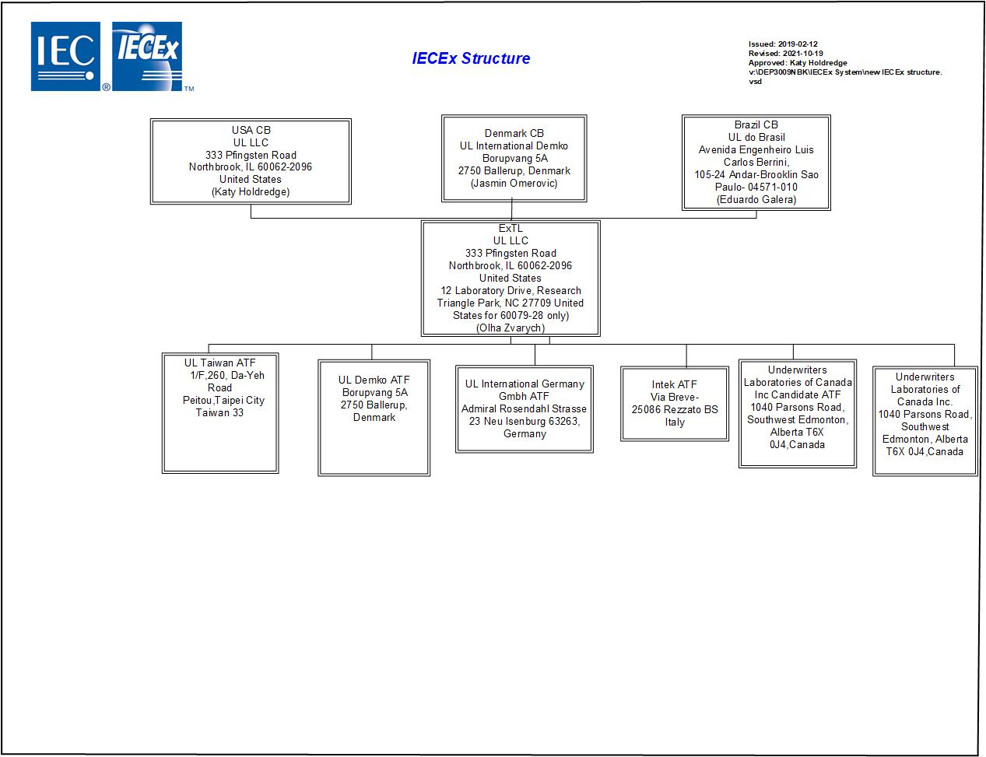
- Organisation Chart of ATF
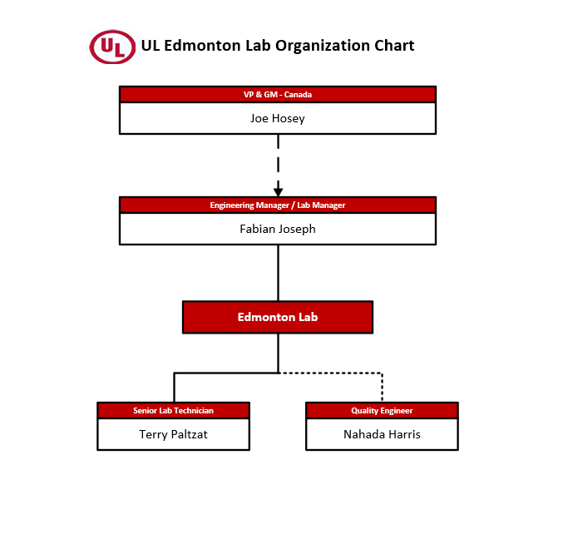
- Accreditation Certificate for ISO/IEC 17025

