**INTERNATIONAL ELECTROTECHNICAL COMMISSION IEC SYSTEM FOR**

**CERTIFICATION TO STANDARDS RELATING TO EQUIPMENT FOR USE IN**

**EXPLOSIVE ATMOSPHERES (IECEx SYSTEM)**

**TITLE: Scope Extension Assessment Report for** **Korea Testing Laboratory, KTL, an Accepted ExCB and an Accepted ExTL within the IECEx System, Equipment Scheme 02, to include IEC 60079-13, IEC TS 60079-46, ISO 80079-36 and ISO 80079-37 in their scope.**

**Circulated To: Members of the IECEx Management Committee, ExMC**

**Introduction**

Korea Testing Laboratory, KTL, an Accepted ExCB and an Accepted ExTL within the IECEx System, Equipment Scheme 02, has applied to include the following Standards within their scope. A special assessment was arranged and conducted in accordance with OD060.

|  |  |  |
| --- | --- | --- |
| IEC 60079-13  Edition 2.0 | Explosive atmospheres - Part 13: Equipment protection by pressurized room "p" and artificially ventilated room "v" | scope extension |
| IS0 80079-36  Edition 1.0 | Explosive atmospheres - Part 36: Non-electrical equipment for explosive atmospheres – Basic method and requirements | scope extension |
| ISO 80079-37  Edition 1.0 | Explosive atmospheres - Part 37: Non-electrical equipment for explosive atmospheres – Non electrical type of protection constructional safety” c” control of ignition source ”b”, liquid immersion ”k” | scope extension |
| IEC TS 60079-46  Edition 1.0 | Explosive atmospheres – Part 46 - Equipment assemblies | scope extension |

This report details the assessment findings of this scope extension with the IECEx

Assessment Team recommending the acceptance of the above scope extension.

***This document is hereby submitted for ExMC approval via correspondence using the IECEx on-line voting system.  ExMC Members are requested to submit their vote via the IECEx On-line*** [***Ballot System***](https://www.iecex.com/ballot) ***by the closing date 2022 03 18***

***Please refer to OD 050 for guidance on the “IECEx On-line voting system.”***

*Chris Agius*

**IECEx Secretary**

|  |  |
| --- | --- |
| **IECEx Secretariat**  **Australia Square**  **Level 33, 264 George Street**  **Sydney. NSW 2000**  **Australia** | **Tel: +61 2 4628 4690**  **Fax: +61 2 46 27 5285**  **Email: info@iecex.com** |

IEC System for certification to standards relating to equipment for use in Explosive Atmospheres (IECEx System)

IECEx Assessment Report Form, F-003

IECEx assessment report form for use by IECEx assessment teams to report assessments conducted according to the relevant IECEx assessment procedures of:

Operational Document IECEx OD 003-2 for the Certified Equipment Scheme

Operational Document IECEx OD 316-* for the Certified Service Facility Scheme

Operational Document IECEx OD 422 for the IECEx Conformity Mark Licensing Scheme

Operational Document IECEx OD 501 for the Personnel Competence Scheme

IECEx ExCB/ExTL assessment report for KTL

INTERNATIONAL  
ELECTROTECHNICAL  
COMMISSION

CONTENTS

1 Assessment information 5

1.1 Type of body covered by this assessment: 5

1.2 Type of assessment: 5

1.3 Details of body 5

1.3.1 Country 5

1.3.2 Name of body 5

1.3.3 Name and title of nominated principal contact 5

1.4 Assessment information 5

1.4.1 Members of the assessment team 5

1.4.2 Place(s) of assessment 5

1.4.3 Assessment date(s) 5

1.5 Application information and background information on the assessment 6

1.6 Scopes 6

1.6.1 ExCB scope for equipment certification scheme 6

1.6.2 ExTL scope 6

2 Common information 7

2.1 Legal entity of body 7

2.2 Financial support 7

2.3 History 7

2.4 Documentation 7

2.4.1 Quality manual 7

2.4.2 Procedures 7

2.4.3 Work instructions 7

2.4.4 Records (including test records where relevant) 7

2.4.5 Document change control 7

2.5 Confidentiality 7

2.6 Communication with public and customers (Hard copy and Electronic) 7

2.7 Recognitions and agreements 7

2.8 Internal audit 7

2.9 Management review 7

2.10 Contracting, subcontracting and witness testing 8

2.10.1 Contracting 8

2.10.2 Subcontracting 8

2.10.3 Off-site and Witness testing 8

2.11 Training and competence 8

2.12 Complaints and appeals (including appeals to IECEx) 8

2.13 Impartiality 8

2.14 Active involvement in development of Decision Sheets 8

2.15 Special facts to be noted 8

2.16 Supporting documentation 8

2.17 Recommendations 8

3 ExCB for IECEx Certified Equipment Scheme 9

3.1 Assessment references 9

3.1.1 General references 9

3.1.2 Additional references applied for this assessment 9

3.2 Candidate ExCB persons interviewed 9

3.3 Associated ExTL(s) 9

3.4 Associated certification functions 9

3.5 National marks and certificates 9

3.6 Standards accepted 9

3.7 National differences to IEC standards 9

3.8 Organisation 10

3.8.1 Names, titles and experience of the senior executives 10

3.8.2 Name, title and experience of the quality management representative 10

3.8.3 Name and title of signatories for certification 10

3.8.4 Other employees in ExCB activity 10

3.9 Organizational structure 10

3.10 Indemnity insurance 10

3.11 Resources 10

3.12 Committees (such as governing or advisory boards) 10

3.13 Certification operations 10

3.13.1 National approval/certification methods 10

3.13.2 Certification policy 10

3.13.3 Application for certification 10

3.13.4 Certification decision 10

3.13.5 Suspension and cancellation of certificates 11

3.14 Certificates issued 11

3.15 National accreditation 11

3.16 Assessment of manufacturers and issue of QARs 11

3.17 Comments (including issues found during assessment) 11

4 ExTL for IECEx Certified Equipment Scheme 12

4.1 Assessment references 12

4.1.1 General references 12

4.1.2 Additional references applied for this assessment 12

4.2 Candidate ExTL persons interviewed 12

4.3 Associated ExCB(s) 12

4.4 Organisation 12

4.4.1 Names, titles and experience of the senior executives 12

4.4.2 Name, title and experience of the quality management representative 12

4.4.3 Other employees in ExTL activity 12

4.5 Organizational structure 13

4.6 Resources 13

4.7 Test reports issued 13

4.8 National accreditation 13

4.9 Calibration 13

4.10 Tests witnessed during the assessment visit 13

4.11 Participation in IECEx Proficiency Testing Programs 13

4.12 Comments (including issues found during assessment) 13

Annex A Scope for IECEx Certified Equipment Scheme 14

A.1 Current standards 14

Annex B Overall Organisation Chart 15

Annex C Accreditation Certificate for ISO/IEC 17065 16

Annex D Accreditation Certificate for ISO/IEC 17025 21

# Assessment information

## Type of body covered by this assessment:

|  |  |
| --- | --- |
| ExCB for IECEx Certified Equipment Scheme |  |
| ExTL for IECEx Certified Equipment Scheme |  |
| ATF for IECEx Certified Equipment Scheme |  |
| ExCB for IECEx Certified Service Facilities Scheme |  |
| ExCB for IECEx Conformity Mark Licensing System |  |
| ExCB for IECEx Certification of Personnel Competency Scheme |  |

NOTE 1 ExCB - IECEx Certification Body

NOTE 2 ExTL - IECEx Testing Laboratory

NOTE 3 ATF - Additional Testing Facility

## Type of assessment:

|  |  |
| --- | --- |
| Pre-assessment for candidate body |  |
| Initial assessment for candidate body |  |
| Surveillance |  |
| Re-assessment |  |
| Scope extension |  |

## Details of body

### Country

Republic of Korea

### Name of body

Korea Testing Laboratory KTL

### Name and title of nominated principal contact

|  |  |  |
| --- | --- | --- |
| Name | Title | E-mail address |
| Dongjin KIM | Senior Researcher,  Certification Management Center | dkim@ktl.re.kr |

## Assessment information

### Members of the assessment team

|  |  |
| --- | --- |
| Name | Role |
| Ron Webb | IECEx Lead Assessor |

### Place(s) of assessment

|  |  |
| --- | --- |
| 87 Digital-ro, 26 gil, Guro-gu, Seoul, Korea 152-718 | 723, Haean-ro, Sangnok-gu, Ansan-si Gyeonggi-do 426-910 Korea |

### Assessment date(s)

22nd – 24th November 2021. Carried out remotely in accordance with OD060 using Microsoft Teams due to COVID-19 travel restrictions

## Application information and background information on the assessment

Application for scope extension was made by way of form ExMC/251B/Q dated 28 June 2021. The following Standards were covered as part of this scope extension assessment.

|  |  |  |
| --- | --- | --- |
| Number | Title | Comments |
| IEC 60079-13  Edition 2.0 | Explosive atmospheres - Part 13: Equipment protection by pressurized room "p" and artificially ventilated room "v" | scope extension |
| IS0 80079-36  Edition 1.0 | Explosive atmospheres - Part 36: Non-electrical equipment for explosive atmospheres – Basic method and requirements | scope extension |
| ISO 80079-37  Edition 1.0 | Explosive atmospheres - Part 37: Non-electrical equipment for explosive atmospheres – Non electrical type of protection constructional safety ”c” control of ignition source ”b”, liquid immersion ”k” | scope extension |
| IEC TS 60079-46  Edition 1.0 | Explosive atmospheres – Part 46 - Equipment assemblies | scope extension |

## Scopes

### ExCB scope for equipment certification scheme

The scope for the ExCB, including the scope extension standards is shown in Annex A.

### ExTL scope

The ExTL scope is the same as the ExCB Scope

# Common information

## Legal entity of body

Not relevant as this is a scope extension assessment. This was covered in the re-assessment in 2018 ref ExMC/1505/DV. Other entries below shown as not relevant are also covered in the re-assessment report.

## Financial support

Not relevant as this is a scope extension assessment. This was covered in the re-assessment in 2018 ref ExMC/1505/DV.

## History

Not relevant as this is a scope extension assessment. This was covered in the re-assessment in 2018 ref ExMC/1505/DV.

## Documentation

### Quality manual

KTL has a top-level Quality Manual covering the higher level requirements of the scheme and below it are additional manuals containing procedures which also meet the IECEx scheme’s requirements.

### Procedures

Procedures have been updated to cover the scope extension standards and the implementation of OD060

### Work instructions

Work Instructions have been updated to cover the scope extension standards and the implementation of OD060

### Records (including test records where relevant)

Not relevant as this is a scope extension assessment. This was covered in the re-assessment in 2018 ref ExMC/1505/DV.

### Document change control

Not relevant as this is a scope extension assessment. This was covered in the re-assessment in 2018 ref ExMC/1505/DV.

## Confidentiality

Not relevant as this is a scope extension assessment. This was covered in the re-assessment in 2018 ref ExMC/1505/DV.

## Communication with public and customers (Hard copy and Electronic)

Not relevant as this is a scope extension assessment. This was covered in the re-assessment in 2018 ref ExMC/1505/DV.

## Recognitions and agreements

Not relevant as this is a scope extension assessment. This was covered in the re-assessment in 2018 ref ExMC/1505/DV.

## Internal audit

Not relevant as this is a scope extension assessment. This was covered in the re-assessment in 2018 ref ExMC/1505/DV.

## Management review

Not relevant as this is a scope extension assessment. This was covered in the re-assessment in 2018 ref ExMC/1505/DV.

## Contracting, subcontracting and witness testing

### Contracting

Not relevant as this is a scope extension assessment. This was covered in the re-assessment in 2018 ref ExMC/1505/DV.

### Subcontracting

Not relevant as this is a scope extension assessment. This was covered in the re-assessment in 2018 ref ExMC/1505/DV.

### Off-site and Witness testing

Not relevant as this is a scope extension assessment. This was covered in the re-assessment in 2018 ref ExMC/1505/DV.

## Training and competence

Details of staff competencies are included in the site assessment report. These meet the requirements of IECEx.

## Complaints and appeals (including appeals to IECEx)

Not relevant as this is a scope extension assessment. This was covered in the re-assessment in 2018 ref ExMC/1505/DV.

## Impartiality

Not relevant as this is a scope extension assessment. This was covered in the re-assessment in 2018 ref ExMC/1505/DV.

## Active involvement in development of Decision Sheets

Not relevant as this is a scope extension assessment. This was covered in the re-assessment in 2018 ref ExMC/1505/DV.

## Special facts to be noted

None other than those raised within the body of this report.

## Supporting documentation

Copies of additional supporting information for this assessment have been provided to the applicant and the IECEx Secretariat. These are included in a site assessment report and include:

* Completed Technical Capability Document (TCD) for the scope extension standards
* Photos of the facilities/tests witnessed, included in the above TCD
* Information on competencies

## Recommendations

Based on the assessment performed on 22-24 November 2021, KTL is recommended for scope extension in the IECEx scheme as:

* An ExCB in the IECEx Certified Equipment Scheme
* An ExTL in the IECEx Certified Equipment Scheme

This is according to the scope of the standards listed in this document including the extension of scope.

|  |  |
| --- | --- |
| Ron Webb | IECEx Lead Assessor |
| Date: 27 January 2022 | |

# ExCB for IECEx Certified Equipment Scheme

## Assessment references

### General references

1. IECEx 02 IECEx Certified Equipment Scheme covering equipment for use in explosive atmospheres – Rules of Procedure
2. IECEx OD003-2 Assessment, surveillance assessment and re-assessment of ExCBs and ExTLs operating in the IECEx 02, IECEx Certified Equipment Scheme
3. ISO/IEC 80079-34 Explosive atmospheres – Part 34: Application of quality systems for equipment manufacture
4. IECEx OD 009 Issuing of CoCs, ExTRs and QARs
5. IECEx OD 025 Guidelines on the Management of Assessment and Surveillance programs for the assessment of Manufacturer’s Quality Systems in accordance with the IECEx Scheme
6. IECEx OD 026 IECEx Certified Equipment Scheme – Guidelines for the qualification of Lead Auditor and Auditors, in accordance with the IECEx System
7. ISO/IEC 17065 General requirements for bodies operating product certification systems Conformity assessment — Requirements for bodies certifying products, processes and services
8. IECEx OD 107 Harmonised check list for certification bodies ISO/IEC 17065
9. IECEx OD 060 IECEx Guide for Business Continuity – Management of Extraordinary Circumstances or Events Affecting IECEx Certification Schemes and Activities
10. IECEx Technical Capability Document (TCD)
11. ExTAG decision sheets (DSs)

NOTE The latest editions of the above documents were applied, unless otherwise specified

### Additional references applied for this assessment

1. IEC OD 280 IECEx Certified Equipment Scheme – Guide to Certification of Non-electrical Equipment and Protective Systems

## ExCB persons interviewed

|  |  |
| --- | --- |
| Name | Position |
| Dongjin KIM | Senior Researcher,  Certification Management Center |
| Yong-ho Song | Lead Auditor,  Certification Management Center |

## Associated ExTL(s)

The ExCB is integral with the ExTL

## Associated certification functions

Not relevant as this is a scope extension assessment. This was covered in the re-assessment in 2018 ref ExMC/1505/DV.

## National marks and certificates

Not relevant as this is a scope extension assessment. This was covered in the re-assessment in 2018 ref ExMC/1505/DV.

## Standards accepted

See Annex A

## National differences to IEC standards

National differences to IEC standards are those for the country differences listed in the latest version of the IECEx System Bulletin.

## Organisation

### Names, titles and experience of the senior executives

|  |  |  |
| --- | --- | --- |
| Name | Title | Experience (years) |
| Seojong KIM | CEO | 25 |

### Name, title and experience of the quality management representative

|  |  |  |
| --- | --- | --- |
| Name | Title | Experience (years) |
| Sang-gon Lee | Quality Manger | 25 |

### Name and title of signatories for certification

|  |  |  |
| --- | --- | --- |
| Name | Title | Comments |
| Jong-koo Park | Director of Certification |  |

### Other employees in ExCB activity

|  |  |  |
| --- | --- | --- |
| Name | Title | Experience in Ex (years) |
| Dongjin KIM | Senior Engineer | 4 |

## Organizational structure

An organisation chart is included as Annex B.

## Indemnity insurance

Not relevant as this is a scope extension assessment. This was covered in the re-assessment in 2018 ref ExMC/1505/DV.

## Resources

KTL has the appropriate resources of competent staff and appropriate procedures to be able to certify to all Standards requested for the scope extension.

## Committees (such as governing or advisory boards)

Not relevant as this is a scope extension assessment. This was covered in the re-assessment in 2018 ref ExMC/1505/DV.

## Certification operations

### National approval/certification methods

KTL also operate as a National Testing Laboratory.

### Certification policy

Not relevant as this is a scope extension assessment. This was covered in the re-assessment in 2018 ref ExMC/1505/DV.

### Application for certification

Not relevant as this is a scope extension assessment. This was covered in the re-assessment in 2018 ref ExMC/1505/DV.

### Certification decision

Not relevant as this is a scope extension assessment. This was covered in the re-assessment in 2018 ref ExMC/1505/DV.

### Suspension and cancellation of certificates

Not relevant as this is a scope extension assessment. This was covered in the re-assessment in 2018 ref ExMC/1505/DV.

## Certificates issued

There have not been any certificates issued to the scope extension standards, but sample reports prepared were submitted and reviewed, and interviews with relevant staff indicated a good understanding of the standards.

## National accreditation

The national accreditation certification for ISO/IEC 17065 is shown in Annex C.

## Assessment of manufacturers and issue of QARs

The procedure for issuing QARs has been updated to include reference to OD060.

## Comments (including issues found during assessment)

Minor errors to KTL procedures were corrected during the assessment to the satisfaction of the assessment team.

# ExTL for IECEx Certified Equipment Scheme

## Assessment references

### General references

1. IECEx02 IECEx Certified Equipment Scheme covering equipment for use in explosive atmospheres – Rules of Procedure
2. IECEx OD003-2 Assessment, surveillance assessment and re-assessment of ExCBs and ExTLs operating in the IECEx 02, IECEx Certified Equipment Scheme
3. IECEx OD009 Issuing of CoCs, ExTRs and QARs
4. ISO/IEC 17025 General requirements for the competence of testing and calibration laboratories
5. IECEx OD 018 Harmonised check list for testing and calibration laboratories ISO/IEC 17025
6. IECEx TCD 60079, ISO 80079 Series and ISO 16852 Technical Capability Document
7. ExTAG decision sheets (DSs)
8. IECEx OD 202 IECEx Certified Equipment Scheme – IECEx Proficiency Testing Program

NOTE The latest editions of the above documents were applied, unless otherwise specified.

### Additional references applied for this assessment

1. IEC OD 280 IECEx Certified Equipment Scheme – Guide to Certification of Non-electrical Equipment and Protective Systems

## ExTL persons interviewed

|  |  |
| --- | --- |
| Name | Position |
| Sang-chul LEE | Senior Researcher |
| Mirim LEE | Senior Researcher |
| Tae-gyu EOM | Researcher |
| Hui-dong CHAE | Researcher |
| Eui-sung LEE | Researcher |
| Jae-sik MIN | Researcher |

## Associated ExCB(s)

The ExTL is integral with the ExCB

## Organisation

### Names, titles and experience of the senior executives

|  |  |  |
| --- | --- | --- |
| Name | Title | Experience (years) |
| Seo-jong KIM | CEO | 25 |

### Name, title and experience of the quality management representative

|  |  |  |
| --- | --- | --- |
| Name | Title | Experience (years) |
| Sang-gon Lee | Quality Manger | 25 |

### Other employees in ExTL activity

|  |  |  |
| --- | --- | --- |
| Name | Title/responsibility | Experience in Ex (years) |
| Yong-won CHOI | Manager | 15 |
| Yeong-seoung MIN | Chief Researcher | 15 |
| Sang-chul LEE | Senior Researcher | 5 |
| Deok-ki YANG | Senior Researcher | 5 |
| Mirim LEE | Senior Researcher | 3 |
| Tae-gyu EOM | Researcher | 7 |
| Hui-dong CHAE | Researcher | 7 |
| Eui-sung LEE | Researcher | 7 |
| Jae-sik MIN | Researcher | 3 |

## Organizational structure

An organisation chart is included as Annex B.

## Resources

KTL has the appropriate resources of competent staff and appropriate procedures to be able to certify Standards requested for scope extension.

## Test reports issued

There have not been any test reports issued to the scope extension standards but sample reports prepared to support the standards were submitted and interviews with relevant staff indicated a good understanding of the standards. The standards are included in the National Accreditation to ISO/IEC 17025

## National accreditation

The national accreditation certification for ISO/IEC 17025 is shown in Annex D. This covers the scope extension standards.

## Calibration

Not relevant as this is a scope extension assessment. This was covered in the re-assessment in 2018 ref ExMC/1505/DV.

## Tests witnessed during the assessment visit

As the scope extension standards do not add any tests not already covered by the existing scope it was not considered necessary to witness any tests.

## Participation in IECEx Proficiency Testing Programs

KTL participate in the PT scheme organised by PTB. The results for the pressurisation program showed a good result. This has relevance for the scope extension for IEC 60079-13.

## Comments (including issues found during assessment)

Minor errors with KTL procedures were corrected during the assessment to the satisfaction of the assessment team.

1. Scope for IECEx Certified Equipment Scheme
   1. Current standards

| Number | Title | Comments |
| --- | --- | --- |
| IEC 60079-0  Edition 7.0 | Explosive atmospheres - Part 0: Equipment - General requirements | in scope |
| IEC 60079-1  Edition 7.0 | Explosive atmospheres - Part 1: Equipment protection by flameproof  enclosures “d” | in scope |
| IEC 60079-2  Edition 6.0 | Explosive atmospheres - Part 2: Equipment protection by pressurized  enclosure “p’ | in scope |
| IEC 60079-5  Edition 4.0 | Explosive atmospheres - Part 5: Equipment protection by powder filling “q” | in scope |
| IEC 60079-6  Edition 4.0 | Explosive atmospheres - Part 6: Equipment protection by oil immersion “o” | in scope |
| IEC 60079-7  Edition 5.1 | Explosive atmospheres - Part 7: Equipment protection by increased  safety "e" | in scope |
| IEC 60079-11  Edition 6.0 | Explosive atmospheres - Part 11: Equipment protection by intrinsic safety “i” | in scope |
| IEC 60079-13  Edition 2.0 | Explosive atmospheres - Part 13: Equipment protection by pressurized room "p" and artificially ventilated room "v" | scope extension |
| IEC 60079-15  Edition 5.0 | Explosive atmospheres – Part 15: Equipment protection by type of protection "n" | in scope |
| IEC 60079-18  Edition 4.1 | Explosive atmospheres – Part 18: Equipment protection by encapsulation “m” | in scope |
| IEC 60079-26  Edition 3.0 | Explosive atmospheres - Part 26: Equipment with equipment protection level (EPL) Ga | in scope |
| IEC 60079-28  Edition 2.0 | Explosive atmospheres - Part 28: Protection of equipment and transmission systems using optical radiation | in scope |
| IEC 60079-31  Edition 2.0 | Explosive atmospheres – Part 31: Equipment dust ignition protection by enclosure "t" | in scope |
| IS0 80079-36  Edition 1.0 | Explosive atmospheres - Part 36: Non-electrical equipment for explosive atmospheres – Basic method and requirements | scope extension |
| ISO 80079-37  Edition 1.0 | Explosive atmospheres - Part 37: Non-electrical equipment for explosive atmospheres – Non electrical type of protection constructional safety ”c” control of ignition source ”b”, liquid immersion ”k” | scope extension |
| IEC TS 60079-46  Edition 1.0 | Explosive atmospheres – Part 46 - Equipment assemblies | scope extension |

1. Overall Organisation Chart

1. Accreditation Certificate for ISO/IEC 17065

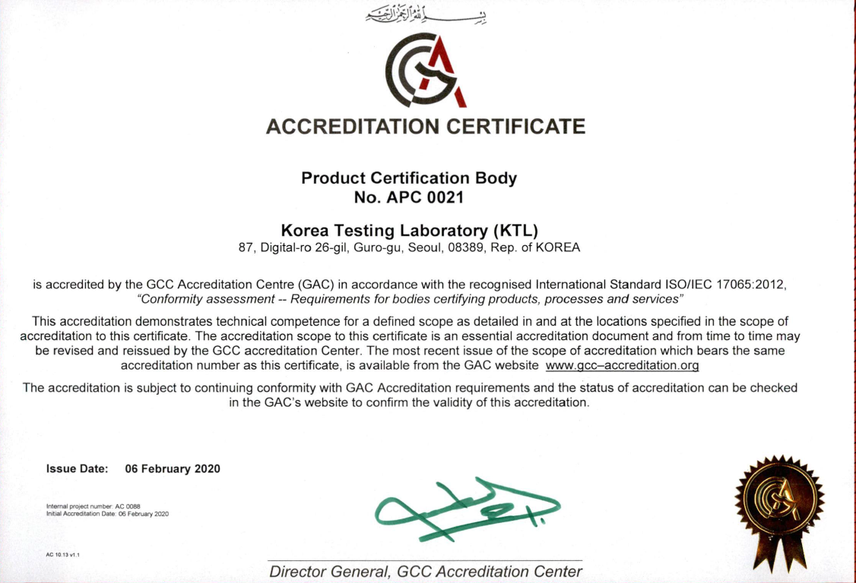

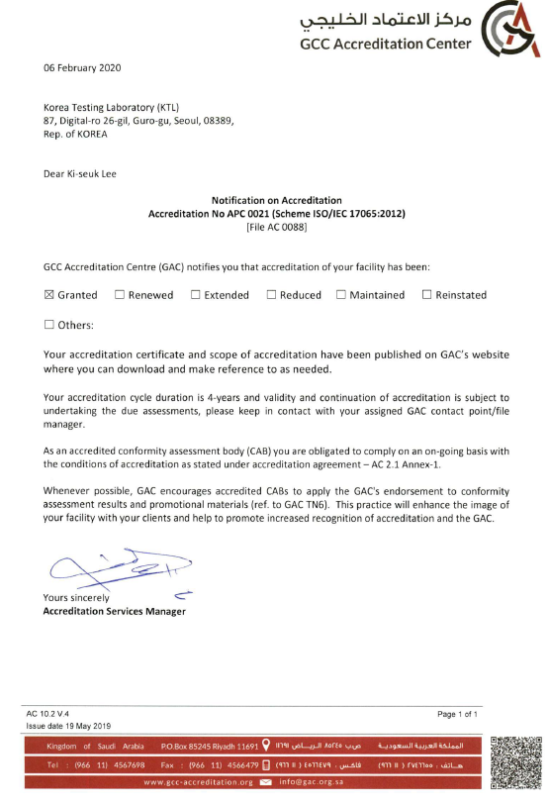

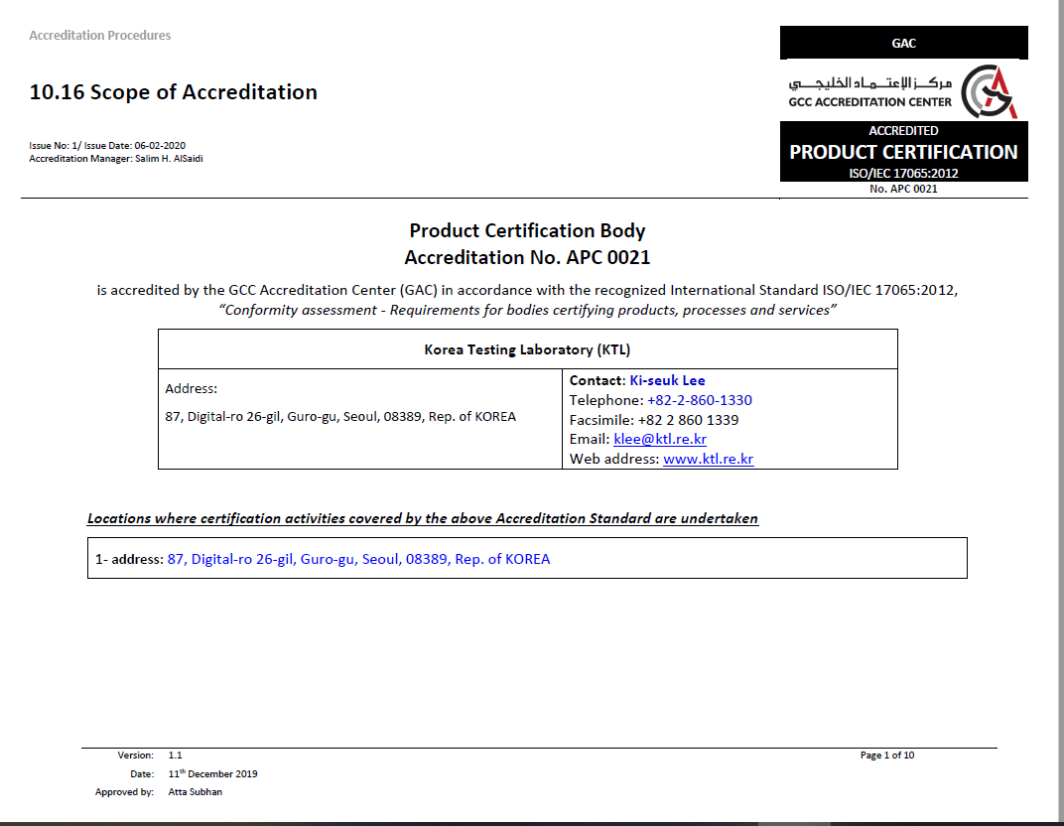

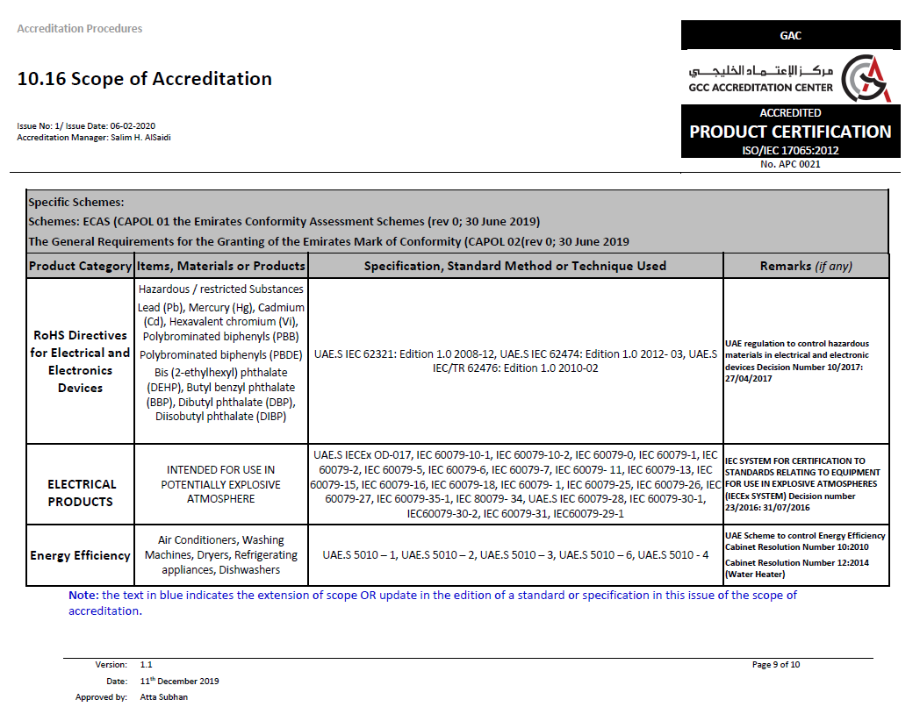

1. Accreditation Certificate for ISO/IEC 17025

