**INTERNATIONAL ELECTROTECHNICAL COMMISSION SYSTEM FOR**

**CERTIFICATION TO STANDARDS RELATING TO EQUIPENT FOR USE**

**IN EXPLOSIVE ATMOSPHERES (IECEx SYSTEM)**

**Circulated to: IECEx Management Committee (ExMC)**

**Title: US Proposal for ExMC Agenda item 12.3 Standards in IECEx Scope**

This document contains a proposal from the USNC/IECEx concerning Standards listed on the IECEx Website.

This proposal will be discussed during the ExMC 2022 Remote meetings.

IECEx Secretariat

|  |  |
| --- | --- |
| **Address:**  **IECEx Secretariat**  **Level 33, Australia Square**  **264 George Street**  **Sydney NSW 2000**  **Australia** | **Contact Details:**  **Tel: +61 2 4628 4690**  **Fax: +61 2 4627 5285**  **e-mail:** [**info@iecex.com**](mailto:info@iecex.com)  [**http://www.iecex.com**](http://www.iecex.com) |

**___________________________________________________________________________________**

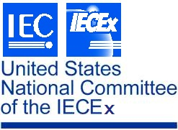

Chair: S. Kiddle **USNC/IECEx**

Vice Chair: K. Holdredge c/o NEMA

Vice Chair: K. Wolf 1300 North 17th St., Ste. 900

Past Chair: E. Massey Arlington, VA 22209

Treasurer: J. Genre

**___________________________________________________________________________________**

08 July 2022

Mr Chris Agius   
Secretary IECEx  
Level 33 Australia Square  
264 George Street  
Sydney NSW 2000  
Australia

Subject: ExMC Agenda Item 12.3, Any Other General Matters

Dear Chris,

USNC/IECEx requests the following modifications on [Standards » IECEx](https://www.iecex.com/publications/standards/):

* Add IEC 62990-1 in the scope of IECEx
* Correct IEC 80079-34, *Application of quality systems for equipment manufacture*, should read as “ISO/IEC 80079-34”

In addition, the title of this page should be revised from “Standards Documentation for Purchase” to “IEC Standards Operated by the IECEx” to align with the approach used by IECEE, and the introductory text revised accordingly

Thank you.

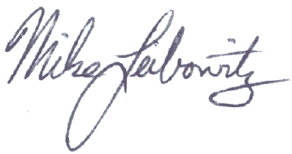Sincerely,

Mike Leibowitz

USNC/IECEx Secretary

MGL

cc: S. Kiddle