**INTERNATIONAL ELECTROTECHNICAL COMMISSION SYSTEM FOR CERTIFICATION TO STANDARDS RELATING TO EQUIPMENT FOR USE IN EXPLOSIVE ATMOSPHERES (IECEx SYSTEM)**

**TITLE: Reassessment and scope extension report for RISE, Research Institutes of Sweden AB, an Accepted Certification Body (ExCB), in the IECEx System Equipment Scheme 02, to include, IS0 80079-36, ISO 80079-37 and ISO 16852 in their scope.**

**Circulation to: Members of the IECEx Management Committee, ExMC**

**INTRODUCTION**

This document contains the Reassessment and scope extension report for RISE, Research Institutes of Sweden AB, an Accepted Certification Body (ExCB) in the IECEx System, Equipment Scheme 02, to include the following Standards within their scope.

|  |  |
| --- | --- |
| Number | Title |
| IS0 80079-36  Edition 1.0 | Explosive atmospheres - Part 36: Non-electrical equipment for explosive atmospheres – Basic method and requirements |
| ISO 80079-37  Edition 1.0 | Explosive atmospheres - Part 37: Non-electrical equipment for explosive atmospheres – Non electrical type of protection constructional safety ”c” control of ignition source ”b”, liquid immersion ”k” |
| ISO 16852 | Flame arrestors - Performance requirements., test methods and limits for use |

The report is hereby submitted for voting by the ExMC.

***This document is hereby submitted for ExMC approval via correspondence using the IECEx on-line voting system.  ExMC Members are requested to submit their vote via the IECEx On-line*** [***Ballot System***](https://www.iecex.com/ballot) ***by the closing date 2022 11 03***

***Please refer to OD 050 for guidance on the “IECEx On-line voting system.”***

***Chris Agius***

**IECEx Secretariat**

|  |  |
| --- | --- |
| **IECEx Secretariat**  **Australia Square**  **Level 33,**  **264 George Street**  **Sydney NSW 2000**  **Australia** | **Tel: +61 2 4628 4690**  **Fax: +61 2 4625 3480**  **Email:** [**info@iecex.com**](mailto:info@iecex.com) |

IEC System for certification to standards relating to equipment for use in Explosive Atmospheres (IECEx System)

IECEx Assessment Report Form, F-003

IECEx assessment report form for use by IECEx assessment teams to report assessments conducted according to the relevant IECEx assessment procedures of:

Operational Document IECEx OD 003-2 for the Certified Equipment Scheme

Operational Document IECEx OD 316-* for the Certified Service Facility Scheme

Operational Document IECEx OD 422 for the IECEx Conformity Mark Licensing Scheme

Operational Document IECEx OD 501 for the Personnel Competence Scheme

IECEx ExCB assessment report for  
 ExCB: RISE Research Institutes of Sweden AB

INTERNATIONAL  
ELECTROTECHNICAL  
COMMISSION

CONTENTS

1 Assessment information 5

1.1 Type of body covered by this assessment: 5

1.2 Type of assessment: 5

1.3 Details of body 5

1.3.1 Country Sweden 5

1.3.2 Name of body RISE Research Institutes of Sweden AB 5

1.3.3 Name and title of nominated principal contact 5

1.4 Assessment information 5

1.4.1 Members of the assessment team 5

1.4.2 Place(s) of assessment 5

1.4.3 Assessment date(s) 6

1.5 Application information and background information on the assessment 6

1.6 Scopes 6

1.6.1 ExCB scope for equipment certification scheme 6

1.6.2 ExTL scope 6

1.6.3 ATF Scope 6

1.6.4 ExCB scope for Service Facilities Scheme 6

1.7 ExCB scope for Conformity Mark Licensing Scheme 7

2 Common information 8

2.1 Legal entity of body 8

2.2 Financial support 8

2.3 History 8

2.4 Documentation 8

2.4.1 Quality manual 8

2.4.2 Procedures 8

2.4.3 Work instructions 9

2.4.4 Records (including test records where relevant) 9

2.4.5 Document change control 9

2.5 Confidentiality 9

2.6 Communication with public and customers (Hard copy and Electronic) 9

2.7 Recognitions and agreements 9

2.8 Internal audit 9

2.9 Management review 9

2.10 Contracting, subcontracting and witness testing 10

2.10.1 Contracting 10

2.10.2 Subcontracting 10

2.10.3 Off-site and Witness testing 10

2.11 Training and competence 10

2.12 Complaints and appeals (including appeals to IECEx) 10

2.13 Impartiality 10

2.14 Active involvement in development of Decision Sheets 10

2.15 Special facts to be noted 10

2.16 Supporting documentation 11

2.17 Recommendations 11

3 ExCB for IECEx Certified Equipment Scheme 12

3.1 Assessment references 12

3.1.1 General references 12

3.1.2 Additional references applied for this assessment 12

3.2 Candidate ExCB persons interviewed 12

3.3 Associated ExTL(s) 12

3.4 Associated certification functions 12

3.5 National marks and certificates 13

3.6 Standards accepted 13

3.7 National differences to IEC standards 13

3.8 Organisation 13

3.8.1 Names, titles and experience of the senior executives 13

3.8.2 Name, title and experience of the quality management representative 13

3.8.3 Name and title of signatories for certification 13

3.8.4 Other employees in ExCB activity 13

3.9 Organizational structure 13

3.10 Indemnity insurance 14

3.11 Resources 14

3.12 Committees (such as governing or advisory boards) 14

3.13 Certification operations 14

3.13.1 National approval/certification methods 14

3.13.2 Certification policy 14

3.13.3 Application for certification 14

3.13.4 Certification decision 15

3.13.5 Suspension and cancellation of certificates 15

3.14 Certificates issued 15

3.15 National accreditation 15

3.16 Assessment of manufacturers and issue of QARs 15

3.17 Comments (including issues found during assessment) 16

Annex A Scope for IECEx Certified Equipment Scheme 17

A.1 Current standards 17

A.2 Superseded standards 18

Annex B Overall Organisation Chart 19

Annex C Organisation Chart of ExCB/ExTL/ATF 20

Annex D Accreditation Certificate for ISO/IEC 17065 21

# Assessment information

## Type of body covered by this assessment:

|  |  |
| --- | --- |
| ExCB for IECEx Certified Equipment Scheme |  |
| ExTL for IECEx Certified Equipment Scheme |  |
| ATF for IECEx Certified Equipment Scheme |  |
| ExCB for IECEx Certified Service Facilities Scheme |  |
| ExCB for IECEx Conformity Mark Licensing System |  |
| ExCB for IECEx Certification of Personnel Competency Scheme |  |

NOTE 1 ExCB - IECEx Certification Body

## Type of assessment:

|  |  |
| --- | --- |
| Pre-assessment for candidate body |  |
| Initial assessment for candidate body |  |
| Surveillance |  |
| Re-assessment |  |
| Scope extension |  |

## Details of body

### Country Sweden

### Name of body RISE Research Institutes of Sweden AB

### Name and title of nominated principal contact

|  |  |  |
| --- | --- | --- |
| Name | Title | E-mail address |
| Peter Bremer | Certification Engineer | peter.bremer@ri.se |

## Assessment information

### Members of the assessment team

|  |  |
| --- | --- |
| Name | Role |
| Lu Qiao (Lucy) | IECEx Lead Assessor |

### Place(s) of assessment

|  |  |
| --- | --- |
| Remote Assessment due to COVID-19 pandemic measures:  Brinellgatan 4  SE-504 62 BORÅS  SWEDEN  Box 857  SE-501 15  BORÅS  SWEDEN |  |

### Assessment date(s)

Four sessions on 2021-05-18 to 2021-05-21

## Application information and background information on the assessment

RISE applies for continued operation as ExCB, with tasks (including new tasks) as:  
- Issuing IECEx Certificates of Conformity (incl. Unit Verification Certificates)  
- Issuing IECEx Quality Assessment Reports  
- Endorsing IECEx Test Reports issued by associated Ex Testing Laboratories  
- Granting of licenses for manufacturer’s to use the IECEx Conformity Mark once application has been received and finalised  
  
RISE has an agreement with the associated Ex Testing Laboratory: GIG - Central Mining Institute Product Certification Team BARBARA (KDB) - in Poland.  
  
The re-assessment is performed as a remote assessment, according to OD 060.

## Scopes

### ExCB scope for equipment certification scheme

The scope of the ExCB related to standards, is shown in Annex A. The specified scope according to section A.1 and A.2 includes standards and editions accepted previously at re-assessments and scope extensions, and additional standards/editions (scope extensions) indicated by an asterix (*).

All the Standards in the current Rise ExCB scope are included in the GIG ExTL scope

Application for a scope extension was made via ExMC/251B/Q. The following Standards were covered as part of this assessment.

|  |  |
| --- | --- |
| Number | Title |
| IS0 80079-36  Edition 1.0 | Explosive atmospheres - Part 36: Non-electrical equipment for explosive atmospheres – Basic method and requirements |
| ISO 80079-37  Edition 1.0 | Explosive atmospheres - Part 37: Non-electrical equipment for explosive atmospheres – Non electrical type of protection constructional safety ”c” control of ignition source ”b”, liquid immersion ”k” |
| ISO 16852 | Flame arrestors - Performance requirements., test methods and limits for use |

### ExTL scope

The scope of standards for RISE ExCB are standards which are also within the scope for the associated ExTL (GIG),

### ATF Scope

Not applicable.

### ExCB scope for Service Facilities Scheme

Not applicable.

## ExCB scope for Conformity Mark Licensing Scheme

RISE procedures for the IECEx Conformity Mark Scheme, procedure number SPCR 154 Was checked and confirmed to align with the requirements of IECEx 04 and OD 422. Application to be forwarded to the IECEx Secretariat.

# Common information

## Legal entity of body

RISE Research Institutes of Sweden AB is a limited company fully owned by the Swedish State, Ministry of Industry and Commerce. As a legal entity RISE has organization number: 556464-6874.

## Financial support

RISE is self-funded under a non-profit concept. The financial situation is reported in the annual report of RISE.

## History

In 1975 SP was moved from Stockholm to Borås.  
Prior to 1993, SP (named Statens Provningsanstalt) was a national authority. In 1994 SP became a company (Ltd.) fully owned by the Swedish Government. In 2007, the name of the company was changed to SP Technical Research Institute of Sweden.

SP applied its competence to the development and evaluation of technologies, material, products, and processes. SP provided certification of products and quality systems as an independent third-party certification body. SP had ten subsidiaries that were not involved in Ex activities.

Type approval of explosion protected equipment started in the early 1960s. SP provided certification according to European Directives for explosion protected equipment since 1994 and according to the ATEX Directive since 1997, as a Notified Body. In August 1999 SP became an approved ExCB in the IECEx system.

In 2016, the three institutes: Innventia, SP and Swedish ICT, merged into one institute named RISE Research Institutes of Sweden AB.

## Documentation

### Quality manual

Refer to:  
- SP’s quality management system (SP QMS): <http://ledningssystem.sp.se/Sidor/default.aspx>, and  
- RISE quality management system (RISE QMS): <https://risecloud.sharepoint.com/sites/Ledningssystem>

There is currently a work going on to transfer and integrate SP QMS (and QMS for the other organisations within RISE), into the common RISE QMS.

### Procedures

IECEx certification is done according to internal instructions: IP.SPCR 154 (2021.05.14) and mark licensing is done according to a reviewed draft update of these instructions.

15383 CEQD Product Certification (2018.03.20) is the basic instruction for general product certification.

*Note: Rise is to prepare and submit an Application to the IECEx Secretariat to become an Accepted ExCB IECEx Mark Licensing Scheme 04*

### Work instructions

Those related working instructions are described in the internal instructions: IP.SPCR 154.

### Records (including test records where relevant)

Records are retained and implemented according to internal instructions: IP.SPCR 154.clause 1.10. Almost all the records are retained in electronic files. Technical department is responsible for the technical drawing and communication records. Certification department is responsible for the report and certificate.

### Document change control

Document change control is described in:  
- SP document 10788, 10392, 10810, 10814 and 11203  
- RISE document 1011, 1081 and 2215

## Confidentiality

(For staff, contractors and members of advisory bodies)

Confidentiality and other security aspects related to information, is described in RISE policy for information security, document 19736. Guidelines is provided in RISE document 892 and, related to classification, in document 19366. Guidelines related to handling of project information, can be found in RISE document 1007. Confidentiality is described for customers in RISE General Terms (section 7) and SPCR 154 (section 7.3).

## Communication with public and customers (Hard copy and Electronic)

Various information sheets are available for customers, which are partly accessible to download in public website. Information sheet for Ex product certification will be available within this year.

## Recognitions and agreements

Certificates issued by RISE are recognized in Europe (EU and EEA including Sweden). RISE is an accredited notified body (NB) according to the European ATEX Directive 2014/34/EU. The European standards used by RISE as notified body, are based on the same international IEC and ISO standards used by IECEx.   
Refer to Accreditation Certificate issued by the Swedish Board for Accreditation and Conformity Assessment (Swedac), Annex D.

RISE has an agreement with the associated Ex Testing Laboratory: GIG (Central Mining Institute Product Certification Team BARBARA (KDB)) in Poland.

## Internal audit

Internal audit is performed according to RISE document 1037. The latest internal audit was done in Jan. 27th, 2020. Corrective action has been taken and verified effectively in Feb. 19th, 2020.

## Management review

Management review is performed according to RISE document 1069. It was done in Feb. 22nd, 2021.

## Contracting, subcontracting and witness testing

For audits of manufacturer´s located in Denmark, RISE has contracted an auditor in Denmark.

RISE has an agreement/contract with the associated Ex Testing Laboratory: GIG (Central Mining Institute Product Certification Team BARBARA (KDB)) in Poland.

### Contracting

Refer to section 2.10 above. There is a contract drawn up with the company Intertek DIC A/S in Denmark, with which the contracted auditor is employed.

### Subcontracting

Refer to section 2.10 above. There is a contract with the institute GIG - Glówny Instytut Górnictwa in Poland (JOZ/1834/2019) with validity until Oct. 17th, 2024. ExTRs and QARs from other ExCBs (incl. GIG) are reviewed according to procedures and work instructions, according to 2.4.2 and 2.4.3 above.

### Off-site and Witness testing

Not applicable for the ExCB (without an integral ExTL).

## Training and competence

Competence requirements are specified in the internal instructions: IP.SPCR 154. Training records are kept by the department Certification and by RISE personnel department.

Document 19603 provides an overall description for RISE, of the handling of competence and qualifications.

Details of staff competencies are included in the site assessment report.

## Complaints and appeals (including appeals to IECEx)

Appeals are handled according to the IECEx Rules, according to section 7.7 in certification rules SPCR 154 and according to section 1.14 in the internal instructions IP.SPCR 154.

Overall routines for RISE, for handling complaints, are described in RISE document 1456 (Skadehantering och försäkringsärenden). Improvement and deviation management process is described in RISE document 10684. Information for customers, on handling complaints, can be found on <https://www.ri.se/en/om-rise/kontakt/klagomal>.

## Impartiality

Impartiality is ensured by instructions and by commitments signed by the employees concerned, at the department Certification.

## Active involvement in development of Decision Sheets

The procedure for commenting on ExTAG DS, is not documented. Active involvement in Decisions Sheets related to testing is limited because RISE is not an ExTL.

## Special facts to be noted

None.

## Supporting documentation

Copies of additional supporting information for this assessment have been provided to the applicant and the IECEx Secretariat. These are included in a site assessment report or provided separately and include:

* Details of issues raised and how these have been resolved
* Checklist for ISO/IEC 17065
* Information on competencies
* Information on contracting/subcontracting
* Assessors’ notes
* Other

## Recommendations

Based on the assessment performed on May 18th~21st, 2021, RISE Research Institutes of Sweden AB is recommended for (continued) acceptance in the IECEx scheme as:

* An ExCB in the IECEx Certified Equipment Scheme and an ExCB for IECEx Conformity Mark Licensing System once the Application has been received and completed.

This is according to the scope of the standards listed in this document (including the extension of scope), (subject to resolution of the issues found during the assessment).

|  |  |  |
| --- | --- | --- |
| Lucy LU |  |  |
| IECEx Lead Assessor |  |  |

Date: 2022.08 16

# ExCB for IECEx Certified Equipment Scheme

## Assessment references

### General references

1. IECEx 02 IECEx Certified Equipment Scheme covering equipment for use in explosive atmospheres – Rules of Procedure
2. IECEx OD003-2 Assessment, surveillance assessment and re-assessment of ExCBs and ExTLs operating in the IECEx 02, IECEx Certified Equipment Scheme
3. ISO/IEC 80079-34 Explosive atmospheres – Part 34: Application of quality systems for equipment manufacture
4. IECEx OD 009 Issuing of CoCs, ExTRs and QARs
5. IECEx OD 025 Guidelines on the Management of Assessment and Surveillance programs for the assessment of Manufacturer’s Quality Systems in accordance with the IECEx Scheme
6. IECEx OD 026 IECEx Certified Equipment Scheme – Guidelines for the qualification of Lead Auditor and Auditors, in accordance with the IECEx System
7. ISO/IEC 17065 General requirements for bodies operating product certification systems Conformity assessment — Requirements for bodies certifying products, processes and services
8. IECEx OD 107 Harmonised check list for certification bodies ISO/IEC 17065
9. IECEx OD 060 IECEx Guide for Business Continuity – Management of Extraordinary Circumstances or Events Affecting IECEx Certification Schemes and Activities
10. IECEx Technical Capability Document (TCD)
11. ExTAG decision sheets (DSs)

NOTE The latest editions of the above documents were applied, unless otherwise specified

### Additional references applied for this assessment

IECEx OD 280 Guide to Certification of Non-electrical Equipment and Protective Systems

NOTE To be added by assessment team. For example, ODs for non-electrical or Ex s where applicable

## Candidate ExCB persons interviewed

|  |  |
| --- | --- |
| Name | Position |
| Peter Bremer | Certification Engineer, Auditor |
| Robert Carlsson | Certification Engineer |
| Lennart Aronsson | Certification Engineer, Auditor |
| Martin Tillander | Director Product Certification, Certification Engineer |

## Associated ExTL(s)

RISE has an agreement with the associated Ex Testing Laboratory: GIG - Glówny Instytut Górnictwa in Poland, according to section 2.10 above.

## Associated certification functions

RISE operates as a Notified Body (NB) in the European certification scheme according to the ATEX Directive 2014/34/EU, and also as an NB according to a number of other EU directives. The NB number is 0402 for all the directives RISE is notified for. RISE operates also in a wide range of other certification schemes for products (e.g. as a CBTL in the IEC CB Scheme) and for quality systems including ISO 9001.

## National marks and certificates

RISE is involved in a number of different types of marks and certificates in various fields, in addition to certification according to the IECEx system and the European ATEX Directive 2014/34/EU. In the field of explosion protected equipment, no national marks other than those related to the IECEx system and the European ATEX Directive, apply.

## Standards accepted

Refer to section 1.6.1 above.

## National differences to IEC standards

Refer to national differences to IEC standards listed in the latest version of the IECEx System Bulletin.

## Organisation

### Names, titles and experience of the senior executives

|  |  |  |
| --- | --- | --- |
| Name | Title | Experience (years) |
| Pia Sandvik | CEO Chief Executive Officer, RISE |  |

### Name, title and experience of the quality management representative

|  |  |  |
| --- | --- | --- |
| Name | Title | Experience (years) |
| Helén Dahl | Quality system coordinator RISE Certification | Quality management systems and certification >20 Year |

### Name and title of signatories for certification

|  |  |  |
| --- | --- | --- |
| Name | Title | Comments |
| Peter Bremer | Certification Engineer, Auditor | CoC, QAR, ExTR |
| Robert Carlsson | Certification Engineer | CoC, ExTR |
| Lennart Aronsson | Certification Engineer, Auditor | CoC, QAR |
| Martin Tillander | Director Product Certification Engineer | CoC, QAR |

### Other employees in ExCB activity

|  |  |  |
| --- | --- | --- |
| Name | Title | Experience in Ex (years) |
| Peter Bremer | Certification Engineer, Auditor | Product & quality system certification, > 35 years |
| Robert Carlsson | Certification Engineer | Product certification, > 22 years |
| Lennart Aronsson | Certification Engineer, Auditor | Product & quality system certification, > 20 years |
| Martin Tillander | Director Product Certification Engineer | Product & quality system certification, > 9 years |

## Organizational structure

RISE is organized in the following five divisions, according to Annex B (Overall Organisation Chart):  
- Bioeconomy and Health  
- Digital Systems  
- Materials and Production  
- Safety and Transport  
- Built Environment

The divisions “Built Environment” and “Safety and Transport” are the two divisions involved in the certification activities for explosion protected equipment. Built Environment, and Safety and Transport, is organized according to Annex C (Organisation Chart).

The unit Product Certification in division Built Environment, handles certification related to explosion protected equipment, assisted by personnel employed by the unit Product Safety in division Safety and Transport.  
  
Lennart Aronsson and Martin Tillander is employed by the unit Product Certification, with Martin Tillander as manager of the unit. Peter Bremer and Robert Carlsson is employed by the unit Product Safety.

## Indemnity insurance

RISE is covered by insurance contract issued by the company If Skadeförsäkring AB (publ), Barks väg 15, Solna Postal address: 106 80 Stockholm, Sweden. Insurance no: LP 0000004630.(2020.07.01~2021.06.30).

Refer also to RISE document 1456 (Skadehantering och försäkringsärenden).

## Resources

RISE resources including staff, quality management documentation and associated ExTL for its tasks as ExCB, is considered adequate.

## Committees (such as governing or advisory boards)

The department Certification has a governing board, consisting of 8 members from interested parties in Nov. 10th, 2020.

## Certification operations

### National approval/certification methods

RISE is involved in European Ex certification activities since 1994 and was appointed as a Notified Body (NB) in 1997 according to the ATEX Directive, with NB no. 0402.

Certification of Quality Management Systems of Ex manufacturers, according to the ATEX Directive, is performed according to RISE certification rules SPCR 379 based on the relevant modules in the ATEX Directive 2014/34/EU.

For the ATEX certification rules, there is a suitable and well-defined work instruction (IP.SPCR 379).

### Certification policy

RISE Police, document no. 19737.

### Application for certification

According to certification rules SPCR 154. Application information is exchanged and confirmed with the customer by email.

### Certification decision

According to internal instructions IP.SPCR 154. The technical file and certification file is retained by the unit Product Safety (the technical department). Certificates and QARs are retained also by the unit Product Certification (the certification department). The certifier will make decision after review.

### Suspension and cancellation of certificates

According to certification rules SPCR 154 (section 7.2) and internal instructions IP.SPCR 154 (section 1.13).

## Certificates issued

Number of certificates issued under the preceding two years for each type of protection. For new applications these should be for national or regional schemes and for currently accepted bodies IECEx certificates should be shown (certificates for other schemes may also be shown). IECEx CoCs and ATEX product certificates (incl. any amendments) according to the following, have been issued by RISE December 2018 to Jan 2021 (two years following the IECEx mid-term assessment):

|  |  |  |  |  |
| --- | --- | --- | --- | --- |
| Standard numbers | Type of protection or other identifying information | Number of issued certificates (for last 2 years) | | Total |
|  |  |
| IEC 60079-1 | Flameproof enclosure | 1 | 1 | 2 |
| IEC 60079-11 | Intrinsic safety | 8 | 1 | 9 |
| IEC 60079-26 | Equipment with EPL Ga | 3 | 0 | 3 |
| IEC 60079-28 | Optical radiation | 0 | 1 | 1 |
| IEC 60079-31 | Dust ignition protection by enclosure | 3 | 0 | 3 |
| ISO 80079-36 | Non-electrical equipment, Basic method… | 3 | 0 | 3 |
| ISO 80079-37 | Non-electrical equipment, “c”, “b” and “k”… | 2 | 0 | 2 |

NOTE Above include certificates to IEC 60079-0 unless otherwise shown, and certificates to corresponding national/European standards.

## National accreditation

RISE is an accredited notified body (NB) according to the ATEX Directive 2014/34/EU.  
Accreditation Certificate (incl. ISO/IEC 17065, ISO/IEC 17020 and ISO/IEC 17021-1) issued by the Swedish Board for Accreditation and Conformity Assessment (Swedac), is shown in Annex D.  
The accreditation certificate for RISE as a certification body according to ISO/IEC 17065, issued by the Swedish Board for Accreditation and Conformity Assessment (Swedac), is shown in Annex D.

## Assessment of manufacturers and issue of QARs

According to certification rules SPCR 154 (section 4) and internal instructions IP.SPCR 154. The procedure was reviewed and found to meet the requirements of the IECEx. During extraordinary condition, audit has been performed remotely.

## Comments (including issues found during assessment)

RISE has the necessary staff, competency and resources for their scope. There were some issues related to the following topics:

* Evidence of principal information on manufacturer’s drawings and documentation not provided in English as required by IECEx OD 017, Drawing and documentation Guidance for IEC Ex Certification – for use by Manufacturers and ExTLs;
* Missing implementation record control; and

In addition, there were insufficient manuals/policies/procedures/work instructions for

* IECEx OD 280, IECEx Certified Equipment Scheme – Guide to Certification of Non-electrical Equipment and Protective Systems;
* IECEx OD 060, IECEx Guide for Business Continuity – Management of Extraordinary Circumstances or Events Affecting IECEx Certification Schemes and Activities
* Commenting on ExTAG Decision Sheets.

All issues were revised to the satisfaction of the audit team and now meet the requirements of the IECEx.

# 

1. Scope for IECEx Certified Equipment Scheme
   1. Current standards

| Number ** | Title | Comments |
| --- | --- | --- |
| IEC 60079-0  Editions 3.1, 4.0, 5.0, 6.0, 7.0* | Explosive atmospheres - Part 0: Equipment - General requirements | OK |
| IEC 60079-1  Editions 3.2, 4, 5, 6.0, 7.0 | Explosive atmospheres - Part 1: Equipment protection by flameproof  enclosures “d” | OK |
| IEC 60079-2  Editions 4, 5, 6.0* | Explosive atmospheres - Part 2: Equipment protection by pressurized  enclosure “p’ | OK |
| IEC 60079-5  Editions 2, 3, 4.0* | Explosive atmospheres - Part 5: Equipment protection by powder filling “q” | OK |
| IEC 60079-6  Editions 2, 3, 4.0, 4.1* | Explosive atmospheres - Part 6: Equipment protection by liquid immersion “o” | OK |
| IEC 60079-7  Editions 3, 4, 5.0, 5.1* | Explosive atmospheres - Part 7: Equipment protection by increased  safety "e" | OK |
| IEC 60079-11  Editions 4, 5, 6.0 | Explosive atmospheres - Part 11: Equipment protection by intrinsic safety “i” | OK |
| IEC 60079-15  Editions 1, 2, 3, 4.0, 5.0* | Explosive atmospheres – Part 15: Equipment protection by type of protection "n" | OK |
| IEC 60079-18  Editions 1, 2, 3.0, 4.0, 4.1* | Explosive atmospheres – Part 18: Equipment protection by encapsulation “m” | OK |
| IEC 60079-25  Editions 1, 3.0* | Explosive atmospheres – Part 25: Intrinsically safe electrical systems | OK |
| IEC 60079-26  Editions 1, 2, 3.0, 4.0* | Explosive atmospheres - Part 26: Equipment with equipment protection level (EPL) Ga | OK |
| IEC 60079-28  Edition 1, 2.0 | Explosive atmospheres - Part 28: Protection of equipment and transmission systems using optical radiation | Restricted to cover “op is” |
| IEC 60079-31  Editions 1.0, 2.0 | Explosive atmospheres – Part 31: Equipment dust ignition protection by enclosure "t" | OK |
| IS0 80079-36  Edition 1.0 | Explosive atmospheres - Part 36: Non-electrical equipment for explosive atmospheres – Basic method and requirements | Scope Extension |
| ISO 80079-37  Edition 1.0 | Explosive atmospheres - Part 37: Non-electrical equipment for explosive atmospheres – Non electrical type of protection constructional safety ”c” control of ignition source ”b”, liquid immersion ”k” | Scope Extension |
| ISO 16852*  Edition 1, 2 | Flame arrestors - Performance requirements., test methods and limits for use | Scope Extension |
| * Additional standard/edition according to section 1.6.1.  **\*\*** Editions including any amendments and consolidated versions. | | |

* 1. Superseded standards

The following superseded standards may form part of a body’s scope, generally for historical reasons.

| Number ** | Title | Comments |
| --- | --- | --- |
| IEC 60079-27  Editions 1 | Explosive atmospheres – Part 27: Fieldbus intrinsically safe concept (FISCO) | OK |
| IEC 61241-0  Edition 1 | Electrical apparatus for use in the presence of combustible dust - Part 0: General requirements | OK |
| IEC 61241-1  Edition 1 | Electrical apparatus for use in the presence of combustible dust - Part 1: Protection by enclosure “tD” | OK |
| IEC 61241-1-1  Edition 2 | Electrical apparatus for use in the presence of combustible dust - Part 1: Electrical apparatus protected by enclosures and surface temperature limitation - Specification for apparatus | OK |
| IEC 61241-4  Edition 1 | Electrical apparatus for use in the presence of combustible dust - Part 4: Protection by pressurization "pD" | OK |
| IEC 61241-11  Edition 1 | Electrical apparatus for use in the presence of combustible dust – Part 11: Protection by intrinsic safety 'iD' | OK |
| IEC 61241-18  Edition 1 | Electrical apparatus for use in the presence of combustible dust - Part 18: Protection by encapsulation "mD" | OK |
| **\*\*** Editions including any amendments and consolidated versions. | | |

1. Overall Organisation Chart

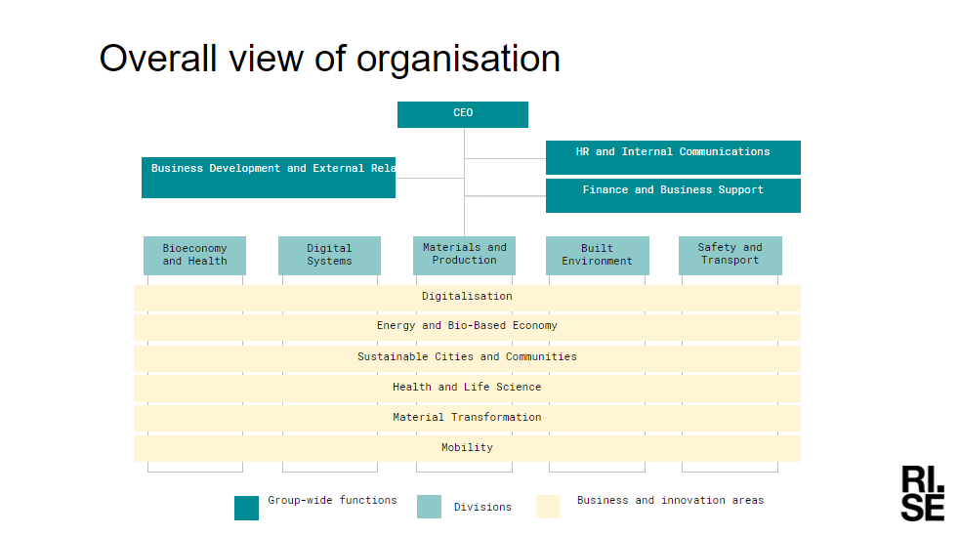

1. Organisation Chart of ExCB/ExTL/ATF

Organisation charts for the RISE divisions:  
- Built Environment  
- Safety and Transport.

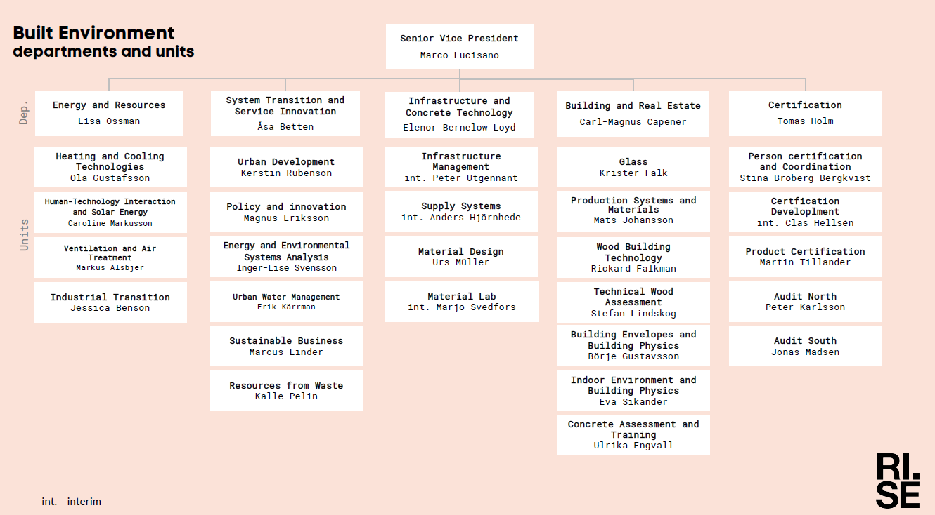

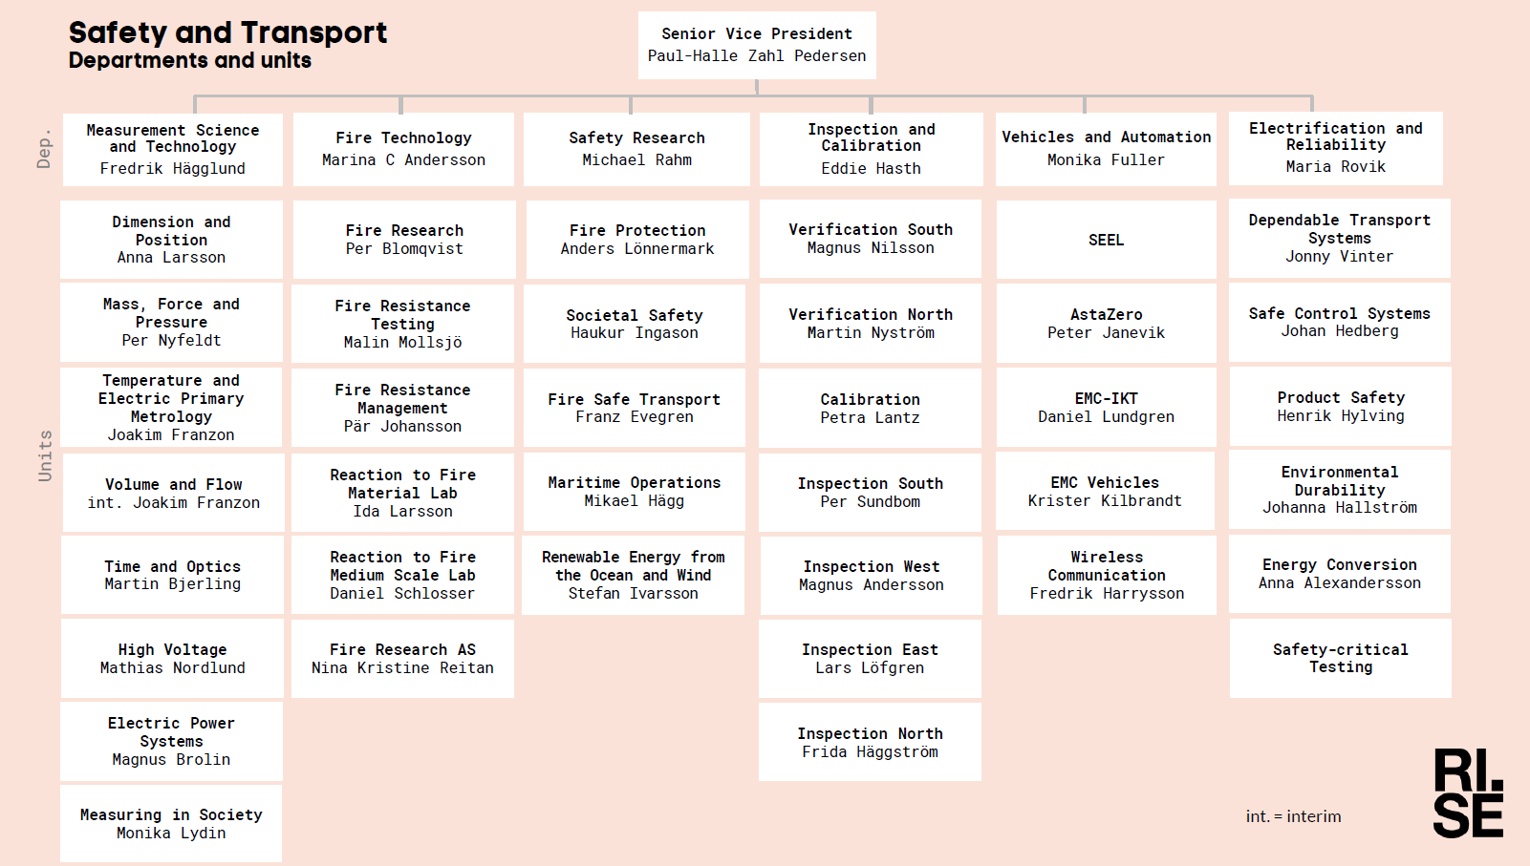

1. Accreditation Certificate for ISO/IEC 17065

Refer to enclosed accreditation certificates issued by the Swedish Board for Accreditation and Conformity Assessment (Swedac):  
- Accreditation Certificate Notified Body ATEX (incl. ISO/IEC 17065, ISO/IEC 17020 and ISO/IEC 17021-1)  
- Accreditation Certificate Product Certification (ISO/IEC 17065)





“*The accreditation is valid until further notice. The Swedish Board for Accreditation and Conformity Assessment (Swedac) regularly carries out surveillance, and a full reassessment every fourth year…*”

*“This accreditation certificate is valid from* 2020-04-30”

This means a validity period of four years for the certificates i.e., from **2020-04-30 to 2024-04-30**

**Secretariat has confirmed currency of SWEDAC Accreditation**