**INTERNATIONAL ELECTROTECHNICAL COMMISSION SCHEME FOR  
CERTIFICATION TO STANDARDS RELATING TO EQUIPMENT FOR USE  
IN EXPLOSIVE ATMOSPHERES (IECEx SYSTEM)**

**Title:** **Re-assessment and Scope Extension Report for the continued acceptance of TÜV SÜD Product Service GmbH an Accepted Ex Certification Body (ExCB) and an Accepted Ex Testing Laboratory (ExTL) within the IECEx Scheme 02 and for Accepted Certification Body Personnel Competencies (CoPC) Scheme 05 to include Unit 4, Unit 5, Unit 6, Unit 7, Unit 8, Unit 9 and Unit 10 in their scope.**

**Introduction**

In accordance with the 5-year re-assessment plan for the surveillance and monitoring of bodies within the IECEx System, the following document contains the Re-assessment and Scope Extension Report for the continued acceptance of TÜV SÜD Product Service GmbH an Accepted Ex Certification Body (ExCB) and an Accepted Ex Testing Laboratory (ExTL) within the IECEx Scheme 02 and for Accepted Certification Body Personnel Competencies Scheme (CoPC) 05.

During the re-assessment the IECEx Assessment Team took the opportunity to also assess

TÜV SÜD Product Service GmbH, for the following extension of scope, applicable to the IECEx o5 CoPC Scheme –

Unit Ex 004 – Maintain equipment in explosive atmospheres

Unit Ex 005 – Overhaul and repair of explosion-protected equipment

Unit Ex 006 – Test electrical installations in or associated with explosive atmospheres

Unit Ex 007 – Perform visual & close inspection of electrical installations in or associated with explosive atmospheres

Unit Ex 008 – Perform detailed inspection of electrical installations in or associated with explosive atmospheres

Unit Ex 009 – Design electrical installations in or associated with explosive atmospheres

Unit Ex 010 – Perform audit inspection of electrical installations in or associated with explosive atmospheres

***This document is hereby submitted for ExMC approval via correspondence using the IECEx on-line voting system. ExMC Members are requested to submit their vote via the IECEx On-line Ballot System by the closing date 2022 11 10***

***Please refer to OD 050 for guidance on the “IECEx On-line voting system.”***

***Chris Agius***

**IECEx Secretariat**

|  |  |
| --- | --- |
| **IECEx Secretariat**  **Australia Square Building  Level 33, 264 George Street**  **Sydney NSW 2000**  **Australia** | **Tel: +61 2 46284690**  **Fax: +61 2 4627 5285**  **Email: info@iecex.com** |

IEC System for certification to standards relating to equipment for use in Explosive Atmospheres (IECEx System)

IECEx Assessment Report Form, F-003

IECEx assessment report form for use by IECEx assessment teams to report assessments conducted according to the relevant IECEx assessment procedures of:

Operational Document IECEx OD 003-2 for the Certified Equipment Scheme

Operational Document IECEx OD 316-* for the Certified Service Facility Scheme

Operational Document IECEx OD 422 for the IECEx Conformity Mark Licensing Scheme

Operational Document IECEx OD 501 for the Personnel Competence Scheme

IECEx ExCB/ExTL/ATF assessment report for   
  
TÜV SÜD Product Service GmbH

INTERNATIONAL  
ELECTROTECHNICAL  
COMMISSION

CONTENTS11

1 Assessment information 6

1.1 Type of body covered by this assessment: 6

1.2 Type of assessment: 6

1.3 Details of body 6

1.3.1 Country 6

1.3.2 Name of body 6

1.3.3 Name and title of nominated principal contact 6

1.4 Assessment information 6

1.4.1 Members of the assessment team 6

1.4.2 Place(s) of assessment 6

1.4.3 Assessment date(s) 7

1.5 Application information and background information on the assessment 7

1.6 Scopes 7

1.6.1 ExCB & ExTL scope for IECEx Equipment Scheme 7

1.6.2 ExCB scope for Service Facilities Scheme 8

1.6.3 ExCB scope for Conformity Mark Licensing Scheme 8

1.6.4 ExCB scope for IECEx Personnel Competence Scheme 9

2 Common information 10

2.1 Legal entity of body 10

2.2 Financial support 10

2.3 History 10

2.4 Documentation 10

2.4.1 Quality manual 10

2.4.2 Procedures 10

2.4.3 Work instructions 10

2.4.4 Records (including test records where relevant) 10

2.4.5 Document change control 10

2.5 Confidentiality 11

2.6 Communication with public and customers (Hard copy and Electronic) 11

2.7 Recognitions and agreements 11

2.8 Internal audit 11

2.9 Management review 11

2.10 Contracting, subcontracting and witness testing 11

2.11 Training and competence 11

2.12 Complaints and appeals (including appeals to IECEx) 12

2.13 Impartiality 12

2.14 Active involvement in development of Decision Sheets 12

2.15 Special facts to be noted 12

2.16 Supporting documentation 12

2.17 Recommendations 13

3 ExCB for IECEx Certified Equipment Scheme 14

3.1 Assessment references 14

3.1.1 General references 14

3.1.2 Additional references applied for this assessment 14

3.2 ExCB persons interviewed 14

3.3 Associated ExTL(s) 14

3.4 Associated certification functions 14

3.5 National marks and certificates 15

3.6 Standards accepted 15

3.7 National differences to IEC standards 15

3.8 Organisation 15

3.8.1 Names, titles and experience of the senior executives 15

3.8.2 Name, title and experience of the quality management representative 15

3.8.3 Name and title of signatories for certification 15

3.8.4 Other employees in ExCB activity 15

3.9 Organizational structure 15

3.10 Indemnity insurance 15

3.11 Resources 16

3.12 Committees (such as governing or advisory boards) 16

3.13 Certification operations 16

3.13.1 National approval/certification methods 16

3.13.2 Certification policy 16

3.13.3 Application for certification 16

3.13.4 Certification decision 16

3.13.5 Suspension and cancellation of certificates 17

3.14 Certificates issued 17

3.15 National accreditation 17

3.16 Assessment of manufacturers and issue of QARs 17

3.17 Comments (including issues found during assessment) 18

4 ExTL for IECEx Certified Equipment Scheme 19

4.1 Assessment references 19

4.1.1 General references 19

4.1.2 Additional references applied for this assessment 19

4.2 ExTL persons interviewed 19

4.3 Associated ExCB(s) 19

4.4 Organisation 19

4.4.1 Names, titles and experience of the senior executives 19

4.4.2 Name, title and experience of the quality management representative 20

4.4.3 Other employees in ExTL activity 20

4.5 Organizational structure 20

4.6 Resources 20

4.7 Test reports issued 20

4.8 National accreditation 21

4.9 Calibration 21

4.10 Tests witnessed during the assessment visit 21

4.11 Participation in IECEx Proficiency Testing Programs 21

4.12 Comments (including issues found during assessment) 22

5 IECEx Conformity Mark Licensing Scheme 23

5.1 Assessment references 23

5.2 Comments (including issues found during assessment) 23

6 ExCB for IECEx Personnel Competence Scheme 23

6.1 Assessment references 23

6.3 ExCB persons interviewed 24

6.4 National certificates 24

6.5 Organisation 24

6.5.1 Names, titles and experience of the senior executives 24

6.5.2 Name, title and experience of the quality management representative 24

6.5.3 Name and title of signatories for certification 24

6.5.4 Other employees in ExCB activity 24

6.6 Organizational Structure 24

6.7 Indemnity insurance 24

6.8 Resources 25

6.9 Committees (such as governing or advisory boards) 25

6.10 Certification operations 25

6.10.1 National approval/certification Methods 25

6.10.2 Certification policy 25

6.10.3 Certification application, assessment and examination processes 25

6.10.4 Issuing of IECEx Personnel Competence Assessment Report (PCAR) 25

6.10.5 Decision on Certification 25

6.10.6 Suspension and cancellation of certificates 26

6.11 Statistics 26

6.12 Question bank 26

6.13 National accreditation 26

6.14 Comments (including issues found during assessment) 26

7 Annexes 27

Annex A Overall Organisation Chart 28

Annex B Accreditation Certificate for ISO/IEC 17025 31

# Assessment information

## Type of body covered by this assessment:

<Check appropriate boxes>

|  |  |
| --- | --- |
| ExCB for IECEx Certified Equipment Scheme |  |
| ExTL for IECEx Certified Equipment Scheme |  |
| ATF for IECEx Certified Equipment Scheme |  |
| ExCB for IECEx Certified Service Facilities Scheme |  |
| ExCB for IECEx Conformity Mark Licensing System |  |
| ExCB for IECEx Certification of Personnel Competency Scheme |  |

NOTE 1 ExCB - IECEx Certification Body

NOTE 2 ExTL - IECEx Testing Laboratory

NOTE 3 ATF - Additional Testing Facility

## Type of assessment:

<Check appropriate boxes>

|  |  |
| --- | --- |
| Pre-assessment for candidate body |  |
| Initial assessment for candidate body |  |
| Surveillance |  |
| Re-assessment |  |
| Scope extension (IECEx 05) |  |

## Details of body

### Country

GERMANY

### Name of body

TÜV SÜD Product Service GmbH - TUV SUD PS - (TPS)

### Name and title of nominated principal contact

|  |  |  |
| --- | --- | --- |
| Name | Title | E-mail address |
| Klaus Lorenz | Head of the ExCB | Klaus.Lorenz@tuev-sued.de |

## Assessment information

### Members of the assessment team

|  |  |
| --- | --- |
| Name | Role |
| Thierry HOUEIX | IECEx Lead Assessor |
| Eduardo Galera | IECEx Assessor for IECEx 02 assessment |

### Place(s) of assessment

Remote Assessment due to COVID-19 pandemic measures:

|  |  |
| --- | --- |
| TÜV SÜD Product Service GmbH | Certification Body CRT MUC Ridlerstraße 65  80339 München / Munich |

### Assessment date(s)

For IECEx02 - Remote assessment conducted according to IECEx OD 060 on 25th, 26th October, 15th and 16 November 2021.

For IECEx05 - Remote assessment conducted according to IECEx OD 060 on 15th & 16 November 2021, plus follow up reviews.

## Application information and background information on the assessment

TÜV SÜD Product Service GmbH was accepted as an IECEx02 Certifying Body and Testing Laboratory since 2008 and as an IECEx05 Certifying Body since 2018.

This was a re-assessment for the continued acceptance as an IECEx CB and IECEx TL for Equipment Scheme 02 and continued acceptance as an IECEx CB for IECEx 05 - Certification of Personnel Competencies.

## Scopes

### ExCB & ExTL scope for IECEx Equipment Scheme

| **Number** | **Title** | ExCB/ExTL |
| --- | --- | --- |
| IEC 60079-0 Ed. 6 | Explosive atmospheres - Part 0: Equipment - General requirements | Included |
| IEC 60079-1 Ed. 7 | Explosive atmospheres - Part 1: Equipment protection by flameproof enclosures “d” | Included |
| IEC 60079-2 Ed. 5 | Explosive atmospheres - Part 2: Equipment protection by pressurized enclosure «p» | Included |
| IEC 60079-5 Ed. 3 | Explosive atmospheres - Part 5: Equipment protection by powder filling «q» | Included |
| IEC 60079-6 Ed. 3 | Explosive atmospheres - Part 6: Equipment protection by oil immersion «o» | Included |
| IEC 60079-7 Ed. 4 | Explosive atmospheres - Part 7: Equipment protection by increased safety "e" | Included |
| IEC 60079-11 Ed. 6 | Explosive atmospheres - Part 11: Equipment protection by intrinsic safety “i” | Included |
| IEC 60079-13 Ed. 1 | Explosive atmospheres - Part 13: Equipment protection by pressurized room 'p' | Included |
| IEC 60079-15 Ed. 4 | Explosive atmospheres - Part 15: Equipment protection by type of protection "n" | Included |
| IEC/TR 60079-16 | Explosive atmospheres - Part 16: Artificial ventilation for the protection of analyser (s) houses | Included |
| IEC 60079-18 Ed. 3 | Explosive atmospheres - Part 18: Equipment protection by encapsulation “m” | Included |
| IEC 60079-25 Ed. 2 | Explosive atmospheres - Part 25: Intrinsically safe electrical systems | Included |
| IEC 60079-26 Ed. 2 | Explosive atmospheres - Part 26: Equipment with equipment protection level (EPL) Ga | Included |
| IEC 60079-28 Ed. 2 | Explosive atmospheres - Part 28: Protection of equipment and transmission systems using optical radiation | Included |
| IEC/IEEE 60079-30-1 Ed. 1 | Part 30-1: Electrical resistance trace heating - General and testing requirements | Included |
| IEC 60079-31 Ed. 2 | Explosive atmospheres - Part 31: Equipment dust ignition protection by enclosure "t" | Included |
| IEC 60079-35-1 | Explosive atmospheres - Part 35-1: Caplights for use in mines susceptible to firedamp - General requirements - Construction and testing in relation to the risk of explosion | Included |
| IEC/TS 60079-46 Ed. 1 | Explosive atmospheres - Part 46: Equipment assemblies | Included |
| IEC/TS 60079-47 | Explosive atmospheres – Part 47: Equipment protection by 2-wire intrinsically safe Ethernet concept (2-WISE) | Included |
| *IEC 61241-0 Ed. 1 | Electrical apparatus for use in the presence of combustible dust - Part 0: General requirements | Included |
| *IEC 61241-1 Ed. 1 | Electrical apparatus for use in the presence of combustible dust - Part 1: Protection by enclosure “tD” | Included |
| *IEC 61241-1-1 Ed. 1 | Electrical apparatus protected by enclosures and surface temperature limitation – specification for apparatus | Included |
| *IEC 61241-4 Ed. 1 | Electrical apparatus for use in the presence of combustible dust - Part 4: Protection by pressurization "pD" | Included |
| *IEC 61241-11 Ed. 1 | Electrical apparatus for use in the presence of combustible dust – Part 11: Protection by intrinsic safety 'iD' | Included |
| *IEC 61241-18 Ed. 1 | Electrical apparatus for use in the presence of combustible dust - Part 18: Protection by encapsulation "mD" | Included |
| *IEC 61779-1 Ed. 1 | Electrical apparatus for the detection and measurement of flammable gases - Part 1: General requirements and test methods | Included |
| *IEC 61779-2 Ed. 1 | Electrical apparatus for the detection and measurement of flammable gases - Part 2: Performance requirements for group I apparatus indicating a volume fraction up to 5% methane in air | Included |
| *IEC 61779-3 Ed. 1 | Electrical apparatus for the detection and measurement of flammable gases - Part 3: Performance requirements for group I apparatus indicating a volume fraction up to 100% methane in air | Included |
| *IEC 61779-4 Ed. 1 | Electrical apparatus for the detection and measurement of flammable gases - Part 4: Performance requirements for group II apparatus indicating a volume fraction up to 100% lower explosive limit | Included |
| *IEC 61779-5 Ed. 1 | Electrical apparatus for the detection and measurement of flammable gases - Part 5: Performance requirements for group II apparatus indicating a volume fraction up to 100% gas | Included |
| ISO 80079-36 Ed. 1 | Explosive atmospheres - Part 36: Non-electrical equipment for explosive atmospheres – Basic method and requirements | Included |
| ISO 80079-37 Ed. 1 | Explosive atmospheres - Part 37: – Non-electrical equipment for explosive atmospheres - Non electrical type of protection constructional safety "c", control of ignition source "b", liquid immersion "k" | Included |

### ExCB scope for Service Facilities Scheme

TUV SUD PS is not ExCB according IECEx 03.

### ExCB scope for Conformity Mark Licensing Scheme

Full scope as shown for ExCB above. However, TUV SUD PS do not issued any Mark License.

### ExCB scope for IECEx Personnel Competence Scheme

The scope and requested scope extension for the IECEx Personnel Competence Scheme are shown below.

| Unit | | Comments |
| --- | --- | --- |
| Unit Ex 000 – Basic knowledge and awareness |  |  |
| Unit Ex 001 – Apply basic principles of protection in explosive atmospheres |  |  |
| Unit Ex 002 – Perform classification of hazardous areas |  |  |
| Unit Ex 003 – Install explosion-protected equipment and wiring systems |  |  |

**Scope Extension request for IECEx Personnel Competence Scheme**

|  |  |  |
| --- | --- | --- |
| Unit Ex 004 – Maintain equipment in explosive atmospheres |  | Requested for this extension |
| Unit Ex 005 – Overhaul and repair of explosion-protected equipment |  | Requested for this extension |
| Unit Ex 006 – Test electrical installations in or associated with explosive atmospheres |  | Requested for this extension |
| Unit Ex 007 – Perform visual & close inspection of electrical installations in or associated with explosive atmospheres |  | Requested for this extension |
| Unit Ex 008 – Perform detailed inspection of electrical installations in or associated with explosive atmospheres |  | Requested for this extension |
| Unit Ex 009 – Design electrical installations in or associated with explosive atmospheres |  | Requested for this extension |
| Unit Ex 010 – Perform audit inspection of electrical installations in or associated with explosive atmospheres |  | Requested for this extension |

# Common information

## Legal entity of body

TUV SUD PS **is a** private limited company in Germany**.** The ExCB and the ExTL is a department within the organization of TÜV SÜD Product Service GmbH.

## Financial support

TPS, a 100% private owned company, is self-f~~o~~unded relying on revenues based on certificate fees, license fees and testing activities.

## History

Under the leadership of the former TÜV Bayern (now: TÜV SÜD), founded in 1872, several product safety laboratories in Munich were united and formed to TÜV Product Service GmbH in 1988. In 1990, TÜV Hessen’s safety laboratory joined, and in 1997, TÜV Südwest in Filderstadt / Stuttgart was integrated into the organization of TÜV Product Service GmbH. In 2006, the TÜV SÜD Holding introduced a new Corporate Identity and the former TÜV Product Service GmbH was renamed as TÜV SÜD Product Service GmbH. Nowadays, in a worldwide network, manufacturers of all kinds of consumer products are served by TPS based on various accreditations and notifications.

## Documentation

### Quality manual

TUV SUD PS has a comprehensive quality manual supported by other procedural documents, which refer to ISO 9001, ISO/IEC 17024, ISO/IEC 17025 and ISO/IEC 17065 standards.

### Procedures

TUV SUD PS has a very comprehensive range of procedures covering all aspects of the testing operations that were audited as part of this assessment. Where applicable each procedure has with it an associated test sheet for completion by the staff. These Procedures were found to meet the requirements of IECEx.

### Work instructions

All relevant Staff Work Instructions for certification as well as all the relevant IECEx rules, guidance, operational documents and ExTAG decision sheets are also listed and available in the Intranet.

### Records (including test records where relevant)

The overall records procedure is described in the Quality system of TPS (TPS_P_16.01 “Control of quality records” and CPL_P_16.01” Retention periods in the certification body for products”). The procedure ensures that all records related to IECEx testing and certification activities are maintained with a minimum retention time of 10 years. Examples of certification records were reviewed, and it was found all the relevant records are properly stored by using registration numbers.

All the issued Certificates for IECEx and ATEX are listed on the Intranet of TÜV SÜD Group ([www.tuev-sued.de](http://www.tuev-sued.de)).

The procedure addresses the requirements of IECEx OD-207.

### Document change control

Document change control is affected by having the master document as the electronic document on the intranet.

Printed copies are effectively uncontrolled and show that it is requested to check the validity before to use it.

The document change control procedure is described in the Quality system of TUV SUD PS.

The certification standards for IECEx operation at TUV SUD PS are listed in the body’s database as a controlled list. By accessing into the intranet, it was found that the editions of listed standards are not completely matched with the scope accepted by IECEx. This deficiency has been subsequently resolved.

## Confidentiality

All employees and members of committees sign confidentiality agreements. Examples of these were sighted by the team and found to meet the requirements of the IECEx.

## Communication with public and customers (Hard copy and Electronic)

IECEx scheme rules for TUV SUD PS Ex certification are available on the TUV SUD PS’s website

## Recognitions and agreements

TUV SUD PS has several agreements with organisations in other countries including organisations listed on OD 001 for IECEx Equipment Scheme this was checked and found to align with IECEx OD 001.

These are not applicable for the IECEx Equipment or Personnel Competence Scheme.

## Internal audit

There is an overall audit system for TUV SUD PS which include ATEX/IECEx Schemes.

Internal audits are done once a year for each type of operation. There is an internal audit regarding the compliance of 17065. The last internal audit took place on 2021-11-10 and this was reviewed. No nonconformities were found.

## Management review

The management review meeting that took place once a year and the last one was on 2021-01-31 was reviewed and covered the required aspects including all items/clauses of 17025 and 17065.

## Contracting, subcontracting and witness testing

Regarding IECEx 02, the ExTL in Filderstadt subcontract some tests and they are listed in their TCD which were checked by the IECEx Assessor Team.

Regarding the witness tests performed in accordance with OD024, there are well registered on the IECEx [online register](https://www.iecex.com/members-area/testing-register/).

There is no subcontract in the field of the IECEx Personnel Competence Scheme.

## Training and competence

<Document references to be initially completed by body being assessed>.

All staff employed are selected for qualifications and/or experience relevant to their responsibilities. Each member of staff has a full job description, which comprehensively defines their responsibilities, job function, qualification requirements and their position within the organisation.

## Complaints and appeals (including appeals to IECEx)

<Document references to be initially completed by body being assessed>

There is a general process in TUV SUD PS for internal complaints, internal and external audits, and external complaints. This covers the complaints mechanism requirements of the ExCB and ExTL.

In the Procedure “ITC_P_10.14E”, there are special clauses to ensure that complaints regarding certified products, service, presentation of results, methods or any other subject are effectively dealt with are also regarding IECEx scheme. Also to ensure that appeals and disputes in respect of certification activity and dealt with fairly and transparently.

## Impartiality

TUV SUD PS’s staff (internal and external) involved in the process of certification activities has signed a commitment regarding impartiality and confidentiality.

There is an Impartiality Committee at TUV SUD PS which meets once a year in the end of the Certification Committee. The last meeting took place on 16/17 March 2022 in Munich.

## Active involvement in development of Decision Sheets

TUV SUD PS’s staff do participate actively in development of IECEx Scheme and in Decision Sheets

## Special facts to be noted

None other than those referred to throughout this report..

## Supporting documentation

Copies of additional supporting information for this assessment have been provided to the applicant and the IECEx Secretariat. These are included in a site assessment report or provided separately and include:

* Details of issues raised and how these have been resolved
* Information on competencies
* Assessors’ notes
* Completed TCD
* Photos of the facilities/tests witnessed are included in the above TCD.

## Recommendations

Based on the assessment performed on 21 & 22 September 2021 and on 11 to 15 October 2021 and the resolution of the Findings/Issues, TÜV SÜD Product Service GmbH is recommended for continued acceptance in the IECEx scheme as:

* An ExTL in the IECEx Certification of Equipment Scheme 02
* An ExCB in the IECEx Certification of Equipment Scheme 02
* An ExCB in the IECEx Certification of Personnel Competency Scheme including the extension of scope request 05

This is according to the scope of the Equipment standards (IECEx 02), and Units of Competence (IECEx 05) listed in this document, including scope extension for the IECEx 05 Scheme.

All issues have been resolved to the satisfaction of the assessment team.

|  |  |  |
| --- | --- | --- |
| Thierry HOUEIX | Eduardo Galera | <name> |
| IECEx Lead Assessor | IECEx Assessor | IECEx Assessor |

Date: 2022-09 09

# ExCB for IECEx Certified Equipment Scheme

* 1. **Assessment references**
     1. **General references**

1. IECEx 02 IECEx Certified Equipment Scheme covering equipment for use in explosive atmospheres – Rules of Procedure
2. IECEx OD003-2 Assessment, surveillance assessment and re-assessment of ExCBs and ExTLs operating in the IECEx 02, IECEx Certified Equipment Scheme
3. ISO/IEC 80079-34 Explosive atmospheres – Part 34: Application of quality systems for equipment manufacture
4. IECEx OD 009 Issuing of CoCs, ExTRs and QARs
5. IECEx OD 025 Guidelines on the Management of Assessment and Surveillance programs for the assessment of Manufacturer’s Quality Systems in accordance with the IECEx Scheme
6. IECEx OD 026 IECEx Certified Equipment Scheme – Guidelines for the qualification of Lead Auditor and Auditors, in accordance with the IECEx System
7. ISO/IEC 17065 General requirements for bodies operating product certification systems Conformity assessment — Requirements for bodies certifying products, processes and services
8. IECEx OD 107 Harmonised check list for certification bodies ISO/IEC 17065
9. IECEx OD 060 IECEx Guide for Business Continuity – Management of Extraordinary Circumstances or Events Affecting IECEx Certification Schemes and Activities
10. IECEx Technical Capability Document (TCD)
11. ExTAG decision sheets (DSs)

NOTE The latest editions of the above documents were applied, unless otherwise specified

* + 1. **Additional references applied for this assessment**

# IECEx OD 280 Guide to Certification of Non-electrical Equipment and Protective System

* 1. **ExCB persons interviewed**

|  |  |
| --- | --- |
| **Name** | **Position** |
| Klaus Lorenz | Head of Certification CRT MUC |
| Ulrich Jacobs | Senior Expert Conformity Assessment |
| Norbert Thimm | Certification Officer |

* 1. **Associated ExTL(s)**
* TÜV SÜD Product Service GmbH (TPS) - GERMANY
* TÜV NORD CERT GmbH (TUN) - GERMANY
* PTI Round Rock, Texas, USA

<To be initially completed by body being assessed>

* 1. **Associated certification functions**
* IECEx 02 Product Certification
* IECEx 05 Competent Person Certification

<To be initially completed by body being assessed>

* 1. **National marks and certificates**

TÜV SÜD Product Service GmbH is an Approved Body under the ATEX Regulation for Explosive Atmosphere: Notified Body number is 0123.

<To be initially completed by body being assessed>

* 1. **Standards accepted**

See clause 1.6 of this report

* 1. **National differences to IEC standards**

National differences to IEC standards are listed in the latest version of the IECEx System Bulletin.

* 1. **Organisation**

<Tables below to be initially completed by body being assessed>

* + 1. **Names, titles and experience of the senior executives**

|  |  |  |
| --- | --- | --- |
| **Name** | **Title** | **Experience (years)** |
| Klaus Lorenz | Head of Certification Body | 7 years |
| Ulrich Jacobs | Certification Reviewer | 11 years |
| Kristof De Gersem | Certifier and auditor | 18 years |

* + 1. **Name, title and experience of the quality management representative**

|  |  |  |
| --- | --- | --- |
| **Name** | **Title** | **Experience (years)** |
| Cajetan Angerer | Quality Manager | 3 years |

* + 1. **Name and title of signatories for certification**

|  |  |  |
| --- | --- | --- |
| **Name** | **Title** | **Comments** |
| Klaus Lorenz | Head of Certification Body | 12 years |

* + 1. **Other employees in ExCB activity**

|  |  |  |
| --- | --- | --- |
| **Name** | **Title** | **Experience in Ex (years)** |
| Ulrich Jacobs | Certification Reviewer | 11 years |
| Norbert Thimm | Certification Officer | 10 years |
| Kristof De Gersem | Certifier and auditor | 18 years |
| Frank Zhu | Technical certifier | 10 years |

* 1. **Organizational structure**

See Annex A

<To be initially completed by body being assessed> with details possibly inserted in relevant Annexes.

* 1. **Indemnity insurance**

**TUV SUD PS** holds professional indemnity and public liability insurance referenced **DEL 000598** **210M** issued by **Allianz Global Corporate & Specialty SE**. These are covered in one policy from 1st January 2020 and 01 January 2022 and signed on 7 December 2020 was reviewed, and its validity was found to be extended every year. The cover is worldwide and all certification activity which means that IECEx certification is included.

<To be initially completed by body being assessed>

* 1. **Resources**

**TUV SUD** PShas an adequate number of staffs for the current level of business who are experienced in Ex activities.

The offices are located in an industrial unit which provides an adequate environment for the work.

* 1. **Committees (such as governing or advisory boards)**

The composition and terms of reference of the Certification Impartiality Committee are given in Quality Manual. The Ex Committee comprises representatives of standardisation, accreditation, Trade organisation representing manufacturers and end-users interests with no single interest predominating. The content of the procedures meets the requirements of ISO/IEC 17065 and the IECEx requirements.

The Ex Committee meets annually. The last meeting took place on 16/17 March 2022 in Munich.

The minutes of this meeting were reviewed by the assessment team and were find in accordance with the IECEx Rules

<To be initially completed by body being assessed>

* 1. **Certification operations**
     1. **National approval/certification methods**

**TUV SUD PS** is recognised under the National accreditation systems and schemes. It has procedures for compliance with IECEx Rules and Operational Documents. **TUV SUD PS** is a Notified Body, No. 0123 regarding ATEX Directive 2014/34/EU.

<To be initially completed by body being assessed>

* + 1. **Certification policy**

The Quality Manual is available in digital form. It contains a quality policy which is generic, but it is written that the aim of TUV SUD PS is also to provide services regarding Ex equipment. Further aspects related to certification policy are covered in the general quality policy and were seen to be in conformity with the requirements of ISO/IEC 17065 and IECEx 02.

* + 1. **Application for certification**

The complete certification process for delivering certificates is contained in the “ID:41715 IECEx05 Application Form” which is available on TUV SUD PS’ website and on the Application Form referenced ID10721 which could be provided to customers by email. The procedures were found by the assessment team to meet the requirements of IECEx.

<Document references to be initially completed by body being assessed>

* + 1. **Certification decision**

In principle, the certification decision is taken by the Head of the Certification Body.

The above is documented in the ID: 2177 Release of a Certificate by the Technical Certifier which defines the certification decision is performed by one of the Technical Certifier with IECEx.

It is written ID:2159 Technical Certifier that the Technical Certifier is not allowed to be involved in evaluation activities.

<Document references to be initially completed by body being assessed>

* + 1. **Suspension and cancellation of certificates**

The suspension and cancellation of certificates rules is well defined in the Certification Procedure referenced ID: 2170 Termination of Certificates.

<Document references to be initially completed by body being assessed>

* 1. **Certificates issued**

Number of certificates issued under for the preceding two years for each type of protection. For new applications these should be for national or regional schemes and for currently accepted bodies IECEx certificates should be shown (certificates for other schemes may also be shown): <Table to be initially completed by body being assessed>

| **TPS** | **Type of protection** | **2018** | **2019** | **2020** | **2021** |
| --- | --- | --- | --- | --- | --- |
| IEC 60079-0 | Explosive atmospheres - Part 0: Equipment - General requirements | 20 | 37 | 59 | 41 |
| IEC 60079-1 | Explosive atmospheres - Part 1: Equipment protection by flameproof enclosures “d” | 7 | 8 | 15 | 6 |
| IEC 60079-2 | Explosive atmospheres - Part 2: Equipment protection by pressurized enclosure «p» | 3 | 11 | 6 | 7 |
| IEC 60079-7 | Explosive atmospheres - Part 7: Equipment protection by increased safety "e" | 6 | 10 | 19 | 11 |
| IEC 60079-11 | Explosive atmospheres - Part 11: Equipment protection by intrinsic safety “i” | 11 | 8 | 9 | 3 |
| IEC 60079-15 | Explosive atmospheres - Part 15: Equipment protection by type of protection "n" | 1 | 4 | 5 | 7 |
| IEC 60079-16 | Explosive atmospheres - Part 16: Artificial ventilation for the protection of analyser (s) houses | 1 | 4 | 5 | 7 |
| IEC 60079-18 | Explosive atmospheres - Part 18: Equipment protection by encapsulation “m” | - | 2 | 9 | 8 |
| IEC 60079-26 | Explosive atmospheres - Part 26: Equipment with equipment protection level (EPL) Ga | - | - | - | - |
| IEC 60079-28 | Explosive atmospheres - Part 28: Protection of equipment and transmission systems using optical radiation | 3 | 8 | 1 | - |
| IEC 60079-31 | Explosive atmospheres - Part 31: Equipment dust ignition protection by enclosure "t" | 9 | 10 | 14 | 5 |
| IEC 60079-35 | Explosive atmospheres - Part 35-1: Caplights for use in mines susceptible to firedamp - General requirements - Construction and testing in relation to the risk of explosion | 1 | - | - | - |
| IEC 60079-46 | Explosive atmospheres - Part 40: Requirements for process sealing between flammable process fluids and electrical systems | 1 | - | - | - |
| IEC 60079-47 | Electrical apparatus for use in the presence of combustible dust - Part 0: General requirements | 1 | - | - | - |
| IEC 61241-1 | Electrical apparatus for use in the presence of combustible dust - Part 1: Protection by enclosure “tD” | - | - | - | 1 |
| IEC 61241-1-1 | Electrical apparatus protected by enclosures and surface temperature limitation – specification for apparatus | - | - | - | 1 |
| ISO 80079-36 | Explosive atmospheres - Part 36: Non-electrical equipment for explosive atmospheres – Basic method and requirements | - | 1 | 5 | 9 |
| ISO 80079-37 | Explosive atmospheres - Part 37: – Non-electrical equipment for explosive atmospheres - Non electrical type of protection constructional safety "c", control of ignition source "b", liquid immersion "k" | - | 1 | 5 | 9 |

NOTE Above include certificates to IEC 60079-0 unless otherwise shown

* 1. **National accreditation**

The national accreditation certification for ISO/IEC 17065 is shown in Annex B.

~~<To be initially completed by body being assessed>~~

* 1. **Assessment of manufacturers and issue of QARs**

CPL_P_10.50E Procedure addresses assessments of manufacturers. The report format includes all the requirements from the IECEx Scheme together with ATEX requirements.

For IECEx certification schemes a set of documented procedures is in place to enable surveillance to be carried out in accordance with the criteria of the certification systems. The requirements for manufacturing surveillance activities (including initial and ongoing inspection of product during manufacture, audit of quality system and audit of products) are detailed within the relevant scheme rules and in relevant procedures.

* 1. **Comments (including issues found during assessment)**

Minor issues were found which were cleared to the satisfaction of the assessment team after the assessment.

Detailed information on this is shown in the site assessment report. All issues have been resolved to the satisfaction of the assessment team.

1. **ExTL for IECEx Certified Equipment Scheme**
   1. **Assessment references**
      1. **General references**
2. IECEx02 IECEx Certified Equipment Scheme covering equipment for use in explosive atmospheres – Rules of Procedure
3. IECEx OD003-2 Assessment, surveillance assessment and re-assessment of ExCBs and ExTLs operating in the IECEx 02, IECEx Certified Equipment Scheme
4. IECEx OD009 Issuing of CoCs, ExTRs and QARs
5. ISO/IEC 17025 General requirements for the competence of testing and calibration laboratories
6. IECEx OD 018 Harmonised check list for testing and calibration laboratories ISO/IEC 17025
7. IECEx TCD 60079, ISO 80079 Series and ISO 16852 Technical Capability Document
8. ExTAG decision sheets (DSs)
9. IECEx OD 202 IECEx Certified Equipment Scheme – IECEx Proficiency Testing Program

NOTE The latest editions of the above documents were applied, unless otherwise specified.

* + 1. **Additional references applied for this assessment**

# IECEx OD 280 Guide to Certification of Non-electrical Equipment and Protective System

* 1. **ExTL persons interviewed**

|  |  |
| --- | --- |
| **Name** | **Position** |
| Tobias Pfeifer | Testing Lab Manager |
| Matthias Kutny | Non electrical protection assessor |

* 1. **Associated ExCB(s)**

TÜV SÜD Product Service GmbH (TPS) – GERMANY

<To be initially completed by body being assessed>

* 1. **Organisation**

<Tables below to be initially completed by body being assessed>

* + 1. **Names, titles and experience of the senior executives**

|  |  |  |
| --- | --- | --- |
| **Name** | **Title** | **Experience (years)** |
| Ulrich Jacobs | Technical Certifier | 20 years in Ex |
| Arno Butzke | Technical Certifier | 2 years in Ex |
| Andreas Pfeil | Technical Certifier | 20 years in Ex |
| Stefan Vierbücher | Technical Certifier | 5 years in Ex |
| Frank Zhu* | Technical Certifier | 10 years in Ex |
| Kristof De Gersem* | Technical Certifier | 18 years in Ex |
| Tiziano Porqueddu* | Technical Certifier | 15 years in Ex |

* + 1. **Name, title and experience of the quality management representative**

|  |  |  |
| --- | --- | --- |
| **Name** | **Title** | **Experience (years)** |
| Cajetan Angerer | Quality Manager | 2 years |

* + 1. **Other employees in ExTL activity**

|  |  |  |
| --- | --- | --- |
| **Name** | **Title/responsibility** | **Experience in Ex (years)** |
| Matthias Kutny | Reviewer | 6 in Ex |
| Mahmoud Karim | Reviewer | 5 in Ex |
| Ulf Liebscher | Reviewer | 22 in Ex |
| Martin Sittko | Reviewer | 11 in Ex |
| Christian Schweißgut | Project Handler | 1 in Ex |
| Werner Müller-Starke | Project Handler | 10 in Ex (retired) |
| Jason Chen | Project Handler | 5 years in Ex |
| Xia Jiayan | Project Handler | 10 years in Ex |
| Nathan Li | Project Handler | 5 years in Ex |
| Ryan Jiang | Project Handler | 5 years in Ex |
| Gareth Liao | Project Handler | 5 years in Ex |
| Lyon Li | Project Handler | 10 years in Ex |

* 1. **Organizational structure**

See Annex A

<To be initially completed by body being assessed> with details possibly inserted in relevant Annexes.

* 1. **Resources**

The Ex operation at **TUV SUD PS** has several professional and technical staff involved in Ex testing. It has a comprehensive range of testing equipment and good facilities for this type of testing.

* 1. **Test reports issued**

Number of test reports (ExTRs) issued under for the preceding two years for each type of protection. For new applications these should be for national or regional schemes and for currently accepted bodies IECEx ExTRs should be shown (test reports for other schemes may also be shown):

| **Standard numbers** | **Type of protection or other identifying information** | **Number of issued reports (ExTRs) (for last 2 years)** | | **Total** |
| --- | --- | --- | --- | --- |
| 2020 | 2021 |
| IEC 60079-0 | Explosive atmospheres - Part 0: Equipment - General requirements | 20 | 17 | 56 ExTR’s were issued in 2020 & 2021. Sometimes more than one ignition protection concept is mentioned on one ExTR. |
| IEC 60079-2 | Explosive atmospheres - Part 2: Equipment protection by pressurized enclosure «p» |  | 3 |
| IEC 60079-7 | Explosive atmospheres - Part 7: Equipment protection by increased safety "e" | 4 | 2 |
| IEC 60079-11 | Explosive atmospheres - Part 11: Equipment protection by intrinsic safety “i” | 5 | 2 |
| IEC 60079-15 | Explosive atmospheres - Part 15: Equipment protection by type of protection "n" | 1 | 0 |
| IEC 60079-18 | Explosive atmospheres - Part 18: Equipment protection by encapsulation “m” | 2 | 4 |
| IEC 60079-31 | Explosive atmospheres - Part 31: Equipment dust ignition protection by enclosure "t" | 3 | 1 |
| IEC/TS 60079-46 | Explosive atmospheres - Part 46: Equipment assemblies | 20 | 13 |
| ISO 80079-36 | Explosive atmospheres - Part 36: Non-electrical equipment for explosive atmospheres – Basic method and requirements | 3 | 7 |
| ISO 80079-37 | Explosive atmospheres - Part 37: – Non-electrical equipment for explosive atmospheres - Non electrical type of protection constructional safety "c", control of ignition source "b", liquid immersion "k" | 3 | 7 |

~~NOTE 1 Above include reports to IEC 60079-0 unless otherwise shown~~

~~NOTE 2 Where the number of reports is low, assessors are expected to carefully check current capability and document the process in this report (this may include adding additional years to the table).~~

~~NOTE 3 Above table does not need to be completed for accepted ExTLs where the body is integral with the ExCB~~

* 1. **National accreditation**

<To be initially completed by body being assessed> (Scope to be checked by assessment team)

The lab in Filderstadt is not accredited and under annual supervision of IECEx.

* 1. **Calibration**

The majority of test equipment is sent out for calibration by an external calibration facility. These calibration facilities are SHATEC_W_11.01E Testing Equipment Control and Calibration accredited.

The calibration procedure was also reviewed

* 1. **Tests witnessed during the assessment visit**

The following tests were witnessed during the assessment visit:

|  |  |  |  |
| --- | --- | --- | --- |
| **Standard and edition** | **Clause number** | **Test** | **Comments** |
| IEC 60079-0 | 26.13 | Surface resistance testing equipment on any non-metallic sample | Correct |
| IEC 60079-11 | 10.5 | Battery Short-circuit testing equipment preferably on a high capacity battery | Correct |
| IEC 60079-7 | 5.3.7 | Temperature rising on a luminaire | Correct |

* 1. **Participation in IECEx Proficiency Testing Programs**

Program: PTB Ex PT Scheme <note if involved in any other program>

~~NOTE 1 It is anticipated that the IECEx Secretariat will provide the assessment team with information on the performance of the body in completed PTB Ex PT Scheme programs.~~

~~NOTE 2 Assessor should ask what is being done about results. This includes what has happened when testing process changed as result of a program, eg could look at management review agenda/minutes~~

|  |  |  |
| --- | --- | --- |
| **Year(s) of participation** | **IECEx** **Proficiency Testing program** | **General information about results** |
| 2019 | Tests of Enclosures - Test Round 2019 | PT result complied |
| 2021 | Flameproof Joints – Test Round 2021 | On going |
| 2021 | Small Component Temperature – Test Round 2021 | On going |

* 1. **Comments (including issues found during assessment)**

Minor issues were found which were cleared to the satisfaction of the assessment team after the assessment.

<Information should be included about the nature of the issues found together with an indication that they have been resolved to the satisfaction of the assessment team>

1. **IECEx Conformity Mark Licensing Scheme**
   1. **Assessment references**
2. IECEx 04 IECEx Certified Equipment Scheme covering equipment for use in explosive atmospheres – IECEx Conformity Mark Licensing Scheme – Rules
3. IECEx OD 422 IECEx Certified Equipment Scheme covering equipment for use in explosive atmospheres – Procedures for the granting of Licenses to issue and use the IECEx Conformity Mark
4. IECEx OD 423 IECEx Certified Equipment Scheme covering equipment for use in explosive atmospheres – Terms and Conditions for use of the IECEx Conformity Mark

NOTE The latest editions of the above documents were applied

* 1. **Comments (including issues found during assessment)**

TÜV SÜD Product Service GmbH have not issued a Mark License since the last Reassessment.

# ExCB for IECEx Personnel Competence Scheme

## Assessment references

1. IECEx 05 IEC System for Certification to Standards relating to Equipment for use in Explosive Atmospheres (IECEx System) IECEx Scheme for Certification of Personnel Competence for Explosive Atmospheres – Rules of Procedure
2. IECEx OD 501 IECEx Scheme for Certification of Personnel Competence for Explosive Atmospheres – Assessment procedures for IECEx acceptance of Certification Bodies (ExCBs) for the purpose of issuing and maintaining IECEx Certificates of Personnel
3. IECEx OD 503 IECEx Scheme for Certification of Personnel Competence for Explosive Atmospheres - ExCB Procedures for issuing and maintaining IECEx Certificates of Personnel Competencies
4. IECEx OD 504 IECEx Scheme for Certification of Personnel Competence for Explosive Atmospheres – Specification for Units of Competence Assessment Outcomes
5. IECEx F-004 - IEC System for Certification to Standards relating to Equipment for use in Explosive Atmospheres (IECEx System) - Site Assessment Report for Assessment of IECEx Candidate and Accepted Ex Certification Bodies (ExCBs) and Candidate and Accepted Ex Testing Laboratories (ExTLs).
6. IECEx OD 506 - Guidance on the use of the IECEx Certificates of Personnel Competence Scheme’s Assessment Question Bank by ExCBs IECEx OD 060 IECEx Guide for Business Continuity – Management of Extraordinary Circumstances or Events Affecting IECEx Certification Schemes and Activities
7. ISO/IEC 17024 Conformity assessment — General requirements for bodies operating certification of persons
8. IECEx OD 507 Check list for assessment to ISO/IEC 17024
9. IECEx OD060 IECEx Guide for Business Continuity – Management of Extraordinary Circumstances or Events Affecting IECEx Certification Schemes and Activities
10. ExPCC Decision Sheets

Additional references applied for this assessment

None

## ExCB persons interviewed

|  |  |
| --- | --- |
| Name | Position |
| Kristof De Gersem | Technical Certifier for IECEx 02 and IECEx 05 |
| Xia Jiayan | Examiner for IECEx 05 |
| Norbert Thimm | Certification Officer |

## National certificates

TUV SUD PS is not accredited in accordance with ISO/IEC 17024

## Organisation

<Tables below to be initially completed by body being assessed>

### Names, titles and experience of the senior executives

|  |  |  |
| --- | --- | --- |
| Name | Title | Experience (years) |
| Klaus Lorenz | Head of the ExCB | 7 years in Ex  (in his role as Head of EXCB) |

### Name, title and experience of the quality management representative

|  |  |  |
| --- | --- | --- |
| Name | Title | Experience (years) |
| Cajetan Angerer | Quality Manager | 2 years in Ex |

### Name and title of signatories for certification

|  |  |  |
| --- | --- | --- |
| Name | Title | Comments |
| Klaus Lorenz | Head of the ExCB | 7 years in Ex  (in his role as Head of EXCB) |
|  |  |  |

### Other employees in ExCB activity

|  |  |  |
| --- | --- | --- |
| Name | Title/responsibility | Experience in Ex (years) |
| Kristof De Gersem | Technical Certifier | 18 years in Ex |
| Frank Zhu | Technical Certifier | 10 years in Ex |
| Xia Jiayan | Examiner | 10 years in Ex |

## Organizational Structure

See Annex A

## Indemnity insurance

<To be initially completed by body being assessed>

TUV SUD PS holds professional indemnity and public liability insurance. These are covered in one policy from TUV SUD Limited General Liability Insurance which was reviewed and found to be valid to contract terminated. The cover is considered acceptable.

## Resources

TUV SUD PS have a total of 4 personnel involved in the ExCB plus some external examiners/invigilators, for the IECEx Personnel Competence Scheme. These resources are considered adequate for this Scheme and managed and controlled by TUV PS central location.

## Committees (such as governing or advisory boards)

The composition and terms of reference of the Certification Committee are given in the procedures named CPL_P_10.03E (Clause 5.3.1) The Steering Group for IECEx Competence comprises representatives of Trade Association, Customer, Industry Representative with no single interest predominating. The content of the procedures meets the requirements of ISO/IEC 17024 and the IECEx requirements.

## Certification operations

### National approval/certification Methods

TUV SUD PS is one of European Notified Body against the ATEX Directive 2014/34/EU.

### Certification policy

The Quality Manual is available on request. It contains a quality policy that makes reference to product and competency certification. Further aspects related to certification policy are covered in procedures ID:2166 Contents and Form of Certificates and were seen to be in conformity with the requirements of ISO/IEC 17065 and IECEx 02 and ISO/IEC 17024 and IECEx05 and supporting Operational Documents.

NOTE Typically this may be a separate policy or included in the quality policy.

### Certification application, assessment and examination processes

The applicant can ask for an application for certification by any method, including by e-mail, in person, by writing etc. The application form needs to be filled by the applicant. After reviewed commercial offer is sent to the applicant.

By issuing a purchase order, the customer admits having knowledge of the sales and certification general and specific terms applicable to TUV SUD PS as stated in the offer.

The approach is laid out in procedure: CPL_W_10.02E Types of Certificates. This procedure was checked and found to meet the requirements of the IECEx.

### Issuing of IECEx Personnel Competence Assessment Report (PCAR)

For each assessment a PCAR is issued to the candidate. However, only PCARs which allow the issue of a CoPC is registered on the IECEx website

### Decision on Certification

In principle, the certification decision is taken by Kristof de Gersem or Frank Zhu in their role as Technical Certifier respectively in their role as local Certification Manager of TUV SUD PS.

The above is documented in the ID: 2347 Roles & activities. Normally the Technical Certifier is the independent reviewer and he propose the decision based on the ExPCAR and the certification file.

### Suspension and cancellation of certificates

<Document references to be initially completed by body being assessed>

The suspension of certificates rules is well defined in [ID](https://roxtra.tuev-sued.com/Roxtra/doc/showfile.aspx?FileID=2170):2170 [Termination of Certificates](https://roxtra.tuev-sued.com/Roxtra/doc/showfile.aspx?FileID=2170) where there is specific reference as to how this relates to the IECEx System.

## Statistics

<To be initially completed by body being assessed>

Detail experience in certification of personal competence for past two years.

| Unit | Experience |
| --- | --- |
| Unit Ex 000 – Basic knowledge and awareness | +-40 certificates issued |
| Unit Ex 001 – Apply basic principles of protection in explosive atmospheres | +-40 certificates issued |
| Unit Ex 002 – Perform classification of hazardous areas | +-20 certificates issued |
| Unit Ex 003 – Install explosion-protected equipment and wiring systems | +-20 certificates issued |
| Unit Ex 004 – Maintain equipment in explosive atmospheres | Scope extension requested |
| Unit Ex 005 – Overhaul and repair of explosion-protected equipment | Scope extension requested |
| **Unit Ex 006 – Test electrical installations in or associated with explosive atmospheres** | **Scope extension requested** |
| **Unit Ex 007 – Perform visual & close inspection of electrical installations in or associated with explosive atmospheres** | **Scope extension requested** |
| **Unit Ex 008 – Perform detailed inspection of electrical installations in or associated with explosive atmospheres** | **Scope extension requested** |
| **Unit Ex 009 – Design electrical installations in or associated with explosive atmospheres** | **Scope extension requested** |
| **Unit Ex 010 – Perform audit inspection of electrical installations in or associated with explosive atmospheres** | **Scope extension requested** |

## 

TUV SUD PS own the required artefact for the requested units. There were sighted during the assessment and photos were stored with the site assessment report.

The examiners listed in 6.5.4 were interviewed and were recognized competent for these units.

## Question bank

TUV SUD PS has provided the question for all Ex Units which are requested to be included in their scope. These questions will be sent to IECEx Secretariat for their inclusion in the IECEx Question Bank.

## National accreditation

It was confirmed that TUV SUD PS have no accreditation to ISO/IEC 17024. The certification of personnel is performed based on the current certification procedure in accordance with ISO 17065 supplemented by additional QM instructions in compliance with ISO/IEC 17024 and the IECEx 05 Scheme rules.

.

## Comments (including issues found during assessment)

All the issues found during the re-assessment were regarding the new units which were requested, including those associated with the scope extension request.

# Annexes

The following annexes contain copy of:

* Annex A: Overall Organisation Chart
* Annex B: Accreditation Certificate for ISO/IEC 17065

1. Overall Organisation Chart

**Organisation Chart for the ExCB**

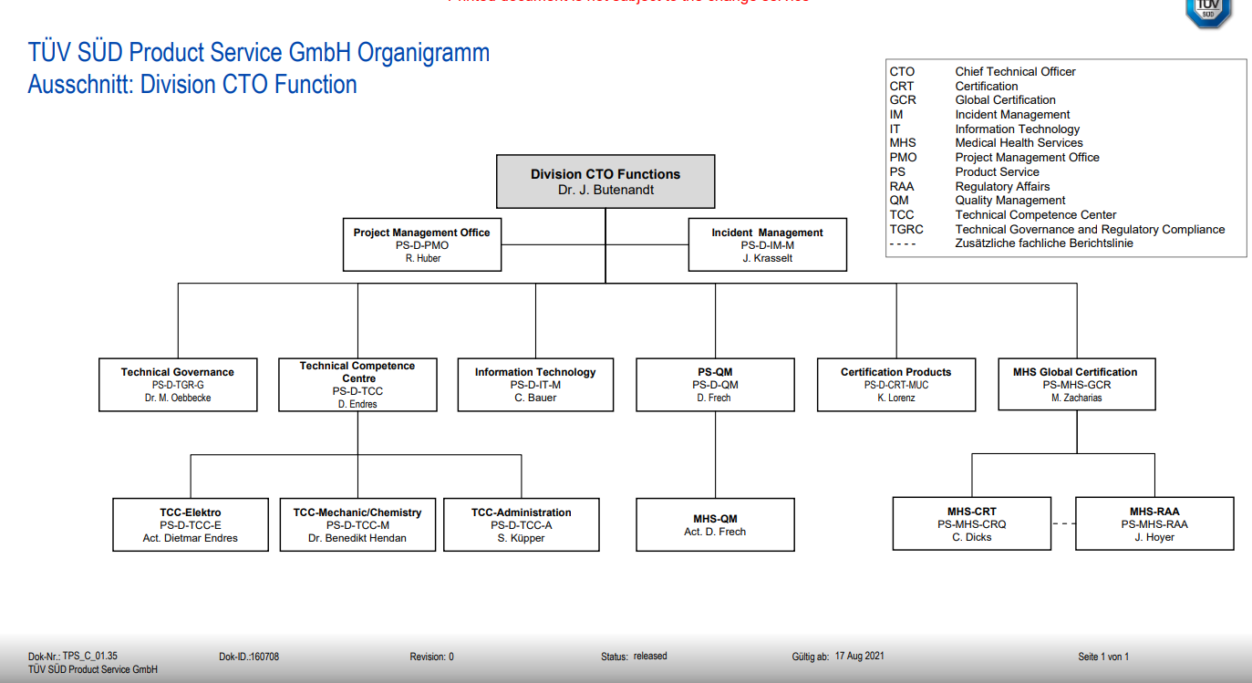

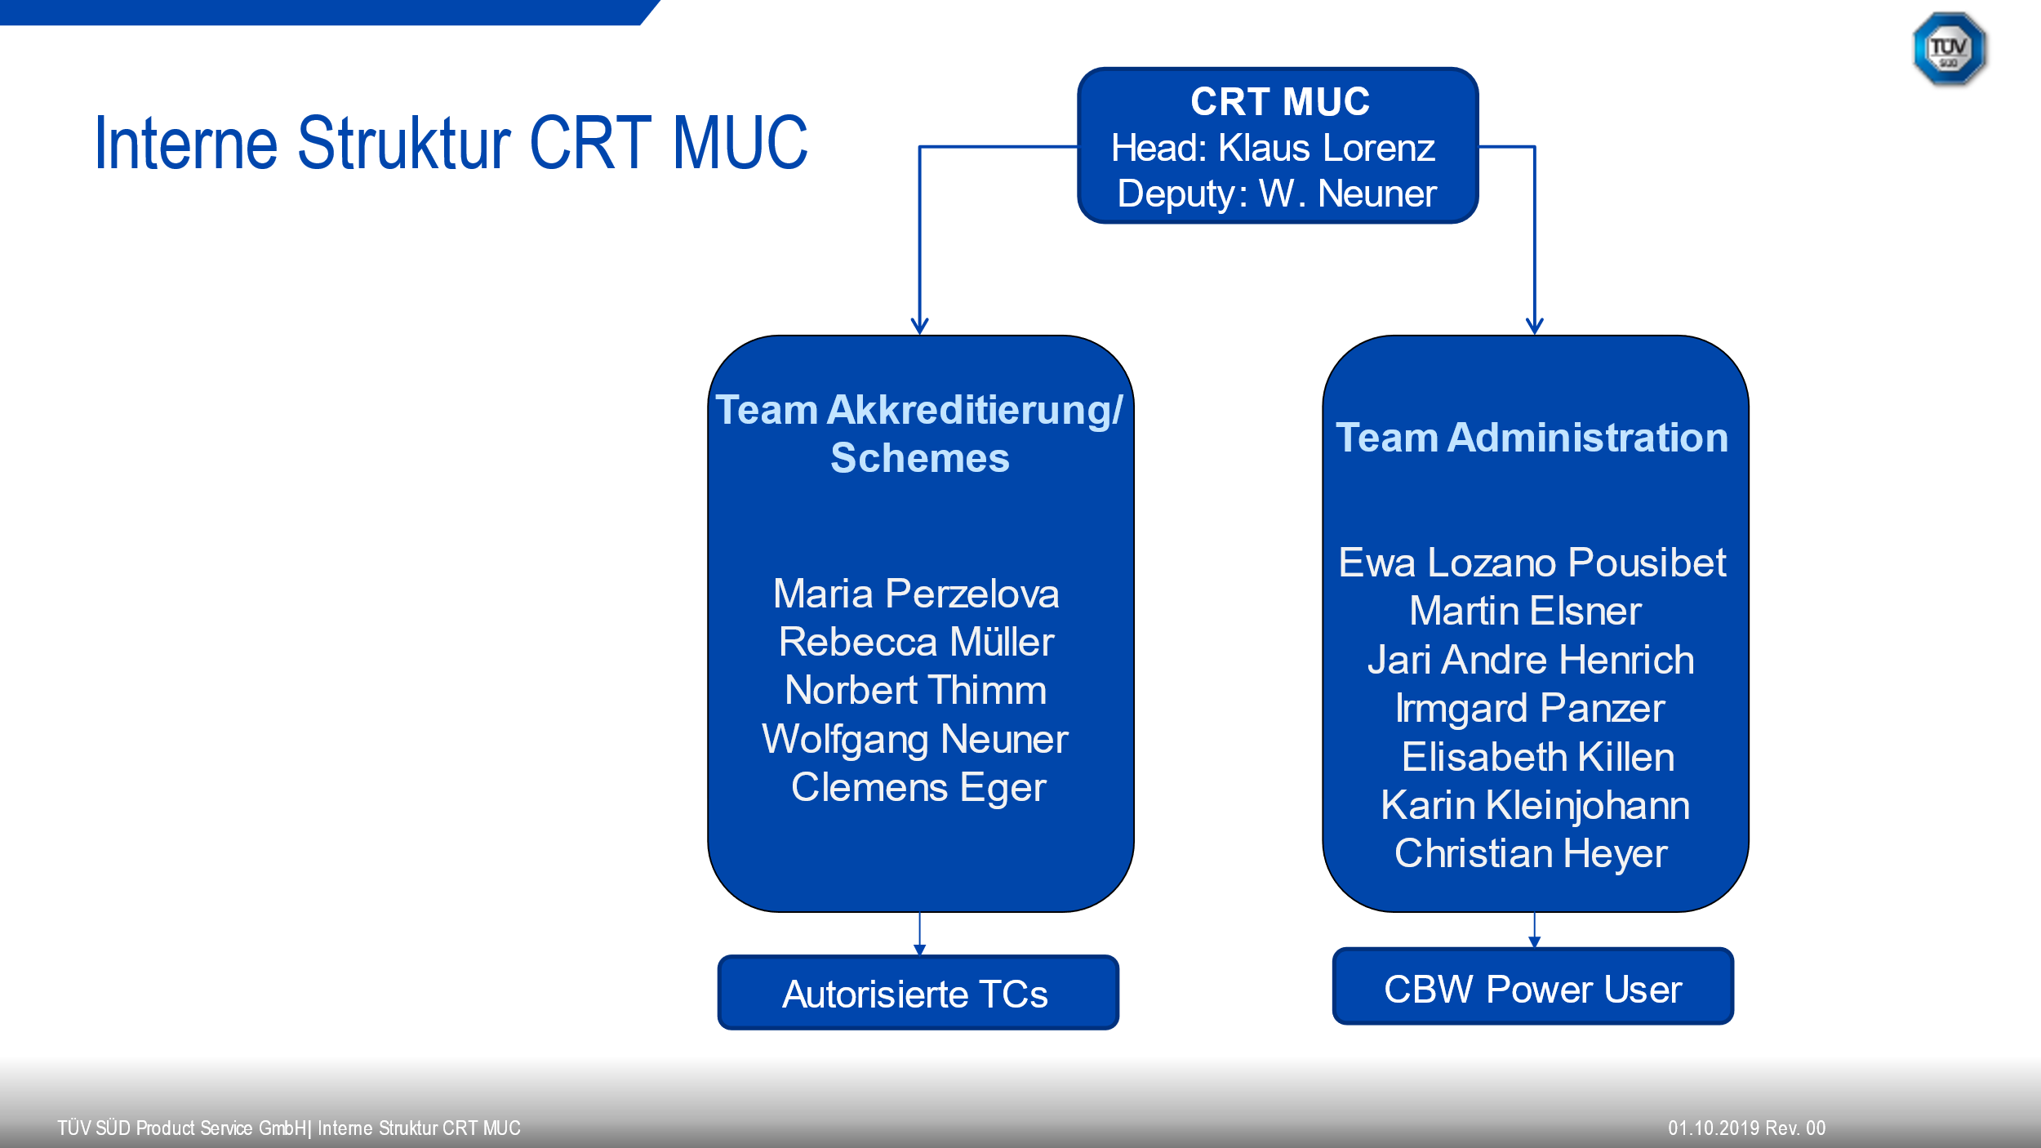

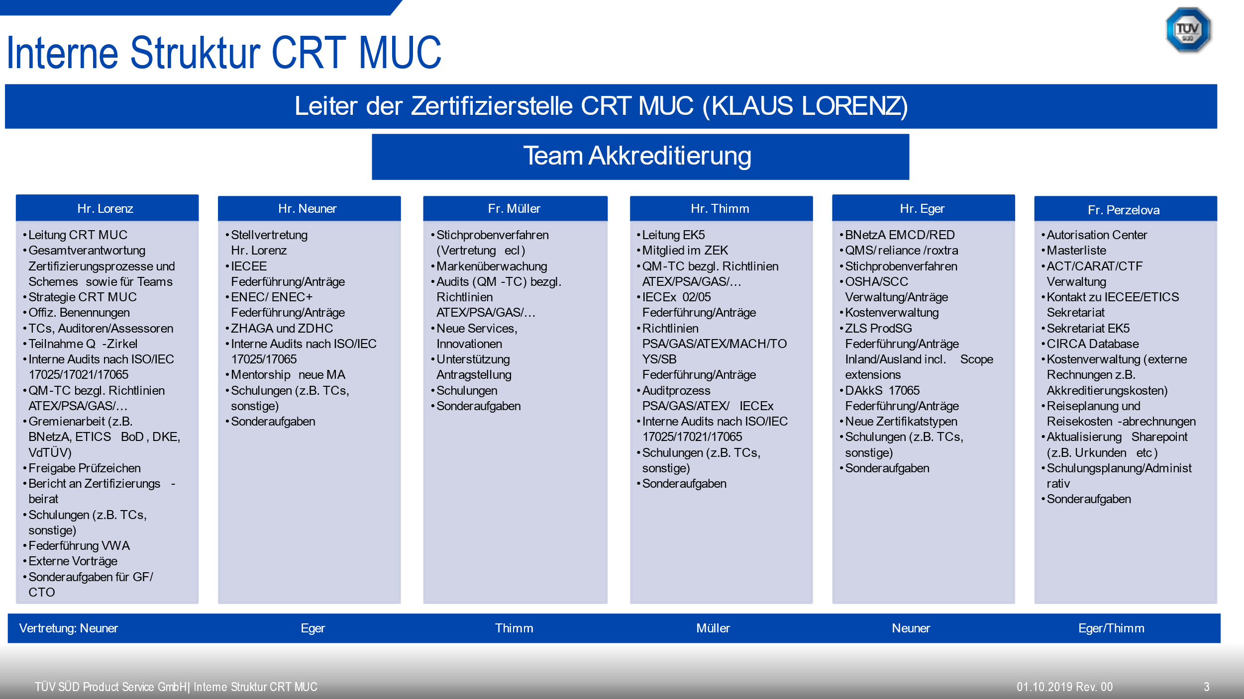

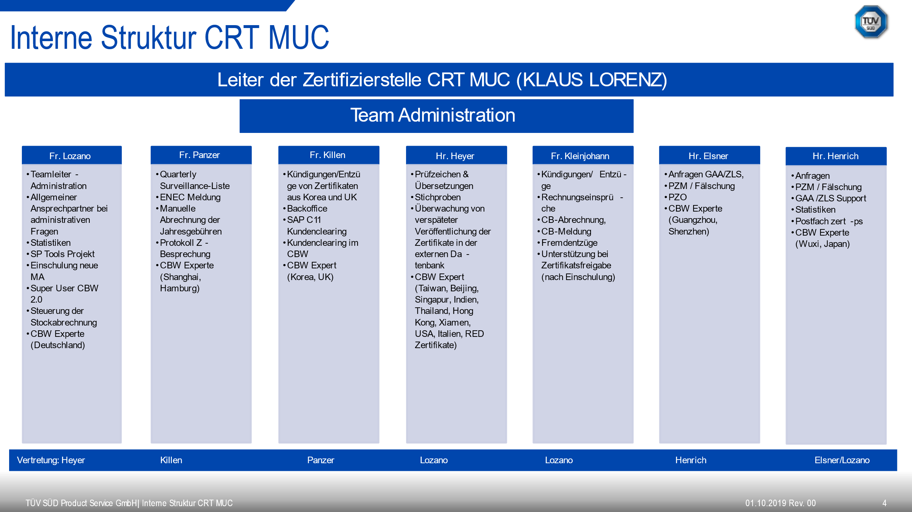

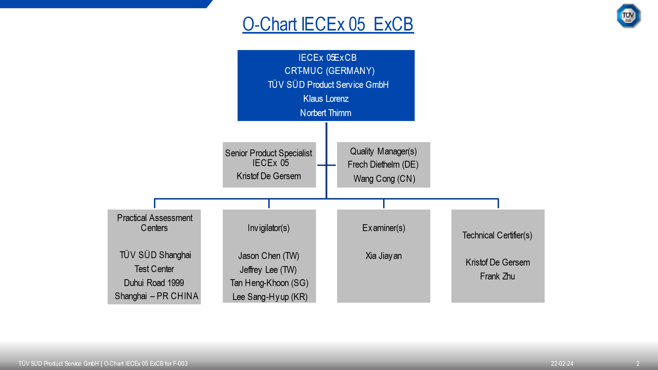

**Organisation Chart for the ExTL**

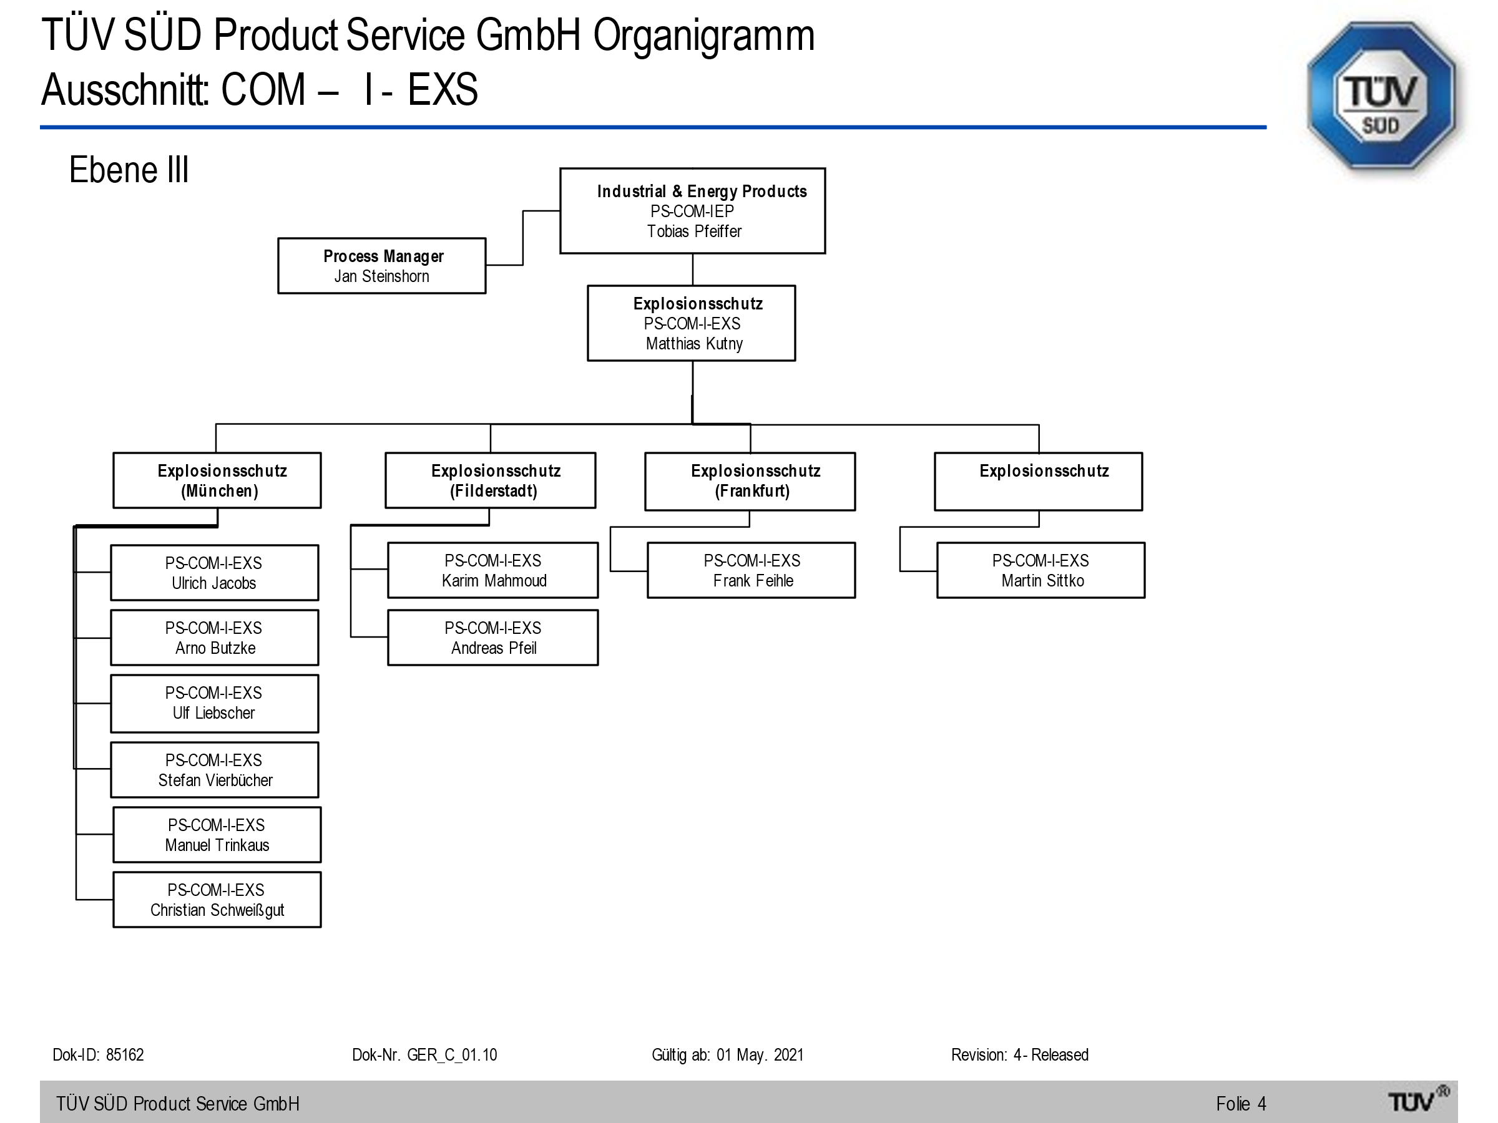

1. Accreditation Certificate for ISO/IEC 17065
2. Accreditation Certificate for ISO/IEC 17025

The lab in Filderstadt is not accredited and under annual supervision of IECEx.