**INTERNATIONAL ELECTROTECHNICAL COMMISSION SYSTEM FOR CERTIFICATION TO STANDARDS RELATING TO EQUIPMENT FOR USE IN EXPLOSIVE ATMOSPHERES (IECEx SYSTEM)**

**TITLE: Reassessment and scope extension report for UL LLC, US, an Accepted Ex Certification Body (ExCB) an Accepted Ex Testing Laboratory (ExTL) in the Equipment Scheme 02, and an Accepted ExCB in the Service Facilities Scheme, 03, as well as the Additional Testing Facility, ATF, Taiwan, to include *IEC/TS 60079-42 for ExTL only within their scope.**

**Circulation to: Members of the IECEx Management Committee, ExMC**

**INTRODUCTION**

This document contains the Reassessment and scope extension report for UL LLC, US, an Accepted Ex Certification Body (ExCB) an Accepted Ex Testing Laboratory (ExTL) in the Equipment Scheme 02, and an Accepted ExCB in the Service Facilities Scheme, 03, to include the following Standard within their ExTL scope.

|  |  |
| --- | --- |
| Number | Title |
| IEC/TS 60079-42 Ed.1 | Explosive atmospheres- Electrical safety devices for the control of potential ignition sources for Ex-Equipment  *\* This TS may be used for testing purposes but not for issuing an IECEx Certificate of Conformity* |

The report is hereby submitted for voting by the ExMC.

***This document is hereby submitted for ExMC approval via correspondence using the IECEx on-line voting system.  ExMC Members are requested to submit their vote via the IECEx On-line*** [***Ballot System***](https://www.iecex.com/ballot) ***by the closing date 2023 04 21***

***Please refer to OD 050 for guidance on the “IECEx On-line voting system.”***

***Chris Agius***

**IECEx Secretariat**

|  |  |
| --- | --- |
| **IECEx Secretariat**  **Australia Square**  **Level 33,**  **264 George Street**  **Sydney, NSW 2000**  **Australia** | **Tel: +61 2 4628 4690**  **Fax: +61 2 4625 3480**  **Email:** [**info@iecex.com**](mailto:info@iecex.com) |

IEC System for certification to standards relating to equipment for use in Explosive Atmospheres (IECEx System)

IECEx Assessment Report Form, F-003

IECEx assessment report form for use by IECEx assessment teams to report assessments conducted according to the relevant IECEx assessment procedures of:

Operational Document IECEx OD 003-2 for the Certified Equipment Scheme

Operational Document IECEx OD 316-* for the Certified Service Facility Scheme

Operational Document IECEx OD 422 for the IECEx Conformity Mark Licensing Scheme

Operational Document IECEx OD 501 for the Personnel Competence Scheme

IECEx ExCB/ExTL/ATF assessment report for

UL LLC, UNITED STATES OF AMERICA

INTERNATIONAL  
ELECTROTECHNICAL  
COMMISSION

CONTENTS

1 Assessment information 7

1.1 Type of body covered by this assessment: 7

1.2 Type of assessment: 7

1.3 Details of body 7

1.3.1 Country 7

1.3.2 Name of body 7

1.3.3 Name and title of nominated principal contact 7

1.4 Assessment information 7

1.4.1 Members of the assessment team 7

1.4.2 Place(s) of assessment 7

1.4.3 Assessment date(s) 8

1.5 Application information and background information on the assessment 8

1.6 Scopes 8

1.6.1 ExCB scope for equipment certification scheme 8

1.6.2 ExTL scope 9

1.6.3 ATF Scope 9

1.6.4 ExCB scope for Service Facilities Scheme 12

1.7 ExCB scope for Conformity Mark Licensing Scheme 13

1.8 ExCB scope for IECEx Personnel Competence Scheme 13

2 Common information 14

2.1 Legal entity of body 14

2.2 Financial support 14

2.3 History 14

2.4 Documentation 14

2.4.1 Quality manual 14

2.4.2 Procedures 15

2.4.3 Work instructions 15

2.4.4 Records (including test records where relevant) 15

2.4.5 Document change control 15

2.5 Confidentiality 15

2.6 Communication with public and customers (Hard copy and Electronic) 16

2.7 Recognitions and agreements 16

2.8 Internal audit 16

2.9 Management review 16

2.10 Contracting, subcontracting and witness testing 17

2.10.1 Contracting 17

2.10.2 Subcontracting 17

2.10.3 Off-site and Witness testing 17

2.11 Training and competence 17

2.12 Complaints and appeals (including appeals to IECEx) 18

2.13 Impartiality 18

2.14 Active involvement in development of Decision Sheets 18

2.15 Special facts to be noted 19

2.16 Supporting documentation 19

2.17 Recommendations 19

3 ExCB for IECEx Certified Equipment Scheme 20

3.1 Assessment references 20

3.1.1 General references 20

3.1.2 Additional references applied for this assessment 20

3.2 Candidate ExCB persons interviewed 20

3.3 Associated ExTL(s) 20

3.4 Associated certification functions 21

3.5 National marks and certificates 21

3.6 Standards accepted 21

3.7 National differences to IEC standards 21

3.8 Organisation 21

3.8.1 Names, titles and experience of the senior executives 21

3.8.2 Name, title and experience of the quality management representative 21

3.8.3 Name and title of signatories for certification 21

3.8.4 Other employees in ExCB activity 22

3.9 Organizational structure 22

3.10 Indemnity insurance 22

3.11 Resources 22

3.12 Committees (such as governing or advisory boards) 22

3.13 Certification operations 23

3.13.1 National approval/certification methods 23

3.13.2 Certification policy 23

3.13.3 Application for certification 23

3.13.4 Certification decision 23

3.13.5 Suspension and cancellation of certificates 23

3.14 Certificates issued 23

3.15 National accreditation 25

3.16 Assessment of manufacturers and issue of QARs 25

3.17 Comments (including issues found during assessment) 26

4 ExTL for IECEx Certified Equipment Scheme 27

4.1 Assessment references 27

4.1.1 General references 27

4.1.2 Additional references applied for this assessment 27

4.2 ExTL persons interviewed 27

4.3 Associated ExCB(s) 28

4.4 Organisation 28

4.4.1 Names, titles and experience of the senior executives 28

4.4.2 Name, title and experience of the quality management representative 28

4.4.3 Other employees in ExTL activity 28

4.5 Organizational structure 29

4.6 Resources 29

4.7 Test reports issued 29

4.8 National accreditation 31

4.9 Calibration 31

4.10 Tests witnessed during the assessment visit 31

4.11 Participation in IECEx Proficiency Testing Programs 32

4.12 Comments (including issues found during assessment) 32

5 ATF for IECEx Certified Equipment Scheme 33

5.1 Assessment references 33

5.1.1 General references 33

5.1.2 Additional references applied for this assessment 33

5.2 ATF persons interviewed 33

5.3 Associated ExTL 33

5.4 Organisation 33

5.4.1 Names, titles and experience of the senior executives 33

5.4.2 Name, title and experience of the quality management representative 34

5.4.3 Other employees in ATF activity 34

5.5 Organizational structure 34

5.6 Resources 34

5.7 Test reports issued 34

5.8 National accreditation 35

5.9 Calibration 35

5.10 Tests witnessed during the assessment visit 35

5.11 Participation in IECEx Proficiency Testing Programs 36

5.12 Comments (including issues found during assessment) 36

6 ExCB for Certified Service Facilities Scheme 38

6.1 Assessment references 38

6.1.1 General references 38

6.1.2 Additional references applied for this assessment 38

6.2 Candidate ExCB persons interviewed 39

6.3 National marks and certificates 39

6.4 Standards accepted 39

6.5 National differences to IEC standards 39

6.6 Organisation 39

6.6.1 Names, titles and experience of the senior executives 39

6.6.2 Name, title and experience of the quality management representative 39

6.6.3 Name and title of signatories for certification 39

6.6.4 Other employees in ExCB activity 39

6.7 Organizational Structure 40

6.8 Indemnity insurance 40

6.9 Resources 40

6.10 Committees (such as governing or advisory boards) 40

6.11 Certification operations 40

6.11.1 National approval/certification Methods 40

6.11.2 Certification policy 40

6.11.3 Application for certification 40

6.11.4 Certification decision 40

6.11.5 Suspension and cancellation of certificates 40

6.12 Statistics 41

6.13 National accreditation 41

6.14 Assessment of service facilities and issue of FARs 41

6.15 Comments (including issues found during assessment) 41

7 IECEx Conformity Mark Licensing Scheme 42

8 ExCB for IECEx Personnel Competence Scheme 42

9 Annexes 42

Annex A Scope for IECEx Certified Equipment Scheme 43

A.1 Current standards 43

A.2 Superseded standards 44

Annex B Overall Organisation Chart 46

Annex C Organisation Chart of ExCB/ExTL/ATF 47

Annex D Accreditation Certificate for ISO/IEC 17065 48

Annex E Accreditation Certificate for ISO/IEC 17025 49

# Assessment information

## Type of body covered by this assessment:

|  |  |
| --- | --- |
| ExCB for IECEx Certified Equipment Scheme |  |
| ExTL for IECEx Certified Equipment Scheme |  |
| ATF for IECEx Certified Equipment Scheme |  |
| ExCB for IECEx Certified Service Facilities Scheme |  |
| ExCB for IECEx Conformity Mark Licensing System |  |
| ExCB for IECEx Certification of Personnel Competency Scheme |  |

NOTE 1 ExCB - IECEx Certification Body

NOTE 2 ExTL - IECEx Testing Laboratory

NOTE 3 ATF - Additional Testing Facility

## Type of assessment:

|  |  |
| --- | --- |
| Pre-assessment for candidate body |  |
| Initial assessment for candidate body |  |
| Surveillance |  |
| Re-assessment |  |
| Scope extension |  |

## Details of body

### Country

United States of America

### Name of body

UL LLC

### Name and title of nominated principal contact

|  |  |  |
| --- | --- | --- |
| Name | Title | E-mail address |
| Katy Holdredge | IECEx Program Owner  Senior Staff Engineer | katy.a.holdredge@ul.com |

## Assessment information

### Members of the assessment team

|  |  |
| --- | --- |
| Name | Role |
| Xu Jianping | IECEx Lead Assessor |
| Michel Brenon | IECEx Expert Assessor |

### Place(s) of assessment

|  |  |
| --- | --- |
| UL LLC  (ExCB and ExTL) | 333 Pfingsten Road  Northbrook, IL 60062  USA  Note:   1. There is an additional address of UL LLC at 12 Laboratory Drive, Research Triangle Park (RTP), NC 27709 USA. The related scope for IECEx operation is limited to some testing in IEC 60079-28. |
| Underwriters Laboratories Taiwan Co. Ltd.  (UL Taiwan ATF of UL LLC ExTL)  The headquarter of UL Taiwan ATF is at Peitou. | Having two locations:   1. No. 2, Wenming 1st St., Guishan, Taoyuan City, Chinese Taipei 333 2. 1/F, 260, Da-Yeh Road, Peitou, Taipei City, Chinese Taipei 112 |

### Assessment date(s)

6 man-days in total, split in 6 half days with two assessors, arranged to cover 11-14 October 2022 and 17-18 October 2022 (all 1/2 days).

Plus additional 2 man-days for the re-assessment of UL Taiwan ATF, arranged from 1 November 2022 to 2 November 2022 (all 1/2 days).

## Application information and background information on the assessment

The following application documents were provided via IECEx secretariat:

* The completed ExTL/ExCB Capability Declaration (F-011) and
* The completed Declaration Form - Changes in Organization for IECEx 02 Scheme as per IECEx OD 060 requirement for remote assessments.

Since UL is using the same quality documentation and staff for nearly all of their work, they requested a single assessment team to carry out the 2022 IECEx re-assessments of both ExCBs (UL LLC and UL International Demko A/S) including relevant ATFs, in order to improve the assessment efficiency.

This re-assessment is a five-year re-assessment, arranged as a remote assessment by using Web-meeting tool (Microsoft Teams) according to the IECEx Operational Procedure OD 060 IECEx Guide for Business Continuity – Management of Extraordinary Circumstances or Events Affecting IECEx Certification Schemes and Activities, and included the re-assessments of UL LLC ExCB and ExTL, as well as the UL Taiwan Additional; Testing Facility, ATF, which is associated with, and supervised by, UL LLC ExTL.

The assessment scope of UL LLC covers its IECEx 02 and IECEx 03-5 operation based on their existing scope of standards, with additional scope extension of *\*IEC TS 60079-42* for ExTL only. Accreditation for functional safety related activity is under ISO/IEC 17065, which is the industry accepted practice due to the type of assessment/investigation. UL LLC’s scope includes the relevant ICS codes for IEC 61508, IEC 61511-1, and IEC TS 60079-42. Refer to Annex A of this report. The assessment scope of UL Taiwan ATF covers its existing scope with updating to latest editions of standards. The details are listed in Clause 1.6.3 of this report.

*\* This TS may be used for testing purposes but not for issuing an IECEx Certificate of Conformity*

## Scopes

### ExCB scope for equipment certification scheme

The scope for the ExCB is shown in Annex A of this report.

### ExTL scope

The UL LLC ExTL is integral with the UL LLC ExCB, and the ExTL scope of standards is the same as for the ExCB, except for IEC 60079-35-1 and IEC TS 60079-42, which are additional for the ExTL. UL International Demko A/S is the associated ExCB for the two standards, with IEC TS 60079-42 currently the subject for scope extension of UL International DEMKO as part of their current re-assessment.

### ATF Scope

The UL LLC ExTL currently has five ATFs associated with and supervised by UL LLC, as follows:

1. UL International Demko A/S, Denmark (known as “UL Demko ATF”);
2. Underwriters Laboratories Taiwan Co. Ltd. (Known as “UL Taiwan ATF”);
3. UL International Germany GmbH, Germany (Known as “UL Germany ATF”);
4. INTEK SpA (Known as “INTEK Italy ATF”); and
5. Underwriters Laboratories of Canada Inc. (Known as “UL Canada ATF”).

The re-assessment of ATFs including UL Demko, UL Germany and UL INTEK Italy will be included in the IECEx re-assessment report for UL Demko ExCB due to the scheduling of the re-assessments. A member of the UL LLC ExCB was present for these re-assessments. The assessment of UL Canada was described in the IECEx assessment report ExMC/1780/DV.

This reassessment report includes the Re-assessment of UL Taiwan ATF. The detailed scope of UL Taiwan ATF, which was positively confirmed during this assessment, is listed as follows:

|  |  |  |  |  |
| --- | --- | --- | --- | --- |
| **Number** | **Title** | **Covered** | **Location** | |
| **Taoyuan** | **Peitou** |
| IEC 60079-0  Editions 6.0, 7.0 | Explosive atmospheres –  Part 0: Equipment - General requirements | 1. 6.3 Opening time test | X | X |
| 1. 6.3 Capacitance discharge timing test | X | X |
| 1. 17.2.1 Ingress Protection – IP Code 1X-2X – Protected Against Solid foreign objects | X | - |
| 1. 26.4.2 Tests for resistance to impact | X | X |
| 1. 26.4.3 Drop test | X | X |
| 1. 26.4.5 Tests for degrees of protection (IP) - Dust | X | - |
| 1. 26.4.5 Tests for degrees of protection (IP) - Water | - | X |
| 1. 26.5.1 Temperature Test | X | X |
| 1. 26.5.2 Thermal shock test | X | X |
| 1. 26.5.3 Small component ignition test (Group I and Group II) | X | - |
| 1. 26.6 Torque test for bushings | X | X |
| 1. 26.8 Thermal endurance to heat | X | X |
| 1. 26.9 Thermal endurance to cold | X | X |
| 1. 26.10 Resistance to UV light | X | X |
| 1. 26.12 Earth continuity | X | X |
| 1. 26.13 Insulation resistance test for plastic enclosure (Surface resistance test of parts of enclosures of non-metallic materials) | X | X |
| 1. 26.14 Measurement of capacitance | X | X |
| 1. 26.15 Verification of ratings of ventilating fans | X | X |
| 1. 26.16 Alternative qualification of elastomeric sealing O-rings | - | X |
| 1. A.3.1Tests of clamping of non-armoured and braided cables | X | X |
| 1. A.3.2 Tests of clamping of armoured cables | X | X |
| IEC 60079-1  Editions 6.0, 7.0 | Explosive atmospheres –  Part 1: Equipment protection by flameproof enclosures “d” | 1. 15.2.2 Determination of explosion pressure (reference pressure) – exclude H2/CH4 and enriched oxygen mixtures | X | - |
| 1. 15.2.3 Overpressure test | X | - |
| 1. 15.3 Test for non-transmission of an internal ignition | X | - |
| 1. 15.4.3 Thermal tests | X | - |
| 1. 15.4 Tests of flameproof enclosures with breathing and draining devices - exclude enriched oxygen for IIC | X | - |
| 1. C3.1 Cable glands – Sealing test | X | X |
| 1. C.3.3.1 Torque Test (for Ex Blanking Elements) | X | X |
| 1. C.3.4.1 Torque Test (for Ex Thread Adapters) | X | X |
| 1. C.3.4.2 Impact Test (for Ex Thread Adapters) | X | X |
| IEC 60079-7  Editions 4.0, 5.0 | Explosive atmospheres –  Part 7: Equipment protection by increased safety "e"  (Exclude testing on rotating electrical machines, luminaires designed for mains supply, resistance heating devices and resistance heating units) | 1. 6.1 Dielectric strength | X | X |
| 1. 6.3.2 Impact and drop tests | X | X |
| 1. 6.6 Secondary batteries | X | X |
| 1. 6.6.2 Batteries – insulation test | - | X |
| 1. 6.6.3 Batteries – mechanical shock test | - | X |
| 1. 6.8 General purpose connection and junction boxes | X | X |
| 1. 6.10 Terminal insulating material tests | X | X |
| 1. 7.1 Dielectric Test | X | X |
| 1. 7.2 Dielectric tests for batteries | X | X |
| 1. 8.2 & Annex E.2 Terminals resistance test | X | X |
| IEC 60079-7  Edition 5.1 | Explosive atmospheres –  Part 7: Equipment protection by increased safety "e" | 1. 6.1 Dielectric strength | X | X |
| 1. 6.3.2 Impact and drop tests | X | X |
| 1. 6.4 Measuring instruments and instrument transformers | X | - |
| 1. 6.5 Transformers and other than instrument transformers | X | - |
| 1. 6.8 General purpose connection and junction boxes | X | X |
| 1. 6.10 Terminal insulating material tests | X | X |
| 1. 7.2 Dielectric tests for batteries | X | X |
| 1. 8.2 & Annex E.2 Terminals resistance test | X | X |
| IEC 60079-11  Editions 5.0, 6.0 | Explosive atmospheres –  Part 11: Equipment protection by intrinsic safety “i” | 1. 5.4, 5.5, 10.1 Energy Limited Circuit Analysis | X | X |
| 1. 7.4.4, 7.4.5, 10.5.1, 10.5.3 Battery Output Test | X | X |
| 1. 8.2.4, 8.3 Protective Transformer Dielectric Voltage Withstand Test | X | X |
| 1. 8.2.4, 10.10 Type Test for Protective Transformers | X | X |
| 1. 10.1 Spark Ignition Test | X | - |
| 1. 10.2 Temperature tests | X | X |
| 1. 10.3 Dielectric strength tests | X | X |
| 1. 10.5.2 and 10.5.3 Battery Temperature and Electrolyte Leakage Test | X | X |
| 1. 10.5.4 Battery Container Pressure Test | X | X |
| 1. 10.6.1 Mechanical Tests for Encapsulation | X | X |
| 1. 10.6.2 Determination of the acceptability of fuses requiring encapsulation | X | X |
| 1. 10.6.3 Mechanical Tests for Partitions | X | X |
| 1. 10.7 Tests for intrinsically safe apparatus containing piezoelectric devices | X | - |
| 1. 10.9 Cable Pull Test | X | X |
| 1. 10.11 Protective Optical Isolator Tests | - | X |
| IEC 60079-15  Edition 4.0 | Explosive atmospheres –  Part 15: Equipment protection by type of protection "n" | 1. 5.1 Temperature test | X | X |
| 1. 6.5 Dielectric voltage withstand test | X | X |
| 1. 7.3.5 Connector Secureness test | X | X |
| 1. 22.3.1.1 Thermal endurance to heat and cold | X | X |
| 1. 22.3.1.2 Drop test | X | X |
| 1. 22.4 Enclosed break tests – Limit to IIA and IIB | X | - |
| 1. 22.4 Non-incendive component test | X | - |
| 1. 22.5 Tests for sealed devices | X | X |
| 1. 22.6.2 Type test requirements for restricted-breathing enclosures | X | X |
| 1. 22.7 Screw lampholder tests | - | X |
| 1. 22.8 Starter holder test (for luminaires) | - | X |
| 1. 22.9 Electronic starter tests | - | X |
| 1. 22.10 Test for wiring of luminaries subject to high-voltage impulses from ignitors | - | X |
| 1. 22.11 Mechanical shock test for batteries | - | X |
| 1. 22.12 Insulation resistance test for batteries | X | X |
| IEC 60079-15  Edition 5.0 | Explosive atmospheres –  Part 15: Equipment protection by type of protection "n" | 1. 5. Temperature test | X | X |
| 1. 6.2 Dielectric strength test | X | X |
| 1. 11.1 Non-incendive component tests | X | - |
| 1. 11.2 Tests for sealed devices | X | X |
| 1. 11.3.2.1 tests for restricted-breathing enclosures | X | - |
| IEC 60079-28  Editions 1.0, 2.0 | Explosive atmospheres –  Part 28: Protection of equipment and transmission systems using optical radiation | 1. 5.2.2 Maximum output power: Component-level testing with variable input method | X | - |
| 1. 5.2.2 Maximum irradiance: Component-level testing with variable input method | X | - |
| 1. 5.2.2.3 Optical irradiance | X | - |
| 1. 5.2.3 Pulsed radiation | X | - |
| IEC 60079-31  Editions 2.0, 3.0 | Explosive atmospheres –  Part 31: Equipment dust ignition protection by enclosure "t"  (Exclude IIIC) | 1. 6.1.1 Dust exclusion by enclosures (IP 5X or 6X) with 2kPa or 4kPa depression | X | - |
| 1. 6.1.2 Temperature Test | X | X |
| 1. 6.1.1.3 Pressure Test | X | - |

NOTE: As needed according to previous editions of standards for supporting the revision of existing ExTRs.

### ExCB scope for Service Facilities Scheme

Equipment repair, including equipment repair standard and associated protection techniques.

|  |  |  |
| --- | --- | --- |
| IEC 60079-19  Edition 4.0  (IECEx 03-5 Program) | Explosive atmospheres – Part 19: Equipment repair, overhaul and reclamation | Comments |
| **With the following types of protection** | **ID** |  |
| Flameproof Enclosure "d" | d | Already in scope |
| Increased Safety "e" | e | Already in scope |
| Type of Protection "n" | n | Already in scope |
| Intrinsic Safety "i" | i | Already in scope |
| Liquid Immersion "o" | o | Already in scope |
| Pressurisation "p" | p | Already in scope |
| Dusts to IEC 60079-31 "t" | t | Already in scope |
| Dusts to IEC 61241-1 "tD" | tD | Already in scope |
| Dusts to IEC 61241-1-1 "DIP" | DIP | Already in scope |
| Other (eg non-electrical) | Ot | Already in scope |

**Other service facility standards.**

|  |  |  |
| --- | --- | --- |
| Number | Title | Comments |
| IEC 60079-17  Edition 5.0 | Explosive atmospheres - Part 17: Electrical installations inspection and maintenance | N/A |

## ExCB scope for Conformity Mark Licensing Scheme

N/A.

## ExCB scope for IECEx Personnel Competence Scheme

UL LLC is also an ExCB in accordance with the IECEx Certification of Personnel Competence Scheme (IECEx 05), but it is not under the scope of this assessment. The corresponding IECEx five year reassessment was covered under ExMC/1823/DV.

# Common information

## Legal entity of body

UL Solutions is the top level parent company in the UL Family of Companies.  All UL IECEx System operations in the United States are part of “UL LLC”, which is a fully-owned subsidiary of UL Solutions.  UL LLC operates in the IECEx System as an ExCB and ExTL.

The legal license of business of UL LLC with registration number 2785499 was reviewed and found to be active with indication of scope coverage of conformity assessment activities.

UL Taiwan, a wholly owned subsidiary of UL Solutions is a private limited company registered in Chinese Taipei (Regd. No. 28452074). An agreement exists between UL LLC and UL Taiwan that requires UL Taiwan ATF to comply with all Standard Operating Procedures, processes, instructions, directives or any other similar input from UL LLC related to the operation of the IECEx System. UL LLC has a procedure, Requirements for UL IECEx System Additional Testing Facilities (ATF), Standard Operation Procedures-ULID-004267, that documents the scope of the arrangement. This extends to the control of assignment of staff for projects by UL LLC, USA.

## Financial support

UL LLC operates on a customer fee for service arrangement. The annual report of UL LLC for 2021 shows a positive financial performance exceeds their plan.

## History

UL Solutions is an independent product safety testing and certification organization founded in 1894, whose corporate mission is to serve the public by testing products for safety. UL Solutions' principal activity is investigating the safety of many kinds of products, including electrical and electronic equipment and products, mechanical products, building materials, construction systems, fire protection equipment, burglary protection systems and equipment, and marine products. UL Standards & Engagement devotes its resources to the development of UL Standards for Safety.

UL LLC was initially assessed and accepted as an ExCB and ExTL for operation of the IECEx 02 certified equipment scheme in 2002. In 2009,UL LLC was accepted as an ExCB to operate IECEx certified facility scheme (IECEx 03-5).

UL Taiwan was established in 1988 and for more than 30 years has carried out testing of electrical and electronic products. In the beginning only lighting products were tested. Today, the laboratory tests a wide range of electrical products categories, including IT equipment, control systems and extensive material testing facilities. UL Taiwan was initially assessed and accepted as an additional testing facility (ATF) under UL LLC ExTL was accepted in 2015.

## Documentation

### Quality manual

UL LLC has established, implemented and maintains comprehensive quality management system (QMS) as described in the UL Global Quality Manual Policy-ULID-001008, and supplemented by local Quality Management System Manuals, if applicable, appropriate to the schemes that they operate.

IECEx Certified Equipment Scheme, Policy-ULID-004414, IECEx Certified Service Facilities Scheme and European Ex Certified Repair Facilities Scheme Rules and Requirements, Policy-ULID-04491, UL Enterprise Certification Body Compliance Policy, Policy-ULID-009204 (fully effective 2023-01-19), UL LLC Certification Body Compliance Manual, Policy-ULID-004128 and UL Solutions Testing Organization and Calibration Organization Policy，Policy-ULID-014435 are the top level policies supporting the Certified Equipment Scheme and Certified Service Facility Scheme and contain references to ISO/IEC 17065:2012 and ISO/IEC 17025:2017, as well as IECEx Rules, Procedures and Operational Documents, where relevant.

The quality manuals and policies were reviewed, and noted all the relevant and current IECEx rules and procedures were properly incorporated within the quality management system of UL LLC. This fulfils the requirements of the IECEx system.

### Procedures

UL LLC has a very wide range of procedures covering all aspects of the certification and testing operations that were assessed as part of this assessment.

IECEx System, ATEX & INMETRO Product Certification Procedure, Standard Operation Procedures-ULID-000350, IECEx System, ATEX UKEx & INMETRO Quality Audit Procedure, Standard Operation Procedures-ULID-000351, and IECEx, European Ex & Voluntary Certified Service Facility Scheme Procedure, Standard Operation Procedures-ULID-004273, are the main procedures globally used for the schemes that they operate under the reassessment scope.

These procedures were reviewed during this reassessment, and found to meet the requirements of the IECEx system.

### Work instructions

UL LLC has work instructions (datasheets) for all of the testing covered within their scope. Majority of the datasheets are in UL 1604-AAIZ-DataSheet-ULID-017616 (ULS-01604-AAIZ-TestRecordDataSheet-2004) and UL 913-AAIZ-DataSheet-ULID-01482 (ULS-00913-AAIZ-DataSheet-2004). For more complicated testing items, the datasheets are supported by Laboratory Procedural Guides (LPGs), e.g., Method for Explosion Test on Electrical Equipment for Hazardous Locations LPG, LPG-ULID-000665.

Additional work instructions are available for administrative and other activities. All the work instructions and datasheets are in electronic format, and available for authorized staff, including the staff working at all the ATFs associated with, and supervised by, UL LLC.

### Records (including test records where relevant)

All records are retained electronically in accordance with IECEx Certified Equipment Scheme, Policy-ULID-004414, IECEx Certified Service Facilities Scheme and European Ex Certified Repair Facilities Scheme Rules and Requirements, Policy-ULID-004491. The referenced procedures describes the storage location, protection, minimum retention time and disposition, if applicable, and noted these fulfill the requirements of the IECEx operational procedure OD 207, Guidance on the Retention of Records

Standard IT backup process for all the electronic records has been put in place, and managed by the IT department of UL LLC. The details are specified in the procedures Handling, Data Backup and Retention Policy, Policy-ULID-000435, and UL’s Enterprise Cloud Computing Policy, Policy-ULID-000436.

Examples of the project archives were reviewed, and found that the records are detailed and sufficient to the satisfaction of the assessment team, and meets the requirements of the IECEx.

### Document change control

The detailed document change control process is addressed the Document Management SOP, Standard Operation Procedures-ULID-001013, which applies to all relevant documents and records, including internal quality documents, external standards, etc., used for various testing and certification activities.

The procedure was viewed and found to meet the requirements of the IECEx System.

## Confidentiality

All files, records, and communications maintained by UL are private and confidential. Procedures for safeguarding confidentiality of information are included in English Standard of Business Conduct, Policy-ULID-000516, Confidential Information and Trade Secrets Policy, Policy-ULID-000520, and records of employee commitment to abide by these requirements are described in the Record of Agreements Pertaining to Confidentiality, Conflict of Interest, Business Ethics, and Other Policies, Standard Operation Procedures-ULID-000207 and information contained in applications for employment. All participants in the board of trustees are required to complete a Confidentiality Agreement for External Parties, Form-ULID-000501, covering their actions, including protecting the confidentiality of the UL LLC CB and its clients.

Confidentiality requirements for outside councils and committees are covered by the contracts with the individuals serving on these councils and committees.

Historically, confidentiality agreements were by way of signed documents at UL LLC. This has transitioned to an online acceptance for new employees or external parties since several years ago. Examples of these records were viewed by the assessment team and found to comply with UL LLC procedures and IECEx requirements.

## Communication with public and customers (Hard copy and Electronic)

UL LLC has a website for communicating with the public and customers with a specific area focused on Hazardous Locations (<https://www.ul.com/services/solutions/hazardous-locations>).

UL LLC also has an app, UL HazLoc, which is publicly available in six languages and includes information relevant to the IECEx.

UL LLC also has hard copy publications, such as the HazLoc Educational Poster, which is distributed to clients, trade shows, etc.

## Recognitions and agreements

UL LLC has a partnership agreement with PTB.

UL LLC has Memorandums of Understanding (MoUs) with Nanyang Explosion Protected Electrical Apparatus Research Institute (CNEx) and National Supervision and Inspection Center for Explosion protection and Safety of Instrumentation (NEPSI).

There is a signed agreement between UL LLC and UL Taiwan ATF that was reviewed during this re-assessment visit and found to be appropriate. It ensures that the control of projects resides with UL LLC in its role as ExCB and ExTL and that the operations at UL Taiwan are as an ATF according to the rules of procedure of the IECEx 02 certified equipment scheme.

## Internal audit

The Internal Quality Audits (IQA) department with input from the IECEx Program Owner plans and conducts annual audits in accordance with the Audit Policy, Policy-ULID-00011, and the Internal Audits Procedure, Standard Operation Procedures-ULID-001014.

The last internal audit for the IECEx ExCB was conducted 2022-04-04 to 2022-04-08 and resulted in one observation. The last internal audit for the testing laboratory was conducted 2022-03-21 to 2022-03-24 and also resulted in one observation. UL annual audits for the testing laboratory covers the auditing of all the ATFs associated with UL LLC ExTL, including UL Taiwan ATF.

The procedures and audit records were reviewed and found to be acceptable, in noting that the internal audits included the auditing of compliance with the requirements of IECEx.

## Management review

The UL LLC IECEx Management Review is conducted annually in accordance with IECEx System Management Review Procedure, Standard Operation Procedures-ULID-004272. The last management review for the IECEx was held on 2nd March 2022 for both certification body and testing laboratory.

The procedure and minutes were reviewed, and noted that the review covers all their associated ATFs, including UL Taiwan ATF. These fulfilled the requirements of the IECEx.

## Contracting, subcontracting and witness testing

### Contracting

UL LLC has a procedure, Requirements for UL IECEx System Additional Testing Facilities (ATF), Standard Operation Procedures-ULID-004267, which covers testing facilities within the UL family of companies. The procedure describes the qualification processes, contracting policies, etc.

UL LLC has four Additional Testing Facilities (ATFs) covered under this procedure as follows:

1. UL International Demko A/S, Borupvang 5A, 2750 Ballerup, Denmark;
2. UL International Germany GmbH, Admiral Rosendahl Strasse 23, Neu Isenburg, St 63263, Germany;
3. Underwriters Laboratories of Canada Inc., 1040 Parsons Rd SW, Edmonton, AB T6X0J4, Canada (not under the scope of this reassessment); and
4. Underwriters Laboratories Taiwan Co. Ltd.,
   1. No. 2, Wenming 1st St., Guishan, Taoyuan City, Chinese Taipei 333, and
   2. 1/F, 260, Da-Yeh Road, Peitou, Taipei City, Chinese Taipei 112.

All the above ATFs operate under the control of, belong to, and work under written agreements with UL LLC to undertake work with it according to IECEx Rules. UL Taiwan has its own ISO/IEC 17025 accreditation received from Taiwan Accreditation Foundation (TAF) with scope coverage of specific test items as listed in this report. No work is further subcontracted through this arrangement.

### Subcontracting

UL LLC has a procedure, Requirements and Qualification Process for UL IECEx System Additional Testing Facilities (ATF) – Non-UL, Standard Operation Procedures-ULID-004271, which covers testing facilities outside the UL family of companies. UL LLC has one Additional Testing Facility (ATF) covered under this procedure as follows:

INTEK SpA, Via Mazzini 75, 25086, Rezzato (BS), Italy.

A written agreement including their respective responsibilities was viewed, and found to meet the requirements of the IECEx System. The tests that are, or may be, subcontracted by UL LLC ExTL will be included in the UL International Demko A/S re-assessment report.

### Off-site and Witness testing

Procedures for witness testing at manufacturers’ premises are included in the IECEx System, ATEX & INMETRO Product Certification Procedure, Standard Operation Procedures-ULID-000350, which fulfil the requirements of the IECEx by referencing and incorporating the requirements of OD 024.

The contracts for the testing being done were available, and the corresponding information were timely registered in the Testing Register at IECEx website according to the latest edition of OD 024. The relevant ExTRs reviewed during this assessment clearly indicate when there has been witness testing done.

## Training and competence

Personnel designated as Reviewers (Verification Staff) are qualified as described in Qualifying Reviewer Staff, Standard Operation Procedures-ULID-000949.

Personnel designated as Project Handlers are qualified as described in the Qualification Process for CAS Evaluation (L2) Staff, Standard Operation Procedures-ULID-000889.

The Lab Managers develop the relevant technical competency criteria for Laboratory Testing Staff. Personnel designated as Laboratory Testing Staff are qualified as described in Laboratory Personnel Requirements, Standard Operation Procedures-ULID-000687.

The Staff Qualification and Monitoring Requirements for the IECEx System, ATEX Directive, UKEx Regulation and INMETRO Certification Schemes, Standard Operation Procedures-ULID-000372, details additional criteria for staff, including the ExCB, and information on training records.

Maintenance of External Documents Related to the IECEx System, Standard Operation Procedures-ULID-004270, covers training requirements for new editions of ExTAG DS and standards.

Formal authorizations of personnel are recorded in UL LLC’s Technical Competency Database (TCD), which is a matrix of competencies listed by standard, and the IECEx ExCB and ExTL Organizational Charts. The details are accessible from the Technical Competency Information Page. There is a clear provision that the person(s) designated as Certification Decision Staff that makes the certification decision for a project shall not participate in the evaluation of the product being certified.

These fulfil the requirements of the IECEx. Examples of training and qualification records were reviewed and found to be satisfactory.

The staff competencies against the scope of standards were checked and found to be satisfactory. The details are included in the site assessment report (F-004).

## Complaints and appeals (including appeals to IECEx)

Complaints and appeals are made as described in UL LLC Certification Body Compliance Manual, Policy-ULID-004128, IECEx Certified Equipment Scheme, Policy-ULID-004414, and IECEx Certified Service Facilities Scheme and European Ex Certified Repair Facilities Scheme Rules and Requirements, Policy-ULID-04491.

UL LLC knows the IECEx appeal mechanism described in IECEx 02. The above procedures address the provision of appeals to IECEx system, and the applicants are advised of this facility via IECEx System Services terms available at the UL Website site, which fulfils the requirements of IECEx System.

Compliance with complaint requirements are also met by the UL LLC ExCB/ExTL along with the signed agreement between UL LLC and UL Taiwan ATF.

In 2021, there have been no appeals related to the IECEx, and there have been 20 complaints for the whole of the HazLoc section. None of these were seen to be of a technical nature that would result in any retesting, etc.

## Impartiality

UL LLC Certification Body Compliance Manual, Policy-ULID-004128 describes UL LLC’s compliance with management of impartiality as well as the mechanism for safeguarding impartiality, including reference to UL Enterprise Conformity Assessment Body Impartiality Policy, ULID-009265. A representative from the ExCB participates in the Impartiality Risk Identification Team assembled by the UL LLC certification body for all of the schemes within its scope.

The requirements of compliance with impartiality are stipulated by the Quality management system of UL Taiwan ATF, and are also conveyed via the signed agreement between UL LLC and UL Taiwan ATF.

These fulfilled the requirements of ISO/IEC 17025, ISO/IEC 17065 and IECEx System.

NOTE: Include reference to methods to achieve the requirements impartiality with the requirements of ISO/IEC 17065, ISO/IEC 17025 and ISO/IEC 17024. Also organizational arrangements (such as corporate structures) that may impact on impartiality should be reviewed.

## Active involvement in development of Decision Sheets

There are responsible personnel at UL LLC for coordinating and dealing with ExTAG documents for comment. Evidence was provided that UL LLC comments on ExTAG documents.

## Special facts to be noted

As part of this assessment, a thorough evaluation was undertaken of the ExTL’s capability to assess and test according to the requested new scope of IEC TS 60079-42, which confirmed that UL LLC have both the testing facilities and technical staff with competence to the new scope of the standard.  Further details are recorded in the site assessment report F-004 and the completed IECEx Technical Capability Document (TCD). In general, the body UL LLC with its supervised UL Taiwan ATF operated the IECEx testing and certification activities in a very professional and competent manner.

## Supporting documentation

Copies of additional supporting information for this assessment have been provided to the applicant and the IECEx Secretariat. These are included in a site assessment report or provided separately and include:

* Details of issues raised and how these have been resolved
* Checklist for ISO/IEC 17065 (UL LLC Certification Body Compliance Manual Policy-ULID-004128)
* Checklist for ISO/IEC 17025 (UL Solutions Testing Organization Policy-ULIS-014435)
* Completed Technical Capability Document (TCD)
* Photos of the facilities/tests witnessed are included in the above TCD
* Information on competencies
* Information on contracting/subcontracting
* Assessors’ notes
* Declaration Form - Changes in Organization for IECEx 02 Scheme as per IECEx OD 060 requirement for remote assessments
* Information on attendance (F-005)

## Recommendations

Based on the assessment performed on dates as detailed in Clause 1.4.3 of this report, UL LLC is recommended for continued acceptance in the IECEx scheme as:

* An ExCB in the IECEx Certified Equipment Scheme
* An ExTL in the IECEx Certified Equipment Scheme
* An ATF in the IECEx Certified Equipment Scheme
* An ExCB in the IECEx Certified Service Facilities Scheme

This is according to the scope of the standards listed in Annex A, Clause 1.6.2, Clause 1.6.3 and Clause 1.6.4 of this document, including the extension of scope.

|  |  |
| --- | --- |
| Xu Jianping | Michel Brenon |
| IECEx Lead Assessor | IECEx Assessor |

Date: 16th February 2023

# ExCB for IECEx Certified Equipment Scheme

## Assessment references

### General references

1. IECEx 02 IECEx Certified Equipment Scheme covering equipment for use in explosive atmospheres – Rules of Procedure
2. IECEx OD 003-2 Assessment, surveillance assessment and re-assessment of ExCBs and ExTLs operating in the IECEx 02, IECEx Certified Equipment Scheme
3. ISO/IEC 80079-34 Explosive atmospheres – Part 34: Application of quality systems for equipment manufacture
4. IECEx OD 009 Issuing of CoCs, ExTRs and QARs
5. IECEx OD 025 Guidelines on the Management of Assessment and Surveillance programs for the assessment of Manufacturer’s Quality Systems in accordance with the IECEx Scheme
6. IECEx OD 026 IECEx Certified Equipment Scheme – Guidelines for the qualification of Lead Auditor and Auditors, in accordance with the IECEx System
7. ISO/IEC 17065 General requirements for bodies operating product certification systems Conformity assessment — Requirements for bodies certifying products, processes and services
8. IECEx OD 107 Harmonised check list for certification bodies ISO/IEC 17065
9. IECEx OD 060 IECEx Guide for Business Continuity – Management of Extraordinary Circumstances or Events Affecting IECEx Certification Schemes and Activities
10. IECEx Technical Capability Document (TCD)
11. ExTAG decision sheets (DSs)

NOTE The latest editions of the above documents were applied, unless otherwise specified

### Additional references applied for this assessment

1. IECEx OD 233 IECEx Operational Document – IECEx Certified Equipment Scheme - Assessment of Ex “s” Equipment
2. IECEx OD 033 IECEx Operations Manual – IECEx Unit Verification Certificates
3. IECEx OD 280 IECEx Certified Equipment Scheme – Guide to Certification of Non-electrical Equipment and protective Systems

## Candidate ExCB persons interviewed

|  |  |
| --- | --- |
| Name | Position |
| Katy Holdredge | IECEx Program Owner / Senior Staff Engineer |
| Lucy Frieders | Technical experts, Staff Engineer |
| Lisa Curtis | Engineering Project Handler, Project Coordinator |
| Nina Khoshaba | Engineering Associate, Project Coordinator |
| David P. Malohn | Audit Team Leader, UL LLC IECEx Deputy ExTL Manager |
| John Chambers | Staff Engineer, Audit Team Leader |

## Associated ExTL(s)

UL LLC is as an integral ExTL with the ExCB of UL LLC.

## Associated certification functions

UL LLC is recognized as a Nationally Recognized Testing Laboratory (NRTL) by the United States Department of Labor Occupational Safety and Health Administration (OSHA) for testing and certification in the U.S.

UL LLC is also accredited as a certification body by Standards Council of Canada (SCC) to ISO/IEC 17065 in Canada.

## National marks and certificates

The UL Listing, Classification and Recognition marks are the main marks used by UL LLC for HazLoc. The cUL Listing, Classification and Recognition marks are also issued for Canada.

UL may issue a Certificate of Compliance for products that bear UL and/or cUL marks, but the primary method for validation of UL certification is UL Product iQ® ([UL Product iQ (ulprospector.com)](https://iq.ulprospector.com/en).

## Standards accepted

Refer to Annex A of this report.

## National differences to IEC standards

National differences to IEC standards are those for the USA differences listed in the latest version of the IECEx System Bulletin.

## Organisation

### Names, titles and experience of the senior executives

|  |  |  |
| --- | --- | --- |
| Name | Title | Experience (years) |
| Katy Holdredge | IECEx Program Owner, UL LLC  Senior Staff Engineer | 25 years |

### Name, title and experience of the quality management representative

|  |  |  |
| --- | --- | --- |
| Name | Title | Experience (years) |
| Mark Jessen | Senior Quality Engineer | 30 years in quality management |

### Name and title of signatories for certification

|  |  |  |
| --- | --- | --- |
| Name | Title | Comments |
| Lucy Frieders | Staff Engineer | 23 years |
| Katy Holdredge | IECEx Program Owner, UL LLC  Senior Staff Engineer | 25 years |
| Susanne Klimars | Senior Project Engineer | 17 years in Ex |
| Frank Lohrengel | Staff Engineer | 12 years UL, plus 13 years Ex experience |
| Erin LaRocco | Staff Engineer | 17 years |
| Susan Lee | Staff Engineer | 24 years |
| Andy Moffat | Project Engineer | 8 years in Ex |

### Other employees in ExCB activity

|  |  |  |
| --- | --- | --- |
| **Name** | Title | Experience in Ex (years) |
| Jasmin Omerovic | IECEx Program Manager | 19 years in Ex |
| Lisa Curtis | International Certification Project Coordinator (ICPC)/ Engineering project Handler | 4 years |
| Nina Khoshaba | International Certification Project Coordinator (ICPC)/  Engineering Associate | 15 years |

## Organizational structure

Refer to Annexes B and C of this report. The details are included in IECEx site assessment report (F-004).

## Indemnity insurance

UL LLC has a policy for professional liability insurance covering its operations worldwide. This was viewed and found to meet the requirements of the IECEx.

The current insurance certificate with policy no. GLO 007565700 is valid until Jun 01, 2023. A copy of the certificate (Memorandum of Insurance) was included in the IECEx site assessment report (F-004), which indicates UL’s general liability covers the additional insureds, including UL International Demko A/S, UL International Germany, UL Taiwan, etc.

## Resources

UL LLC has appropriate resources in terms of buildings, facilities, equipment and qualified personnel to fulfil their IECEx scope.

## Committees (such as governing or advisory boards)

There is a board of trustees for all of UL. This has responsibility for:

* Election of officers of the corporation;
* Overview of the finances of the corporation;
* Overview of formulation of strategic matters relating to policy of UL; and
* Overview of implementation of UL policies.

It draws its members from a wide range of interest groups, including representatives of consumers and public safety, as well as at-large representation with expertise in public safety, education, insurance, standardization, international and/or domestic commerce, law, or other expertise as needed.

As specified in Clause 5.2 of UL LLC Certification Body Compliance Manual (Policy-ULID-004128), UL LLC also established a mechanism for safeguarding impartiality. The participants in the mechanism are identified by the UL LLC CB Management Team, in collaboration with CPO and the Program Owners for each scheme, to assure proper representation of parties interested in the activities of the UL LLC CB. Participants may be selected from industry experts, Authorities Having Jurisdiction and other regulators, manufacturers, user groups, industry and trade organizations, and other appropriate stakeholders. They meet at least twice each calendar year via teleconferences. The latest records were reviewed, and found to meet the impartiality requirements of ISO/IEC 17025 and ISO/IEC 17065.

In addition, UL has various Engineering and Advisory Councils, which provide valuable advice to support UL’s mission of public safety, public health and protection of the environment.

## Certification operations

### National approval/certification methods

UL LLC issues UL/cUL marks based using the U.S. and Canadian deviations to the IEC 60079 and ISO 80079 series of standards, e.g., UL 60079-X and CAN/CSA C22.2 No. 60079-X.

### Certification policy

UL LLC’s certification policies include IECEx Certified Equipment Scheme, UL Enterprise Certification Body Compliance Policy, Policy-ULID-009204 (fully effective since 2023-01-19) and UL LLC Certification Body Compliance Manual, Policy-ULID-004128, which fulfil the requirements of the IECEx System.

### Application for certification

When a customer seeks certification they either submit a request for quote (RFQ) through the website or send an e-mail request. The sales organization, in conjunction with the ExCB and, if necessary, the ExTL, sends the quote based on the information provided. When the quote is accepted by the customer, the customer service department verifies that a signed Global Services Agreement (GSA) is on file. If not, one is sent and signed before certification is issued.

The process, as well as the Global Services Agreement (GSA) Form with Terms and Conditions was viewed and found to be satisfactory.

### Certification decision

The detailed certification decision processes are described in the IECEx Certified Equipment Scheme, Policy-ULID-004414, Clause 11, and IECEx System, ATEX & INMETRO Product Certification Procedure, 00-IC-S0052, Clause 7.7, and the certification decision is taken by UL staff that have the delegation for Certification signatories, which are listed in Clause 3.8.3 of this report.

The documents were reviewed during the assessment, and noted these are harmonized with IECEx operational procedures, and fulfil the requirements of IECEx.

### Suspension and cancellation of certificates

The suspension and cancellation of certificates rules is defined in Suspension and Cancellation of IECEx System Documents, Work Instructions-ULID-004098, and the IECEx operational procedure OD 209 is properly incorporated with the suspension and cancellation instructions.

Examples of suspended and cancelled certificates were checked, and noted the records on notification of applicant of certificate suspension and cancellation are available. This all meets IECEx requirements.

## Certificates issued

Number of certificates issued under for the preceding two years for each type of protection. For new applications these should be for national or regional schemes and for currently accepted bodies IECEx certificates should be shown (certificates for other schemes may also be shown):

| Standard numbers | Type of protection or other identifying information | Number of issued certificates | | | Total |
| --- | --- | --- | --- | --- | --- |
| 2020 | 2021 | 2022* |
| IEC 60079-1 | Explosive atmospheres - Part 1: Equipment protection by flameproof  enclosures “d” | 81 | 59 | 31 | 171 |
| IEC 60079-2 | Explosive atmospheres - Part 2: Equipment protection by pressurized  enclosure “p” | 2 | 1 | 2 | 5 |
| IEC 60079-5 | Explosive atmospheres - Part 5: Equipment protection by powder filling “q” | 2 | 2 | 2 | 6 |
| IEC 60079-6 | Explosive atmospheres - Part 6: Equipment protection by liquid immersion “o” | 0 | 0 | 0 | 0 |
| IEC 60079-7 | Explosive atmospheres - Part 7: Equipment protection by increased  safety "e" | 82 | 147 | 94 | 323 |
| IEC 60079-11 | Explosive atmospheres - Part 11: Equipment protection by intrinsic safety “i” | 60 | 101 | 75 | 236 |
| IEC 60079-13 | Explosive atmospheres - Part 13: Equipment protection by pressurized room "p" and artificially ventilated room "v" | 0 | 0 | 0 | 0 |
| IEC 60079-15 | Explosive atmospheres – Part 15: Equipment protection by type of protection "n" | 114 | 89 | 41 | 244 |
| IEC 60079-18 | Explosive atmospheres – Part 18: Equipment protection by encapsulation “m” | 0 | 4 | 2 | 6 |
| IEC 60079-25 | Explosive atmospheres – Part 25: Intrinsically safe electrical systems | 0 | 0 | 3 | 3 |
| IEC 60079-26 | Explosive atmospheres - Part 26: Equipment with Separation Elements or combined Levels of Protection | 14 | 7 | 6 | 27 |
| IEC 60079-28 | Explosive atmospheres - Part 28: Protection of equipment and transmission systems using optical radiation | 9 | 11 | 9 | 29 |
| IEC 60079-29-1 | Explosive atmospheres - Part 29-1: Gas detectors – Performance requirements of detectors for flammable gases | 1 | 3 | 5 | 9 |
| IEC 60079-29-4 | Explosive Atmospheres – Part 29-4: Gas detectors - Performance requirements of open path detectors for flammable gases | 0 | 1 | 3 | 4 |
| IEC 60079-30-1 | Explosive atmospheres – Part 30-1: Electrical resistance trace heating – General and testing requirements | 1 | 0 | 0 | 1 |
| IEC/IEEE 60079-30-1 | Explosive atmospheres – Part 30-1: Electrical resistance trace heating – General and testing requirements | 0 | 0 | 0 | 0 |
| IEC 60079-31 | Explosive atmospheres – Part 31: Equipment dust ignition protection by enclosure "t" | 64 | 88 | 36 | 188 |
| IEC 60079-33 | Explosive atmospheres – Part 33: Equipment protection by special protection “s” | 0 | 0 | 0 | 0 |
| IEC TS 60079-40 | Explosive atmospheres - Part 40: Requirements for process sealing between flammable process fluids and electrical systems | 0 | 0 | 0 | 0 |
| IEC TS 60079-42 | Explosive atmospheres - Part 42: Electrical safety devices for the control of potential ignition sources from Ex-Equipment | N/A | N/A | N/A | N/A |
| IEC TS 60079-46 | Explosive atmospheres – Part 46 - Equipment assemblies | 0 | 1 | 1 | 2 |
| IEC TS 60079-47 | Explosive atmospheres – Part 47: Equipment protection by 2-wire intrinsically safe Ethernet concept (2-WISE) | 0 | 0 | 0 | 0 |
| IEC 62784 | Vacuum cleaners and dust extractors providing equipment protection level Dc for the collection of combustible dusts - Particular requirements | 0 | 0 | 0 | 0 |
| IS0 80079-36 | Explosive atmospheres - Part 36: Non-electrical equipment for explosive atmospheres – Basic method and requirements | 1 | 3 | 1 | 5 |
| ISO 80079-37 | Explosive atmospheres - Part 37: Non-electrical equipment for explosive atmospheres – Non electrical type of protection constructional safety ”c” control of ignition source ”b”, liquid immersion ”k” | 0 | 3 | 1 | 4 |

NOTE 1) Above include certificates to IEC 60079-0 unless otherwise shown.

2) The statistic number for 2022 is as of 09/21/2022

3) The standards with “*” may be used for testing purposes but not for issuing an IECEx CoC.

## National accreditation

The national accreditation certification for ISO/IEC 17065:2012 is shown in Annex D of this report. The accreditation certificate issued by the ANSI National Accreditation Board (ANAB) is valid until 1st December 2023, and the accreditation scope includes the following ICS codes for IEC 61508, IEC 61511-1, and IEC TS 60079-42:

* 25.040.40 Industrial process measurement and control;
* 29.020 Electrical Engineering in General;
* 13.110 Safety of Machinery;
* 25.040.10 Machining centres;
* 13.230 Explosion Protection; and
* 29.260.20 Electrical apparatus for explosive atmospheres.

These cover the scope of the standards listed in Annex A of this report, including the standards for electrical and non-electrical equipment for explosive atmospheres, as well as the relevant technical standards for scope extension of standard IEC TS 60079-42.

## Assessment of manufacturers and issue of QARs

IECEx System, ATEX UKEx & INMETRO Quality Audit Procedure, Standard Operation Procedures-ULID-000351, addresses assessments of manufacturers. The report format is addressed in IECEx System, ATEX UKEx & INMETRO Quality Audit Report, Form-ULID-000220, and covers all requirements from the IECEx, including the provisions for using IECEx OD 060.

The requirements for manufacturing surveillance activities (including initial and on-going inspection of product during manufacture, audit of quality system and audit of products) are detailed within Standard Operation Procedures-ULID-000351.

During this assessment, the out-of-date QARs were also checked and noted there are several QARs being out-of-date with various reasons. Evidence indicated that all of these are in UL’s dynamic tracking management according to the requirements of IECEx.

A number of UL LLC QAR files were reviewed and found to meet with UL LLC procedures and IECEx requirements.

## Comments (including issues found during assessment)

A number of issues and observations were raised during this assessment, and reported to, and accepted by, the management of UL LLC at the end of this remote assessment visit.

All the issues relating with ExCB were subsequently resolved to the satisfaction of the assessment team. Details of issues and how these have been resolved was clearly listed in Annex A of the IECEx site assessment report (F-004).

# ExTL for IECEx Certified Equipment Scheme

## Assessment references

### General references

1. IECEx 02 IECEx Certified Equipment Scheme covering equipment for use in explosive atmospheres – Rules of Procedure
2. IECEx OD 003-2 Assessment, surveillance assessment and re-assessment of ExCBs and ExTLs operating in the IECEx 02, IECEx Certified Equipment Scheme
3. IECEx OD 009 Issuing of CoCs, ExTRs and QARs
4. ISO/IEC 17025 General requirements for the competence of testing and calibration laboratories
5. IECEx OD 018 Harmonised check list for testing and calibration laboratories ISO/IEC 17025
6. IECEx TCD 60079, ISO 80079 Series and ISO 16852 Technical Capability Document
7. ExTAG decision sheets (DSs)
8. IECEx OD 202 IECEx Certified Equipment Scheme – IECEx Proficiency Testing Program

NOTE The latest editions of the above documents were applied, unless otherwise specified.

### Additional references applied for this assessment

1. IECEx OD 233 IECEx Operational Document – IECEx Certified Equipment Scheme - Assessment of Ex “s” Equipment
2. IECEx OD 033 IECEx Operations Manual – IECEx Unit Verification Certificates
3. IECEx OD 280 IECEx Certified Equipment Scheme – Guide to Certification of Non-electrical Equipment and protective Systems

## ExTL persons interviewed

|  |  |
| --- | --- |
| Name | Position |
| Olha Zvarych | ExTL Manager, UL LLC |
| David Malohn | ExTL Deputy Manager, UL LLC, Staff Engineer |
| Timothy Conte | Laboratory Leader |
| Christopher Jones | Senior Engineering Technician |
| Alexander Hilliard | Senior Laboratory Technician |
| Abhay Shashipadme | Engineering Technician |
| Bialas, Matthew | Engineering Technician |
| Kinlaw, Primus | Senior Engineering Technician |
| Bieszczad, Michal | Senior Laboratory Technician |
| Plummer David | Senior Staff at RTP |
| Demetrius Ward | Engineering Technician |
| Amber Boswell | Laboratory Technician (Plastic Team) |
| Elianna Enriquez | Quality Engineer (Plastic Team) |
| Carmine Baffa | Laboratory Technician (Plastic Team) |

## Associated ExCB(s)

|  |  |
| --- | --- |
| **UL LLC**  333 Pfingsten Rd. Northbrook, IL 60062  USA | **UL International Demko A/S** Borupvang 5A  2750 Ballerup  Denmark  **Note**: The ExCB is not under the scope of this assessment. |
| **UL do Brasil**  Avenida Engenheiro Luis Carlos Berrini, 105 -  24 Andar - Brooklin - Sao Paulo - 04571-010  Brasil  **Note**: The ExCB is not under the scope of this assessment. |  |

## Organisation

### Names, titles and experience of the senior executives

|  |  |  |
| --- | --- | --- |
| Name | Title | Experience (years) |
| Olha Zvarych | UL LLC IECEx ExTL Manager  Business Manager | 3 years in Ex, 7 years at UL |
| David P. Malohn | ExTL Deputy Manager, UL LLC  Staff Engineer | 25 years in Ex, 25 years at UL |

### Name, title and experience of the quality management representative

|  |  |  |
| --- | --- | --- |
| **Name** | Title | Experience (years) |
| Christopher M. Bednar | Manager, Lab Quality & Operational Excellence | 24 years in the lab, with 12 in CBTL activities, 16 in quality. |

### Other employees in ExTL activity

| **Name** | Title/responsibility | Experience in Ex (years) |
| --- | --- | --- |
| Jasmin Omerovic | IECEx Program Manager | 19 years |
| Timothy Conte | Laboratory Leader | 10 years |
| Bialas, Thomas, | Engineering Technician | 5 years |
| Bieszczad, Michal | Senior Laboratory Technician | 5 years |
| Hilliard, Alexander | Senior Laboratory Technician | 3 years |
| Jeon, Nathan | Laboratory Technician | 9 years |
| Jones, Christopher | Senior Engineering Technician | 43 years |
| Kinlaw, Primus | Senior Engineering Technician | 37 years |
| Abhay Shashipadme | Engineering Technician | 26 years |
| Plummer David | Senior Staff  (Research Triangle Park) | 24 years |
| Demetrius Ward | Engineering Technician | 1.5 years |
| Amber Boswell | Laboratory Technician (Plastic Team) | 2 years |
| Carmine Baffa | Laboratory Technician (Plastic Team) | 5 years |

## Organizational structure

Refer to Annexes B and C of this report. The details are included in IECEx site assessment report (F-004).

## Resources

UL LLC has appropriate resources in terms of buildings, facilities, equipment and qualified personnel to fulfil their IECEx scope.

## Test reports issued

Number of test reports (ExTRs) issued under for the preceding two years for each type of protection. For new applications these should be for national or regional schemes and for currently accepted bodies IECEx ExTRs should be shown (test reports for other schemes may also be shown):

| Standard numbers | Type of protection or other identifying information | Number of issued reports | | | Total |
| --- | --- | --- | --- | --- | --- |
| 2020 | 2021 | 2022* |
| IEC 60079-1 | Explosive atmospheres - Part 1: Equipment protection by flameproof  enclosures “d” | 96 | 92 | 44 | 232 |
| IEC 60079-2 | Explosive atmospheres - Part 2: Equipment protection by pressurized  enclosure “p” | 5 | 4 | 5 | 14 |
| IEC 60079-5 | Explosive atmospheres - Part 5: Equipment protection by powder filling “q” | 2 | 2 | 2 | 6 |
| IEC 60079-6 | Explosive atmospheres - Part 6: Equipment protection by liquid immersion “o” | 0 | 0 | 0 | 0 |
| IEC 60079-7 | Explosive atmospheres - Part 7: Equipment protection by increased  safety "e" | 103 | 185 | 114 | 402 |
| IEC 60079-11 | Explosive atmospheres - Part 11: Equipment protection by intrinsic safety “i” | 82 | 129 | 94 | 305 |
| IEC 60079-13 | Explosive atmospheres - Part 13: Equipment protection by pressurized room "p" and artificially ventilated room "v" | 0 | 0 | 0 | 0 |
| IEC 60079-15 | Explosive atmospheres – Part 15: Equipment protection by type of protection "n" | 123 | 103 | 49 | 275 |
| IEC 60079-18 | Explosive atmospheres – Part 18: Equipment protection by encapsulation “m” | 1 | 6 | 6 | 13 |
| IEC 60079-25 | Explosive atmospheres – Part 25: Intrinsically safe electrical systems | 0 | 0 | 3 | 3 |
| IEC 60079-26 | Explosive atmospheres - Part 26: Equipment with Separation Elements or combined Levels of Protection | 16 | 10 | 7 | 33 |
| IEC 60079-28 | Explosive atmospheres - Part 28: Protection of equipment and transmission systems using optical radiation | 9 | 11 | 9 | 29 |
| IEC 60079-29-1 | Explosive atmospheres - Part 29-1: Gas detectors – Performance requirements of detectors for flammable gases | 1 | 3 | 5 | 9 |
| IEC 60079-29-4 | Explosive Atmospheres – Part 29-4: Gas detectors - Performance requirements of open path detectors for flammable gases | 0 | 1 | 3 | 4 |
| IEC 60079-30-1 | Explosive atmospheres – Part 30-1: Electrical resistance trace heating – General and testing requirements | 1 | 0 | 0 | 1 |
| IEC/IEEE 60079-30-1 | Explosive atmospheres – Part 30-1: Electrical resistance trace heating – General and testing requirements | 0 | 0 | 0 | 0 |
| IEC 60079-31 | Explosive atmospheres – Part 31: Equipment dust ignition protection by enclosure "t" | 76 | 118 | 49 | 243 |
| IEC 60079-33 | Explosive atmospheres – Part 33: Equipment protection by special protection “s” | 0 | 0 | 0 | 0 |
| IEC 60079-35-1 | Explosive atmospheres – Part 35-1: Caplights for use in mines susceptible to firedamp – General requirements – Construction and testing in relation to the risk of explosion | 0 | 0 | 0 | 0 |
| IEC TS 60079-40 | Explosive atmospheres - Part 40: Requirements for process sealing between flammable process fluids and electrical systems | 0 | 0 | 0 | 0 |
| IEC TS 60079-42 | Explosive atmospheres - Part 42: Electrical safety devices for the control of potential ignition sources from Ex-Equipment | 0 | 0 | 0 | 0 |
| IEC TS 60079-46 | Explosive atmospheres – Part 46 - Equipment assemblies | 0 | 1 | 1 | 2 |
| IEC TS 60079-47 | Explosive atmospheres – Part 47: Equipment protection by 2-wire intrinsically safe Ethernet concept (2-WISE) | 0 | 0 | 0 | 0 |
| IEC 62784 | Vacuum cleaners and dust extractors providing equipment protection level Dc for the collection of combustible dusts - Particular requirements | 0 | 0 | 0 | 0 |
| IS0 80079-36 | Explosive atmospheres - Part 36: Non-electrical equipment for explosive atmospheres – Basic method and requirements | 1 | 3 | 1 | 5 |
| ISO 80079-37 | Explosive atmospheres - Part 37: Non-electrical equipment for explosive atmospheres – Non electrical type of protection constructional safety ”c” control of ignition source ”b”, liquid immersion ”k” | 0 | 3 | 1 | 4 |

NOTE 1 Above include reports to IEC 60079-0 unless otherwise shown

NOTE 2 Where the number of reports is low, assessors are expected to carefully check current capability and document the process in this report (this may include adding additional years to the table).

NOTE 3 The statistic number for 2022 is as of 09/21/2022.

NOTE 4 Above table does not need to be completed for accepted ExTLs where the body is integral with the ExCB.

## National accreditation

The national accreditation certification for ISO/IEC 17025:2017 is shown in Annex E of this report. The accreditation certificate issued by International Accreditation Service (IAS) was effective from 30th July 2022 and valid until 1st October 2023. National accreditation scope was checked including the accredited scope for the location of UL LLC at Research Triangle Park for some testing to IEC 60079-28 (refer to Annex E), and the assessors were satisfied with the coverage of the scope of standards listed in the Annex A of this report.

## Calibration

All equipment used is calibrated, where necessary, by accredited external accredited calibration laboratories. The equipment calibration handling is described in Clause 7.4, UL Solutions Testing Organization and Calibration Organization Policy，Policy-ULID-014435, which specifies that the electrical and electronic measuring equipment shall be calibrated at an interval not exceeding 24 months, and majority of them is 12 months. An interactive database is used to keep control of the calibration details. Original copies of the calibration certificates are stored in the database.

All test equipment checked during the witness tests had an indication of the calibration status. The calibration certificates for selected pieces of equipment were viewed and found to be acceptable.

## Tests witnessed during the assessment visit

The following tests were witnessed during the assessment visit:

| Standard and edition | Clause number | Test | Comments |
| --- | --- | --- | --- |
| IEC 60079-0:2017  Ed.7.0 | Clause 26.4.2 | Resistance to impact | Testing performed  and satisfactory |
| IEC 60079-0:2017  Ed.7.0  IEC 60079-31:2022  Ed.3.0 | Clause 26.5.1 | Temperature measurement  (preferably of an EPL Da equipment) | Testing performed  and satisfactory |
| IEC 60079-1:2017  Ed.7.0 | Clause 15.2.2 | Determination of explosion pressure with ethylene | Testing performed  and satisfactory |
| IEC 60079-1:2017  Ed.7.0 | Clause C.3.1 | Sealing test for cable gland | Testing performed  and satisfactory |
| IEC 60079-2:2014  Ed.6.0 | Clause 16.4.2 | Purging test for pressurized enclosure where the protective gas is air | Testing performed  and satisfactory |
| IEC 60079-5:2015  Ed.4.0 | Clause 5.1.3 | Dielectric strength test of the filling material | Testing performed  and satisfactory |
| IEC 60079-7:2017  Ed.5.1 | Clause 4.4.1 | CTI determination for Group II material | Testing performed  and satisfactory |
| IEC 60079-15:2017  Ed.5.0 | Clause 11.3.2.2 | Restricted-breathing testing (without test port) | Testing performed  and satisfactory |
| IEC 60079-18:2017  Ed.4.1 | Clause 8.1.1 and 8.1.2 | Water absorption test and Dielectric strength test | Testing performed  and satisfactory |
| IEC 60079-28:2015  Ed.2.0 | Clause 5.2.2.2 and 5.2.2.3 | Measurement of optical power and irradiance | Testing performed  and satisfactory |
| IEC 60079-29-1:2020 Ed.2.1 | Clause 5.4.16 | Time of response | Testing performed  and satisfactory |
| IEC/IEEE 60079-30-1:2015  Ed.1.0 | Clause 5.1.4 | Flammability test | Testing performed  and satisfactory |
| ISO 80079-36:2016  Ed.1.0 | Clause 8.2.2 | Small Component Thermal Ignition Test | Testing performed  and satisfactory |
| IEC TS 60079-42:2019  Ed.1.0 | Clause 7.1 | Type tests (preferably using a safety device with temperature, current or pressure protection functions ) | Testing performed  and satisfactory |

All the witness testing have been successfully performed in a remote mode. They have been conducted timely and in a professional manner. They were adequately commented by the personnel or team in charge and exchanges with the Expert assessor were open and fruitful. Proper set-ups, appropriate tools for measurements are noted. Paragraphs, equivalent to working instructions are embedded in the datasheets; Calibration is well maintained.

## Participation in IECEx Proficiency Testing Programs

Program: PTB Ex PT Scheme

|  |  |  |
| --- | --- | --- |
| Year(s) of participation | IECEx Proficiency Testing program | General information about results |
| 2011-2012 | Program 1 "Explosion pressure" | Verified during 2017 reassessment. |
| Program 2 "Spark ignition” | Verified during 2017 reassessment. |
| 2013-2014 | Program 3 "Flame Transmission" | Verified during 2017 reassessment. |
| Program 4 "Temperature Classification" | Verified during 2017 reassessment. |
| 2015-2016 | Program 5 "Electrostatic Charge" | Verified during 2017 reassessment. |
| Program 6 "Intrinsic Safety" | Verified during 2017 reassessment. |
| 2017-2018 | Program 7 "Explosion Pressure" | Satisfactory. |
| Program 8 "Pressured Enclosure" | Satisfactory (after second round). |
| 2019-2020 | Program 9 "Tests of Enclosures (IP)" | Satisfactory (after second round). |
| Program 10 "Battery Testing" | Satisfactory. |
| 2021-2022 | Program 11 “Flameproof Joints” | Satisfactory. |
| Program 12 “Small Component Temperature” | Satisfactory. |

## Comments (including issues found during assessment)

A number of issues and observations were raised during this assessment, and reported to, and accepted by, the management of UL LLC at the end of this remote assessment visit.

All the issues relating with ExTL were subsequently resolved to the satisfaction of the assessment team. Details of issues and how these have been resolved was clearly listed in Annex B of the IECEx site assessment report (F-004).

# ATF for IECEx Certified Equipment Scheme

## Assessment references

### General references

1. IECEx 02 IECEx Certified Equipment Scheme covering equipment for use in explosive atmospheres – Rules of Procedure
2. IECEx OD 003-2 Assessment, surveillance assessment and re-assessment of ExCBs and ExTLs operating in the IECEx 02, IECEx Certified Equipment Scheme
3. ISO/IEC 17025 General requirements for the competence of testing and calibration laboratories
4. IECEx OD 018 Harmonised check list for testing and calibration laboratories ISO/IEC 17025
5. IECEx TCD 60079, ISO 80079 Series and ISO 16852 Technical Capability Document
6. ExTAG decision sheets (DSs)
7. IECEx OD 202 IECEx Certified Equipment Scheme – IECEx Proficiency Testing Program

NOTE The latest editions of the above documents were applied, unless otherwise specified.

### Additional references applied for this assessment

N/A.

## ATF persons interviewed

|  |  |
| --- | --- |
| **Name** | **Position** |
| Morse Lin | Business Manager, Asia |
| Tony Yang | ATF Manager, Engineering Leader |
| Oswald Chang | Staff Engineer |
| Peggy Tsai | Senior Project Engineer |
| Sara Chu | Project Engineer Associate |
| Fox Wu | Engineering Technician |
| Tony Hsu | Senior Quality Engineer |
| Kila Yang | Quality Assurance Analyst |
| Eric Kuan | Senior Systems & Calibration Engineer |
| Jacky Chuang | Senior Laboratory Support Technician |
| Stanley Chien | Senior Laboratory Technician (remotely presented) |

## Associated ExTL

The associated ExTL is UL LLC at:

* 333 Pfingsten Rd., Northbrook, IL 60062, USA.

## Organisation

### Names, titles and experience of the senior executives

| **Name** | **Title** | **Experience (years)** |
| --- | --- | --- |
| Olha Zvarych | ExTL Manager, UL LLC | 3 years in Ex, 7 years at UL |
| David Malohn | ExTL Deputy Manager, UL LLC | 25 years |
| Tony Yang | ATF Manager, UL Taiwan | 8 years in Ex, 16 years at UL |

### Name, title and experience of the quality management representative

|  |  |  |
| --- | --- | --- |
| **Name** | **Title** | **Experience (years)** |
| Tony Hsu | Senior Quality Engineer | 17 years |

### Other employees in ATF activity

|  |  |  |
| --- | --- | --- |
| **Name** | **Title/responsibility** | **Experience in Ex (years)** |
| Stanley Chien | Senior Laboratory Technician | 8 years, 16 years at UL |
| Fox Wu | Engineering Technician | 6 years in Ex, 17 years at UL |
| Eillen Chen | Senior Laboratory Assistant | On Job Training (New) |
| Jimmy Lin | Engineer | On Job Training (New) |

## Organizational structure

The organisation of UL LLC and its relationship to UL Taiwan are shown in Annex C. The detailed organizational chart is included in IECEx site assessment report (F-004).

## Resources

At the time of this assessment, there are a total of nine engineers and three technicians for the Ex (Hazloc) work. Two staff are qualified and authorized to perform testing work within UL family of companies by UL LLC.

There are two sites of UL Taiwan at Taoyuan and Peitou, which are used by the staff as necessary. The site at Peitou houses the main offices and laboratories for UL Taiwan. Some testing is only carried out at one of the sites and this requires the staff and technicians to go to the appreciate site.

The laboratory as an ATF under UL LLC ExTL was found to have appropriate resources in terms of buildings, facilities, equipment and qualified personnel to fulfil their IECEx scope.

## Test reports issued

Number of test reports issued in the preceding two years for each type of test covered by the standards listed in the Scope.

| **Standard numbers** | **Type of protection or other identifying information** | **Number of issued reports** | | | **Total** |
| --- | --- | --- | --- | --- | --- |
| **2020** | **2021** | **2022\*** |
| IEC 60079-1 | Explosive atmospheres - Part 1: Equipment protection by flameproof enclosures “d” | 3 | 5 | 2 | 10 |
| IEC 60079-7 | Explosive atmospheres - Part 7: Equipment protection by increased  safety "e" | 2 | 7 | 6 | 15 |
| IEC 60079-11 | Explosive atmospheres - Part 11: Equipment protection by intrinsic safety “i” | 3 | 2 | 6 | 11 |
| IEC 60079-15 | Explosive atmospheres – Part 15: Equipment protection by type of protection "n" | 10 | 6 | 7 | 23 |
| IEC 60079-28 | Explosive atmospheres - Part 28: Protection of equipment and transmission systems using optical radiation | 0 | 1 | 1 | 2 |
| IEC 60079-31 | Explosive atmospheres – Part 31: Equipment dust ignition protection by enclosure "t" | 3 | 8 | 6 | 17 |

NOTE 1 Above include reports to the standards or the test item(s) of standards.

NOTE 2 Where the number of reports is low, assessors are expected to carefully check current capability and document the process in this report.

NOTE 3 The statistic number for 2022 is as of 10/21/2022.

## National accreditation

UL Taiwan has accreditation to ISO/IEC 17025: 2017 from TAF (Taiwan Accreditation Foundation), valid to January 22, 2024, Certificate Number: L0944-220901 (Refer to Annex E of this report). The accreditation body TAF are signatories to ILAC.

The accreditation for UL Taiwan covers the location of both Peitou and Taoyuan. The accreditation scope includes the standards IEC 60079-0, -1, -7, -11, -15，-28, -31 and IEC 60529.

## Calibration

The test equipment calibration handling is described in Equipment management SOP-ULID-005055, Issue 18.0, which specifies that all the measuring equipment shall be periodically calibrated at an interval not exceeding 36 months, and majority of them is 12 months. External calibrations are carried out using calibration laboratories that have accreditation from TAF (Taiwan Accreditation Foundation). All the calibration results are required to be verified before putting into service.

The test equipment checked during the witness tests had an acceptable label for indication of the calibration status. Examples of the calibration certificates were viewed and found to be satisfactory.

## Tests witnessed during the assessment visit

The following tests were witnessed during the assessment visit:

| **Standard and edition** | **Clause number** | **Test** | **Comments** |
| --- | --- | --- | --- |
| IEC 60079-0:2017 Ed.7.0  IEC 60079-7:2017 Ed.5.1 | 26.4.5 | IP5X test according to IEC 60529 for Ex e equipment | Satisfactory  (Conducted at Peitou) |
| IEC 60079-0:2017 Ed.7.0  IEC 60079-7:2017 Ed.5.1 | 26.4.5 | IPX4 tests according to IEC 60529 for Ex e equipment | Satisfactory  (Conducted at Peitou) |
| IEC 60079-0:2017 Ed.7.0  IEC 60079-31:2022 Ed.3.0 | 26.5.1 | Temperature measurement  (preferably of an EPL Da equipment) | Satisfactory  (Conducted at Taoyuan) |
| IEC 60079-0:2017 Ed.7.0 | 26.10 | Resistance to UV light | Satisfactory  (Conducted at Peitou) |
| IEC 60079-0:2017 Ed.7.0 | 26.13 | Measurement of surface resistance | Satisfactory  (Conducted at Taoyuan) |
| IEC 60079-1:2017 Ed.7.0 | C.3.3.1 | Torque Test (for Ex Blanking Elements) | Satisfactory  (Conducted at Taoyuan) |
| IEC 60079-1:2017 Ed.7.0 | C.3.4.1 | Torque Test (for Ex Thread Adapters) | Satisfactory  (Conducted at Taoyuan) |
| IEC 60079-11:2011 Ed.6.0 | 10.1 | Spark ignition test for IIC equipment | Satisfactory  (Conducted at Taoyuan) |
| IEC 60079-11:2011 Ed.6.0 | 10.5.2 and 10.5.3 | Battery Temperature and Electrolyte Leakage Test | Satisfactory  (Conducted at Taoyuan) |
| IEC 60079-15:2017 Ed. 5 | 11.2.3 | Sealed device | Satisfactory  (Conducted at Taoyuan) |
| IEC 60079-28:2015 Ed.2.0 | 5.2.2.2 and 5.2.2.3 | Measurement of optical power and irradiance | Satisfactory  (Conducted at Taoyuan) |
| IEC 60079-31:2022 Ed 3.0 | 6.1.1.3 | Pressure test for "ta" equipment | Satisfactory  (Conducted at Taoyuan) |

All the witness testing have been successfully conducted in a remote mode. The outcome is the fact that the Technicians and Engineers, who have participated to the tests, are active, clear in their explanations and have the proper skill to perform the tests. The equipment are currently available and globally well maintained. Their calibration is done in due time status. The set-ups were satisfactory. Based on the direct exchanges, the witness testing, the CVs and training records, UL Taiwan ATF is fully capable to conduct the tests that are in its scope.

## Participation in IECEx Proficiency Testing Programs

Program: PTB Ex PT Scheme

| **Year(s) of participation** | **IECEx Proficiency Testing program** | **General information about results** |
| --- | --- | --- |
| 2011-2012 | Program 1 "Explosion pressure" | Program prior to participation in the IECEx. |
| Program 2 "Spark ignition” | Program prior to participation in the IECEx. |
| 2013-2014 | Program 3 "Flame Transmission" | Program prior to participation in the IECEx. |
| Program 4 "Temperature Classification" | Program prior to participation in the IECEx. |
| 2015-2016 | Program 5 "Electrostatic Charge" | Program prior to participation in the IECEx. |
| Program 6 "Intrinsic Safety" | Program prior to participation in the IECEx. |
| 2017-2018 | Program 7 "Explosion Pressure" | Satisfactory. |
| Program 8 "Pressured Enclosure" | N/A, not in scope. |
| 2019-2020 | Program 9 "Tests of Enclosures (IP)" | Satisfactory (after second round). |
| Program 10 "Battery Testing" | Satisfactory. |
| 2021-2022 | Program 11 “Flameproof Joints” | Satisfactory (after second round). |
| Program 12 “Small Component Temperature” | Satisfactory (after second round). |

## Comments (including issues found during assessment)

A number of issues and observations were raised during this assessment, and reported to and accepted by the management of UL Taiwan ATF at the end of this remote assessment visit.

All the issues relating with ATF were subsequently resolved to the satisfaction of the assessment team. Details of issues and how these have been resolved was clearly listed in Annex C of the IECEx site assessment report (F-004).

# ExCB for Certified Service Facilities Scheme

## Assessment references

### General references

1. IECEx 03-* IECEx Certified Service Facilities Scheme covering repair and overhaul of Ex equipment – Rules of Procedure for the Scheme (IECEx 03-0) and for “sub-Schemes” on particular service activities (IECEx 03-2, 03-3, 03-4 and 03-5)
2. IECEx OD 316-2 IECEx Certified Service Facilities Scheme – Part 2: Selection of Ex equipment and design of Ex installations Assessment procedures for IECEx acceptance of Candidate Certification Bodies (ExCBs) for the purpose of issuing IECEx Certificates to Ex Service Facilities providing selection of Ex equipment and design of Ex installations related services
3. IECEx OD 316-3 IECEx Certified Service Facilities Scheme – Part 3: Ex installation and initial inspection Assessment procedures for IECEx acceptance of Candidate Certification Bodies (ExCBs) for the purpose of issuing IECEx Certificates to Ex Service Facilities providing Ex installation and initial inspection service IECEx
4. IECEx OD 316-4 IECEx Certified Service Facilities Scheme – Part 4: Ex inspection and maintenance Assessment procedures for IECEx acceptance of Candidate Certification Bodies (ExCBs) for the purpose of issuing IECEx Certificates to Ex Service Facilities providing Ex installations related services
5. IECEx OD 316-5 IECEx Certified Service Facilities Scheme – Part 5: Repair, overhaul and reclamation of Ex equipment. Assessment procedures for IECEx acceptance of Candidate Certification Bodies (ExCBs) for the purpose of issuing IECEx Certificates to Ex Service Facilities involved in the repair, overhaul and reclamation of Ex equipment
6. ISO/IEC 17065 General requirements for bodies operating product certification systems Conformity assessment — Requirements for bodies certifying products, processes and services
7. IEC 60079-17 Explosive atmospheres - Part 17: Electrical installations inspection and maintenance
8. IECEx TCD 60079-19, Technical Capability Document IEC 60079-19:2019, Explosive atmospheres - Parts 19: Equipment repair, overhaul and reclamation
9. IECEx OD 060 IECEx Guide for Business Continuity – Management of Extraordinary Circumstances or Events Affecting IECEx Certification Schemes and Activities
10. IEC 60079-19 Explosive atmospheres – Part 19: Equipment repair, overhaul and reclamation
11. ExSFC Decision Sheets

NOTE The latest editions of the above documents were applied

### Additional references applied for this assessment

1. IECEx OD 313-5 IECEx Certified Service Facilities Scheme –Part 5: Repair, overhaul and reclamation of Ex equipment Assessment and Certification of Service Facilities involved in the repair, overhaul and reclamation of Ex equipment – Procedures
2. IECEx OD 314-5 IECEx Certified Service Facilities Scheme –Part 5: Repair, overhaul and reclamation of Ex equipment Quality Management System requirements for IECEx Service Facilities involved in the repair, overhaul and reclamation of Ex equipment
3. IECEx OD 315-5 IECEx Certified Service Facilities Scheme – Part 5: Repair, overhaul and reclamation of Ex equipment Additional requirements for IECEx Service Facilities involved in the repair, overhaul and reclamation of Ex equipment

NOTE To be added by assessment team if applicable. For example, OD 060 if done as a remote assessment.

## Candidate ExCB persons interviewed

|  |  |
| --- | --- |
| Name | Position |
| Katy Holdredge | IECEx Program Owner / Senior Staff Engineer |
| David P. Malohn | Audit Team Leader |
| John Chambers | Staff Engineer, Audit Team Leader |
| Lucy Frieders | Staff Engineer, Audit Team Leader |

## National marks and certificates

UL LLC lists facilities that are qualified to rebuild motors and generators to ANSI/UL 674. The primary method for validation of these facilities is UL Product iQ® ([UL Product iQ (ulprospector.com)](https://iq.ulprospector.com/en).

## Standards accepted

Refer to Clause 1.6.4 of this report.

## National differences to IEC standards

National differences to IEC standards are those for the USA differences listed in the latest version of the IECEx System Bulletin.

## Organisation

### Names, titles and experience of the senior executives

|  |  |  |
| --- | --- | --- |
| Name | Title | Experience (years) |
| Erin LaRocco | IECEx Certified Service Facility Owner  Staff Engineer | 17 years |

### Name, title and experience of the quality management representative

|  |  |  |
| --- | --- | --- |
| Name | Title | Experience (years) |
| Mark Jessen | Senior Quality Engineer | 30 years in quality management |

### Name and title of signatories for certification

|  |  |  |
| --- | --- | --- |
| Name | Title | Comments (years) |
| Lucy Frieders | Staff Engineer | 23 years |
| Katy Holdredge | IECEx Program Owner, UL LLC  Senior Staff Engineer | 25 years |
| Erin LaRocco | Staff Engineer | 17 years |
| Susan Lee | Staff Engineer | 24 years |

### Other employees in ExCB activity

| Name | Title/responsibility | Experience in Ex (years) |
| --- | --- | --- |
| John Chambers | Staff Engineer, Audit Team Leader | 25 years |
| Juan Martinez | Staff Engineer, Audit Team Leader | 22 years |
| Eduardo Galera | Product Manager, Audit Team Leader | 18 years |
| Edson Ribeiro | Staff Engineer, Audit Team Leader | 15 years |

## Organizational Structure

Refer to Annexes B and C of this report. The details are included in IECEx site assessment report (F-004)

## Indemnity insurance

Refer to Clause 3.10 of this report.

## Resources

UL LLC has appropriate facilities and trained personnel for operation of IECEx certified facility scheme. At the time of this assessment, there are five Team Lead Auditors qualified for IECEx 03 certified facility scheme according to IEC 60079-19.

## Committees (such as governing or advisory boards)

Refer to Clause 3.12 of this report.

## Certification operations

### National approval/certification Methods

Refer to Clause 6.3 of this report.

### Certification policy

UL LLC’s certification policies include IECEx Certified Service Facilities Scheme and European Ex Certified Repair Facilities Scheme Rules and Requirements, Policy-ULID-04491, UL Enterprise Certification Body Compliance Policy, Policy-ULID-009204 (fully effective 2023-01-19) and UL LLC Certification Body Compliance Manual, Policy-ULID-004128, which fulfil the requirements of the IECEx System.

### Application for certification

When a customer seeks certification they either submit a request for quote (RFQ) through the website or send an e-mail request. The sales organization, in conjunction with the ExCB, sends the quote based on the information provided. When the quote is accepted by the customer, the customer service department verifies that a signed Global Services Agreement (GSA) is on file. If not, one is sent and signed before certification is issued.

### Certification decision

The certification decision is taken by UL staff that have the delegation for Certification signatories which are listed in 6.6.3.

The above is documented in IECEx Certified Service Facilities Scheme and European Ex Certified Repair Facilities Scheme Rules and Requirements, Policy-ULID-04491, clause 11 and IECEx, European Ex & Voluntary Certified Service Facility Scheme Procedure, Standard Operation Procedures-ULID-004273, Clause 6.7.

### Suspension and cancellation of certificates

Refer to Clause 3.13.5 of this report.

During the assessment there is an issue raised on notification of certificate cancellation, this has been subsequently resolved to the satisfaction of the assessment team.

## Statistics

Detail experience in assessment and certification of Ex related Service Facilities for the Ex Protection under this application during the past 2 years:

|  |  |  |  |
| --- | --- | --- | --- |
| Types of protection | ID | Number of CoCs issued during the past 2 years | Comments |
| Flameproof Enclosure "d" | d | 11 | OK |
| Increased Safety "e" | e | 9 | OK |
| Type of Protection "n" | n | 9 | OK |
| Intrinsic Safety "i" | i | 3 | OK |
| Liquid Immersion "o" | o | 0 | OK |
| Pressurisation "p" | p | 1 | OK |
| Dusts to IEC 60079-31 "t" | t | 0 | OK |
| Dusts to IEC 61241-1 "tD" | tD | 0 | OK |
| Dusts to IEC 61241-1-1 "DIP" | DIP | 0 | OK |
| Other (eg non-electrical) | Ot | 0 | OK |

## National accreditation

UL LLC does not have national accreditation for service facilities.

## Assessment of service facilities and issue of FARs

IECEx, European Ex & Voluntary Certified Service Facility Scheme Procedure, Standard Operation Procedures-ULID-004273, addresses assessments of service facilities. The report format is addressed in IECEx & European Ex Certified Service Facility Scheme Facility Assessment Report, Form-ULID-004263. These procedures and their referenced documents and work instructions cover all relevant requirements from the IECEx, including the provisions for using IECEx OD 060.

The requirements for service facility surveillance activities (including initial and on-going surveillance) are detailed within Standard Operation Procedures-ULID-004273.

A number of UL LLC FAR files were reviewed and seen to be satisfactory.

## Comments (including issues found during assessment)

A number of issues and observations were raised during this assessment, and reported to and accepted by the management of UL LLC at the end of this remote assessment visit.

All the issues relating with ExCB were subsequently resolved to the satisfaction of the assessment team. Details of issues and how these have been resolved was clearly listed in Annex D of the IECEx site assessment report (F-004).

# IECEx Conformity Mark Licensing Scheme

N/A

# ExCB for IECEx Personnel Competence Scheme

UL LLC is also an ExCB in accordance with the IECEx Certification of Personnel Competence Scheme (IECEx 05), but it is not under the scope of this assessment.

# Annexes

1. Scope for IECEx Certified Equipment Scheme
   1. Current standards

| Number | Title | Comments |
| --- | --- | --- |
| IEC 60079-0  Edition 7.0 | Explosive atmospheres - Part 0: Equipment - General requirements | Already in scope |
| IEC 60079-1  Edition 7.0 | Explosive atmospheres - Part 1: Equipment protection by flameproof  enclosures “d” | Already in scope |
| IEC 60079-2  Edition 6.0 | Explosive atmospheres - Part 2: Equipment protection by pressurized  enclosure “p” | Already in scope |
| IEC 60079-5  Edition 4.0 | Explosive atmospheres - Part 5: Equipment protection by powder filling “q” | Already in scope |
| IEC 60079-6  Edition 4.1 | Explosive atmospheres - Part 6: Equipment protection by liquid immersion “o” | Already in scope |
| IEC 60079-7  Edition 5.1 | Explosive atmospheres - Part 7: Equipment protection by increased  safety "e" | Already in scope |
| IEC 60079-11  Edition 6.0 | Explosive atmospheres - Part 11: Equipment protection by intrinsic safety “i” | Already in scope |
| IEC 60079-13  Edition 2.0 | Explosive atmospheres - Part 13: Equipment protection by pressurized room "p" and artificially ventilated room "v" | Already in scope |
| IEC 60079-15  Edition 5.0 | Explosive atmospheres – Part 15: Equipment protection by type of protection "n" | Already in scope |
| IEC 60079-18  Edition 4.1 | Explosive atmospheres – Part 18: Equipment protection by encapsulation “m” | Already in scope |
| IEC 60079-25  Edition 3.0 | Explosive atmospheres – Part 25: Intrinsically safe electrical systems | Already in scope |
| IEC 60079-26  Edition 4.0 | Explosive atmospheres - Part 26: Equipment with Separation Elements or combined Levels of Protection | Already in scope |
| IEC 60079-28  Edition 2.0 | Explosive atmospheres - Part 28: Protection of equipment and transmission systems using optical radiation | Already in scope |
| IEC 60079-29-1  Edition 2.1 | Explosive atmospheres - Part 29-1: Gas detectors – Performance requirements of detectors for flammable gases | Already in scope |
| IEC 60079-29-4  Edition 1.0 | Explosive Atmospheres – Part 29-4: Gas detectors - Performance requirements of open path detectors for flammable gases | Already in scope |
| IEC/IEEE 60079-30-1  Edition 1.0 | Explosive atmospheres – Part 30-1: Electrical resistance trace heating – General and testing requirements | Already in scope |
| IEC 60079-31  Edition 3.0 | Explosive atmospheres – Part 31: Equipment dust ignition protection by enclosure "t" | Already in scope |
| IEC TS 60079-32-2  Edition 1.0 | Explosive atmospheres - Part 32-2: Electrostatics hazards - Tests  (may be used for testing purposes but not for issuing an IECEx Certificate of Conformity) | Already in scope |
| IEC 60079-33  Edition 1.0 | Explosive atmospheres – Part 33: Equipment protection by special protection “s” | Already in scope |
| IEC 60079-35-1  Edition 1.0 | Explosive atmospheres – Part 35-1: Caplights for use in mines susceptible to firedamp – General requirements – Construction and testing in relation to the risk of explosion | Already in  For ExTL only  (Associated with UL Demko ExCB) |
| IS0 80079-36  Edition 1.0 | Explosive atmospheres - Part 36: Non-electrical equipment for explosive atmospheres – Basic method and requirements | Already in scope |
| ISO 80079-37  Edition 1.0 | Explosive atmospheres - Part 37: Non-electrical equipment for explosive atmospheres – Non electrical type of protection constructional safety ”c” control of ignition source ”b”, liquid immersion ”k” | Already in scope |
| IEC TS 60079-40  Edition 1.0 | Explosive atmospheres - Part 40: Requirements for process sealing between flammable process fluids and electrical systems | Already in scope |
| IEC TS 60079-42  Edition 1.0 | Explosive atmospheres - Part 42: Electrical safety devices for the control of potential ignition sources from Ex-Equipment  (may be used for testing purposes but not for issuing an IECEx Certificate of Conformity) | Satisfactory  Scope extension  For ExTL only  (Associated with UL Demko ExCB) |
| IEC TS 60079-46  Edition 1.0 | Explosive atmospheres – Part 46 - Equipment assemblies | Already in scope |
| IEC TS 60079-47  Edition 1.0 | Explosive atmospheres – Part 47: Equipment protection by 2-wire intrinsically safe Ethernet concept (2-WISE) | Already in scope |
| IEC 62784  Edition 1.1 | Vacuum cleaners and dust extractors providing equipment protection level Dc for the collection of combustible dusts - Particular requirements | Already in scope |

* 1. Superseded standards

The following superseded standards may form part of a body’s scope, generally for historical reasons.

| Number | Title | Comments |
| --- | --- | --- |
| IEC 60079-27  Edition 2.0 | Explosive atmospheres – Part 27: Fieldbus intrinsically safe concept (FISCO) | Already in scope |
| IEC 60079-30-1  Edition 1.0 | Explosive atmospheres – Part 30-1: Electrical resistance trace heating – General and testing requirements | Already in scope |
| IEC 61241-0  Edition 1.0 | Electrical apparatus for use in the presence of combustible dust - Part 0: General requirements | Already in scope |
| IEC 61241-1  Edition 1.0 | Electrical apparatus for use in the presence of combustible dust - Part 1: Protection by enclosure “tD” | Already in scope |
| IEC 61241-1 -1  Edition 2.0 | Electrical apparatus for use in the presence of combustible dust - Part 1-1: Electrical apparatus protected by enclosures and surface temperature limitation - Specification for apparatus | Already in scope |
| IEC 61241-4  Edition 1.0 | Electrical apparatus for use in the presence of combustible dust - Part 4: Protection by pressurization "pD" | Already in scope |
| IEC 61241-11  Edition 1.0 | Electrical apparatus for use in the presence of combustible dust – Part 11: Protection by intrinsic safety 'iD' | Already in scope |
| IEC 61241-18  Edition 1.0 | Electrical apparatus for use in the presence of combustible dust - Part 18: Protection by encapsulation "mD" | Already in scope |
| IEC 61779-1  Edition 1.0 | Electrical apparatus for the detection and measurement of flammable gases - Part 1: General requirements and test methods | Already in scope |
| IEC 61779-4  Edition 1.0 | Electrical apparatus for the detection and measurement of flammable gases - Part 4: Performance requirements for group II apparatus indicating up to 100% lower explosive limit | Already in scope |
| IEC 61779-5  Edition 1.0 | Electrical apparatus for the detection and measurement of flammable gases - Part 5: Performance requirements for group II apparatus indicating a volume fraction up to 100 % gas | Already in scope |
| IEC 62086-1  Edition 1.0 | Electrical apparatus for explosive gas atmospheres - Electrical resistance trace heating - Part 1: General and testing requirements | Already in scope |
| IECEx DS2015/001A  2015 10 09 | Equipment assemblies | Already in scope |

1. Overall Organisation Chart

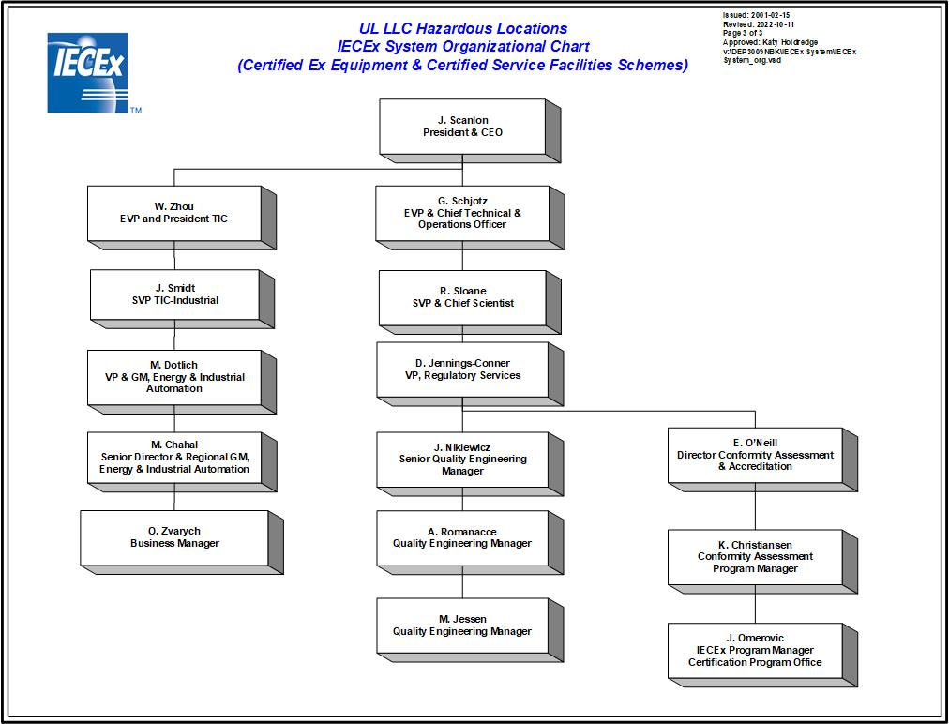

1. Organisation Chart of ExCB/ExTL/ATF

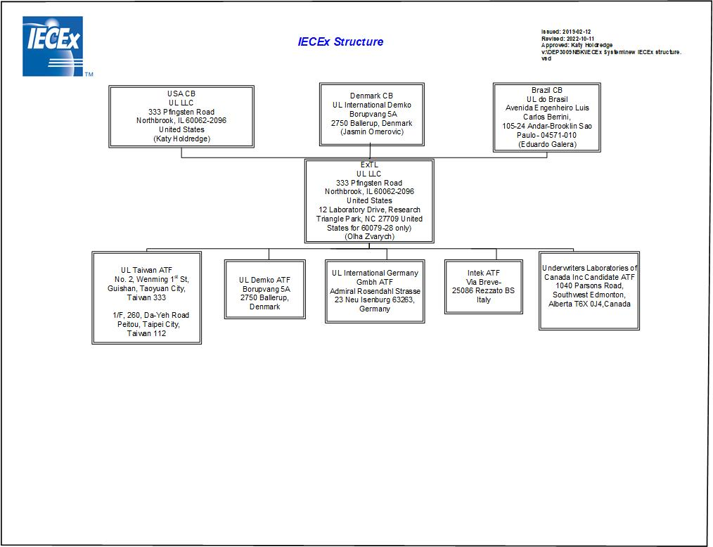

1. Accreditation Certificate for ISO/IEC 17065

(UL LLC ExCB at Northbrook)

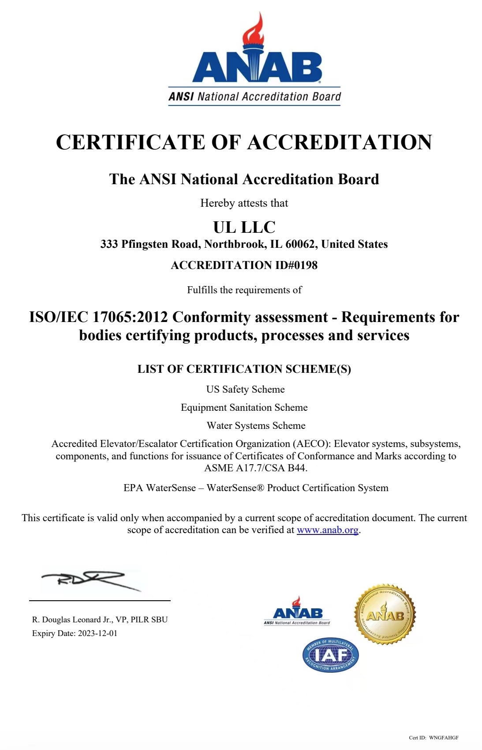

1. Accreditation Certificate for ISO/IEC 17025

(UL LLC ExTL at Northbrook)

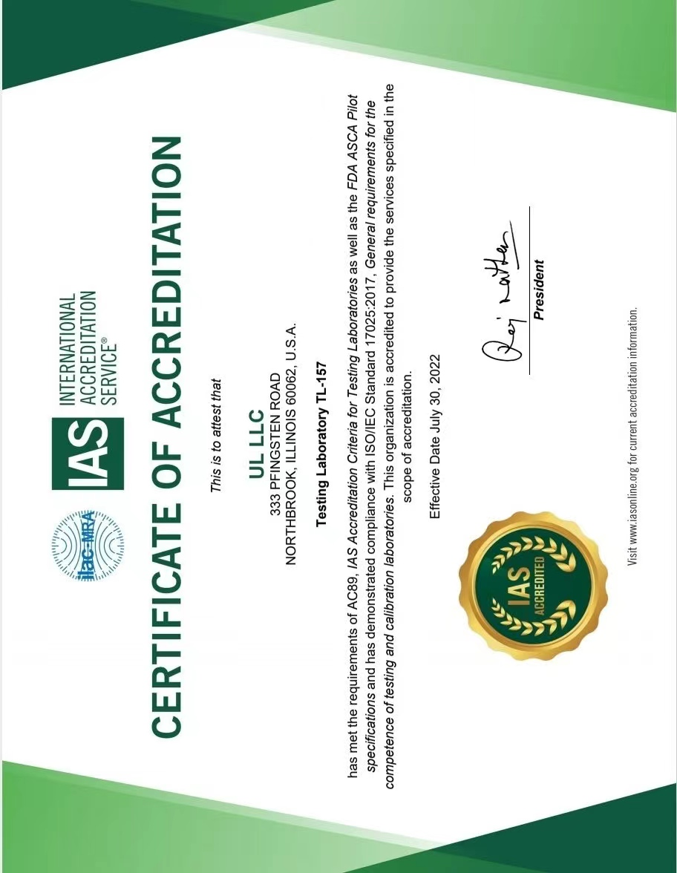

**Annex E**

**Accreditation Certificate for ISO/IEC 17025 (Con’t)**

(UL LLC ExTL at Research Triangle Park)

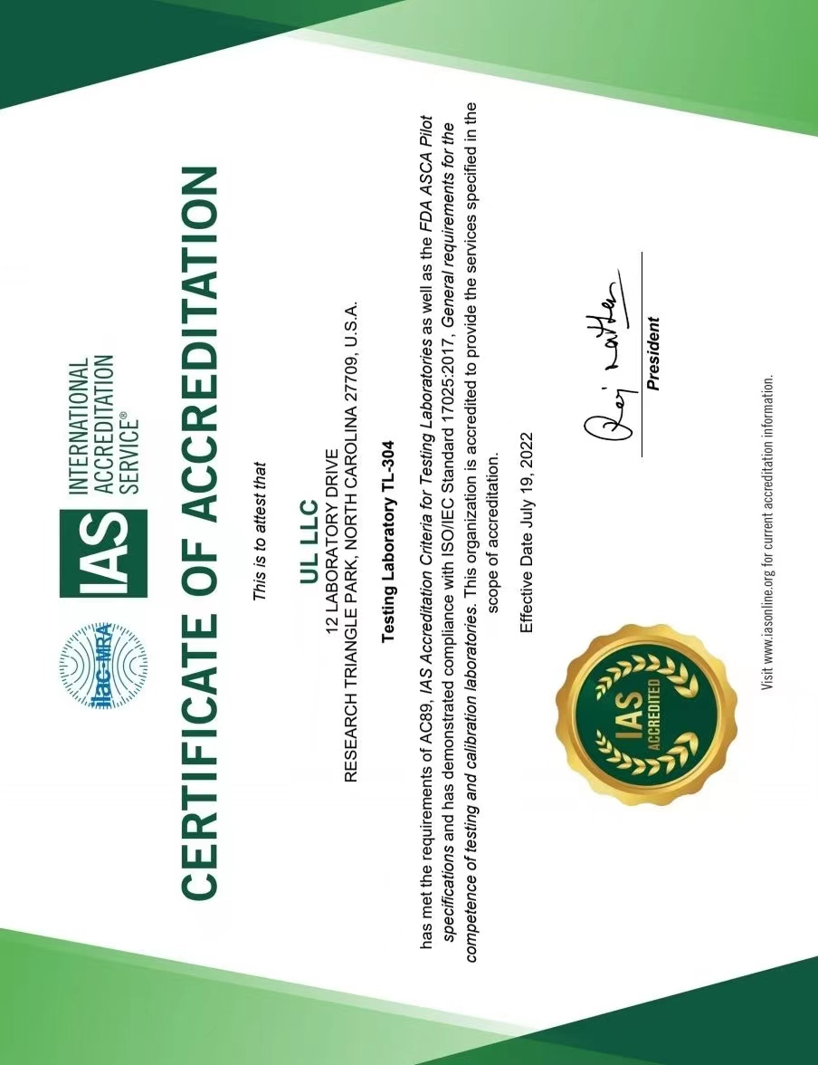

**Annex E**

**Accreditation Certificate for ISO/IEC 17025 (Con’t)**

(UL Taiwan ATF)

