**INTERNATIONAL ELECTROTECHNICAL COMMISSION IEC SYSTEM FOR**

**CERTIFICATION TO STANDARDS RELATING TO EQUIPMENT FOR USE IN**

**EXPLOSIVE ATMOSPHERES (IECEx SYSTEM)**

**TITLE: IECEx Assessment Report for the acceptance of International Certification Registrar Co., Ltd (ICR)** **as an Accepted IECEx Testing Laboratory (ExTL), in the IECEx System, Equipment Scheme, IECEx 02.**

**INTRODUCTION**

This document contains the IECEx Assessment Report for the acceptance of International Certification Registrar Co., Ltd (ICR) as an Accepted IECEx Testing Laboratory (ExTL), in the IECEx System, Equipment Scheme, IECEx 02.

***This document is hereby submitted for ExMC approval via correspondence using the IECEx on-line voting system.  ExMC Members are requested to submit their vote via the IECEx On-line*** [***Ballot System***](https://www.iecex.com/ballot) ***by the closing date 2023 06 14***

*Please refer to OD 050 for guidance on the “IECEx On-line voting system.”*

.

**Chris Agius**

IECEx Secretary

|  |  |
| --- | --- |
| **Visiting address:**  **IECEx Secretariat**  **Level 33, Australia Square 264 George Street Sydney NSW 2000 Australia** | **Contact Details:**  **Tel: +61 2 4628 4690**  **Fax: +61 2 4627 5285**  **E-mail: info@iecex.com**  [**http://www.iecex.com**](http://www.iecex.com) |

IEC System for certification to standards relating to equipment for use in Explosive Atmospheres (IECEx System)

IECEx Assessment Report Form, F-003

IECEx assessment report form for use by IECEx assessment teams to report assessments conducted according to the relevant IECEx assessment procedures of:

Operational Document IECEx OD 003-2 for the Certified Equipment Scheme

Operational Document IECEx OD 316-* for the Certified Service Facility Scheme

Operational Document IECEx OD 422 for the IECEx Conformity Mark Licensing Scheme

Operational Document IECEx OD 501 for the Personnel Competence Scheme

IECEx ExTL assessment report for

International Certification Registrar Co., Ltd (ICR)

INTERNATIONAL  
ELECTROTECHNICAL  
COMMISSION

CONTENTS

(Update when report is complete – by right click, Update field, Update entire table)

1 Assessment information 5

1.1 Type of body covered by this assessment: 5

1.2 Type of assessment: 5

1.3 Details of body 5

1.3.1 Country 5

1.3.2 Name of body 5

1.3.3 Name and title of nominated principal contact 5

1.4 Assessment information 5

1.4.1 Members of the assessment team 5

1.4.2 Place(s) of assessment 5

1.4.3 Assessment date(s) 6

1.5 Application information and background information on the assessment 6

1.6 Scopes 6

1.6.1 ExCB scope for equipment certification scheme 6

1.6.2 ExTL scope 6

1.6.3 ATF Scope – N/A 6

1.6.4 ExCB scope for Service Facilities Scheme – N/A 6

1.7 ExCB scope for Conformity Mark Licensing Scheme – N/A 6

1.8 ExCB scope for IECEx Personnel Competence Scheme – N/A 6

2 Common information 7

2.1 Legal entity of body 7

2.2 Financial support 7

2.3 History 7

2.4 Documentation 7

2.4.1 Quality manual 7

2.4.2 Procedures 7

2.4.3 Work instructions 7

2.4.4 Records (including test records where relevant) 7

2.4.5 Document change control 7

2.5 Confidentiality 7

2.6 Communication with public and customers (Hard copy and Electronic) 8

2.7 Recognitions and agreements 8

2.9 Management review 8

2.10 Contracting, subcontracting and witness testing 8

2.10.1 Contracting 8

2.10.2 Subcontracting 8

2.10.3 Off-site and Witness testing 8

2.11 Training and competence 8

2.12 Complaints and appeals (including appeals to IECEx) 9

2.13 Impartiality 9

2.14 Active involvement in development of Decision Sheets 9

2.15 Special facts to be noted 9

2.16 Supporting documentation 9

2.17 Recommendations 9

3 ExCB for IECEx Certified Equipment Scheme – N/A 10

4 ExTL for IECEx Certified Equipment Scheme 10

4.1 Assessment references 10

4.1.1 General references 10

4.1.2 Additional references applied for this assessment 10

4.2 Candidate ExTL persons interviewed 10

4.3 Associated ExCB(s) 10

4.4 Organisation 10

4.4.1 Names, titles and experience of the senior executives 10

4.4.2 Name, title and experience of the quality management representative 10

4.4.3 Other employees in ExTL activity 11

4.5 Organizational structure 11

4.6 Resources 11

ICR has the adequate resources of competent staff, appropriate procedure /work instructions and a new test facility to cover a full scope of IECEx accreditation. 11

4.7 Test reports issued 11

4.8 National accreditation 11

4.9 Calibration 11

4.10 Tests witnessed during the assessment visit 11

4.11 Participation in IECEx Proficiency Testing Programs 12

4.12 Comments (including issues found during assessment) 12

Annex A Scope for IECEx Certified Equipment Scheme 13

A.1 Current standards 13

A.2 Superseded standards - N/A 13

Annex B Overall Organisation Chart 14

Annex C Organisation Chart of ExTL 15

15

Annex D Accreditation Certificate for ISO/IEC 17025 16

# Assessment information

## Type of body covered by this assessment:

|  |  |
| --- | --- |
| ExCB for IECEx Certified Equipment Scheme |  |
| ExTL for IECEx Certified Equipment Scheme |  |
| ATF for IECEx Certified Equipment Scheme |  |
| ExCB for IECEx Certified Service Facilities Scheme |  |
| ExCB for IECEx Conformity Mark Licensing System |  |
| ExCB for IECEx Certification of Personnel Competency Scheme |  |

## Type of assessment:

|  |  |
| --- | --- |
| Pre-assessment for candidate body |  |
| Initial assessment for candidate body |  |
| Surveillance |  |
| Re-assessment |  |
| Scope extension |  |

## Details of body

### Country

Republic of Korea

### Name of body

ICR Co., Ltd.

112, 113 Hwanggeum 3-ro 7beon-gil,

Yangchon-eup, Gimpo-si, Gyeonggi-do,

Republic of Korea

### Name and title of nominated principal contact

|  |  |  |
| --- | --- | --- |
| Name | Title | E-mail address |
| Dae-song Yang | Manager | yds@icrqa.com |

## Assessment information

### Members of the assessment team

|  |  |
| --- | --- |
| Name | Role |
| Gordana Ostojic | IECEx Lead Assessor |

### Place(s) of assessment

|  |  |
| --- | --- |
| ICR Co., Ltd.  112, 113 Hwanggeum 3-ro 7beon-gil,  Yangchon-eup, Gimpo-si, Gyeonggi-do,  Republic of Korea | Due to the COVID-19 pandemic related restrictions, the assessment is remotely carried out by using Microsoft Teams, IECEx OD-060 is applied for this assessment. |

### Assessment date(s)

Remote Audit:

Day 1: 12 December 2022: Sydney time: 10:00 -13:00; break 2 h and 15:00- 17:00

Day 2: 13 December 2022: Sydney time: 10:00 -13:00; break 2 h and 15:00- 17:00

Day 3: 14 December 2022: Sydney time: 10:00 -13:00; break 2 h and 15:00- 17:00

Day 4: 15 December 2022: Sydney time: 10:00 -13:00; break 2 h and 15:00- 17:00

Day 5: 16 December 2022 Sydney time: 10:00 -13:00; break 2 h and 15:00- 17:00

## Application information and background information on the assessment

Documents ExMC/48L/Q and Annex C of IECEx were fully completed by applicant for IECExTL candidate and were reviewed by IECEx Secretariat in 2022.

Due to the COVID-19 pandemic related restrictions, the assessment is remotely carried out by using Microsoft Teams, IECEx OD-060 is applied for this assessment

## Scopes

### ExCB scope for equipment certification scheme

ICR Polska is already an established IECEx CB and is the associated ExCB to this ExTL. The scope for the associated ExCB is shown on [www.iecex.com](http://www.iecex.com) and covers the scope of IECEx TL, which is shown in Annex A.

### ExTL scope

The ExTL is not integral with ExCB, however the scope of ExCB covers all the scope of this applicant ExTL. The scope of the ExTL is included in Annex A.

### ATF Scope – N/A

### ExCB scope for Service Facilities Scheme – N/A

## ExCB scope for Conformity Mark Licensing Scheme – N/A

## ExCB scope for IECEx Personnel Competence Scheme – N/A

# Common information

## Legal entity of body

International Certification Registrar Co., Ltd. (ICR) has been registered under Business Registration number 105-86-35114 since 2002. It has been registered for Professional, Scientific and Technical activities including Certification services and Training.

## Financial support

ICR is private company and source of funds are from Testing and Certification services.

## History

ICR has started as accredited body for ISO 9001 and ISO 14001 and registered as Auditor Training provider. It has been moved to testing and achieved ISO 17025 laboratory accreditation by Kolas for medical equipment testing firstly, then for EMC and later extended to hazardous area Ex protection testing. In 2020 new Explosion-proof test facility has been built and agreement with ICR Polska established as IEC ExCB.

## Documentation

### Quality manual

The Quality Manual ICRT-QMA-01 – revision 7: 2023, describes the quality management system of the ICR according to the specified quality policy and objectives, integrity objectives and commitments, resources and all other management system requirements of ISO/IEC17025:2017）, ISO 9001: 2015， IECEE 02, IECEx 02, etc

Section for Quality policy and objective of Quality Manual addresses commitment to IECEx scheme and certification services.

### Procedures

Series of ICRT-QPA documents address Quality procedures for Control of documents, Control of records, Equipment management and calibration, Technical records and reports, Complaints, Improvements and corrective action etc, describing responsibility, work flow, various quality and technical activities. The document ICRT-QPA-32 describes the requirements for general procedure relevant to IECEx Testing & Certification and associated IECEx scheme requirements.

### Work instructions

The series procedures starting with ICRT-WI-16 are dedicated to Ex type of protections: ICRT-WI-16-19 for General Requirements; ICRT-WI-16-06 for Intrinsic safety ; ICRT-WI-16-08 for Encapsulation; ICRT-WI-16-25 for Flameproof; ICRT-WI-16-29 for Dust protected enclosures. The procedures meet the requirements of the IECEx Scheme 02

### Records (including test records where relevant)

Quality procedure ICRT – QPA -20, ICRT-QPA-22 and ICRT-QPA-32 provide requirements and details on records including technical records, preparation and keeping/storing, computer data & back-up. They use hard copy and electronic records. The system meets the process requirements of OD 207. The overall system meets the requirements of IECEx.

### Document change control

Documentation change control is addressed in Quality manual ICRT-QMA-01 clause 21, and further in procedure ICRT-QPA-21. The data obtained from outside are also controlled. The system meets the requirements for IECEx

## Confidentiality

Requirements for confidentiality and impartiality are contained in Quality manual ICRT-QMA-01 Clause 2 and ICRT-QPA-02, Confidentiality control procedure. These documents are dealing with protection of internal data, test records, reports, technical intelligence information, patents with protection of customer property and technology secrets and they cover staff, contractors and advisory bodies. Every year Risk analysis is carried out and staff once again sign a confidentiality agreement. The procedures meet the requirements of the IECEx Scheme 02.

## Communication with public and customers (Hard copy and Electronic)

Refer to ICR website (<http://www.icrqa.com/renewal_eng/main/main.asp>)

## Recognitions and agreements

ICR as IECEx TL has agreement with ICR Polska as IECEx CB. Further ICR is the CB laboratory of IECEE CB Scheme.

**2.8 Internal audit**

Internal audit is carried out in accordance with the requirements of Quality Manual ICR-QMA-01 Clause 26 and Internal Audits procedure ICR-QPA-25.

The last internal audit report from 2022 was carried out by external auditor and it included ATEX requirements in addition to ISO 17025 requirement. The audit activities covered all departments and all elements involved in the management system. No non-conformities were raised related to ATEX activities. IECEx department will be audited once the laboratory is accepted as an IECExTL The system meets the requirements of ISO/IEC 17065, 17025 and IECEx.

## Management review

Quality Manual ICRT-QMA-01 clause 27 and procedure ICRT-QPA-03 describe details about Management review agenda items, scope and other relevant tasks to improve efficiency of management system, analysing any risk to the business and confidentiality/impartiality. Analysis. Example of Management Review report from 2022 was viewed and had item on discussion about ICR Polska as ExCB and further processes for acceptance as IECExTL..

The system meets the requirements of ISO/IEC 17065, 17025 and IECEx.

## Contracting, subcontracting and witness testing

### Contracting

Quality Manual ICRT-QMA-01 clause 8, procedure ICRT-QPA-08 provide details on facility and environmental conditions other than laboratory use for testing and provide guidance on the requirements. There is no contracting in the field of Ex testing,

The procedure for Ex Testing ICRT-QPA-32 provides details on the requirements of OD024 for testing at other locations than the laboratory

### Subcontracting

There is currently no subcontracting in the field of explosion-protection testing and no testing in non-fixed locations.

### Off-site and Witness testing

Procedure for Ex testing ICRT-QPA-32 clause 5.12 has details and refer to use of the procedure OD024 when required.

## Training and competence

Training and competence is addressed in clause 4 of Quality Manual ICRT-QMA-01 and further detailed in Personnel Management ICRT-QPA-04, where Quality manager and Technical manager establish yearly plan for training and strive for timely and effective training of personnel to enable them to continuously upgrade their skills.

Details of staff competencies are included in the site assessment report. On regular basis there is training of staff of ExTL on the operations, outcome of audits, revised standards and procedures related to IECEx testing. Examples of training records were sighted and meet the requirements of the IECEx. Competency of staff is monitored and evaluated, there is a competency matrix for the applicant ExTL. This was found to be satisfactory

Details of staff competencies are included in the site assessment report.

## Complaints and appeals (including appeals to IECEx)

Complaints and appeals are addressed in Quality Manual clause 17 and further details on appeals in clause of 5.13 of Ex Testing procedure ICRT-QPA-32, which covers the requirements for making a complaint to IECEx.

## Impartiality

Impartiality is addressed in Quality Manual ICRT-QMA-01 clause 1. Further management of Impartiality and Integrity, procedure ICRT-QPA-01 provides details for risk analysis of various factor that can affect impartiality and how to control it on regular basis. ICR has an impartiality risk assessment document as required by ISO/IEC 17065 and 17025.

## Active involvement in development of Decision Sheets

The procedure ICRT-QPA-32 clause 5.14 provides details on the activity involved with preparation, issue and commenting on Decision sheets.

## Special facts to be noted

None other than those noted in the report.

## Supporting documentation

Copies of additional supporting information for this assessment have been provided to the applicant and the IECEx Secretariat. These are included in a site assessment report or provided separately and include:

* Details of issues raised and how these have been resolved
* Checklist for ISO/IEC 17025
* Completed Technical Capability Document (TCD)
* Photos of the facilities/tests witnessed are included in the above TCD
* Information on competencies
* Assessors’ notes
* Other

## Recommendations

Based on the assessment performed on 2022-12-12, 2022-12-13, 2022-12-14, 2022-12-15 and 2022-12-16, ICR is recommended for acceptance in the IECEx scheme as:

* An ExTL in the IECEx Certified Equipment Scheme

This is according to the scope of the standards listed in this document.

|  |
| --- |
| Gordana Ostojic |
| IECEx Lead Assessor |

Date: 2023-03-13

# ExCB for IECEx Certified Equipment Scheme – N/A

# ExTL for IECEx Certified Equipment Scheme

## Assessment references

### General references

1. IECEx02 IECEx Certified Equipment Scheme covering equipment for use in explosive atmospheres – Rules of Procedure
2. IECEx OD003-2 Assessment, surveillance assessment and re-assessment of ExCBs and ExTLs operating in the IECEx 02, IECEx Certified Equipment Scheme
3. IECEx OD009 Issuing of CoCs, ExTRs and QARs
4. ISO/IEC 17025 General requirements for the competence of testing and calibration laboratories
5. IECEx OD 018 Harmonised check list for testing and calibration laboratories ISO/IEC 17025
6. IECEx TCD 60079, ISO 80079 Series and ISO 16852 Technical Capability Document
7. ExTAG decision sheets (DSs)
8. IECEx OD 202 IECEx Certified Equipment Scheme – IECEx Proficiency Testing Program

### Additional references applied for this assessment

IECEx OD 060 IECEx Guide for Business Continuity – Management of Extraordinary Circumstances or Events Affecting IECEx Certification Schemes and Activities

## Candidate ExTL persons interviewed

|  |  |
| --- | --- |
| Name | Position |
| Daesong Yang | Team Manager / Testing Engineer |
| Jihwan Park | Associate Research Engineer / Testing Engineer |
| Kyungman Kang | Associate Research Engineer / Testing Engineer |
| Jaeik Yun | Researcher / Testing Engineer |

## Associated ExCB(s)

ICR Polska Sp. z o.o.

Plac Przymierza, 6

03-944 Warsaw Poland

## Organisation

Refer to Annexes B and C.

### Names, titles and experience of the senior executives

|  |  |  |
| --- | --- | --- |
| Name | Title | Experience (years) |
| Deokyong Kim | President | 27 |

### Name, title and experience of the quality management representative

|  |  |  |
| --- | --- | --- |
| Name | Title | Experience (years) |
| Sangwoo Sim | Vice President / Quality manager | 22 |

### Other employees in ExTL activity

|  |  |  |
| --- | --- | --- |
| Name | Title/responsibility | Experience in Ex (years) |
| Seokgwang Yeo | Director / Technical manager | 9 |
| Daesong Yang | Team Manager / Testing Engineer | 8 |
| Jihwan Park | Associate Research Engineer / Testing Engineer | 7 |
| Kyungman Kang | Associate Research Engineer / Testing Engineer | 5 |
| Jaeik Yun | Researcher / Testing Engineer | 5 |

## Organizational structure

Annex B is providing structure and position of Ex testing department inside of ICR.

Annex C details structure within Ex testing department.

## Resources

## ICR has the adequate resources of competent staff, appropriate procedure /work instructions and a new test facility to cover a full scope of IECEx accreditation.

## Test reports issued

As ICR is new candidate for IECExTL, the Table below is showing number of Reports issued to national or regional schemes

|  |  |  |  |  |
| --- | --- | --- | --- | --- |
| Standard numbers | Type of protection or other identifying information | Number of issued reports (ExTRs) (for last 2 years) | | Total |
| 2021 | 2022 |
| IEC 60079-0 | Explosive atmospheres - General requirements | 7 | 1 | 8 |
| 60079-1 | Explosive atmospheres Equipment- protection by flameproof enclosures “d” | 3 | 1 | 4 |
| 60079-11 | Explosive atmospheres -Equipment protection by intrinsic safety "i" | 3 |  | 3 |
| 60079-31 | Explosive atmospheres - Equipment dust ignition protection by enclosure "t" | 1 |  | 1 |

## National accreditation

Scope of ISO/IEC 17025 accreditation covers all protections in the scope of IECExTL.

Laboratory is accredited by KOLAS, a National Laboratory Accreditation Scheme, registration number:.1100111-2431479.

The national accreditation certification for ISO/IEC 17025 is shown in Annex E.

## Calibration

All the equipment used in the explosion protection laboratory is sent to external Calibration providers that are qualified to supply KOLAS endorsed reports. Quality Manager and Testing Engineer performing certain calibration related tasks as per ICRT-QPA-06. Their calibration system meets the requirements of ISO/IEC 17025 and IECEx.

## Tests witnessed during the assessment visit

The following tests were witnessed during the assessment:

|  |  |  |  |  |
| --- | --- | --- | --- | --- |
| Standard and edition | | Clause number | Test | Comments |
| IEC 60079-0 | Clause 26.13 | | Surface resistance of non-metallic part | Satisfactory |
| IEC 60079-0 | Clause 26.4.5 | | IP66 test | Satisfactory |
| IEC 60079-1: | Clause 15.2.2 | | Determination of explosion pressure (reference pressure) | Satisfactory |
| IEC 60079-1: | Clause 15.3 | | Non-transmission test | Satisfactory |
| IEC 60079-0 | Clause 26.5 | | Temperature-rise test | Satisfactory |
| IEC 60079-11 | Clause 10.1 | | Spark ignition test | Satisfactory |

## Participation in IECEx Proficiency Testing Programs

ICR applied for the current PTB program for Flameproof joints measurements and for Small component ignition test. – Test Round 2021. Further the previous Test Rounds relevant to scope of accreditation were also successfully completed in 2019 and 2020 as per Table below:.

|  |  |  |
| --- | --- | --- |
| Year(s) of participation | IECEx Proficiency Testing program | General information about results |
| 2019 | TR2013 – Temperature Classification | Satisfactory. |
| 2019 | TR2015 – Intrinsic Safety | Satisfactory. |
| 2019 | TR2019 – Battery Testing | Satisfactory. |
| 2019 | TR2019 – Tests of Enclosures | Satisfactory. |
| 2020 | TR2013 – Flame Transmission | Satisfactory. |
| 2020 | TR2017 – Explosion Pressure | Satisfactory. |
| 2021 | TR2021 - Small Component Temperature | Satisfactory. |
| 2021 | TR2021 - Flameproof Joint | Satisfactory. |

## Comments (including issues found during assessment)

ICR has the necessary resources and quality system in place for their scope as an ExTL. There were some findings related to level of details in test records, test method, calibration requirements and IECEx scheme rules requirements. All issues were addressed to the satisfaction of the IECEx Assessor and now meet the requirements of the IECEx.

1. Scope for IECEx Certified Equipment Scheme
   1. Current standards

| Number | Title | Comments |
| --- | --- | --- |
| IEC 60079-0  Edition 7.0 | Explosive atmospheres - Part 0: Equipment - General requirements | √ |
| IEC 60079-1  Edition 7.0 | Explosive atmospheres - Part 1: Equipment protection by flameproof  enclosures “d” | √ |
| IEC 60079-11  Edition 6.0 | Explosive atmospheres - Part 11: Equipment protection by intrinsic safety “i” | √ |
| IEC 60079-18  Edition 4.1 | Explosive atmospheres – Part 18: Equipment protection by encapsulation “m” | √ |
| IEC 60079-31  Edition 2.0 | Explosive atmospheres – Part 31: Equipment dust ignition protection by enclosure "t" | √ |

* 1. Superseded standards - N/A

1. Overall Organisation Chart

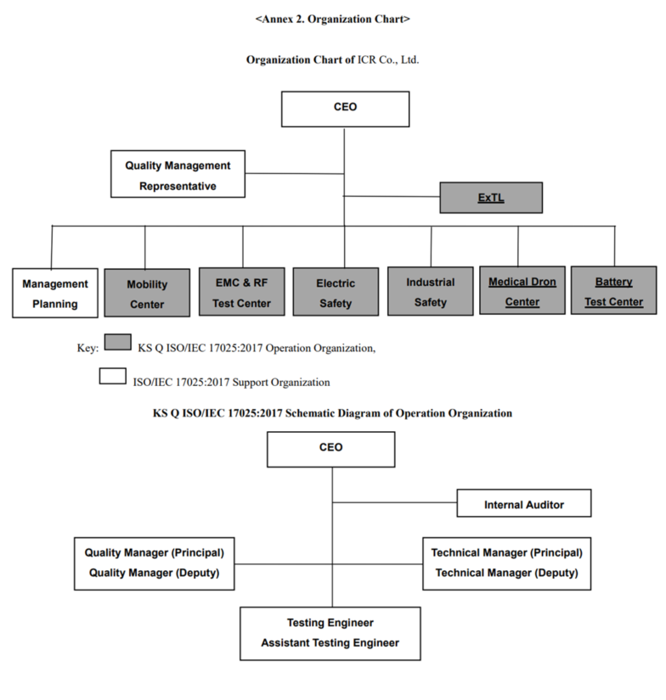

1. Organisation Chart of ExTL

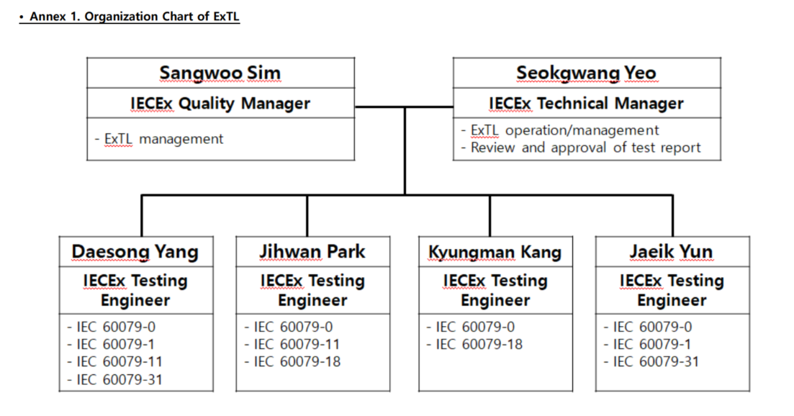

1. Accreditation Certificate for ISO/IEC 17025

