INTERNATIONAL ELECTROTECHNICAL COMMISSION SCHEME FOR
CERTIFICATION TO STANDARDS RELATING TO EQUIPMENT FOR USE
IN EXPLOSIVE ATMOSPHERES (IECEx SYSTEM)

Title: Re-assessment Report for Mining and Surface Certification (Pty) Ltd, MASC (ICS) South Africa, an Accepted ExCB for IECEx Certified Service Facilities Scheme, 03.

Circulated to: IECEx Management Committee, ExMC

Introduction

In accordance with the 5 year re-assessment plan for the surveillance and monitoring of bodies within the IECEx System, the following document contains the IECEx Re-assessment Report for the continued acceptance of Mining and Surface Certification (Pty) Ltd, MASC (ICS), South Africa, in the IECEx Certified Service Facilities Scheme, 03.

This report is hereby submitted for endorsement during the ExMC 2023 Meeting being held in Edinburgh.

Chris Agius

Chris Agius

IECEx Secretariat

Address:  Level 33, Australia Square  264 George Street  Sydney NSW 2000  Australia | Contact Details:  Tel: +61 2 46 28 4690  Fax: +61 2 46 27 5285  e-mail: info@iecex.com  http://www.iecex.com

IEC System for certification to standards relating to equipment for use in Explosive Atmospheres (IECEx System)

IECEx Assessment Report Form, F-003

IECEx assessment report form for use by IECEx assessment teams to report assessments conducted according to the relevant IECEx assessment procedures of:

Operational Document IECEx OD 003-2 for the Certified Equipment Scheme

Operational Document IECEx OD 316-* for the Certified Service Facility Scheme

Operational Document IECEx OD 422 for the IECEx Conformity Mark Licensing Scheme

Operational Document IECEx OD 501 for the Personnel Competence Scheme

IECEx ExCB assessment report for
Mining And Surface Certification (Pty) Ltd, MASC (ICS) South Africa

INTERNATIONAL
ELECTROTECHNICAL
COMMISSION

CONTENTS
(Update when report is complete – by right click, Update field, Update entire table)
1 Assessment information 5
1.1 Type of body covered by this assessment: 5
1.2 Type of assessment: 5
1.3 Details of body 5
1.3.1 Country 5
1.3.2 Name of body 5
1.3.3 Name and title of nominated principal contact 5
1.4 Assessment information 5
1.4.1 Members of the assessment team 5
1.4.2 Place(s) of assessment 5
1.4.3 Assessment date(s) 5
1.5 Application information and background information on the assessment 6
1.6 Scopes 6
1.6.1 ExCB scope for equipment certification scheme 6
1.6.2 ExTL scope 6
1.6.3 ATF Scope 6
1.6.4 ExCB scope for Service Facilities Scheme 6
1.7 ExCB scope for Conformity Mark Licensing Scheme 6
1.8 ExCB scope for IECEx Personnel Competence Scheme 6
2 Common information 6
2.1 Legal entity of body 6
2.2 Financial support 7
2.3 History 7
2.4 Documentation 7
2.4.1 Quality manual 7
2.4.2 Procedures 7
2.4.3 Work instructions 8
2.4.4 Records (including test records where relevant) 8
2.4.5 Document change control 8
2.5 Confidentiality 8
2.6 Communication with public and customers (Hard copy and Electronic) 8
2.7 Recognitions and agreements 8
2.8 Internal audit 9
2.9 Management review 9
2.10 Contracting, subcontracting and witness testing 9
2.10.1 Contracting 9
2.10.2 Subcontracting 9
2.10.3 Off-site and Witness testing 9
2.11 Training and competence 9
2.12 Complaints and appeals (including appeals to IECEx) 9
2.13 Impartiality 10
2.14 Active involvement in development of Decision Sheets 10
2.15 Special facts to be noted 10
2.16 Supporting documentation 10
2.17 Recommendations 10
3 ExCB for IECEx Certified Equipment Scheme 12
4 ExTL for IECEx Certified Equipment Scheme 12
5 ATF for IECEx Certified Equipment Scheme 12
6 ExCB for Certified Service Facilities Scheme 13
6.1 Assessment references 13
6.1.1 General references 13
6.1.2 Additional references applied for this assessment 13
6.2 Candidate ExCB persons interviewed 13
6.3 National marks and certificates 13
6.4 Standards accepted 14
6.5 National differences to IEC standards 14
6.6 Organisation 14
6.6.1 Names, titles and experience of the senior executives 14
6.6.2 Name, title and experience of the quality management representative 14
6.6.3 Name and title of signatories for certification 14
6.6.4 Other employees in ExCB activity 14
6.7 Organizational Structure 14
6.8 Indemnity insurance 14
6.9 Resources 15
6.10 Committees (such as governing or advisory boards) 15
6.11 Certification operations 15
6.11.1 National approval/certification Methods 15
6.11.2 Certification policy 15
6.11.3 Application for certification 15
6.11.4 Certification decision 15
6.11.5 Suspension and cancellation of certificates 15
6.12 Statistics 16
6.13 National accreditation 16
6.14 Assessment of service facilities and issue of FARs 16
6.15 Comments (including issues found during assessment) 16
7 IECEx Conformity Mark Licensing Scheme 16
8 ExCB for IECEx Personnel Competence Scheme 16
9 Annexes 17
Annex A Overall organisation Chart of MASC 18
Annex B Organisation Chart of ExCB in Scheme 03-5 19
Annex C Accreditation Certificate for ISO/IEC 17065 20

Assessment information

Type of body covered by this assessment:
ExCB for IECEx Certified Equipment Scheme
ExTL for IECEx Certified Equipment Scheme
ATF for IECEx Certified Equipment Scheme
ExCB for IECEx Certified Service Facilities Scheme
ExCB for IECEx Conformity Mark Licensing System
ExCB for IECEx Certification of Personnel Competency Scheme

NOTE 1 ExCB - IECEx Certification Body
NOTE 2 ExTL - IECEx Testing Laboratory
NOTE 3 ATF - Additional Testing Facility

Type of assessment:
Pre-assessment for candidate body
Initial assessment for candidate body
Surveillance
Re-assessment
Scope extension

Details of body

Country
South Africa

Name of body
Mining And Surface Certification (Pty) Ltd

Name and title of nominated principal contact
Name | Title | E-mail address
Roelof Viljoen | International Certification Operations director | viljoenr@sactl.com

Assessment information

Members of the assessment team
Name | Role
Marino Kelava | IECEx Lead Assessor

Place(s) of assessment
Mining And Surface Certification (Pty) Ltd | 45 Jurg Avenue, Lelyta Park Unit 5, Hennopspark Ext 87, Centurion, 0157, South Africa

Assessment date(s)
November 28th to December 1st 2022 (4 man-days)

Application information and background information on the assessment
This is a Re-assessment of CB operating under Scheme 03-5.

Scopes

ExCB scope for equipment certification scheme
N/A

ExTL scope
N/A

ATF Scope
N/A

ExCB scope for Service Facilities Scheme
Equipment repair, including equipment repair standard and associated protection techniques.
IEC 60079-19  Edition 4.0 | Explosive atmospheres – Part 19: Equipment repair, overhaul and reclamation | Comments
With the following types of protection | ID
Flameproof Enclosure "d" | yes | Included in scope
Increased Safety "e" | yes | Included in scope
Type of Protection "n" | yes | Included in scope
Intrinsic Safety "i" | yes | Included in scope
Oil Filled "o" | no | NOT IN THE SCOPE
Pressurisation "p" | no | NOT IN THE SCOPE
Dusts to IEC 60079-31 "t" | yes | Included in scope
Dusts to IEC 61241-1 "tD" | yes | Included in scope
Dusts to IEC 61241-1-1 "DIP" | yes | Included in scope
Other (eg non-electrical) | yes, non-electrical | Included in scope

Other service facility standards: N/A

ExCB scope for Conformity Mark Licensing Scheme
N/A

ExCB scope for IECEx Personnel Competence Scheme
N/A

Common information

Legal entity of body
Mining And Surface Certification (Pty) Ltd (MASC) is a registered Proprietary Limited (Pty Ltd), Reg. No. 2015/021934/07, which gives it the status of a legal person.

In addition it holds South African Department of Mineral Resources (DMR) and Department of Labour (DOL) approvals for the issuing of certificates and product certification.

To distinguish between National (RSA) and International (IECEx) certification, in 2014 MASC registered additional legal Entity under the name “International Ex Certification Services (Pty) Ltd”, also known as ICS. The registration number is 2014/055772/07. A contract between the two entities defines the responsibilities in the certification process.
Documents were checked during the assessment and found to meet the requirements of the IECEx.

Financial support
The individual applicants’ fees fund MASC. This facility has been in existence since the year 2008 and intends to support the certification activities with funds from certification applicants. These funds are adequate for covering all required activities to meet the procedures defined in the MASC Quality Manual.

History
Mining And Surface Certification (MASC) was founded in 2008 as an Ex (Hazardous Locations) Certification Body, approved testing laboratory (ATL) and training provider specializing in Ex (explosion protection) equipment / installation certification and other hazardous locations services and support.

To date MASC has obtained
- SANAS Accreditation (South African National Accreditation System)
  - Test Lab - T0444
  - Certification Body – C83.
- Department of Labour (DOL) approval
- DMRE (Department of Mineral Resources & Energy) approval
- IECEx
  - Certification Body (ExCB) under both the Equipment and Service Facility Scheme
  - Test Lab (ExTL) under the Equipment Scheme

Documentation

Quality manual
Quality Manual with identification number CB_QMS_04 to 08, addresses all the major quality requirements with cross references to relevant ISO/IEC 17065:2012 clauses. The manual is issued in English. The Manual is available in electronic version on the MASC intranet and is regarded as the valid version for use.
The Quality Manual as well as related documents from different levels were reviewed during the assessment and found to meet the requirements of the IECEx.

Procedures
There are a significant number of detailed procedures dealing with the operation at MASC. All these procedures are referenced in the above Quality Manual. Again, these documents are available on the intranet. Certification within the IECEx Scheme, CB_QMS_04, Issue 04, issued 2022-11-04, is the main procedure used for IECEx Scheme 03-5.
Procedures most relevant for the operation under IECEx were reviewed during the assessment and found to meet the requirements of the IECEx.

Work instructions
In addition there are many work instructions available and a range of other documentation such as guides. All those documents are accessible on the intranet.
A number of instructions were reviewed during the assessment and found to meet the requirements of applicable Ex standards and the IECEx.

Records (including test records where relevant)
MASC establishes suitable procedures dealing with quality records. All critical records are in hard copy and/or in electronic form. All records are retained for a minimum of 10 years according to the relevant procedure CB QM procedure CB_QMS_08.
Example of the project archive was reviewed, and found that the records are detailed, and information is sufficient to the satisfaction of the assessment team and was found to be in compliance with IECEx OD-207.

Document change control
Documents are all subject to a change control procedure CB QM procedure 8. The detail is specified in Clause 8.3, which includes regular checks of those being used. Only documents published on the intranet (MASC computer system) are regarded as controlled for the purpose of staff use. When a document is revised, an indication, such as text in different colour, is included in the document to show where changes have occurred.
The use of the correct standard is controlled through quality meetings and information by e-mail (only one standard under Scheme 03-5).

Confidentiality
There is a statement in the Quality Manual that stipulates all personnel including the internal staff as well as members of Advisory Board are required to sign a Confidentiality, Impartiality, Disclosure and Conflict of Interest Statement. Personnel are also trained to ensure they follow the confidentiality requirements to protect the integrity and reputation of the business. Examples of the written Statements from board members and internal staff were reviewed and found satisfactory.
The system meets the requirements of ISO/IEC 17065 and IECEx.

Communication with public and customers (Hard copy and Electronic)
Communication with public and customers is assured by information on the internet site at- https://www.masc-ex.com/
MASC maintains and publishes information on:
- company profile,
- types of management systems and certification programs in which it operates,
- direct link to IECEx website,
- processes for processing requests for information, complaints and appeals,
- service request form applicable for product and services certification as well,
- impartiality policy.
Other information is available on request.

Recognitions and agreements
MASC has a wide range of recognitions and agreements, including:
• ATEX / UKEx (SIRA, CML & Baseefa)
• ANZEx (ExT&C, TestSafe)
• USA (MSHA, QPS)
• India (QVC Cert)
• Russia (Nanio CCVE)

Internal audit
The requirements for internal audit are specified in MASC QMS procedure 8.8 Internal Audits. Auditing is done at least once a year. The latest audit was conducted on 2022-11-09. There is a limited number of staff trained and accepted for internal auditing.
Both schemes (02 and 03-5) are included. All audit records are retained.
The system meets the requirements of ISO/IEC 17065 and IECEx.

Management review
The detailed processes on management review are contained in clause 8.5 of CB_QMS_08. The management review is specified to be conducted once a year. The latest meeting of management review was held on 2022-11-15. The review covered the operation of IECEx Certification Body, including internal audits, corrective actions, accreditation audits, customer satisfaction and complaints data (including IECEx). The matters covered by the meeting also addressed the relevant requirements for ISO/IEC 17065.
A documented report on management review was viewed and found satisfactory for the IECEx.

Contracting, subcontracting and witness testing

Contracting
N/A

Subcontracting
N/A

Off-site and Witness testing
N/A

Training and competence
CB_QMS_ 06 covers training and requires an annual plan. There is a document for the annual plan on training, CB_QMS_SD_50 - Rev 03. Training plans are made annually, supplemented on demand and checked by management review. Records are kept of the trainings carried out. This details the staff and the training that they have undertaken, and particularly noted that training was arranged for a new staff, and qualification document was sighted and satisfactory.
There was a meeting with the output of the IECEx Annual Meeting (Remotely), 06 – 09 September, 2022.
Competence of staff is documented in Annex F Competence Training Matrix 2022-11-07 Rev 09. Terine to include document when prepared/updated!
This was found to be satisfactory, meeting the requirements of the IECEx.

Complaints and appeals (including appeals to IECEx)
Complaints are collected and dealt with in accordance with procedure CB_QMS-07, clause 7.13 and procedure CB_QMS_SD-01 which also covers appeals. CB_QMS_SD_03 - MASC CB Application Form (QAR-FAR)_Rev 10 contains information for customers/applicants that includes the latest appeals process to IEC via IECEx in accordance with CA 01 and IECEx 01-S.
There were no complaints and or appeals since the last Re-assessment.

Impartiality
MASC is an independent body with no activities or interests in the services that are audited or certified. MASC has a public statement on their website to confirm its independence and impartiality.
Based on the document CB QM procedure CB_QMS-05, clause 5.2, different measures were discussed to safeguard impartiality. The risk analysis shows different threats that were identified. Self-interest, familiarity, external pressure are among the identified threats and measures have been implemented to mitigate the risks.
Company profile was verified. All personnel have to sign statement on impartiality. Based on this it may be assumed that all personnel is aware of the risks and their responsibility to safeguard the impartiality.
The impartiality is supervised by an Advisory Board including representation of end users, manufacturers, government, service facilities and associations. The last meeting of the Advisory Board was on the 21st of February 2022.
All staff, Board Members and the Advisory Board have signed regarding impartiality, honesty and confidentiality of their work. During the assessment, the list and several signed documents were checked.
The process meets the requirements for ISO/IEC 17065 and IECEx.

Active involvement in development of Decision Sheets
Terine regularly receive all proposed and issued Decision Sheets. She always informs co-workers and after internal discussion they provide their comments to the IECEx secretariat.
The process was checked and found meeting the requirements for IECEx.

Special facts to be noted
None.

Supporting documentation
Copies of additional supporting information for this assessment have been provided to the applicant and the IECEx Secretariat. These are included in a site assessment report or provided separately and include:
- Details of issues raised and how these have been resolved
- Checklist for ISO/IEC 17065
- Completed Technical Capability Document (TCD)
- Information on competencies
- Assessors’ notes
- Other
NOTE Assessors are to amend above list as appropriate

Recommendations
Based on the assessment performed on 28th to 30th November 2022, MASC is recommended for continued acceptance in the IECEx scheme as:
- An ExCB in the IECEx Certified Service Facilities Scheme
This is according to the scope of the standards listed in this document.
Marino Kelava
IECEx Lead Assessor
Date: March 2023

ExCB for IECEx Certified Equipment Scheme
Not relevant for this assessment.

ExTL for IECEx Certified Equipment Scheme
Not relevant for this assessment.

ATF for IECEx Certified Equipment Scheme
Not relevant for this assessment.

ExCB for Certified Service Facilities Scheme

Assessment references

General references
- IECEx 03-* IECEx Certified Service Facilities Scheme covering repair and overhaul of Ex equipment – Rules of Procedure for the Scheme (IECEx 03-0) and for “sub-Schemes” on particular service activities (IECEx 03-2, 03-3, 03-4 and 03-5)
- IECEx OD 316-2 IECEx Certified Service Facilities Scheme – Part 2: Selection of Ex equipment and design of Ex installations Assessment procedures for IECEx acceptance of Candidate Certification Bodies (ExCBs) for the purpose of issuing IECEx Certificates to Ex Service Facilities providing selection of Ex equipment and design of Ex installations related services
- IECEx OD 316-3 IECEx Certified Service Facilities Scheme – Part 3: Ex installation and initial inspection Assessment procedures for IECEx acceptance of Candidate Certification Bodies (ExCBs) for the purpose of issuing IECEx Certificates to Ex Service Facilities providing Ex installation and initial inspection service IECEx
- IECEx OD 316-4 IECEx Certified Service Facilities Scheme – Part 4: Ex inspection and maintenance Assessment procedures for IECEx acceptance of Candidate Certification Bodies (ExCBs) for the purpose of issuing IECEx Certificates to Ex Service Facilities providing Ex installations related services
- IECEx OD 316-5 IECEx Certified Service Facilities Scheme – Part 5: Repair, overhaul and reclamation of Ex equipment. Assessment procedures for IECEx acceptance of Candidate Certification Bodies (ExCBs) for the purpose of issuing IECEx Certificates to Ex Service Facilities involved in the repair, overhaul and reclamation of Ex equipment
- ISO/IEC 17065 General requirements for bodies operating product certification systems Conformity assessment — Requirements for bodies certifying products, processes and services
- IECEx TCD 60079-19, Technical Capability Document IEC 60079 -19: 2010, Explosive atmospheres - Parts 19: Equipment repair, overhaul and reclamation
- IECEx OD 060 IECEx Guide for Business Continuity – Management of Extraordinary Circumstances or Events Affecting IECEx Certification Schemes and Activities
- IEC 60079-17 Explosive atmospheres - Part 17: Electrical installations inspection and maintenance
- IEC 60079-19 Explosive atmospheres – Part 19: Equipment repair, overhaul and reclamation
- ExSFC Decision Sheets
NOTE The latest editions of the above documents were applied

Additional references applied for this assessment
NOTE To be added by assessment team if applicable. For example, OD 060 if done as a remote assessment.

Candidate ExCB persons interviewed
Name | Position
Terine Orsmond | International Certification - Project Manager
Regardt Zeelie | International Certification -Manager
Francoius du Toit | Director
Tony Mouton | Markscheme Manager

National marks and certificates
MASC holds national accreditation (SANAS C83) and is also assessed by the IECEx for this activity.
The system was checked and found to meeting IECEx requirements.

Standards accepted
IEC 60079-19 Ed.4

National differences to IEC standards
National differences to IEC standards are those for the EU differences listed in the latest version of the IECEx System Bulletin.

Organisation

Names, titles and experience of the senior executives

Name | Title | Experience (years)
Roelof Viljoen | Director | 28 years
Francoius du Toit | Director | 18 years

Name, title and experience of the quality management representative

Name | Title | Experience (years)
Roelof Viljoen | Director | 28 years
Terine Orsmond | Deputy Quality Manager | 13 Years

Name and title of signatories for certification

Name | Title | Comments (years)
Roelof Viljoen | Director | 28 years
Tony Mouton | Mark Scheme and SHEQ Manager | 13 years
Regardt Zeelie | International Certification Manager | 6 Years
Francoius du Toit | National Operations Director & Certification Manager | 18 years

Other employees in ExCB activity

Name | Title/responsibility | Experience in Ex (years)
None

Organizational Structure
See Annex A to this report.

Indemnity insurance
MASC holds indemnity insurance from SHA, a division of Santam Limited. A copy of the insurance certificate (No. PU-INT728413) was sighted and valid one year from 13th December 2022 with renewals per expiry. The policy is worldwide, except US, with appropriate insured amount. It is noted MASC’s activity in US is extremely limited (there was no job in US concerning the Scheme 03-5 to date). Assessment revealed MASC to have adequate arrangements (maintenance of reserves) to cover liabilities arising from their operations in Scheme 03-5 for eventual customers located in US.

Resources
MASC is equipped with all the necessary resources and has an adequate number of competent staff for the current level of business for IECEx certification. There is an extensive range of procedures for support of the operation at MASC.
The organization of work in ExCB was found meeting the requirements of ISO/IEC 17065 and IECEx.
NOTE 1 Information should be given here about the adequacy of resources of competent staff, appropriate procedures/work instructions, and facilities.
NOTE 2 Some information may also be included here about outsourcing, eg using external contractors, where this is not adequately covered in 2.10.

Committees (such as governing or advisory boards)
MASC has a certification committee (Advisory Board) comprising of various members representing Department of Mineral Resources (DMR) and Department of Labour (DOL), End-Users, South African Flameproof Association (SAFA), Manufacturers, Surface & Mining Industry, service facilities and MASC ExCB. They meet annually or more often if required.
Last meeting was 2022-02-21. The minutes were viewed, and the topics covered found to meet the requirements of ISO/IEC 17065.
The system was found meeting the requirements of ISO/IEC 17065 and the IECEx requirements.

Certification operations

National approval/certification Methods
MASC is recognised under the National accreditation systems and schemes. They have procedures for compliance with IECEx Rules and Operational Documents.

Certification policy
MASC has a specific certification policy, Clause 5\MASC-QPS Quality Policy Statement Rev 6, that states they are open to everyone who wishes to use their services, they will treat everyone equally, they will try to establish themselves internationally, they will ensure a staff situation with no conflict of interest, they will follow requirements of standards and internal procedures, and they will use income to improve the operation continuously.
The system was found meeting the requirements of ISO/IEC 17065 and the IECEx requirements.
NOTE Typically this may be a separate policy or included in the quality policy

Application for certification
MASC has an application form CB QM SD_03 specific to Ex certification. Application as well as the description on the certification process is available on MASC website. ExCB QM procedure SD_65 describe the process of certification for Service Facilities.

Certification decision
The Certification Decision is made according ExCB QM procedure CB_QMS_07, clause 7.6. The final decision is taken by the MASC Certification Manager. The procedure as well as examples of records of certification decision were reviewed and found to meet the requirements of ISO/IEC 17065 and IECEx.

Suspension and cancellation of certificates
For the IECEx suspension and withdrawal of certificates is covered in QM procedure CB_QMS_07, clause 7.11. There are no cancelled or suspended certificates in Scheme 03-5.

Statistics

Detail experience in assessment and certification of Ex related Service Facilities for the Ex Protection under this application during the past 2 years:
Types of protection | ID | Comments
Flameproof Enclosure "d" | d | 3 projects under IECEx 03-5
Increased Safety "e" | e | 0 projects under IECEx 03-5
Type of Protection "n" | n | 1 project under IECEx 03-5
Intrinsic Safety "i" | i | 0 projects under IECEx 03-5
Oil Filled "o" | o | NOT IN THE SCOPE
Pressurisation "p" | p | NOT IN THE SCOPE
Dusts to IEC 60079-31 "t" | t | 0 projects under IECEx 03-5
Dusts to IEC 61241-1 "tD" | tD | 0 projects under IECEx 03-5
Dusts to IEC 61241-1-1 "DIP" | DIP | 0 projects under IECEx 03-5
Other (eg non-electrical) | non-electrical | 0 projects under IECEx 03-5

National accreditation
MASC holds a national accreditation from SANAS to ISO/IEC 17065. SANAS is a signatory to the International Laboratory Accreditation Cooperation (ILAC) and the International Accreditation Forum (IAF).
The current SANAS accreditation certificate for MASC is attached in Annex B of this report. It is noted that the accreditation scope covers IEC 60079-19. The accreditation was last updated 08 March 2022.
The results of the last ISO/IEC 17065 audit were reviewed, and it was verified that all nonconformities relevant to the Ex department were resolved to the satisfaction of SANAS.

Assessment of service facilities and issue of FARs
The assessment of service facilities and issuance of FAR is covered in CB_QMS_SD_30 / CB_QMS_SD_65. Provisions of IECEx OD-060 are included.
NOTE Include information about how the ExCB applies the provisions of OD 060 if applicable

Comments (including issues found during assessment)
Three certificates issued to date, issues identified at the assessment have been successfully closed.

IECEx Conformity Mark Licensing Scheme
Not relevant for this assessment.

ExCB for IECEx Personnel Competence Scheme
Not relevant for this assessment.

Annexes
See Contents. (add, modify or delete annexes as necessary). Please note the following instructions for the IEC template:
NOTE When creating a new annex DO NOT type the word Annex, just create a new empty page and then apply the styles ANNEX title to the first (empty) line. The word "Annex" followed by the letter "A" or "B", etc will automatically appear.
TIP: When typing annex titles, separate the lines of the title by "shift+return"
- Overall organisation Chart of MASC
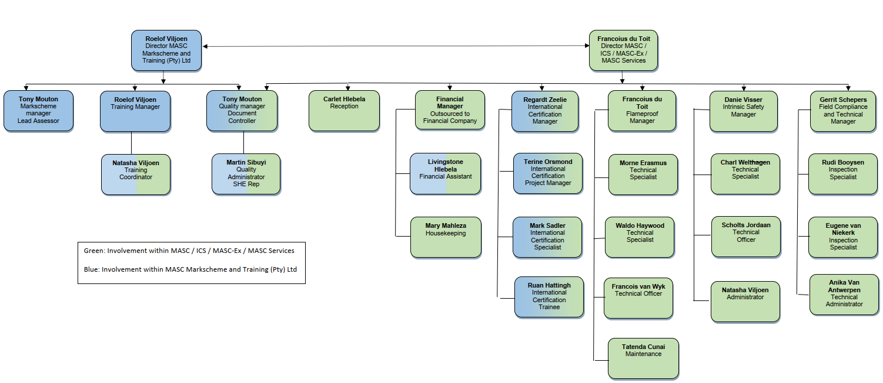

- Organisation Chart of ExCB in Scheme 03-5

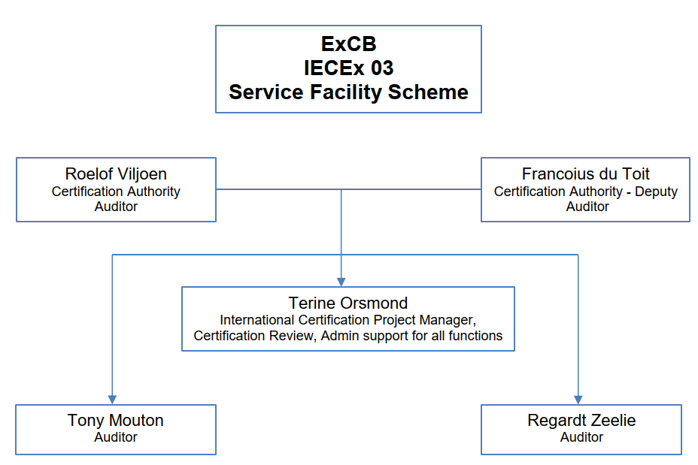

- Accreditation Certificate for ISO/IEC 17065
