**INTERNATIONAL ELECTROTECHNICAL COMMISSION SYSTEM FOR CERTIFICATION TO STANDARDS RELATING TO EQUIPMENT FOR USE IN EXPLOSIVE ATMOSPHERES (IECEx SYSTEM)**

**Reassessment and Scope extension report** **for JExM - Jiamusi Explosion-Proof Electric Machine Institute Co., Ltd (Formerly known as CHEM).**

**Circulation to: Members of the IECEx Management Committee, ExMC**

**INTRODUCTION**

This document contains the Scope extension and Reassessment report for JExM - Jiamusi Explosion-Proof Electric Machine Institute Co., Ltd (Formerly known as CHEM) to include the following Standard in their scope-

**IEC/IEEE 60079-30-1:2015**

***This document is hereby submitted for ExMC approval via correspondence using the IECEx on-line voting system.  ExMC Members are requested to submit their vote via the IECEx On-line*** [***Ballot System***](https://www.iecex.com/ballot) ***by the closing date 2023 09 04***

***Please refer to OD 050 for guidance on the “IECEx On-line voting system.”***

***Chris Agius***

**IECEx Secretariat**

|  |  |
| --- | --- |
| **IECEx Secretariat**  **Australia Square**  **Level 33,**  **264 George Street**  **Sydney, NSW 2000**  **AUSTRALIA** | **Tel: +61 2 4628 4690**  **Fax: +61 2 4625 3480**  **Email:** [**info@iecex.com**](mailto:info@iecex.com) |

IEC System for certification to standards relating to equipment for use in Explosive Atmospheres (IECEx System)

IECEx Assessment Report Form, F-003

IECEx assessment report form for use by IECEx assessment teams to report assessments conducted according to the relevant IECEx assessment procedures of:

Operational Document IECEx OD 003-2 for the Certified Equipment Scheme

Operational Document IECEx OD 316-* for the Certified Service Facility Scheme

Operational Document IECEx OD 422 for the IECEx Conformity Mark Licensing Scheme

Operational Document IECEx OD 501 for the Personnel Competence Scheme

**IECEx ExTL assessment report for**

**JExM - Jiamusi Explosion-Proof Electric Machine Institute Co., Ltd.**

**154005 Heilongjiang Province**

**CHINA**

INTERNATIONAL  
ELECTROTECHNICAL  
COMMISSION

CONTENTS

1 Assessment information 5

1.1 Type of body covered by this assessment: 5

1.2 Type of assessment: 5

1.3 Details of body 5

1.3.1 Country 5

1.3.2 Name of body 5

1.3.3 Name and title of nominated principal contact 5

1.4 Assessment information 5

1.4.1 Members of the assessment team 5

1.4.2 Place(s) of assessment 6

1.4.3 Assessment date(s) 6

1.5 Application information and background information on the assessment 6

1.6 Scopes 6

1.6.1 ExCB scope for equipment certification scheme 6

1.6.2 ExTL scope 6

1.6.3 ATF Scope 6

1.6.4 ExCB scope for Service Facilities Scheme 7

1.7 ExCB scope for Conformity Mark Licensing Scheme 7

1.8 ExCB scope for IECEx Personnel Competence Scheme 7

2 Common information 8

2.1 Legal entity of body 8

2.2 Financial support 8

2.3 History 8

2.4 Documentation 8

2.4.1 Quality manual 8

2.4.2 Procedures 8

2.4.3 Work instructions 8

2.4.4 Records (including test records where relevant) 8

2.4.5 Document change control 9

2.5 Confidentiality 9

2.6 Communication with public and customers (Hard copy and Electronic) 9

2.7 Recognitions and agreements 9

2.8 Internal audit 9

2.9 Management review 9

2.10 Contracting, subcontracting and witness testing 9

2.10.1 Contracting 9

2.10.2 Subcontracting 9

2.10.3 Off-site and Witness testing 9

2.11 Training and competence 9

2.12 Complaints and appeals (including appeals to IECEx) 10

2.13 Impartiality 10

2.14 Active involvement in development of Decision Sheets 10

2.15 Special facts to be noted 10

2.16 Supporting documentation 10

2.17 Recommendations 10

3 ExCB for IECEx Certified Equipment Scheme 11

4 ExTL for IECEx Certified Equipment Scheme 12

4.1 General references 12

4.1.1 Additional references applied for this assessment 12

4.2 Candidate ExTL persons interviewed 12

4.3 Associated ExCB(s) 12

4.4 Organisation 12

4.4.1 Names, titles and experience of the senior executives 12

4.4.2 Name, title and experience of the quality management representative 12

4.4.3 Other employees in ExTL activity 12

4.5 Organizational structure 13

4.6 Resources 13

4.7 Test reports issued 14

4.8 National accreditation 14

4.9 Calibration 14

4.10 Tests witnessed during the assessment visit 15

4.11 Participation in IECEx Proficiency Testing Programs 16

4.12 Comments (including issues found during assessment) 17

5 ATF for IECEx Certified Equipment Scheme 18

Not within the scope of this application. 18

6 ExCB for Certified Service Facilities Scheme 19

Not within the scope of this application. 19

7 IECEx Conformity Mark Licensing Scheme 20

Not within the scope of this application. 20

8 ExCB for IECEx Personnel Competence Scheme 21

Not within the scope of this application. 21

9 Annexes 22

Annex A Scope for IECEx Certified Equipment Scheme 23

A.1 Current standards 23

A.2 Superseded standards 23

Annex B Overall Organisation Chart 24

B.1 Organisation Chart of JExM 24

Annex C Organisation Chart of ExTL 25

Annex D Accreditation Certificate for ISO/IEC 17065 26

D.1 Not applicable 26

Annex E Accreditation Certificate for ISO/IEC 17025 27

E.1 Copy of the Certificate 27

Annex F Accreditation Certificate for ISO/IEC 17024 28

F.1 Not applicable 28

Annex G 29

G.1 List of Associated Ex Certification Bodies and their scope of Standards 29

China Quality Certification Center (CQC) 29

# Assessment information

## Type of body covered by this assessment:

|  |  |
| --- | --- |
| ExCB for IECEx Certified Equipment Scheme |  |
| ExTL for IECEx Certified Equipment Scheme |  |
| ATF for IECEx Certified Equipment Scheme |  |
| ExCB for IECEx Certified Service Facilities Scheme |  |
| ExCB for IECEx Conformity Mark Licensing System |  |
| ExCB for IECEx Certification of Personnel Competency Scheme |  |

NOTE 1 ExCB - IECEx Certification Body

NOTE 2 ExTL - IECEx Testing Laboratory

NOTE 3 ATF - Additional Testing Facility

## Type of assessment:

|  |  |
| --- | --- |
| Pre-assessment for candidate body |  |
| Initial assessment for candidate body |  |
| Surveillance |  |
| Re-assessment |  |
| Scope extension – added IEC/IEEE 60079-30-1 |  |

## Details of body

### Country

Peoples Republic of China

### Name of body

JExM - Jiamusi Explosion-Proof Electric Machine Institute Co., Ltd.

This body was earlier known as CHEM - National Quality Supervision and Inspection Centre of Hoisting & Metallurgical & Explosion-Proof Electric Machine. They have requested for a change in the name in the IECEx system to match their name in the organizational context and the CNAS accreditation.

The location and premises are unchanged. The technical capability and competency of the staff are generally unchanged and were re-assessed for compliance with the IECEx requirements.

### Name and title of nominated principal contact

|  |  |  |
| --- | --- | --- |
| Name | Title | E-mail address |
| Zeng Xin | Quality administrator of JExM | rubyzx@126.com |

## Assessment information

### Members of the assessment team

|  |  |
| --- | --- |
| Name | Role |
| Ajay Maira | IECEx Lead Assessor |
| Yin Hong | IECEx Assessor and translator |

### Place(s) of assessment

|  |  |
| --- | --- |
| 3 Anqing Street  Jiamusi  154005 Heilongjiang Province  Peoples Republic of China |  |

### Assessment date(s)

2023-04-24 to 2023-04-27, 2023-05-10

## Application information and background information on the assessment

JExM - Jiamusi Explosion-Proof Electric Machine Institute Co., Ltd, previously known as CHEM - National Quality Supervision and Inspection Centre of Hoisting & Metallurgical & Explosion-Proof Electric Machine is an IEC ExTL. They were accepted as an IECEx TL in 2012 (ExMC/795 /DV). An IECEx re-assessment was carried out in 2017 (ExMC/1412/DV) that included an increase in the scope of the Standards.

They are now being re-assessed and have also applied to an increase in the scope of the Standards (to include IEC/IEEE 60079-30-1:2015)

In parallel, they have applied to include Jiamusi Explosion-Proof Electric Machine Institute Co.,Ltd. Wuxi Branch – (abbr JExM (WX)) as an Additional Test Facility ATF). A separate IECEx initial assessment report has been prepared for that.

Jiamusi Explosion-Proof Electric Machine Institute Co., Ltd. (Abbr. JExM) is the legal entity of both JExM and JExM (WX).

JExM is associated with several IECEx CBs. See Section 1.6 for details.

Due to international travel restrictions, this IECEx peer assessment was conducted by IECEx Lead Assessor under IECEx OD 060, but utilizing an IECEx Technical Assessor on site, as a translator.

## Scopes

### ExCB scope for equipment certification scheme

JExM is an IECEx TL and is associated with several IECEx CB’s:

* China Quality Certification Center (CQC)
* China Quality Mark Certification Group Co. Ltd (CQM)
* Shanghai Inspection and Testing Institute of Instruments and Automatic Systems Co., Ltd. (SITIIAS)/ National Supervision and Inspection Centre for Explosion Protection and Safety of Instrumentation (NEPSI)

The scope of the relevant IEC Standards for the ExCB’s includes the Standards and editions applied by JExM are shown in Annex G.

### ExTL scope

The ExTL (JExM) is not integral with an ExCB, and the scope of the ExTL is included in Annex A.

### ATF Scope

Not within the scope of this application.

### ExCB scope for Service Facilities Scheme

Not within the scope of this application.

## ExCB scope for Conformity Mark Licensing Scheme

Not within the scope of this application.

## ExCB scope for IECEx Personnel Competence Scheme

Not within the scope of this application.

# Common information

## Legal entity of body

JExM, formerly known as CHEM, which is a legal entity, undertakes the legal responsibilities.

## Financial support

JExM, a legal entity, is self-financing with responsibility for the profits and losses.

## History

CHEM - National Quality Supervision and Inspection Centre of Hoisting & Metallurgical & Explosion-Proof Electric Machine is a private company founded in 1992.

CHEM was established under the authorization of State Bureau of Technical Supervision. The scope covers various kinds of performance tests for explosion-proof electric apparatus. The history of explosion-proof performance test can be traced back to the year of 1962.

As mentioned in 1.3.2 above, there is now a name change to JExM.

## Documentation

### Quality manual

Quality management documents contain: quality manual, procedure documents, working instructions, and records forms.

Quality policy is in 2.2 of Quality Manual, “Fair, scientific and accurate inspection, high-quality, efficient and satisfactory service.”

Manuals, work instructions and regulations to be used by staff are available in Office Automation System.

The Quality Manual is written in accordance with ISO/IEC 17025:2005 and was checked during the assessment and also found to meet the requirements of the IECEx

### Procedures

A comprehensive list of Quality controlled procedures, work instructions, forms has been provided and has been detailed in the F-004 Site Assessment Report. The relevant procedures were found to meet the requirements of the IECEx.

### Work instructions

See 2.4.2

### Records (including test records where relevant)

CX-D02-2021 Procedure for documents control

CX-D10-2021 Control procedure of records, method and results of testing activities are recorded as prescribed in this procedure. Documents are stored to provide a permanent test record.

CX-D10-2021 requires that record templates are implemented after preparation, review and approval by the authorized person, and the latest record templates are available in the OA system, so they are current, complete and accurate, and all records are stored in the Archives storage room, where they can only be accessed by permission.

The system complies with OD 207.

### Document change control

JExM has an office automation system for updating, implementing and recording changes to the quality management documents.

Based on office automation system, all the obsolete data promptly removed from documents and reference data maintained are in an up-to-date condition.

## Confidentiality

CX-D01-2020 “Procedures document for protecting customer confidential information and ownership”. All employees sign confidentiality agreements when they start work. Examples of these were sighted by the team and found to meet the requirements of the IECEx.

## Communication with public and customers (Hard copy and Electronic)

Public access procedures are available at:

[https://www.jexm.net](https://www.jexm.net/)/

## Recognitions and agreements

JExM operate as an ExTL under CQM, NEPSI and CQC as ExCBs.

## Internal audit

CX-D11-2020 Procedure for internal audits. These are being conducted on an annual basis. Audit reports for the audits conducted in March 2022 and March 2023 were reviewed. The audit reports contain reference to IECEx OD 018. There were two nonconformances and both have been resolved.

## Management review

Last management review meeting was carried out in Oct 2022. The report was reviewed and found satisfactory. The system meets the requirements of ISO/IEC 17025, and IECEx

## Contracting, subcontracting and witness testing

### Contracting

There are no contractors used.

### Subcontracting

The IEC 60079-0 Transferred Charge test marked with an * in the TCD has been subcontracted to PCEC. Also, the IEC 60079-1 Bubble Pore test, and Sinter Density test have been subtracted. Signed agreement dated 2023-05-23 is available.

Some tests in the newly released IEC 60079-11:2023 are also listed in the agreement, but are not applicable presently as JExM have not been assessed to this later Standard.

All other tests are conducted in-house.

### Off-site and Witness testing

The off-site and witness testing arrangements are listed in JS-A02-2023. The procedure mentions that the test will be registered in the IECEx Witness test register which fulfils the requirements of the IECEx by referencing and incorporating the requirements of OD 024.

## Training and competence

CX-D13-2020 Personnel training and supervision procedure.

Details of staff competencies (Competence Matrix-JExM，23.04.02 updated) are included in the site assessment report F004.

Standards of professional ability, skills and job descriptions been prescribed in Clause 6.2.2 Qualification and CX-D34-2020 Personnel management procedure.

The testing lab make training plan, training is made based on the plan, and all training was applied to attain and maintain skills with due attention to quality requirements.

## Complaints and appeals (including appeals to IECEx)

CX-D06-2020 Processing procedure for complaint and customer service was reviewed and found satisfactory.

## Impartiality

JExM-SC-09/2023 Code of Conduct Statement of impartiality provides the procedure and requirements to maintain impartiality. These fulfilled the requirements of ISO/IEC 17025, and IECEx System.

## Active involvement in development of Decision Sheets

Yes, JExM provides comments, and implements all Decision Sheets in the procedures used.

## Special facts to be noted

JExM have extensive test equipment with skilled operators and experienced engineers to conduct testing and write reports. Their expertise in testing Ex motors is of a very high standard.

## Supporting documentation

Copies of additional supporting information for this assessment have been provided to the applicant and the IECEx Secretariat. These are included in a site assessment report or provided separately and include:

* Details of issues raised and how these have been resolved.
* Checklist for ISO/IEC 17025 (Internal audit report)
* Completed Technical Capability Document (TCD)
* Photos of the facilities/tests witnessed are included in the above TCD
* Information on competencies
* Assessors’ notes

## Recommendations

Based on the assessment performed on 2023-04-24 to 2023-05-10, JExM is recommended for continued acceptance in the IECEx scheme as:

* An ExTL in the IECEx Certification Equipment Scheme

This is according to the scope of the standards listed in this document subject to resolution of the issues found during the assessment).

|  |  |  |
| --- | --- | --- |
| Ajay Maira | Yin Hong |  |
| IECEx Lead Assessor | IECEx Assessor and Translator |  |

Date: 2023-06-26

# ExCB for IECEx Certified Equipment Scheme

JExM is not a CB.

JExM has established arrangements with three IECEx certification bodies listed in Annex G.

A procedure CX-D30-2023 has been prepared to define the responsibilities of the ExCB’s and the JExM.

# ExTL for IECEx Certified Equipment Scheme

## General references

1. IECEx02 IECEx Certified Equipment Scheme covering equipment for use in explosive atmospheres – Rules of Procedure
2. IECEx OD003-2 Assessment, surveillance assessment and re-assessment of ExCBs and ExTLs operating in the IECEx 02, IECEx Certified Equipment Scheme
3. IECEx OD009 Issuing of CoCs, ExTRs and QARs
4. ISO/IEC 17025 General requirements for the competence of testing and calibration laboratories
5. IECEx OD 018 Harmonised check list for testing and calibration laboratories ISO/IEC 17025
6. IECEx TCD 60079, ISO 80079 Series and ISO 16852 Technical Capability Document
7. ExTAG decision sheets (DSs)
8. IECEx OD 202 IECEx Certified Equipment Scheme – IECEx Proficiency Testing Program

NOTE The latest editions of the above documents were applied, unless otherwise specified.

### Additional references applied for this assessment

NOTE To be added by assessment team. For example, ODs for non-electrical or Ex s where applicable

## Candidate ExTL persons interviewed

|  |  |
| --- | --- |
| Name | Position |
| See Site Assessment Report F-004 |  |

## Associated ExCB(s)

- China Quality Certification Center (CQC)

- China Quality Mark Certification Group Co. Ltd (CQM)

- Shanghai Inspection and Testing Institute of Instruments and Automatic Systems Co., Ltd. (SITIIAS)/ National Supervision and Inspection Centre for Explosion Protection and Safety of Instrumentation (NEPSI)

The agreements with ExCBs were presented during the assessment and found to meet the requirements of the IECEx.

## Organisation

### Names, titles and experience of the senior executives

|  |  |  |
| --- | --- | --- |
| Name | Title | Experience (years) |
| Wang Weiyue | Director of JExM & JExM (WX) | 31 |

### Name, title and experience of the quality management representative

|  |  |  |
| --- | --- | --- |
| Name | Title | Experience (years) |
| Zeng Xin | Quality administrator of JExM | 13 |

### Other employees in ExTL activity

|  |  |  |
| --- | --- | --- |
| Name | Title/responsibility | Experience in Ex (years) |
| Wang Weiyue | Director of JExM | 31 years working experience in testing. |
| Zhang Liyuan | Vice director of  JExM | 33 years working experience in testing. |
| Jiao Xilai | Manager of Integrated Management Office Ⅰ | 13 years working experience. |
| Zeng Xin | Quality administrator of JExM | 13 years working experience. |
| Sun Meiling | Translator in Integrated Management Office Ⅰ | 1 year working experience. |
| Ying Yi | Manager of Ex-testing lab Ⅰ | 15 years working experience in testing. |
| Yao Xin | Test engineer | 9 years working experience in testing. |
| Han Dan | Test engineer | 5 years working experience in testing. |
| Hao Changhai | Manager of Ex-testing lab Ⅱ | 9 years working experience in testing. |
| Liu Dezhang | Test engineer | 3 years working experience in testing. |
| Dong Jiabo | Test engineer | 13 years working experience in testing. |
| Fu Yongpeng | Test engineer | 2 years working experience in testing. |
| Dong Jiali | Manager of Electrical Inspection Office Ⅰ | 11 years working experience in testing. |
| Li Jigui | Test engineer | 23 years working experience in testing. |
| Wang Long | Test engineer | 2 years working experience in testing. |
| Xu Jie | Manager of Ex-testing labIII | 11years working experience in testing. |
| Xu Qiangqiang | Test engineer | 10years working experience in testing. |
| Kang Jian | Manager of Ex-testing labIV | 13 years working experience in testing |
| Jiang Shuai | Test engineer | 2 years working experience in testing |
| Zhang Hao | Test engineer | 2years working experience in testing |

## Organizational structure

See Annex A and B.

## Resources

CX-D19-2020 Test sample management procedure has been implemented for the handling, storage and return to the client of materials and samples. Samples are only accessible to authorized persons. The testing lab has appropriate storage areas arranged to prevent deterioration or damage to the sample.

The list of calibrated equipment used for all measurements for tests nominated by JExM were provided during the assessment and noted in the TCD.

JExM establishes relevant organizational structure, equips itself with relevant resources (incl. personnel, facilities and environment), establishes quality management system, and generates and publishes Quality Manual, Procedure Documents and relevant Work instructions, which shall be conscientiously followed during testing and certification.

JExM carries out internal audit and management assessment regularly as required to improve the effectiveness of the quality system continually and enhance testing service quality.

JExM is very well resourced with appropriate procedures and competent staff for carrying out activities for the standards in their scope.

.

## Test reports issued

Number of test reports (ExTRs) issued for the preceding two years for each type of protection.

|  |  |  |  |  |
| --- | --- | --- | --- | --- |
| Standard numbers | Type of protection or other identifying information | Number of issued reports (ExTRs) (for last 2 years) | | Total |
| 2021 | 2022 |
| IEC 60079-0 | Explosive atmospheres - Part 0: Equipment - General requirements | 3 | 11 | 14 |
| IEC 60079-1 | Explosive atmospheres - Part 1: Equipment protection by flameproof enclosures “d” | 15 | 10 | 25 |
| IEC 60079-2 | Explosive atmospheres - Part 2: Equipment protection by pressurized enclosure “p” | 2 | 1 | 3 |
| IEC 60079-7 | Explosive atmospheres - Part 7: Equipment protection by increased safety "e" | 0 | 0 | 0 |
| IEC 60079-11 | Explosive atmospheres - Part 11: Equipment protection by intrinsic safety “i” | 0 | 0 | 0 |
| IEC 60079-15 | Explosive atmospheres – Part 15: Equipment protection by type of protection "n" | 1 | 0 | 1 |
| IEC 60079-18 | Explosive atmospheres – Part 18: Equipment protection by encapsulation “m” | 1 | 0 | 1 |
| IEC 60079-31 | Explosive atmospheres – Part 31: Equipment dust ignition protection by enclosure "t" | 0 | 0 | 0 |
| IEC/IEEE 60079-30-1 | Explosive atmospheres. Part 30-1: Electrical resistance trace heating. General and testing requirements | 0 | 0 | 0 |

## National accreditation

JExM has CNAS national accreditation certification using ISO/IEC 17025 for the Standards listed in Annex E.

It was noted that the Edition for IEC 60079-11 was retained at Ed 6.0. The Certificate/listing in ANNEX E was current at the time of the audit and the next assessment by CNAS has taken place.

NOTE The national accreditation is checked annually by the IECEx Secretariat.

## Calibration

CX-D16-2022 Management procedure for measurement equipment. The testing lab make annual Verification and calibration plan to ensure that all the equipment is of accuracy compatible with the assessment and testing undertaken.

Monthly checks are made for all test equipment mentioned in a spreadsheet to check for calibration,

The facility provides appropriate environments provided for handling, control, storage and maintenance of all testing and measuring equipment.

CX-D17-2021 Control procedure for measurement traceability,

The System for calibration of test equipment procedures were reviewed during the assessment and found to comply with ISO/IEC 17025 and IECEx requirements

## Tests witnessed during the assessment visit

The following tests were witnessed during the assessment visit:

|  |  |  |  |
| --- | --- | --- | --- |
| **Standard and edition** | **Clause number** | **Test** | **Comments** |
| IEC 60079-1 Ed 7.0 | 15.2.2 | Flameproof pressure determination for a Junction box. | Satisfactory.  Added details to check analyser span and zero before use.  Added detail of using manual valves close to the sample to obtain correct reference pressure results. |
| IEC 60079-1 Ed 7.0 | 15.3.2 | Flameproof non-transmission test for a Junction box. | Satisfactory.  Added details to check analyser span and zero before use. |
| IEC 60079-0 Ed 7.0 | 26.4.5 | IP5X test for a luminaire | Satisfactory.  Added details to check for system leakage prior to test.  Added details in procedure to prevent extraction of more than the maximum 80 vols if extraction rate lesser than 40 Vol / hr |
| IEC 60079-0 Ed 7.0 | 26.4.5 | IPX4 test for a luminaire | Satisfactory. |
| IEC 60079-7 Ed 5.0 | A.5 | Motor tE test for an Ex e motor. | Satisfactory. |
| IEC 60079-2 Ed 6.0 | A.3 | Purging test for Pressurized enclosure where the protective gas is air. | Satisfactory. |
| IEC 60079-11 Ed 6.0 | 5.2 | Circuit analysis for intrinsic safety | Satisfactory.  Discussions were held on power calculation when component protected by series fuse and resistor.  Discussed. Adding more details to the segregation assessment of the printed circuit board. |
| IEC 60079-11 Ed 6.0 | 10.1 | Use of spark test apparatus using Group I with safety factor 1.5, preferably on a power supply. | Satisfactory.  Discussed setting of external power supplies to the most onerous condition during testing of the sample. |
| IEC 60079-11 Ed 6.0 | 10.5.3 | Battery short circuit test | Satisfactory. |
| IEC 60079-18 Ed 4.0 | 8.1.2 | Dielectric strength test on Ex m compound sample | Satisfactory. |

## Participation in IECEx Proficiency Testing Programs

Program: PTB Ex PT Scheme

NOTE 1 It is anticipated that the IECEx Secretariat will provide the assessment team with information on the performance of the body in completed PTB Ex PT Scheme programs.

NOTE 2 Assessor should ask what is being done about results. This includes what has happened when testing process changed as result of a program, eg could look at management review agenda/minutes

|  |  |  |  |
| --- | --- | --- | --- |
| **IECEx Proficiency Testing program** | **Program years** | Participated?  **Y/N/NA** | Comment on results |
| Program 1 "Explosion pressure" | 2011-2012 | N | JExM did not participate |
| Program 2 "Spark ignition" | 2011-2012 | N | JExM did not participate |
| Program 3 "Flame Transmission" | 2013-2014 | Y | JExM participated. |
| Program 4 "Temperature Classification" | 2013-2014 | Y | JExM participated. |
| Program 5 "Electrostatic Charge" | 2015-2016 | Y | JExM participated. |
| Program 6 "Intrinsic Safety" | 2015-2016 | Y | JExM participated. |
| Program 7 "Explosion Pressure" | 2017-2018 | Y | JExM participated. The phase II results were satisfactory.  . |
| Program 8 "Pressurized Enclosure" | 2017-2018 | Y | JExM participated. There were no warning or alerts in the report. |
| Program 9 “Battery Testing” | 2019-2020 | Y | JExM participated. There were no warning or alerts in the report. |
| Program 10 “Tests of Enclosures” | 2019-2020 | Y | JExM participated. There were no warning or alerts in the report. |
| Program 11 "Flameproof Joints" | 2021-2022 | Y | JExM participated. Good results |
| Program 12 "Small Component Temperature” | 2021-2022 | Y | JExM participated. Good results |
| Program 13:  “Explosion Pressure” | 2023-2024 | N/A presently | Participation confirmed on PT Scheme website |
| Program 14:  “Connection and Junction Boxes” | 2023-2024 | N/A presently | Participation confirmed on PT Scheme website |

## Comments (including issues found during assessment)

JExM have shown a high level of understanding the issues found during the assessment and been very active in resolving all issues to the satisfaction of the IECEx assessors,

# ATF for IECEx Certified Equipment Scheme

### Not within the scope of this application.

It may be noted that JExM (WX) have applied to become an ATF under JExM. A separate IECEx assessment has details.

# ExCB for Certified Service Facilities Scheme

### Not within the scope of this application.

# IECEx Conformity Mark Licensing Scheme

## Not within the scope of this application.

# ExCB for IECEx Personnel Competence Scheme

## Not within the scope of this application.

# Annexes

See Contents.

1. Scope for IECEx Certified Equipment Scheme

**Scope of the IECEx TL:**

**JExM - Jiamusi Explosion-Proof Electric Machine Institute Co., Ltd.**

3 Anqing Street  
Jiamusi,  
154005 Heilongjiang Province  
  
Requested increase in scope to include IEC/IEEE 60079-30-1 as listed in the Table below:

* 1. Current standards

| Number | Title | Comments |
| --- | --- | --- |
| IEC 60079-0  Edition 7.0 | Explosive atmospheres - Part 0: Equipment - General requirements | In scope of CNAS |
| IEC 60079-1  Edition 7.0 | Explosive atmospheres - Part 1: Equipment protection by flameproof  enclosures “d” | In scope of CNAS |
| IEC 60079-2  Edition 6.0 | Explosive atmospheres - Part 2: Equipment protection by pressurized  enclosure “p’ | In scope of CNAS |
| IEC 60079-7  Edition 5.1 | Explosive atmospheres - Part 7: Equipment protection by increased  safety "e" | In scope of CNAS |
| IEC 60079-11  Edition 6.0 | Explosive atmospheres - Part 11: Equipment protection by intrinsic safety “i” | In scope of CNAS |
| IEC 60079-15  Edition 5.0 | Explosive atmospheres – Part 15: Equipment protection by type of protection "n" | In scope of CNAS |
| IEC 60079-18  Edition 4.1 | Explosive atmospheres – Part 18: Equipment protection by encapsulation “m” | In scope of CNAS |
| IEC/IEEE 60079-30-1  Edition 1.0 | Explosive atmospheres – Part 30-1: Electrical resistance trace heating – General and testing requirements | In scope of CNAS |
| IEC 60079-31  Edition 3.0 | Explosive atmospheres – Part 31: Equipment dust ignition protection by enclosure "t" | In scope of CNAS |

* 1. Superseded standards

Nil.

1. Overall Organisation Chart
   1. Organisation Chart of JExM

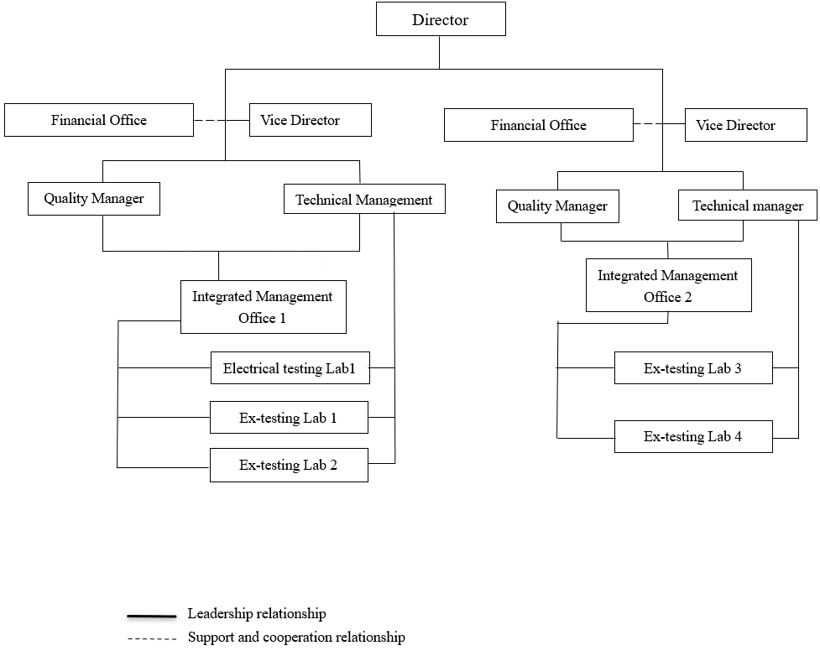

1. Organisation Chart of ExTL

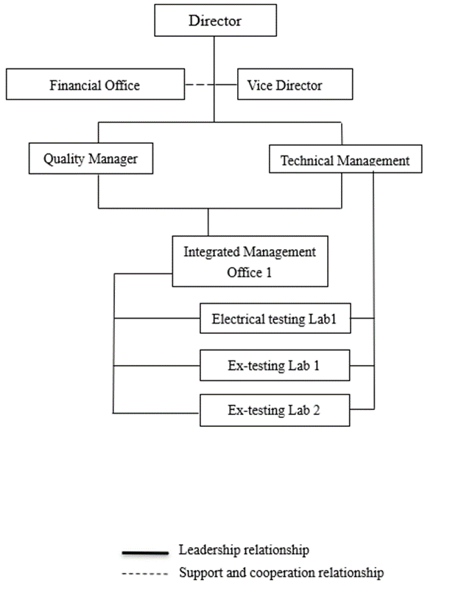

1. Accreditation Certificate for ISO/IEC 17065
   1. Not applicable
2. Accreditation Certificate for ISO/IEC 17025
   1. Copy of the Certificate



1. Accreditation Certificate for ISO/IEC 17024
   1. Not applicable
2. 1. List of Associated Ex Certification Bodies and their scope of Standards

China Quality Certification Center (CQC)

Section 9, No.188, Nansihuan (the South Fourth Ring

Road) Xilu (West Road), Beijing 100070, P.R. China

**China Quality Mark Certification Group Co. Ltd (CQM)**

No.33 Zengguang Road,  
Haidian District,  
Beijing City,  
Postal Code:100048

**Shanghai Inspection and Testing Institute of Instruments and Automatic Systems Co., Ltd. (SITIIAS)/ National Supervision and Inspection Centre for Explosion Protection and Safety of Instrumentation (NEPSI)**

103 Cao Bao Road

Shanghai 200233

**Comparison table** showing Standards in scope of JExM and their availability in the associated ExCB’s:

| Number | ExTL JExM | ExCB CQC | ExCB CQM | ExCB NEPSI | Comments |
| --- | --- | --- | --- | --- | --- |
| IEC 60079-0  Edition 7.0 |  |  |  |  | Okay |
| IEC 60079-1  Edition 7.0 |  |  |  |  | Okay |
| IEC 60079-2  Edition 6.0 |  |  |  |  | Okay |
| IEC 60079-7  Edition 5.1 |  |  |  |  | Okay |
| IEC 60079-11  Edition 6.0 |  |  |  |  | Okay |
| IEC 60079-15  Edition 5.0 |  |  |  |  | Okay |
| IEC 60079-18  Edition 4.1 |  |  |  |  | Okay |
| IEC/IEEE 60079-30-1  Edition 1.0 |  |  |  |  | Okay |
| IEC 60079-31  Edition 3.0 |  |  |  |  | Okay |