**INTERNATIONAL ELECTROTECHNICAL COMMISSION SCHEME FOR  
CERTIFICATION TO STANDARDS RELATING TO EQUIPMENT FOR USE  
IN EXPLOSIVE ATMOSPHERES (IECEx SYSTEM)**

**Title:** **Re-assessment and Scope Extension Report for the continued acceptance of** **Intertek Testing Services NA Ltd., an Accepted Ex Testing Laboratory (ExTL), within the IECEx Scheme 02 to include IEC/IEEE 60079-30-1 and ISO 80079-36 in their scope.**

**Introduction**

In accordance with the 5-year re-assessment plan for the surveillance and monitoring of bodies within the IECEx System, the following document contains the Re-assessment and Scope Extension Report for the continued acceptance of Intertek Testing Services NA Ltd, ExTL, within the IECEx Scheme 02

During the re-assessment the IECEx Assessment Team took the opportunity to also assess

Intertek Testing Services NA Ltd. ExTL, for the following extension of scope-

|  |  |  |
| --- | --- | --- |
| IEC/IEEE 60079-30-1  Edition 1.0 | Explosive atmospheres – Part 30-1: Electrical resistance trace heating – General and testing requirements | Scope extension |

|  |  |  |
| --- | --- | --- |
| IS0 80079-36  Edition 1.0 | Explosive atmospheres - Part 36: Non-electrical equipment for explosive atmospheres – Basic method and requirements | Scope extension |

***This document is hereby submitted for ExMC approval via correspondence using the IECEx on-line voting system. ExMC Members are requested to submit their vote via the IECEx On-line Ballot System by the closing date 20230908***

***Please refer to OD 050 for guidance on the “IECEx On-line voting system.”***

***Chris Agius***

**IECEx Secretariat**

|  |  |
| --- | --- |
| **IECEx Secretariat**  **Australia Square Building  Level 33, 264 George Street**  **Sydney NSW 2000**  **Australia** | **Tel: +61 2 46284690**  **Fax: +61 2 4627 5285**  **Email: info@iecex.com** |

IEC System for certification to standards relating to equipment for use in Explosive Atmospheres (IECEx System)

IECEx Assessment Report Form, F-003

IECEx assessment report form for use by IECEx assessment teams to report assessments conducted according to the relevant IECEx assessment procedures of:

Operational Document IECEx OD 003-2 for the Certified Equipment Scheme

Operational Document IECEx OD 316-* for the Certified Service Facility Scheme

Operational Document IECEx OD 422 for the IECEx Conformity Mark Licensing Scheme

Operational Document IECEx OD 501 for the Personnel Competence Scheme

IECEx ExCB/ExTL/ATF assessment report for:

Intertek Testing Services NA Ltd. – Edmonton

INTERNATIONAL  
ELECTROTECHNICAL  
COMMISSION

CONTENTS

1 Assessment information 5

1.1 Type of body covered by this assessment: 5

1.2 Type of assessment: 5

1.3 Details of body 5

1.3.1 Country 5

1.3.2 Name of body 5

1.3.3 Name and title of nominated principal contact 5

1.4 Assessment information 5

1.4.1 Members of the assessment team 5

1.4.2 Place(s) of assessment 5

1.4.3 Assessment date(s) 6

1.5 Application information and background information on the assessment 6

1.6 Scopes 6

1.6.1 ExCB scope for equipment certification scheme 6

1.6.2 ExTL scope 6

2 Common information 7

2.1 Legal entity of body 7

2.2 Financial support 7

2.3 History 7

2.4 Documentation 8

2.4.1 Quality manual 8

2.4.2 Procedures 8

2.4.3 Work instructions 8

2.4.4 Records (including test records where relevant) 8

2.4.5 Document change control 8

2.5 Confidentiality 9

2.6 Communication with public and customers (Hard copy and Electronic) 9

2.7 Recognitions and agreements 9

2.8 Internal audit 9

2.9 Management review 9

2.10 Contracting, subcontracting and witness testing 9

2.10.1 Contracting 9

2.10.2 Subcontracting 9

2.10.3 Off-site and Witness testing 10

2.11 Training and competence 10

2.12 Complaints and appeals (including appeals to IECEx) 10

2.13 Impartiality 11

2.14 Active involvement in development of Decision Sheets 11

2.15 Special facts to be noted 11

2.16 Supporting documentation 11

2.17 Recommendations 11

3 ExCB for IECEx Certified Equipment Scheme 12

4 ExTL for IECEx Certified Equipment Scheme 13

4.1 Assessment references 13

4.1.1 General references 13

4.1.2 Additional references applied for this assessment 13

4.2 ExTL persons interviewed 13

4.3 Associated ExCB(s) 13

4.4 Organisation 13

4.4.1 Name, title and experience of the quality management representative 13

4.4.2 Other employees in ExTL activity 14

4.5 Organizational structure 14

4.6 Resources 14

4.7 Test reports issued 14

4.8 National accreditation 15

4.9 Calibration 15

4.10 Tests witnessed during the assessment visit 15

4.11 Participation in IECEx Proficiency Testing Programs 15

4.12 Comments (including issues found during assessment) 16

Annexes 17

Annex A Scope for IECEx Certified Equipment Scheme 18

A.1 Current standards 18

Annex B Overall Organisation Chart 19

Annex C Organisation Chart of ExTL 20

Annex D Accreditation Certificate for ISO/IEC 17025 21

# Assessment information

## Type of body covered by this assessment:

|  |  |
| --- | --- |
| ExCB for IECEx Certified Equipment Scheme |  |
| ExTL for IECEx Certified Equipment Scheme |  |
| ATF for IECEx Certified Equipment Scheme |  |
| ExCB for IECEx Certified Service Facilities Scheme |  |
| ExCB for IECEx Conformity Mark Licensing System |  |
| ExCB for IECEx Certification of Personnel Competency Scheme |  |

NOTE 1 ExCB - IECEx Certification Body

NOTE 2 ExTL - IECEx Testing Laboratory

NOTE 3 ATF - Additional Testing Facility

## Type of assessment:

|  |  |
| --- | --- |
| Pre-assessment for candidate body |  |
| Initial assessment for candidate body |  |
| Surveillance |  |
| Re-assessment |  |
| Scope extension |  |

## Details of body

### Country

Canada

### Name of body

Intertek Testing Services NA Ltd.

### Name and title of nominated principal contact

|  |  |  |
| --- | --- | --- |
| Name | Title | E-mail address |
| Brian Whittle | Operations Manager | [Brian.whitte@intertek.com](mailto:Brian.whitte@intertek.com) |

## Assessment information

### Members of the assessment team

|  |  |
| --- | --- |
| Name | Role |
| Bernard Piquette | IECEx Lead Assessor |
| Klauspeter Graffi | IECEx Assessor |

### Place(s) of assessment

|  |  |
| --- | --- |
| Intertek Testing Services NA Ltd.  14920 135Ave NW Edmonton, AB T5V 1R9 Canada |  |

### Assessment date(s)

March 30, 2023 through March 31, 2023

## Application information and background information on the assessment

## Scopes

### ExCB scope for equipment certification scheme

Not Applicable

### ExTL scope

The scope for the ExTL is shown in Annex A. All standards in the ExTL scope are included in the scope of the ExCB.

Scope Extension request F-011

|  |  |  |
| --- | --- | --- |
| IEC/IEEE 60079-30-1  Edition 1.0 | Explosive atmospheres – Part 30-1: Electrical resistance trace heating – General and testing requirements | Scope extension |

and

|  |  |  |
| --- | --- | --- |
| IS0 80079-36  Edition 1.0 | Explosive atmospheres - Part 36: Non-electrical equipment for explosive atmospheres – Basic method and requirements | Scope extension |

# Common information

## Legal entity of body

Intertek Edmonton is registered as the formal entity Intertek Testing Services NA Ltd., corporation number 321533-4, under the Canada Business Corporations Act - 1995-12-31. The certificate of registration and the listing on the government website were viewed. It is a subsidiary of Intertek Group plc registered in the UK. Intertek Group plc is a technical services company in the UK.

## Financial support

Intertek Testing Services NA, Inc. is incorporated under the laws of Canada as a for-profit corporation. Intertek does not engage in the sale or promotion of any product or material. The management personnel, in such capacity, receive no stock option or any financial benefits from any producer, supplier or vendor of any product involved.

Intertek has sufficient breadth of interest that the loss or award of a specific contract would not be a determinative factor in its financial well-being. Trade Associations and clients of Intertek have no influence or control over the employment security of Intertek employees.

It is fully funded by the commercial activities based in Edmonton.

## History

Intertek Testing Services N.A., Ltd. is a wholly owned subsidiary of Intertek Group plc. (registered in U.K.). Intertek Group plc is a technical services company in U.K.

Electrical Products Business Line of Intertek Testing Services N.A., Inc. has a chain of testing laboratories and a Certification Body.

Additional History:

1972 Electrical Testing Laboratories, Inc then located in NY City, NY established its first satellite office in Atlanta, GA area for the certification of carpet products.

1978 Renamed to ETL Testing Laboratories. Shortly after, the Northern California office was opened in South San Francisco for the testing of electrical products and insulated glass.

In 1988, ETL Testing Laboratories was purchased by Inchcape, plc, and became part of Inchcape Testing Services.

In 1994, Inchcape Testing Services acquires SEMKO

In 1996, Inchcape Testing Services is sold and the company name is changed to Intertek Testing Services NA.

In 2002, Intertek became a publicly owned company.

The Edmonton office was established in 2011 and moved into a testing laboratory in 2013. It completed an assessment to ISO 17025 by A2LA in 2017 and an IECEx TL Initial assessment in the same year. The site was also added to the registry and audited by the Standards Council of Canada and ANSI. It remains as SNAP site for OSHA. The laboratory includes facilities for Hazardous Location and Product Safety testing with a focus on industrial control, process control and industrial heating equipment.

## Documentation

### Quality manual

There is an Intertek Global Quality Policy Manual, which was at revision date 20 May 2022 at the time of the assessment visit.

Intertek conducts its operations in accordance with the procedures contained within the Global Management System (GMS), Specific Management System (SMS), Regional Management System (RMS) and Local Management System (LMS) which are based on, and in compliance with ISO/IEC 17065, ISO/IEC Standard 17025 and ISO/IEC Standard 17020

The General Quality Manual was checked and found to meet the requirements of the IECEx System

### Procedures

There is a specific procedure SMS-IECEx-OP-19 IECEx Certified Equipment Scheme rev 21 March 2023, which also incorporates sub-procedures based on IECEx OD009. This procedure is applied to all ExCBs and ExTLs within the Intertek group. It references a number of other Intertek procedures that are relevant for the operation of Intertek bodies as ExCBs and ExTLs.

The documentation was checked and found to meet the IECEx System requirements.

### Work instructions

Work instructions can be global, regional or site-specific. Relevant regional work instructions include:

GMS-QC-16: Control of Intertek Issued Controlled Document

GMS-QC-17: Control of Documents Issued by External Bodies

GMS-QC-18: Controlled Document Coding Convention

GMS-QC-19: Numbering of Test Reports

GMS-QC-20: Numbering of Certificates

GMS-QC-21: Management System Document Issuance and Change Process

GMS-QC-22: Intertek Country and Facility Coding

These were reviewed and found to meet the requirements of IECEx.

### Records (including test records where relevant)

The relevant global procedures in regard to record are GMS-FM-15: Control and Disposal of Records and GMS-FM-16: Project File Transfer Between Offices/Sites

There is a retention period of 10 years after the certification ends but in practice all records are stored electronically indefinitely. Hard copy documents are scanned and placed into the appropriate project file and the original shredded

The records storage system was found to meet the requirements of IECEx recommendations in OD 207 Guidance on the Retention of Records

### Document change control

All new documents or changes to existing documents are balloted by relevant people throughout the global organisation, prior to being approved. Staff have access to all documents in the system, but access to change documents depends on the position a staff member holds. Each document carries a message that printed documents are uncontrolled. The system was found to be comprehensive and robust. The procedure which addresses the system is GMS-QC-21: Management System Document Issuance and Change Process

The document change control system meets the requirements of IECEx

## Confidentiality

All Intertek personnel including committee members, contractors or individuals acting on the laboratory’s behalf are required to read and sign the Intertek confidentiality Agreement.

The relevant procedure is GMS-QC-04 Protection of Client Confidential Information and Proprietary Rights.

Forms signed by employees were reviewed during the assessment.

The above was found to meet the requirements for IECEx.

## Communication with public and customers (Hard copy and Electronic)

There is the company website located at www.intertek.com which is the main source of communication with the public and customers. The website includes some information on IECEx. There is a printed chart that they produce which includes information on 'Hazardous Locations & Potentially Explosive Atmospheres'.

## Recognitions and agreements

Intertek has no formal agreement with another test laboratory except Tests laboratories of the Intertek group.

## Internal audit

The relevant global procedure for internal auditing is GMS-QC-13: Internal Quality Auditing.

Internal auditing of the quality system was carried out in June 2022. Audit report and how the non-conformities have been resolved have been reviewed during the assessment.

The system was found to be effective and meets the requirements of IECEx.

## Management review

Management review is addressed in GMS-QC-08: Management Review. The most recent management review meeting at Edmonton was carried out on 3 February 2022. The meeting included discussions on IECEx assessment. The 2023 Management Review was delayed and carried out April 5, 2023 after the assessment.

The latest Management review was reviewed and found complying with the requirements of IECEx.

## Contracting, subcontracting and witness testing

### Contracting

There are no contract employees associated with Intertek Edmonton, but they might use the services of other parts of Intertek.

### Subcontracting

Subcontracting is addressed GMS-OP-01: Subcontracting of Testing/Evaluation. There is also a reference in SMS-IECEx-OP-19 IECEx Certified Equipment Scheme.

The following tests are, or may be, subcontracted by the body:

| Standard | Clause | Test |
| --- | --- | --- |
| 60079-0: 2011 | 26.10 | Resistance to Light |
| 60079-1:2014 | Annex B | Additional requirements for elements, with non-measurable paths of breathing and draining devices |
| 60079-2:2014 | 16.7.2 | Infallibility test |
| 60079-5:205 | 5.1.3 | Insulation resistance of the filling material |
| 60079-7:2015 | 6.2 | Rotating electrical machines |
| 60079-7:2015 | 6.3.5 | Sulphur dioxide test for level of protection "eb" for the connection of bi-pin lamp caps to lampholders |
| 60079-7:2015 | 6.3.6 | Vibration test for level of protection "eb" for luminaires with bi-pin lamps |
| 60079-7:2015 | 6.3.7 | Tests for wiring of luminaires subject to high-voltage impulses from ignitors |
| 60079-7:2015 | 6.3.8 | Tests for electronic starters for tubular fluorescent lamps and for ignitors in Level of Protection “ec” for discharge lamps |
| 60079-7:2015 | 6.3.9 | Test for starter holders for luminaires in Level of Protection “ec” |
| 60079-7:2015 | 6.6 | Verification and tests for cells and batteries of Level of Protection “eb” |
| 60079-7:2015 | 6.7 | Verification and tests for cells and batteries of Level of Protection “ec” |
| 60079-11:2011 | 10.8 | Type tests for diode safety barriers and safety shunts |
| 60079-11:2011 | 10.11 | Optical isolators tests |
| 60079-18:2017 | 8.2.7 | Test for resettable thermal protective device |

These are all carried out by ITS US.

### Off-site and Witness testing

SMS-IECEx-OP-19 IECEx Certified Equipment Scheme includes reference to OD 024. One agreement has been registered by Intertek in the IECEx OD 024 register. This agreement was viewed.

The process that Intertek have put in place ~~looks~~ is appropriate and in accordance with IECEx requirements.

## Training and competence

There is a global system of assigning competence to staff. There are three levels progressing from Level 1 through Level 2 to Level 3. Level 3 staff may also be designated as reviewers. The system is defined in GMS-SP-05 Qualification of Technical Staff Competence and in GMS-SP-06 Qualification of Reviewers and Mandated Reviewers.

Details of staff competencies are included in the site assessment report.

The training of the staff and their competency was verified during the assessment as meeting the requirements of IECEx.

## Complaints and appeals (including appeals to IECEx)

Complaints and appeals relevant to IECEx are addressed in SMS-IECEx-OP-19 IECEx Certified Equipment Scheme with reference to the general system in GMS-QC-03 Appeals & Disputes Handling. The procedure make reference to the IEC Board of appeals.

In addition to complaints a continuous customer feedback program is in place. “NPS” comments are logged from customer surveys which are conducted during billing activities during the job and ultimately at end of the project. All negative responses must be resolved and acknowledged by the local manager.

## Impartiality

Impartiality is not a specific requirement of an ExTL and would be addressed through the appropriate ExCB. Since ExCB to be used by Intertek Edmonton are part of Intertek they both fall under their global system for dealing with impartiality, which includes a Global Safeguarding Committee.

## Active involvement in development of Decision Sheets

Intertek Edmonton has ~~undertaken to put~~ a system in place to provide responses on ExTAG documents. The process is addressed in SMS-IECEx-OP-19 Certified Equipment Scheme.

## Special facts to be noted

A representative from the Intertek ExCB located in Cortland was present for the assessment as shown in table in 3.2 below. All issues raised during the assessment were resolved to the satisfaction of the assessment team.

## Supporting documentation

Copies of additional supporting information for this assessment have been provided to the applicant and the IECEx Secretariat. These are included in a site assessment report or provided separately and include:

* Details of issues raised and how these have been resolved
* Checklist for ISO/IEC 17025
* Completed Technical Capability Document (TCD)
* Photos of the facilities/tests witnessed are included in the above TCD
* Information on contracting/subcontracting
* Assessors’ notes
* Other

## Recommendations

Based on the assessment performed on March 30-31,2023, Intertek Testing Services NA Ltd. Is recommended for continued acceptance in the IECEx scheme as:

* An ExTL in the IECEx Certified Equipment Scheme

This is according to the scope of the standards listed in this document including the extension of scope.

|  |  |
| --- | --- |
| Bernard Piquette | Klauspeter Graffi |
| IECEx Lead Assessor | IECEx Assessor |

Date: 2023-06-05

# ExCB for IECEx Certified Equipment Scheme

Not relevant for ExTL

# ExTL for IECEx Certified Equipment Scheme

## Assessment references

### General references

1. IECEx02 IECEx Certified Equipment Scheme covering equipment for use in explosive atmospheres – Rules of Procedure
2. IECEx OD003-2 Assessment, surveillance assessment and re-assessment of ExCBs and ExTLs operating in the IECEx 02, IECEx Certified Equipment Scheme
3. IECEx OD009 Issuing of CoCs, ExTRs and QARs
4. ISO/IEC 17025 General requirements for the competence of testing and calibration laboratories
5. IECEx OD 018 Harmonised check list for testing and calibration laboratories ISO/IEC 17025
6. IECEx TCD 60079, ISO 80079 Series and ISO 16852 Technical Capability Document
7. ExTAG decision sheets (DSs)
8. IECEx OD 202 IECEx Certified Equipment Scheme – IECEx Proficiency Testing Program

NOTE The latest editions of the above documents were applied, unless otherwise specified.

### Additional references applied for this assessment

OD 280 IECEx Certified Equipment Scheme – Guide to Certification of Non-electrical Equipment and Protective Systems Ed. 1.0

## ExTL persons interviewed

|  |  |
| --- | --- |
| Name | Position |
| Brian Whittle | Operations Manager |
| Kevin Wolf | Assistant Chief – CB representative |
| Shivanjali Choudhry | Quality Supervisor |
| Valerie Fernandes | Regional Quality Manager |
| Andrew Browne | Assistant Chief – Industrial / QAR Auditor |
| Matthew Penner | Lab Supervisor |
|  |  |

## Associated ExCB(s)

The associated ExCB is :

Intertek Testing Services NA, Inc - 3933 US Route 11 South Cortland, NY 13045, USA.Kevin Wolf, representative of the ExCB was present during the assessment.

## Organisation

Names, titles and experience of the senior executives

|  |  |  |
| --- | --- | --- |
| Name | Title | Experience (years) |
| Brian Whittle | Operations Manager | 22 |

### Name, title and experience of the quality management representative

|  |  |  |
| --- | --- | --- |
| Name | Title | Experience (years) |
| Kevin Wolf | Assistant Chief | 22 |
| Shivanjali Choudhry | Quality Supervisor | 1.5 |

### Other employees in ExTL activity

|  |  |  |
| --- | --- | --- |
| Name | Title/responsibility | Experience in Ex (years) |
| Andrew Browne | Assistant Chief – Industrial / QAR Auditor | 11 Years |
| Matthew Penner | Lab Supervisor | 10 Years |
| Vivek Prasad | Team Lead | 10 Years |
| Ashutosh Danak | Technical Analyst | 3 Years |
| Hamad Hassan | Project Engineer | 1.5 Years |
| Shivanjali Choudhry | Project Engineer | 1.5 Years |
| Krutik Parikh | Lab Technologist | 0.1 Years |

## Organizational structure

The overall organizational structure of Intertek North America is shown in Annex B and the organization of the Intertek Edmonton ExTL is shown in Annex C.

## Resources

Intertek Edmonton was found to have the appropriate staff resources, testing equipment and procedures to carry out assessment and testing to the standards shown in the proposed scope.

## Test reports issued

Number of test reports (ExTRs) issued under for the preceding two years for each type of protection. For new applications these should be for national or regional schemes and for currently accepted bodies IECEx ExTRs should be shown (test reports for other schemes may also be shown):

|  |  |  |  |  |
| --- | --- | --- | --- | --- |
| Standard numbers | Type of protection or other identifying information | Number of issued reports (ExTRs) (for last 2 years) | | Total |
| 2021 | 2022 +(2023) |
| IEC 60079-0 | General requirements | 4 | 7 | 11 |
| IEC 60079-1 | Flameproof enclosure "d" | 1 | 1 | 2 |
| IEC 60079-2 | Pressurized enclosure "p" | 2 | 4 | 6 |
| IEC 60079-6 | Oil Immersion "o" | 0 | 0 | 0 |
| IEC 60079-7 | Increased safety "e" | 0 | 1 | 1 |
| IEC 60079-11 | Intrinsic safety "i" | 4 | 5 | 9 |
| IEC 60079-15 | Type of protection "n" | 1 | 1 | 2 |
| IEC 60079-18 | Protection by encapsulation “m” | 0 | 0 | 0 |
| IEC 60079-25 | Intrinsically safe electrical systems | 0 | 0 | 0 |
| IEC 60079-26 | Equipment protection level (EPL) Ga | 0 | 0 | 0 |
| IEC 60079-31 | Dust ignition protection by enclosure "t" | 0 | 0 | 0 |
| IEC 60079-40 | Process sealing between flammable process fluids and electrical systems | 0 | 1 | 1 |
| IEC TS 60079-46 | Equipment assemblies | 0 | 0 | 0 |
| ISO/IEC 80079-36 | Non-electrical equipment- Basic method and requirements | 0 | 1 Draft | 1 draft |

## National accreditation

Intertek Edmonton has accreditation to ISO.IEC 17025 from A2LA. The certificate for this is shown in Annex D. The certification is valid to April 2025. All standards included in the proposed scope are covered in the scope of the A2LA, with the exception of IEC 60079-25. which capability can reasonably be considered to be covered by IEC 60079-11 and ISO 80079-36.

As IEC 80079-36 and IEC/TS 60079-46 are not included in the scope of accreditation according to ISO/IEC 17025, Intertek shall be considered as subject to an annual surveillance visit until its accreditation cover this standard.

## Calibration

Global procedure GMS-FM-11 -12 -13 -14 addresses calibration. All calibration is done externally. The system of calibration was found to be carried out in a competent manner. All equipment viewed during the assessment visit was found to be in calibration.

## Tests witnessed during the assessment visit

|  |  |  |  |
| --- | --- | --- | --- |
| The following tests were witnessed during the assessment visit: Standard and edition | Clause number | Test | Comments |
| IEC 60079-0: 2017 General Requirements | 26.13 | Surface resistance test of part of enclosure of non-metallic enclosure (please select and prepare a suitable sample of non-metallic material part of enclosure) | Acceptable |
|  | 26.4.5 | Degree of protection (IP) by enclosures (please select and prepare an enclosure for IP 6X testing) | Acceptable |
| IEC 60079-1: 2014 Flameproof enclosures ‘d’ | 15.2.2 | Determination of explosion pressure (reference pressure)  (please select and prepare a sample for group IIB testing) | Acceptable |
|  | 15.4.3 | Thermal Test of enclosure with breathing and draining devices | Acceptable |
| IEC 60079-7: 2015 Increased Safety ‘e’ | 6.3.4.1.1 | Level of Protection “eb”, rectification test (please select and prepare a test sample and perform this testing) | Acceptable |
| IEC 60079-11: 2011 Intrinsic Safety ‘i’ | 10.1 | Spark ignition test (please prepare the STA for group IIC, Ga testing) | Acceptable |
|  | 10.5.3 | Spark ignition and surface temperature of cells and batteries | Acceptable |
| IEC 60079-18: 2014 Encapsulation | 8.1.2 | Dielectric strength | Acceptable |
| IEC 60079-15: 2017 Type of protection “n” | 11.2.3 | Leakage tests on sealed devices | Acceptable |
| IEC/IEEE 60079-30-1  Edition 1.0 | 5.4 | Flammability test | Acceptable |
|  | 5.1.7 | Cold bend test | Acceptable |
|  | 5.1.9 | Water resistance test | Acceptable |

## Participation in IECEx Proficiency Testing Programs

Program: PTB Ex PT Scheme

Intertek participated in all IECEx Proficiency Testing Programs PTB Ex PT Scheme, since their acceptance as ExTL.

| Year(s) of participation | IECEx Proficiency Testing program | General information about results |
| --- | --- | --- |
| 2021 | PTB- Small Component ignition | Results are included in the final report provided by the Ex PT provider |
| 2021 | PTB – Flameproof Joints | Results are included in the final report provided by the Ex PT provider |
| 2019 | PTB – Enclosures | Results are included in the final report provided by the Ex PT provider |
| 2019 | PTB – Battery Testing Results are included in the final report provided by the Ex PT provider | Results are included in the final report provided by the Ex PT provider |
| 2017 | PTB - Explosion Pressure | Results are included in the final report provided by the Ex PT provider |
| 2017 | PTB - Pressurized Enclosure | Completed late – results within group parameters |

Intertek is also involved in the IFM proficiency testing program.

## Comments (including issues found during assessment)

Issues were raised during the site assessment requiring action. These were cleared to the satisfaction of the assessment team. Details of issues and how these have been resolved are listed in the site assessment report.

These included:

* Scope of accreditation
* Traceability
* Participation in the development of ExTAG documents
* Surface resistance test
* Thermal test
* Application of OD 024
* Registration of the calibration
* Typing errors
* Dielectric strength test

# Annexes

1. Scope for IECEx Certified Equipment Scheme
   1. Current standards

| Number | Title | Comments |
| --- | --- | --- |
| IEC 60079-0  Edition 7.0 | Explosive atmospheres - Part 0: Equipment - General requirements |  |
| IEC 60079-1  Edition 7.0 | Explosive atmospheres - Part 1: Equipment protection by flameproof  enclosures “d” |  |
| IEC 60079-2  Edition 6.0 | Explosive atmospheres - Part 2: Equipment protection by pressurized enclosure “p’ |  |
| IEC 60079-6  Edition 4.1 | Explosive atmospheres - Part 6: Equipment protection by oil immersion “o” |  |
| IEC 60079-7  Edition 5.1 | Explosive atmospheres - Part 7: Equipment protection by increased  safety "e" |  |
| IEC 60079-11  Edition 6.0 | Explosive atmospheres - Part 11: Equipment protection by intrinsic safety “i” |  |
| IEC 60079-13  Edition 2.0 | Explosive atmospheres - Part 13: Equipment protection by pressurized room "p" and artificially ventilated room "v" |  |
| IEC 60079-15  Edition 5.0 | Explosive atmospheres – Part 15: Equipment protection by type of protection "n" |  |
| IEC 60079-18  Edition 4.1 | Explosive atmospheres – Part 18: Equipment protection by encapsulation “m” |  |
| IEC 60079-25  Edition 3.0 | Explosive atmospheres – Part 25: Intrinsically safe electrical systems |  |
| IEC 60079-26  Edition 3.0 | Explosive atmospheres - Part 26: Equipment with equipment protection level (EPL) Ga |  |
| IEC/IEEE 60079-30-1  Edition 1.0 | Explosive atmospheres – Part 30-1: Electrical resistance trace heating – General and testing requirements | Scope extension |
| IEC 60079-31  Edition 2.0 | Explosive atmospheres – Part 31: Equipment dust ignition protection by enclosure "t" |  |
| IS0 80079-36  Edition 1.0 | Explosive atmospheres - Part 36: Non-electrical equipment for explosive atmospheres – Basic method and requirements | Scope extension |
| IEC TS 60079-40  Edition 1.0 | Explosive atmospheres - Part 40: Requirements for process sealing between flammable process fluids and electrical systems |  |
| IEC TS 60079-46  Edition 1.0 | Explosive atmospheres – Part 46 - Equipment assemblies |  |

1. Overall Organisation Chart

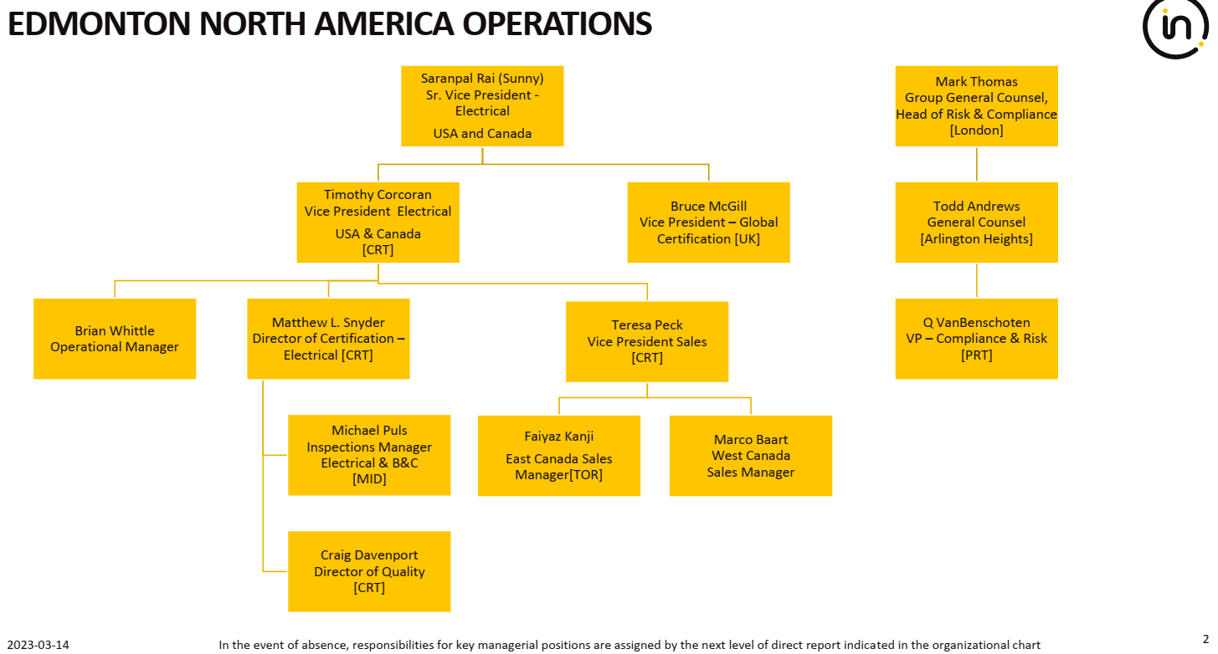

1. Organisation Chart of ExTL

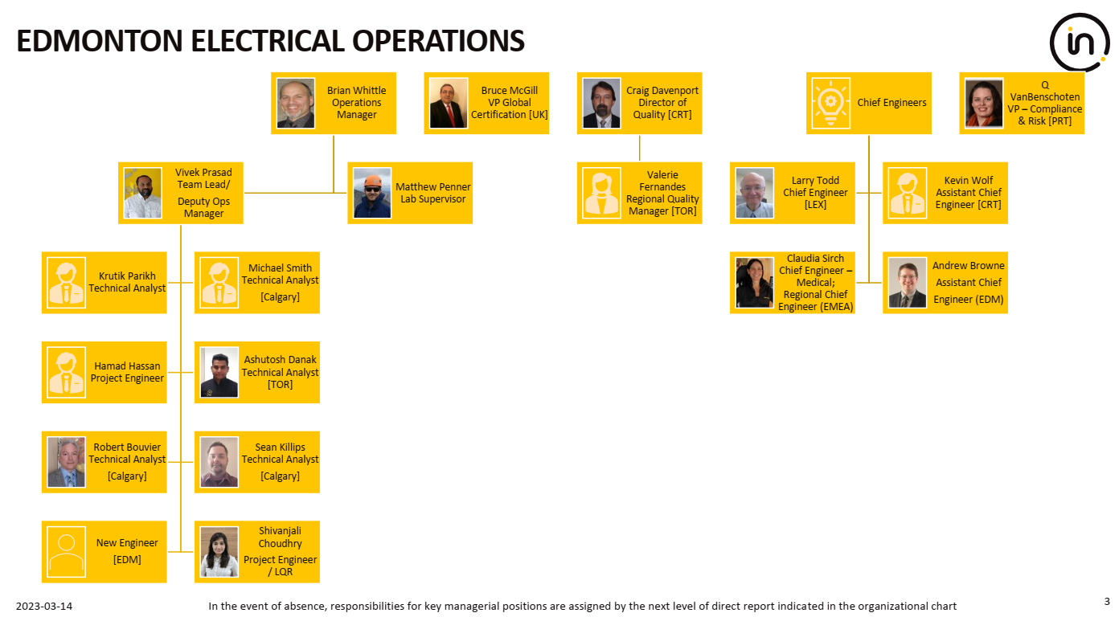

1. Accreditation Certificate for ISO/IEC 17025

